Part 1 Experiment description

“The minimal information required in this section includes the type of the experiment (such as normal-versus-diseased comparison, time course, dose response, and so on) and the experimental variables, including parameters or conditions tested (such as time, dose, genetic variation or response to a treatment or compound).”
“this section specifies the experimental relationships between the array and sample entities—that is, which samples and which arrays were used in each hybridization assay. Each of these will be assigned unique identifiers that are cross-referenced with the information provided in the following sections.”
- tissue type
Reply: Normal rat renal tubular epithelial (NRK-52E) cells.
- experimental variables (runners vs. non-runners, high fat vs. low fat)
Reply: TGF-β1-treated+ shCtrl vs. TGF-β1-treated+shAMPKα2 KD
- n-count
Reply:3
- tissues used for slide
Reply: Normal rat renal tubular epithelial (NRK-52E) cells.
- mouse age, and other variables (wean weight, pooled samples, etc.)
Reply: No
Part 2 Array design.

“The aim of this section is to provide a systematic definition of all arrays used in the experiment, including the genes represented and their physical layout on the array.”
“The array-type definition includes information common to all arrays of a particular type (such as glass-slide spotted with PCR-amplified cDNA clones) as well as precise descriptions of the physical content of each element (spot or feature). This section consists of three parts: (i) a description of the array as a whole (such as platform type, provider and surface type); (ii) a description of each type of element or spot used (properties that are typically common to many elements, such as 'synthesized oligo-nucleotides' or 'PCR products from cDNA clones'); and (iii) a description of the specific properties of each element, such as the DNA sequence and, possibly, quality-control indicators.”

- Array series
- Deconvoluted spot list with gene names
- Array type (mouse, human, cDNA, oligo, number of genes)
- Array size
- Slide type (and coating)
Reply: Affymetrix GeneChip Rat 230 2.0(details see at website https://www.thermofisher.com/order/catalog/product/902493?SID=srch-hj-902493 and http://www.affymetrix.com/products_services/arrays/specific/rat230-20.affx)

Part 3 Samples
“The MIAME 'sample' concept represents the biological material (or biomaterial) for which the gene expression profile is being established. This section is divided into three parts which describe the source of the original sample (such as organism taxonomy and cell type) and any biological in vivo or in vitro treatments applied, the technical extraction of the nucleic acids, and their subsequent labeling.”

- Cy3/Cy5 labels for tissues
- Dye swap? Or reference control?
- Labelling protocol used
Reply: Affymetrix One-Cycle Target Labeling kit, and Control Reagents kit were used (Affymetrix, Santa Clara, CA).
- Sample extraction protocol used
Reply:
(1) Collect cells (80% cell density of 6-well plate), centrifuge for 5 minutes at 2000 rpm, remove supernatant, add 1 mL Trizol into cell precipitation, and then stir for 5 minutes at room temperature after full mixing, then transfer to a new 1.5 mL EP tube.
(2) 200 mL chloroform was added to each tube, and the EP tube was reversed up and down by hand for 15 seconds. The EP tube was stationary at room temperature for 8 minutes.
(3) 4℃, 12800 rpm, centrifugation for 15 min.
(4) Absorbing the upper liquid to a new 1.5 mL EP tube, adding isopropanol with equal volume precooling, and then stilling at 4 C for 10 minutes.
(5) The supernatant was discarded after centrifugation for 12 minutes at 4 C and 12800 rpm.
(6) Add 1 mL, 75% ethanol (fresh preparation with DEPC water), wash and precipitate.
(7) centrifuge at 4, 11800 rpm for 5 minutes and discard most of the supernatants.
(8) centrifuge again for 5 minutes at 4 C and 11800 rpm, discard the supernatant and dry at room temperature.
(9) When the RNA precipitation is basically transparent, RNase-free water (the volume depends on the amount of RNA precipitation) is added to dissolve completely. The concentration and quality of RNA extracted are determined by nanodrop 2000/2000C spectrophotometer.
- Amount of sample labelled
Reply：10ug

Part 4 Hybridizations

“This section defines the laboratory conditions under which the hybridizations were carried out. Other than a free-text description of the hybridization protocol, MIAME requires that a number of critical hybridization parameters are explicitly specified: choice of hybridization solution (such as salt and detergent concentrations), nature of the blocking agent, wash procedure, quantity of labeled target used, hybridization time, volume, temperature and descriptions of the hybridization instruments.”
- Hybridization protocol
Reply：GeneChip Hybridization Wash and Stain Kit was used (Affymetrix; Thermo Fisher Scientifc, Inc., MA, USA).
1、Hybrid reaction liquid was prepared.
2、Hybridization procedure (Table A) is used to heat the hybrid solution.
3、At the same time, 130 L pre-hybridization solution was injected into the chip, and the pre-hybridization was conducted at 45 for 10 minutes.
4、The pre-hybridization solution of the chip was sucked out and 130 l hybridization solution was injected. Put it in the hybridizing furnace, 45 C, 60 rpm for 16 hours (no)
More than 18 hours.
5、After hybridization, the chip was taken out and dyed automatically with GeneChip Fluidics Station 450 instrument.
6、Scanning after washing and dyeing to obtain data

- ALL modifications and deviations from the protocol
Reply: No.
- Manual hybridization or automatic chamber?
Reply：automatic chamber
- Number of slides done at the same time
Reply：3 vs. 3，6 slides
- Hyb time
Reply:14h-16h.
- Number of washes
Reply:3 times.
- Amount of labelled sample hybridized
Reply：130ul.
Part 5 Measurements

“Image data should be provided as raw scanner image files (such as TIFF), accompanied by scanning information that includes relevant scan parameters and laboratory protocols.”

- Which version of scanner software used
- Laser power for scan
- Instrument model numbers
- Must save original .tiff format images (composite image is optional)
Reply：GeneChip Scanner 3000 7G was used(Affymetrix; Thermo Fisher Scientifc, Inc., MA, USA).
For each experimental image, a microarray quantification matrix contains the complete image analysis output as directly generated by the image analysis software (normally provided as separate spreadsheet-type files). Note that for a given image this is a 2D matrix, where array elements (spots or features) constitute one dimension and quantification types (such as mean and median intensity, mean or median background intensity) are the second dimension.

- Normalization protocol：
Reply：RMA
- Does the scanner software subtract background? How much?
Reply：No, the probes with a coefficient of variation greater than 25% were filtered out in subsequent data analysis.

- Spot raw values, background intensity, ch1 and 2 intensity, etc.
Reply：Rawdata file is the original data processed by RMA algorithm.(see Rawdata file)
- Corresponding gene name
Reply：Information of gene name was on the official website of Affymetrix.
- Methods of analysis (MAN, Spotfire, Genespring) be detailed.
Relpy：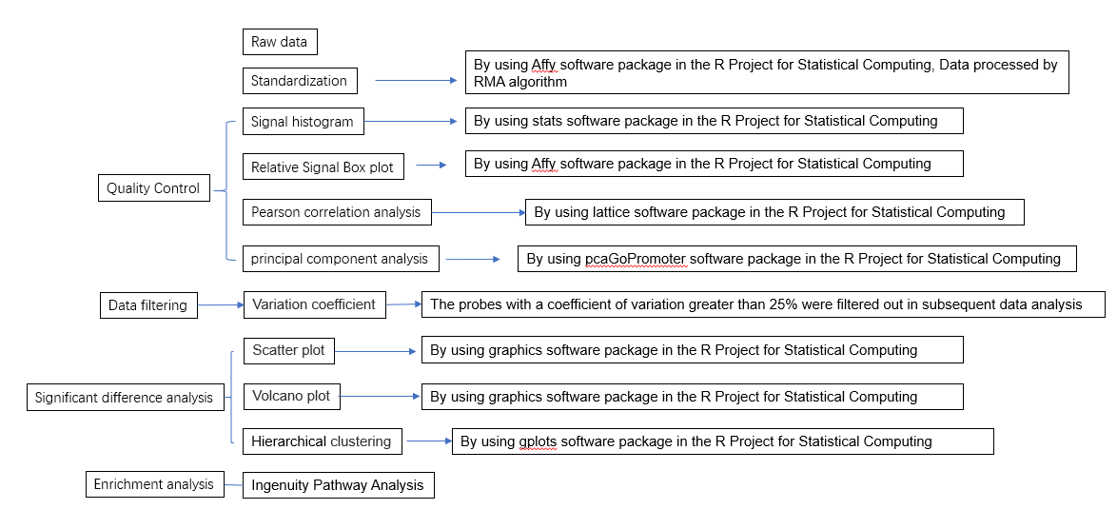

- Normalized to controls? Controls removed? All normalization parameters
Reply：All samples are processed with RMA algorithm, and data standardization does not involve internal reference genes.
- Name of Images, Experiment, and location of files.
Reply:1.Rawdata
No. | Rawdata name | Group
1 | E2672_(Rat230_2).tiff | TGF-β1-treated+shAMPKα2 KD
2 | E2673_(Rat230_2). tiff | TGF-β1-treated+shAMPKα2 KD
3 | E2674_(Rat230_2). tiff | TGF-β1-treated+shAMPKα2 KD
4 | E6340-1_(Rat230_2). tiff | TGF-β1-treated+ shCtrl
5 | E6340-2_(Rat230_2). tiff | TGF-β1-treated+ shCtrl
6 | E6340-3_(Rat230_2). tiff | TGF-β1-treated+ shCtrl
2. Quality Control
Signal histogram：named Signal_Histogram.pdf in supplyment file.
Relative Signal Box plot：named Relative_Signal_Box_Plot.pdf in supplemental file.
Pearson correlation analysis：named Pearson_s_Correlation.pdf in supplemental file.
Principal component analysis：named Principal_Component_Analysis.pdf in supplemental file.
3. Significant difference analysis
Scatter plot：named Scatter_Plot_TGF-β1-treated+shAMPKα2 KD_vs_TGF-β1-treated+ shCtrl.pdf in supplemental file.
Volcano plot：named Volcano_Plot_TGF-β1-treated+shAMPKα2 KD_vs_TGF-β1-treated+ shCtrl.pdf in supplemental file.
Hierarchical clustering：named Heatmap_TGF-β1-treated+shAMPKα2 KD_vs_TGF-β1-treated+ shCtrl.pdf in supplemental file.
Different Gene Expression：named DiffGene_TGF-β1-treated+shAMPKα2 KD_vs_TGF-β1-treated+ shCtrl.xlsx in supplemental file.
4.Ingenuity Pathway Analysis
Canonical Pathway Analysis: named Canonical_Pathway.xlsx, Canonical_Pathway_Histogram.PNG and Canonical_Pathway_MAP.PNG in supplemental file.
- Lowess or other normalization if used (and parameters)
Reply: No

Finally, the gene expression matrix (summarized information) consists of sets of gene expression levels for each sample. If microarray quantification matrices can be considered spot/image centric, then the gene expression matrix is gene/sample centric. At this point, the expression values may have been normalized, consolidated and transformed in any number of ways by the submitter in order to present the data in a form amenable to scientific analysis. Rather than attempting to impose a standard for gene expression values, MIAME indicates preferred detailed specifications of all numerical calculations applied to unprocessed quantifications in (b) that have led to the data in (c). Experimenters are encouraged, though not required, to provide reliability indicators (such as s.d.) for each data point.

- Output file
Reply：Reply:1.Rawdata
No. | Rawdata name | Group
1 | E2672_(Rat230_2).tiff | TGF-β1-treated+shAMPKα2 KD
2 | E2673_(Rat230_2). tiff | TGF-β1-treated+shAMPKα2 KD
3 | E2674_(Rat230_2). tiff | TGF-β1-treated+shAMPKα2 KD
4 | E6340-1_(Rat230_2). tiff | TGF-β1-treated+ shCtrl
5 | E6340-2_(Rat230_2). tiff | TGF-β1-treated+ shCtrl
6 | E6340-3_(Rat230_2). tiff | TGF-β1-treated+ shCtrl
2. Quality Control
Signal histogram：named Signal_Histogram.pdf in supplemental file.
Relative Signal Box plot：named Relative_Signal_Box_Plot.pdf in supplemental file.
Pearson correlation analysis：named Pearson_s_Correlation.pdf in supplemental file.
Principal component analysis：named Principal_Component_Analysis.pdf in supplemental file.
3. Significant difference analysis
Scatter plot：named Scatter_Plot_TGF-β1-treated+shAMPKα2 KD_vs_TGF-β1-treated+ shCtrl.pdf in supplemental file.
Volcano plot：named Volcano_Plot_TGF-β1-treated+shAMPKα2 KD_vs_TGF-β1-treated+ shCtrl.pdf in supplemental file.
Hierarchical clustering：named Heatmap_TGF-β1-treated+shAMPKα2 KD_vs_TGF-β1-treated+ shCtrl.pdf in supplemental file.
Different Gene Expression：named DiffGene_TGF-β1-treated+shAMPKα2 KD_vs_TGF-β1-treated+ shCtrl.xlsx in supplemental file.
4.Ingenuity Pathway Analysis
Canonical Pathway Analysis: named Canonical_Pathway.xlsx, Canonical_Pathway_Histogram.PNG and Canonical_Pathway_MAP.PNG in supplemental file.
- Normalized ratios
Reply：|Fold Change|>3
- Numerical manipulations
Reply：Difference analysis by using Limma software package
- Cut off values
Reply：|Fold Change|>3 and FDR<0.05

Part 6 Normalization controls

“A typical microarray experiment involves a number of hybridization assays in which the data from multiple samples are analyzed to identify relative changes in expression levels, identify differentially expressed genes and, in many cases, discover classes of genes or samples having similar patterns of expression.”

- Hypothesis
- Gene expression patterns found
- Controls used, normalization methods used (see above)
Reply：Hypothesis: Recent studies have shown that AMPK can regulate EMT processes during kidney fibrosis. However, the underlying mechanisms for AMPK changes in renal tubular EMT remain unclear. In this study, the expression of AMPKα2 in EMT-derived normal rat renal tubular epithelial (NRK-52E) cells induced by TGF-β1 was investigated. Gene microarray was used to analyze differential gene expression in EMT-derived NRK-52E cells before and after the AMPKα2 knockout. Ingenuity pathway analysis (IPA) was performed to reveal specific genes and signaling pathways involved in the regulation of the EMT by AMPKα2.

