# Supplementary Materials

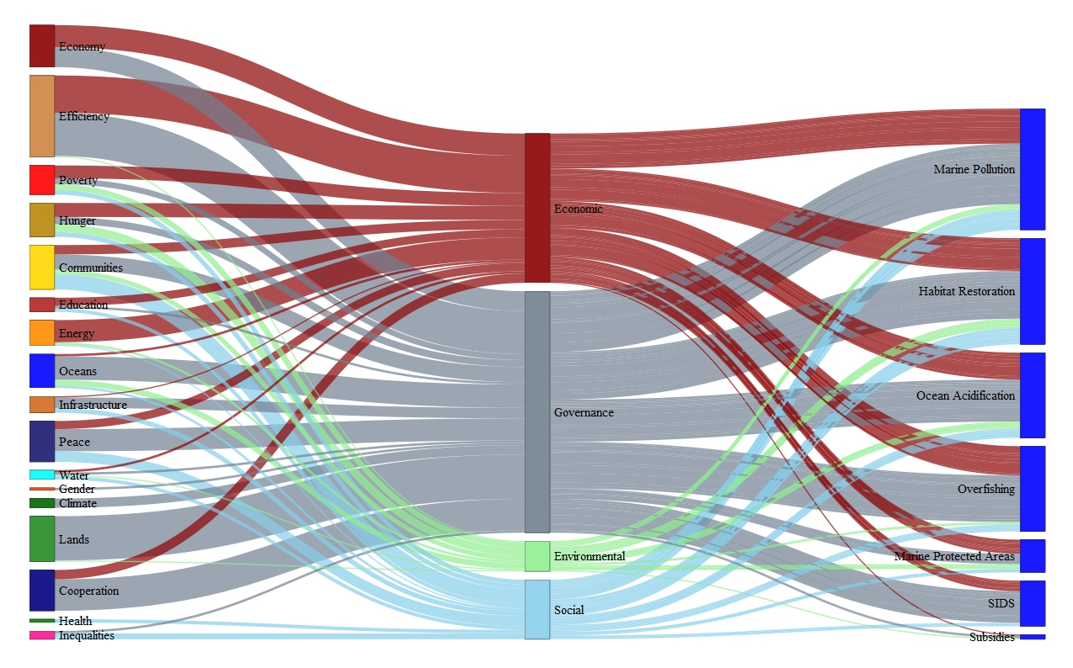

Figure S1. The four dimensions (economic, governance, environmental, and social) that regulate whether context-dependent relationships are realized from other SDGs to SDG Ocean targets

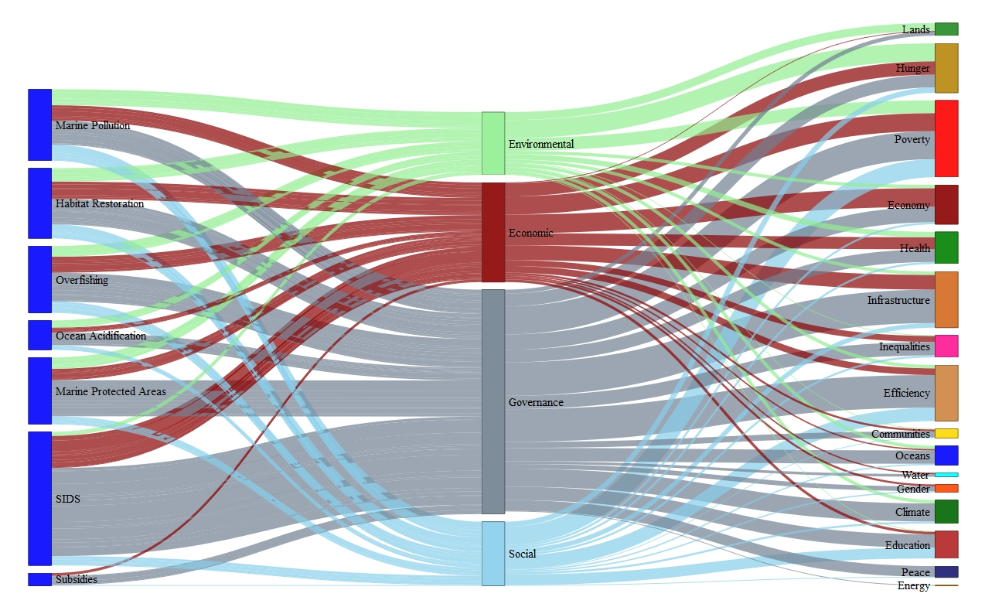

Figure S2. The four dimensions (economic, governance, environmental, and social) that regulate whether context-dependent relationships are realized from SDG Ocean targets to other SDGs



Figure S3. All relationships accounting for all expert input, including relationships with less that 2/3 support. The left figure is from other SDGs to SDG Ocean targets, and the right is from SDG Ocean targets to other SDGs.



Figure S4. The centrality measures that were most informative for analyzing institutional metrics, according to A) PCA and B) t-Distributed Stochastic Neighbor Embedding analysis.

Table S1. Indirect co-benefit production for all co-benefits for SDG Ocean targets

|  |  |  |  |  |  |  |  |
| --- | --- | --- | --- | --- | --- | --- | --- |
|  | SDG1 | SDG2 | SDG3 | SDG4 | SDG5 | SDG7 | Total |
| SDG1 | 0 | 0.049226 | 0.097907 | 0.007071 | 0.046224 | 0.03182 | 0.232247 |
| SDG2 | 0 | 0 | 0.093851 | 0.062567 | 0.046375 | 0.030501 | 0.233294 |
| SDG3 | 0 | 0.046988 | 0 | 0.006749 | 0.044123 | 0.030374 | 0.128234 |
| SDG4 | 0 | 0.04453 | 0.007479 | 0 | 0.04279 | 0.002431 | 0.09723 |
| SDG5 | 0 | 0.049332 | 0.093851 | 0.062567 | 0 | 0.030501 | 0.236251 |
| SDG7 | 0 | 0.047505 | 0.090375 | 0.06025 | 0.00762 | 0 | 0.20575 |

Table S2. Indirect co-benefit production for pre-requisite co-benefits for SDG Ocean targets

|  |  |  |  |  |  |  |  |
| --- | --- | --- | --- | --- | --- | --- | --- |
|  | SDG1 | SDG2 | SDG3 | SDG4 | SDG5 | SDG7 | Total |
| SDG1 | 0 | 0.116179 | 0.154905 | 0 | 0.167814 | 0 | 0.438898 |
| SDG2 | 0 | 0 | 0.017403 | 0 | 0.139224 | 0 | 0.156627 |
| SDG3 | 0 | 0.108434 | 0 | 0 | 0.156627 | 0 | 0.26506 |
| SDG4 | 0 | 0.102811 | 0.018563 | 0 | 0.148505 | 0 | 0.26988 |
| SDG5 | 0 | 0.108434 | 0.144578 | 0 | 0 | 0 | 0.253012 |
| SDG7 | 0 | 0.096436 | 0.002655 | 0.070833 | 0.021241 | 0 | 0.191165 |

Table S3. Indirect co-benefit production for all context-independent co-benefits for SDG Ocean targets

|  |  |  |  |  |  |  |  |
| --- | --- | --- | --- | --- | --- | --- | --- |
|  | SDG1 | SDG2 | SDG3 | SDG4 | SDG5 | SDG7 | Total |
| SDG1 | 0 | 0.074555 | 0.127461 | 0.010224 | 0.141229 | 0.078802 | 0.432271 |
| SDG2 | 0 | 0 | 0.121584 | 0.076613 | 0.141404 | 0.074751 | 0.414353 |
| SDG3 | 0 | 0.070413 | 0 | 0.009656 | 0.133383 | 0.074425 | 0.287876 |
| SDG4 | 0 | 0.064429 | 0.019276 | 0 | 0.128335 | 0.005232 | 0.217272 |
| SDG5 | 0 | 0.066803 | 0.119924 | 0.005232 | 0 | 0.01167 | 0.20363 |
| SDG7 | 0 | 0.061358 | 0.007739 | 0.075212 | 0.016034 | 0 | 0.160343 |

Table S4. Indirect co-benefit production for all context-dependent co-benefits for SDG Ocean targets

|  |  |  |  |  |  |  |  |
| --- | --- | --- | --- | --- | --- | --- | --- |
|  | SDG1 | SDG2 | SDG3 | SDG4 | SDG5 | SDG7 | Total |
| SDG1 | 0 | 0 | 0 | 0 | 0 | 0 | 0 |
| SDG2 | 0 | 0 | 0 | 0 | 0 | 0 | 0 |
| SDG3 | 0 | 0 | 0 | 0 | 0 | 0 | 0 |
| SDG4 | 0 | 0 | 0 | 0 | 0 | 0 | 0 |
| SDG5 | 0 | 0 | 0.021739 | 0.333333 | 0 | 0.043478 | 0.398551 |
| SDG7 | 0 | 0 | 0.5 | 0 | 0 | 0 | 0.5 |

Table S5. The number of direct relationships from each SDG to the SDG Ocean targets



Table S6. The Aruban institutions and their associated codes used in the network analysis

|  |  |
| --- | --- |
| Institutions | Code |
| Directie Onderwijs., | I1 |
| WEB NV. (Utilities Aruba N.V.) | I2 |
| ELMAR NV. | I3 |
| Advisory Board of Aruba (Raad van Advies) | I4 |
| Air Navigation Services Aruba N.V. (ANSA N.V.) | I5 |
| Aruba Airport Authority N.V. (AAA) | I6 |
| Aruba Fire Department | I7 |
| Aruba Free Zone | I8 |
| Aruba Investment Agency | I9 |
| Aruba Kingdom Games Foundation (SKA) | I10 |
| Aruba Olympic Committee (COA) | I11 |
| Aruba Police Force | I12 |
| Aruba Ports Authority N.V.(APA) | I13 |
| Aruba School of Music Rufo Wever | I14 |
| Aruba Sports Union (ASU) | I15 |
| Aruba Tourism Authority (ATA) | I16 |
| Aruban National Archives | I17 |
| Arubus N.V. | I18 |
| Aruparking | I19 |
| Biblioteca Nacional Aruba (BNA) | I20 |
| Bureau City Inspector (BCI) | I21 |
| Bureau European Union and Kingdom Relations, | I22 |
| Bureau Intellectual Property (BIE) | I23 |
| Bureau Landsbemiddelaar (BLB) | I24 |
| Bureau of Addiction Care and Counselling (BOV) | I25 |
| Bureau of Compulsory Education (BLP) | I26 |
| Bureau Sostenemi (BSO) | I27 |
| Bureau Traimerdia (BTm) | I28 |
| Bureau Vrouwenzaken (BVZ) | I29 |
| Cas di Cultura/Stichting Schouwburg Aruba (CdC/SSA) | I30 |
| Central Audit Department (CAD) | I31 |
| Central Bank van Aruba | I32 |
| Centro pa Desaroyo di Aruba (CEDE Aruba) | I33 |
| Civil Registry office (Dienst Burgerlijke Stand en Bevolkingsregister DBSB) | I34 |
| Commission of Sports Subsidy (SSC) | I35 |
| Correctional Institute Aruba (KIA) | I36 |
| Crisis Management Office | I37 |
| Departamento di Aduana (Douane) | I38 |
| Departamento di Impuesto (DI) | I39 |
| Departamento di Integracion, Maneho y Admision di Stranhero (DIMAS) | I40 |
| Departamento di Progreso Laboral (DPL) | I41 |
| Departamento di Recurso Humano (DRH) | I42 |
| Departamento Meteorologico Aruba (DMA) | I43 |
| Department of Casino Affairs | I44 |
| Department of Civil Aviation Aruba (DCA) | I45 |
| Department of Economic Affairs, Commerce and Industry | I46 |
| Department of Education of Aruba (DO) | I47 |
| Department of Information Technology and Automation (DIA) | I48 |
| Department of Legislation and Legal Affairs | I49 |
| Department of Nature and Environment (DNE) | I50 |
| Department of Public Health (DVG) | I51 |
| Department of Public Transportation | I52 |
| Department of Rental & Consumer Affairs (DHC) | I53 |
| Department of Security | I54 |
| Dienst Landmeetkunde en Vastgoedregistratie (DLV) | I55 |
| Dienst Openbare Werken (DOW) | I56 |
| Dienst Technische Inspectie (DTI) | I57 |
| Directie Arbeid en Onderzoek (DAO) | I58 |
| Directie Cultuur Aruba (DCA) | I59 |
| Directie Financiën (DFIN) | I60 |
| Directie Infrastructuur en Planning (DIP) | I61 |
| Directie Landbouw, Veeteelt en Visserij en Markthallen (DLVV) | I62 |
| Directie Sociale Zaken (DSZ) | I63 |
| Directie Telecommunicatie Zaken (DTZ) | I64 |
| Directie Volks Gezondheid., | I65 |
| Directie Voogdijraad (Guardianship Council) | I66 |
| Directorate of Shipping Aruba (DSV) | I67 |
| Enseñansa pa Empleo (EPE) | I68 |
| Financial Intelligence Unit | Meldpunt Ongebruikelijke Transacties (FIU | MOT) | I69 |
| Foreign Relations Directorate (DBB) | I70 |
| Fundacion Arubano Maneho di Facilidad Deportivo (FAMFD) | I71 |
| Fundacion Cas Pa Comunidad Arubano (FCCA) | I72 |
| Fundacion Centro di Pesca Hadicurari (Hadicurari) | I73 |
| Fundacion Facilidadnan Deportivo Frans Figaroa (FFDFF) | I74 |
| Fundacion Lotto pa Deporte (Lotto) | I75 |
| Fundacion Parke Nacional Arikok (FPNA) | I76 |
| Government Information Services (BUVO) | I77 |
| Health Inspection Aruba (Inspectie Volksgezondheid Aruba (IVA) | I78 |
| High Commissioner Aruba Financial Center (HCFC) | I79 |
| Inspectie Beveiliging Scheep- en Luchtvaart (IBSL) | I80 |
| Inspectorate of Education (IO) | I81 |
| Instituto Alarma y Seguridad Aruba (IASA) | I82 |
| Instituto Biba Saludabel y Activo (IBISA) | I83 |
| Instituto Pedagogico Arubano (IPA) | I84 |
| Joint Court of Justice of Aruba, Curaçao, Sint Maarten and of Bonaire, Saint Eustatius and Saba | I85 |
| Medical Institute San Nicolas (IMSAN) | I86 |
| Medical Laboratory Services Aruba Foundation (Fundacion Servicio Laboratorio Medico) Aruba (FSLMA) | I87 |
| Monuments Office Aruba | I88 |
| Museo Historico Arubano/Historisch Museum Aruba (MHA/HMA) | I89 |
| National Criminal Investigation Department (LR) | I90 |
| National Health Insurance Aruba (AZV) | I91 |
| Nationale 'United Nations Educational, Scientific and Cultural Organization' Commissie Aruba (UNESCO) | I92 |
| Objection Advisory Board | I93 |
| Office for Government Grant Coordination | I94 |
| Office Internal Services (BID) | I95 |
| Openbaar Onderwijs (OO) | I96 |
| Post Aruba N.V. | I97 |
| Public Prosecutor's Office | I98 |
| Refineria di Aruba N.V. | I99 |
| Royal Dutch Coast Guard | I100 |
| Service Unit Public Schools (DPS) | I101 |
| Servicio di Limpieza di Aruba (Serlimar) | I102 |
| Setar N.V. | I103 |
| Social and Economic Council (SER) | I104 |
| Social Security Bank of Aruba (SVB) | I105 |
| Stichting Algemeen Pensioenfonds Aruba (APFA) | I106 |
| Stichting Monumenten Fonds Aruba (SMFA) | I107 |
| The Minister plenipotentiary of Aruba | I108 |
| Union di Organisacionnan Cultural Arubano (UNOCA) | I109 |
| University of Aruba (UVA) | I110 |
| Veterinary Services (VET) | I111 |
| Volkskredietbank van Aruba (VKB) | I112 |

Table S7. Centrality measures for the importance of Aruban institutions in regulating progress on the various SDG ocean targets. The topological coefficient is a relative measure for the extent to which a node shares nodes with other nodes, so low values here indicate that an institution is connected with other institutions that are not otherwise connected. We interpret that as suggesting that institutions with low topological coefficient scores are more critical for coordinating activities across institutions that are otherwise not connected with the broader institutional system.

|  |  |  |  |  |
| --- | --- | --- | --- | --- |
| Institution Code | Subgraph Centrality Scores | Topological Coefficient | Barycenter Centrality | Bottleneck Centrality |
| I100 | 1402.92489 | 0.6888889 | 0.00617284 | 0 |
| I101 | 48165.28615 | 0.3740741 | 0.00763359 | 0 |
| I102 | 5062.57032 | 0.2114625 | 0.00775194 | 7 |
| I104 | 160245.2346 | 0.1650246 | 0.01162791 | 62 |
| I105 | 2506.03322 | 0.484127 | 0.00689655 | 0 |
| I107 | 2256.04774 | 0.3055556 | 0.00704225 | 0 |
| I108 | 4388.05916 | 0.3809524 | 0.00699301 | 2 |
| I109 | 2256.04774 | 0.3055556 | 0.00704225 | 0 |
| I110 | 48165.28615 | 0.3740741 | 0.00763359 | 0 |
| I112 | 3943.49674 | 0.4333333 | 0.00719425 | 0 |
| I12 | 6317.37529 | 0.1903226 | 0.00917431 | 43 |
| I13 | 5856.40607 | 0.2536998 | 0.00757576 | 15 |
| I16 | 46499.86058 | 0.207478 | 0.00980392 | 57 |
| I18 | 2363.30758 | 0.326087 | 0.00740741 | 0 |
| I2 | 4898.2664 | 0.3355482 | 0.00735294 | 3 |
| I22 | 4388.05916 | 0.3809524 | 0.00699301 | 2 |
| I23 | 99212.45073 | 0.2882353 | 0.00869565 | 9 |
| I26 | 48165.28615 | 0.3740741 | 0.00763359 | 0 |
| I28 | 48165.28615 | 0.3740741 | 0.00763359 | 0 |
| I29 | 2506.03322 | 0.484127 | 0.00689655 | 0 |
| I30 | 2256.04774 | 0.3055556 | 0.00704225 | 0 |
| I32 | 28101.63704 | 0.3529412 | 0.008 | 0 |
| I33 | 63571.22545 | 0.3222222 | 0.00787402 | 2 |
| I34 | 1322.48095 | 0.3773585 | 0.00769231 | 0 |
| I37 | 283.6938 | 0.5058824 | 0.00574713 | 3 |
| I38 | 2892.83834 | 0.3142857 | 0.00719425 | 13 |
| I40 | 1402.92489 | 0.6888889 | 0.00617284 | 0 |
| I41 | 3943.49674 | 0.4333333 | 0.00719425 | 0 |
| I43 | 373.34547 | 0.4705882 | 0.00578035 | 3 |
| I44 | 28101.63704 | 0.3529412 | 0.008 | 0 |
| I46 | 126099.178 | 0.2304582 | 0.00952381 | 35 |
| I47 | 48165.28615 | 0.3740741 | 0.00763359 | 0 |
| I48 | 48165.28615 | 0.3740741 | 0.00763359 | 0 |
| I49 | 1402.92489 | 0.6888889 | 0.00617284 | 0 |
| I50 | 3375.3943 | 0.2271062 | 0.0075188 | 37 |
| I52 | 2363.30758 | 0.326087 | 0.00740741 | 0 |
| I54 | 1402.92489 | 0.6888889 | 0.00617284 | 0 |
| I55 | 2363.30758 | 0.326087 | 0.00740741 | 0 |
| I56 | 12278.22642 | 0.2484848 | 0.00840336 | 17 |
| I58 | 3943.49674 | 0.4333333 | 0.00719425 | 0 |
| I59 | 2256.04774 | 0.3055556 | 0.00704225 | 0 |
| I6 | 4382.49514 | 0.3577236 | 0.00719425 | 0 |
| I60 | 28101.63704 | 0.3529412 | 0.008 | 0 |
| I61 | 9478.83701 | 0.3278302 | 0.008 | 5 |
| I62 | 28.27895 | 0.5714286 | 0.00518135 | 0 |
| I67 | 942.56889 | 0.4102564 | 0.00649351 | 2 |
| I69 | 1402.92489 | 0.6888889 | 0.00617284 | 0 |
| I70 | 4388.05916 | 0.3809524 | 0.00699301 | 2 |
| I73 | 28.27895 | 0.5714286 | 0.00518135 | 0 |
| I75 | 28101.63704 | 0.3529412 | 0.008 | 0 |
| I76 | 1247.34309 | 0.3857143 | 0.00689655 | 1 |
| I77 | 1322.48095 | 0.3773585 | 0.00769231 | 0 |
| I79 | 28101.63704 | 0.3529412 | 0.008 | 0 |
| I8 | 39008.83326 | 0.289916 | 0.00826446 | 6 |
| I80 | 942.56889 | 0.4102564 | 0.00649351 | 2 |
| I82 | 1402.92489 | 0.6888889 | 0.00617284 | 0 |
| I84 | 48165.28615 | 0.3740741 | 0.00763359 | 0 |
| I85 | 1402.92489 | 0.6888889 | 0.00617284 | 0 |
| I88 | 2256.04774 | 0.3055556 | 0.00704225 | 0 |
| I9 | 39008.83326 | 0.289916 | 0.00826446 | 6 |
| I90 | 2892.83834 | 0.3142857 | 0.00719425 | 13 |
| I92 | 48165.28615 | 0.3740741 | 0.00763359 | 0 |
| I96 | 48165.28615 | 0.3740741 | 0.00763359 | 0 |