T1000: A reduced toxicogenomics gene set for improved decision making

¹Othman Soufan, ²Jessica Ewald, ¹Charles Viau, ³Doug Crump, ⁴Markus Hecker, ^{2,*}Niladri Basu and ^{1,5,*}Jianguo Xia
¹Institute of Parasitology, McGill University, Montreal, Quebec, Canada; ²Faculty of Agricultural and Environmental Sciences, McGill University, Montreal, Quebec, Canada; ³Ecotoxicology and Wildlife Health Division, Environment and Climate Change Canada, National Wildlife Research Centre, Carleton University, Ottawa, Canada; ⁴School of the Environment & Sustainability and Toxicology Centre, University of Saskatchewan, Saskatoon, Canada; ⁵Department of Animal Science, McGill University, Montreal, Quebec, Canada.
Supplementary Information 1

In the following figure, the plot of the different iterations for computing prior scores is illustrated. At each step, most distant (i.e. most contributing) genes are selected, removed from the dataset and then the process of applying dimensionality reduction using PCA followed by K-means clustering is repeated. For Part A, a 2-Dimensional visualization using PCA is provided for the information prepared for the genes. Each single points represents the prior information encoded and gathered from CTD, KEGG and Hallmark for a corresponding single gene. The green, light blue and light red colors reflects the three clusters after applying K-means. The black squares are the centroids (or Cen.) for these clusters. The blue crosses are the most distant points (or Out. for outliers). After the Out. points are removed and the process is repeated for a second time, we get to Itr2 as illustrated in Part B. In Part C, we show the statistics for 100 iterations to see that the proposed features well characterize Out. from Cent. genes and that Out. genes have more prominent effects indicated by the light blue curves.
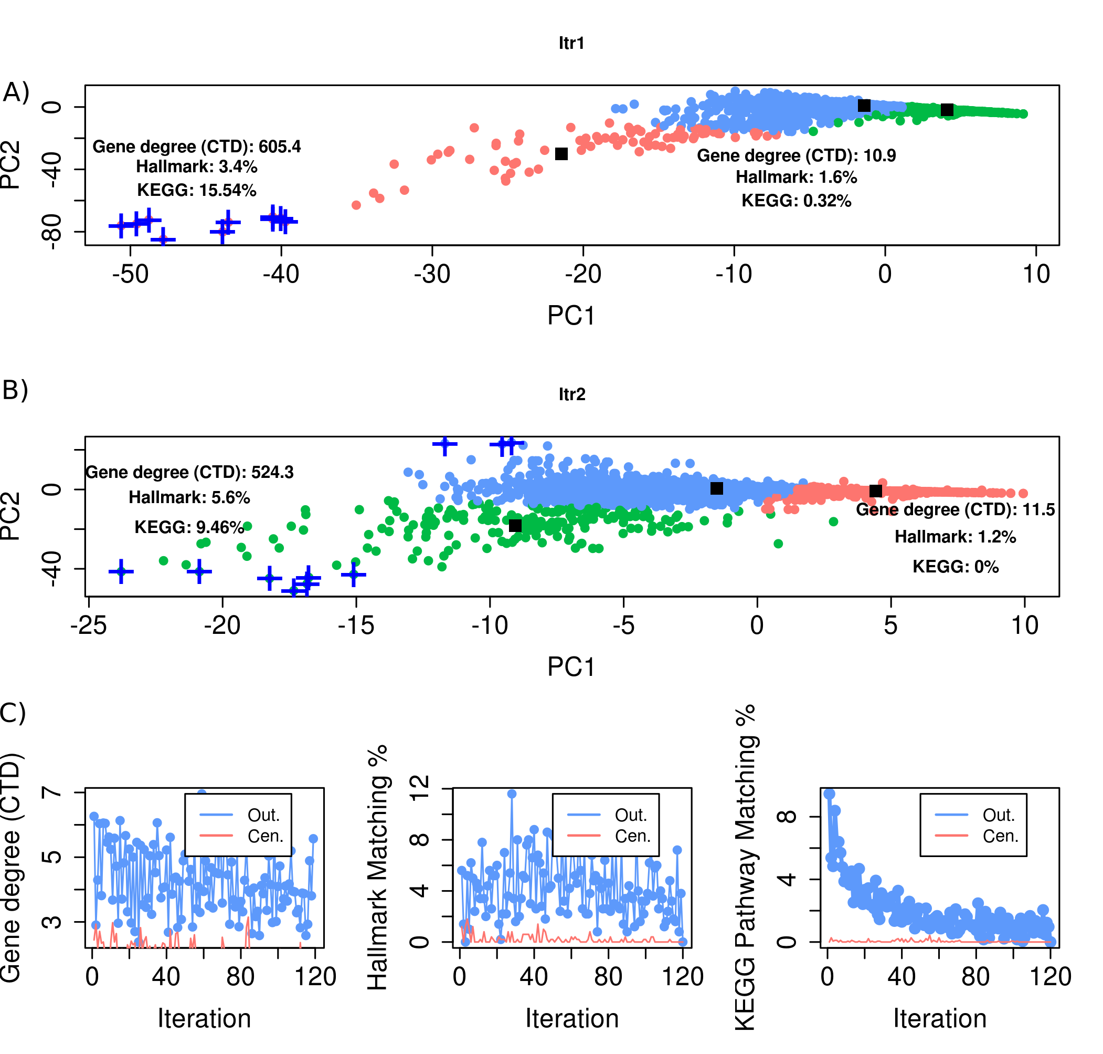
Supplementary Information 1 Figure 1: Plot of the different iterations for computing prior scores.

