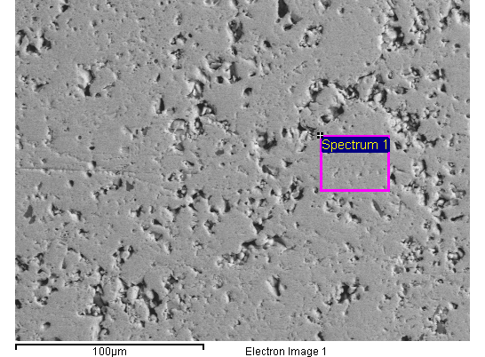

|  |  |  |  |  |  |  |
| --- | --- | --- | --- | --- | --- | --- |
| Element | App | Intensity | Weight% | Weight% | Atomic% |  |
|  | Conc. | Corrn. |  | Sigma |  |  |
| S K | 103.72 | 0.9072 | 51.59 | 0.55 | 66.12 |  |
| Ni K | 99.26 | 0.9253 | 48.41 | 0.55 | 33.88 |  |
|  |  |  |  |  |  |  |
| Totals |  |  | 100.00 |  |  |  |

Spectrum Label: Spectrum 1

Livetime 9.4 s

Acquisition geometry ( degrees ):

Tilt = 0.0

Azimuth = 0.0

Elevation = 35.0

Accelerating voltage = 20.00 kV

Total spectrum counts = 77035

|  |  |  |  |
| --- | --- | --- | --- |
| Sample data : | Energy (eV) | Resn. (eV) | Area |
| Strobe : | 1.3 | 90.06 | 89621 |
|  |  |  |  |
| Optimization data : Nickel K series |  |  |  |
|  | Energy (eV) | Resn. (eV) | Area |
| Strobe : | .0 | 83.95 | 289412 |
| Optimization element : | 7474.9 | 164.12 | 28207 |

Sample: NiS2#1952-3_HP

Type: Default

ID:

Project: Project 1

Owner: INCA

Site: Site of Interest 1

24/01/2019 12:48:27

MicroLab-Electron Microscopy Laboratory of Técnico

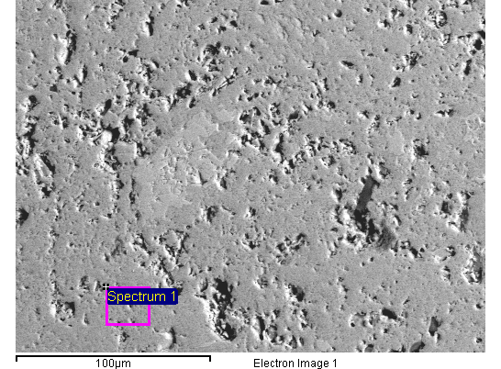

|  |  |  |  |  |  |  |
| --- | --- | --- | --- | --- | --- | --- |
| Element | App | Intensity | Weight% | Weight% | Atomic% |  |
|  | Conc. | Corrn. |  | Sigma |  |  |
| S K | 59.69 | 0.9047 | 50.90 | 0.51 | 65.50 |  |
| Ni K | 58.95 | 0.9262 | 49.10 | 0.51 | 34.50 |  |
|  |  |  |  |  |  |  |
| Totals |  |  | 100.00 |  |  |  |

Spectrum Label: Spectrum 1

Livetime 18.0 s

Acquisition geometry ( degrees ):

Tilt = 0.0

Azimuth = 0.0

Elevation = 35.0

Accelerating voltage = 20.00 kV

Total spectrum counts = 97906

|  |  |  |  |
| --- | --- | --- | --- |
| Sample data : | Energy (eV) | Resn. (eV) | Area |
| Strobe : | 1.3 | 90.60 | 171042 |
|  |  |  |  |
| Optimization data : Nickel K series |  |  |  |
|  | Energy (eV) | Resn. (eV) | Area |
| Strobe : | .0 | 83.95 | 289412 |
| Optimization element : | 7474.9 | 164.12 | 28207 |

Sample: NiS2#1952-3_HP2

Type: Default

ID:

Project: Project 1

Owner: INCA

Site: Site of Interest 1

24/01/2019 12:53:33

MicroLab-Electron Microscopy Laboratory of Técnico

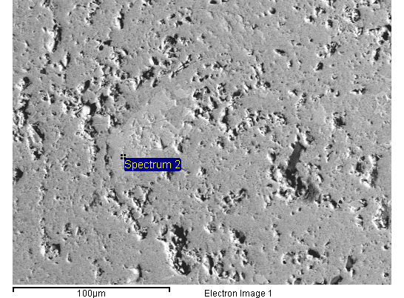

|  |  |  |  |  |  |  |
| --- | --- | --- | --- | --- | --- | --- |
| Element | App | Intensity | Weight% | Weight% | Atomic% |  |
|  | Conc. | Corrn. |  | Sigma |  |  |
| S K | 39.43 | 0.8533 | 36.56 | 0.48 | 51.35 |  |
| Ni K | 75.85 | 0.9461 | 63.44 | 0.48 | 48.65 |  |
|  |  |  |  |  |  |  |
| Totals |  |  | 100.00 |  |  |  |

Spectrum Label: Spectrum 2

Livetime 17.9 s

Acquisition geometry ( degrees ):

Tilt = 0.0

Azimuth = 0.0

Elevation = 35.0

Accelerating voltage = 20.00 kV

Total spectrum counts = 92068

|  |  |  |  |
| --- | --- | --- | --- |
| Sample data : | Energy (eV) | Resn. (eV) | Area |
| Strobe : | 1.3 | 89.91 | 169563 |
|  |  |  |  |
| Optimization data : Nickel K series |  |  |  |
|  | Energy (eV) | Resn. (eV) | Area |
| Strobe : | .0 | 83.95 | 289412 |
| Optimization element : | 7474.9 | 164.12 | 28207 |

Sample: NiS2#1952-3_HP2

Type: Default

ID:

Project: Project 1

Owner: INCA

Site: Site of Interest 1

24/01/2019 12:54:24

MicroLab-Electron Microscopy Laboratory of Técnico