Title: Validation of COI metabarcoding primers for terrestrial arthropods

Running Title: Primers for arthropod metabarcoding
Word count: ____
Authors: Vasco Elbrecht^{1*}, Thomas WA Braukmann¹, Natalia V Ivanova^{1,2}, Sean WJ Prosser¹, Mehrdad Hajibabaei^{1,2}, Michael Wright^{1,2}, Evgeny V Zakharov^{1,2}, Paul DN Hebert^{1,2}, Dirk Steinke^{1,2}

Affiliations:
1) Centre for Biodiversity Genomics, University of Guelph, 50 Stone Road East, Guelph, Ontario, N1G 2W1, Canada
2) Department of Integrative Biology, University of Guelph, 50 Stone Road East, Guelph, Ontario, N1G 2W1, Canada

*Corresponding author: Vasco Elbrecht (elbrecht@uoguelph.ca),

Abstract:
Metabarcoding can rapidly determine the species composition of bulk samples and thus aids ecosystem assessment. However, it is essential to use primer sets that minimize amplification bias among taxa to maximize species recovery. Despite this fact, the performance of primer sets employed for metabarcoding terrestrial arthropods has not been sufficiently evaluated. Thus this study tests the performance of 36 primer sets on a mock community containing 374 species. Amplification success was assessed with gradient PCRs and the 21 most promising primer sets selected for metabarcoding. These 21 primer sets where also tested by metabarcoding a Malaise trap sample. We identified eight primer sets, mainly those including inosine and/or high degeneracy, that recovered more than 95% of the species in the mock community. Results from the Malaise trap sample were congruent with the mock community, but primer sets generating short amplicons produced potential false positives. Taxon recovery from the 21 amplicon pools of the mock community and Malaise trap sample were used to select four primer sets for metabarcoding evaluation at different annealing temperatures (40-60 Cº) using the mock community. Temperature did only have a minor effect on taxa recovery that varied with the specific primer pair.
This study reveals the weak performance of some primer sets employed in past studies. It also demonstrated that certain primer sets can recover most taxa in a diverse species assemblage. Thus there is no need to employ several primer sets targeting the same amplicon. While we identified several suited primer sets for arthropod metabarcoding, the primer selection depends on the targeted taxonomic groups, as well as DNA quality, desired taxonomic resolution, and sequencing platform employed for analysis.

Key words: DNA metabarcoding, primer bias, degeneracy, insects, biodiversity.

Introduction
Over the past decade, two methodological and technological advances have made it possible to address the urgent need for the capacity to undertake large-scale surveys of biodiversity (Vörösmarty et al. 2010; Dirzo et al. 2014; Steffen et al. 2015). First, the emergence of DNA barcoding which uses sequence variation in short, standardized gene regions (i.e. DNA barcodes) to discriminate species, has made it possible to quickly and reliably characterize species diversity (Hebert et al. 2003). Second, high-throughput sequencers (HTS) permit the inexpensive acquisition of millions of sequence records (Reuter et al. 2015). The coupling of HTS with DNA barcoding, commonly known as metabarcoding, allows for characterization of biodiversity at unprecedented scales (Creer et al. 2016) as shown by studies on terrestrial (Gibson et al. 2014; Beng et al. 2016), freshwater (Hajibabaei et al. 2011; Carew et al. 2013; Andújar et al. 2017), and marine (Leray & Knowlton 2015) ecosystems.
Metabarcoding studies on bulk collections of animals usually targets a 658 bp region of the cytochrome c oxidase subunit I (COI) (Folmer et al. 1994; Andújar et al. 2018). This gene region has gained broad adoption because of the rapidly expanding reference database (Ratnasingham & Hebert 2007; Porter & Hajibabaei 2018b) and its good taxonomic resolution (Meusnier et al. 2008). Ribosomal markers have been suggested as an alternative (Deagle et al. 2014; Marquina et al. 2018) because their slower rate of evolution results in more conserved motifs/regions aiding the design of universal primer sets. However, reference databases for ribosomal markers are very limited for most taxonomic groups (Clarke et al. 2014) and ribosomal primer sets show no substantial improvement in taxon recovery over well-designed COI primer sets (Elbrecht et al. 2016; Clarke et al. 2017; Elbrecht & Leese 2017; Krehenwinkel et al. 2017).
An important consideration for metabarcoding studies is the primer combination used for amplification of the target fragment. It is critical that primer sets optimally match the template sequences of the target species. Mismatches between primer and template is skewing read abundance and lead to a substantial bias in taxon detection (Piñol et al. 2014; Elbrecht & Leese 2015). Failure to minimize amplification bias reduces the amount of taxa detected in a sample (Elbrecht & Leese 2017). Furthermore, insufficient sequencing depth and/or low DNA concentration can introduce stochastic effects that additionally bias taxon recovery (Barnes & Turner 2015; Leray & Knowlton 2017).
The effectiveness of primer sets can be evaluated by in vitro tests with mock communities (Elbrecht & Leese 2015; Brandon-Mong et al. 2015; Leray & Knowlton 2017) or by in silico tests (Clarke et al. 2014; Elbrecht & Leese 2016; Piñol et al. 2018; Bylemans et al. 2018b; Marquina et al. 2018). The failure to evaluate primers can seriously compromise data quality. For instance, a primer set (Zeale et al. 2011) often employed for analyzing the gut contents of insect predators (see references in (Jusino et al. 2018) lacks degeneracy, leading to poor taxon recovery (Brandon-Mong et al. 2015). The use of multiple primer sets or even multiple marker genes was proposed to improve taxon recovery (Alberdi et al. 2017; Zhang et al. 2018). This approach may be optimal for samples of very phylogenetically divergent groups such as protists (Pawlowski et al. 2012) or marine benthic communities (Cowart et al. 2015; Wangensteen et al. 2018; Drummond 2018). However, given the increased cost and time (Bohmann et al. 2018; Zhang et al. 2018), the use of multiple primer sets is unnecessary for taxonomic groups with limited diversity. We hypothesize that in the case of terrestrial arthropods a single well-designed primer set can be sufficiently effective, and the use multiple primer sets is not necessary.
This study compares the performance of commonly used and newly developed primer sets on the recovery of species in a bulk DNA extract from 374 insect species (Braukmann et al. 2018) and from a Malaise trap sample. Based on a hierarchical testing scheme (Figure 1) using gradient PCRs and assessing species recovery with metabarcoding, we selected four primer pairs whose metabarcoding performance was tested on a range of annealing temperatures.

Material and Methods
Tested samples and experimental outline
We used two samples to test a range of primer sets for metabarcoding: a mock community of 374 species (Braukmann et al. 2019) and a sample collected with a Malaise trap (Figure 1). The mock community is comprised of 374 species (Figure 1A), each specimen represented by a individual BIN (taxonomic breakdown shown in Figure S1A, (Ratnasingham & Hebert 2013)). A detailed list of specimens and their Barcode of Life Datasystems process IDs (BOLD, Ratnasingham & Hebert 2007) is given in Table S1. For most specimens, the full 658 bp barcode region was available through BOLD, but we completed reads for three taxa with shorter sequences by extracting haplotypes from our metabarcoding data using a denoising approach (Elbrecht et al. 2018b). The resulting reference library is available as a fasta file (See Scripts S1 for the fasta file). To compare mock community results with a field sample, we collected insects with a Townes-style Malaise trap (Bugdorm, Taiwan) deployed in a grassland/forest area near Waterloo, Ontario, Canada (43°29'30.8"N 80°36'59.6"W). We selected a single weekly sample (June 30 - July 7, 2018) and dried it for three days in a disposable grinding chamber. The sample was ground to fine powder using an IKA Tube Mill control (IKA, Breisgau, Germany) at 25,000 rpm for 2 x 3 minutes. DNA was extracted from 21 mg of ground tissue using the DNeasy Blood & Tissue kit (Qiagen, Venlo, Netherlands).
These mock community DNA extracts were used to test 36 primer pairs by comparing amplification success across a range of annealing temperatures. Twenty-one primers pairs whose amplicon concentrations plateaued in amplicon concentration at lower annealing temperatures were selected for metabarcoding both the mock community and the Malaise trap sample. Four representative primer sets showing high success in species recovery were selected to determine the optimal annealing temperature for maximizing species recovery from bulk samples (see Figure 1).

Gradient PCRs
Thirty-six primer combinations commonly used for metabarcoding were selected for gradient PCR tests (Figure 2). Some of these primers represent new combinations, as well as new variants of primers by shifting the primer binding site by 3 bp, by incorporating degeneracy, or by replacing inosine "I" with "N" and vice versa. PrimerMiner v0.18 was used to generate an alignment visualization (Elbrecht & Leese 2016) using reference sequences for 31 arthropod orders downloaded and aligned as part of an earlier study ((Vamos et al. 2017). The plot of the full alignment with binding sites for all primers used in this study is available in Figure S2.
Mock community gradient PCRs for 36 primer combinations were run on an Eppendorf Mastercycler pro (Hamburg, Germany). PCRs were set up with 2× Multiplex PCR Master Mix Plus (Qiagen, Hilden, Germany), 0.5 μM of each primer (IDT, Skokie, Illinois), 12.5 ng DNA, and molecular grade water (HyPure, GE, Utha, USA) for a total volume of 25 μL. One positive control and one negative control using the BF2 + BR2 primer set (Elbrecht & Leese 2017) were included with each primer set.
The following thermocycling protocol was used: initial denaturation at 95°C for 5 min then 29 cycles of denaturation at 95°C for 30 s followed by a gradient of annealing temperatures from 44.5 – 64.5 °C for 30 s with extension at 72°C for 50 s, and a final extensions of 5 min at 72°C. PCR success and fragment length were determined by visualizing amplicons on a 1% agarose gel. Amplicon concentration was quantified without prior cleanup using a High Sensitivity dsDNA Kit on a Qubit fluorometer (Thermo Fisher Scientific, MA, USA).

Primer selection for metabarcoding
Based on the results of gradient PCR (Figure 1B), we selected 21 primer sets for metabarcoding that showed strong, consistent amplification and reached plateau in amplicon concentration at lower annealing temperatures (Figure 1C, Figure S8). A few primer sets generated amplicons at 46°C, but were excluded because they failed to reach an asymptote in concentration at lower annealing temperatures.

Metabarcoding (mock community and malaise trap)
21 primer sets for both the mock community and the Malaise trap sample where selected for DNA metabarcoding and Illumina MiSeq sequencing. We employed a fusion primer based two-step PCR protocol that amplifies target fragments in the first step and attaches in-line tags and Illumina TruSeq library sequence tails during the second PCR (Elbrecht & Steinke 2018). We used in-line tags of different length and sequenced half the samples reverse orientation as well as amplicons shifted against each other to ensure sufficient sequence diversity for sequencing (Elbrecht & Leese 2015). The 7 bp tags with different insert lengths were randomly generated using R scripts (Elbrecht & Steinke 2018), but were subsequently manually edited to maximize the Levenshtein distance between tags (Figure S3). Figure S4 shows the fusion primer sequences used for library preparation. For the first PCR step, we used the same protocol as for the gradient PCR, but used a fixed annealing temperature of 46°C and 24 cycles of amplification. One negative control containing the BF2 + BR2 primer combination and one containing no primers were included in the PCR (see Table S2 for primer list).

1 μL of the PCR product generated by each primer set was used as template for the second PCR step (with no quantification or reaction cleanup) under similar PCR conditions except the extension time was increased to 2 minutes while the number of cycles was reduced to 14. PCR products were cleaned using SPRIselect (Beckman Coulter, CA, USA) with a sample to volume ratio of 0.76x. DNA concentration was quantified using a Qubit fluorometer, High Sensitivity dsDNA Kit (Thermo Fisher Scientific, MA, USA). Subsequently, individual libraries were equimolar pooled following adjustment for amplicon length (Table S1). The mock community library was sequenced on an Illumina MiSeq with 300 bp paired end sequencing (v3 chemistry) with a 5% PhiX spike in. Amplicons for the Malaise sample were generated with half the DNA amount (6.25 ng) and 29 cycles for the first PCR step. Individual libraries were pooled equimolar, but we factored in the preference for shorter reads by Illumina sequencing using the mock community sequencing results (Figure S9, Table S1). The Malaise sample was also sequenced on a Illumina MiSeq with 300 bp paired end sequencing (v3 chemistry) with a 5% PhiX spike in.

Bioinformatic processing
Quality control of raw sequence data was done with FastQC v0.11.7 and multiQC v1.4 (Ewels et al. 2016). Sequence data were first demultiplexed and processed with the R wrapper script JAMP v0.68 (https://github.com/VascoElbrecht/JAMP). Reads were paired-end merged using Usearch v11.0.667 (Edgar 2010), allowing for more relaxed settings with respect to mismatches between reads (fastq_maxdiffs = 99, fastq_pctid = 75). Primer sequences were subsequently trimmed using cutadapt v1.18 with default settings (Martin 2011). Reads deviating by more than 10 bp from the expected amplicon length were discarded. Usearch (Edgar & Flyvbjerg 2015) was used to remove reads with an expected error probability of 1 or higher, and to dereplicate and map reads against the 374 reference sequences of the mock community (usearch_global with minimum 97% identity). Resulting tables were automatically summarized into a hit table of all samples using the function map2ref implemented in JAMP. The hit table was subsampled using a custom R script (Scripts S1) to determine the number of taxa detected at different sequencing depths. Figure 3 overviews the processing steps and all scripts are available in Scripts S1.
Data for the Malaise sample was processed using the same pipeline but mapped against a reference database consisting of public sequence records for arthropods found in Ontario (downloaded from BOLD December 2018). Gaps and terminal Ns were removed from all sequences. Sequences outside the length range of 648-668 bp were discarded (Scripts S1). Reads were mapped against this reference database using map2ref, but singletons in each sample were discarded and mapping required a 99% match and maxaccepts=0, maxrejects=0, to reduce the number of false positives. Reads matching to the same Barcode Index Number (BIN, Ratnasignham & Hebert 2013) were collapsed and reads that matched reference sequences that lacked a BIN assignment were merged based on taxonomy, and combined into 11 MOTUs.

Gradient metabarcoding
Out of the 21 metabarcoded primer sets, we selected four primer sets that recovered most of the mock community (ArF5 + Fol-degen-rev, BF3 + BR2, mlCOIintF + Fol-degen-rev and fwhF2 + fwhR2n, Figure 1D) to evaluate the impact of nine annealing temperatures (40.0, 41.6, 43.7, 46.0, 48.5, 50.8, 53.0, 54.7 and 56.0 °C) on taxon recovery. Temperatures below 46°C were specifically chosen to explore the impact of non-specific amplification. Other than running the first and second PCR step as gradient PCRs, all laboratory conditions and bioinformatic steps were identical to the prior mock community metabarcoding run. For tagging samples in the second PCR step, additional fusion primers were developed (Fig S5) and checked for sufficient Levenshtein distance (Fig S6, (Elbrecht & Steinke 2018)). Individual samples were equimolar pooled, and the library sequenced using an Illumina MiSeq with 300 bp paired end sequencing (v3 chemistry) and a 5% PhiX spike in. Bioinformatic analysis was identical to the previous mock community MiSeq run at 46 °C annealing temperature.

Statistical analysis
For statistical analysis R v3.5.0 was used - all scripts to generate figures are available in Scripts S1. The relative abundance of reads per taxon (above 0.001%) for each of the 21 primer sets (Table S1) tested with the mock community was analysed using a Principal Component Analysis implemented in the R package FactoMineR v1.34. The same data was used to visualize the similarity between communities recovered with each primer set, using the R package vegan v2.5-2. A dendrogram was generated using both Jaccard similarity and Bray–Curtis dissimilarity.

Results
Gradient PCR results and primer set selection
All primer sets generated amplicons with the expected length (Fig. S7) although a few amplicons showed faint secondary bands after gradient PCR. Amplicon concentrations reached an asymptote for 21 of the 36 primer sets (58%) at < 50°C and they were selected for sequencing (Fig. S8). While some other primers showed clear bands in the agarose gel (Fig. S7), they were excluded from sequencing because of their limited annealing temperature range.
Amplification success for newly designed primers was mixed (Fig. S7 & Fig. S8). A more degenerate version of ZBJ−ArtF1c + ZBJ−ArtR2c had decreased amplification efficiency. Substituting N for inosine led to increased amplification efficiency for BF1i+BR1i, while replacing inosine with N reduced amplification efficiency for Bn+En. The binding site of the BF2 primer was shifted 3 bp forward (BF3) to reduce slippage effects (Elbrecht et al. 2018a). In combination with the BR2 primer set, both versions showed similar amplification efficiency.

Metabarcoding and bioinformatic processing
Sequencing of the mock community tested with 21 primer sets on MiSeq (300 bp PE) produced 24,348,000 reads of good quality (Q30=<85.8% of reads). Raw sequence data is available on NCBI SRA via accession number SRX4908948. Sequencing depth was negatively correlated with amplicon length (Fig. S9, linear regression, p < 0.0001), with at least 0.28 million sequences per sample. The number of discarded sequences after data processing varied among primer sets (Fig. 3A); on average 80.61% (SD = 9.84%) of the reads were mapped to the 374 reference sequences. For the primer sets MZplankF2 + C_LepFolR, BF3 + BR2, BF2 + BR2 and AncientLepF3 + C_LepFolR more than 3% of the amplicons deviated by more than 10 bp from the expected amplicon length (Fig. 3, Fig. S10). Primer combinations involving mlCOIintF, BF1, BF2 and fwhF2 showed length variation of 1-2 bp base pairs (Fig. S10). Additionally, an average of 12.03% (SD = 8.07%) of all reads were discarded through expected error quality filtering (min ee = 1, Fig. 3A). In particular, longer amplicons with little or no overlap in paired end sequencing were affected (Fig. 3B). Raw read data mapped against reference sequences is depicted in Table S1.
The Malaise sample yielded 16,629,020 reads of good quality (Q30=<92.59% of reads). Raw sequence data is available on NCBI SRA via accession number SRX5175597. Sequencing depth was positively correlated with amplicon length (linear regression, p = 0.0004, Fig S9), but there was a reduced length bias in comparison to the mock community sequencing run (Fig. S9).

Primer performance and BIN / species recovery with metabarcoding
Recovery of the mock community was high for most primer sets with an average of 91% of the 374 species recovered (SD = 0.64%, subsampling to 100,000 reads, Figure 4A). With decreasing sequencing depth, recovery diminished, as shown by rarefaction curves (Fig. S11). The primer sets ZBJ−ArtF1c + ZBJ−ArtR2c, LepF1 + MLepF1−Rev and LCO1490 + Ill_C_R showed poor species recovery in comparison with the other primers. Interestingly, rarefaction analysis showed no strict relationship between recovery and primer degeneracy. For example, LCO1490 + HCO2198 had no degenerate sites but had good recovery (90% of taxa). However, primers that lacked degeneracy often had low amplification success and detected fewer species than primer sets with degeneracy (Fig. S12). The primer combinations fwhF2 + fwhR2n, BF2/BF3 + BR2, ArF5 + Fol-degen-rev and mlCOIintF showed the best performance with similar recovery rates (recovery =< 95% of the community, Fig.4, Fig. S12). Taxa recovery was consistent across orders, except for Hymenoptera which where often recovered with lower read counts (Fig. S1A). A Principal Component Analysis (PCA) of relative taxon recovery shows that primer combinations with similar taxon recovery tended to cluster together (Fig. S13), although only 29.36% of variability can be explained by both components. Jaccard similarity and Bray-Curtis based dendograms (Fig. S14) illustrate that recovery is generally similar among primers, but that combinations with poor species recovery tend to cluster together.

Sequencing of the Malaise sample confirmed the strong performance of some primer sets, but others showed lower species recovery (Figure 4B). As the species composition of the Malaise sample was unknown, BIN counts at different sequencing depths were used to estimate taxon recovery for all sets of primers. Heat maps for both the Malaise sample (Fig. S18) and the mock community (Fig. S12) were generally congruent but short amplicons from the Malaise sample detected more taxa present in very low abundance. This trend was also reflected in the number of taxa detected with each primer set (Figure 4B) because longer amplicons such as Ill_B_F + HCO2198, AcientLepF3 + C_LepFolR or LCO1490 + HCO2198 exhibited lower taxon recovery than shorter fragments. Most primers that performed well for the mock community also did so for the Malaise sample (highlighted in green in Figure 4B), except the ArF5 + Fol−degen−rev primer set. These patterns were consistent with varying sequencing depths with no asymptote reached in the rarefaction analysis (Fig. S19). Additionally, the rarefaction analysis shows a greater range in the number of taxa detected with different primer sets than for the mock community (Fig S11). Detection across orders was very consistent for primer sets that show good taxa recovery, while especially Hymenoptera and Hemiptera were underrepresented with primer sets recovering fewer taxa (Fig S1B).

Gradient PCR metabarcoding
When the performance of the four good performing primer pairs was analyzed at nine annealing temperatures, 23,770,810 sequences (NCBI SRA; ID: SRX4908947) were obtained with good read quality (Q30 =< 82.9% of reads). Sequence coverage averaged 0.58 million (SD = 0.1 million) per sample with a lowest value of 0.38 million reads. Results at 46°C were very similar to the prior metabarcoding run with abundance differences mostly affecting low abundant OTUs (Figure S15, linear regression adj. R² > 0.97). Changes in annealing temperature from 40 - 56°C only had minor effects on species recovery (Figure 5). In particular, two primer sets (mlCOIintF + Fol−degen−rev; fwhF2 + fwhR2n) showed little variation in species recovery across the range of annealing temperatures. By comparison, recovery rates decreased at temperatures above ~53°C for both BF3 + BR2 and ArF5 + Fol−degen−rev (Figure 5, Figure S16). Length variation in amplicons as a result of primer slippage was not temperature dependent, but the BF3+BR2 primer set generated more short non-target amplicons at lower temperatures (over 1/4 of sequences, Figure S17).

Discussion
Using a mock community, we tested a total of 36 different primer combinations, 21 of which were selected for a more detailed metabarcoding analysis. While we did not run replicates for most primer sets, results at 46 °C for gradient metabarcoding and the mock community run were similar. This result is consistent with previous studies which indicated that replicates typically produce similar results (Elbrecht et al. 2017; Braukmann et al. 2018), particularly when the variation of low abundant OTUs (i.e. < 0.001 %) introduced by stochastic effects is ignored (Leray & Knowlton 2017). Consequently, for metabarcoding of bulk samples, replication should be done at the sampling level (Hurlbert 1984) rather than using DNA extracts or replicate PCRs. While technical replicates do increase confidence in experimental outcomes (Zepeda-Mendoza et al. 2016; Elbrecht & Steinke 2018; Macher & Weigand 2018), they deliver limited information given the substantial increase in cost and laboratory workload. If the detection of rare taxa is important for a project, an increase in sequencing depth (Smith & Peay 2014; Braukmann et al. 2018) and use of a tagging system resistant to tag switching (e.g. fusion primers (Elbrecht et al. 2017)) is a good alternative to replication. Even with the shallow sequencing depth (100,000 reads) used in this study, most primer sets recovered a majority of the taxa in the mock community. This was not necessarily the case for the Malaise trap sample (Figure S19) which is more diverse than the mock community tested (Steinke et al. In Prep). However, the comparison of taxon recovery at different sequencing depth by the tested primer sets allowed for good benchmarking, without capturing the full community. We were also able to characterize the positive bias of the Illumina MiSeq towards shorter fragments (Figure S9), which can be off set by adjusted amplicon concentrations when running fragments of different length in the same run (Fig. S9).

Primer performance
As several primer sets recovered most of the taxa in the mock community in similar proportions (Figure 4A), our study has identified several suitable primer sets for metabarcoding terrestrial arthropods communities. The exact choice of primer set will depend on the context of a study, required amplicon length and desired taxonomic resolution (Meusnier et al. 2008; Porter & Hajibabaei 2018a). For instance, the fwhF2 + fwhR2n primer set produces a 205 bp amplicon that is ideal when targeting degraded DNA in eDNA or gut contents (Bylemans et al. 2018a). The BF1 + BR2 and all three mlCOIintF-based primer sets generate slightly longer fragments (316/313 bp), but they are prone to slippage (Elbrecht et al. 2018a) which can cause problems with sequence denoising
(Callahan et al. 2017) during data analysis. We overcame this problem for the longer BF2+BR2 fragment (421 bp) by moving the BF2 primer 3 bp forward (BF3). The BF3 + BR2 combination as well as the ArF5 + Fol−degen−rev primer set represent good choices for long (>400 bp) COI fragment amplification. The ArF5 + Fol−degen−rev primer set appears to be less affected by non-specific amplification at lower annealing temperatures than the BF3 + BR2 primer pair. Although these longer fragments improve taxonomic resolution, they show less overlap in Illumina paired end sequencing leading to more reads being excluded during quality filtering (Figure 3).
We observed an increase in rare taxa detected with short amplicons in the Malaise sample, but these are likely false positives due to the decreased taxonomic resolution of shorter amplicons (Meusnier et al. 2008; Porter & Hajibabaei 2018a). Even though the ZBJ−ArtF1c + ZBJ−ArtR2c primer set detected over 700 taxa in the Malaise sample, a value comparable to other well performing primer pairs, it failed to detect abundant BINs that most of the other primer pairs recovered (Fig. S18). Well performing primers showed no bias against specific orders, while less suitable primers did struggle with detection of Hymenoptera and Hemiptera. The decreased detection of Hymenoptera in the mock community can likely be attributed to the lysis protocol used for DNA extraction from the insect abdomens (Braukmann et al. 2019). This was not the case for the malaise sample, where the bulk sample was ground to a fine powder, making the tissue more accessible to the lysis buffer.

Primer design
Primer sets with differing degeneracy, inosine inclusion, and differences in the primer binding region showed variable taxonomic recovery making it difficult to establish clear predictors for primer performance. While degeneracy generally improves the universality of a primer (Krehenwinkel et al. 2017), some highly degenerate primers performed poorly in our tests (Figure 4). Additionally, even if a primer set shows good taxon recovery, it can still be susceptible to dimerization, to non-specific amplification, or to primer slippage (Elbrecht et al. 2018a) (Figure S10). Until these complexities are difficult to predicted in silico, it is important to validate metabarcoding primer sets in vivo using taxa and samples from the targeted ecosystems. For example, the BF2+BR2 primer set generated non-specific amplicons (often bacterial), which can become a serious complication for eDNA studies where target DNA is scarce
(Macher et al. 2018; Hajibabaei et al. 2019b). High primer degeneracy will likely increase primer universality but decrease specificity. This is less problematic when metabarcoding DNA extracts from bulk specimen samples where target DNA predominates, but can be different for environmental DNA samples.
The present study did not reveal if the use of inosine can reduce problems created by high primer degeneracy. Some primers modified with inosine performed well, but others did not. The same was true for highly degenerate primers. However, we did show that for the fusion primer system (Elbrecht & Steinke 2018), primers employed in the second PCR step can be designed with "N" instead of inosine (Figure S5). This substantially reduces costs when large fusion primer quantities are needed for reliably tagging and sample multiplexing. Primer performance could be further improved by adding degeneracy and / or using inosine, but performance will suffer if too much degeneracy is added. Despite careful primer design following best practices (Abd-Elsalam 2003), primer performance can still vary in its suitability for the primer binding site. A primer that works well on paper, might still not work in vivo and we strongly recommend testing primers with a mock community or field sample.

Annealing temperature
While primer choice is critical for metabarcoding projects, PCR is also biased by the polymerase used (Nichols et al. 2018), cycle number (Vierna et al. 2017; Krehenwinkel et al. 2017), GC content (Braukmann et al. 2019), inhibitors (Demeke & Jenkins 2009; Sellers et al. 2018), and annealing temperature (Aylagas et al. 2016; Clarke et al. 2017; Krehenwinkel et al. 2018). It is generally assumed that primers bind better at lower annealing temperatures as potential mismatches between template and primer have less influence. While touchdown PCR does not improve species recovery (Clarke et al. 2017), lower annealing temperatures slightly increase it (Aylagas et al. 2016). Although it seems intuitive that lower annealing temperatures lead to better taxonomic recovery, previous studies explored only a limited temperature range never going below 46°C, likely due to the increased risk of non-specific amplification. We studied four representative primer pairs at 9 different annealing temperatures across a wider range (gradient PCR from 40 - 56°C) and were unable to find a universal effect of annealing temperature. BF3 + BR2, mlCOIintF + Fol−degen−rev and fwhF2 + fwhR2n primer sets are largely unaffected by changes in annealing temperature. On the other hand, recovery peaks at 48.5 °C for the ArF5 + Fol−degen−rev primer set. For all four primer pairs, annealing temperatures between 46 - 50 °C are probably good choices for metabarcoding. However, this highly depends on melting temperature (T_{m}). It is advisable to test newly designed metabarcoding primer across an annealing temperature gradient. However, given that of most tested primers did perform similarly well at temperatures usually used for metabarcoding, sequencing gradient PCRs might not always be necessary. Running the four primer pairs at temperatures below 46 °C did not substantially increase taxa recovery, while for some primers it also increased the risk of dimer amplification and occurrence of non-target DNA.

No need for multiple primer sets
Eight primer combinations (Figure 4, highlighted in green) each detected 95% or more of the taxa present in the mock community, and most of them could therefore be suitable choices for metabarcoding studies targeting terrestrial arthropods. Of these, seven showed very good performance with the malaise trap sample. This is in stark contrast to earlier studies (Alberdi et al. 2017; Zhang et al. 2018) recommending the use of multiple primer sets to increase coverage. This discrepancy can be explained by primer choice, because (Zhang et al. 2018) used LCO1490 and HCO2198 primers which lack degeneracy, and (Alberdi et al. 2017) worked with gut content samples, thus replicates might be substantially affected by stochastic effects resulting from low DNA yield. Additionally, the primers used (ZBJ−ArtF1c + ZBJ−ArtR2c) by Alberdi et al. (2017) performed poorly in our study. This particular primer combination (Zeale et al. 2011) is widely used for metabarcoding studies (Jusino et al. 2018) but our results show substantial amplification bias, confirming the low taxon recovery observed before for this primer pair (Brandon-Mong et al. 2015). An alternative primer pair to analyze gut content from predators consuming insects could be the pair fwhF2 + fwhR2n because it shows better taxonomic recovery.
The use of COI primer sets with limited or no degeneracy such as in (Zhang et al. 2018; Jusino et al. 2018) is not recommended. In general, careful primer design and validation (ideally using mock communities) cannot be replaced by the use of multiple COI primer sets (Alberdi et al. 2017; Zhang et al. 2018) or ribosomal markers (Deagle et al. 2014), given the increased workload of a multi marker/primer approach and the limited taxonomic resolution of ribosomal markers (Clarke et al. 2017; Marquina et al. 2018). These results were also recently confirmed by (Hajibabaei et al. 2019a), which showed that the use of multiple primer sets did not substantially improve taxa detection.

Conclusions
Our study demonstrates that the fwh2, BF1/2/3 + BR2 and mlCOIintF based primer sets all perform well when metabarcoding terrestrial arthropod samples. For most of these primer sets, annealing temperatures of 46-50°C are ideal. When data is analyzed for Exact Sequence Variants (ESVs), the BF3 + BR2 primer set is recommended as it is not affected by primer slippage. The present study also reinforces the importance of careful primer validation using mock and field samples, especially when primer performance has not yet been evaluated for the taxonomic group under study. As a general rule, the use of multiple primer sets seems rarely justified as it increases laboratory effort without substantially improving taxon recovery.

Data availability
Raw sequence data is available on the NCBI SRA archive; accession SRX4908948 provides data for the mock community, accession SRX5175597 for the Malaise sample, and accession SRX4908947 for the gradient PCR experiment. Demultiplexed read 1 and read 2 files are available for all sequencing runs under the accessions listed in Table S3. The JAMP bioinformatics pipeline is available on GitHub https://github.com/VascoElbrecht/JAMP with the used settings detailed in Scripts S1. Sequence alignments generated with PrimerMiner are available at Dryad DOI.

Authors’ contributions
Project design VE, DS; mock community assembly NI, SP; laboratory work VE, TWAB; Illumina sequencing MW, MH; bioinformatic analysis and statistics VE; funding PDNH, manuscript draft VE, DS, PDNH, TWAB . All authors developed the manuscript.

Supporting Information

Figure S1: Mock community composition.
Figure S2: Sequence alignment for 29 insect orders, including primer binding annotations. The alignment was used for primer development.
Figure S3: Evaluation of Levenshtein distances for fusion primers used to metabarcode the 21 primer sets.
Figure S4: Fusion primers used to metabarcode the 21 primer sets.
Figure S5: Fusion primers used for gradient metabarcoding.
Figure S6: Evaluation of Levenshtein distances for fusion primers used in gradient PCR.
Figure S7: Gradient PCR gels for the initial 36 primer combinations.
Figure S8: Amplicon concentration of the 36 primer sets after the first gradient PCR test.
Figure S9: Sequencing depth for the mock community metabarcoding run.
Figure S10: Distribution of read lengths after paired end merging for the mock community metabarcoding run.
Figure S11: Rarefaction curves showing taxon recovery for the mock sample with different primer sets.
Figure S12: Heat map showing taxon recovery for the mock sample with different primer sets.
Figure S13: Principal component analysis of the metabarcoding OTU table for the mock community metabarcoding run.
Figure S14: Jaccard similarity and Bray-Curtis distance based on taxa recovered from the mock community metabarcoding run
Figure S15: Plot showing the similarity between taxon recovery at 46 °C with primers of both the mock community metabarcoding and the final gradient metabarcoding run.
Figure S16: Heat map showing taxon recovery with four primer sets at different annealing temperatures (40 - 56 °C).
Figure S17: Distribution of read length after paired end merging for the final gradient run.
Figure S18: Heat map showing taxon recovery for the Malaise trap metabarcoding run with 21 primer sets.
Figure S19: Rarefaction curves showing taxon recovery for the Malaise trap metabarcoding run with different primer sets.
Scripts S1: R scripts used for bioinformatics processing, figure generation and statistical analysis.
Table S1: Raw OTU table for both the 21 primer and the gradient metabarcoding run, as well as details on mock sample composition.
Table S2: Primer sequences and primer combinations evaluated in this study.
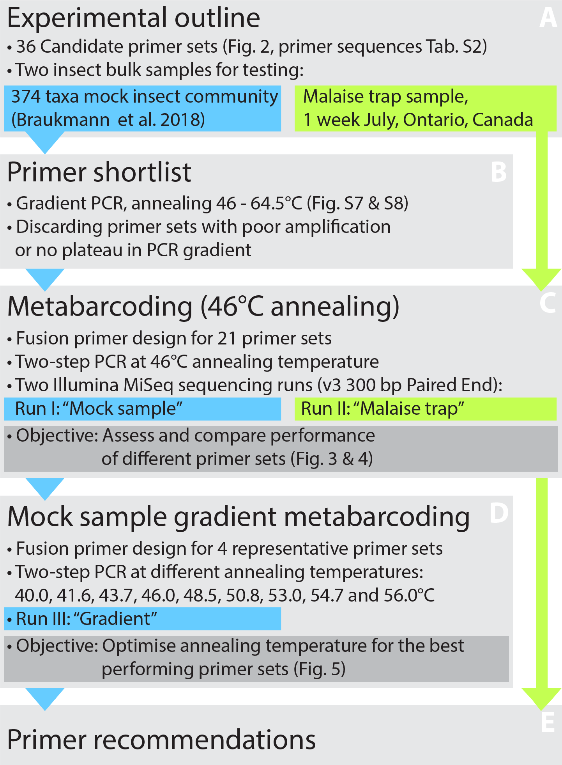
Figure 1: Overview of the experimental design. The performance of 36 primer pairs was tested via gradient PCRs with a mock community of insects (A). The 21 pairs that showed best amplification results (B) were selected for further DNA metabarcoding runs utilizing both the mock community and a Malaise trap sample (C). Based on the metabarcoding results, four primer sets showing the good performance were selected for a third test that examined the effects of varying annealing temperatures on taxon recovery and non-specific amplification (D). Based on all results, the optimal primer sets were designated (E).
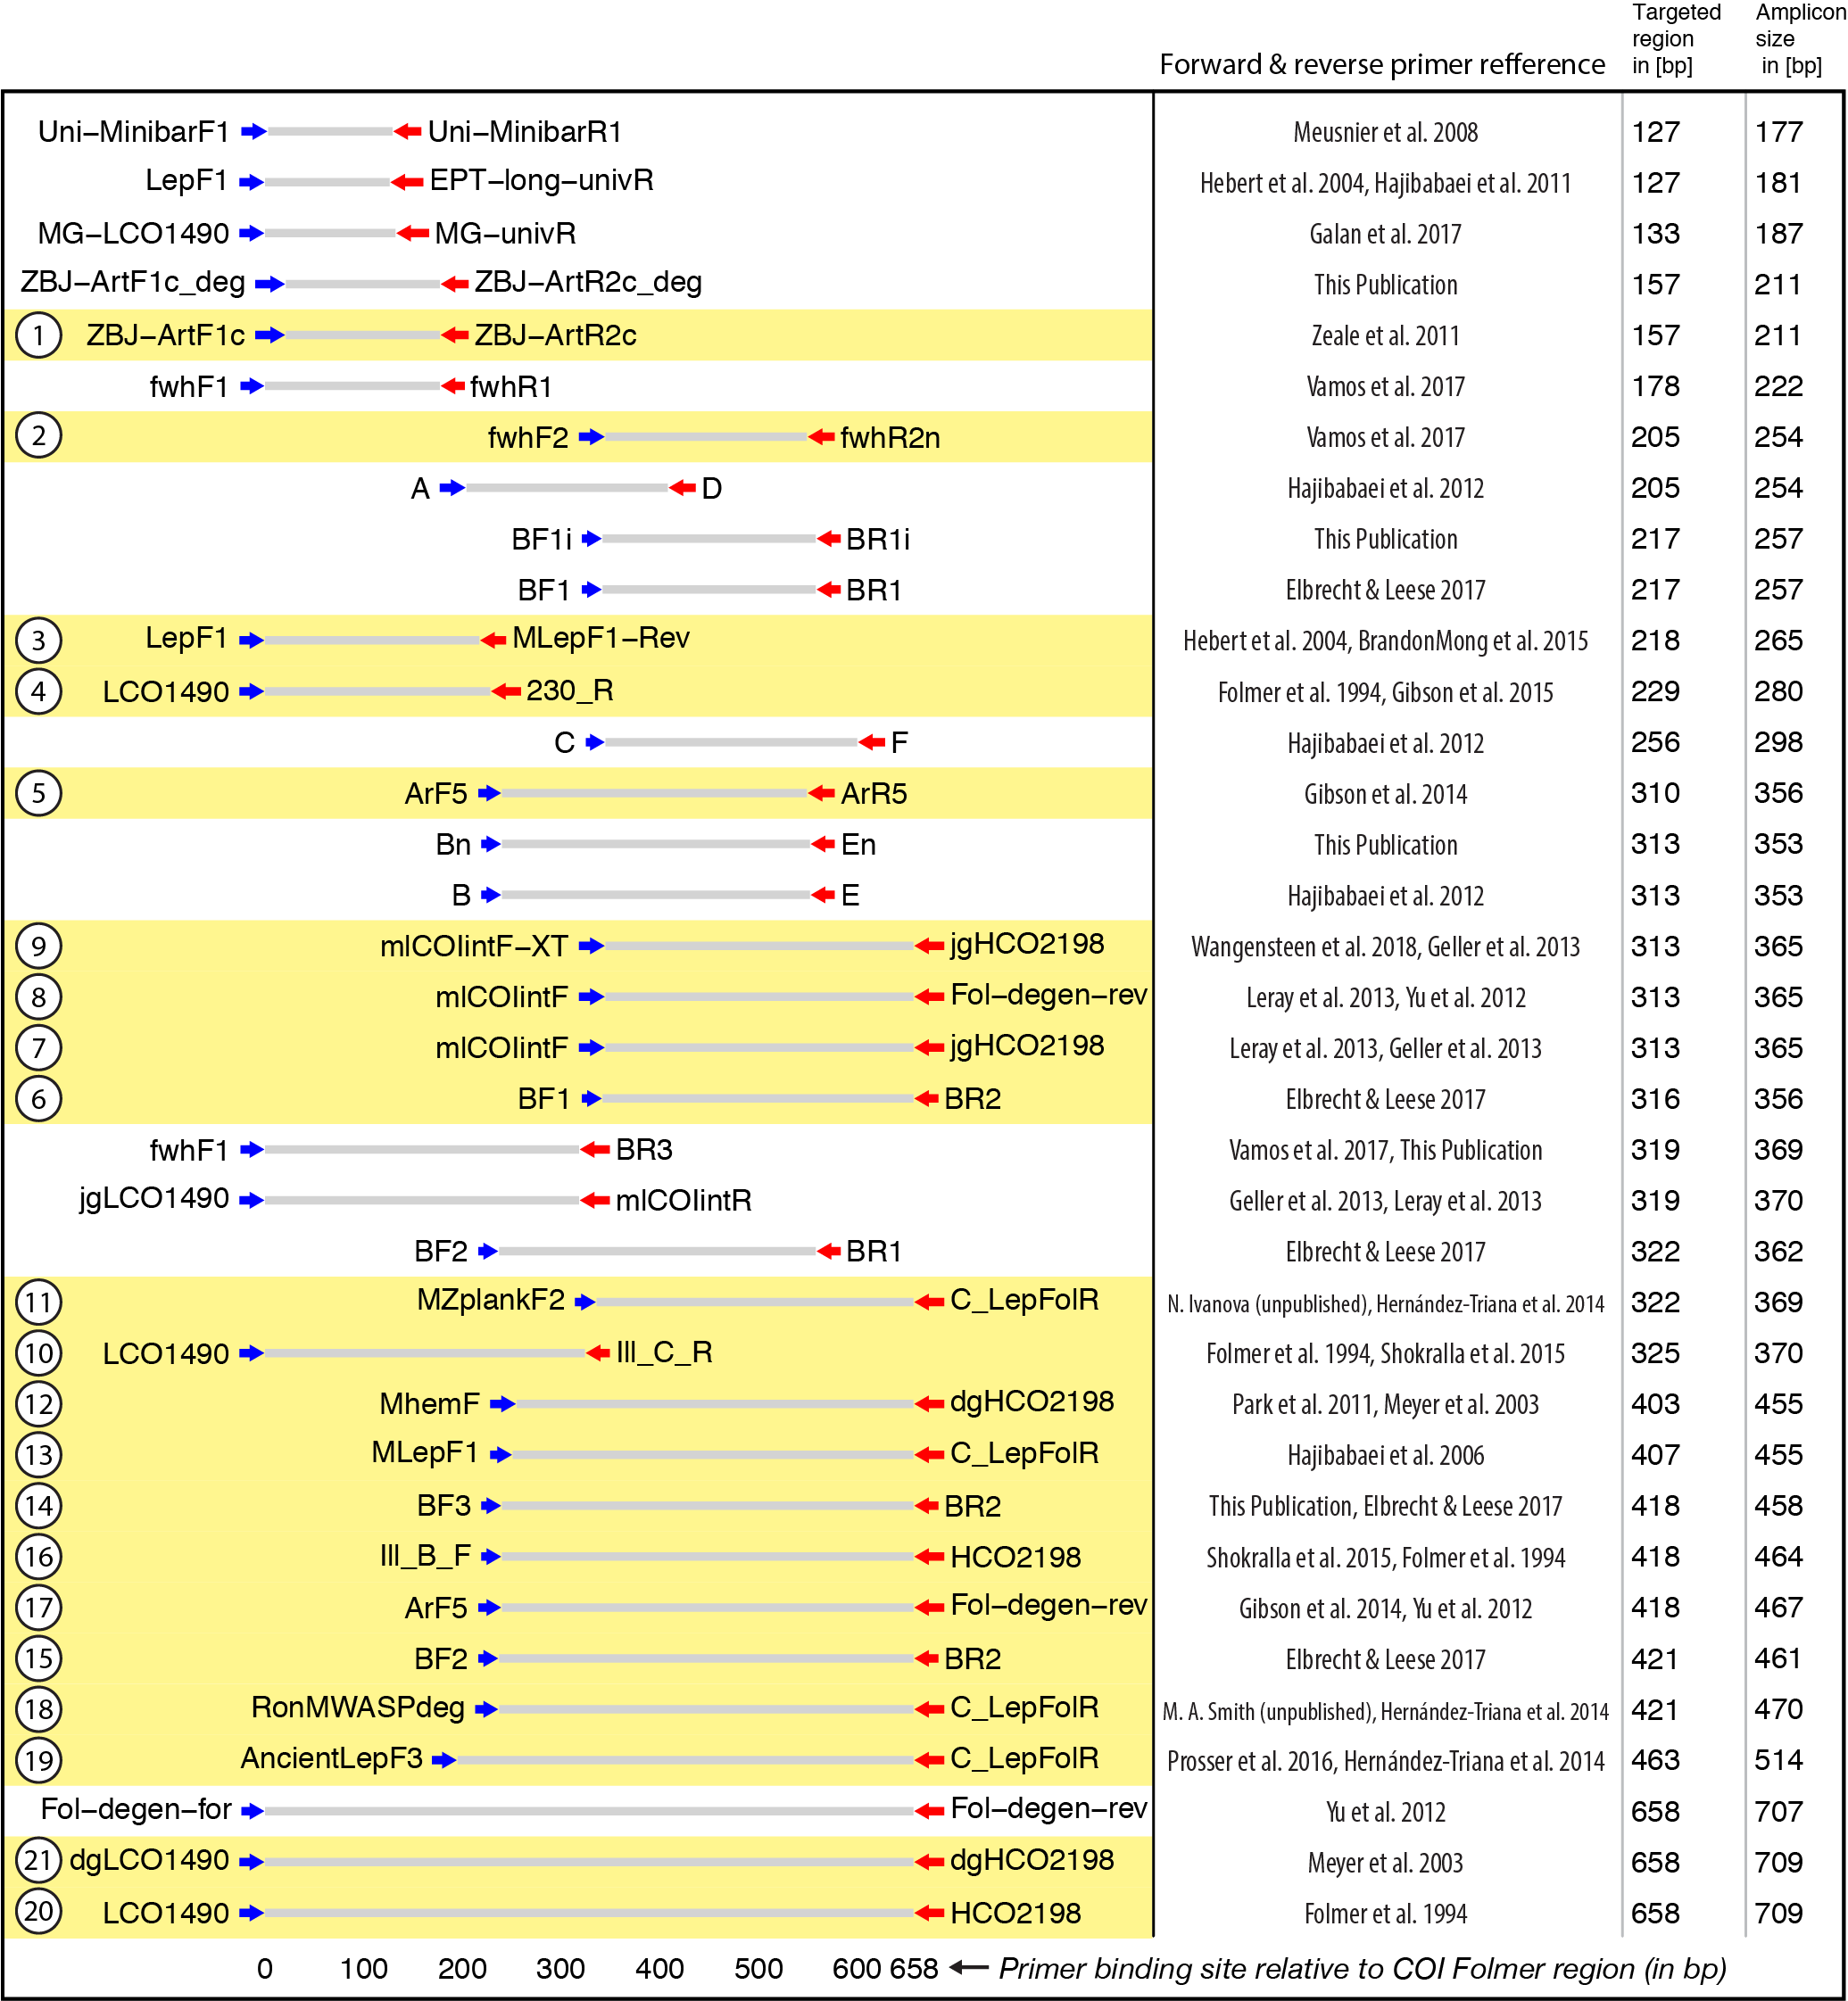
Figure 2: Target and amplicon length for the 36 primer sets evaluated via gradient PCR. The 21 primer sets selected for sequencing are highlighted in yellow while an ID for each pair is shown on the left. Primer references: (Folmer et al. 1994; Meyer 2003; Hebert et al. 2004; Hajibabaei et al. 2006; Meusnier et al. 2008; Hajibabaei et al. 2011; Zeale et al. 2011; Park et al. 2011; Yu et al. 2012; Hajibabaei et al. 2012; Leray et al. 2013; Geller et al. 2013; Gibson et al. 2014; Hernández-Triana et al. 2014; Shokralla et al. 2015; Brandon-Mong et al. 2015; Gibson et al. 2015; Prosser et al. 2015; Elbrecht & Leese 2017; Vamos et al. 2017; Wangensteen et al. 2018; Galan et al. 2018).
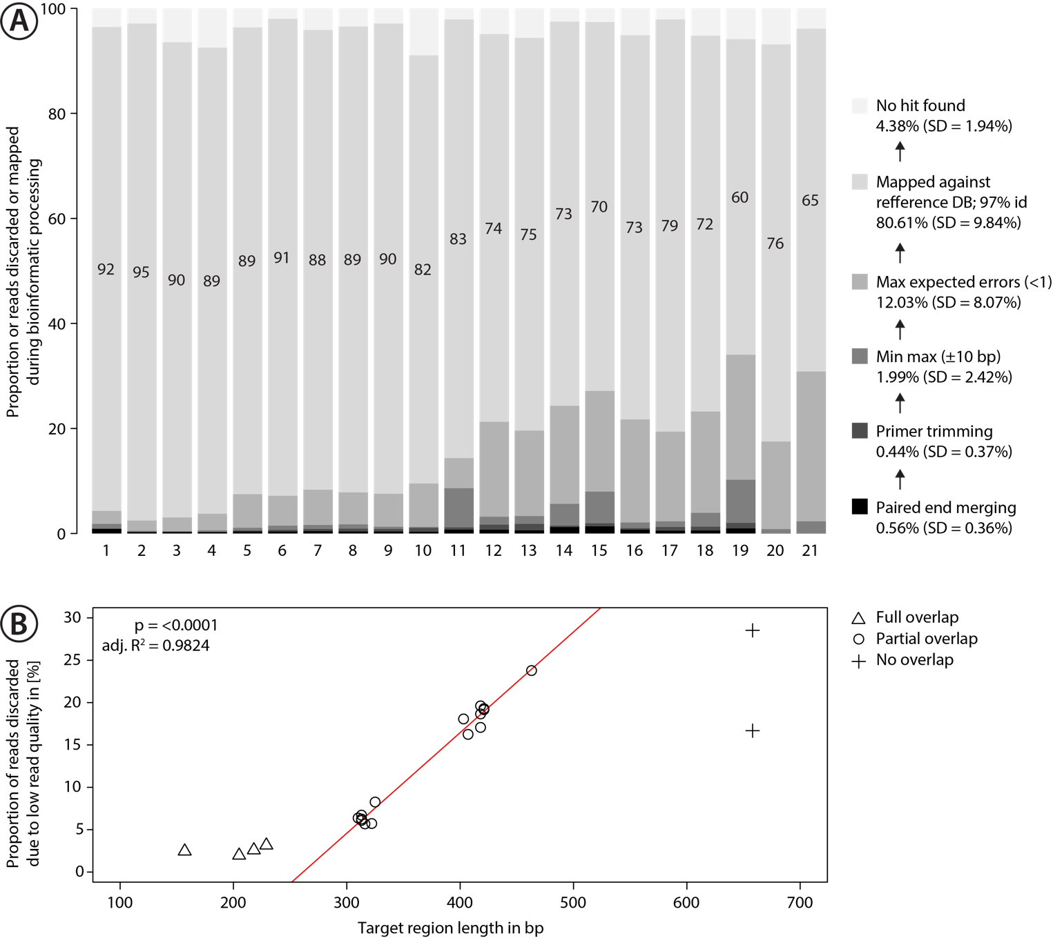
Figure 3: Proportion of sequences discarded or mapped to reference sequences in the mock community. A: Bar plots show the relative proportion of reads that were discarded or mapped. Numbers in bars indicate the proportion of reads that matched one of the 374 species in the mock community. The number for each primer pair on the x-axis corresponds with that in Figure 2. B: Proportion of sequences discarded by max expected errors = 1 filtering using Usearch, plotted against the length of the target region (in bp). Red line indicates linear regression.
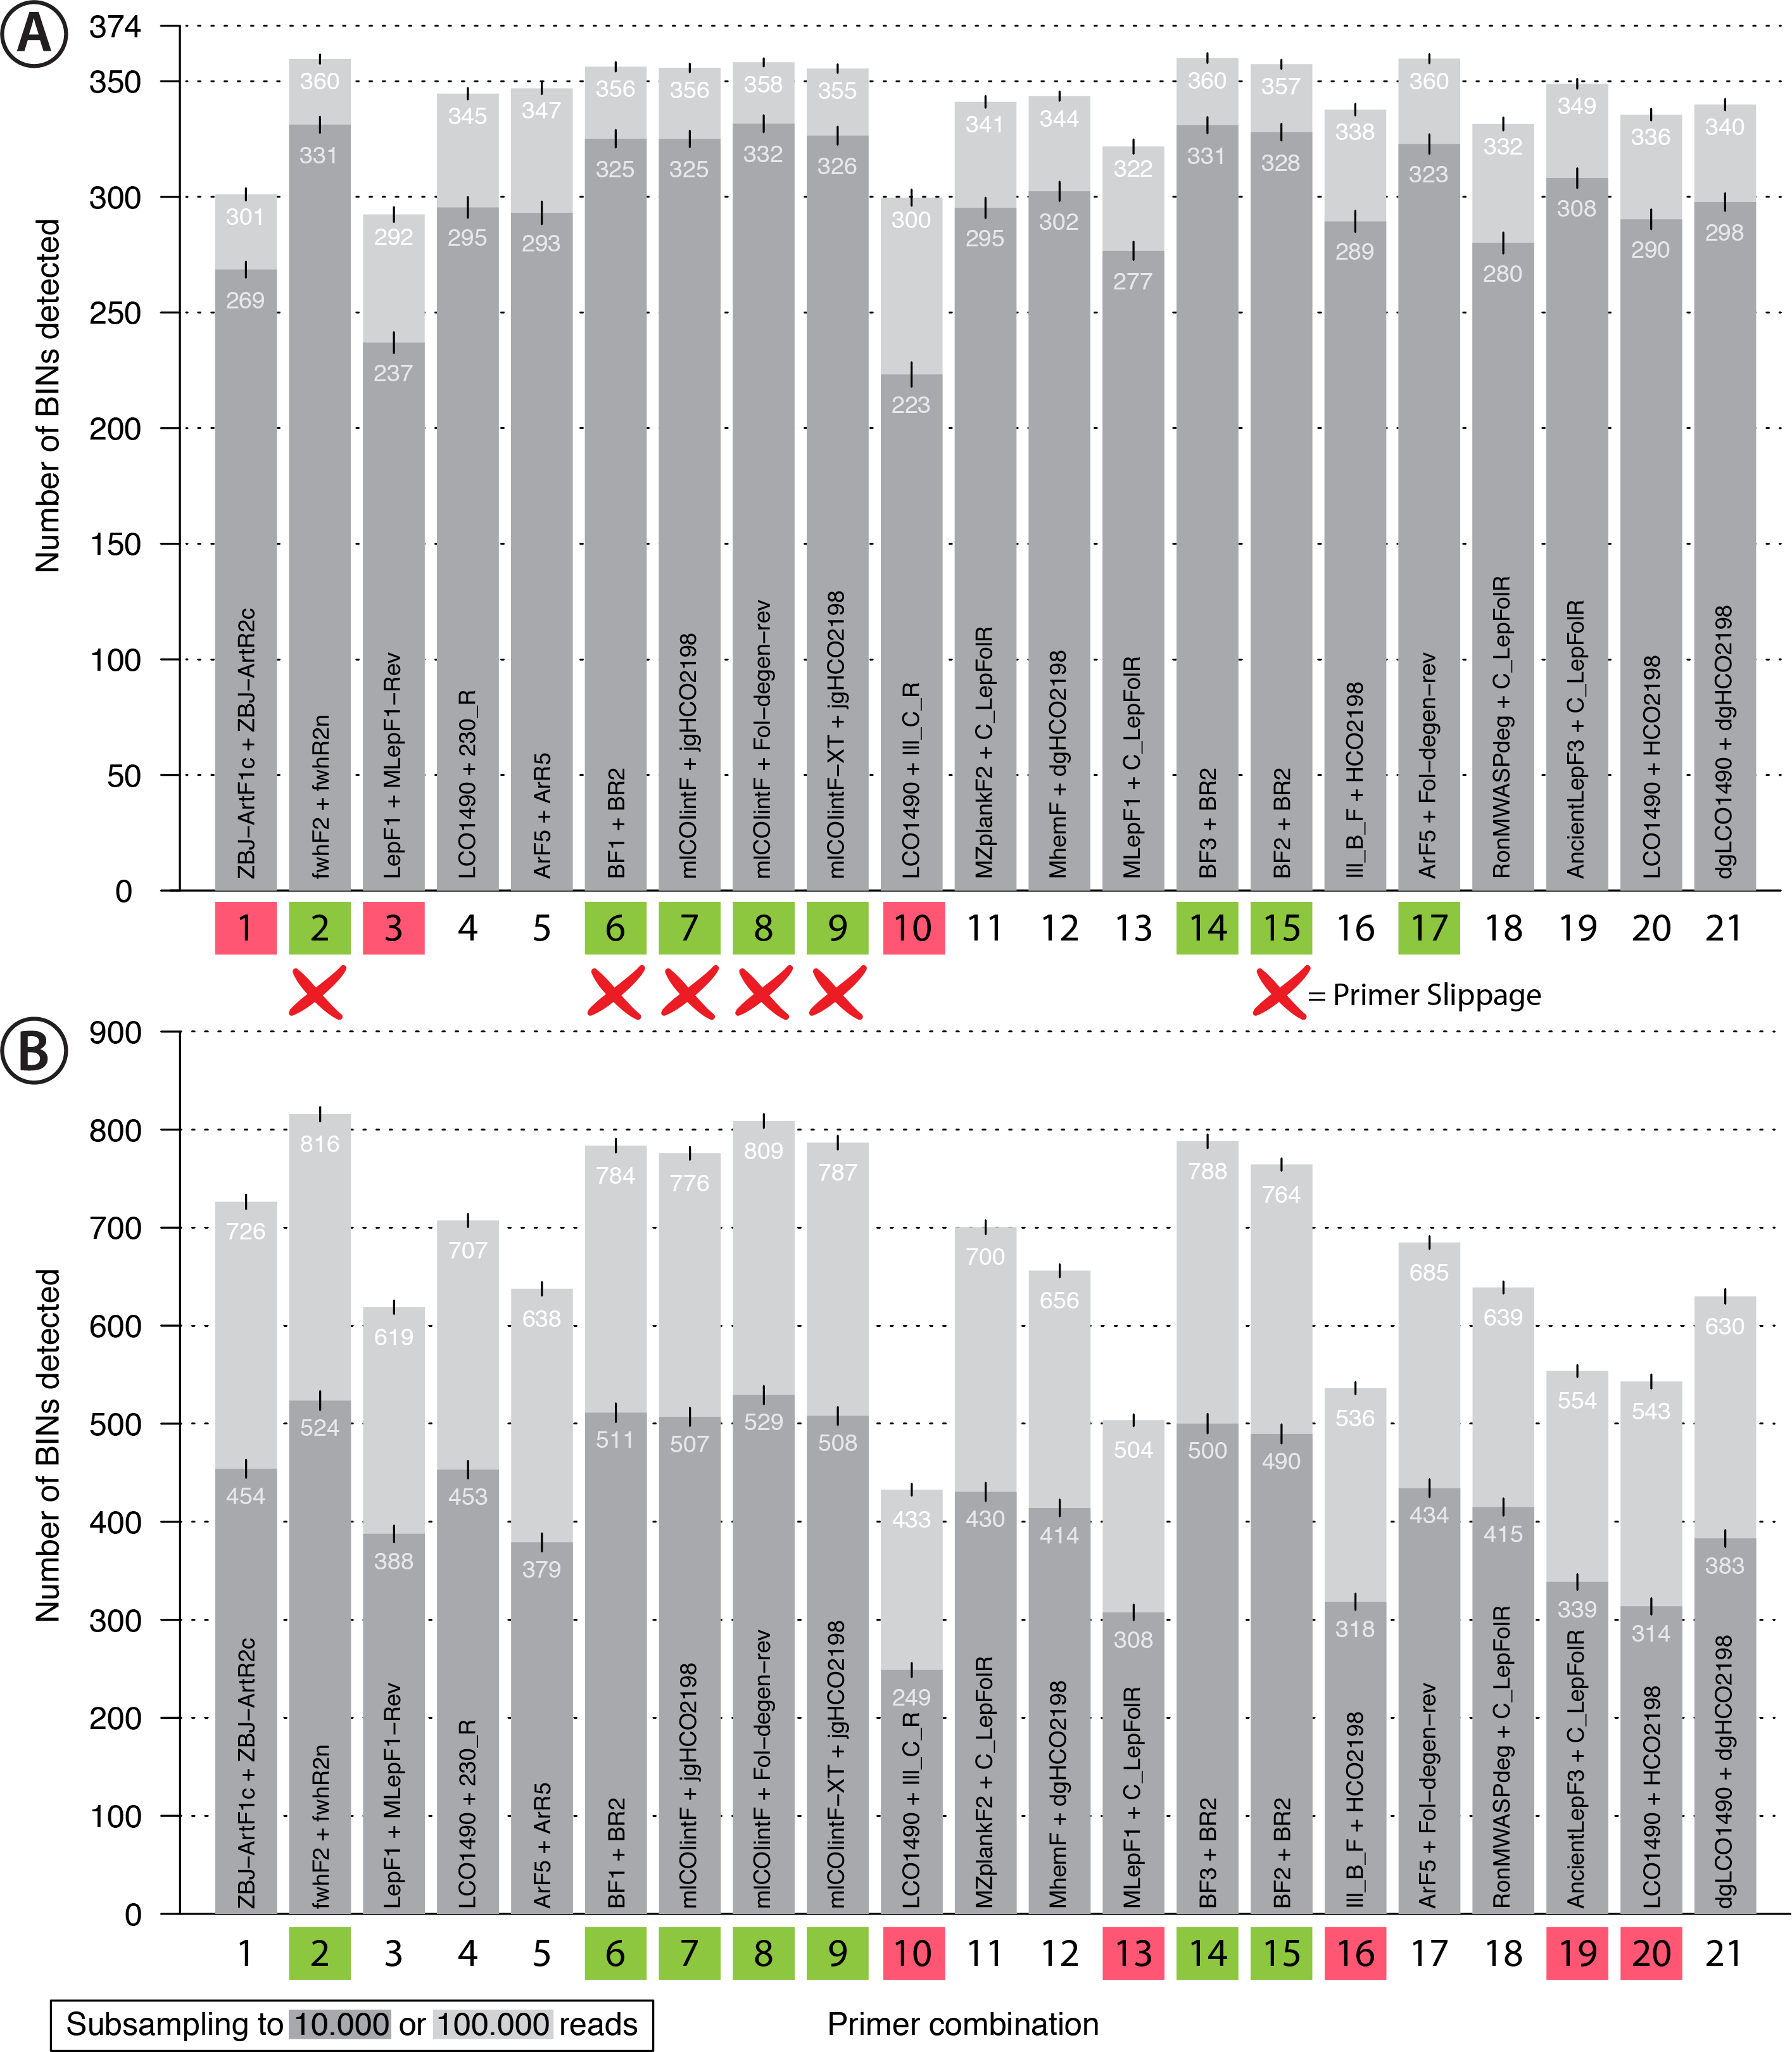
Figure 4: Bar plot showing the number of BINs recovered using metabarcoding with 21 primer pairs. The dark grey bar indicates subsampling at 10,000 reads while the light grey bar indicates subsampling at 100,000 reads per sample, each run with 1,000 replicates. Error bars show the standard deviation. Primer combinations affected by primer slippage (Elbrecht & Steinke 2018) are marked with a red X. A: Mock sample data, with primer combinations highlighted in green that detected more than 350 of the 374 BINs, while those that recovered fewer than 310 BINS are highlighted in red. B: Malaise trap data - primer combinations highlighted in green detected more than 750 BINs while those highlighted in red detected less than 600 BINs.
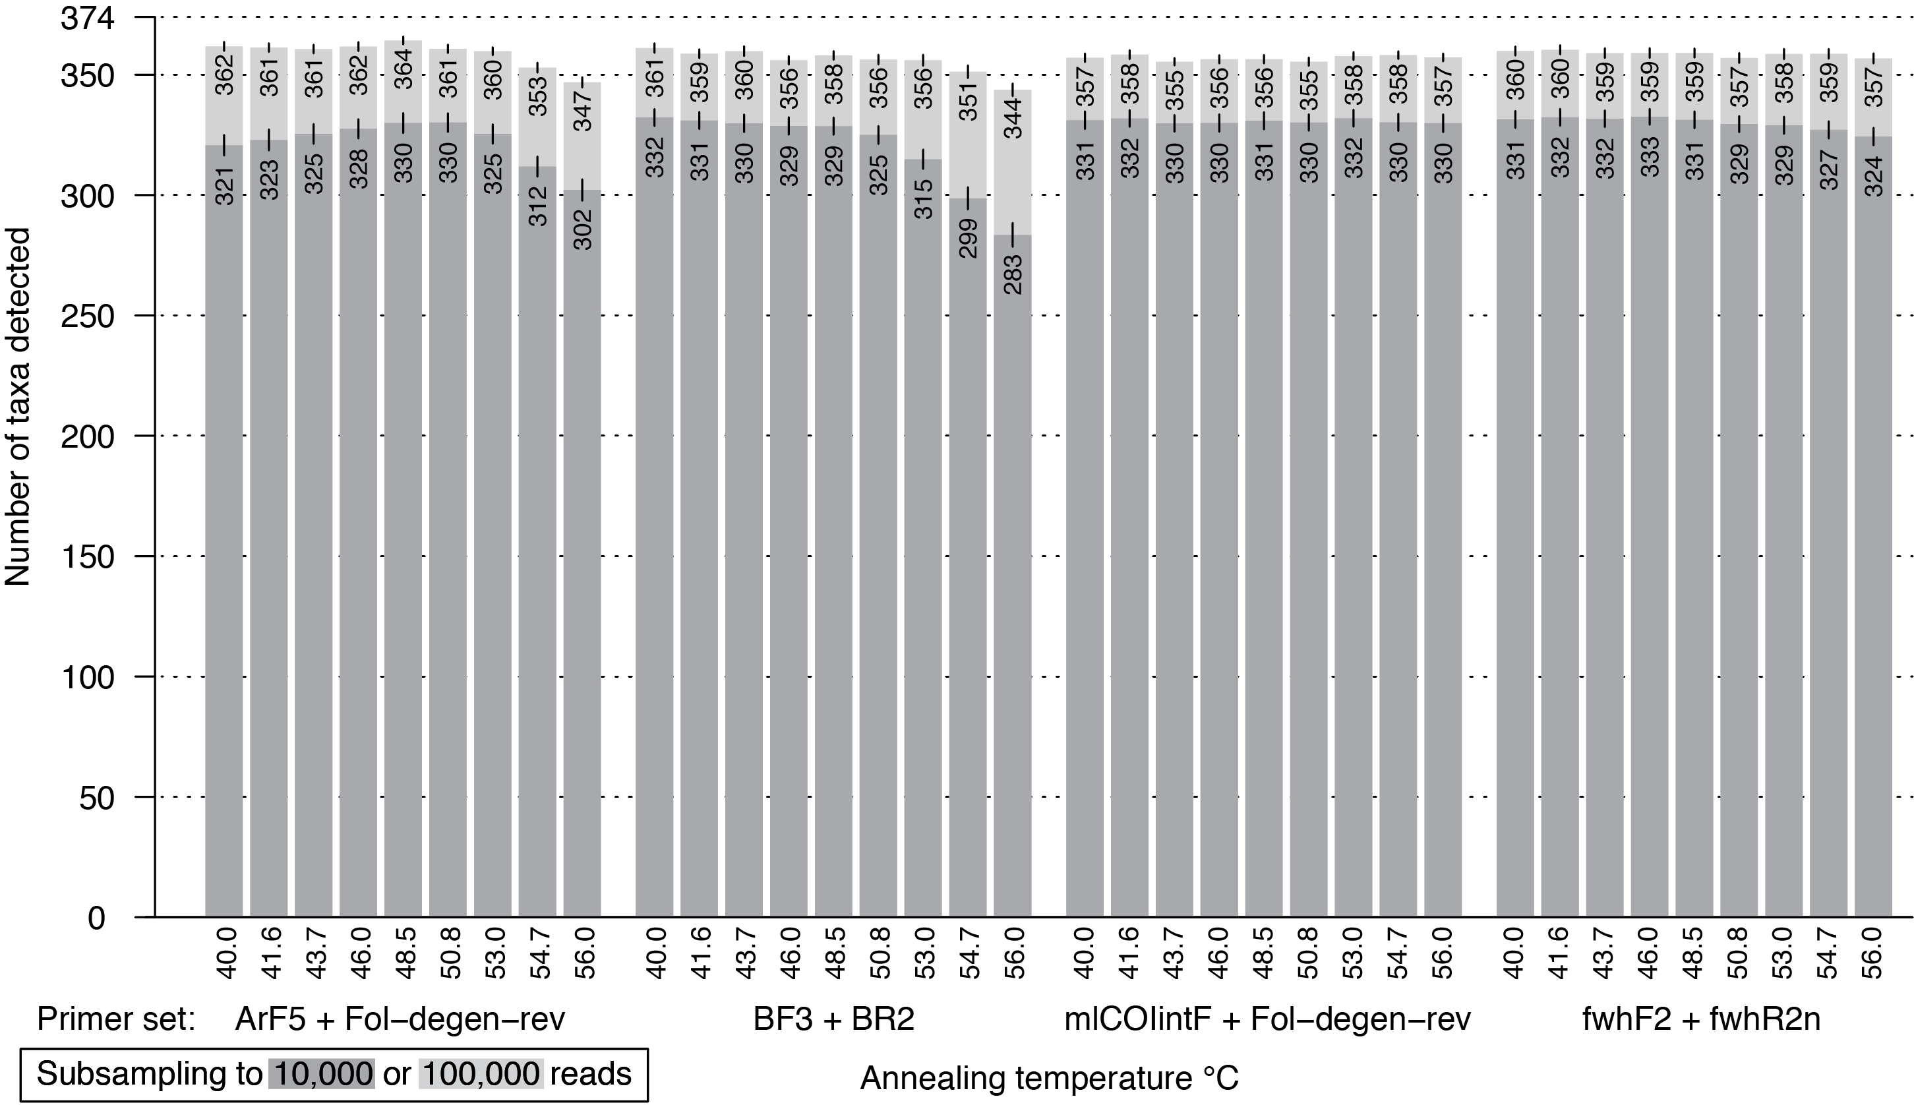
Figure 5: Bar plot showing the number of BINs recovered from the mock community at different annealing temperatures. The dark grey bar indicates subsampling at 10,000 reads, while the light grey bar depicts subsampling at 100,000 reads per samples; both were run with 1,000 replicates. Error bars show the standard deviation.

Acknowledgements
We thank all staff at the CBG who collected the samples employed to assemble the mock community, and Al Woodhouse from the Waterloo District School Board for his aid with Malaise trap sampling. We also thank the Optimist Club of Kitchener-Waterloo for access to their site at Camp Heidelberg. This study was supported by funding through the Canada First Research Excellence Fund. It represents a contribution to the Food From Thought research program.

Abd-Elsalam, K.A. (2003). Bioinformatic tools and guideline for PCR primer design. african Journal of biotechnology, 2, 91–95–95.
Alberdi, A., Aizpurua, O., Gilbert, M.T.P. & Bohmann, K. (2017). Scrutinizing key steps for reliable metabarcoding of environmental samples (A. Mahon, Ed.). Methods in Ecology and Evolution, 17, 730–14.
Andújar, C., Arribas, P., Gray, C., Bruce, K., Woodward, G., Yu, D.W. & Vogler, A.P. (2017). Metabarcoding of freshwater invertebrates to detect the effects of a pesticide spill. Molecular Ecology.
Andújar, C., Arribas, P., Yu, D.W., Vogler, A.P. & Emerson, B.C. (2018). Why the COI barcode should be the community DNA metabarcode for the metazoa. Molecular Ecology, 27, 3968–3975.
Aylagas, E., Borja, A., Irigoien, X. & Rodríguez-Ezpeleta, N. (2016). Benchmarking DNA Metabarcoding for Biodiversity-Based Monitoring and Assessment. Frontiers in Environmental Science, 3, 1809–12.
Barnes, M.A. & Turner, C.R. (2015). The ecology of environmental DNA and implications for conservation genetics. Conservation Genetics, 1–17.
Beng, K.C., Tomlinson, K.W., Shen, X.H., Surget-Groba, Y., Hughes, A.C., Corlett, R.T. & Slik, J.W.F. (2016). The utility of DNA metabarcoding for studying the response of arthropod diversity and composition to land-use change in the tropics. Scientific Reports, 1–13.
Bohmann, K., Gopalakrishnan, S., Nielsen, M., Nielsen, L.D.S.B., Jones, G., Streicker, D.G. & Gilbert, M.T.P. (2018). Using DNA metabarcoding for simultaneous inference of common vampire bat diet and population structure. Molecular ecology resources, 18, 1050–1063.
Brandon-Mong, G.J., Gan, H.M., Sing, K.W., Lee, P.S., Lim, P.E. & Wilson, J.J. (2015). DNA metabarcoding of insects and allies: an evaluation of primers and pipelines. Bulletin of Entomological Research, 105, 717–727.
Braukmann, T.W.A., Ivanova, N.V., Prosser, S.W.J., Elbrecht, V., Steinke, D., Ratnasingham, S., deWaard, J.R., Sones, J.E., Zakharov, E.V. & Hebert, P.D.N. (2019). Metabarcoding a Diverse Arthropod Mock Community. Molecular ecology resources, 1–41.
Braukmann, T.W., Ivanova, N.V., Prosser, S.W., Elbrecht, V., Steinke, D., Ratnasingham, S., deWaard, J.R., Sones, J.E., Zakhariv, E.V. & Hebert, P.D. (2018). Revealing the Complexities of Metabarcoding with a Diverse Arthropod Mock Community. bioRxiv, 1–40.
Bylemans, J., Furlan, E.M., Gleeson, D.M., Hardy, C.M. & Duncan, R.P. (2018a). Does Size Matter? An Experimental Evaluation of the Relative Abundance and Decay Rates of Aquatic Environmental DNA. Environmental science & technology, 52, 6408–6416.
Bylemans, J., Gleeson, D.M., Hardy, C.M. & Furlan, E. (2018b). Toward an ecoregion scale evaluation of eDNA metabarcoding primers: A case study for the freshwater fish biodiversity of the Murray-Darling Basin (Australia). Ecology and Evolution, 58, 403–16.
Callahan, B.J., McMurdie, P.J. & Holmes, S.P. (2017). Exact sequence variants should replace operational taxonomic units in marker-gene data analysis. 1–5.
Carew, M.E., Pettigrove, V.J., Metzeling, L. & Hoffmann, A.A. (2013). Environmental monitoring using next generation sequencing: rapid identification of macroinvertebrate bioindicator species. Frontiers in zoology, 10, 1–1.
Clarke, L.J., Beard, J.M., Swadling, K.M. & Deagle, B.E. (2017). Effect of marker choice and thermal cycling protocol on zooplankton DNA metabarcoding studies. Ecology and Evolution, 7, 873–883.
Clarke, L.J., Soubrier, J., Weyrich, L.S. & Cooper, A. (2014). Environmental metabarcodes for insects: in silicoPCR reveals potential for taxonomic bias. Molecular ecology resources, 14, 1160–1170.
Cowart, D.A., Pinheiro, M., Mouchel, O., Maguer, M., Grall, J., Miné, J. & Arnaud-Haond, S. (2015). Metabarcoding Is Powerful yet Still Blind: A Comparative Analysis of Morphological and Molecular Surveys of Seagrass Communities (S. Mazzuca, Ed.). PloS one, 10, e0117562–26.
Creer, S., Deiner, K., Frey, S., Porazinska, D., Taberlet, P., Thomas, W.K., Potter, C. & Bik, H.M. (2016). The ecologist's field guide to sequence-based identification of biodiversity (R. Freckleton, Ed.). Methods in Ecology and Evolution, 7, 1008–1018.
Deagle, B.E., Jarman, S.N., Coissac, E., Pompanon, F. & Taberlet, P. (2014). DNA metabarcoding and the cytochrome c oxidase subunit I marker: not a perfect match. Biology Letters, 10, 1–4.
Demeke, T. & Jenkins, G.R. (2009). Influence of DNA extraction methods, PCR inhibitors and quantification methods on real-time PCR assay of biotechnology-derived traits. Analytical and Bioanalytical Chemistry, 396, 1977–1990.
Dirzo, R., Young, H.S., Galetti, M., Ceballos, G., Isaac, N.J.B. & Collen, B. (2014). Defaunation in the Anthropocene. Science (New York, NY), 345, 401–406.
Drummond, A.J. (2018). Evaluating a multigene environmental DNA approach for biodiversity assessment. 1–19.
Edgar, R.C. (2010). Search and clustering orders of magnitude faster than BLAST. Bioinformatics, 26, 2460–2461.
Edgar, R.C. & Flyvbjerg, H. (2015). Error filtering, pair assembly and error correction for next-generation sequencing reads. Bioinformatics, 31, 3476–3482.
Elbrecht, V. & Leese, F. (2015). Can DNA-Based Ecosystem Assessments Quantify Species Abundance? Testing Primer Bias and Biomass—Sequence Relationships with an Innovative Metabarcoding Protocol (M. Hajibabaei, Ed.). PloS one, 10, e0130324–16.
Elbrecht, V. & Leese, F. (2016). PrimerMiner: an R package for development and in silico validation of DNA metabarcoding primers. Methods in Ecology and Evolution, 8, 622–626.
Elbrecht, V. & Leese, F. (2017). Validation and development of freshwater invertebrate metabarcoding COI primers for Environmental Impact Assessment. Frontiers in Environmental Science, 5, 1–11.
Elbrecht, V. & Steinke, D. (2018). Scaling up DNA metabarcoding for freshwater macrozoobenthos monitoring. Freshwater biology.
Elbrecht, V., Hebert, P.D.N. & Steinke, D. (2018a). Slippage of degenerate primers can cause variation in amplicon length. Scientific Reports, 1–5.
Elbrecht, V., Taberlet, P., Dejean, T., Valentini, A., Usseglio-Polatera, P., Beisel, J.-N., Coissac, E., Boyer, F. & Leese, F. (2016). Testing the potential of a ribosomal 16S marker for DNA metabarcoding of insects. PeerJ, 4, e1966–12.
Elbrecht, V., Vamos, E.E., Steinke, D. & Leese, F. (2018b). Estimating intraspecific genetic diversity from community DNA metabarcoding data. PeerJ, 6, e4644–13.
Elbrecht, V., Vamos, E., Meissner, K., Aroviita, J. & Leese, F. (2017). Assessing strengths and weaknesses of DNA metabarcoding based macroinvertebrate identification for routine stream monitoring. Methods in Ecology and Evolution, 1–21.
Ewels, P., Magnusson, M., Lundin, S. & Käller, M. (2016). MultiQC: summarize analysis results for multiple tools and samples in a single report. Bioinformatics, 32, 3047–3048.
Folmer, O., Black, M., Hoeh, W., Lutz, R. & Vrijenhoek, R. (1994). DNA primers for amplification of mitochondrial cytochrome c oxidase subunit I from diverse metazoan invertebrates. Molecular marine biology and biotechnology, 3, 294–299.
Galan, M., Pons, J.-B., Tournayre, O., Pierre, É., Leuchtmann, M., Pontier, D. & Charbonnel, N. (2018). Metabarcoding for the parallel identification of several hundred predators and their prey: Application to bat species diet analysis. Molecular ecology resources, 14, 1–16.
Geller, J., Meyer, C., Parker, M. & Hawk, H. (2013). Redesign of PCR primers for mitochondrial cytochrome coxidase subunit I for marine invertebrates and application in all-taxa biotic surveys. Molecular ecology resources, 13, 851–861.
Gibson, J.F., Shokralla, S., Curry, C., Baird, D.J., Monk, W.A., King, I. & Hajibabaei, M. (2015). Large-Scale Biomonitoring of Remote and Threatened Ecosystems via High-Throughput Sequencing (D. Fontaneto, Ed.). PloS one, 10, e0138432–15.
Gibson, J., Shokralla, S., Porter, T.M., King, I., van Konynenburg, S., Janzen, D.H., Hallwachs, W. & Hajibabaei, M. (2014). Simultaneous assessment of the macrobiome and microbiome in a bulk sample of tropical arthropods through DNA metasystematics. Proceedings of the National Academy of Sciences, 111, 8007–8012.
Hajibabaei, M., Janzen, D.H., Burns, J.M., Hallwachs, W. & Hebert, P.D.N. (2006). DNA barcodes distinguish species of tropical Lepidoptera. Proceedings of the National Academy of Sciences of the United States of America, 103, 968–971.
Hajibabaei, M., Porter, T.M., Wright, M. & Rudar, J. (2019a). COI metabarcoding primer choice affects richness and recovery of indicator taxa in freshwater systems. bioRxiv, 11, 2639–30.
Hajibabaei, M., Porter, T., Robinson, C. & BioRxiv, D.B. (2019b). Watered-down biodiversity? A comparison of metabarcoding results from DNA extracted from matched water and bulk tissue biomonitoring samples. biorxiv.org
.
Hajibabaei, M., Shokralla, S., Zhou, X., Singer, G. & Baird, D.J. (2011). Environmental Barcoding: A Next-Generation Sequencing Approach for Biomonitoring Applications Using River Benthos. PloS one, 6, 1–7.
Hajibabaei, M., Spall, J.L., Shokralla, S. & van Konynenburg, S. (2012). Assessing biodiversity of a freshwater benthic macroinvertebrate community through non-destructive environmental barcoding of DNA from preservative ethanol. BMC ecology, 12, 1–1.
Hebert, P.D.N., Cywinska, A., Ball, S.L. & deWaard, J.R. (2003). Biological identifications through DNA barcodes. Proceedings of the Royal Society B: Biological Sciences, 270, 313–321.
Hebert, P.D.N., Penton, E.H., Burns, J.M., Janzen, D.H. & Hallwachs, W. (2004). Ten species in one: DNA barcoding reveals cryptic species in the neotropical skipper butterfly Astraptes fulgerator. Proceedings of the National Academy of Sciences of the United States of America, 101, 14812–14817.
Hernández-Triana, L.M., Prosser, S.W., Rodríguez-Perez, M.A., Chaverri, L.G., Hebert, P.D.N. & Ryan Gregory, T. (2014). Recovery of DNA barcodes from blackfly museum specimens (Diptera: Simuliidae) using primer sets that target a variety of sequence lengths. Molecular ecology resources, 14, 508–518.
Hurlbert, S.H. (1984). Pseudoreplication and the Design of Ecological Field Experiments. Ecological Monographs, 54, 187–211.
Jusino, M.A., Banik, M.T., Palmer, J.M., Wray, A.K., Xiao, L., Pelton, E., Barber, J.R., Kawahara, A.Y., Gratton, C., Zachariah Peery, M. & Lindner, D.L. (2018). An improved method for utilizing high-throughput amplicon sequencing to determine the diets of insectivorous animals. Molecular ecology resources.
Krehenwinkel, H., Fong, M., Kennedy, S., Huang, E.G., Noriyuki, S., Cayetano, L. & Gillespie, R. (2018). The effect of DNA degradation bias in passive sampling devices on metabarcoding studies of arthropod communities and their associated microbiota (M. Kuntner, Ed.). PloS one, 13, e0189188–14.
Krehenwinkel, H., Wolf, M., Lim, J.Y., Rominger, A.J., Simison, W.B. & Gillespie, R.G. (2017). Estimating and mitigating amplification bias in qualitative and quantitative arthropod metabarcoding. Scientific Reports, 1–12.
Leray, M. & Knowlton, N. (2015). DNA barcoding and metabarcoding of standardized samples reveal patterns of marine benthic diversity. Proceedings of the National Academy of Sciences, 112, 2076–2081.
Leray, M. & Knowlton, N. (2017). Random sampling causes the low reproducibility of rare eukaryotic OTUs in Illumina COI metabarcoding. PeerJ, 5, e3006–27.
Leray, M., Yang, J.Y., Meyer, C.P., Mills, S.C., Agudelo, N., Ranwez, V., Boehm, J.T. & Machida, R.J. (2013). A new versatile primer set targeting a short fragment of the mitochondrial COI region for metabarcoding metazoan diversity: application for characterizing coral reef fish gut contents. Frontiers in zoology, 10, 1–14.
Macher, J.N. & Weigand, A.M. (2018). A DNA metabarcoding protocol for hyporheic freshwater meiofauna: Evaluating highly degenerate COI primers and replication strategy. Metabarcoding and Metagenomics, 2, 63–15.
Macher, J.N., Vivancos, A., Piggott, J.J., Centeno, F.C., Matthaei, C.D. & Leese, F. (2018). Comparison of environmental DNA and bulk-sample metabarcoding using highly degenerate cytochrome coxidase I primers. Molecular ecology resources, 17, 1231–43.
Marquina, D., Andersson, A.F. & Ronquist, F. (2018). New mitochondrial primers for metabarcoding of insects, designed and evaluated using in silicomethods. Molecular ecology resources, 1–39.
Martin, M. (2011). Cutadapt removes adapter sequences from high-throughput sequencing reads. EMBnet journal, 17, 10–12.
Meusnier, I., Singer, G.A., Landry, J.-F., Hickey, D.A., Hebert, P.D. & Hajibabaei, M. (2008). A universal DNA mini-barcode for biodiversity analysis. BMC genomics, 9, 214.
Meyer, C.P. (2003). Molecular systematics of cowries (Gastropoda: Cypraeidae) and diversification patterns in the tropics. Biological Journal of the Linnean Society, 79, 401–459.
Nichols, R.V., Vollmers, C., Newsom, L.A., Wang, Y., Heintzman, P.D., Leighton, M., Green, R.E. & Shapiro, B. (2018). Minimizing polymerase biases in metabarcoding. Molecular ecology resources, 12, R18–13.
Park, D.-S., Foottit, R., Maw, E. & Hebert, P.D.N. (2011). Barcoding Bugs: DNA-Based Identification of the True Bugs (Insecta: Hemiptera: Heteroptera) (M.T.P. Gilbert, Ed.). PloS one, 6, e18749–9.
Piñol, J., Mir, G., Gomez-Polo, P. & Agustí, N. (2014). Universal and blocking primer mismatches limit the use of high-throughput DNA sequencing for the quantitative metabarcoding of arthropods. Molecular ecology resources, 15, 1–12.
Piñol, J., Senar, M.A. & Symondson, W.O.C. (2018). The choice of universal primers and the characteristics of the species mixture determine when DNA metabarcoding can be quantitative. Molecular Ecology, 6, 1809–13.
Porter, T.M. & Hajibabaei, M. (2018a). Automated high throughput animal CO1 metabarcode classification. Scientific Reports, 1–10.
Porter, T.M. & Hajibabaei, M. (2018b). Over 2.5 million COI sequences in GenBank and growing (W. Arthofer, Ed.). PloS one, 13, e0200177–16.
Prosser, S.W.J., deWaard, J.R., Miller, S.E. & Hebert, P.D.N. (2015). DNA barcodes from century-old type specimens using next-generation sequencing. Molecular ecology resources, 16, 487–497.
Ratnasingham, S. & Hebert, P. (2007). BOLD: The Barcode of Life Data System (http://www. barcodinglife. org). Molecular Ecology Notes, 7, 355–364.
Ratnasingham, S. & Hebert, P.D.N. (2013). A DNA-Based Registry for All Animal Species: The Barcode Index Number (BIN) System (D. Fontaneto, Ed.). PloS one, 8, e66213–16.
Reuter, J.A., Spacek, D.V. & Snyder, M.P. (2015). High-Throughput Sequencing Technologies. Molecular Cell, 58, 586–597.
Sellers, G.S., Di Muri, C., Gómez, A. & Hänfling, B. (2018). Mu-DNA: a modular universal DNA extraction method adaptable for a wide range of sample types. Metabarcoding and Metagenomics, 2, e24556–11.
Shokralla, S., Porter, T.M., Gibson, J.F., Dobosz, R., Janzen, D.H., Hallwachs, W., Golding, G.B. & Hajibabaei, M. (2015). Massively parallel multiplex DNA sequencing for specimen identification using an Illumina MiSeq platform. Scientific Reports, 5, 9687.
Smith, D.P. & Peay, K.G. (2014). Sequence Depth, Not PCR Replication, Improves Ecological Inference from Next Generation DNA Sequencing (C.A. Kellogg, Ed.). PloS one, 9, e90234.
Steffen, W., Richardson, K., Rockström, J., Cornell, S.E., Fetzer, I., Bennett, E.M., Biggs, R., Carpenter, S.R., de Vries, W., de Wit, C.A., Folke, C., Gerten, D., Heinke, J., Mace, G.M., Persson, L.M., Ramanathan, V., Reyers, B. & Sörlin, S. (2015). Planetary boundaries: guiding human development on a changing planet. Science (New York, NY), 347, 1259855.
Vamos, E.E., Elbrecht, V. & Leese, F. (2017). Short COI markers for freshwater macroinvertebrate metabarcoding. Metabarcoding and Metagenomics, 1–20.
Vierna, J., Doña, J., Vizcaíno, A., Serrano, D. & Jovani, R. (2017). PCR cycles above routine numbers do not compromise high-throughput DNA barcoding results. (F. Chain, Ed.). Genome, 60, 868–873.
Vörösmarty, C.J., McIntyre, P.B., Gessner, M.O., Dudgeon, D., Prusevich, A., Green, P., Glidden, S., Bunn, S.E., Sullivan, C.A., Liermann, C.R. & Davies, P.M. (2010). Global threats to human water security and river biodiversity. Nature, 467, 555–561.
Wangensteen, O.S., Palacín, C., Guardiola, M. & Turon, X. (2018). DNA metabarcoding of littoral hard-bottom communities: high diversity and database gaps revealed by two molecular markers. PeerJ, 6, e4705–30.
Yu, D.W., Ji, Y., Emerson, B.C., Wang, X., Ye, C., Yang, C. & Ding, Z. (2012). Biodiversity soup: metabarcoding of arthropods for rapid biodiversity assessment and biomonitoring. Methods in Ecology and Evolution, 3, 613–623.
Zeale, M.R.K., Butlin, R.K., Barker, G.L.A., Lees, D.C. & Jones, G. (2011). Taxon-specific PCR for DNA barcoding arthropod prey in bat faeces. Molecular ecology resources, 11, 236–244.
Zepeda-Mendoza, M.L., Bohmann, K., Baez, A.C. & Gilbert, M.T.P. (2016). DAMe: a toolkit for the initial processing of datasets with PCR replicates of double-tagged amplicons for DNA metabarcoding analyses. BMC Research Notes, 1–13.
Zhang, G.K., Chain, F.J.J., Abbott, C.L. & Cristescu, M.E. (2018). Metabarcoding using multiplexed markers increases species detection in complex zooplankton communities. Evolutionary Applications, 215, 403–40.

