Multi-gene incongruence consistent with hybridisation in Cladocopium (Symbiodiniaceae), an ecologically important genus of coral reef symbionts: Supplementary Information

Authors
Joshua I. Brian, Simon K. Davy, Shaun P. Wilkinson

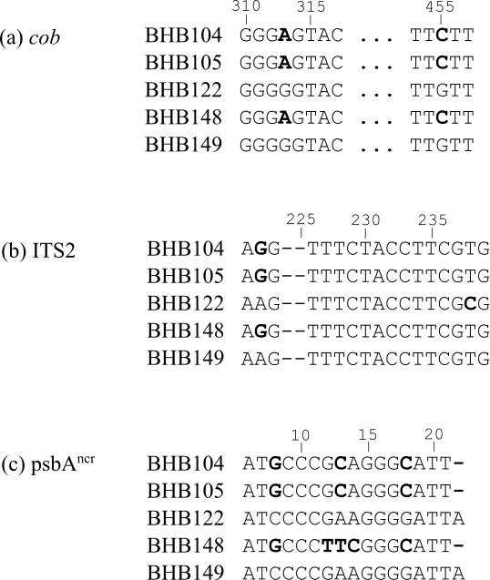

Figure S1: Short selections of raw sequence data for non-incongruent sample BHB148 and related sequences (polymorphisms in bold). For all three gene regions (a) – (c), BHB148 groups with the samples BHB104 and BHB105. It is likely the reticulate pattern observed for this sample in Fig. 3b and Fig. 3c is caused by additional unique variation in base pairs 12-14 in the psbA^{ncr} region, which has led to BHB148 being designated as sister to the wrong subgroup in psbA^{ncr} trees.

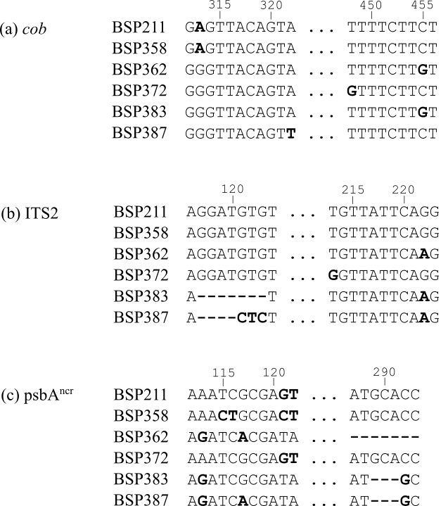

Figure S2: Short selections of raw sequence data for non-incongruent samples BSP358, BSP72, BSP387 and related sequences (polymorphisms in bold). There is significant variation in these sequences, however in general it is clear there are two distinct groups recovered by the ITS2 and psbA^{ncr} regions: {BSP211, BSP358, BSP372} and {BSP362, BSP383, BSP387}. This is less clear in the cob gene, thanks to point mutations at bases 448 and 322 for samples BSP372 and BSP387 respectively, in addition to two unique point mutations in sample BSP358 at base pairs 154 and 163 (not presented here). This additional variation in the highly homogeneous cob gene explains the incongruences observed in Fig. 4a and 4c, whereas the raw sequences are consistent with a linear evolutionary history in these samples.

Table S1: Evolutionary models selected by PAUP* for each dataset for building maximum likelihood trees, for the AU tests. HKY = Hasegawa, Kishino and Yano (1985); GTR = Generalised Time Reversible (Tavaré 1986); F81 = Felsenstein (1981); JC = Jukes and Cantor (1969); K80 = Kimura (1980); K81 = Kimura (1981); SYM = Symmetrical (Zharkikh 1994). G = gamma coefficient, I = proportion of invariant sites.
Dataset | Gene Region | Model | I | G
BBR | cob | GTR+I | 0.921 | -
 | ITS2 | K81+I | 0.654 | -
 | psbA^{ncr} | SYM+G | - | 0.548
BHB | cob | GTR+I | 0.918 | -
 | ITS2 | HKY | - | -
 | psbA^{ncr} | SYM+G | - | 0.502
BLS | cob | GTR+I | 0.924 | -
 | ITS2 | K81+I | 0.648 | -
 | psbA^{ncr} | JC+G | - | 0.693
BSP | cob | GTR | 0.833 | -
 | ITS2 | K80 | - | -
 | psbA^{ncr} | SYM+G | - | 0.528
HEW | cob | GTR+I | 0.850 | -
 | ITS2 | K80 | - | -
 | psbA^{ncr} | SYM+G | - | 0.606
LIE | cob | GTR+I | 0.921 | -
 | ITS2 | K80 | - | -
 | psbA^{ncr} | SYM+G | - | 0.706
LIW | cob | GTR | - | -
 | ITS2 | K80 | - | -
 | psbA^{ncr} | SYM+G | - | 0.526
Atauro | cob | F81+I | 0.875 | -
 | ITS2 | K80 | - | -
 | psbA^{ncr} | SYM+G | - | 0.460
Timor | cob | GTR | - | -
 | ITS2 | K80 | - | -
 | psbA^{ncr} | K80+G | - | 0.503

Supplementary Information References

Felsenstein J (1981) Evolutionary trees from DNA sequences: a maximum likelihood approach. Journal of molecular evolution, 17, 368-376.

Hasegawa M, Kishino H, Yano TA (1985) Dating of the human-ape splitting by a molecular clock of mitochondrial DNA. Journal of molecular evolution, 22, 160-174.

Jukes TH, Cantor CR (1969) Evolution of protein molecules. Mammalian protein metabolism, 3, 132.

Kimura M (1980) A simple method for estimating evolutionary rates of base substitutions through comparative studies of nucleotide sequences. Journal of molecular evolution, 16, 111-120.

Kimura M (1981) Estimation of evolutionary distances between homologous nucleotide sequences. Proceedings of the National Academy of Sciences, 78, 454-458.

Tavaré S (1986) Some probabilistic and statistical problems in the analysis of DNA sequences. Lectures on mathematics in the life sciences, 17, 57-86.

Zharkikh A (1994) Estimation of evolutionary distances between nucleotide sequences. Journal of molecular evolution, 39, 315-329.

