**Supplemental Materials**

Detection of environmental DNA of the invasive red-eared slider in a pond for evaluating their distribution compared with water quality

Aozora Kakuda, Izumi Katano, Rio Souma, Mariko Nagano, Toshifumi Minamoto, and Hideyuki Doi

Table S1 Results of the water quality analysis. Not measured by our study is represented by -



Table S1 Continued



Table S2 Linear regression slopes with a ± 95% confidence interval, SE, t values, p values, and VIFs for the relationships between the water quality analysis factors and eDNA concentration in the ponds

|  |  |  |  |  |  |
| --- | --- | --- | --- | --- | --- |
| Water　quality analysis | slope | SE | *t* value | *p* value | VIF |
| Chl. *a* | -27.529 | 17.990 | -1.530 | 0.170 | 4.254 |
| SS | -0.006 | 0.057 | -0.107 | 0.918 | 6.183 |
| PO₄-P | 0.590 | 1.454 | 0.406 | 0.697 | 8.169 |
| NO₃-N | -0.145 | 0.092 | -1.571 | 0.160 | 34.537 |
| TP | 0.029 | 0.337 | -0.086 | 0.934 | 1.859 |
| TN | 0.099 | 0.071 | 1.395 | 0.206 | 59.685 |
| DOM | 48.111 | 25.980 | 1.852 | 0.106 | 8.631 |
| TOM | -59.544 | 52.215 | -1.140 | 0.292 | 14.371 |
| Intercept | 9.187 | 1.253 | 7.332 | 0.000 | - |

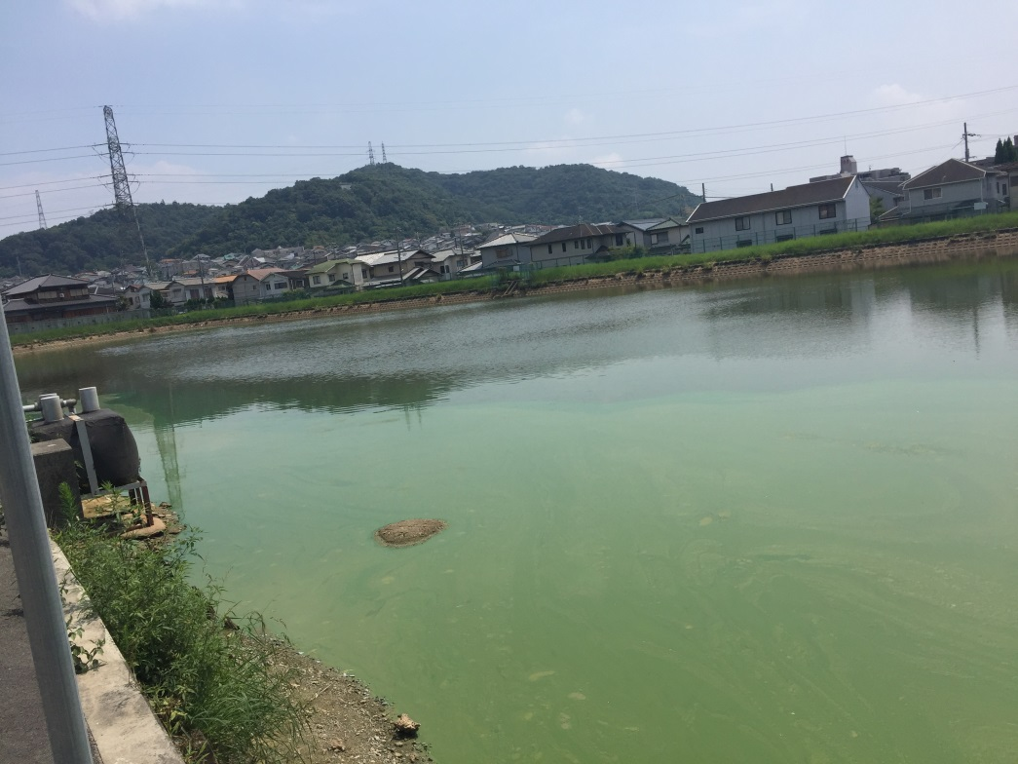

Picture S1 Pond No. 11

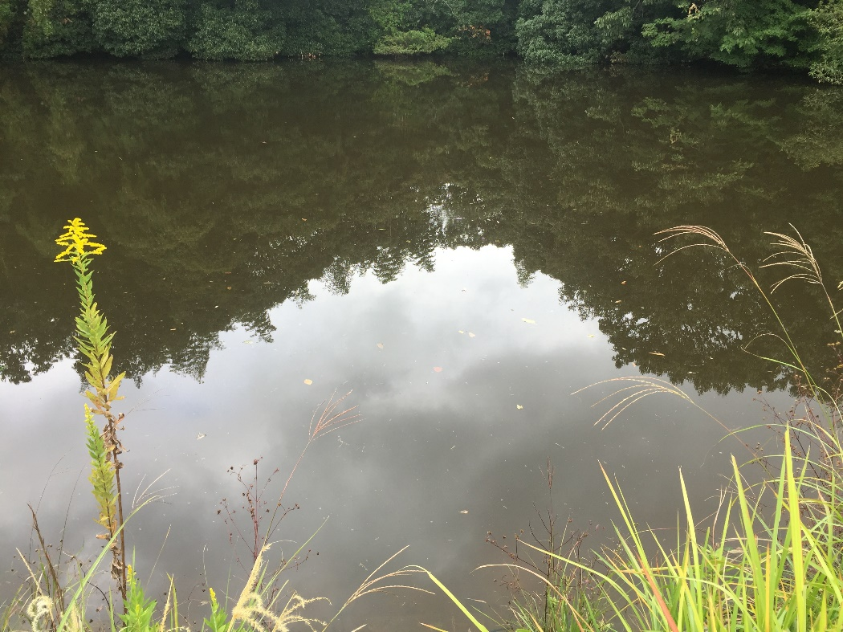

Picture S2 Pond No. 33