S1 File. Construction of pmiR-FSHb-3’UTR-MUT reporter plasmid

The full-length 3’UTR of rat FSHb mRNA was cloned between the XhoI and NotI sites of the pmiR-RB-REPORTTM plasmid. To disrupt the binding site of the FSHb 3’UTR, the target sequence TCTTCCA (574-580) was mutated into AGAAGGT, forming the pmiR-FSHb-3’UTR-MUT plasmid. The primers used in the colony experiment were as follows:

FSHb F: GCGCTCGAGGGAACAATGGACATTGCC
FSHb R: AATGCGGCCGCTTCATCAGTACGACTTTA
FSHb-MUT F: TACTCAACAGAAGGTAAGCATGTGGAGTATTGA
FSHb-MUT R: ACATGCTTACCTTCTGTTGAGTATCCTAACCTT

The PCR colony was identified after purification of the PCR product, enzyme cleavage, purification of the cleavage product, connection and convention.

The plasmid was extracted from the colony, and the sequence was identified by a sequencing company. The results of sequencing (Fig 1) showed that the target sequences were mutated successfully.
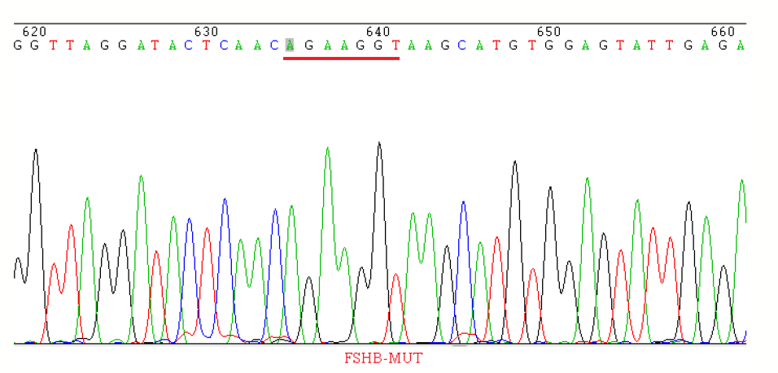

S1. Fig 1. DNA sequence peak map. Sequence of the extracted plasmid; the target sequence was mutated into AGAAGGT.

