The differences between legs in walking and running

% of variance in ML foot placement that can be explained by ML trunk CoM state (R²)
Very small, nonsignificant differences were found between right and left legs for R² during swing phases of walking and running (Fig 1).

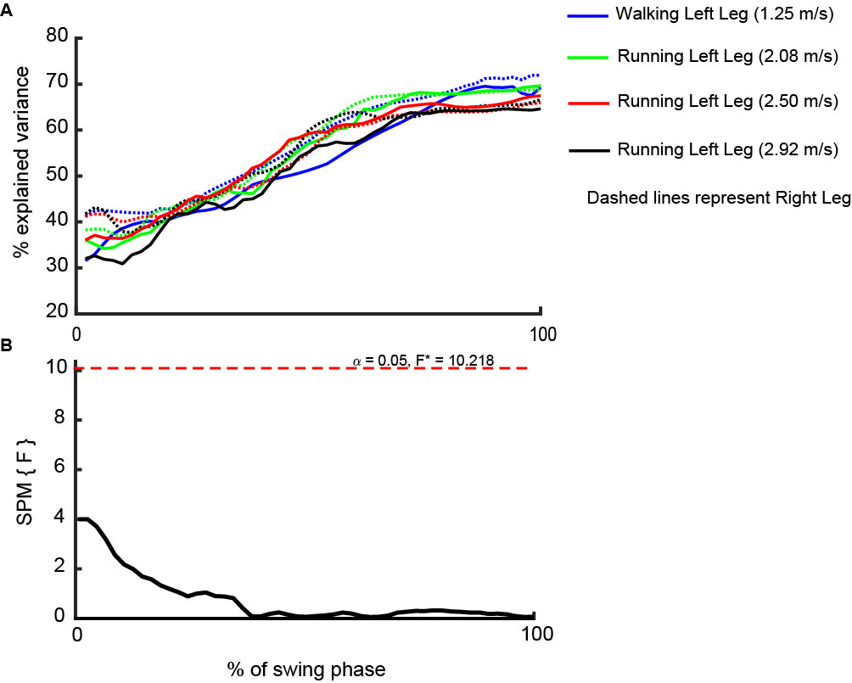
Fig 1. A. % of variance in ML foot placement that can be explained by ML trunk CoM state (R²) in walking and running. B. The differences of R² between left and right legs in walking and runinng.

We calculated the average of R² over legs in walking and running because our results indicated very small, nonsignificant differences between legs during swing phase (Fig 1.). Then, the effect of running speed on this parameter was considered:

The effect of running speeds (2.08, 2.50, and 2.92 m.s⁻¹) on:

% of variance in ML foot placement that can be explained by ML trunk CoM state (R²)
Very small, nonsignificant differences of R² were found between different running speeds (Fig 2.).
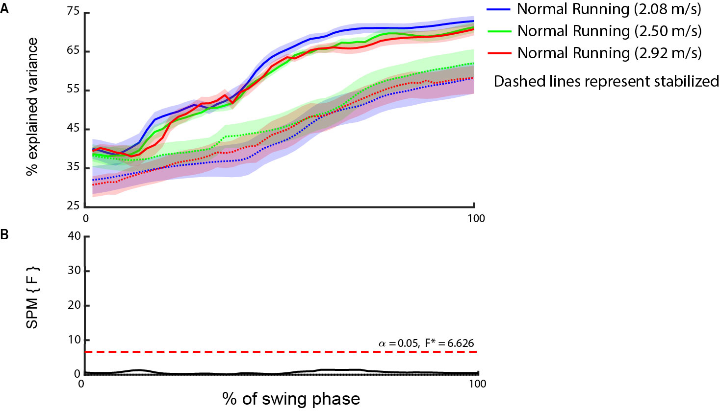
Fig 2. A. % of variance in ML foot placement that can be explained by ML trunk CoM state (R²) in running with three different speeds [2.08, 2.50, and 2.92 m/s]. B. The effect of running speeds (2.08, 2.50, and 2.92 m/s) on R². The shaded regions indicate standard deviation of R².

We calculated the average of R² over running speed because our results indicated very small, nonsignificant differences of R² between running speeds (Fig 2.).

Step width
The main effects of speed on step width was significant in running (F (1, 2) = 9.25, p = 0.002) (Fig 3.), however, because step width for all running speeds was higher/lower than during walking, this would not lead to interesting interaction effects. Thus, step width was also averaged over running speeds.
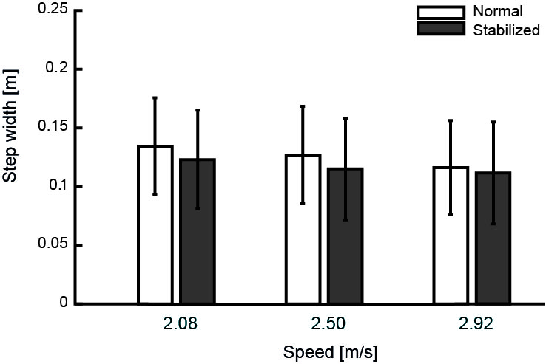
Fig 3. Effect of speed on step width.

Step width variability
There was no significant main effect of speed on step width variability in running (F (1, 2) = 1.48, p = 0.254) (Fig 4.).
Fig 4. Effect of speed on step width variability.

We calculated the average of step width variability over running speeds because our results indicated no significant differences of step width variability between running speeds (Fig 4.).
Then the differences of R², step width, and step width variability between walking and running were considered.

Energy cost
Energy costs of ML stability control in walking and running was also investigated. Reduced energy costs in stabilized condition would support that the control of ML stabilization requires energy consumption and differential effects between walking and running might indicate differences in these costs between these modes of locomotion. Since energy cost is not directly related to foot placement strategy, which is the main focus of this study, all the information about this parameter can be read below:

Instruments
Breath-by-breath oxygen consumption was also obtained from a pulmonary gas exchange system (Cosmed K4b², Cosmed, Italy).

Data processing
Oxygen uptake ($\dot{V}O_{2}$; ml min⁻¹) and respiratory exchange ratio (RER) were determined with the pulmonary gas exchange system during the last minute of each trial. The metabolic rate reached a plateau within the 5- minutes trial, as was confirmed through visual inspection. We calculated gross metabolic rate (E_{gross}; J kg⁻¹ min⁻¹) as [3]:
$E_{gross}=((4.940∙RER+16.40)∙\dot{V}O_{2})$/body mass (kg)
Resting metabolic rate, determined with the same method as we did for gross metabolic rate during seated position for 5 min prior to the trials, was subtracted from gross metabolic rate to calculate net metabolic rate during walking and running. To calculate net energy cost (EC; J kg⁻¹ m⁻¹), net metabolic rate was divided by speed (m min⁻¹).

Statistical analysis
The main effect of speed on energy cost were not significant in running ( F (1, 2) = 0.214, p=0.809) (Fig 5.).

Fig 5. Effect of speed on energy cost.

Because our results indicated no significant effect of speed on energy cost in running, we calculated the average of energy cost over running speeds.
Next, in line with hypothesis 2, we tested the difference between normal walking and running by paired t-test. To test our third and fourth hypothesis, a two-way repeated analysis of variance with conditions (normal vs stabilized) and mode of locomotion (walking vs running) as within-subject factors was conducted to evaluate the effect of external lateral stabilization, mode of locomotion and interaction (mode of locomotion X condition) on energy cost.

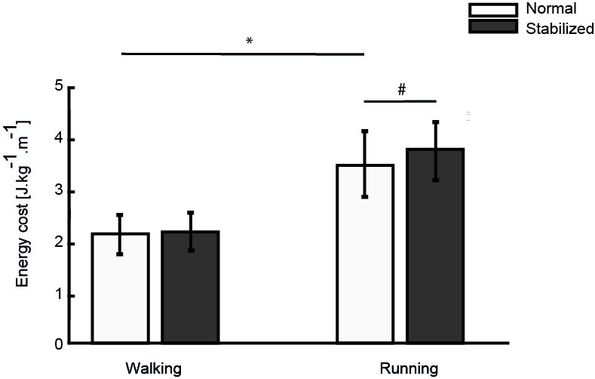
Fig 6. Condition effect: The effect of external lateral stabilization on energy cost in walking and running. # represents the significant differences of energy cost between normal and stabilized conditions (based on the results of Bonferroni post-hoc). * represents the significant differences of energy cost between normal walking and running (based on the results of paired t-test). Error bars represent standard deviation.

Results
As expected, the energy cost was significantly higher in running than walking (t (1, 9) = -11.30, p<0.001). However, in contrast with expectations, energy costs were significantly higher in the stabilized conditions (condition effect; F (1, 9) = 5.81, p = 0.039), and the increase in energy costs with external lateral stabilization was more pronounced in running than in walking (interaction effect; F (1, 9) = 6.84, p = 0.028).(Fig 6.).

Discussion
We measured energy to assess costs of stability control. Reduced energy costs in stabilized walking would support that ML stabilization is an active process and differential effects between walking and running might indicate differences in these costs between these modes of locomotion. Previous studies reported mixed results on the effects of external lateral stabilization on energy costs. Several studies reported significant effects of stabilization. Donelan et al. [6] reported a significant 5.7% and 9.2% reduction in EC during preferred and zero step width conditions respectively, while walking with arm swing restriction. Ortega et al. [7] also reported significant effects of lateral stabilization on EC in walking. Perhaps this study was most similar in set-up to our study; participants were allowed familiarization, walked with preferred step width, and participants were allowed normal arm swing. With arm swing the effect of lateral stabilization was slightly lower (a significant 3-4% reduction), compared to walking without arm swing (a significant 6-7% reduction). Arellano et al. reported significant 5.5% and 2% reductions in EC while walking and running, respectively, without arm swing at a zero target step width [8]. In contrast, Dean et al. [5] did not find a significant reduction in EC during walking with stabilization at preferred step width, although they did find an effect in a prescribed zero step width condition. IJmker et al. [1] reported a significant reduction in EC during walking with stabilization, but only after removal of an outlier. In a second study by IJmker et al. [9] with able-bodied participants and people with a lower limb prosthesis, the effect of stabilization failed to reach significance. While it was speculated that the lateral stabilization might impede functional medio-lateral motion in amputees, no satisfying explanation was provided for the lack of effect in the control group. These conflicting findings in literature, may be explained by differences in experimental conditions or designs. To investigate whether external lateral stabilization reduces the energy cost during walking and in which conditions, further analyses such as meta-regression could to be performed on data from the studies mentioned. Our results showed that foot placement is used to control ML stability in walking and running. The energy cost of this strategy appears to be low, as the decrease in the use of the foot placement strategy during stabilized walking and running did not lead to decreases in energy costs. Instead, energy costs slightly increased, especially during running. Unintended effects of the external stabilization, e.g. on propulsion may have outweighed the benefits. Low energy costs may explain why foot placement is likely to be preferred over other stability control strategies, such as control through ankle moments [10-12].

References
1. Wang, Y. and M. Srinivasan, Stepping in the direction of the fall: the next foot placement can be predicted from current upper body state in steady-state walking. Biology letters, 2014. 10(9): p. 20140405.
2. Hurt, C.P., et al., Variation in trunk kinematics influences variation in step width during treadmill walking by older and younger adults. Gait & posture, 2010. 31(4): p. 461-464.
3. Garby, L. and A. Astrup, The relationship between the respiratory quotient and the energy equivalent of oxygen during simultaneous glucose and lipid oxidation and lipogenesis. Acta Physiologica Scandinavica, 1987. 129(3): p. 443-444.
4. Donelan, J.M., et al., Mechanical and metabolic requirements for active lateral stabilization in human walking. Journal of biomechanics, 2004. 37(6): p. 827-835.
5. Ortega, J.D., L.A. Fehlman, and C.T. Farley, Effects of aging and arm swing on the metabolic cost of stability in human walking. Journal of biomechanics, 2008. 41(16): p. 3303-3308.
6. Arellano, C.J. and R. Kram, The energetic cost of maintaining lateral balance during human running. Journal of Applied Physiology, 2011. 112(3): p. 427-434.
7. Dean, J.C., N.B. Alexander, and A.D. Kuo, The effect of lateral stabilization on walking in young and old adults. IEEE Transactions on Biomedical Engineering, 2007. 54(11): p. 1919-1926.
8. Ijmker, T., et al., Energy cost of balance control during walking decreases with external stabilizer stiffness independent of walking speed. Journal of biomechanics, 2013. 46(13): p. 2109-2114.
9. IJmker, T., et al., Can external lateral stabilization reduce the energy cost of walking in persons with a lower limb amputation? Gait & posture, 2014. 40(4): p. 616-621.
10. Bruijn, S.M. and J.H. van Dieën, Control of human gait stability through foot placement. Journal of The Royal Society Interface, 2018. 15(143): p. 20170816.
11. Reimann, H., T. Fettrow, and J.J. Jeka, Strategies for the control of balance during locomotion. Kinesiology Review, 2018. 7(1): p. 18-25.
12. Hof, A. and J. Duysens, Responses of human ankle muscles to mediolateral balance perturbations during walking. Human movement science, 2018. 57: p. 69-82.

