Running Title (45 char max): Metabarcoding with fusion primer sets

Title: Scaling up DNA metabarcoding for freshwater macrozoobenthos monitoring
Authors: Vasco Elbrecht^{1*}, Dirk Steinke^{1,2}

Affiliations:
1) Centre for Biodiversity Genomics, University of Guelph, 50 Stone Road East, Guelph, Ontario, N1G 2W1, Canada
2) Department of Integrative Biology, University of Guelph, 50 Stone Road East, Guelph, Ontario, N1G 2W1, Canada
*Corresponding author: Vasco Elbrecht (elbrecht@uoguelph.ca),

Abstract:
The viability of DNA metabarcoding for assessment of freshwater macrozoobenthos has been demonstrated over the past years. It matured to a stage where it can be applied to monitoring at a large scale, keeping pace with increased high throughput sequencing (HTS) capacity. However, workflows and sample tagging need to be optimized to accommodate for hundreds of samples within a single sequencing run. We here conceptualize a streamlined metabarcoding workflow, in which samples are processed in 96-well plates. Each sample is replicated starting with tissue extraction. Negative and positive controls are included to ensure data reliability. With our newly developed fusion primer sets for the BF2+BR2 primer pair up to three 96-well plates (288 wells) can be uniquely tagged for a single Illumina sequencing run. By including Illumina indices tagging can be extended to thousands of samples. We hope that our metabarcoding workflow will be used as a practical guide for future large-scale biodiversity assessments involving freshwater invertebrates. However, we also want to point out that this is just one approach, and that we hope this article will stimulate discussion and publication of alternatives and extensions.

Key words: Biomonitoring, High throughput sequencing, Macrozoobenthos, Multiplexing, Fusion Primer, Metabarcoding workflow, Replication

Introduction
Reliable monitoring of freshwater macroinvertebrate diversity is a key component in the assessment and management of stream ecosystems (Dudgeon et al. 2006, Vörösmarty et al. 2010). DNA-based identification methods such as metabarcoding are promising alternatives (Baird and Hajibabaei 2012) to morphological identification, which is often limited in resolution and dependent on taxonomic experience (Sweeney et al. 2011). In addition to reducing human bias, DNA based identifications can also lead to improved stream assessment (Stein et al. 2013). Over the past few years several studies demonstrated the feasibility of metabarcoding-based monitoring of freshwater macroinvertebrates (Hajibabaei et al. 2011, Carew et al. 2013, Gibson et al. 2015, Andújar et al. 2017). Despite some methodological limitations (presence/absence data, primer bias (Elbrecht and Leese 2015)), assessment results are at least comparable if not superior to conventional morphology-based stream monitoring approaches (Gibson et al. 2015, Elbrecht et al. 2017b, Emilson et al. 2017). Some macroinvertebrate reference databases are already fairly comprehensive especially for common taxa (Carew et al. 2017, Elbrecht et al. 2017a), and many aspects of the metabarcoding approach have been thoroughly validated recently (Hajibabaei et al. 2012, Carew et al. 2013, Elbrecht and Leese 2015, Gibson et al. 2015, Elbrecht and Leese 2017, Elbrecht et al. 2017a, Emilson et al. 2017, Andújar et al. 2017). Consequently, many countries are now actively working towards the use of DNA metabarcoding for routine monitoring of macroinvertebrates (Leese et al. 2016).
Routine stream monitoring requires the collection and identification of thousands of kick samples (Buss et al. 2015), however, current metabarcoding studies are typically limited to a few dozen samples. If DNA metabarcoding is to be used in routine large scale monitoring projects, a substantial scale up of laboratory protocols is needed in a way that ensures a high level of reliability and quality of data.
We propose a streamlined metabarcoding approach that runs up to 288 individual samples on a single Illumina sequencing run (Fig. 1), using the BF2+BR2 fusion primer system (Elbrecht and Leese 2017) which has been shown to work well with macroinvertebrate monitoring samples (Elbrecht et al. 2017b). The extended primer set allows for flexible multiplexing of samples in up to three 96-well plates thereby simplifying sample handling and reducing the risk of cross-contamination. By incorporating replicates already at the tissue homogenization stage, as well as including positive and negative controls, samples affected by laboratory issues can be reliably detected and either excluded from subsequent analysis or re-extracted. Furthermore, by minimizing the number of validation steps throughout the protocol and the use of streamlined fusion primer tags in a 96-well format, we ensure practicality of the protocol. Rather than continuously validating or replicating every step of the workflow, we recommend utilizing controls and replicates in a manner that highlights samples affected by errors.

Sample collection, homogenization and DNA extraction
After samples are collected using a standardized protocol (Fig. 1A), invertebrate specimens should be separated from any debris such as substrate and non-target organic matter (Fig. 1B). This increases the chance that some taxa and specimens will be overlooked (Haase et al. 2010), but homogenizing an entire sample might introduce PCR inhibitors and render standardization extremely difficult. Once specimens are separated from debris they can be dried (Fig. 1C) and homogenized (Fig. 1D). DNA of bulk samples has also been extracted directly from the preservation ethanol (Hajibabaei et al. 2012), through homogenization of the wet sample (Hajibabaei et al. 2011), or by lysing the complete sample (Braukmann et al. in prep). We, however, recommend the homogenization of dried bulk samples using e.g. bead mills, which allows DNA extraction of the entire community using just a small quantity of tissue powder (10-15 mg, (Elbrecht and Leese 2015, Elbrecht et al. 2017b)). Two replicates per sample should be used for DNA extraction (Fig. 1E), both of which will be metabarcoded to facilitate the detection of insufficient tissue homogenization, as taxon composition will vary substantially between replicates if homogenization was incomplete. Any method of DNA extraction yielding high quality DNA can be used (Fig. 1F). As tissue powder is easily electrically charged, direct transfer of powder into the 96-well plate should be avoided. Rather the powder should be incubated in individual 1.5 ml reaction tubes and the lysate transferred, to reduce the risk of cross-contamination. For the same reason, a strong adhesive plate sealing tape (if necessary detergent resistant) should be used throughout the entire workflow to prevent spilling of samples. Additionally, plates should always be centrifuged before opening and sealed with fresh sealing tape (ideally tightened with a plastic squeegee). To enable detection of cross-contamination each row and each column needs to contain an extraction blank that will be included in PCR and sequencing (Fig. 1). Tissue powder from a previous project or a mock sample can be used as a positive control throughout the metabarcoding workflow. It's recommended to homogenize the positive control sample with liquid nitrogen to ensure it's homogeneity if used across several experiments (Elbrecht and Leese 2015). To increase PCR success and for easier troubleshooting we recommend normalizing all DNA extracts to identical concentrations. Ideally, DNA is quantified by using a chromatogram-based approach (e.g. Fragment analyzer, Advanced Analytical, USA), which will also quantify DNA quality and verify that the negative controls are clean.

Amplification and tagging: Two step PCR protocol
After the DNA is extracted and normalized, the barcode marker can be amplified. For freshwater macrozoobenthos, the cytochrome oxidase subunit I (COI) gene is usually used, but some authors also recommended ribosomal markers (Deagle et al. 2014). We think ribosomal markers do not offer any advantages over well-designed degenerated COI primer sets (Elbrecht and Leese 2017). Additionally, ribosomal markers often lack adequate reference data (Elbrecht et al. 2016). We recommend the use of BF2+BR2 primer set as it was specifically designed for freshwater macrozoobenthos and has been already evaluated using both mock and kick samples (Elbrecht et al. 2017b, Elbrecht and Leese 2017). Further PCR and primer modifications are dependent on the strategy used to multiplex several uniquely tagged samples for a sequencing run. We recommend the use of a two-step PCR protocol, in which the first PCR amplifies the target fragment utilizing universal primers, while the second PCR uses fusion primer versions of the same primer sets, which include an inline tag and Illumina sequencing tails (Fig. 2). Fusion primers can be used directly in a single PCR approach, but a two-step PCR setup is less susceptible to PCR inhibition (Schnell et al. 2015). Additionally, fusion primers greatly reduce the chance for tag switching (Elbrecht et al. 2017b), which can become an issue with other more modular tagging approaches (Esling et al. 2015, Schnell et al. 2015). Furthermore, inline tags of different length and parallel sequencing in forward and reverse direction can substantially increase sequence diversity which in turn leads to better results on Illumina machines and allows for a reduced spike-in of ~5% PhiX (Wu et al. 2015, Elbrecht and Leese 2015). That being said, fusion primers can be quite costly, as many versions with different in-line tags are needed. They also need to be developed for each new primer set (thus using commercial indexing kits for small projects might be more cost effective). However, if the same fusion primer set is used more frequently, it can become highly cost effective. One primer costs around $50 and yields over 100 µl with a 100 pmol/µl concentration, of which 25 pmol are used per 50 µl PCR reaction. Such a set (forward + reverse primer) can be used to tag 400 samples at a cost of $100 ($0.25 per reaction).
Previously developed BF2+BR2 fusion primer sets were limited to tagging a maximum of 72 samples (Elbrecht and Leese 2017), which will quickly become insufficient for large-scale metabarcoding projects. Therefore, we developed new fusion primer sets that allow unique tagging and multiplexing of up to 288 samples on three 96-well microplates within the same run (Fig. 3, see Fig S1 for full primer sequences and Tab S1 for plate layouts). These new tags use a 7 bp sequence for both forward and reverse primers, while avoiding inline tags of 0 - 1 bp length which are easily affected by insertions or deletions caused by sequencing errors (Faircloth and Glenn 2012). Because the manual development of large numbers of different tags is difficult, we employed an R script that we used to randomly generate 100.000 tagging sets (Script S1). Seven previously developed primer pairs were incorporated into the design process, but the overall base composition was kept similar where possible (Fig S2). The similarity between tags of each generated set was subsequently visualized (Fig S3), and the primer set with most divergent tags was chosen in order to reduce potential tag switching through sequencing errors. Tags in the selected set differed by at least 3 bp, with the exception of four fusion primers that had only a 2 bp insert. We also calculated the Levenshtein distance utilizing the R package stringdist v0.9.4.6 (Van der Loo 2014) to ensure single insertions or deletions (indels) won’t lead to tag switching (Figure S4, Faircloth and Glenn 2012). The Levenshtein distance was always 2 or higher, which should be sufficient given that Illumina sequencers are relatively unaffected by indels (Salipante et al. 2014). For PCR we recommend using a reaction volume of 50 µl with a high quality standard Taq. It is our experience that proof reading Taq's often struggle with degeneracy and long primer tails. For the first PCR (Fig. 2), a master mix using the standard BF2+BR2 primers is added to each 96-well plate. As the extracted DNA (including negative/positive controls) is already present in a 96-well format, ~25 ng DNA can be easily transferred to the PCR plate (Fig. 1H). After the initial PCR 1 µl amplicon is used as template for the second PCR that individually tags each sample (Fig. 1I). The number of cycles needed in each PCR might have to be optimised depending on how strongly samples are inhibited. While the cycle number should be kept as low as possible, studies on barcoding data show that a high number of cycles is not necessarily compromising data quality (Vierna et al. 2017, Krehenwinkel et al. 2017). PCR success of the first and second PCR can be verified by electrophoresis, however, bands might only be visible after the second PCR depending on cycle number. Amplicons from failed PCR reactions should be excluded from sequencing.

Library Preparation and Pooling
Amplicons of the second PCR can be directly used for sequencing after chromatographic quantification (Fig. 1J) and cleanup (to remove residual primers and other PCR components). As long as it is possible to measure the concentration of amplicons independently from primer dimers, samples can be pooled first and then subjected to cleanup. Otherwise, each individual sample will need to be cleaned separately before quantification. Usually, all samples are pooled with identical amplicon concentration to ensure similar sequencing depth across all of them. However, in some cases sample concentrations can be adjusted, e.g. if amplicons of different length are sequenced on the same run (Elbrecht and Leese 2017) or if the number of specimens across samples is highly variable (Beerman et al. in prep, Theissinger et al. in press). It should also be stressed that both the quantification and pooling step are absolutely essential for the desired sequencing depth across samples, and the accuracy of any used quantification method should be verified prior to any experiments (Elbrecht et al. 2017b). As negative controls are difficult to quantify due to low concentration any adjustment to the concentration of other samples would lead to a strong overrepresentation. We therefore recommend adding each negative control to the library in volumes equal to the average volume of the samples used for pooling.
An effective solution for cleanup is magnetic bead purification as it also allows for removal of amplicons that do not match the targeted marker length (Fig. 1L). Usually a left sided size selection is sufficient as long as no strong double bands are present. Alternative cleanup methods will be needed if BSA was included as a PCR enhancer, as it can prevent re-suspension of magnetic beads (Elbrecht et al. 2017a). The clean library can then be directly loaded onto an Illumina sequencer. As only inline barcodes are used for sample tagging, both Illumina indexing read steps can be skipped (Fig. 1M). Following sequencing, reads are demultiplexed using the first 7 bp of read one and two (e.g. implemented in the R package "JAMP", http://github.com/VascoElbrecht/JAMP).

Sequencing depth
The number of samples (or plates) that can be sequenced on the same run depends on the number of sequences a platform produces as well as on the desired sequencing depth for each sample. The lower the sequencing depth the more taxa will remain undetected, especially those with low abundance, low biomass, and those strongly affected by primer bias (Alberdi et al. 2017, Elbrecht et al. 2017a). For macrozoobenthos bulk samples we recommend a sequencing depth of at least 100000 sequences per replicate. As the BF2+BR2 primer set amplifies a 421 bp region, paired end sequencing with at least 250 bp sequence length is necessary. Table 1 shows an overview of currently available Illumina sequencers that meet these criteria (end of 2017) and the expected sequencing depth they can produce per well. A library can be easily re-sequenced when sequencing depth turns out to be insufficient. Additionally, sequencing depth between samples might vary depending on quantification accuracy for individual samples. Samples with insufficient sequencing depth can be recovered, e.g. by adding additional PCR product to the affected samples in a library for a re-run (alternatively respective samples can be excluded from the dataset if only a few are affected).

Table 1: Sequencing depth per well with different Illumina sequencing platforms suitable for the BF2+BR2 fusion primers (k = 1.000 spots).
Sequencer | MiSeq |  |  | HiSeq (1 of 2 lanes)
Sequencing Kit | 250 PE v2 Nano* | 250 PE v2 | 300 PE v3 | 250 PE v2 rapid run
Throughput (max) | 1 000k | 15 000k | 25 000k | 150 000k
Number of plates
sequenced:
One (96 wells) | 10.4k | 156.2k | 260.4k | 1 562.5k
Two (192 wells) | 5.2k | 78.1k | 130.2k | 781.3k
Three (288 wells) | 3.5k | 52.1k | 86.8k | 520.8k
* 2/3 the cost of the 250 PE v2 kit, too expensive

Bioinformatics processing and troubleshooting
The choice of bioinformatics pipelines and clustering settings can drastically affect the resulting taxon list, especially when it comes to rare taxa (Fig. 1N, (Kopylova et al. 2016)). However, as long as data is strictly filtered (removal of singletons, abundance based filtering of Operational taxonomic units (OTUs)) and an appropriate OTU clustering algorithm is used for the pool of all samples, results should be reliable (see e.g. (Elbrecht et al. 2017b)). However, only samples with sufficient sequencing depth should be used in such analysis, and if samples vary strongly in sequencing depth, rarefaction should be applied across all samples to ensure equal sequencing depth. If a single replicate is of insufficient sequencing depth, the sample should be removed from the dataset. Both replicates for each sample should be very similar in OTU composition. Any discrepancies could indicate e.g. problems caused by insufficient tissue homogenization, cross-contamination or PCR and sequencing errors (Lange et al. 2015, Zepeda-Mendoza et al. 2016). Low abundance OTUs that are not shared among replicates should be removed, or the complete sample should be discarded (Fig. 1O). However, these samples and OTUs should still be included and highlighted when reporting the raw data, ideally in form of an OTU table. Strong cross-contamination can also be detected by discrepancies between the replicates, especially if the contamination is patchy and not systematic (Kelly et al. 2005). The positive control can be used to confirm consistency of the metabarcoding protocol between plates and sequencing runs. Additionally, the 12 negative controls should be inspected for potential cross-contamination and severe tag switching. Tag switching with very low abundance might be observed, but is not a concern (Elbrecht et al. 2017b). The sum of the abundance of each OTU in the negative controls can be subtracted from all other samples in order to reduce the effects of low abundance tag switching on the data set. However, if severe tag switching or cross-contamination is detected, the entire metabarcoding run might have to be repeated (ideally starting from the DNA extraction stage).

Discussion and conclusions
Our proposed metabarcoding strategy is based on sufficiently validated laboratory methods, while still keeping the workflow simple and scalable. By working with 96-well microplates high sample throughput can be easily achieved while at the same time reducing the risk of cross-contamination. By running two replicates starting at the DNA extraction stage, together with negative and positive controls, we ensure that errors are still detectable despite the reduced need to validate each individual laboratory step. The BF2+BR2 fusion primer sets which are extended here (Fig S1) are well tested for macroinvertebrate communities (Elbrecht et al. 2017b, Elbrecht and Leese 2017), enabling the tagging and sequencing of up to 288 wells in a single sequencing run. We are confident that this metabarcoding workflow will produce reliable results for up to 123 replicated samples per sequencing run (Fig. 1) utilizing a simplified fusion primer based sample tagging process.
The number of samples that can be multiplexed with our tagging system is optimized for the currently available Illumina platforms. However, the throughput of sequencers continues to increase with new sequencers and kits being introduced frequently. Already today a shorter COI fragment could be used to amplify macrozoobenthos bulk samples (Meusnier et al. 2008), which would allow for sequencing at ~50x increased throughput (e.g. HiSeq vs. NovaSeq). Such an approach would require thousands of samples being uniquely tagged and multiplexed for a single sequencing run. Although our inline tags are only able to tag 288 wells, they could be extended to several thousand tagging combinations by incorporating Illumina indexing into the fusion primers.
While we are convinced that our metabarcoding approach is efficient and reliable it needs to be validated in practice and thoroughly compared to other protocols. We hope that this manuscript will encourage discussion and helps to find better approaches for the scale-up of metabarcoding for biodiversity assessment. Variations of the our proposed workflow as well as comparisons to alternative metabarcoding protocols are explicitly encouraged.
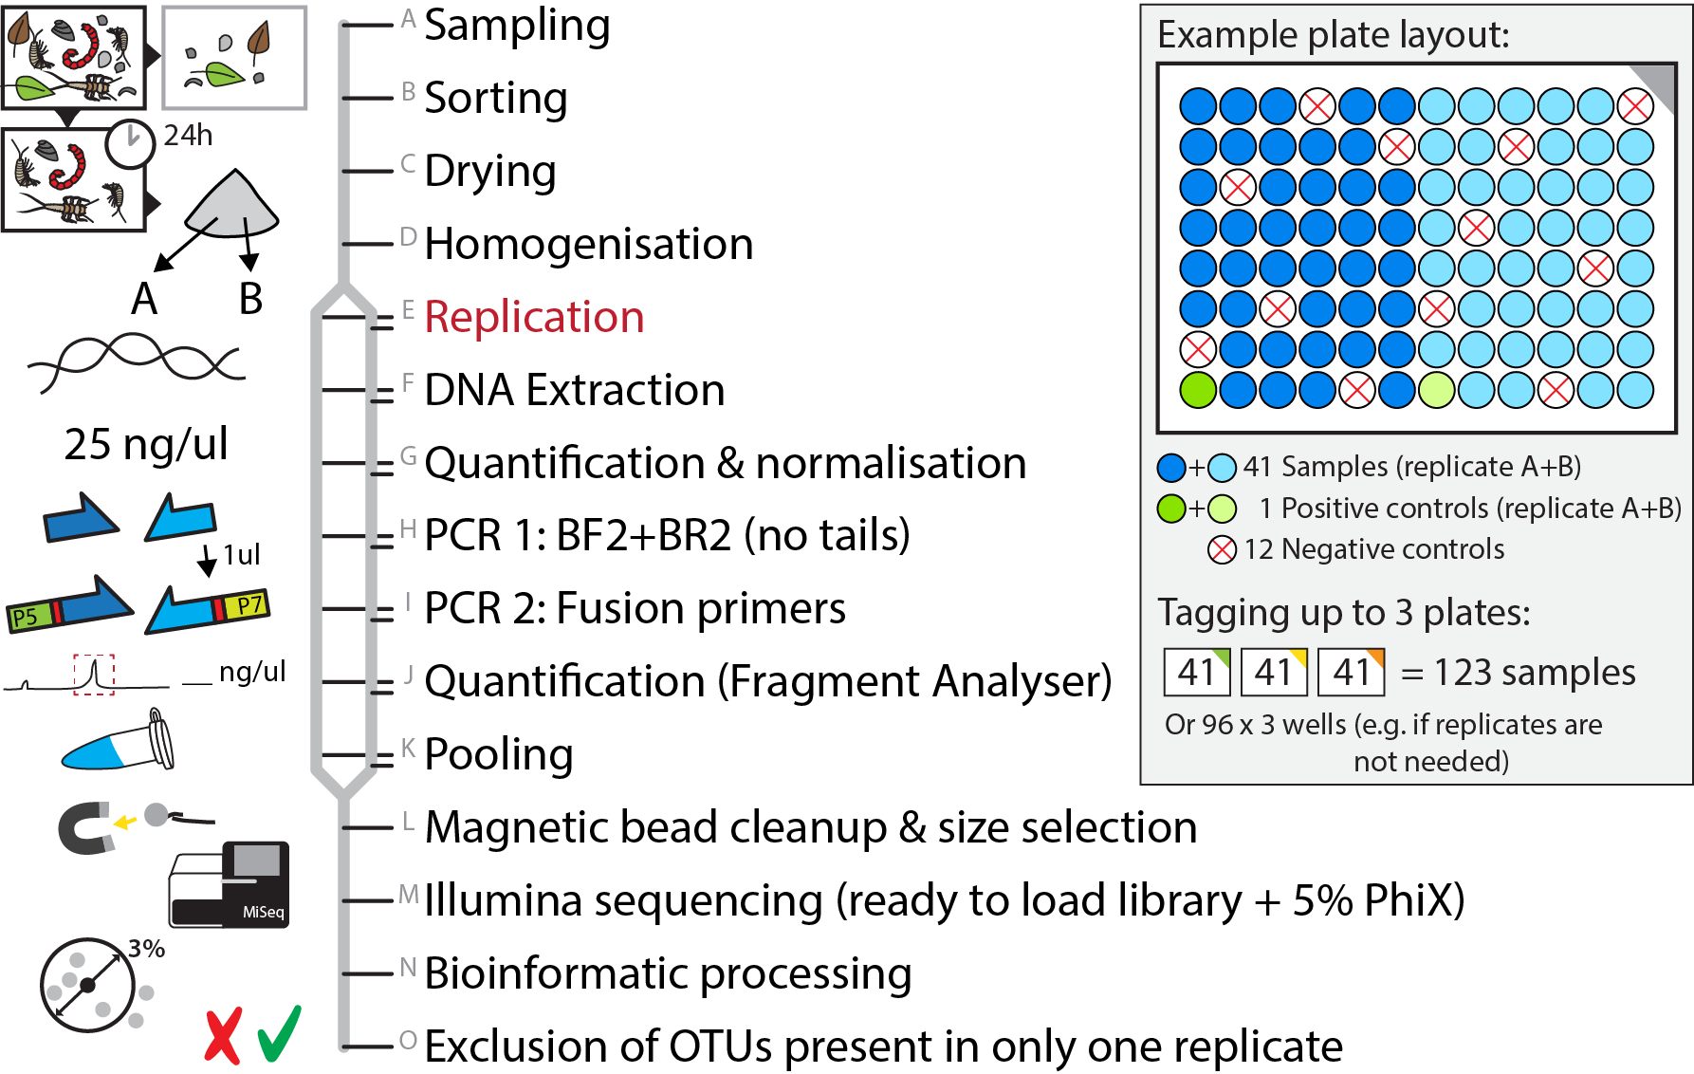
Figure 1: Overview of the proposed metabarcoding work flow for macroinvertebrates using a 96-well plate format and replication for each sample. Twelve negative controls are included at the DNA extraction stage to detect potential cross-contamination as well as tag switching. One positive control (replicated as well) can be used to estimate the overall performance of the metabarcoding run. Failed extractions or PCRs can be excluded from the sequencing run, and repeated on a new plate. With the newly designed BF2+BR2 fusion primers developed in this publication up to three 96-well plates can be multiplexed for a single run.
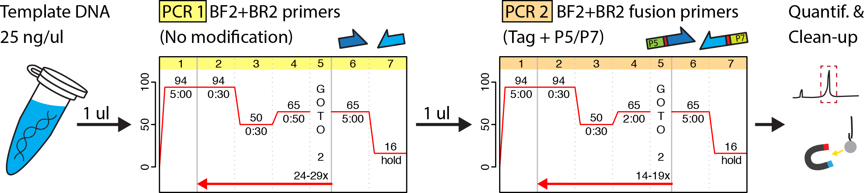
Figure 2: Overview of the two-step metabarcoding PCR protocol (using HotMaster Taq, QuantaBio, USA). The first PCR uses the standard BF2+BR2 primers without modifications, thereby increasing amplification efficiency. Subsequently, 1 μl of amplicon product from the first PCR is used (without cleanup) as template for the second PCR step utilizing fusion primers, which adds inline tags as well as Illumina sequencing adaptors. Note that the extension time is increased for the second PCR in order to ensure the entire fusion primer gets amplified. After the second PCR the product can be prepared for sequencing (quantification, pooling with other amplicons and clean-up).
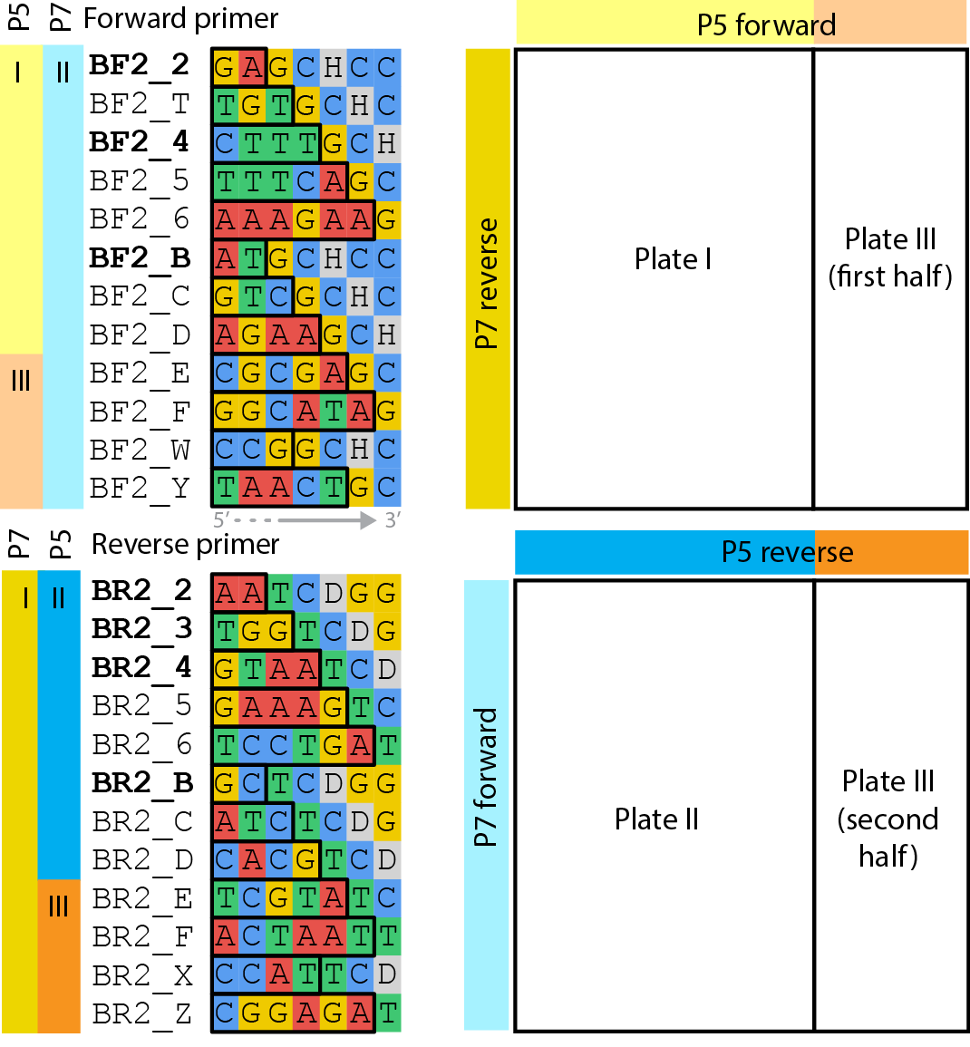
Figure 3: Overview of the newly developed inline tags for the BF2+BR2 primer set. Names of previously published primers are highlighted in bold (Elbrecht and Leese 2017) and the inline tag for each primer is indicated by a black box (the full 7 bp sequence has to be used for demultiplexing). The pipetting schema for three 96-well plates is shown on the right. All three plates can be pooled and used for the same sequencing run, or just plate I + II if two plates are sufficient, or only plate III if tagging for only one plate is desired.

Acknowledgements
We would like to thank Thomas Braukmann, Sean Prosser, Natalia Ivanova, Edith Vamos, Nina Röder, and Matthias Geiger for helpful discussions and feedback, which improved earlier versions of this manuscript. V.E. and D.S. are supported by funding through the Canada First Research Excellence Fund. This work represents a contribution to the ‘Food From Thought’ research program and the EU Action ‘DNAqua-Net’ (CA15219).

Author contributions
V.E. developed the laboratory workflow, fusion primer set, and wrote the manuscript. D.S. revised the manuscript.

Supporting information
Fig. S1: Newly developed fusion primer sets (BF2+BR2), suitable for tagging 288 individual wells.
Fig. S2: Base composition of the inline tagging region.
Fig. S3: Hamming distance between tags for all fusion primers.
Fig. S4: Levenshtein distance between tags for all fusion primers.
Script S1: R script used to randomly generate inline barcodes for the given primer sets (includes visualization, as shown in Fig. S3 and Fig. 3).
Table S1: Table providing an overview of proposed tagging combinations (as shown in Fig. 3).

Literature Cited
Alberdi, A., O. Aizpurua, M. T. P. Gilbert, and K. Bohmann. 2017. Scrutinizing key steps for reliable metabarcoding of environmental samples. Methods in Ecology and Evolution 17:730–14.
Andújar, C., P. Arribas, C. Gray, K. Bruce, G. Woodward, D. W. Yu, and A. P. Vogler. 2017. Metabarcoding of freshwater invertebrates to detect the effects of a pesticide spill. Molecular Ecology.
Baird, D. J., and M. Hajibabaei. 2012. Biomonitoring 2.0: a new paradigm in ecosystem assessment made possible by next-generation DNA sequencing. 21:2039–2044.
Beermann, A., Zizka, V., Elbrecht, V., Baranov, V., Leese, F. (in prep). Under the cloak of taxonomic family level. DNA metabarcoding of Chironomidae in a multiple stressor mesocosm experiment manipulating salinity, fine sediment and flow velocity
Braukmann, T.W.A, Ivanova, N., Prosser, S., Sones, J., deWaard, J., Zakharov, E., Ratnasingham, S., Steinke, D., Hebert, P.D.N. (in prep). Understanding arthropod diversity using a mock community.
Buss, D. F., D. M. Carlisle, T.-S. Chon, J. Culp, J. S. Harding, H. E. Keizer-Vlek, W. A. Robinson, S. Strachan, C. Thirion, and R. M. Hughes. 2015. Stream biomonitoring using macroinvertebrates around the globe: a comparison of large-scale programs. Environmental monitoring and assessment 187:4132.
Carew, M. E., S. J. Nichols, J. Batovska, R. St Clair, N. P. Murphy, M. J. Blacket, and M. E. Shackleton. 2017. A DNA barcode database of Australia’s freshwater macroinvertebrate fauna. Marine and freshwater research:1–15.
Carew, M. E., V. J. Pettigrove, L. Metzeling, and A. A. Hoffmann. 2013. Environmental monitoring using next generation sequencing: rapid identification of macroinvertebrate bioindicator species. Frontiers in zoology 10:1–1.
Deagle, B. E., S. N. Jarman, E. Coissac, F. Pompanon, and P. Taberlet. 2014. DNA metabarcoding and the cytochrome c oxidase subunit I marker: not a perfect match. Biology Letters 10:20140562–20140562.
Dudgeon, D., A. H. Arthrington, M. O. Gessner, Z.-I. Kawabata, D. J. Knowler, C. Lévêque, R. J. Naiman, A.-H. Prieur-Richard, D. Soto, M. L. J. Stiassny, and C. A. Sullivan. 2006. Freshwater biodiversity: importance, threats, status and conservation challenges. Biological Reviews 81:163.
Elbrecht, V., and F. Leese. 2015. Can DNA-Based Ecosystem Assessments Quantify Species Abundance? Testing Primer Bias and Biomass—Sequence Relationships with an Innovative Metabarcoding Protocol. PloS one 10:e0130324–16.
Elbrecht, V., and F. Leese. 2017. Validation and development of freshwater invertebrate metabarcoding COI primers for Environmental Impact Assessment. Frontiers in Freshwater Science.
Elbrecht, V., B. Peinert, and F. Leese. 2017a. Sorting things out: Assessing effects of unequal specimen biomass on DNA metabarcoding. Ecology and Evolution 7:6918–6926.
Elbrecht, V., E. Vamos, K. Meissner, J. Aroviita, and F. Leese. 2017b. Assessing strengths and weaknesses of DNA metabarcoding based macroinvertebrate identification for routine stream monitoring. Methods in Ecology and Evolution:1–21.
Elbrecht, V., P. Taberlet, T. Dejean, A. Valentini, P. Usseglio-Polatera, J.-N. Beisel, E. Coissac, F. Boyer, and F. Leese. 2016. Testing the potential of a ribosomal 16S marker for DNA metabarcoding of insects. PeerJ 4:e1966–12.
Emilson, C. E., D. G. Thompson, L. A. Venier, T. M. Porter, T. Swystun, D. Chartrand, S. Capell, and M. Hajibabaei. 2017. DNA metabarcoding and morphological macroinvertebrate metrics reveal the same changes in boreal watersheds across an environmental gradient. Scientific Reports:1–11.
Esling, P., F. Lejzerowicz, and J. Pawlowski. 2015. Accurate multiplexing and filtering for high-throughput amplicon-sequencing. Nucleic acids research 43:2513–2524.
Faircloth, B. C., and T. C. Glenn. 2012. Not All Sequence Tags Are Created Equal: Designing and Validating Sequence Identification Tags Robust to Indels. PloS one 7:e42543–11.
Gibson, J. F., S. Shokralla, C. Curry, D. J. Baird, W. A. Monk, I. King, and M. Hajibabaei. 2015. Large-Scale Biomonitoring of Remote and Threatened Ecosystems via High-Throughput Sequencing. PloS one 10:e0138432–15.
Haase, P., S. U. Pauls, K. Schindehütte, and A. Sundermann. 2010. First audit of macroinvertebrate samples from an EU Water Framework Directive monitoring program: human error greatly lowers precision of assessment results. Journal of the North American Benthological Society 29:1279–1291.
Hajibabaei, M., J. L. Spall, S. Shokralla, and S. van Konynenburg. 2012. Assessing biodiversity of a freshwater benthic macroinvertebrate community through non-destructive environmental barcoding of DNA from preservative ethanol. BMC ecology 12:1–1.
Hajibabaei, M., S. Shokralla, X. Zhou, G. Singer, and D. J. Baird. 2011. Environmental Barcoding: A Next-Generation Sequencing Approach for Biomonitoring Applications Using River Benthos. PloS one 6:1–7.
Kelly, P., F. Pereira-Maxwell, S. Carnaby, and I. White. 2005. Confidence in polymerase chain reaction diagnosis can be improved by Bayesian estimation of post-test disease probability. Journal of Clinical Epidemiology 58:252–260.
Kopylova, E., J. A. Navas-Molina, C. Mercier, Z. Z. Xu, F. Mahé, Y. He, H.-W. Zhou, T. Rognes, J. G. Caporaso, and R. Knight. 2016. Open-Source Sequence Clustering Methods Improve the State Of the Art. mSystems 1.
Krehenwinkel, H., M. Wolf, J. Y. Lim, A. J. Rominger, W. B. Simison, and R. G. Gillespie. 2017. Estimating and mitigating amplification bias in qualitative and quantitative arthropod metabarcoding. Scientific Reports:1–12.
Lange, A., S. Jost, D. Heider, C. Bock, B. Budeus, E. Schilling, A. Strittmatter, J. Boenigk, and D. Hoffmann. 2015. AmpliconDuo: A Split-Sample Filtering Protocol for High-Throughput Amplicon Sequencing of Microbial Communities. PloS one 10:e0141590–22.
Leese, F., F. Altermatt, A. Bouchez, and T. Ekrem. 2016. DNAqua-Net: Developing new genetic tools for bioassessment and monitoring of aquatic ecosystems in Europe. Research Ideas and Outcomes.
Meusnier, I., G. A. Singer, J.-F. Landry, D. A. Hickey, P. D. Hebert, and M. Hajibabaei. 2008. A universal DNA mini-barcode for biodiversity analysis. BMC genomics 9:214.
Salipante, S. J., Kawashima, T., Rosenthal, C., Hoogestraat, D. R., Cummings, L. A., Sengupta, D. J., et al. (2014). Performance comparison of Illumina and ion torrent next-generation sequencing platforms for 16S rRNA-based bacterial community profiling. Applied and Environmental Microbiology, 80(24), 7583–7591.
Schnell, I. B., K. Bohmann, and M. T. P. Gilbert. 2015. Tag jumps illuminated - reducing sequence-to-sample misidentifications in metabarcoding studies. Molecular ecology resources 15:1289–1303.
Stein, E. D., B. P. White, R. D. Mazor, J. K. Jackson, and J. M. Battle. 2013. Does DNA barcoding improve performance of traditional stream bioassessment metrics? Freshwater Science 33:302–311.
Sweeney, B. W., J. M. Battle, J. K. Jackson, and T. Dapkey. 2011. Can DNA barcodes of stream macroinvertebrates improve descriptions of community structure and water quality? Journal of the North American Benthological Society 30:195–216.
Theissinger, K., A. Kästel , V. Elbrecht , J. Makkonen , S. Michiels , S. I. Schmidt , S. Allgeier , F. Leese , C. A. Brühl (in press). Using DNA metabarcoding for assessing chironomid diversity and community change in mosquito controlled temporary wetlands. Metabarcoding an Metagenomics
Van der Loo, M. (2014). The Stringdist Package for Approximate String Matching. The R Journal, 6(1), 111–122.
Vierna, J., J. Doña, A. Vizcaíno, D. Serrano, and R. Jovani. 2017. PCR cycles above routine numbers do not compromise high-throughput DNA barcoding results. Genome 60:868–873.
Vörösmarty, C. J., P. B. McIntyre, M. O. Gessner, D. Dudgeon, A. Prusevich, P. Green, S. Glidden, S. E. Bunn, C. A. Sullivan, C. R. Liermann, and P. M. Davies. 2010. Global threats to human water security and river biodiversity. Nature 467:555–561.
Wu, L., C. Wen, Y. Qin, H. Yin, Q. Tu, J. D. Van Nostrand, T. Yuan, M. Yuan, Y. Deng, and J. Zhou. 2015. Phasing amplicon sequencing on Illumina Miseq for robust environmental microbial community analysis. BMC Microbiology:1–12.
Zepeda-Mendoza, M. L., K. Bohmann, A. C. Baez, and M. T. P. Gilbert. 2016. DAMe: a toolkit for the initial processing of datasets with PCR replicates of double-tagged amplicons for DNA metabarcoding analyses. BMC Research Notes:1–13.

