Title: Assessing intraspecific genetic diversity from community DNA metabarcoding data

Running Title (45 char max): Extracting haplotypes from metabarcoding data
Authors: Vasco Elbrecht^{1,2*}, Ecaterina Edith Vamos¹, Dirk Steinke², Florian Leese ^{1,3}

Affiliations:
1) Aquatic Ecosystem Research, Faculty of Biology, University of Duisburg-Essen, Universitätsstraße 5, 45141 Essen, Germany
2) Centre for Biodiversity Genomics, University of Guelph, 50 Stone Road East, Guelph, Ontario, N1G 2W1, Canada
3) Centre for Water and Environmental Research (ZWU) Essen, University of Duisburg-Essen, Universitätsstraße 2, 45141 Essen, Germany
**Corresponding author: Vasco Elbrecht (vasco.elbrecht@uni-due.de),

Abstract:
Background. DNA metabarcoding is used to generate species composition data for entire communities. However, sequencing errors in high throughput sequencing instruments are fairly common, usually requiring reads to be clustered into operational taxonomic units (OTU), loosing information on intraspecific diversity in the process.
Methods. This study combines sequence denoising strategies, normally applied in microbial research, with additional abundance based filtering to extract haplotypes from freshwater macroinvertebrate metabarcoding data sets. This novel approach is implemented in the R package "JAMP" and can be applied to Cytochrome c oxidase subunit I (COI) amplicon datasets. We tested our haplotyping method by sequencing i) a single-species mock community composed of 31 individuals with different haplotypes spanning three orders of magnitude in biomass and ii) 18 monitoring samples each amplified with four different primer sets and two PCR replicates.
Results. We detected all 15 haplotypes of the single specimens in the mock community with relaxed filtering and denoising settings. However, up to 480 additional unexpected haplotypes remained in both replicates. Rigorous filtering removes most unexpected haplotypes, but also can discard expected haplotypes mainly from the small specimens. In the monitoring samples, the different primer sets detected 177 - 200 OTUs, each containing an average of 2.40 to 3.30 haplotypes per OTU. Population structures were consistent between replicates, and similar between primer pairs, depending on the primer length. A closer look at abundant taxa in the data set revealed various population genetic patterns, e.g. Taeniopteryx nebulosa and Hydropsyche pellucidula with a difference in north-south haplotype distribution, while Oulimnius tuberculatus and Asellus aquaticus display no clear population pattern but differ in genetic diversity.
Discussion. We developed a strategy to infer intraspecific genetic diversity from bulk invertebrate samples using metabarcoding data. It needs to be stressed that at this point metabarcoding-informed haplotyping is not capable to capture the full diversity present in bulk samples, due to variation in specimen size, primer bias and loss of sequence variants with low abundance. Nevertheless, for a high number of species intraspecific diversity is recovered, identifying potentially isolated populations and potential taxa for further more detailed phylogeographic investigation. While we are currently lacking large-scale metabarcoding data sets to fully take advantage our new approach, metabarcoding-informed haplotyping holds great promise for biomonitoring efforts that not only seek information about biological diversity but also underlying genetic diversity.

Keywords: metabarcoding, high-throughput sequencing, haplotyping, population genetics, ecosystem assessment

Introduction
High-throughput analysis of DNA barcodes retrieved from environmental samples, i.e. DNA metabarcoding, allows for the rapid and standardized assessment of community composition without the need for morpho-taxonomy (Taberlet et al., 2012a; Creer et al., 2016). This new surge of data enables biodiversity surveys at speeds and scales that were previously inconceivable in ecological and evolutionary studies. While the approach has major strengths and is generally regarded as a game changer for ecological research (Creer et al., 2016), it still has limitations such as the fact that sequences are typically clustered into operational taxonomic units (OTUs, Fig. S1) thereby ignoring any intraspecific variation
(Callahan, McMurdie & Holmes, 2017). However, clustering is a crucial step to reduce the influence of PCR and sequencing errors that can otherwise generate false sequence variation (Edgar, 2013). This inability to detect intraspecific variation hampers our ability to detect impacts at the population level. Simultaneous assessment of inter- and intraspecific diversity, however, would be a milestone forward in ecological research and management because haplotype data are direct proxies to register spatio-temporal dynamics of populations and both parameters can differ substantially (Taberlet et al., 2012b). Especially assessing fragmentation (e.g. Weiss & Leese 2016) or changes in population size in response to environmental impacts are key area in basic and applied ecological research (e.g. Sutherland et al. 2012). Also for management this parameter is important because because genetic variation is typically lost long before complete species or OTUs (Bálint et al., 2011). Unfortunately, methods to extract haplotype information from metabarcoding data sets are generally not widely available and thus most studies are based on single-specimen analyses. Some of those are based on denoising algorithms capable of distinguishing between true haplotypes and sequencing noise (e.g.
Tikhonov, Leach & Wingreen, 2015; Eren et al., 2015; Edgar, 2016; Callahan et al., 2016; Amir et al., 2017) and have been tested for microbial samples (e.g.
Eren et al., 2015; Callahan et al., 2016; Needham, Sachdeva & Fuhrman, 2017). Wares & Pappalardo (2016) suggested that haplotype information in metazoan datasets can be used to, for instance, improve taxa abundance estimates, which was successfully demonstrated with bat diet samples (Corse et al., 2017). Recent studies were also able to infer haplotypes with metabarcoding for single specimens (Shokralla et al., 2014), arthropod bulk samples (Elbrecht & Leese, 2015; Pedro et al., 2017) and environmental water samples (Sigsgaard et al., 2016), all highlighting the possibility to extract sequence variant information within OTUs when targeting metazoan taxa.
We here further explore bioinformatics strategies in order to unlock the potential of metabarcoding based haplotyping of entire and complex metazoan communities. Therefore, we combined stringent quality filtering of reads with the recently developed unoise3 denoising strategy (Edgar, 2016) and calibrated this approach using a previously characterized single-species mock sample composed of specimens with known haplotypes (Elbrecht & Leese, 2015; Vamos, Elbrecht & Leese, 2017). Subsequently, we multi-species metabarcoding data collected from 18 sample sites as part of a governmental freshwater macroinvertebrates biomonitoring program (Elbrecht et al., 2017). These were denoised with the developed strategy and we tested the potential to detect intraspecific variation across the broad geographic gradient across multiple taxa.

Materials & Methods
We tested our haplotyping strategy on two available DNA metabarcoding datasets, 1) a single-species mock sample containing 31 specimens with known haplotypes (Vamos, Elbrecht & Leese, 2017) and 2) a multi-species macroinvertebrate community dataset from the Finnish governmental stream monitoring program (Elbrecht et al., 2017). The samples were sequenced for a region nested within the classical Folmer COI region (Folmer et al., 1994) with two replicates each. Hereby, the single-species sample (1) was sequenced using a short primer set amplifying 178 bp, while the multi-species monitoring samples were amplified using four different primer sets targeting a region of up to 421 bp (Elbrecht & Leese, 2017). Paired-end sequencing (250 bp) was performed on Illumina MiSeq and HiSeq systems with high sequencing depth (on average 1.53 million reads per sample, SD = 0.29).
To extract individual haplotypes from the metabarcoding datasets, we used strict quality filtering followed by denoising (unoise3 (Edgar, 2016), with additional threshold-based filtering steps (see Fig. 1B). The full metabarcoding and haplotyping pipelines are available as R package (https://github.com/VascoElbrecht/JAMP), which requires Usearch v10.0.240 (Edgar, 2013). All used pipeline commands are also available as supporting information (Fig. S2, Scripts S1, JAMP v0.28). In short, pre-processing of reads involved sample demultiplexing, paired-end merging, primer trimming, generation of reverse complements where needed (to align all reads in the forward direction), max ee filtering = 0.5 (Edgar & Flyvbjerg, 2015), only keeping reads of exact length targeted by the respective primer set, subsampling to 1 and 0.4 million reads, respectively, to generate the same sequencing depth for the single species and monitoring bulk samples. To further reduce the amount of sequences affected by sequencing errors we applied read denoising with unoise3 as implemented in Usearch (Edgar, 2016) to all samples of a dataset using only reads with >= 10 abundance in each sample after dereplication. Different expected error cutoffs and alpha values were tested, with ee = 0.5 and alpha = 5 being used for the final analysis of the 18 bulk samples.
For the single-species mock sample, the denoised and quality filtered reads (prior to denoising) were mapped against the expected 15 haplotype sequences using Vsearch (v2.4.3) (Rognes et al., 2016). The unoise3 implementation into the JAMP package adds additional threshold-based filtering after the denoising step, which we used for the Finnish mulit-species monitoring samples in order to discard low abundant haplotypes and OTUs "Denoise(... , minhaplosize = 0.01, OTUmin = 0.1)". Additionally, within each OTU and sample site, only haplotypes with at least 5% abundance per sample were considered for generating haplotype maps and networks, in order to exclude low abundance OTUs which can be difficult to separate from PCR artifacts and sequencing errors.

Results
Our approach starts with denoising of quality filtered reads using unoise3 (Edgar, 2016) followed by an additional threshold-based filtering step which includes OTU clustering of denoised reads (Edgar, 2013) and the removal of low abundant OTUs / haplotypes (see Fig. 1B). We validated this approach by using a single species mock community of known haplotype composition (Elbrecht & Leese, 2015), in which we found 943 unexpected haplotypes above 0.003% abundance with no expected error filtering applied (Fig. 1A). Filtering the raw sequence data with different quality thresholds (max ee, Edgar & Flyvbjerg, 2015) reduced the number of unexpected haplotypes by only up to 10.22% (Fig S3). The consistency between the two independent sequencing replicates indicates that a major fraction of the detected haplotypes represent in fact real biological signal (e.g. somatic mutations, numts or heteroplasmy, Bensasson et al., 2001; Shokralla et al., 2014), which is difficult to differentiate from PCR and sequencing errors. Even after using different alpha values for the unoise3 algorithm some unexpected sequence variants remained (Fig S4). An error filtering of max ee = 0.5 in combination with an alpha of 5 was chosen for subsequent analysis (Fig. 1C), as it offers the best trade-off between expected and unexpected haplotypes (9 of 15 expected, 6 unexpected with low abundance), while retaining 67.08% (SD = 17.69%) of the original sequence data after quality filtering and before denoising.
For the denoising of our multi-species environmental biomonitoring samples, additional and more conservative filtering steps were introduced to ensure only true sequence variants are included in the analysis (discarding low abundant OTUs and haplotypes below 0.1% and 0.01%, as well as haplotypes below 5% read abundance within each OTU of the respective sample, Fig. 1C green line). Denoising of metabarcoding data from 18 macroinvertebrate samples of the Finnish routine stream monitoring, recovered 177 - 200 OTUs containing 534 - 646 haplotypes (on average 2.40 - 3.30 haplotypes per OTU, SD = 2.13 - 3.26) for the different primer pairs (Table S1). Most OTUs were only present in a few sample locations, allowing for only limited population genetic analysis (Fig. S5, see also Fig. S7 in Elbrecht et al., 2017). Fig. 2 depicts some examples of haplotype diversity and geographic distribution for more common and widely distributed taxa in this study. For Taeniopteryx nebulosa (Plecoptera) and Hydropsyche pellucidula (Trichoptera) we found distinct patterns of latitudinal variation in haplotype composition (Fig. 2A, B), while Oulimnius tuberculatus (Coleoptera) showed low genetic variation across all primer combinations (Fig. 2C, Fig. S3C). Asellus aquaticus (Isopoda) on the other hand showed very high genetic diversity for endemic haplotypes (Fig. 2D).
Extracted haplotype patterns between replicates were highly reproducible (R² = 0.751, SD = 0.242), while at the same time recovering more sequence variants with longer amplicons (Fig. S6). Taxon occurrence for the four taxa analysed in detail matched morphology based identifications (Elbrecht et al., 2017) in most cases (only four false positive detections, Fig. 2). The few inconsistencies between replicates in haplotypes and taxa occurrence are mostly affecting low abundance reads. In the sequence alignments, all four primer sets shared most of the variable positions (Fig. S6).

Discussion
In this case study, we developed and demonstrated a bioinformatic strategy to process metabarcoding data first using a controlled single-species approach, in order to extract intraspecific genetic diversity information from complex multi-species metazoan environmental samples. While our multi-species dataset was limited to only 18 sampling sites, and many taxa were not widely distributed (Elbrecht et al., 2017), we could still infer potential population genetic patterns for some of the abundant and more widespread taxa. Where available, observed population genetic patterns were also consistent with previous studies, e.g. earlier work reported high genetic diversity for A. aquaticus (Sworobowicz et al., 2015). Other published work, e.g. on H. pellucidula (Múrria et al., 2010) and O. tuberculatus (Čiampor & Kodada, 2010) was too limited in sampling size and region for proper comparison.
Deriving haplotypes from metabarcoding data does not require specialized field or laboratory protocols, as existing data is analyzed. And while our dataset is very limited with just 18 sample sites, there are efforts underway to implement DNA metabarcoding based monitoring of stream water quality in Europe, potentially generating HTS data for thousands of sample sites every year (Leese et al., 2016, Leese et al. in press). Such haplotype data, even though limited in resolution and based only on a single gene marker, could be used to formulate hypotheses about taxa dispersal at an unprecedented scale (Hughes, Schmidt & FINN, 2009), which would be highly beneficial for the renaturation and management of aquatic ecosystems.
While the detection of haplotypes from bulk samples was demonstrated in this and other studies (Sigsgaard et al., 2016; Corse et al., 2017; Pedro et al., 2017), the limitations of metabarcoding based haplotyping remain relatively unexplored. Metabarcoding data sets can be affected by primer bias (Elbrecht & Leese, 2015), tag switching (Esling, Lejzerowicz & Pawlowski, 2015; Schnell, Bohmann & Gilbert, 2015), as well as PCR and sequencing errors (Nakamura et al., 2011; Tremblay et al., 2015). Such issues can lead to artificial haplotypes, which are usually sufficiently different to distinguish them from actual haplotypes in the samples, especially if they are less abundant and thus likely influenced by stochastic effects (Leray & Knowlton, 2017). We applied very strict quality filtering in our pipeline, and cautiously discarded all haplotypes below 5% abundance within an OTU. This is necessary, as low abundant OTUs can not be separated from sequencing errors, somatic mutations (Shokralla et al., 2014) and other noise in the data, as we have shown for the single species mock samples. Strict filtering will remove rare and low abundant OTUs, but it is necessary to reduce the amount of false positive artificial OTUs that result from the currently rather high error rates of HTS instruments. Even with such strict filtering settings, we can not be fully confident that all false haplotypes were excluded e.g. as the result of undetected chimeric sequences (Edgar et al., 2011) or systematic sequencing errors (Nakamura et al., 2011; Schirmer et al., 2015; Schirmer, 2016) that likely persist across replicates. Approaches relying on the comparison of replicate samples could be an appropriate strategy in particular when working with unicellular organisms (Lange et al., 2015). However, as for our metazoan communities many variants occur across both repicates (Fig. 1). Macroinvertebrate communities can vary considerably in biomass, which means rare and small specimens will be underrepresented when extracting DNA from bulk samples (Elbrecht, Peinert & Leese, 2017). Thus, taxa in the sample are sequenced at different sequencing depth, which likely has an influence on the amount of false haplotypes detected within each OTU. Additionally, differences in specimen biomass can skew the detection of haplotypes, as only those of large specimens will be retained in bioinformatics analysis (haplotypes of small specimens are likely below 5% abundance). Such uncertainties need to be considered when doing population genetic analysis, which is usually done at specimen level, with the exact number of specimens and haplotypes known for each sampling site. It has to be emphasized that at this point metabarcoding based haplotyping only provides very limited information of genetic diversity and phylogeography of a given taxon. However, interesting patterns emerging from such studies can be subsequently explored by collecting taxa of interest and using standard population genetic markers with a higher resolution (e.g. microsatellites, ddRAD (Peterson et al., 2012)). Our study demonstrates the feasibility and potential of metabarcoding data for the investigation of population genetic patterns of entire complex environmental communities. The shortcomings and the level of resolution of this novel approach need to be carefully tested. Additionally, more bioinformatics approaches suited for the analysis of metazoan bulk samples need to be developed, especially with respect to variation in specimen biomass (Elbrecht, Peinert & Leese, 2017). Furthermore, most software currently used in this field was developed for microbial samples and should therefore be further tested and benchmarked for its feasibility in studies involving eukaryotes. Despite the clear limitations of this haplotyping approach, we are confident that it will be useful in future large-scale studies of genetic diversity. While metabarcoding studies will remain affected by sequencing errors (potentially leading to false haplotypes), we expect that most of these issues can be mitigated by increasing the number of sampling sites to several hundred or even thousands. For large-scale efforts such as routine monitoring using metabarcoding (Baird & Hajibabaei, 2012; Gibson et al., 2015; Elbrecht et al., 2017), this might soon become a feasible option if not standard.

Conclusions
Our study demonstrates that haplotypes can be extracted from complex metazoan metabarcoding datasets. This proof of concept work already shows emerging population genetic patterns for a few species, but more large-scale validation studies are needed to explore the limitations and the potential of metabarcoding based haplotyping. While some shortcomings such as occasional false positive detections and loss of rare and small taxa are difficult to overcome per sample for such complex communities, these can be partly offset by studying comparative patterns of intraspecific variation across many taxa and sites. As metabarcoding becomes more accessible and larger DNA-based biodiversity assessment and monitoring initiatives emerge, sampling and extracting haplotypes from hundreds of sites might become a feasible path of future research.

Data availability. Unprocessed raw sequence data are available from previous studies on the NCBI SRA archive. Single species mock sample: SRR5295658 and SRR5295659 (Vamos, Elbrecht & Leese, 2017), monitoring samples: SRR4112287 (Elbrecht et al., 2017). The JAMP R package is available on GitHub (github.com/VascoElbrecht/JAMP) with the used R scripts (Script S1) and full haplotype tables (Table S1) available as supporting information.

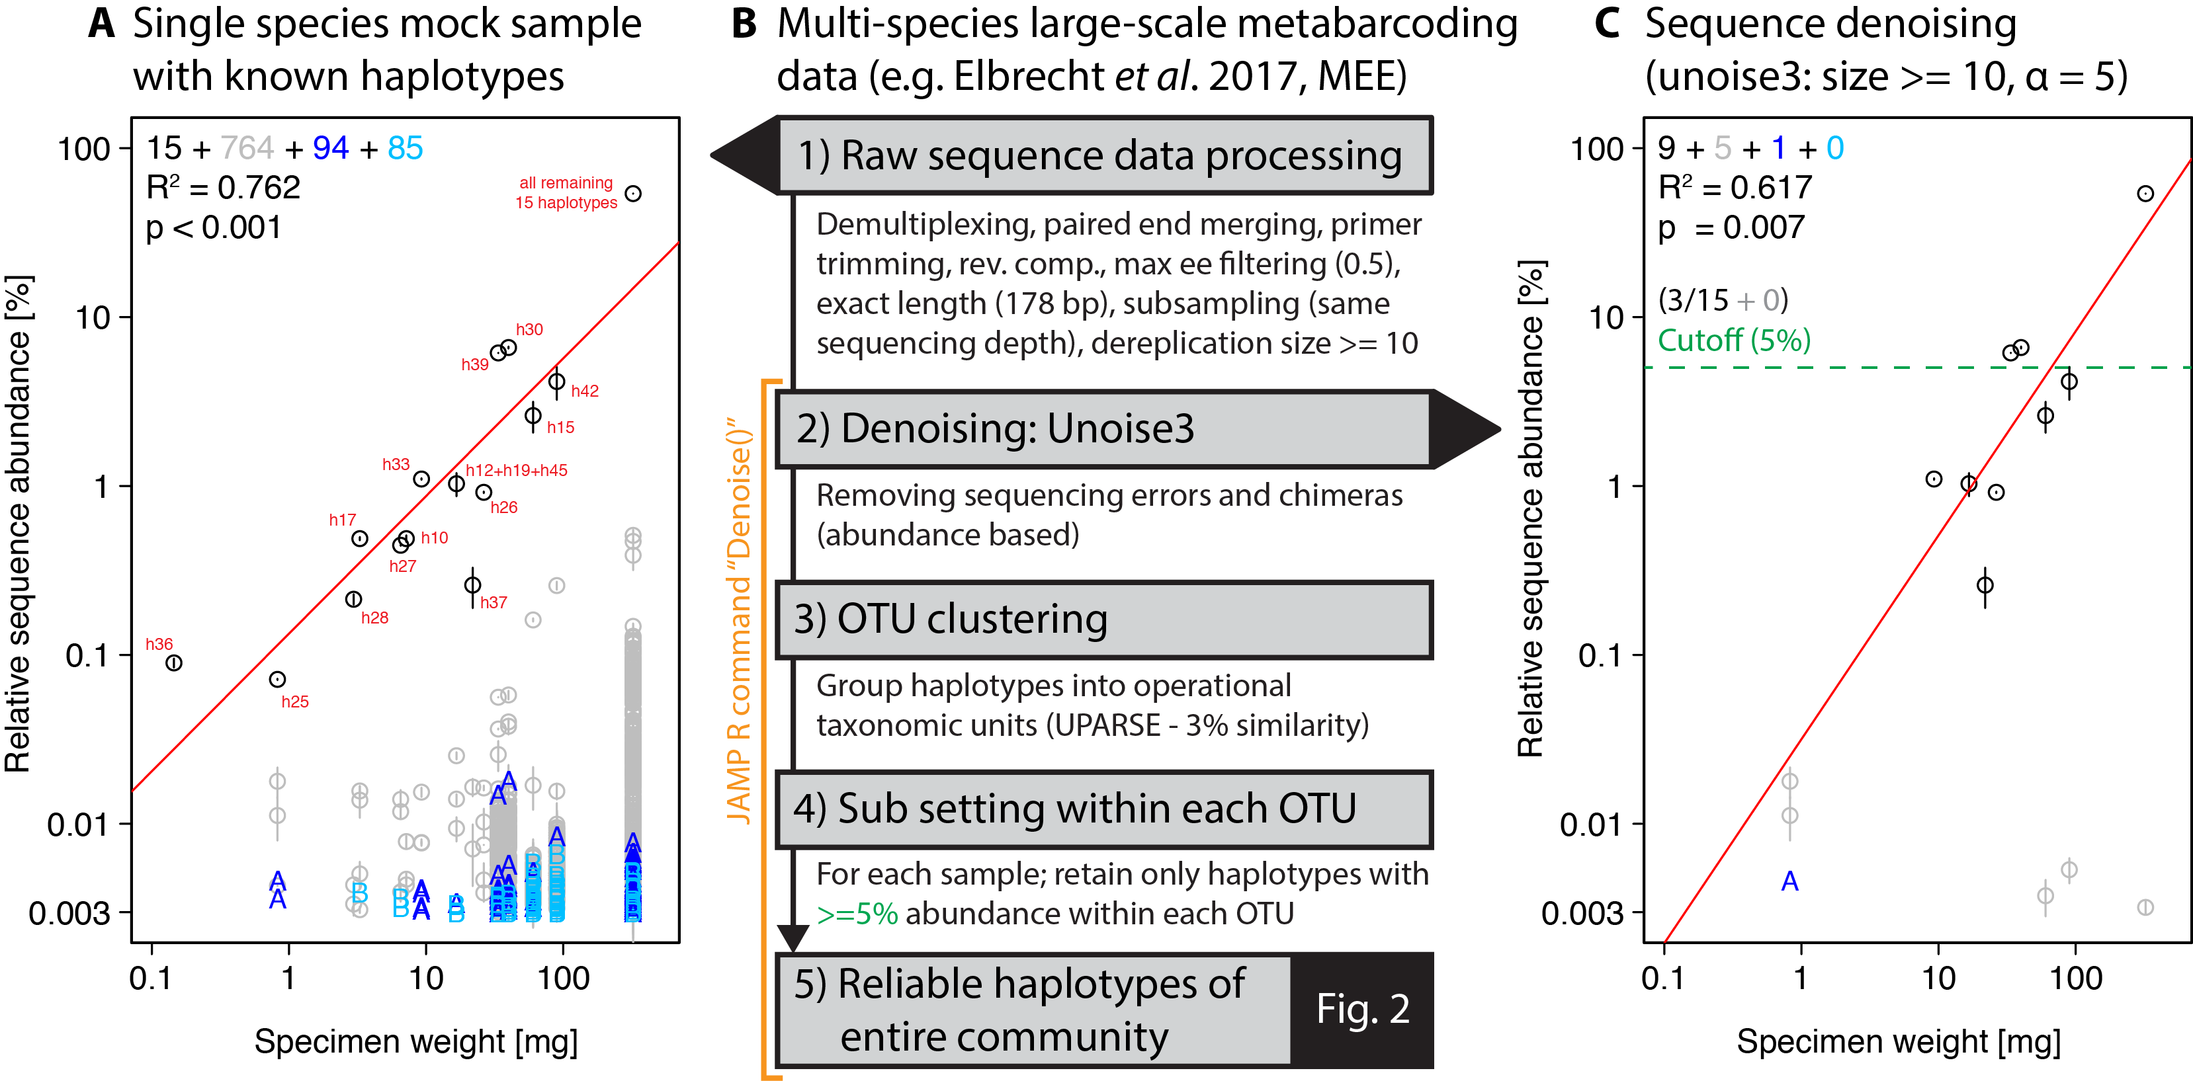
Figure 1: Overview of DNA metabarcoding data of a single-species mock sample containing specimens with 15 distinct haplotypes (black circles). Detected haplotypes (unexpected ones shown in grey and blue) plotted against specimen biomass for the processed data (A) and followed by read denoising using unoise3 (C). Denoising was applied to both replicates individually, with a circle if the read was detected in both samples (error bar = SD) and A or B if the read was found in only one replicate. For processing of large-scale samples (B, Fig. 2), all samples were pooled and jointly denoised, followed by OTU clustering and read mapping then followed by discarding of haplotypes below a 5% threshold within each sample.
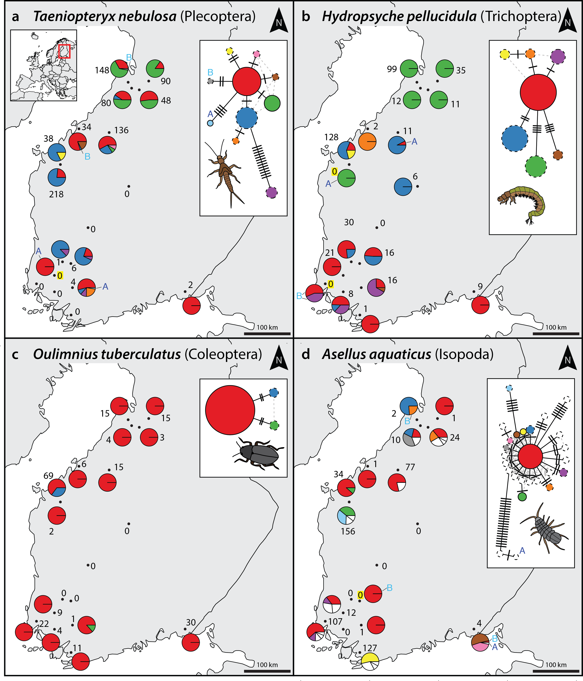
Figure 2: Haplotype maps and networks extracted from multi-species community metabarcoding datasets amplified with the BF2+BR2 primer set for four abundant macroinvertebrate taxa (A = Taeniopteryx nebulosa, B = Hydropsyche pellucidula, C = Oulimnius tuberculatus, D = Asellus aquaticus). Numbers next to each sampling site indicate sample size of the respective taxa based on morphological identification in a sample (Elbrecht et al., 2017). Conflicts between DNA and morphology based-detections are highlighted in yellow. Haplotype frequency composition per site is indicated by pie charts. For A. aquaticus only the 10 most common haplotypes are visualised with different colours (remaining ones in white). Each crossline in a network represents one base pair difference between the respective haplotypes. Dashed lines around a circle indicate novel haplotypes that were not available in the BOLD reference database. An A or B next to a haplotype in the map or network indicates the presence of this haplotype in only in one replicate.
Acknowledgements
We would like to thank members of the leeselab for helpful discussions. This study is part of the European Cooperation in Science and Technology (COST) Action DNAqua-Net (CA15219). D.S. was supported by the Canada First Research Excellence Fund for the Food from Thought initiative. E.E.V. was supported by a grant of the Bodnarescu Foundation.

Author contributions
V.E. developed the haplotyping concept, with contributions from E.E.V. and F.L., V.E. developed the bioinformatics and analysed the data, V.E., E.E.V., D.S., and F.L. wrote and revised the paper.

Supporting information
Figure S1: Schematic overview of errors affecting metabarcoding data and clustering / denoising strategies to reduce them.
Figure S2: Overview of the haplotyping strategy used here and their implementation in the JAMP R package.
Figure S3: Effect of different quality filtering (max ee) on reads of the single species mock sample.
Figure S4: Effect of different alpha values in read denoising of the single-species mock sample.
Figure S5: Bar plots of haplotype distribution within each OTU.
Figure S6: Detailed plots of four example taxa from the denoised multi-species monitoring samples, showing haplotype maps & networks, similarity between replicates and sequence alignment for all BF/BR primer sets.
Table S1: Finland haplotype table (for all four different primer combinations).
Scripts S1: Metabarcoding and denoising pipeline, and additional scripts used to produce the figures.

Amir A, McDonald D, Navas-Molina JA, Kopylova E, Morton JT, Zech Xu Z, Kightley EP, Thompson LR, Hyde ER, Gonzalez A, Knight R 2017. Deblur Rapidly Resolves Single-Nucleotide Community Sequence Patterns. mSystems 2:e00191–16–7. DOI: 10.1128/mSystems.00191-16.
Baird DJ, Hajibabaei M 2012. Biomonitoring 2.0: a new paradigm in ecosystem assessment made possible by next-generation DNA sequencing. 21:2039–2044.
Bálint M, Domisch S, Engelhardt CHM, Haase P, Lehrian S, Sauer J, Theissinger K, Pauls SU, Nowak C 2011. Cryptic biodiversity loss linked to global climate change. Nature Climate Change 1:1–6. DOI: 10.1038/nclimate1191.
Bensasson D, Zhang DX, Hartl DL, Hewitt GM 2001. Mitochondrial pseudogenes: evolution's misplaced witnesses. Trends in ecology & evolution (Personal edition) 16:314–321.
Callahan BJ, McMurdie PJ, Holmes SP 2017. Exact sequence variants should replace operational taxonomic units in marker-gene data analysis. :1–5. DOI: 10.1038/ismej.2017.119.
Callahan BJ, McMurdie PJ, Rosen MJ, Han AW, Johnson AJA, Holmes SP 2016. DADA2: High-resolution sample inference from Illumina amplicon data. Nature Methods 13:581–583. DOI: 10.1038/nmeth.3869.
Corse E, MEGLÉCZ E, Archambaud G, Ardisson M, MARTIN J-F, Tougard C, Chappaz R, DUBUT V 2017. A from-benchtop-to-desktop workflow for validating HTS data and for taxonomic identification in diet metabarcoding studies. Molecular ecology resources 17:e146–e159. DOI: 10.1111/1755-0998.12703.
Creer S, Deiner K, Frey S, Porazinska D, Taberlet P, Thomas WK, Potter C, Bik HM 2016. The ecologist's field guide to sequence-based identification of biodiversity. Methods in Ecology and Evolution 7:1008–1018. DOI: 10.1111/2041-210X.12574.
Čiampor F Jr, Kodada J 2010. Taxonomy of the Oulimnius tuberculatus species group (Coleoptera: Elmidae) based on molecular and morphological data. Zootaxa.
Edgar RC 2013. UPARSE: highly accurate OTU sequences from microbial amplicon reads. Nature Methods 10:996–998. DOI: 10.1038/nmeth.2604.
Edgar RC 2016. UNOISE2: improved error-correction for Illumina 16S and ITS amplicon sequencing. bioRxiv. DOI: 10.1101/081257.
Edgar RC, Flyvbjerg H 2015. Error filtering, pair assembly and error correction for next-generation sequencing reads. Bioinformatics 31:3476–3482. DOI: 10.1093/bioinformatics/btv401.
Edgar RC, Haas BJ, Clemente JC, Quince C, Knight R 2011. UCHIME improves sensitivity and speed of chimera detection. Bioinformatics 27:2194–2200. DOI: 10.1093/bioinformatics/btr381.
Elbrecht V, Leese F 2015. Can DNA-Based Ecosystem Assessments Quantify Species Abundance? Testing Primer Bias and Biomass—Sequence Relationships with an Innovative Metabarcoding Protocol. PloS one 10:e0130324–16. DOI: 10.1371/journal.pone.0130324.
Elbrecht V, Leese F 2017. Validation and development of freshwater invertebrate metabarcoding COI primers for Environmental Impact Assessment. Frontiers in Freshwater Science. DOI: 10.3389/fenvs.2017.00011.
Elbrecht V, Peinert B, Leese F 2017. Sorting things out: Assessing effects of unequal specimen biomass on DNA metabarcoding. Ecology and Evolution 7:6918–6926. DOI: 10.1002/ece3.3192.
Elbrecht V, Vamos E, Meissner K, Aroviita J, Leese F 2017. Assessing strengths and weaknesses of DNA metabarcoding based macroinvertebrate identification for routine stream monitoring. Methods in Ecology and Evolution:1–21. DOI: 10.7287/peerj.preprints.2759v2.
Eren AM, Morrison HG, Lescault PJ, Reveillaud J, Vineis JH, Sogin ML 2015. Minimum entropy decomposition: Unsupervised oligotyping for sensitive partitioning of high- throughput marker gene sequences. 9:968–979. DOI: 10.1038/ismej.2014.195.
Esling P, Lejzerowicz F, Pawlowski J 2015. Accurate multiplexing and filtering for high-throughput amplicon-sequencing. Nucleic acids research 43:2513–2524. DOI: 10.1093/nar/gkv107.
Folmer O, Black M, Hoeh W, Lutz R, Vrijenhoek R 1994. DNA primers for amplification of mitochondrial cytochrome c oxidase subunit I from diverse metazoan invertebrates. Molecular marine biology and biotechnology 3:294–299.
Gibson JF, Shokralla S, Curry C, Baird DJ, Monk WA, King I, Hajibabaei M 2015. Large-Scale Biomonitoring of Remote and Threatened Ecosystems via High-Throughput Sequencing. PloS one 10:e0138432–15. DOI: 10.1371/journal.pone.0138432.
Hughes JM, Schmidt DJ, FINN DS 2009. Genes in Streams: Using DNA to Understand the Movement of Freshwater Fauna and Their Riverine Habitat. BioScience 59:573–583. DOI: 10.1525/bio.2009.59.7.8.
Lange A, Jost S, Heider D, Bock C, Budeus B, Schilling E, Strittmatter A, Boenigk J, Hoffmann D 2015. AmpliconDuo: A Split-Sample Filtering Protocol for High-Throughput Amplicon Sequencing of Microbial Communities. PloS one 10:e0141590–22. DOI: 10.1371/journal.pone.0141590.
Leese F, Altermatt F, Bouchez A, Ekrem T 2016. DNAqua-Net: Developing new genetic tools for bioassessment and monitoring of aquatic ecosystems in Europe. Research Ideas and Outcomes. DOI: 10.3897/rio.2.e11321.
Leese F, Bouchez A, Abarenkov K, Altermatt F, Borja A et al. (in press). Why We Need Sustainable Networks Bridging Countries, Disciplines, Cultures and Generations for Aquatic Biomonitoring 2.0: A Perspective Derived From the DNAqua-Net COST Action. Advances in Ecological Research DOI: 10.1016/bs.aecr.2018.01.001
Leray M, Knowlton N 2017. Random sampling causes the low reproducibility of rare eukaryotic OTUs in Illumina COI metabarcoding. PeerJ 5:e3006–27. DOI: 10.7717/peerj.3006.
Múrria C, Zamora-Muñoz C, Bonada N, Ribera C, Prat N 2010. Genetic and morphological approaches to the problematic presence of three Hydropsychespecies of the pellucidulagroup (Trichoptera: Hydropsychidae) in the westernmost Mediterranean Basin. Aquatic Insects 32:85–98. DOI: 10.1080/01650424.2010.482939.
Nakamura K, Oshima T, Morimoto T, Ikeda S, Yoshikawa H, Shiwa Y, Ishikawa S, Linak MC, Hirai A, Takahashi H, Altaf-Ul-Amin M, Ogasawara N, Kanaya S 2011. Sequence-specific error profile of Illumina sequencers. Nucleic acids research 39:e90. DOI: 10.1093/nar/gkr344.
Needham DM, Sachdeva R, Fuhrman JA 2017. Ecological dynamics and co-occurrence among marine phytoplankton, bacteria and myoviruses shows microdiversity matters. The ISME Journal:1–16. DOI: 10.1038/ismej.2017.29.
Pedro PM, Piper R, Bazilli Neto P, Cullen L Jr., Dropa M, Lorencao R, Matté MH, Rech TC, Rufato MO Jr., Silva M, Turati DT 2017. Metabarcoding Analyses Enable Differentiation of Both Interspecific Assemblages and Intraspecific Divergence in Habitats With Differing Management Practices. Environmental Entomology:1–9. DOI: 10.1093/ee/nvx166.
Peterson BK, Weber JN, Kay EH, Fisher HS, Hoekstra HE 2012. Double Digest RADseq: An Inexpensive Method for De Novo SNP Discovery and Genotyping in Model and Non-Model Species. PloS one 7:e37135. DOI: 10.1371/journal.pone.0037135.t001.
Rognes T, Flouri T, Nichols B, Quince C, Mahé F 2016. VSEARCH: a versatile open source tool for metagenomics. PeerJ 4:e2584–22. DOI: 10.7717/peerj.2584.
Schirmer M 2016. Illumina Error Profiles: Resolving Fine-Scale Variation in Metagenomic Sequencing Data. BMC bioinformatics:1–15. DOI: 10.1186/s12859-016-0976-y.
Schirmer M, Ijaz UZ, D'Amore R, Hall N, Sloan WT, Quince C 2015. Insight into biases and sequencing errors for amplicon sequencing with the Illumina MiSeq platform. Nucleic acids research:1–16. DOI: 10.1093/nar/gku1341.
Schnell IB, Bohmann K, Gilbert MTP 2015. Tag jumps illuminated - reducing sequence-to-sample misidentifications in metabarcoding studies. Molecular ecology resources 15:1289–1303. DOI: 10.1111/1755-0998.12402.
Shokralla S, Gibson JF, Nikbakht H, Janzen DH, Hallwachs W, Hajibabaei M 2014. Next-generation DNA barcoding: using next-generation sequencing to enhance and accelerate DNA barcode capture from single specimens. Molecular ecology resources:n/a–n/a. DOI: 10.1111/1755-0998.12236.
Sigsgaard EE, Nielsen IB, Bach SS, Lorenzen ED, Robinson DP, Knudsen SW, Pedersen MW, Jaidah MA, Orlando L, Willerslev E, Møller PR, THOMSEN PF 2016. Population characteristics of a large whale shark aggregation inferred from seawater environmental DNA. Nature Ecology & Evolution 1:0004–5. DOI: 10.1038/s41559-016-0004.
Sutherland WJ, Freckleton RP, Godfray HCJ, Beissinger SR, Benton T, Cameron DD, et al. (2012). Identification of 100 fundamental ecological questions. Journal of Ecology, 101(1), 58–67. DOI: 10.1111/1365-2745.12025
Sworobowicz L, Grabowski M, Mamos T, Burzyński A, Kilikowska A, Sell J, Wysocka A 2015. Revisiting the phylogeography of Asellus aquaticusin Europe: insights into cryptic diversity and spatiotemporal diversification. Freshwater biology 60:1824–1840. DOI: 10.1111/fwb.12613.
Taberlet P, Coissac E, Pompanon F, Brochmann C, Willerslev E 2012a. Towards next-generation biodiversity assessment using DNA metabarcoding. Molecular Ecology 21:2045–2050. DOI: 10.1111/j.1365-294X.2012.05470.x.
Taberlet P, Zimmermann NE, Englisch T, Tribsch A, Holderegger R, Alvarez N, Niklfeld H, Coldea G, Mirek Z, Moilanen A, Ahlmer W, Marsan PA, Bona E, Bovio M, Choler P, Cieślak E, Colli L, Cristea V, Dalmas J-P, Frajman B, Garraud L, Gaudeul M, Gielly L, Gutermann W, Jogan N, Kagalo AA, Korbecka G, Küpfer P, Lequette B, Letz DR, Manel S, Mansion G, Marhold K, Martini F, Negrini R, Niño F, Paun O, Pellecchia M, Perico G, Piękoś-Mirkowa H, Prosser F, Puşcaş M, Ronikier M, Scheuerer M, Schneeweiss GM, Schönswetter P, Schratt-Ehrendorfer L, Schüpfer F, Selvaggi A, Steinmann K, Thiel-Egenter C, van Loo M, Winkler M, Wohlgemuth T, Wraber T, Gugerli F, IntraBioDiv Consortium 2012b. Genetic diversity in widespread species is not congruent with species richness in alpine plant communities. Ecology letters 15:1439–1448. DOI: 10.1111/ele.12004.
Tikhonov M, Leach RW, Wingreen NS 2015. Interpreting 16S metagenomic data without clustering to achieve sub-OTU resolution. The ISME Journal 9:68–80. DOI: 10.1038/ismej.2014.117.
Tremblay J, Singh K, Fern A, Kirton ES, He S, Woyke T, Lee J, Chen F, Dangl JL, Tringe SG 2015. Primer and platform effects on 16S rRNA tag sequencing. Frontiers in Microbiology 6:8966–15. DOI: 10.3389/fmicb.2015.00771.
Vamos EE, Elbrecht V, Leese F 2017. Short COI markers for freshwater macroinvertebrate metabarcoding. Metabarcoding and Metagenomics. DOI: 10.7287/peerj.preprints.3037v1.
Wares J, Pappalardo P 2016. Can Theory Improve the Scope of Quantitative Metazoan Metabarcoding? Diversity 8:1–15. DOI: 10.3390/d8010001.
Weiss M & Leese F (2016). Widely distributed and regionally isolated! Drivers of genetic structure in Gammarus fossarum in a human-impacted landscape. BMC Evolutionary Biology, 1–14. DOI: 10.1186/s12862-016-0723-z

