Appendix B

 |  |  | References
Locomotion mode | Walker | Jumper | Astley, 2016; Emerson, 1979; Taigen et al., 1982
Physiological parameters
Endurance | high | low | Putnam and Bennett, 1981; Zug, 1985
Aerobic scope | high | low | Bennett and Licht, 1973; Carey, 1979
Cellular characteristics
Muscle fiber type | Same phenotype  (FOG/FG fibers) |  | Lutz and Lieber, 2000; Putnam and Bennett, 1983 (but see Sperry, 1981)
Fatigue resistance | high | low | Chadwell et al., 2002; Stary et al., 2004; Vydeska-Chichova et al., 2005
ATP production | Mitochondrial OXPHOS | Glycolytic pathways | Desprat et al., 2017; Lutz and Rome, 1994; Navas et al., 2008; Putnam and Bennett, 1983
Major enzymes activities | CS; COX | LDH; PFK | Navas et al., 2008; Putnam and Bennet, 1983 ; Seebacher and Franklin, 2011; Rogers et al., 2007

Table 1: main physiological characteristics of anurans, depending on the two major locomotion modes. Walking anurans are schematically described as endurance performers, with high aerobic capacities, due to a mainly oxidative metabolism, whereas jumper species are powered by anaerobic ATP production. Interspecific dispersal ability may be directly linked to locomotion mode, and intraspecific dispersal performances are more likely due to an enhanced metabolic efficiency. CS: Citrate synthase; COX: Cytochrome-C-oxidase; FG: fast glycolytic; FOG: fast oxidative glycolytic; LdH: Lactate dehydrogenase; OXPHOS: Oxidative phosphorylation; PFK: Phosphofructokinase

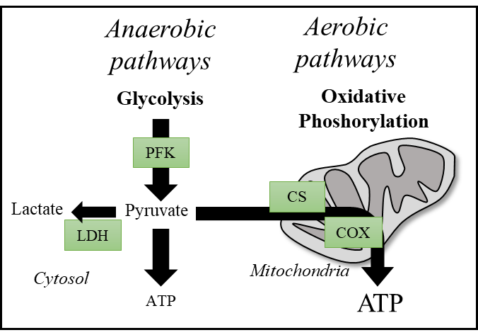

Figure 1: schematic overview of metabolic pathways and associated key-enzymes likely used by amphibians during locomotion. CS: Citrate synthase; COX: Cytochrome-C-oxidase; LdH: Lactate dehydrogenase; OXPHOS: Oxidative phosphorylation; PFK: Phosphofructokinase.
References
Astley, H. C. (2016). The diversity and evolution of locomotor muscle properties in anurans. Journal of Experimental Biology 219, 3163-3173.
Bennett, A. F. and Licht, P. (1973). Relative contributions of anaerobic and aerobic energy production during activity in Amphibia. Journal of Comparative Physiology A: Neuroethology, Sensory, Neural, and Behavioral Physiology 87, 351-360.
Chadwell, B. A., Hartwell, H. J. and Peters, S. E. (2002). Comparison of isometric contractile properties in hindlimb extensor muscles of the frogs Rana pipiens and Bufo marinus: functional correlations with differences in hopping performance. J Morphol 251, 309-22.
Desprat, J. L., Teulier, L., Puijalon, S., Dumet, A., Romestaing, C., Tattersall, G. J., Lengagne, T. and Mondy, N. (2017). Doping for sex: Bad for mitochondrial performances? Case of testosterone supplemented Hyla arborea during the courtship period. Comp Biochem Physiol A Mol Integr Physiol 209, 74-83.
Emerson, S. B. (1979). The ilio-sacral articulation in frogs: form and function. Biological Journal of the Linnean Society 11, 153-168.
Gleeson, T. T. (1991). Patterns of metabolic recovery from exercise in amphibians and reptiles. Journal of Experimental Biology 160, 187-207.
Lutz, G. and Rome, L. (1994). Built for jumping: the design of the frog muscular system. Science 263, 370-372.
Lutz, G. J. and Lieber, R. L. (2000). Myosin isoforms in anuran skeletal muscle: Their influence on contractile properties and in vivo muscle function. Microscopy research and technique 50, 443-457.
Putnam, R. W. and Bennett, A. F. (1983). Histochemical, enzymatic, and contractile properties of skeletal muscles of three anuran amphibians. Am. J. Physiol 244, R558-R567.
Rogers, K. D., Thompson, M. B. and Seebacher, F. (2007). Beneficial acclimation: sex specific thermal acclimation of metabolic capacity in the striped marsh frog (Limnodynastes peronii). J Exp Biol 210, 2932-8.
Sperry, D. G. (1981). Fiber type composition and postmetamorphic growth of anuran hindlimb muscles. Journal of Morphology 170, 321-345.
Stary, C. M., Mathieu-Costello, O. and Hogan, M. C. (2004). Resistance to fatigue of individual Xenopus single skeletal muscle fibres is correlated with mitochondrial volume density. Exp Physiol 89, 617-21.
Taigen, T. L., Emerson, S. B. and Pough, F. H. (1982). Ecological correlates of anuran exercise physiology. Oecologia 52, 49-56.
Vydevska-Chichova, M., Mileva, K., Todorova, R., Dimitrova, M. and Radicheva, N. (2005). Slow and fast fatigable frog muscle fibres: electrophysiological and histochemical characteristics. Gen Physiol Biophys 24, 381-96.
Zug, G. R. (1985). Anuran locomotion: fatigue and jumping performance. Herpetologica, 188-194

