Supplemental information SI3. Spatial autocorrelation in the residuals
Spatial autocorrelation in the residuals was evaluated using the ‘dsm.cor’ function of the‘dsm’ package. As described in the article, the correlogram show a small amount of spatial autocorrelation in the residuals (Fig. SI3.1). The confidence interval increased in width as the number of lags increased.
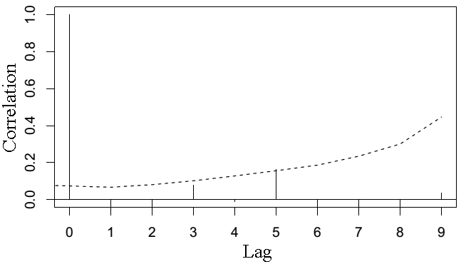
Figure SI.3.1. Autocorrelation of deviance residuals between segments (lags) for the fitted density surface model selected. The dashed line represents the 95% confidence interval. Lag 0 is the correlation between a segment and itself, Lag 1 between a segment and its immediate neighbours (i.e. segments that touch), Lag 2 between a segment and the segment one segment away, and so on. Correlations are only calculated within a given transect.

