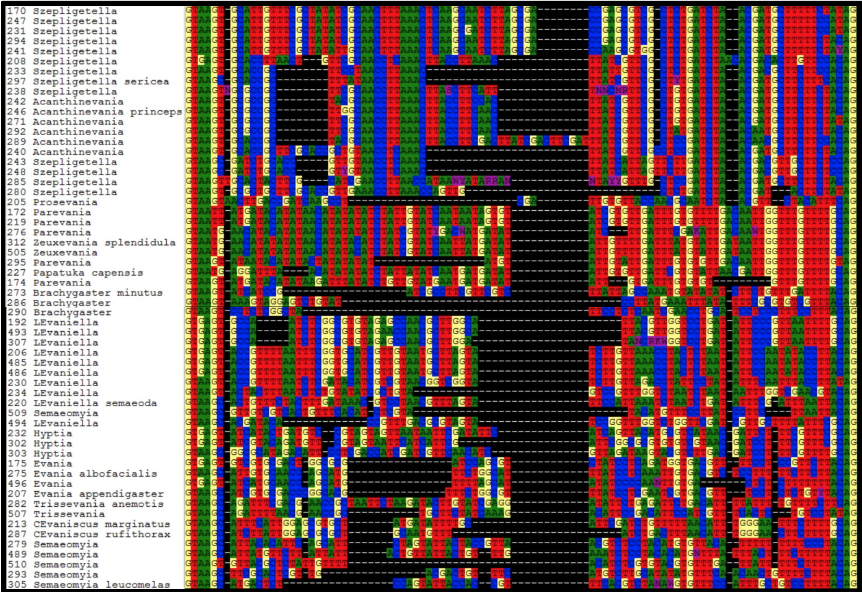
Figure S8. RPS23 intron aligned for all taxa within Evaniidae. Species of Decevania were removed due to high sequence length variation to facilitate better visualization of sequence motifs across all taxa.

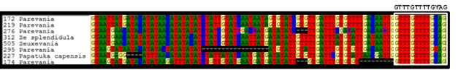
Figure S9. RPS23 intron aligned for Zeuxevania, Parevania, and Papatuka. Box showing sequence motif.

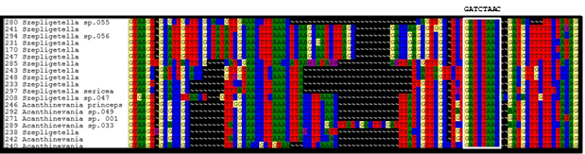Figure S10. RPS23 aligned intron for Acanthinevania and Szepligetella. Box showing sequence motif.

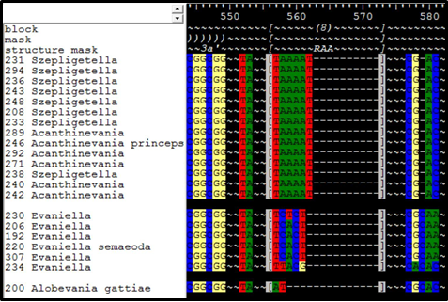
Figure S11. Part of 28S alignment for Acanthinevania, Szepligetella, Evaniella, and Alobevania. Note the diagnostic TAAAAT motif in RAA8 for Acanthinevania and Szepligetella.

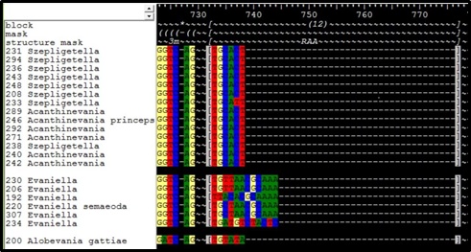
Figure S12. Part of 28S alignment for Acanthinevania, Szepligetella, Evaniella, and Alobevania. Note the diagnostic TGCAYT motif in RAA12 for Acanthinevania and Szepligetella.

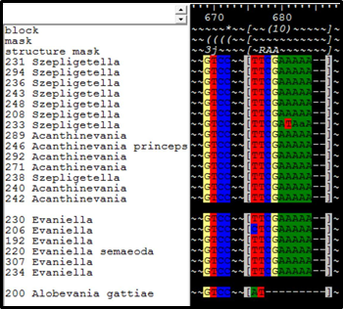
Figure S13. Part of 28S alignment for Acanthinevania, Szepligetella, Evaniella, and Alobevania. Note the diagnostic YTCGAWAAA motif in RAA10 for Acanthinevania, Szepligetella, and Evaniella.

