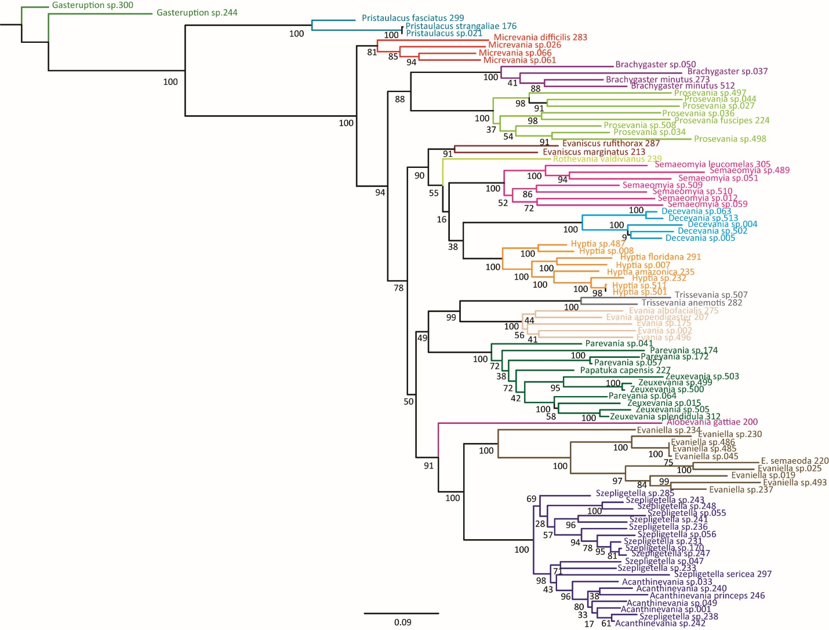
Figure S15. Maximum Likelihood analyses of the concatenated dataset. Bootstrap Values are listed beside each node.

