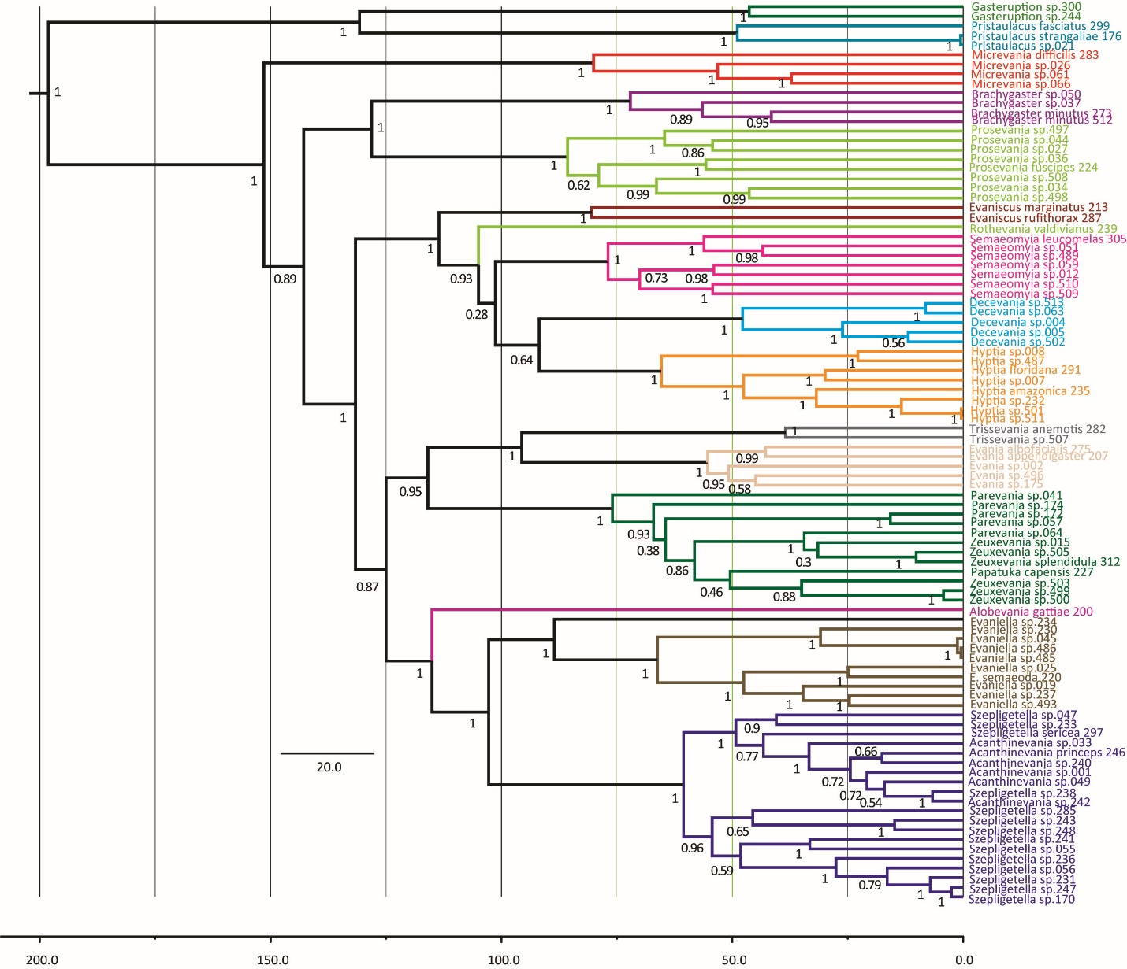
Figure S14. Estimated divergence times for Evaniidae under a normal distribution. Posterior probabilities are listed beside the relevant node. The 95% HDP for all clades is listed in Table 2. The scale is in millions of years.

