# The differences between limbs in walking and running

## % of variance in foot placement that can be explained by trunk state (R2)

Very small differences were found between right and left limbs for R2 in walking and running (**Fig. 1**).

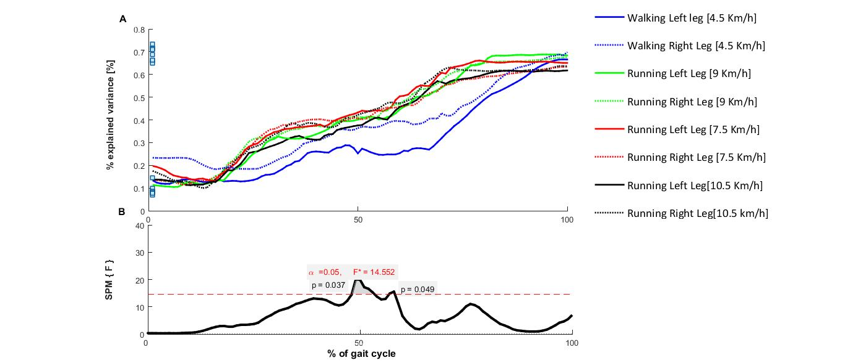

**Fig. 1. A.** % of variance in foot placement that can be explained by trunk state (R2) in walking and running. **B**. The differences of R2 between left and right limbs in walking and runinng.

**We calculated the average of R2 over limbs in walking and running because our results indicated very small differences between limbs (Fig. 1). Then, the effect of running speed on these parameters was considered:**

# The effect of running speeds (7.5, 9.0, and 10.5 Km/h) on:

## % of variance in foot placement that can be explained by trunk state (R2)

Small differences of R2 were found between different running speeds for 60-80% of the stride (**Fig. 2**).

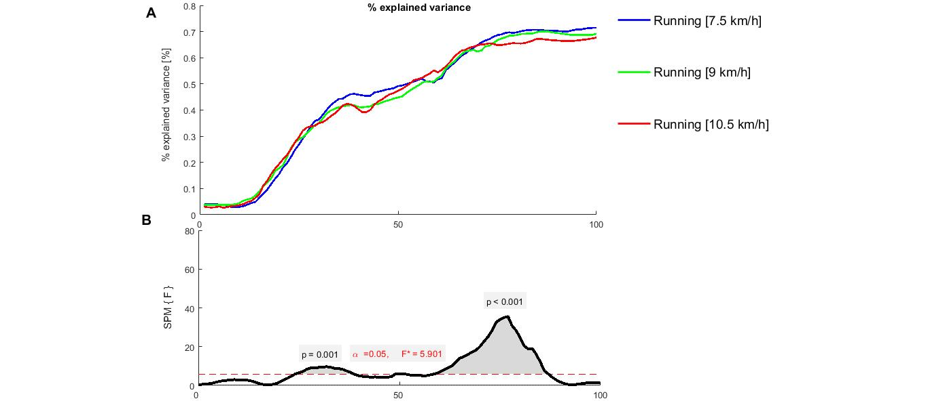

## Fig. 2. A. % of variance in foot placement that can be explained by trunk state (R2) in running with three different speeds [7.5, 9, and 10.5 km/h].The effect of running speeds (7.5, 9.0, and 10.5 Km/h) on R2.

## Step width

The main effect of speed and the interaction effect (stabilization x speed) on step width were not significant in running (p=0.225 and p=0.201) (**Fig. 3**).

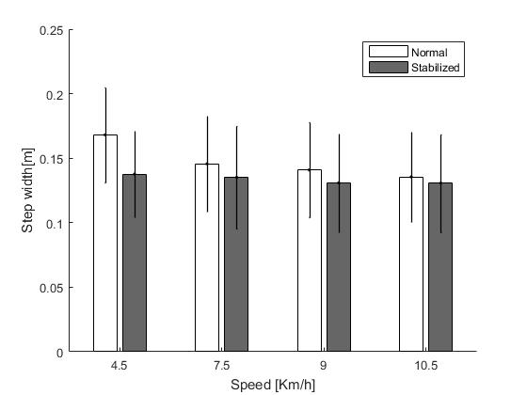

**Fig. 3.** Effect of condition and speed on step width

## Step width variability

There was no significant main effect of speed nor an interaction effect (stabilization x speed) on step width variability in running (*p=0.587* and *p=0.990*, respectively) (**Fig. 4**).

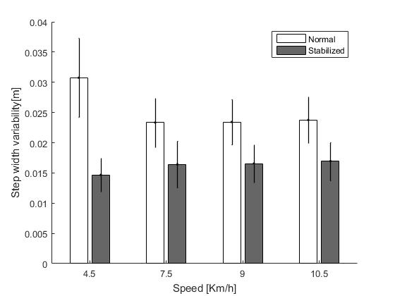

**Fig. 4**. Effect of condition and speed on step width

## Energetic cost

The main effect of speed and the interaction effect (stabilization x speed) on energetic cost were not significant in running (*p=0.809* and *p=0.583*, respectively) (**Fig. 5**).

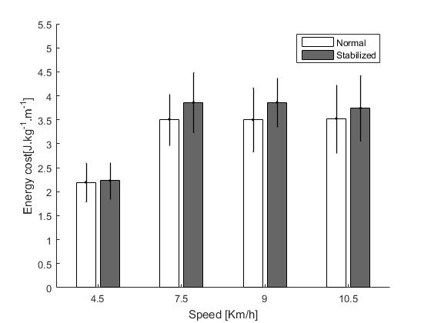

**Fig. 5.** Effect of condition and speed on energetic cost.

**We calculated the average of mentioned parametersover running speeds because our results indicated very small differences between speeds. Therefore, we can compare the control of ML stability between walking and running.**