Supplemental Information
Modelling of the SDF-1/CXCR4 Regulated In vivo Homing of Therapeutic Mesenchymal Stem/stromal Cells
Wang Jinª, Xiaowen Liang^{b}, Anastasia Brooks^{b}, Kathryn Futrega^{c}, Xin Liu^{b}, Michael R. Doran^{c,d,e}, Matthew J. Simpsonª, Michael S. Roberts^{b,f}, Haolu Wang^{b}
ª School of Mathematical Sciences, Queensland University of Technology, Brisbane, Australia
^{b}Therapeutics Research Centre, The University of Queensland Diamantina Institute, The University of Queensland, Translational Research Institute, Brisbane, Australia
^{c}Institute of Health and Biomedical Innovation, Queensland University of Technology, Translational Research Institute, Brisbane, Australia
^{d}Mater Research Institute, The University of Queensland, Translational Research Institute, Brisbane, Australia
^{e}Australian National Centre for the Public Awareness of Science, Australian National University, Canberra, Australia
^{f}School of Pharmacy and Medical Science, University of South Australia, Adelaide, Australia

Correspondence: Michael S. Roberts, Ph.D., The University of Queensland Diamantina Institute, The University of Queensland, Translational Research Institute, QLD 4103, Australia. Telephone: 61-07-3443-8033; Email: m.roberts@uq.edu.au and Haolu Wang, MBBS., Ph.D., The University of Queensland Diamantina Institute, The University of Queensland, Translational Research Institute, QLD 4103, Australia. Telephone: 61-07-3443-7488; Email: h.wang21@uq.edu.au

Additional results
Fig. S1 shows the overall goodness-of-fit of the model calibration with an initial MSC does of 5 × 10⁵ cells/animal. Fig. S2 shows the model calibration and validation with the independent external data, as well as the corresponding goodness-of-fit plot. To validate the model for SDF-1 in the liver, we first calibrate Equation (3) in the main manuscript to the published independent external data (Wilson et al., 2016), to estimate parameters a_{B}, b_{B}, and c_{B}. The parameter estimates are then inputted into Equation (4) with the association coefficients $η_{1}$, $η_{2}$, and $η_{3}$ estimated by calibrating both Equations (3) and (4) into the data of SDF-1level presented in the main manuscript, to predict the SDF-1 level in the liver. The predicted SDF-1 level (black solid line in Fig. S2A) is then superimposed onto the independent external data.

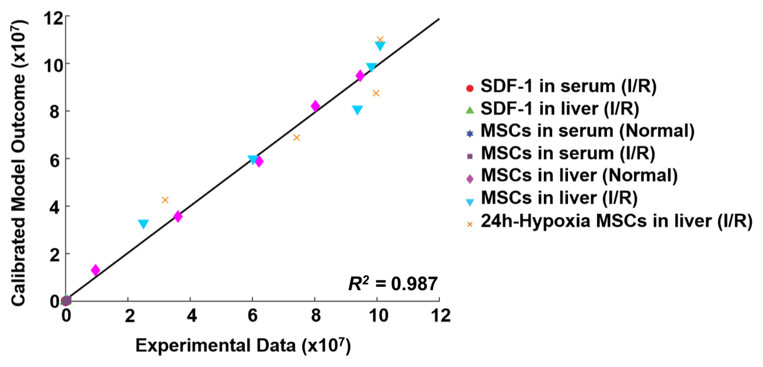
Figure S1. Goodness-of-fit plot of model calibration. Model predictions and experimental data are analyzed using linear regression, with R²=0.987 (n = 34).

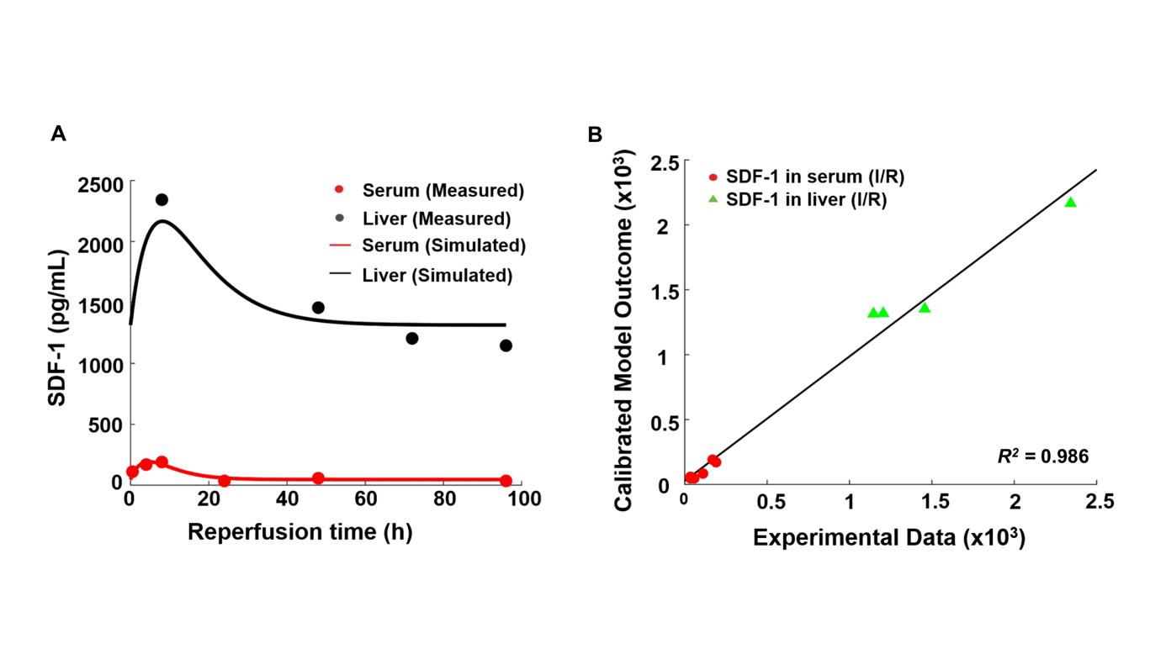
Figure S2. Model validation results with independent external data. (A) Model validation with the SDF-1 concentrations in the blood and liver of mice with hepatic ischemia/reperfusion (I/R) injury. The solid line in each panel represents the concentration-time profile of the SDF-1 simulated by the model while the circles represent measured data. Concentrations of the SDF-1 is expressed as SDF-1 amount per kilogram of tissue. (B) Goodness-of-fit plot of model validation. Model predictions and experimental data are analyzed using linear regression, with R²=0.986 (n = 10).

