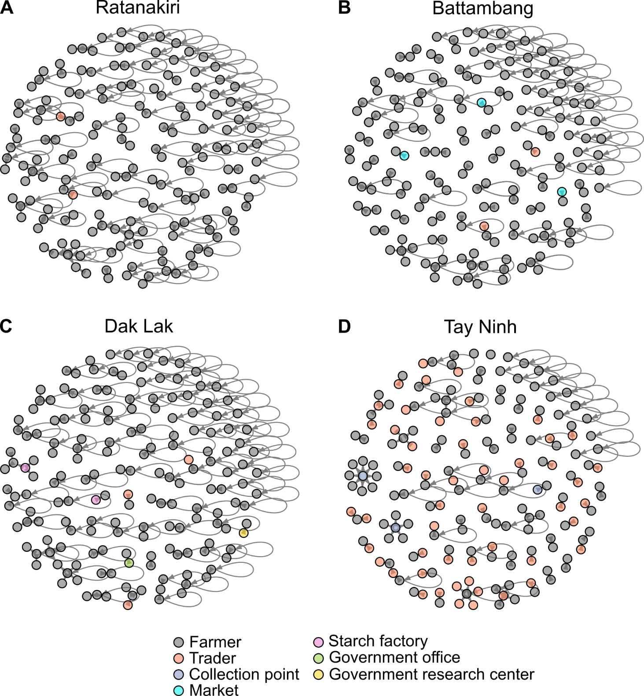

Supplementary figure 1. Fruchterman-Reingold plots of respondents’ egocentric stake exchange networks at 4 sites in Cambodia and Vietnam in 2016. Subplots A and B are Cambodian sites, while subplots C and D are Vietnamese sites. Subplot A and C represent low-intensity sites, while B and D are high-intensity sites. Arrows indicate directionality of exchange, while node color denotes type of actor involved in exchange (see legend). Self-loops indicate the use of farm saved seed stocks from the previous year. Note these are visual representations including only exchanges reported by surveyed individuals, not estimates of the full structure of the complete network.

