Supplemental Information

Table S1. Museum specimens used in this study. All are from the University of Alaska Museum (UAM). Sequences are deposited in NCBI SRA accession SRP151072.

UAM # | Taxon | Age | Sex | Date | Locality | Field # | SRA #
7066 | Plectrophenax hyperboreus | AD | M | 25-Jul-97 | USA: Alaska: Bering Sea, St. Matthew Island | KSW1610 | SAMN09469434
7407 | Plectrophenax hyperboreus | AHY | F | 24-Jul-97 | USA: Alaska: Bering Sea, St. Matthew Island | KSW1588 | SAMN09469433
7524 | Plectrophenax hyperboreus | AD | F | 25-Jul-97 | USA: Alaska: Bering Sea, St. Matthew Island | KSW1611 | SAMN09469435
8200 | Plectrophenax hyperboreus | AD | F | 25-Jul-97 | USA: Alaska: Bering Sea, St. Matthew Island | KSW1617 | SAMN09469436
8474 | Plectrophenax nivalis | U | M | 22-Sep-98 | USA: Alaska: Alaska Peninsula, Cold Bay, Frosty Peak | KSW2691 | SAMN09469440
8476 | Plectrophenax nivalis | IM | F | 22-Sep-98 | USA: Alaska: Alaska Peninsula, Cold Bay, Frosty Peak | KSW2690 | SAMN09469439
11856 | Plectrophenax nivalis | AHY | F | 29-Jun-99 | USA: Alaska: Alaska Peninsula, Cold Bay, Frosty Peak | CLP163 | SAMN09469437
27725 | Plectrophenax nivalis | AD | M | 5-Jun-09 | USA: Alaska, Aleutian Islands, Kiska Island | JJW292 | SAMN09469438

Supplemental Information, cont.

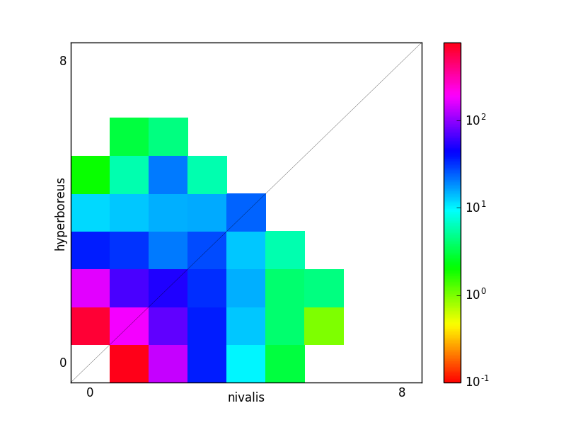
Figure S1. A 2D FS plot of the folded spectrum analyzed using δaδi, in which the color scale represents the logarithm of the number of variants (Gutenkunst et al. 2009).

Figure S2. Frequency distribution of locus lengths.

Figure S3a. Distribution of F_{ST} values among SNP sites between Plectrophenax hyperboreus and P. nivalis (excludes 7,662 sites with F_{ST} = 0).

Figure S3b. Distribution of F_{ST} values among 521 loci between Plectrophenax hyperboreus and P. nivalis (excludes 2,113 loci with F_{ST} = 0).

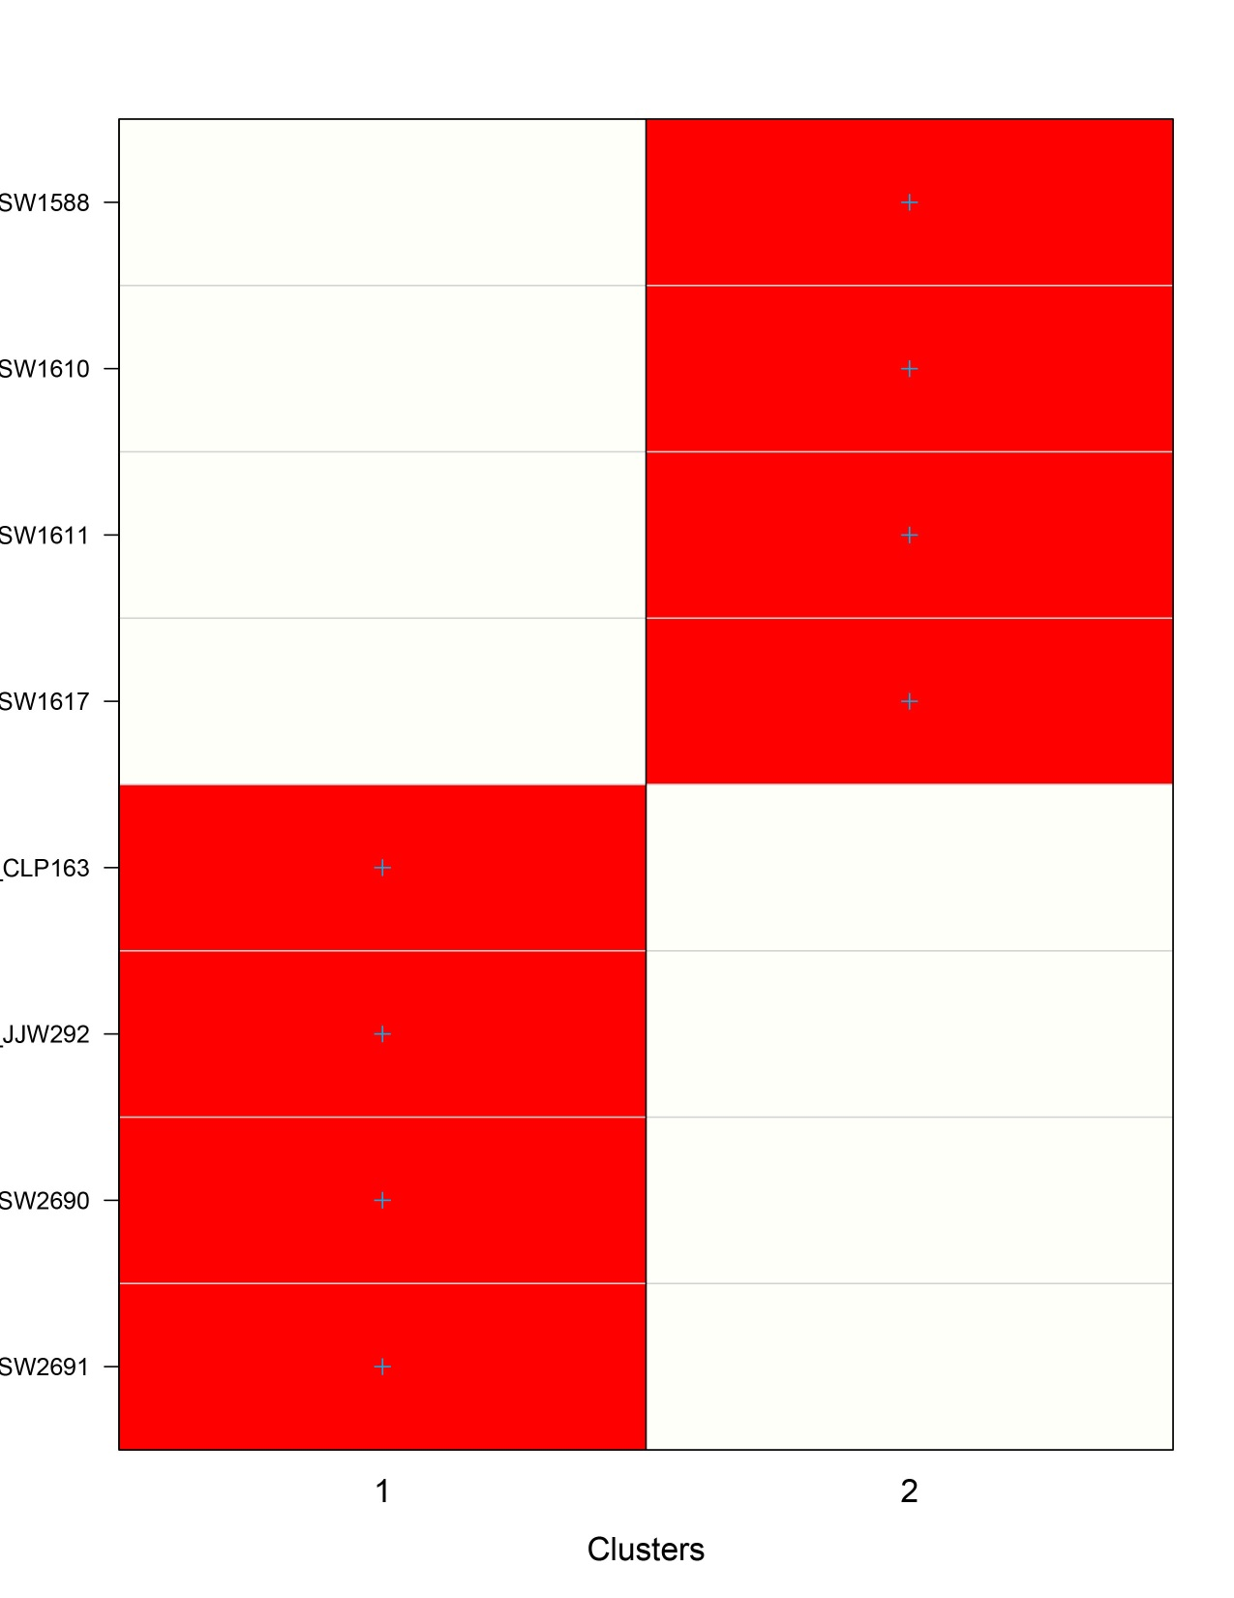
K
K
K
K
K
K

Figure S4. Group assignments using Discriminant Analysis of Principal Components (DAPC) in adegenet (Jombart & Ahmed 2011). Cluster 1 is P. nivalis; cluster 2 is P. hyperboreus.

Supplemental Information, cont.

The five bunting loci with the highest F_{ST} values and the best BLAST match with the zebra finch genome:

Query= uce-5659_ALL_buntings_assembled_contigs |uce-5659

Length=1087

Score E
Sequences producing significant alignments: (Bits) Value

ref|NC_011475.1| Taeniopygia guttata isolate Black17 chromoso... 1869 0.0

ALIGNMENTS
>ref|NC_011475.1| Taeniopygia guttata isolate Black17 chromosome 11, Taeniopygia_guttata-3.2.4
Length=21403021

Features flanking this part of subject sequence:
292623 bp at 5' side: LOW QUALITY PROTEIN: iroquois-class homeodomain protein I...
223208 bp at 3' side: alpha-ketoglutarate-dependent dioxygenase FTO

Score = 1869 bits (1012), Expect = 0.0
Identities = 1063/1088 (98%), Gaps = 1/1088 (0%)

Query= uce-2530_ALL_buntings_assembled_contigs |uce-2530

Length=1104

Score E
Sequences producing significant alignments: (Bits) Value

ref|NC_011468.1| Taeniopygia guttata isolate Black17 chromoso... 1709 0.0

ALIGNMENTS
>ref|NC_011468.1| Taeniopygia guttata isolate Black17 chromosome 4A, Taeniopygia_guttata-3.2.4
Length=20704505

Features in this part of subject sequence:
dachshund homolog 2 isoform X3
dachshund homolog 2 isoform X1

Score = 1709 bits (925), Expect = 0.0
Identities = 1053/1112 (95%), Gaps = 20/1112 (2%)

Query= uce-3157_ALL_buntings_assembled_contigs |uce-3157

Length=1058

Score E
Sequences producing significant alignments: (Bits) Value

ref|NC_011466.1| Taeniopygia guttata isolate Black17 chromoso... 1491 0.0

ALIGNMENTS
>ref|NC_011466.1| Taeniopygia guttata isolate Black17 chromosome 3, Taeniopygia_guttata-3.2.4
Length=112617285

Features flanking this part of subject sequence:

25635 bp at 5' side: parkin coregulated gene protein
23761 bp at 3' side: protein quaking

Score = 1491 bits (807), Expect = 0.0
Identities = 1000/1087 (92%), Gaps = 37/1087 (3%)

Query= uce-1915_ALL_buntings_assembled_contigs |uce-1915

Length=1038

Score E
Sequences producing significant alignments: (Bits) Value

ref|NC_011493.1| Taeniopygia guttata isolate Black17 chromoso... 1541 0.0

ALIGNMENTS
>ref|NC_011493.1| Taeniopygia guttata isolate Black17 chromosome Z, Taeniopygia_guttata-3.2.4
Length=72861351

Features in this part of subject sequence:
LOW QUALITY PROTEIN: doublesex- and mab-3-related transcr...

Score = 1541 bits (834), Expect = 0.0
Identities = 984/1051 (94%), Gaps = 32/1051 (3%)

Query= uce-451_ALL_buntings_assembled_contigs |uce-451

Length=1206

Score E
Sequences producing significant alignments: (Bits) Value

ref|NC_011465.1| Taeniopygia guttata isolate Black17 chromoso... 1971 0.0

ALIGNMENTS
>ref|NC_011465.1| Taeniopygia guttata isolate Black17 chromosome 2, Taeniopygia_guttata-3.2.4
Length=156412533

Features flanking this part of subject sequence:

419746 bp at 5' side: hepatocyte nuclear factor 4-gamma
138007 bp at 3' side: zinc finger homeobox protein 4

Score = 1971 bits (1067), Expect = 0.0
Identities = 1164/1208 (96%), Gaps = 18/1208 (1%)

