Appendix A

Figure legends

Figure S1. Region-specific patterns in field-level P. manihoti pest pressure (expressed as total number of mealybugs per 50 plants; Log10-transformed) and A. lopezi parasitism, as recorded at 110 different sites during the 2014-2017 dry season. Local parasitism rates are contrasted with established thresholds for successful biological control (Hawkins & Cornell 1994) (i.e., maxima of 33-36% for parasitoids in exotic locations), as depicted by the red box.
Figure S2. Temporal fluctuations in domestic (Thai Baht/kg) and export price (US$ FOB Bangkok) of cassava starch over a 2008-2016 period, covering the late 2008 P. manihoti invasion, the Nov. 2009 introduction of A. lopezi and subsequent region-wide distribution of the parasitoid (over 2010-2014). Data sourced from Thai Tapioca Starch Association (http://www.thaitapiocastarch.org).

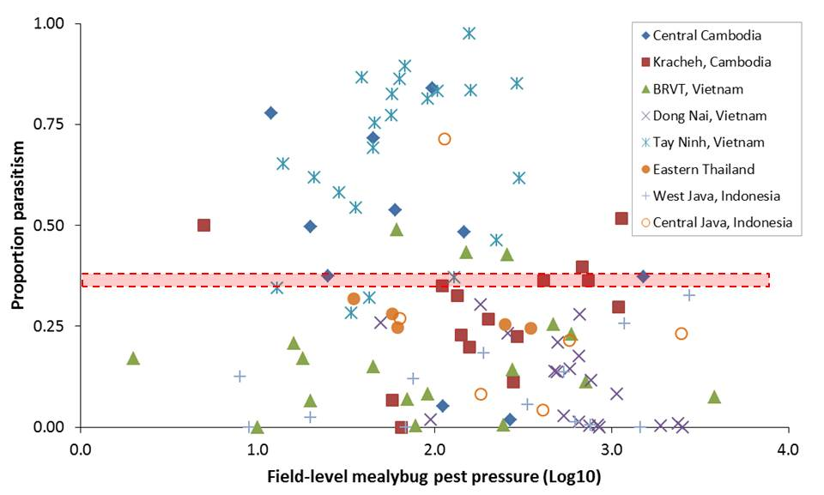

Figure S1.

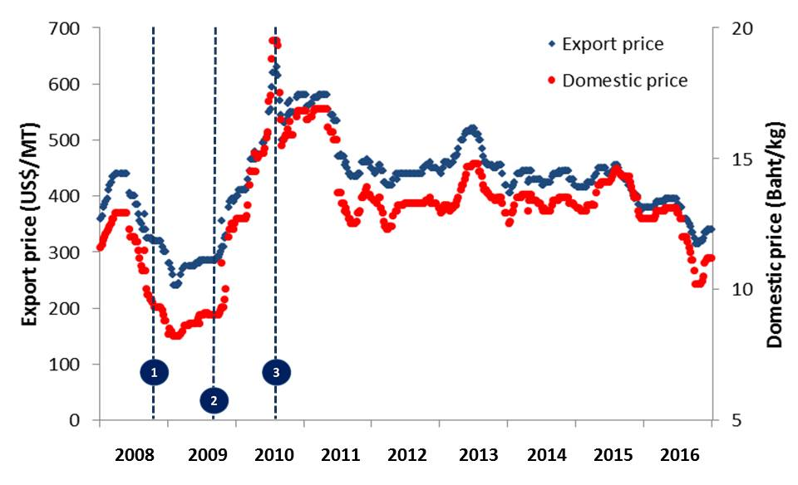

Figure S2.

