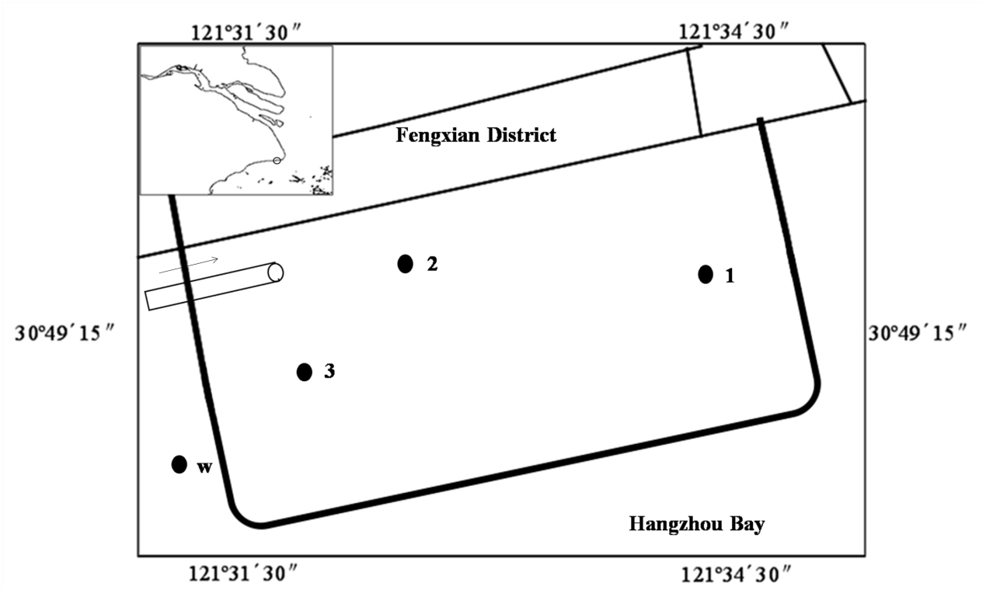
Figure 1: Location of sampling sites in FengXian.

Figure 2: Environmental parameters of water samples.
Y-axis shows the concentration of environmental factors."N" and "W" indicate lagoon and adjacent offshore respectively, and the numbers indicate the sampling month.

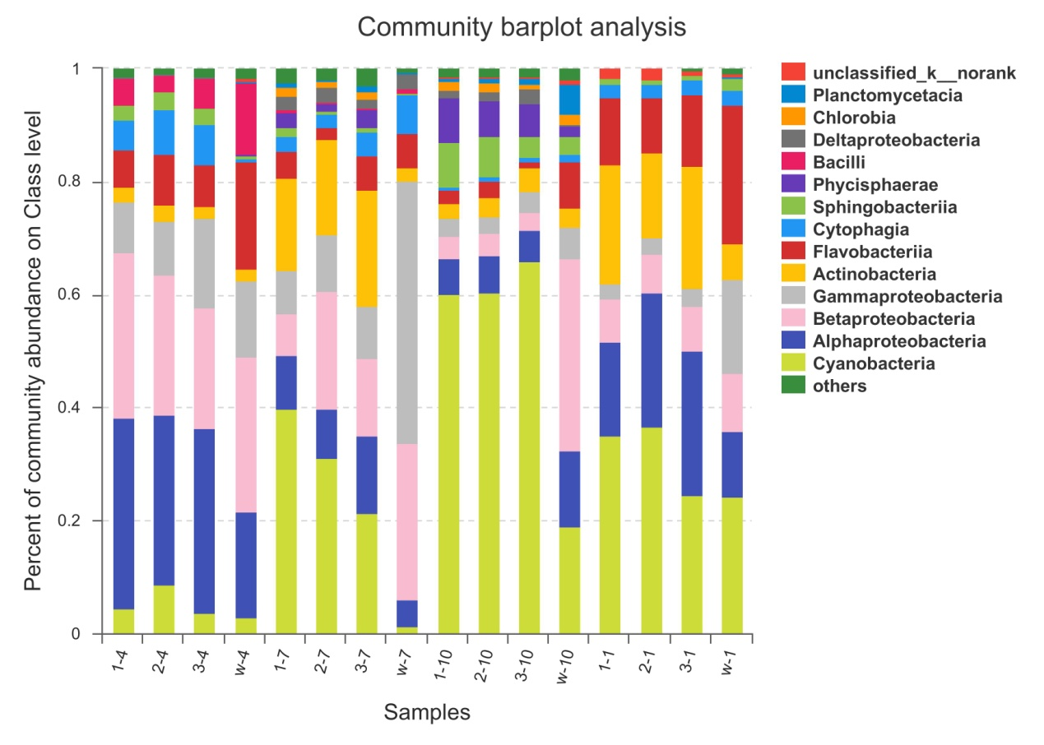
Figure 3: Abundance distribution of the bacterial community at the phylum level.
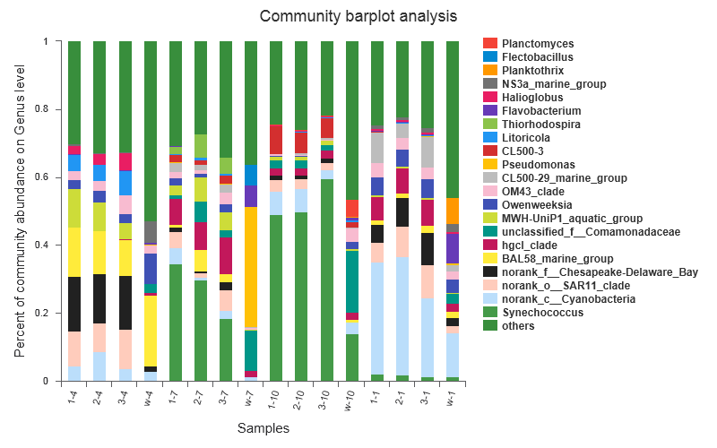
Figure 4: Abundance distribution of the bacterial community at the genes level.

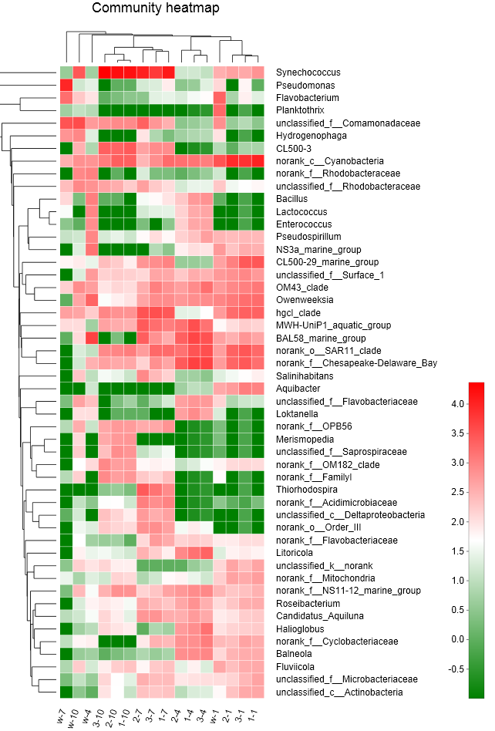
Figure 5: Heatmap of the top 50 genes according to abundance.
Phylogenetic relationships are shown on the right tree. The top tree shows the clustering relationship of the samples.
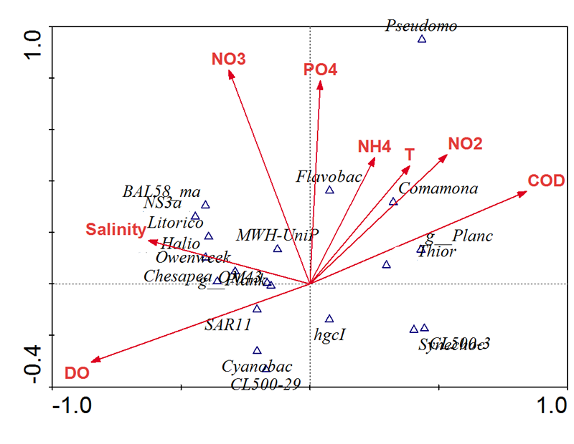
Figure 6: The relationship between major bacterial taxa and environmental factors.

