Supplementary material

Table S1. Estuaries where leaf samples of *Sarcocornia* *pillansii* were collected.

|  |  |  |  |  |
| --- | --- | --- | --- | --- |
| Estuary | X_coord | Y_coord | Province | Region |
| Orange (Gariep) | 16.44958 | -28.63031 | Western Cape | Cool temperate |
| Langebaan | 18.00567 | -33.04816 | Western Cape | Cool temperate |
| Berg (Groot) | 18.14389 | -32.76975 | Western Cape | Cool temperate |
| Olifants | 18.18766 | -31.70212 | Western Cape | Cool temperate |
| Jakkals | 18.31309 | -32.08562 | Western Cape | Cool temperate |
| Wadrift | 18.32527 | -32.20459 | Western Cape | Cool temperate |
| Verlorenvlei | 18.33317 | -32.31592 | Western Cape | Cool temperate |
| Rietvlei/Diep | 18.48165 | -33.89071 | Western Cape | Cool temperate |
| Uilkraals | 19.40764 | -34.60755 | Western Cape | Warm temperate |
| Heuningnes | 20.11925 | -34.7148 | Western Cape | Warm temperate |
| Duiwenhoks | 21.00118 | -34.36503 | Western Cape | Warm temperate |
| Goukou | 21.42353 | -34.37835 | Western Cape | Warm temperate |
| Gourits | 21.8859 | -34.34534 | Western Cape | Warm temperate |
| Hartenbos | 22.12578 | -34.11511 | Western Cape | Warm temperate |
| Klein Brak | 22.14859 | -34.09293 | Western Cape | Warm temperate |
| Groot Brak | 22.23929 | -34.05725 | Western Cape | Warm temperate |
| Knysna | 23.06145 | -34.08271 | Western Cape | Warm temperate |
| Keurbooms | 23.37819 | -34.04985 | Western Cape | Warm temperate |
| Groot (Wes) | 23.56918 | -33.98178 | Western Cape | Warm temperate |
| Kabeljous | 24.9325 | -34.00881 | Eastern Cape | Warm temperate |
| Swartkops | 25.63305 | -33.86625 | Eastern Cape | Warm temperate |
| Sundays | 25.85373 | -33.72184 | Eastern Cape | Warm temperate |
| Boknes | 26.58626 | -33.72717 | Eastern Cape | Warm temperate |
| Bushmans | 26.66362 | -33.69492 | Eastern Cape | Warm temperate |
| Kariega | 26.6864 | -33.68277 | Eastern Cape | Warm temperate |
| Kowie | 26.90163 | -33.60363 | Eastern Cape | Warm temperate |
| Great Fish | 27.14068 | -33.49523 | Eastern Cape | Warm temperate |
| Bira | 27.32603 | -33.38376 | Eastern Cape | Warm temperate |
| Keiskamma | 27.49123 | -33.28148 | Eastern Cape | Warm temperate |
| Nahoon | 27.9517 | -32.9864 | Eastern Cape | Warm temperate |

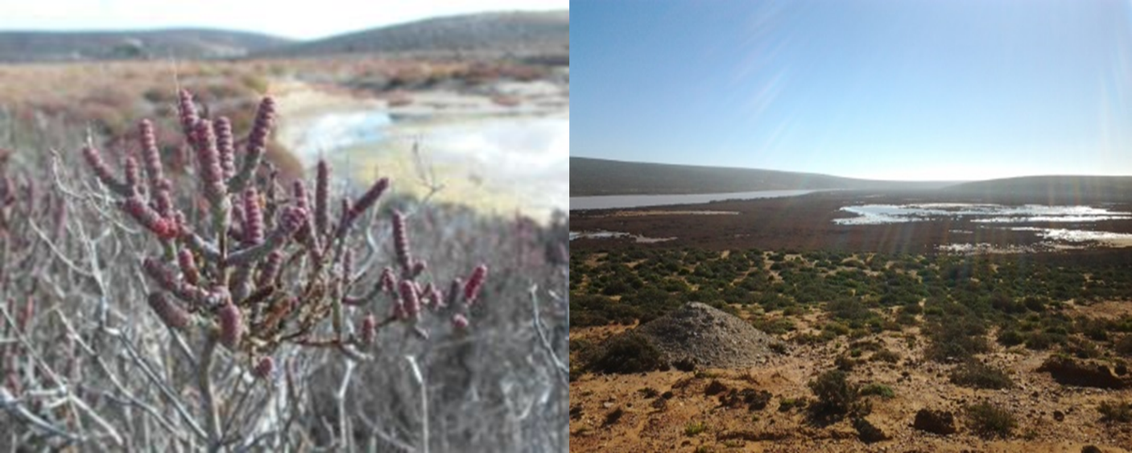

Plate S1: Characteristics and habitat of Sarcocornia pillansii.

Table S2: BIOCLIM layers and reasons for the selection in the study

|  |  |  |  |
| --- | --- | --- | --- |
| BIOCLIM layer | Variable | Reason for selection | Reference |
| BIO1 | Annual Mean Temperature | Major determinant of coastal and terrestrial species distribution | Slenzka et al. (2013) |
| BIO5 | Max Temperature of Warmest Month | Influences the evaporation rate along the west coast where S. pillansii is most abundant | Mucina et al. (2006) |
| BIO6 | Min Temperature of Coldest Month | Limits the distribution of subtropical estuarine species into warm and cool temperate regions | Adams et al. (2016) |
| BIO12 | Annual Precipitation | Influences the evaporation rate along the west coast where S. pillansii is most abundant | Mucina et al. (2006) |
| BIO13 | Precipitation of Wettest Month | Limits the distribution of subtropical estuarine species into warm and cool temperate regions | Adams et al. (2016) |
| BIO14 | Precipitation of Driest Month | Influences the evaporation rate along the west coast where S. pillansii is most abundant | Mucina et al. (2006) |

Table S3: Sampling localities, segregating sites in the 18S-5.8S-26S cistron alignment of Sarcocornia pillansii.



Table S4: Sampling localities from west to east, segregating sites in the trnQ-5’ rps16 intergenic spacer cistron alignment of Sarcocornia pillansii

