Supplementary Material

Differences in persistence between dogs and wolves in an unsolvable task in the absence of humans.
Akshay Rao^{1,2* +}, Lara Bernasconi^{2,3 +}, Martina Lazzaroni^{1,2}, Sarah Marshall-Pescini^{1,2}, Friederike Range^{1,2}
+ These authors contributed equally to this research
* Correspondence: Akshay Rao: akshay.rao@vetmeduni.ac.at

Supplementary results
Table 1: Descriptive statistics of each correlate in dogs and wolves.
 |  | Ball |  | Pipe
 |  | Dogs | Wolves | Dogs | Wolves
Contact Latency (Seconds) | Min | 0.6 | 0.4 | 0.6 | 0.2
 | Max | 2.0 | 2.0 | 2.4 | 3.2
 | Mean | 1.0 | 1.2 | 1.1 | 1.3
 | Median | 0.9 | 1.2 | 1.0 | 1.0
 | Std. Dev | 0.4 | 0.7 | 0.5 | 0.9
Persistence (Seconds) | Min | 0.0 | 14.6 | 0.0 | 0.2
 | Max | 282.8 | 940.8 | 821.4 | 950.6
 | Mean | 29.4 | 319.0 | 97.3 | 239.9
 | Median | 4.1 | 169.2 | 2.4 | 45.7
 | Std. Dev | 73.3 | 299.2 | 244.2 | 356.8
Behavioural Variety | Min | 0 | 6 | 0 | 1
 | Max | 13 | 17 | 14 | 14
 | Mean | 3 | 10 | 3 | 7
 | Median | 3 | 9 | 2 | 6
 | Std. Dev | 3 | 3 | 4 | 5

Complete GAMLSS model information

Persistence models

Full model
Data Distribution: Gamma (Supplementary Figure 1)

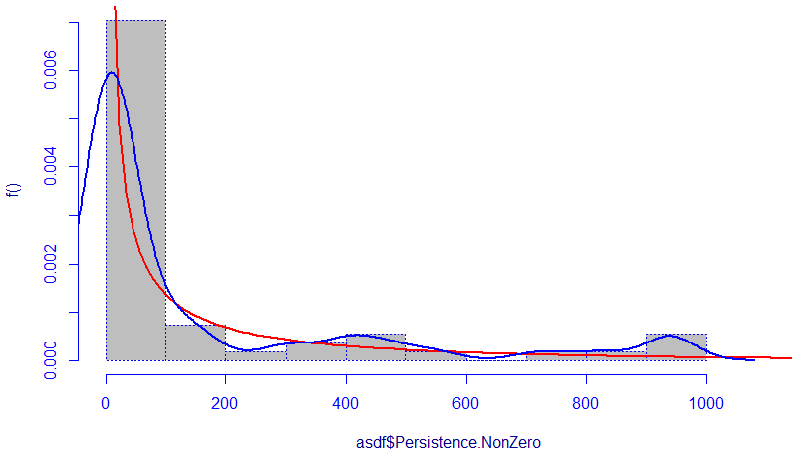
Supplementary Figure 1. This figure shows the best fitting distribution for the persistence data (after addition of a miniscule constant to all values). The grey bars show a histogram, the blue line shows a kernel density estimate and the red line shows the fit distribution.

Output – Initial model
Model Formula: gamlss(Persistence.NonZero ~ Species * Object,
family = "GA", random = ~1 | Individual)
Fitting method : RS()
Mu link function : log
Mu Coefficients :
Estimate Std. Error t value Pr(>|t|)
(Intercept) 3.3798 0.5019 6.734 1.71e-08 ***
SpeciesWolf 2.3856 0.7863 3.034 0.00386 **
ObjectPipe 1.1979 0.7215 1.660 0.10326
SpeciesWolf:ObjectPipe -1.4831 1.1058 -1.341 0.18603
Sigma link function: log
Sigma Coefficients:
Estimate Std. Error t value Pr(>|t|)
(Intercept) 0.69691 0.07488 9.307 2.06e-12 ***
Significance codes: ‘***’: P < 0.001, ‘**’: P < 0.01, ‘*’: P < 0.05
No. of observations in the fit : 54
Degrees of Freedom for the fit : 5
Residual Deg. of Freedom : 49
at cycle : 2

Global Deviance : 475.2195
AIC : 485.2195
SBC : 495.1644
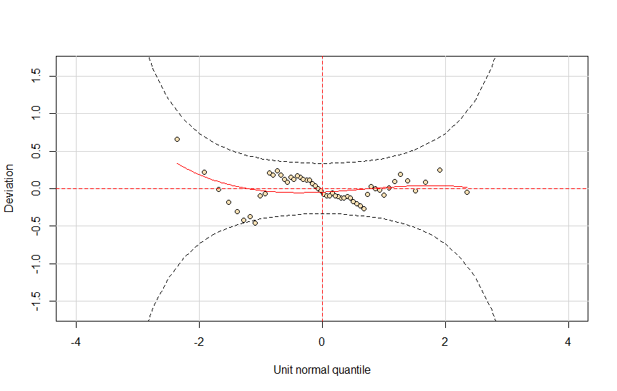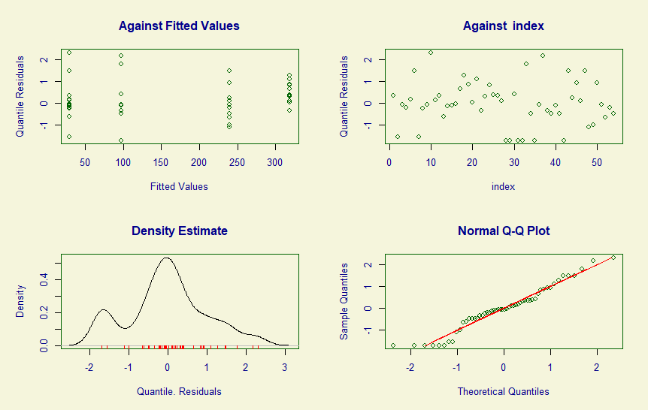
Supplementary Figure 2. Diagnostic Residual QQ Plots (above) and detrended QQ Plot / Worm Plot (Below) for the full persistence model.

Output – after reduction
Model Formula: gamlss(Persistence.NonZero ~ Species + Object,
family = "GA", random = ~1 | Individual)
Fitting method : RS()
Mu link function : log
Mu Coefficients :
Estimate Std. Error t value Pr(>|t|)
(Intercept) 3.7299 0.5193 7.183 3.1e-09 ***
SpeciesWolf 1.6782 0.5883 2.853 0.00629 **
ObjectPipe 0.5733 0.5817 0.986 0.32909
Sigma link function: log
Sigma Coefficients:
Estimate Std. Error t value Pr(>|t|)
(Intercept) 0.70674 0.07477 9.452 1.03e-12 ***
Significance codes: ‘***’: P < 0.001, ‘**’: P < 0.01, ‘*’: P < 0.05
No. of observations in the fit : 54
Degrees of Freedom for the fit : 4
Residual Deg. of Freedom : 50
at cycle : 2

Global Deviance : 476.9758
AIC : 484.9758
SBC : 492.9317

Model for Dogs
Model Formula: gamlss(Persistence.NonZero ~ Object,
family = "GA", random = ~1 | Individual)
Fitting method : RS()
Mu link function : log
Mu Coefficients :
Estimate Std. Error t value Pr(>|t|)
(Intercept) 3.3798 0.5800 5.827 2.92e-06 ***
ObjectPipe 1.1979 0.8338 1.437 0.162
Sigma link function: log
Sigma Coefficients:
Estimate Std. Error t value Pr(>|t|)
(Intercept) 0.84161 0.09691 8.684 1.97e-09 ***
Significance codes: ‘***’: P < 0.001, ‘**’: P < 0.01, ‘*’: P < 0.05
No. of observations in the fit : 31
Degrees of Freedom for the fit : 3
Residual Deg. of Freedom : 28
at cycle : 2

Global Deviance : 173.4407
AIC : 179.4407
SBC : 183.7426

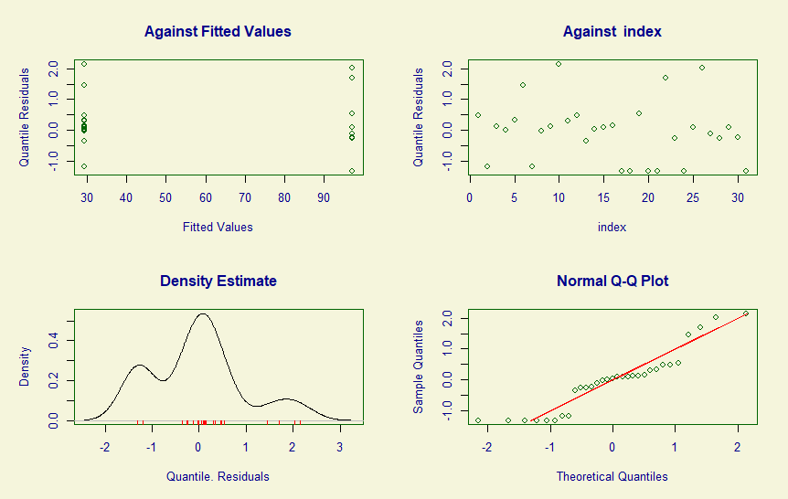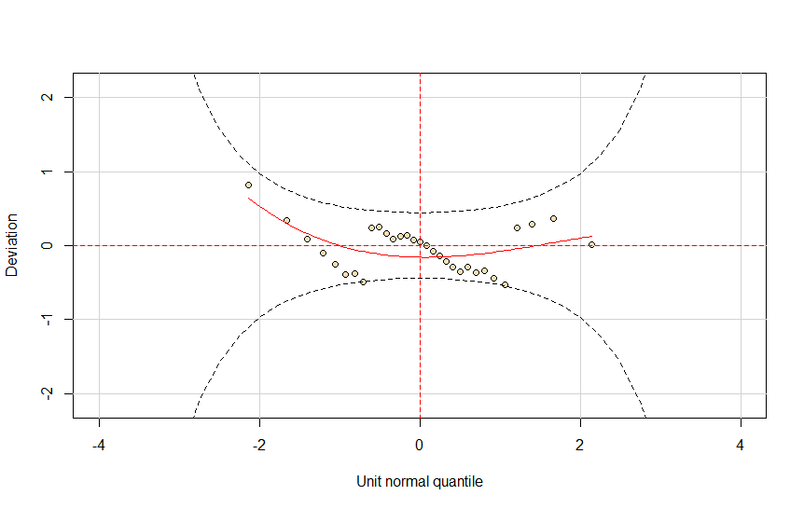
Supplementary Figure 3. Diagnostic Residual QQ Plots (above) and detrended QQ Plot / Worm Plot (Below) for the persistence model for dogs.

Model for Wolves
Model Formula: gamlss(Persistence.NonZero ~ Object,
family = "GA", random = ~1 | Individual)
Fitting method : RS()
Mu link function : log
Mu Coefficients :
Estimate Std. Error t value Pr(>|t|)
(Intercept) 5.7653 0.4347 13.262 2.28e-11 ***
ObjectPipe -0.2853 0.6019 -0.474 0.641
Sigma link function: log
Sigma Coefficients:
Estimate Std. Error t value Pr(>|t|)
(Intercept) 0.3659 0.1213 3.017 0.00681 **
Significance codes: ‘***’: P < 0.001, ‘**’: P < 0.01, ‘*’: P < 0.05
No. of observations in the fit : 23
Degrees of Freedom for the fit : 3
Residual Deg. of Freedom : 20
at cycle : 2

Global Deviance : 293.0476
AIC : 299.0476
SBC : 302.454
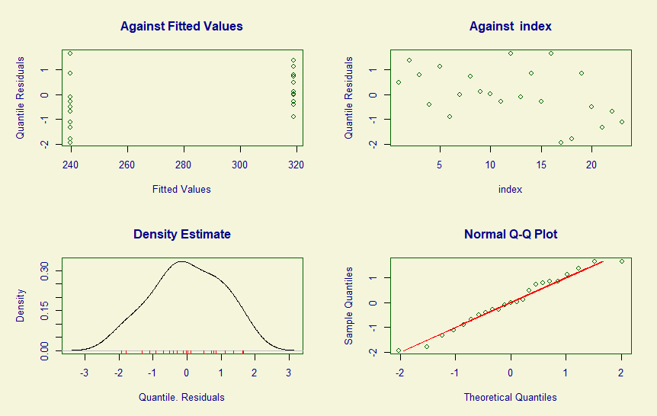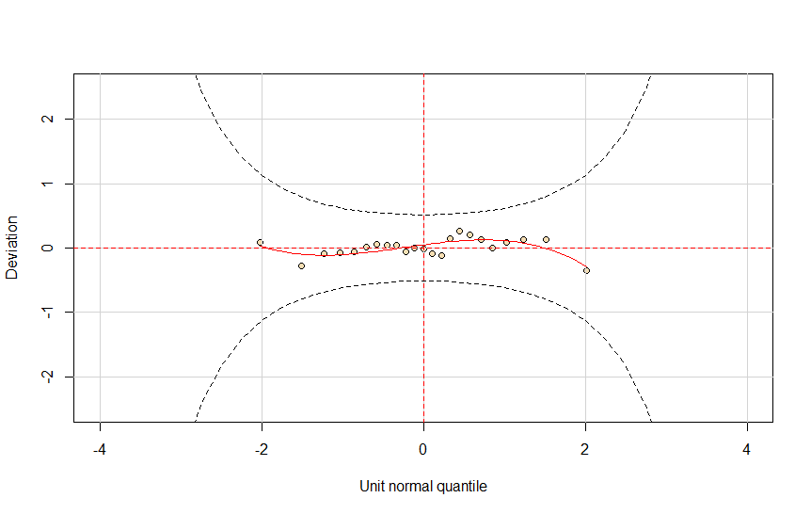
Supplementary Figure 4. Diagnostic Residual QQ Plots (above) and detrended QQ Plot / Worm Plot (Below) for the persistence model for wolves.

Contact Latency models
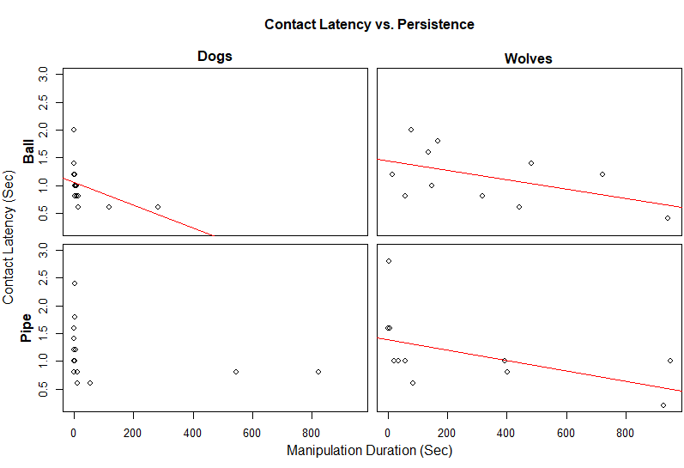
Supplementary Figure 5. Scatter plots showing the relationship between persistence and contact latency in dogs and wolves. Red lines show statistically significant trends.

Model for Dogs (both objects)
Data Distribution: Inverse Gaussian (Supplementary Figure 6)
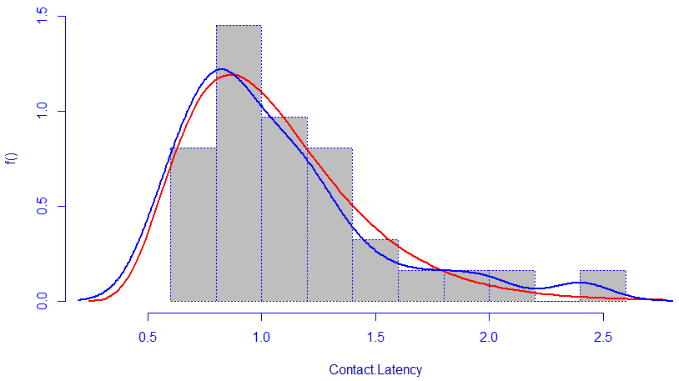
Supplementary Figure 6. This figure shows the best fitting distribution for dogs’ latency data for both objects. The grey bars show a histogram, the blue line shows a kernel density estimate and the red line shows the fit distribution.

Output – Initial model
Model Formula: gamlss(Contact.Latency ~ Object*Approach.Posture +
Object*Persistence, family = "IG", random = ~1 | Individual)
Fitting method : RS()
Mu link function : log
Mu Coefficients :
Estimate Std. Error t value Pr(>|t|)
(Intercept) -0.0047426 0.0917484 -0.052 0.9592
ObjectPipe 0.1884369 0.1344814 1.401 0.1739
Approach.PostureUnsure 0.1930160 0.2157746 0.895 0.3799
Persistence -0.0020949 0.0007516 -2.787 0.0102 *
ObjectPipe:Approach.PostureUnsure -0.3767103 0.3901429 -0.966 0.3439
ObjectPipe:Persistence 0.0015127 0.0007711 1.962 0.0615
Sigma link function: log
Sigma Coefficients:
Estimate Std. Error t value Pr(>|t|)
(Intercept) -1.1718 0.1319 -8.885 4.7e-09 ***
Significance codes: ‘***’: P < 0.001, ‘**’: P < 0.01, ‘*’: P < 0.05
No. of observations in the fit : 31
Degrees of Freedom for the fit : 7
Residual Deg. of Freedom : 24
at cycle : 2

Global Deviance : 14.26868
AIC : 28.26868
SBC : 38.30659
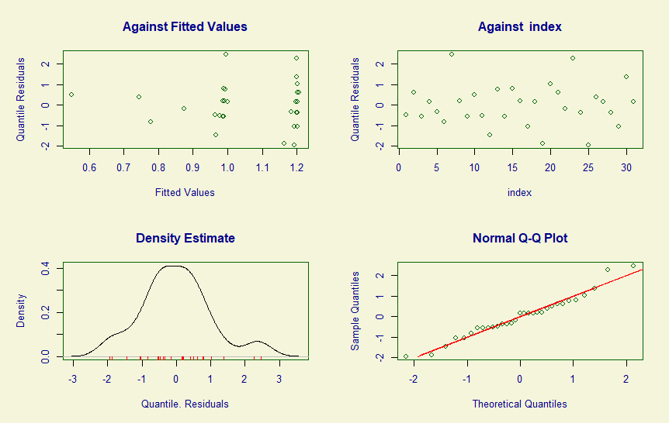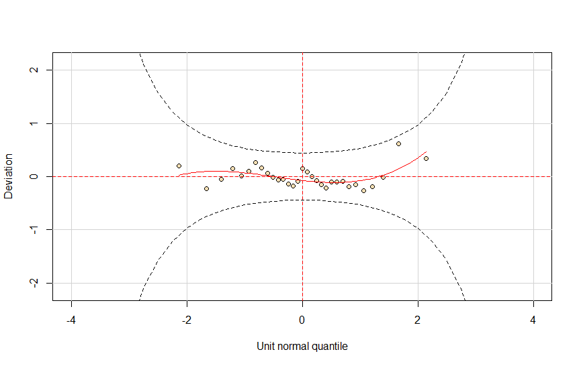
Supplementary Figure 7. Diagnostic Residual QQ Plots (above) and detrended QQ Plot / Worm Plot (Below) for the latency model for dogs (both objects).

Output – after reduction
Model Formula: gamlss(Contact.Latency ~ Object*Persistence,
family = "IG", random = ~1 | Individual)
Fitting method : RS()
Mu link function : log
Mu Coefficients :
Estimate Std. Error t value Pr(>|t|)
(Intercept) 0.038841 0.084963 0.457 0.65136
ObjectPipe 0.131939 0.127902 1.032 0.31178
Persistence -0.002261 0.000751 -3.010 0.00574 **
ObjectPipe:Persistence 0.001696 0.000771 2.200 0.03691 *
Sigma link function: log
Sigma Coefficients:
Estimate Std. Error t value Pr(>|t|)
(Intercept) -1.1532 0.1316 -8.763 3.08e-09 ***
Significance codes: ‘***’: P < 0.001, ‘**’: P < 0.01, ‘*’: P < 0.05
No. of observations in the fit : 31
Degrees of Freedom for the fit : 5
Residual Deg. of Freedom : 26
at cycle : 2

Global Deviance : 15.42009
AIC : 25.42009
SBC : 32.59003

Model for Dogs (Ball only)
Data Distribution: Inverse Gamma (Supplementary Figure 8)
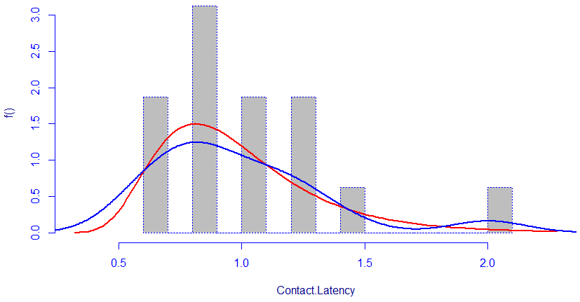
Supplementary Figure 8. This figure shows the best fitting distribution for dogs’ latency data with the ball. The grey bars show a histogram, the blue line shows a kernel density estimate and the red line shows the fit distribution.
Model Formula: gamlss(Contact.Latency ~ Persistence, family = "IGAMMA")
Fitting method : RS()
Mu link function : log
Mu Coefficients :
Estimate Std. Error t value Pr(>|t|)
(Intercept) -0.1070376 0.0721967 -1.483 0.1603
Persistence -0.0022034 0.0009402 -2.344 0.0344 *
Sigma link function: log
Sigma Coefficients:
Estimate Std. Error t value Pr(>|t|)
(Intercept) -1.322 0.165 -8.01 8.48e-07 ***
Significance codes: ‘***’: P < 0.001, ‘**’: P < 0.01, ‘*’: P < 0.05
No. of observations in the fit : 16
Degrees of Freedom for the fit : 3
Residual Deg. of Freedom : 13
at cycle : 9

Global Deviance : 1.345757
AIC : 7.345757
SBC : 9.663523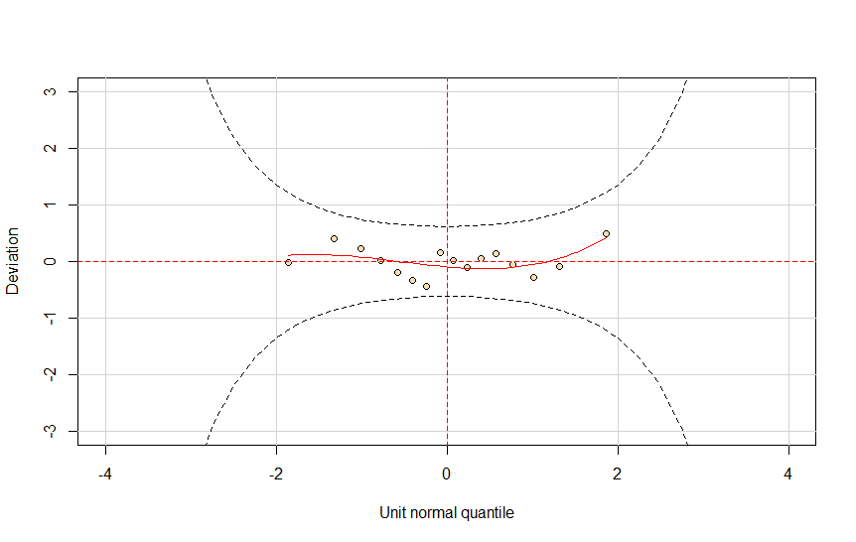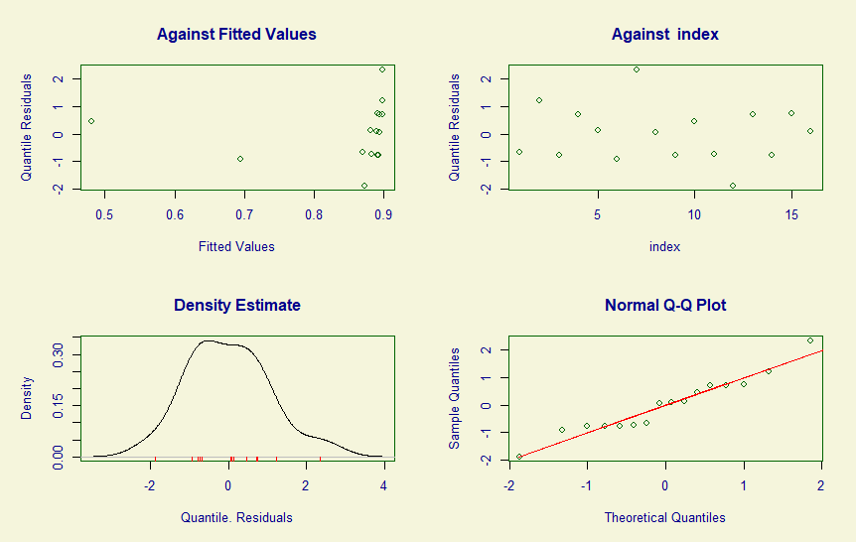
Supplementary Figure 9. Diagnostic Residual QQ Plots (above) and detrended QQ Plot / Worm Plot (Below) for the latency model for dogs with the ball.

Model for Dogs (Pipe Only)
Data Distribution: Inverse Gaussian (Supplementary Figure 10)
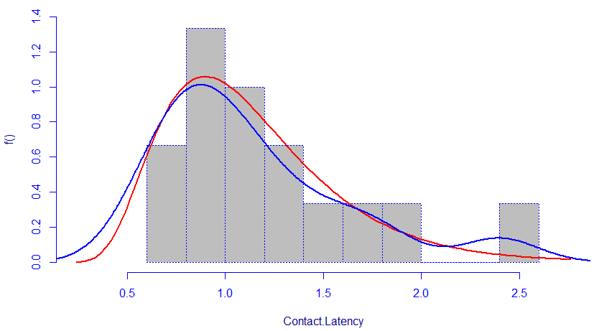
Supplementary Figure 10. This figure shows the best fitting distribution for dogs’ latency data with the pipe. The grey bars show a histogram, the blue line shows a kernel density estimate and the red line shows the fit distribution.
Model Formula: gamlss(Contact.Latency ~ Persistence, family = "IG")
Fitting method : RS()
Mu link function : log
Mu Coefficients :
Estimate Std. Error t value Pr(>|t|)
(Intercept) 0.1707804 0.1056188 1.617 0.130
Persistence -0.0005646 0.0003470 -1.627 0.128
Sigma link function: log
Sigma Coefficients:
Estimate Std. Error t value Pr(>|t|)
(Intercept) -1.0545 0.1826 -5.776 4.8e-05 ***
Significance codes: ‘***’: P < 0.001, ‘**’: P < 0.01, ‘*’: P < 0.05
No. of observations in the fit : 15
Degrees of Freedom for the fit : 3
Residual Deg. of Freedom : 12
at cycle : 2

Global Deviance : 13.09385
AIC : 19.09385
SBC : 21.218
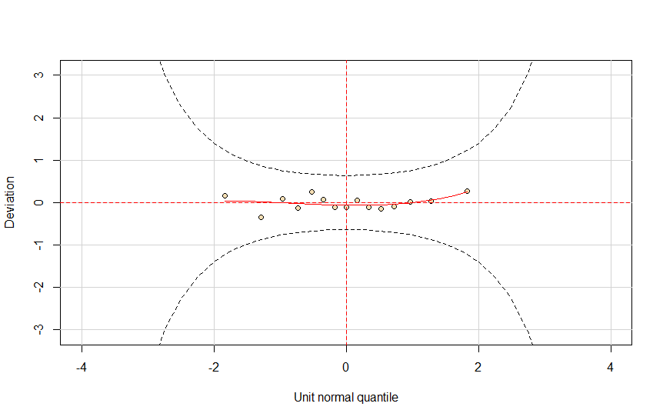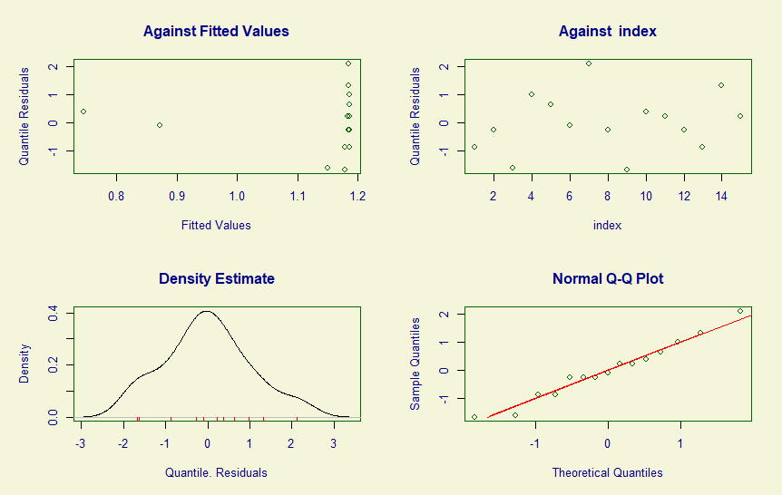
Supplementary Figure 11. Diagnostic Residual QQ Plots (above) and detrended QQ Plot / Worm Plot (Below) for the latency model for dogs with the pipe.

Model for Wolves (Both objects)
Data Distribution: Gamma (Supplementary Figure 12)
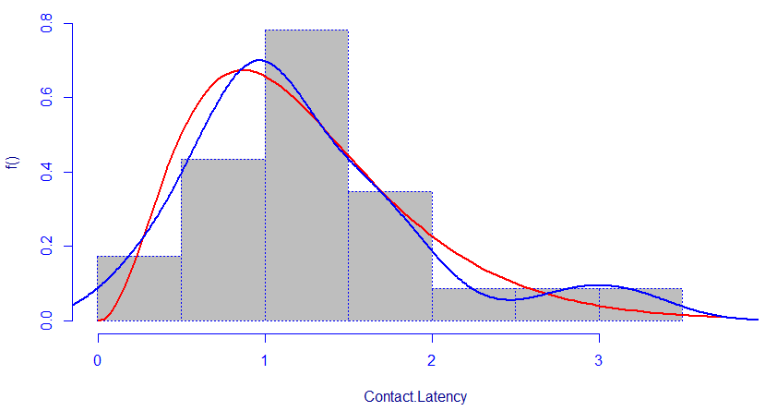
Supplementary Figure 12. This figure shows the best fitting distribution for wolves’ latency data for both objects. The grey bars show a histogram, the blue line shows a kernel density estimate and the red line shows the fit distribution.

Output – initial model
Model Formula: gamlss(Contact.Latency ~ Object*Approach.Posture +
Object*Persistence, family = "GA", random = ~1 | Individual)
Fitting method : RS()
Mu link function : log
Mu Coefficients :
Estimate Std. Error t value Pr(>|t|)
(Intercept) 0.4472794 0.1998355 2.238 0.0389 *
ObjectPipe 0.0306313 0.2509205 0.122 0.9043
Persistence -0.0008132 0.0004253 -1.912 0.0729
ObjectBall:Approach.PostureUnsure -0.4108930 0.3525895 -1.165 0.2600
ObjectPipe:Persistence -0.0003220 0.0005229 -0.616 0.5461
Sigma link function: log
Sigma Coefficients:
Estimate Std. Error t value Pr(>|t|)
(Intercept) --0.8114 0.1463 -5.547 3.55e-05 ***
Significance codes: ‘***’: P < 0.001, ‘**’: P < 0.01, ‘*’: P < 0.05
No. of observations in the fit : 23
Degrees of Freedom for the fit : 6
Residual Deg. of Freedom : 17
at cycle : 2

Global Deviance : 32.19387
AIC : 44.19387
SBC : 51.00683
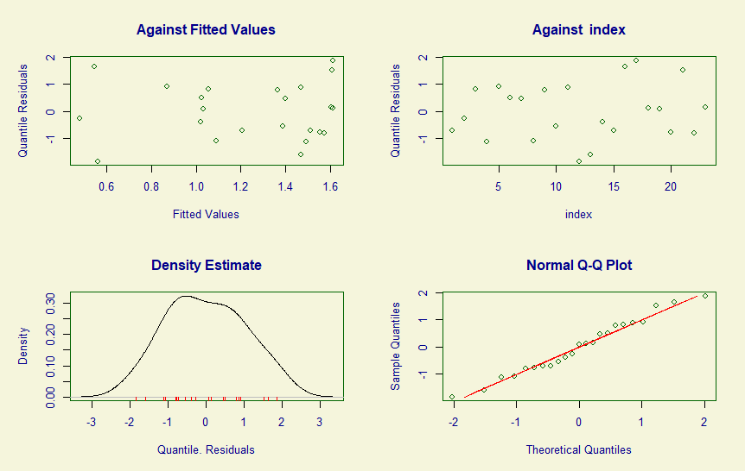
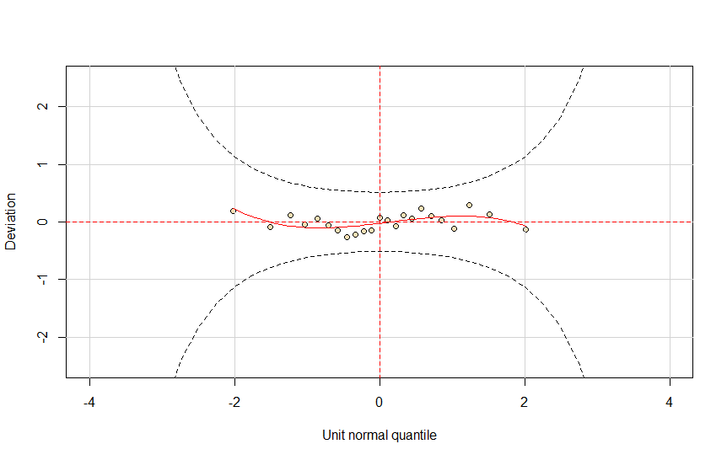

Supplementary Figure 13. Diagnostic Residual QQ Plots (above) and detrended QQ Plot / Worm Plot (Below) for the latency model for wolves (both objects).

Output – after reduction
Model Formula: gamlss(Contact.Latency ~ Persistence,
family = "IG", random = ~1 | Individual)
Fitting method : RS()
Mu link function : log
Mu Coefficients :
Estimate Std. Error t value Pr(>|t|)
(Intercept) 0.4578351 0.1245598 3.676 0.001500 **
Persistence -0.0010453 0.0002653 -3.939 0.000811 ***
Sigma link function: log
Sigma Coefficients:
Estimate Std. Error t value Pr(>|t|)
(Intercept) -0.7830 0.1456 -5.379 2.89e-05 ***
Significance codes: ‘***’: P < 0.001, ‘**’: P < 0.01, ‘*’: P < 0.05
No. of observations in the fit : 23
Degrees of Freedom for the fit : 3
Residual Deg. of Freedom : 20
at cycle : 2

Global Deviance : 33.58641
AIC : 39.58641
SBC : 42.99289

Behavioural Variety models
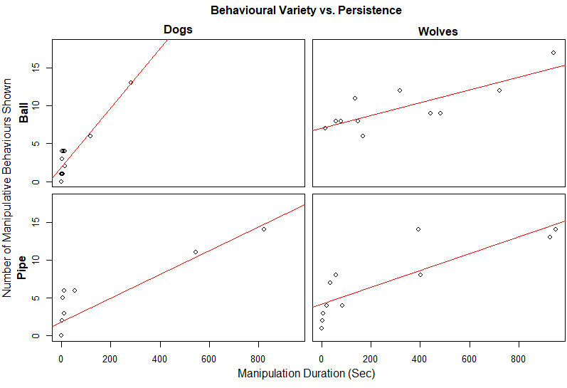
Supplementary Figure 14. Scatter plots showing the relationship between persistence and behavioural variety in dogs and wolves. Red lines show statistically significant trends.

Model for Dogs (Both objects)
Data Distribution: Double Poisson (Supplementary Figure 15)
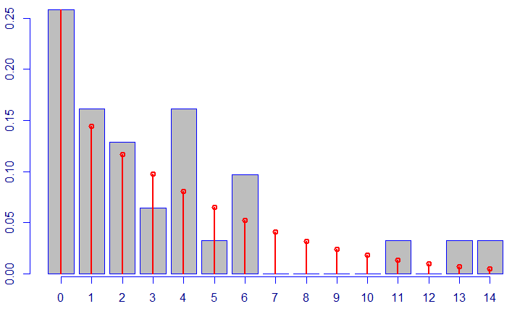
Supplementary Figure 15. This figure shows the best fitting distribution for dogs’ behavioural variety data for both objects. The grey bars show a histogram (behavioural variety is plotted on the x axis and frequency on the y axis) and the red lines shows the fit distribution.
Model Formula: gamlss(Behavioural.Variety ~ Object*Persistence,
family = "DPO", random = ~1 | Individual)
Fitting method : RS()
Mu link function : log
Mu Coefficients :
Estimate Std. Error t value Pr(>|t|)
(Intercept) 0.744245 0.245678 3.029 0.00548 **
ObjectPipe -0.057195 0.360233 -0.159 0.87507
Persistence 0.006681 0.001538 4.344 0.00019 ***
ObjectPipe:Persistence -0.004117 0.001600 -2.573 0.01615 *
Sigma link function: log
Sigma Coefficients:
Estimate Std. Error t value Pr(>|t|)
(Intercept) 0.5658 0.2982 1.898 0.0689
Significance codes: ‘***’: P < 0.001, ‘**’: P < 0.01, ‘*’: P < 0.05
No. of observations in the fit : 31
Degrees of Freedom for the fit : 5
Residual Deg. of Freedom : 26
at cycle : 3

Global Deviance : 121.6563
AIC : 131.6563
SBC : 138.8262
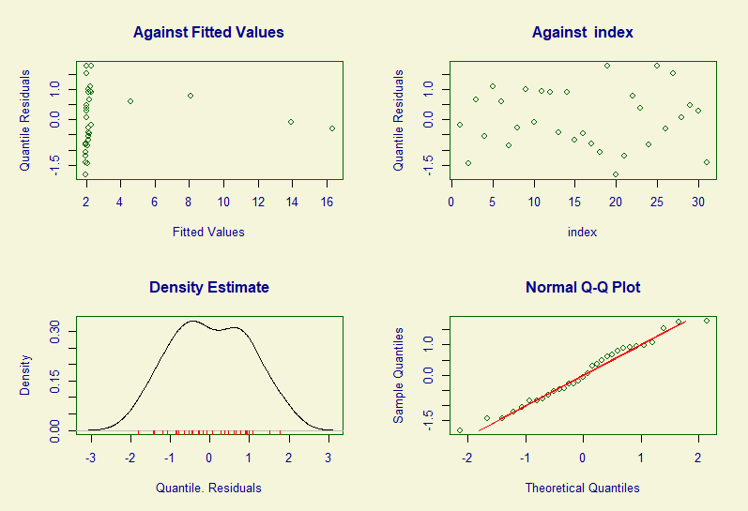
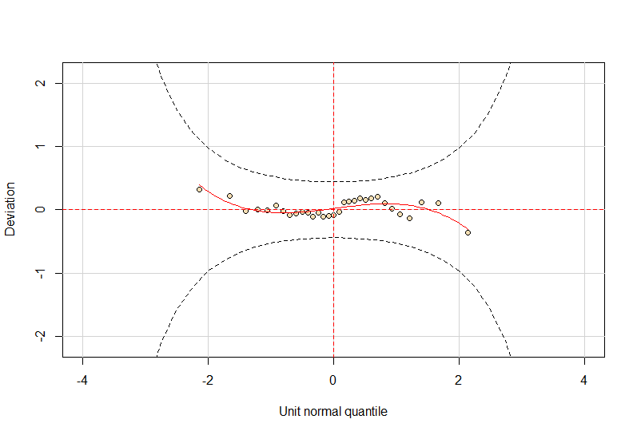

Supplementary Figure 16. Diagnostic Residual QQ Plots (above) and detrended QQ Plot / Worm Plot (Below) for the behavioural model for dogs (both objects).

Model for Dogs (Ball only)
Data Distribution: Negative Binomial type II (Supplementary Figure 17)
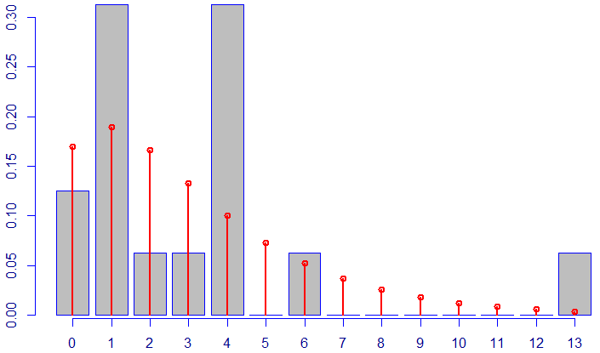
Supplementary Figure 17. This figure shows the best fitting distribution for dogs’ behavioural variety data for the ball. The grey bars show a histogram (behavioural variety is plotted on the x axis and frequency on the y axis) and the red lines shows the fit distribution.
Model Formula: gamlss(Behavioural.Variety ~ Persistence,
family = "NBII", random = ~1 | Individual)
Fitting method : RS()
Mu link function : log
Mu Coefficients :
Estimate Std. Error t value Pr(>|t|)
(Intercept) 0.7007885 0.0847888 8.265 9.35e-07 ***
Persistence 0.0069811 0.0003337 20.923 5.83e-12 ***
Sigma link function: log
Sigma Coefficients:
Estimate Std. Error t value Pr(>|t|)
(Intercept) -33.72915 0.03114 -1083 <2e-16 ***
Significance codes: ‘***’: P < 0.001, ‘**’: P < 0.01, ‘*’: P < 0.05
No. of observations in the fit : 16
Degrees of Freedom for the fit : 3
Residual Deg. of Freedom : 13
at cycle : 114

Global Deviance : 58.82094
AIC : 64.82094
SBC : 67.13871
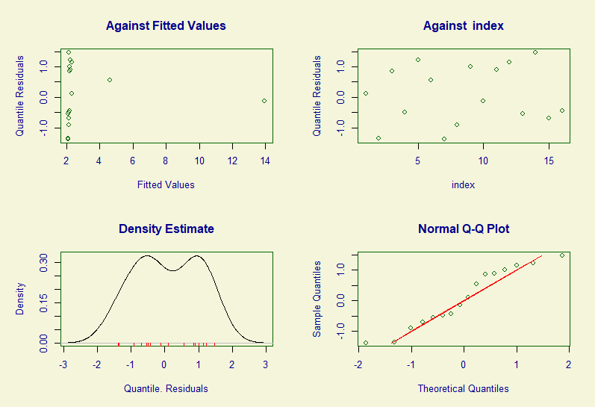
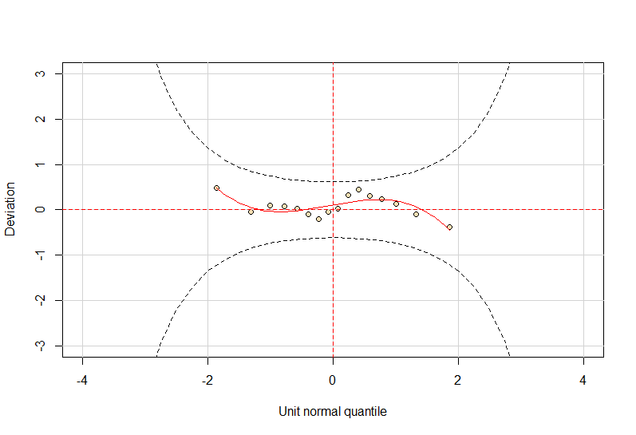

Supplementary Figure 18. Diagnostic Residual QQ Plots (above) and detrended QQ Plot / Worm Plot (Below) for the behavioural model for dogs (both objects).

Model for Dogs (Pipe only)
Data Distribution: Zero Inflated Negative Binomial type I (Supplementary Figure 19)
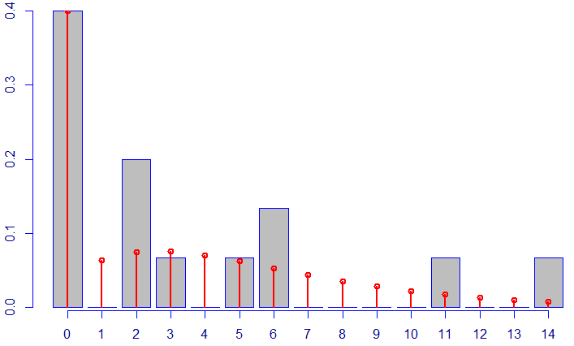
Supplementary Figure 19. This figure shows the best fitting distribution for dogs’ behavioural variety data for the pipe. The grey bars show a histogram (behavioural variety is plotted on the x axis and frequency on the y axis) and the red lines shows the fit distribution.
Model Formula: gamlss(Behavioural.Variety ~ Object*Persistence,
family = "ZINBI", random = ~1 | Individual)
Fitting method : RS()
Mu link function : log
Mu Coefficients :
Estimate Std. Error t value Pr(>|t|)
(Intercept) 1.2667618 0.2293453 5.523 9.82e-05 ***
Persistence 0.0017764 0.0008244 2.155 0.0505
Sigma link function: log
Sigma Coefficients:
Estimate Std. Error t value Pr(>|t|)
(Intercept) -36.08113 0.01872 -1927 <2e-16 ***
Significance codes: ‘***’: P < 0.001, ‘**’: P < 0.01, ‘*’: P < 0.05
No. of observations in the fit : 15
Degrees of Freedom for the fit : 4
Residual Deg. of Freedom : 11
at cycle : 4

Global Deviance : 55.72675
AIC : 63.72675
SBC : 66.55895
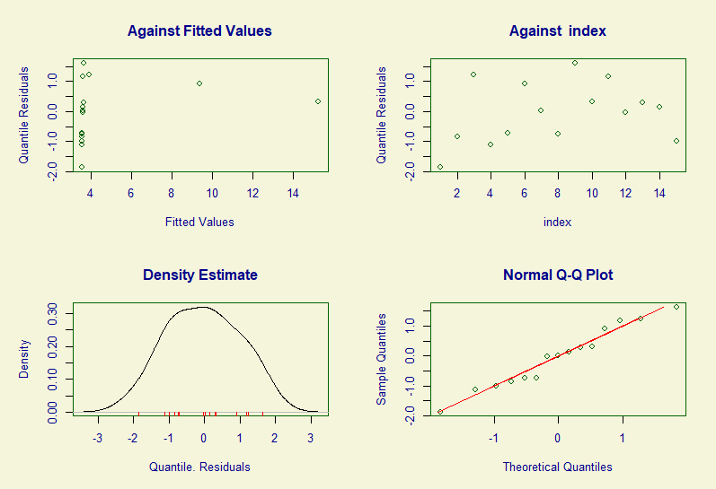
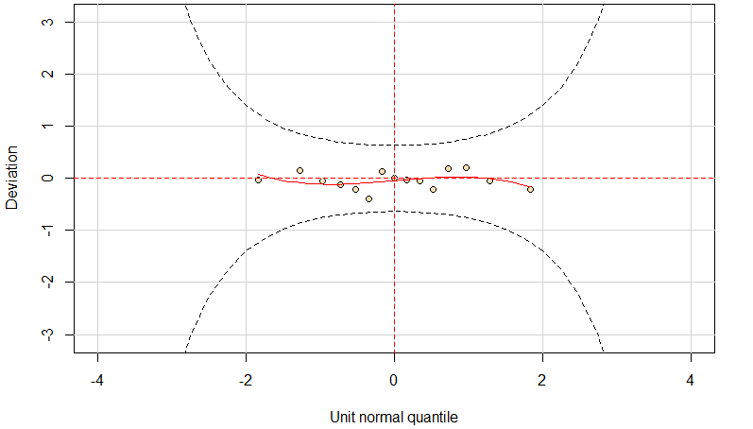

Supplementary Figure 20. Diagnostic Residual QQ Plots (above) and detrended QQ Plot / Worm Plot (Below) for the behavioural model for dogs (both objects).

Model for Wolves (both objects)
Data Distribution: Double Poisson (Supplementary Figure 21)
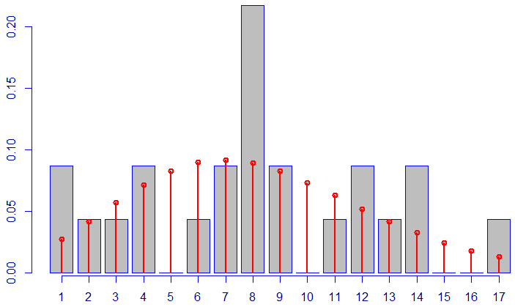
Supplementary Figure 21. This figure shows the best fitting distribution for dogs’ behavioural variety data for both objects. The grey bars show a histogram (behavioural variety is plotted on the x axis and frequency on the y axis) and the red lines shows the fit distribution.

Output – initial model
Model Formula: gamlss(Behavioural.Variety ~ Object*Persistence,
family = "DPO", random = ~1 | Individual)
Fitting method : RS()
Mu link function : log
Mu Coefficients :
Estimate Std. Error t value Pr(>|t|)
(Intercept) 2.0067160 0.1440354 13.932 4.41e-11 ***
ObjectPipe -0.5913600 0.2088115 -2.832 0.0111 *
Persistence 0.0007498 0.0002655 2.824 0.0112 *
ObjectPipe:Persistence 0.0006431 0.0003387 1.898 0.0738
Sigma link function: log
Sigma Coefficients:
Estimate Std. Error t value Pr(>|t|)
(Intercept) -0.1169 0.3101 -0.377 0.711
Significance codes: ‘***’: P < 0.001, ‘**’: P < 0.01, ‘*’: P < 0.05
No. of observations in the fit : 23
Degrees of Freedom for the fit : 5
Residual Deg. of Freedom : 18
at cycle : 2

Global Deviance : 107.0752
AIC : 117.0752
SBC : 122.7526
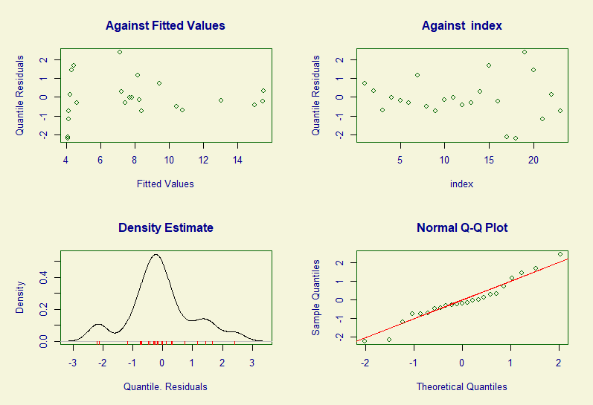
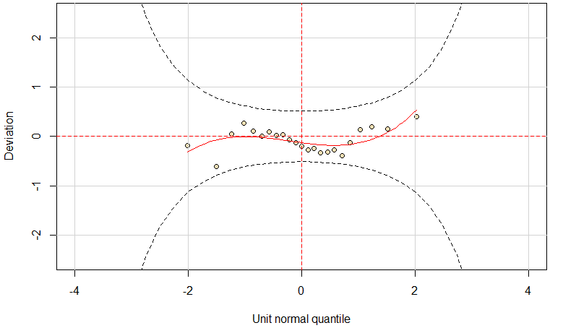

Supplementary Figure 22. Diagnostic Residual QQ Plots (above) and detrended QQ Plot / Worm Plot (Below) for the behavioural model for dogs (both objects).

Output – after reduction
Model Formula: gamlss(Behavioural.Variety ~ Object + Persistence,
family = "DPO", random = ~1 | Individual)
Fitting method : RS()
Mu link function : log
Mu Coefficients :
Estimate Std. Error t value Pr(>|t|)
(Intercept) 1.8593750 0.1297384 14.332 1.22e-11 ***
ObjectPipe -0.3301370 0.1466826 -2.251 0.0364 *
Persistence 0.0011270 0.0001907 5.909 1.09e-05 ***
Sigma link function: log
Sigma Coefficients:
Estimate Std. Error t value Pr(>|t|)
(Intercept) -0.02217 0.30976 -0.072 0.944
Significance codes: ‘***’: P < 0.001, ‘**’: P < 0.01, ‘*’: P < 0.05
No. of observations in the fit : 23
Degrees of Freedom for the fit : 4
Residual Deg. of Freedom : 19
at cycle : 2

Global Deviance : 109.3864
AIC : 117.3864
SBC : 121.9284

Results for analyses for persistence including outliers
Wolves were more persistent than dogs (GAMLSS: t = 2.21, P = 0.032) in their manipulation of both objects (i.e. the interaction between species and object was not significant, GAMLSS: t = -1.82, P = 0.07). Dogs manipulated the pipe significantly longer than the ball (GAMLSS: t = 2.16, P = 0.04) but wolves’ persistence did not differ significantly between the two objects (GAMLSS: t = -0.33, P = 0.74) (Figure 23).
Figure 23: Differences in persistence between dogs and wolves
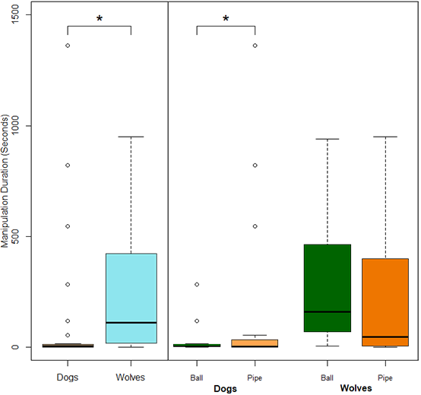
Left: Plot (including outliers) showing time (in seconds) spent manipulating both apparatuses combined for dogs and wolves. Right: Plot (including outliers) showing time (in seconds) spent manipulating each object separately for dogs and wolves. Circles indicate outliers, * indicates a P value under 0.05 at α = 0.05.

GAMLSS model information for persistence models including outliers

Full model
Data Distribution: Gamma (Supplementary Figure 26)
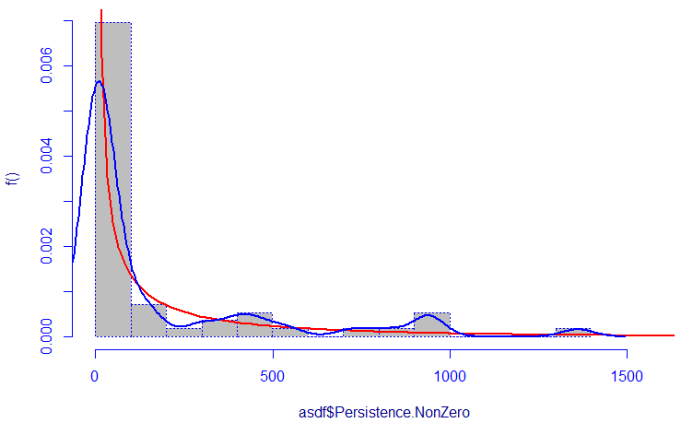
Supplementary Figure 26. This figure shows the best fitting distribution for the persistence data including outliers (after addition of a miniscule constant to all values). The grey bars show a histogram, the blue line shows a kernel density estimate and the red line shows the fit distribution.

Output – Initial model
Model Formula: gamlss(Persistence.NonZero ~ Species * Object,
family = "GA", random = ~1 | Individual)
Fitting method : RS()
Mu link function : log
Mu Coefficients :
Estimate Std. Error t value Pr(>|t|)
(Intercept) 3.3798 0.5074 6.660 1.87e-08 ***
SpeciesWolf 2.3001 0.7751 2.967 0.00456 **
ObjectPipe 1.7922 0.7176 2.497 0.01578 *
SpeciesWolf:ObjectPipe -1.9921 1.0962 -1.817 0.07505
Sigma link function: log
Sigma Coefficients:
Estimate Std. Error t value Pr(>|t|)
(Intercept) 0.70792 0.07341 9.643 4.38e-13 ***
Significance codes: ‘***’: P < 0.001, ‘**’: P < 0.01, ‘*’: P < 0.05
No. of observations in the fit : 56
Degrees of Freedom for the fit : 5
Residual Deg. of Freedom : 51
at cycle : 2

Global Deviance : 505.5419
AIC : 515.5419
SBC : 525.6687
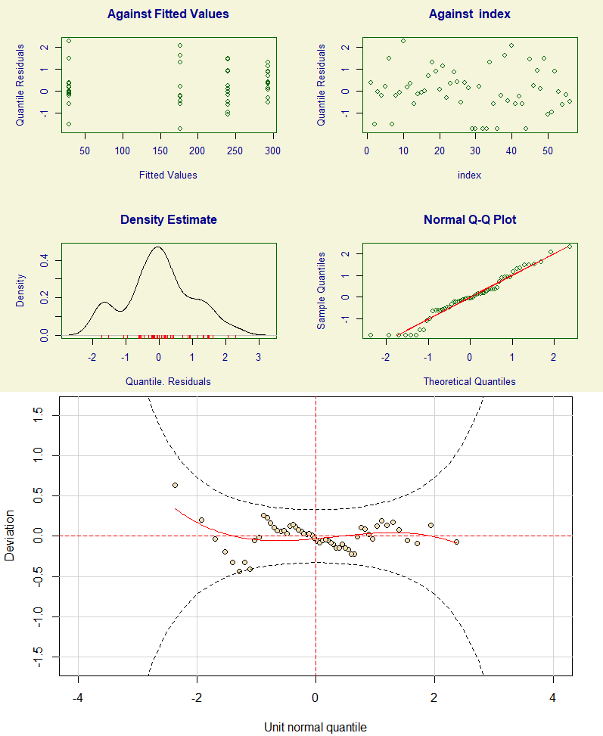
Supplementary Figure 27. Diagnostic Residual QQ Plots (above) and detrended QQ Plot / Worm Plot (Below) for the full persistence model.

Output – after reduction
Model Formula: gamlss(Persistence.NonZero ~ Species + Object,
family = "GA", random = ~1 | Individual)
Fitting method : RS()
Mu link function : log
Mu Coefficients :
Estimate Std. Error t value Pr(>|t|)
(Intercept) 3.8782 0.5646 6.869 8.02e-09 ***
SpeciesWolf 1.3800 0.6253 2.207 0.0317 *
ObjectPipe 0.9631 0.6189 1.556 0.1257
Sigma link function: log
Sigma Coefficients:
Estimate Std. Error t value Pr(>|t|)
(Intercept) 0.72466 0.07323 9.895 1.49e-13 ***
Significance codes: ‘***’: P < 0.001, ‘**’: P < 0.01, ‘*’: P < 0.05
No. of observations in the fit : 56
Degrees of Freedom for the fit : 4
Residual Deg. of Freedom : 52
at cycle : 2

Global Deviance : 508.6553
AIC : 516.6553
SBC : 524.7567

Model for Dogs including outliers
Model Formula: gamlss(Persistence.NonZero ~ Object,
family = "GA", random = ~1 | Individual)
Fitting method : RS()
Mu link function : log
Mu Coefficients :
Estimate Std. Error t value Pr(>|t|)
(Intercept) 3.3798 0.5856 5.771 2.99e-06 ***
ObjectPipe 1.7922 0.8282 2.164 0.0388 *
Sigma link function: log
Sigma Coefficients:
Estimate Std. Error t value Pr(>|t|)
(Intercept) 0.85119 0.09527 8.934 7.97e-10 ***
Significance codes: ‘***’: P < 0.001, ‘**’: P < 0.01, ‘*’: P < 0.05
No. of observations in the fit : 32
Degrees of Freedom for the fit : 3
Residual Deg. of Freedom : 29
at cycle : 2

Global Deviance : 194.6167
AIC : 200.6167
SBC : 205.0139

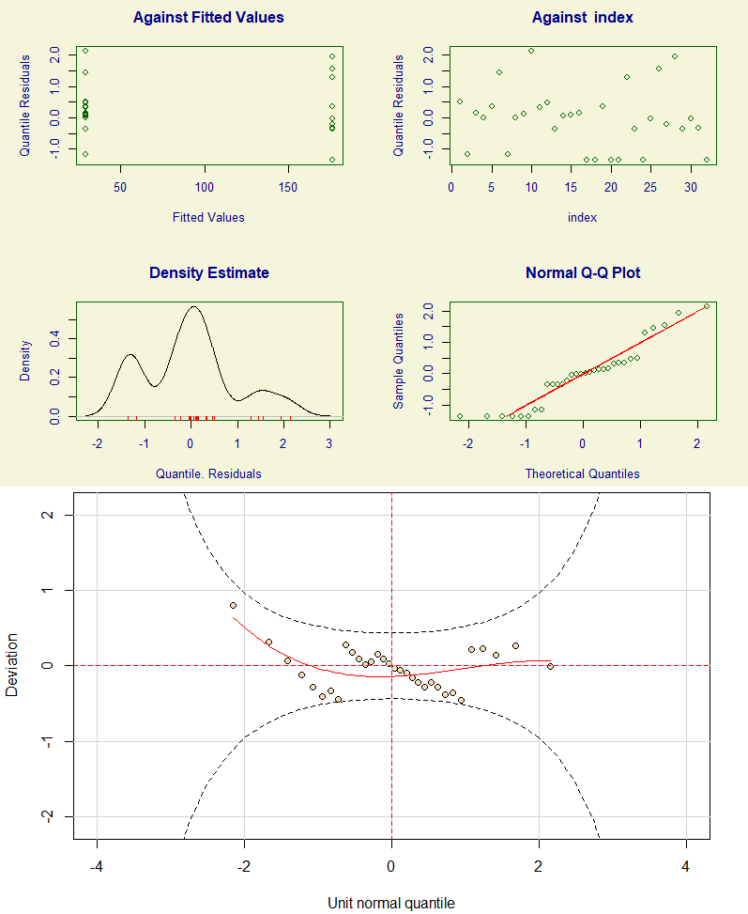
Supplementary Figure 28. Diagnostic Residual QQ Plots (above) and detrended QQ Plot / Worm Plot (Below) for the persistence model for dogs including outliers.

Model for Wolves including outliers
Model Formula: gamlss(Persistence.NonZero ~ Object,
family = "GA", random = ~1 | Individual)
Fitting method : RS()
Mu link function : log
Mu Coefficients :
Estimate Std. Error t value Pr(>|t|)
(Intercept) 5.6799 0.4256 13.345 1e-11 ***
ObjectPipe -0.1999 0.6019 -0.332 0.743
Sigma link function: log
Sigma Coefficients:
Estimate Std. Error t value Pr(>|t|)
(Intercept) 0.3882 0.1182 3.283 0.00354 **
Significance codes: ‘***’: P < 0.001, ‘**’: P < 0.01, ‘*’: P < 0.05
No. of observations in the fit : 24
Degrees of Freedom for the fit : 3
Residual Deg. of Freedom : 21
at cycle : 2

Global Deviance : 302.2474
AIC : 308.2474
SBC : 311.7816
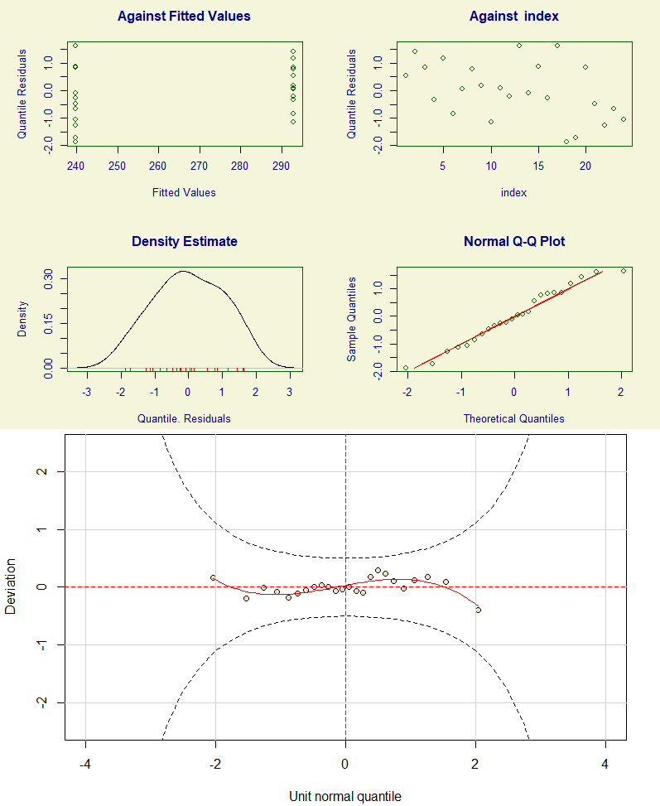
Supplementary Figure 29. Diagnostic Residual QQ Plots (above) and detrended QQ Plot / Worm Plot (Below) for the persistence model for wolves.

