**To be used in conjunction with training manual from Sotocinal et al. 2011 Mol Pain 7:55**

**Eyes: 0**

Sotocinal et al. 2011 – “Rats in pain display a narrowing of the orbital area, a tightly closed eyelid, or an eye squeeze. An eye squeeze is defined as the orbital muscles around the eyes being contracted. The nictitating membrane may be visible around the eye and becomes more pronounced as the pain intensifies. As a guideline, any eye closure that reduces the eye size by more than half should be coded as a “2” […] Photographs of sleeping rats should not be taken and/or coded”

Pang lab – Eyes are completely bulgy, eye lids not showing

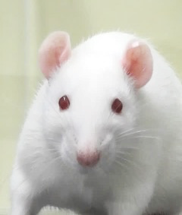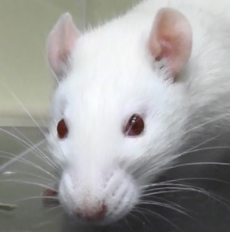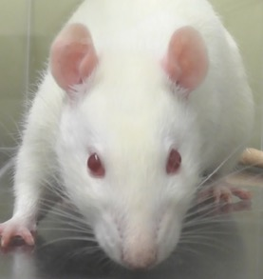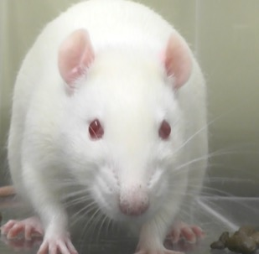

**Eyes: 1**

Pang lab – Eyes are slightly sunken into their head, tension in the eye lids, <50% closed

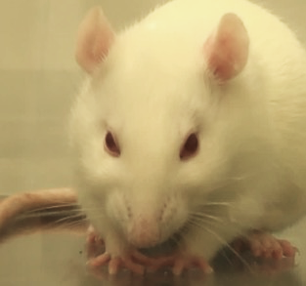

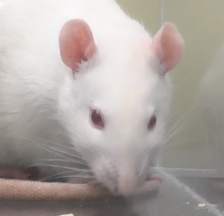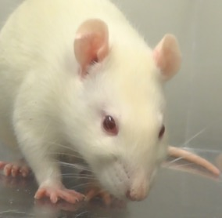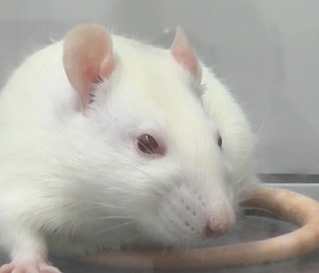

**Eyes: 2**

Pang lab – eyes are squeezed together, >50% closed

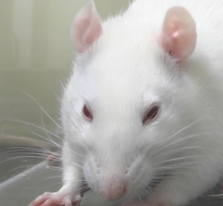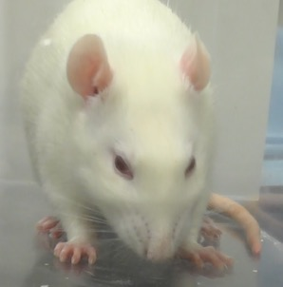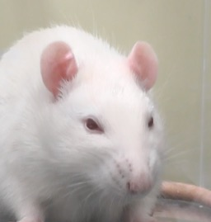

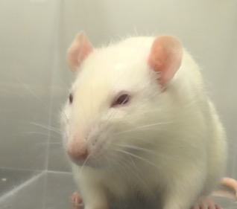

**Ears: 0**

Sotocinal et al. 2011 – “The ears of rats in pain may be curled and pointed more than in the baseline position. In the baseline position ears are roughly perpendicular to the head, face forward, and are angled slightly backward. Importantly, the ears also have a rounded shape. In pain, the ears tend to fold, curl inwards and are angled forward. This curling of the ears tends to result in a ‘pointed’ shape of the ears. In pronounced pain states, the ears are angled outward and are held close to 45o away from both the perpendicular axis and the nose. As a result, the space between the ears may appear wider relative to baseline.”

Pang lab – Ears are rounded, facing forwards and approximately perpendicular to the head.

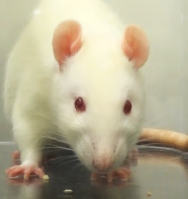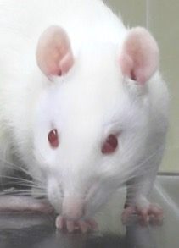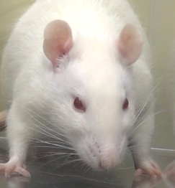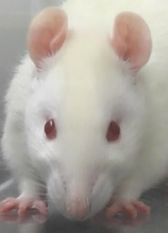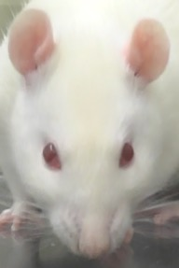

**Ears: 1**

Pang lab – Ears are slightly rotated outwards, a bit further apart, more slender (curled)

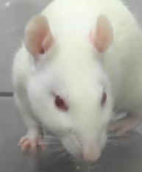

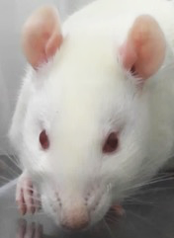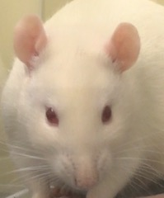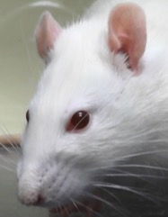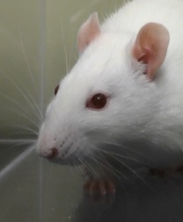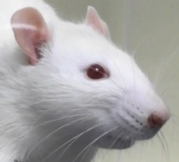

**Ears: 2**

Pang lab – Ears are rotated outwards, base of ears tend to be further apart, and ear shape is usually curled or narrowed.

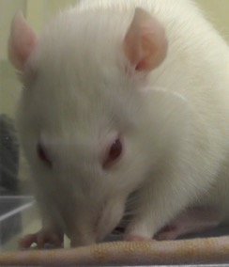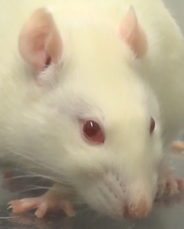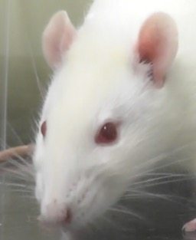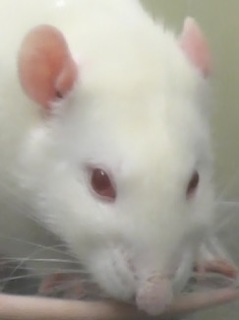

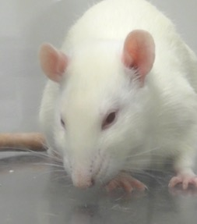

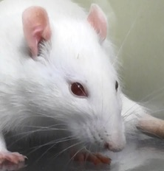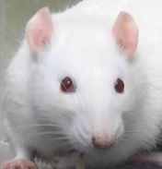

**Nose/cheek: 0**

Sotocinal et al. 2011 – “Rats in pain display a lack of bulge on top of the nose (i.e., a flattening of the nose). In the ‘no pain’ condition a clear bulge is present at the bridge of the nose. The whisker pads are also rounded and slightly puffed out, leaving a clear crease between the pads and the cheek. When in pain, the bridge of the nose flattens and elongates, causing the whisker pads to flatten. At this time the crease between the pads and the cheek is no longer present. In frontal headshots, the nose may appear narrower and longer”

Pang lab – Whisker pad/muzzle is round, cheeks are round & relaxed, obvious crease between nose and cheek

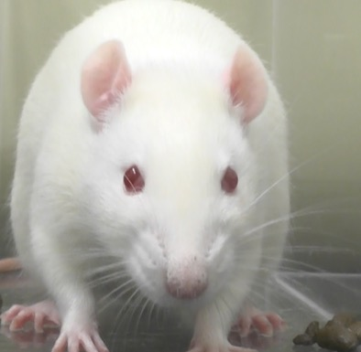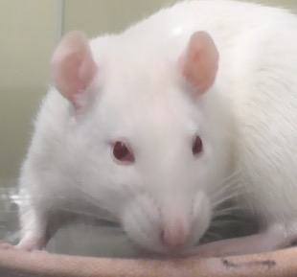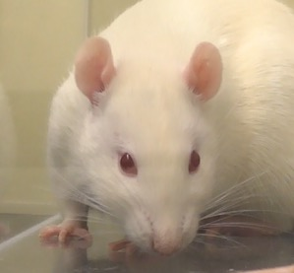

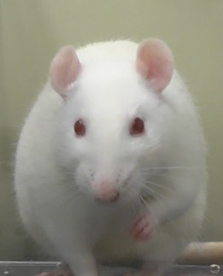

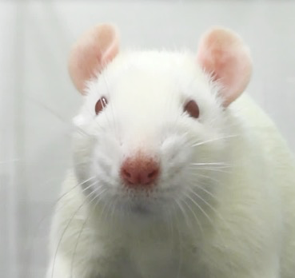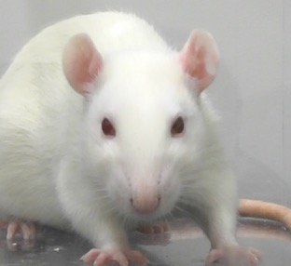

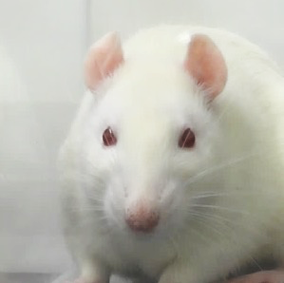

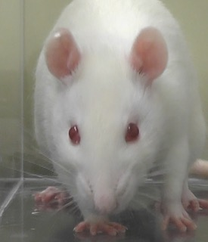

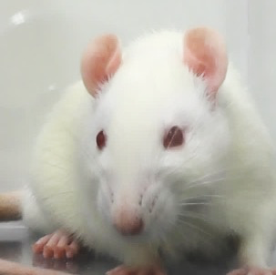

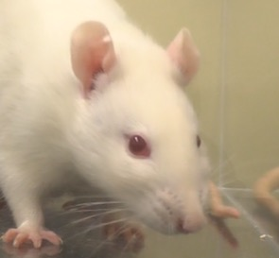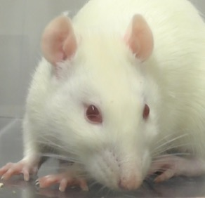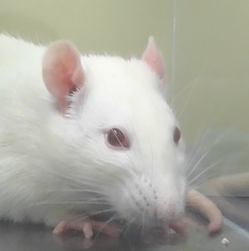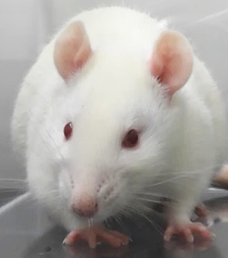

**Nose/cheek: 1**

Pang lab – Whisker pad is usually flat, nose is more narrow, cheeks a bit more slender, less of a crease between nose and cheek

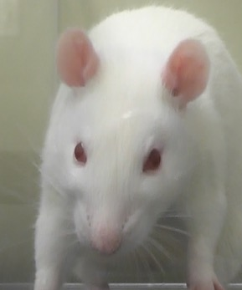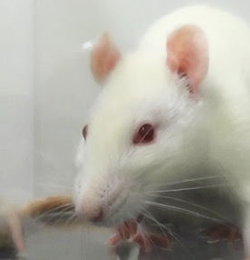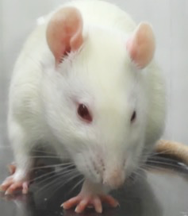

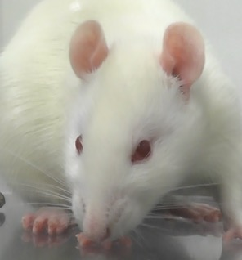

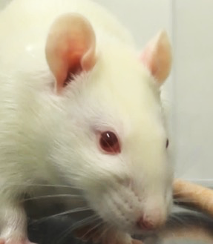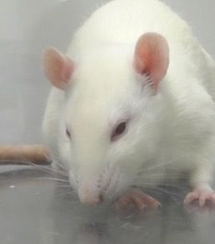

**Nose/cheek: 2**

Pang lab – Whisker pad is flat, nose is slender, cheeks are flat, small or no crease between nose and cheek, head looks pointy

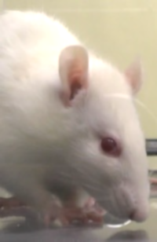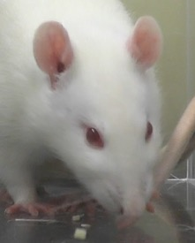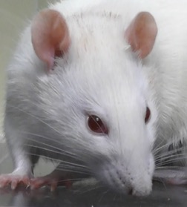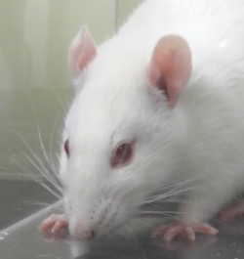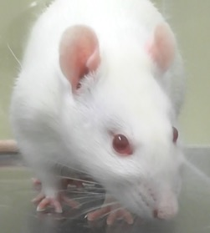

**Whiskers: 0**

Sotocinal et al. 2011 – “Rats in pain have whiskers that have moved from the baseline position and orientation. Whiskers start relaxed and drooping slightly downward and, as pain progresses, tension in the pads increases and they become angled back along the head. In pain, the whisker pad is contracted causing the whiskers to bunch and be directed outwards away from the face. This gives the appearance of the whiskers as ‘standing on end’. As follicles become tense, whiskers are closer together and are less distinct.”

Pang lab – Whiskers are spread, relaxed, and floppy/droopy at the ends

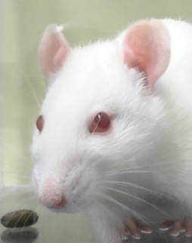

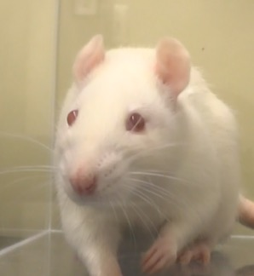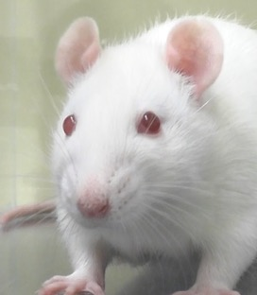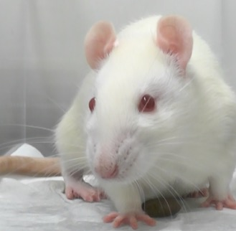

**Whiskers: 1**

Pang lab – Whiskers are straight at the ends and are pulled towards cheeks

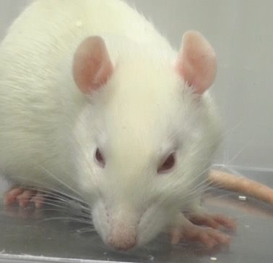

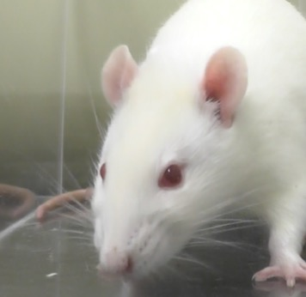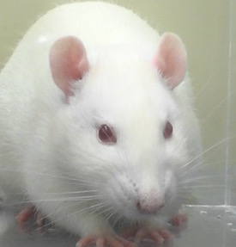

**Whiskers: 2**

Pang lab – Whiskers are straight at the ends and top whiskers are horizontal or pointed away from the cheeks

