Supplemental information to The effects of experimental forestry treatments on site conditions: short response study from an oak-hornbeam forest

Kovács, B.^{1,2,3}, Tinya, F.¹, Guba, E.¹, Németh, Cs.³, Sass, V.⁴, Bidló, A.⁴, Ódor, P.^{1,3}

¹ MTA Centre for Ecological Research, Institute of Ecology and Botany, Alkotmány út 2-4, H-2163 Vácrátót, Hungary
² Department of Plant Systematics, Ecology and Theoretical Biology, Eötvös Loránd University, Pázmány Péter sétány 1/C, H-1117 Budapest, Hungary
³ MTA Centre for Ecological Research, GINOP Sustainable Ecosystems Research Group, Klebelsberg Kuno utca 3, H-8237 Tihany, Hungary
⁴ University of Sopron, Institute of Environmental and Earth Sciences, Bajcsy-Zsilinszky utca 4, H-9400 Sopron, Hungary

Supplemental Information 1 – Results of the soil profile analyses

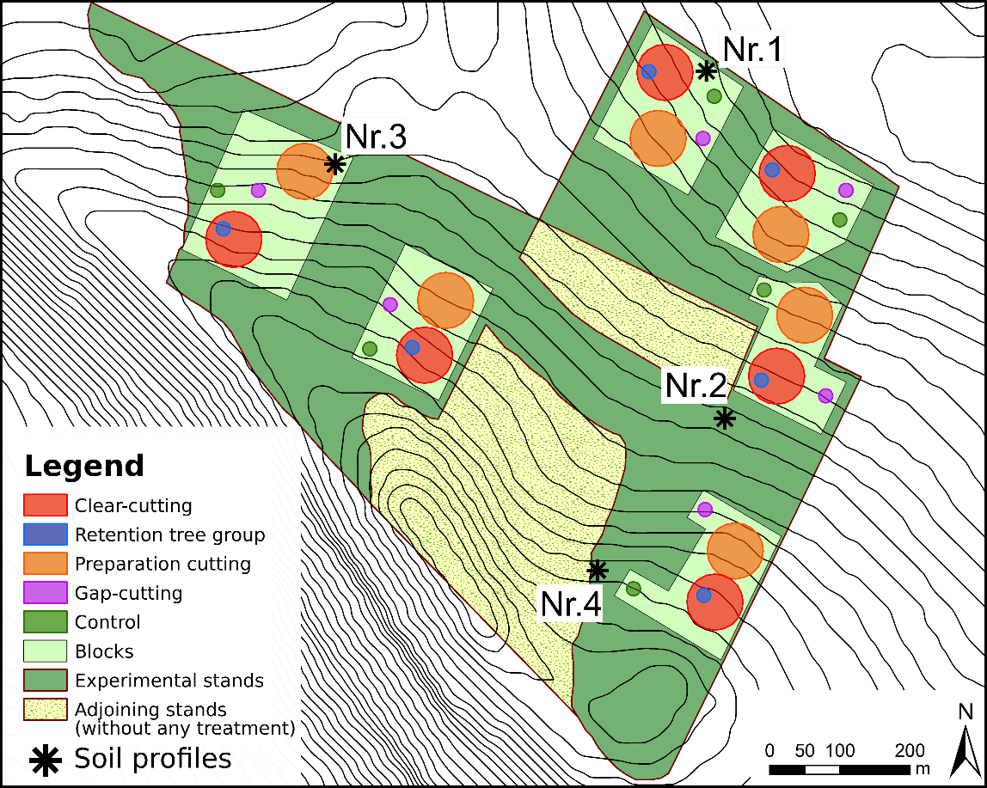
Figure S1.1. Four soil profiles were conducted across the experimental site for studying the soil conditions. All soil profiles were established and analyzed in 18-19 June 2014. The locations are marked with asterisks.

Here we present a short description of soil characterization in the localities shown on Figure A1.1. and a brief overview about the results of the four soil profiles. According to the (MSZ-08-0205:1978) standards the following variables are shown on the tables: # – the number of the layer distinguished by expert judgement; layer – upper and lower limit horizon (cm from mineral soil surface); Coarse fragments – volume of the coarse particles (%); pH – pH measured by using H₂O and KCl solutions, respectively; CaCO₃ – presence / content of carbonates within a given layer (%); y₁ – hydrolytic acidity; y₂ – exchangeable acidity; soil texture – the volumetric content of clay (<0.002 mm), silt (0.002-0.02 mm), fine sand (0.02-0.2 mm) and coarse sand (0.2-2 mm), separately (%); C – soil organic carbon content (%); N – total nitrogen content (%); P_{AL} – extractable phosphorus (mg/100 g soil); K_{AL} – extractable potassium (mg/100 g soil).
Soil pH was potentiometrically measured using supernatant suspension of 10 g air-dried and sieved (<2 mm) samples and 25 ml of distilled water (pH(H₂O)) and 25 ml of 1 mol/l KCL (pH(KCL)) solution, respectively (MSZ-08-0205:1978). In the case of y₁, 40 g air-dried soil samples were extracted with 100 ml 1 mol/l Ca(CH₃COO)₂ solution; regarding to y₂ extractions were made using unbuffered 1 mol/l KCl solution. In both cases measurements were performed by titration (Ballenegger and di Gléria 1962). Kuron’s method was applied for gauging hy of air-dry soils (Verstraeten & Livens, 1971): with 50% (v/v) H₂SO₄ solution and 35.2% RH according to (MSZ-08-0205:1978). Chemical compounds were evaluated on composite samples of the 1:1 mixture of the four, sieved (<0.5 mm) subsamples per plot. Total soil carbon and nitrogen content were determined by dry combustion method using Elementar vario MAX CNS-analyzer (Elementar Analysesysteme, Langenselbold, Germany) applying the ISO standards (ISO 10694:1995; ISO 13878:1998): soil samples were weighed up to 80-100 g, and a tungsten oxide catalyst was added. The applied combustion temperature was 1140°C. Plant available phosphorus and potassium were determined by ammonium lactate (AL) solution method (0.1M NH₄-lactate + 0.4 M HOAc, adjusted to pH 3.75) developed by Egnér et al. (1960 cf. Carter & Gregorich, 2008) according to the operative Hungarian standards (MSZ 20135:1999). P₂O₅was measured colorimetrically, K₂O₅was quantified by flame photometry.

Soil profile Nr.1
Bedrock:  loess with other sediments, limestone and sandstone stones and boulders are present  Genetic soil type:  brown forest soils with clay illuviation (luvisol)  Soil texture  loam / clay loam  Coarse fragments:  below the depth of 100 cm; 10 V/V%  Notes:  iron and manganese concretion in the deeper layers | 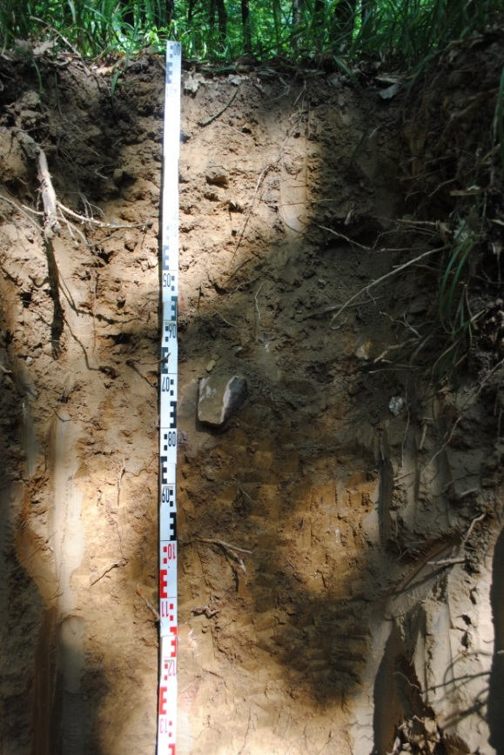

 | Layer (cm) | Coarse fragm. (%) | pH (H₂O) | pH (KCl) | CaCO₃  (%) | y₁ | y₂ | hy | Soil texture |  |  |  | SOC (%) | N  (%) | P₂O₅ | K₂O
 |  |  |  |  |  |  |  |  | Clay (%) | Silt (%) | Fine sand (%) | Coarse sand (%) |  |  | mg/100 g soil
1 | 0-10 | - | 4.9 | 4.0 | - | 30.74 | 21.89 | 2.08 | 23 | 34 | 37 | 6 | 4.57 | 0.20 | 2.6 | 9.5
2 | 10-20 | - | 4.6 | 3.7 | - | 30.01 | 21.70 | 1.74 | 21 | 30 | 43 | 6 | 2.05 | 0.10 | 1.5 | 6.3
3 | 20-40 | - | 4.8 | 3.7 | - | 26.52 | 21.70 | 1.93 | 9 | 46 | 39 | 6 | 1.90 | 0.10 | 0.4 | 6.6
4 | 40-70 | - | 4.8 | 3.7 | - | 19.17 | 18.03 | 2.40 | 33 | 26 | 35 | 6 | 1.40 | 0.08 | 1.6 | 7.8
5 | 70-100 | - | 5.1 | 3.7 | - | 12.58 | 11.09 | 2.86 | 33 | 24 | 36 | 7 | 0.60 | 0.05 | - | 8.0
6 | 100-150 | - | 6.1 | 5.2 | - | 8.82 | - | 2.81 | 29 | 30 | 37 | 4 | 0.62 | 0.04 | 1.9 | 6.4
7 | 150-200 | - | 7.4 | 6.9 | 15 | - | - | 1.75 | 17 | 28 | 42 | 13 | 0.85 | 0.03 | 1.6 | 5.1

Soil profile Nr.2
Bedrock:  loess with other sediments  Genetic soil type:  brown forest soils with clay illuviation (luvisol)  Soil texture:  loam / clay loam  Coarse fragments:  minimal  Notes:  iron and manganese concretion in the deeper layers | 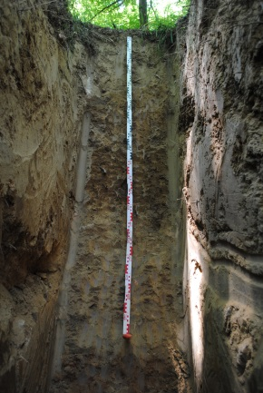

 | Layer (cm) | Coarse fragm. (%) | pH (H₂O) | pH (KCl) | CaCO₃  (%) | y₁ | y₂ | hy | Soil texture |  |  |  | SOC (%) | N  (%) | P₂O₅ | K₂O
 |  |  |  |  |  |  |  |  | Clay (%) | Silt (%) | Fine sand (%) | Coarse sand (%) |  |  | mg/100 g soil
1 | 0-10 | - | 4.6 | 3.7 | - | 39.01 | 23.38 | 1.95 | 23 | 26 | 45 | 6 | 3.97 | 0.19 | 4.0 | 7.5
2 | 10-20 | - | 4.4 | 3.5 | - | 37.41 | 26.23 | 1.64 | 21 | 30 | 43 | 6 | 2.52 | 0.13 | 1.0 | 5.3
3 | 20-50 | - | 4.7 | 3.6 | - | 25.10 | 20.01 | 1.64 | 21 | 32 | 41 | 6 | 1.21 | 0.07 | 0.2 | 5.2
4 | 50-90 | - | 5.1 | 3.8 | - | 13.57 | 10.08 | 2.84 | 31 | 30 | 34 | 5 | 0.58 | 0.04 | 2.2 | 8.8
5 | 90-130 | - | 5.5 | 4.8 | - | 10.39 | 4.77 | 2.91 | 29 | 30 | 35 | 6 | 0.46 | 0.04 | 6.2 | 8.8
6 | 130-210 | - | 7.8 | 6.8 | 5 | - | - | 1.83 | 17 | 32 | 44 | 7 | 0.72 | 0.04 | 2.8 | 5.4
7 | 210-250 | - | 7.7 | 6.9 | 2 | - | - | 3.80 | 39 | 20 | 28 | 13 | 0.47 | 0.04 | 2.9 | 7.2

Soil profile Nr.3
Bedrock:  limestone and loess with other sediments  Genetic soil type:  rendzic leptosol and brown forest soils with clay illuviation (luvisol)  Soil texture:  loam  Coarse fragments:  increasing downwards  Notes:  - | 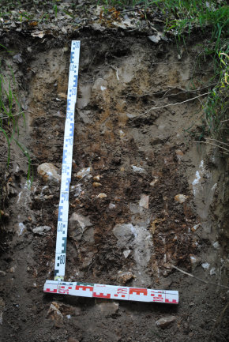

 | Layer (cm) | Coarse fragm. (%) | pH (H₂O) | pH (KCl) | CaCO₃  (%) | y₁ | y₂ | hy | Soil texture |  |  |  | SOC (%) | N  (%) | P₂O₅ | K₂O
 |  |  |  |  |  |  |  |  | Clay (%) | Silt (%) | Fine sand (%) | Coarse sand (%) |  |  | mg/100 g soil
1 | 0-10 | - | 4.6 | 3.7 | - | 40.89 | 20.49 | 2.23 | 19 | 28 | 44 | 9 | 5.70 | 0.26 | 0-10 | -
2 | 10-20 | - | 4.6 | 3.5 | - | 33.75 | 19.29 | 1.96 | 25 | 26 | 39 | 10 | 2.53 | 0.12 | 10-20 | -
3 | 20-30 | - | 5.3 | 4.1 | - | 18.08 | 7.33 | 2.36 | 29 | 26 | 34 | 11 | 2.25 | 0.12 | 20-30 | -
4 | 30-70 | 21 | 6.9 | 6.2 | - | - | - | 3.61 | 35 | 26 | 27 | 12 | 2.63 | 0.12 | 30-70 | 21

Soil profile Nr.4
Bedrock:  limestone and loess with other sediments  Genetic soil type:  brown forest soils with clay illuviation (luvisol)  Soil texture:  loam / clay loam  Coarse fragments:  minimal  Notes:  - | 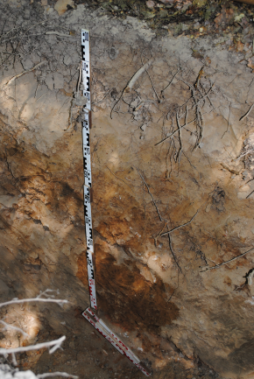

 | Layer (cm) | Coarse fragm. (%) |  | pH (H₂O) | pH (KCl) | CaCO₃  (%) | y₁ | y₂ | hy | Soil texture |  |  |  | SOC (%) | N  (%) | P₂O₅ | K₂O
 |  |  |  |  |  |  |  |  |  | Clay (%) | Silt (%) | Fine sand (%) | Coarse sand (%) |  |  | mg/100 g soil
1 | 0-10 |  | - | 47 | 3.6 | - | 31.99 | 16.63 | 1.44 | 11 | 26 | 44 | 19 | 3.66 | 0.15 | 3.0 | 6.4
2 | 10-20 |  | - | 4.3 | 3.6 | - | 25.39 | 19.12 | 0.99 | 11 | 26 | 42 | 21 | 2.04 | 0.08 | 0.8 | 3.5
3 | 20-50 |  | - | 4.3 | 3.5 | - | 24.71 | 24.11 | 0.99 | 13 | 26 | 41 | 20 | 0.89 | 0.05 | 0.5 | 2.8
4 | 50-80 |  | - | 4.7 | 3.5 | - | 24.16 | 23.02 | 2.11 | 25 | 22 | 38 | 15 | 0.59 | 0.04 | 0.1 | 6.1

Supplemental Information 2 – Additional information to the experimental site and treatments

Clear-cutting | 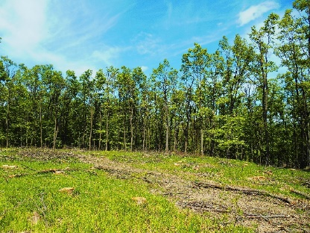 | 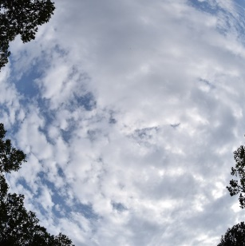
Retention tree group | 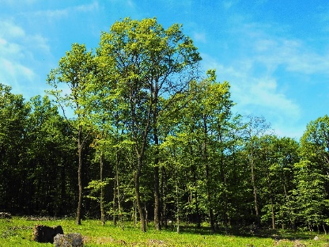 | 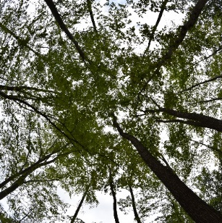
Preparation cutting | 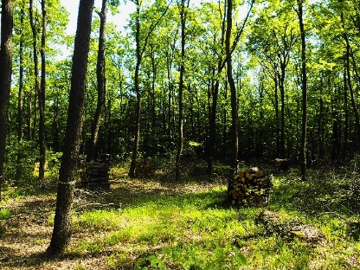 | 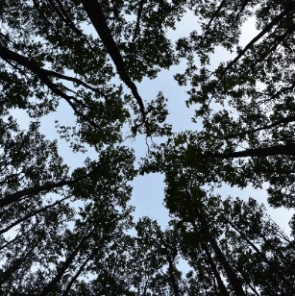
Gap-cutting | 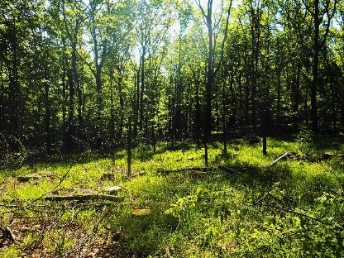
Control | 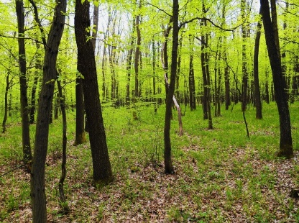 | 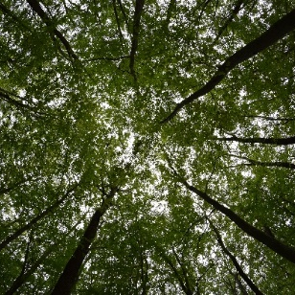

Figure S2.1. Stand and fish-eye photos of the treatments within the Pilis Experiment.
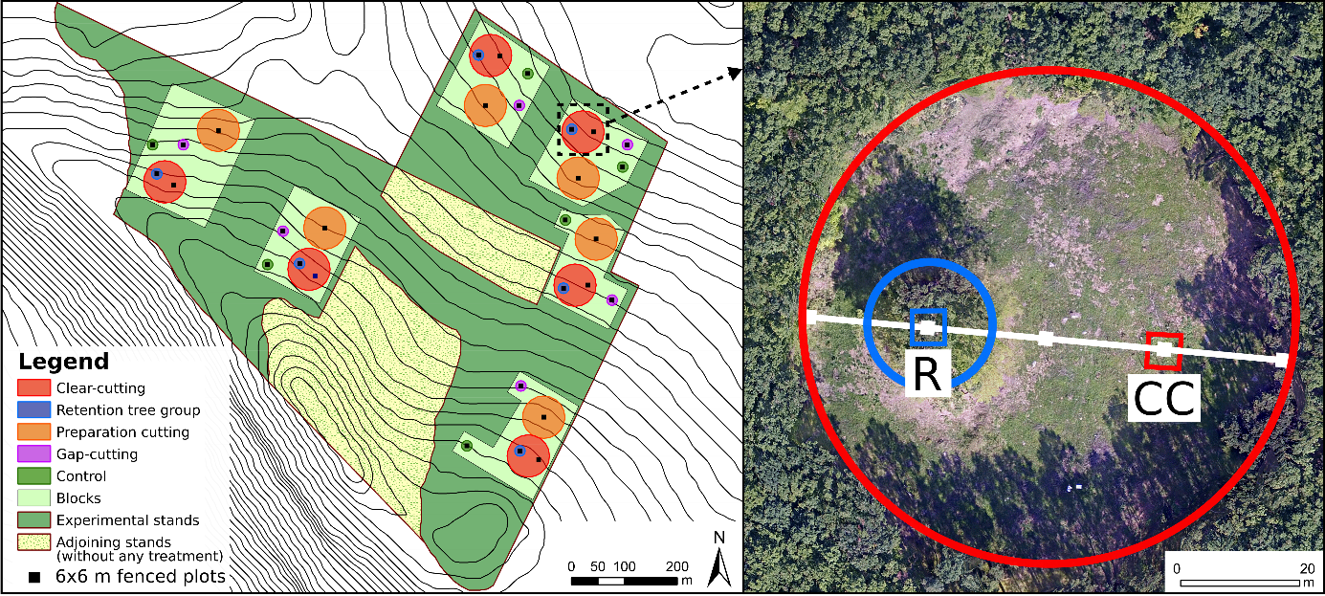

Figure S2.2. Spatial configuration of the measurement plots within the different treatment types.
The 6 × 6 m fenced plots are pictured as black squares (left panel). Plots of retention tree groups (R) and clear-cuttings (CC) were shifted to the 1:3 intersections along mainly the east-west diameter (photo on the right).

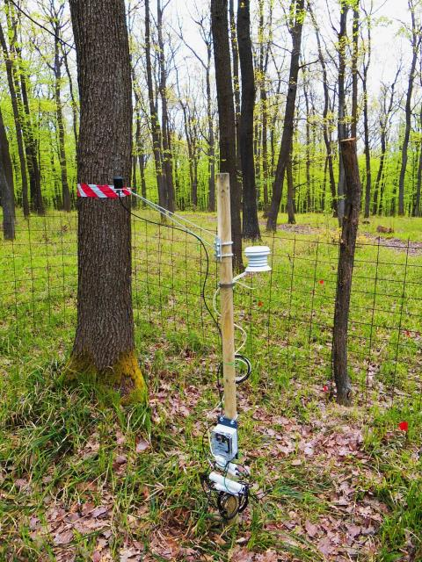
Soil water content and soil temperature sensor
Data logger
PAR sensor
Air temparature and relative humidity

Figure S2.3. The instrumentation of the microclimate measurements.
4-channeled Onset ‘HOBO H021-002’ data loggers (Onset Computer Corporation, Bourne, MA) were mounted on wooden poles. Photosynthetically active radiation (PAR, λ=400-700 nm) was measured at 150 cm above ground level using Onset ‘S-LIA-M003’ quantum sensors. Air temperature and relative humidity data were collected at 130 cm above ground level with Onset ‘S-THB-M002’ combined T/RH sensors housed in standard radiation shields to avoid direct sunlight. Soil temperature was measured with ‘S-TMB-M002’ 12-Bit temperature sensors by Onset placed 2 cm below ground. Soil water content were collected by Onset ‘S-SMD-M005’ soil moisture sensors buried 20 cm below ground level to measure the average soil moisture in 10-20 cm soil depth.
Supplemental Information 3 – Microclimate, litter and soil variables before and after the treatments

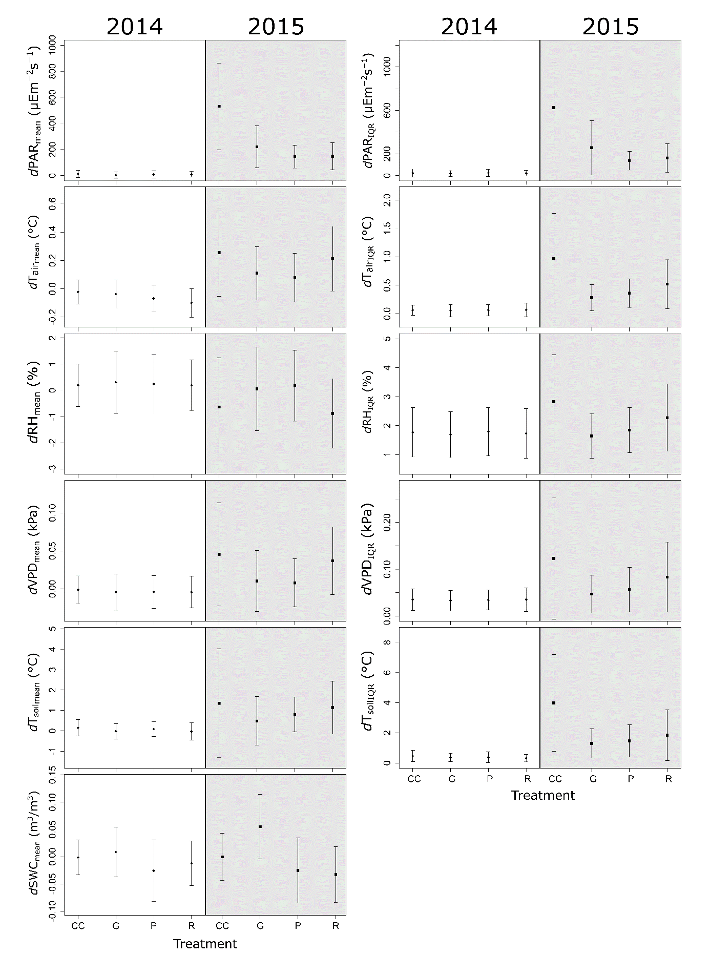
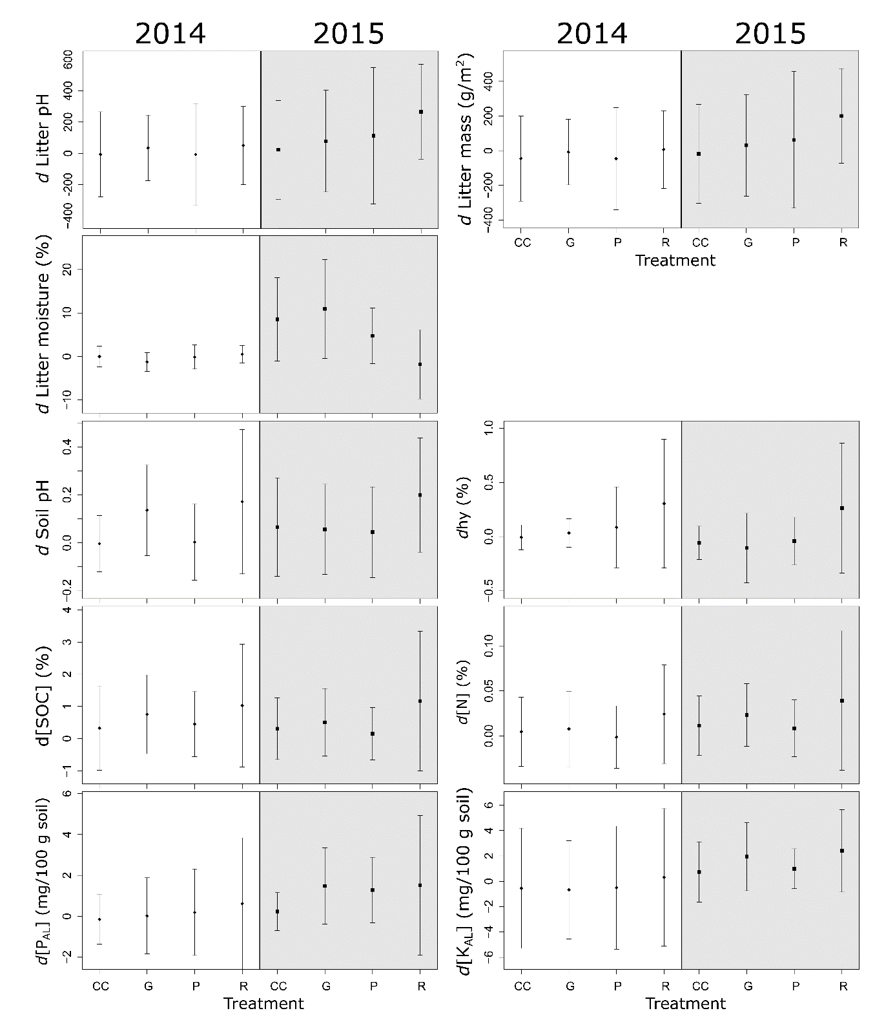Fig. S3.1. Microclimate, litter and soil variables before (2014) and after (2015) the treatments.
PAR: photosynthetically active radiation (μEm⁻²s⁻¹); DIFN: relative diffuse light (%);T_{air}: air temperature (°C); RH: relative humidity (%); VPD: vapor pressure deficit (kPa); T_{soil}: soil temperature (°C); SWC: soil moisture (m³/m³); Litter mass: total mass of collected litter on the surface (gm⁻²); Litter pH: litter pH in water; Litter moisture content: gravimetric moisture content of litter samples (%); Soil pH: soil pH in water; hy: Kuron’s hygrscopicity (%); [SOC]: total soil carbon content (%); [N]: total nitrogen content (%); [P_{AL}]: concentration of AL-soluble phosphorus (mg/100 g soil); [K_{AL}]: concentration of AL-soluble potassium (mg/100 g soil). Letter ‘d’ in the variable abbreviations refers to the differences from the mean values measured in the ‘Control’ plots. Full circles show the mean; vertical lines denote the standard deviation of the samples.

