Basin of Small Rivers as an Indicator of the Environment State
Olena Mitryasova¹, Volodymyr Pohrebennyk,²
¹ Petro Mohyla Black Sea National University, Ukraine
² Lviv Polytechnic National University, Ukraine

Corresponding Author:
Volodymyr Pohrebennyk
Gen. Chuprynka Street, 130, Lviv, 79057, Ukraine
Email address: volodymyr.d.pohrebennyk@lpnu.ua

Abstract
Background. Small rivers are an important component of the natural environment. Water resources of small rivers are part of the shared water resources and are often the main and sometimes the only one source of local water.
Small rivers are the regulators of the water regime of the landscapes, the factors for maintaining balance and redistribution of moisture.
The aim is analysis of interaction between parameters of the quality of the water environment like conductivity and nitrates on the example of natural waters of small rivers.
Objects are small rivers Bìst and Rosselle (Saardand lands, Germany) and Mertvovod (Mykolaiv region, Ukraine).
Methods. We used the method of correlative analysis which is effective and efficient for the determination of connections between the parameters of water quality that helps to identify sources of pollution, as well as interpret phenomena, forecast the situation related to the change in the quality of natural waters.
The hydrochemical monitoring data were obtained from autonomous automated stations that are located on the rivers Bist, Rossel and Mertvovod. We investigated the following correlation dependencies between such combinations of natural waters quality parameters: nitrates and conductivity. Monitoring data are processed using software MS Excel; correlation dependence was defined using the CORREL.
Results. Correlation value is changed in the range from −1 to + 1 that demonstrates the indirect and direct dependence between the selected parameters. If the value is closer to +1, this means the presence of a strong connection, if closer to 0 – weak. The time periods for the calculation of the correlation between the parameters of natural waters quality is selected: 4, 8, 16 and 24 hours respectively. The following time periods allow the best to trace and predict changes in the natural aquatic environment. Correlation analysis of the concentration of nitrates and conductivity showed that for r. Bìst and r. Rosselle dominates is the positive value of the correlation between the study parameters, which proves their strong interaction. However, at certain concentrations of nitrate-ions observed custom phenomenon of sharp decrease in correlation to the «-1», which is explained by the Onsager equation, namely an excess concentration of nitrates is associated with erosion of different types of fertilizers from the fields as a result of rainfall.
Discussion. Trend analysis of the studied indicators of Mertvovod water quality was conducted on an average value of each indicator (pH, phosphates, nitrates, BOD, soluble oxygen). We used trend analysis for Mertvovod because we did not have enough data in time. Found a significant increase in phosphates with time. This can be explained by the arrival of various surface active substances and, to a lesser extent, the lack of quality sewage treatment facilities. Positive changes are founded in water object that is related to a decrease in the value of BOD.
Keywords: small rivers; correlation method; trend analysis; monitoring of natural waters; quality indicators of the aquatic environment.
Introduction
Basin of a small river is a complex self-regulating system. Basin of small rivers is an indicator of the environment state, due to the level of anthropogenic load which are landscapes, soils, surface and underground water, flora and fauna, the atmosphere. Ecosystem of the small river first reacts to changes in the interaction of the system «human-society-nature». So the actual remains are monitoring of the small river condition (Vasenko, Ribalova, Poddashkin, 2010), (Klymenko, Prishchepa, Voznyuk, 2006), (Mitryasova et al., 2016), (Rybalova, 2011).
The main feature of the small rivers is their close ties with the landscape. Small rivers are the regulators of the water regime of the landscapes, the factors for maintaining balance and redistribution of moisture, as well as the factors that determine the hydrological and hydro chemical specific of medium and large rivers.
Purpose is an environmental analysis of the state of small rivers, to determine and analyze possible impacts on the state of the water object.
Objects are small rivers Bìst and Rosselle Saardand lands (Germany)and Mertvovod in Mykolaiv region (Ukraine).
The subject is the hydro-chemical indexes such as COD, phosphates and nitrates conductivity, nitrates of small rivers.
Materials & Methods
The following research methods were used: comparisons and analogies; analysis; observation; synthesis; generalization. The following study programs were used for the study: Google Maps, Microsoft Exсel, Origin software. Calculations are made using the correlation formulas 1 and 2 (River Rossel, 2013), (Rybalova, 2011):
(1)
$r= \frac{\sum{(x-\overline{x})(y-\overline{y})}}{\sqrt{\sum{{(x-\overline{x})}^{2}\sum{{(y-\overline{y})}^{2}}}}}$ r = -1; +1,
where $x$,$y$ are the numeric values of the variables, which set the correlation connection; where $\overline{x}$, $\overline{y}$ – – average arithmetic value.
$R= \sqrt{1-(1-r_{yx1}^{2})(1-r_{{yx2}/{x1}}^{2})}$ , (2)
r = 0; +1,
where $r_{yx1}$ – doubles correlation coefficient;
$r_{yх2/x1}$ – partial correlation coefficient.
To describe the magnitude of the correlation coefficient are the following, which are presented in table (Snedecor, Cochran, 1980):
Also in research we used such scientific methods: theoretical methods: analysis, synthesis, monitoring, systematization, generalization (Mazlum, Ozer, Mazlum, 1999), (Mitryasova et al., 2016), (Rybalova, 2011), (Snedecor, Cochran, 1980).
Table
The interpretation of the correlation coefficient
Value | The interpretation of the correlation coefficient
≤ 0,2 | very weak
≤ 0,5 | weak
≤ 0,7 | average
≤ 0,9 | high
≥ 0,9 | very high

The value of the correlation varies between + 1 and-1, respectively, showing the direct and indirect correlation dependency between selected parameters. If the value is closer to 1, then it means the presence of a strong connection, and if the closer to 0, then the weak. If the correlation coefficient is negative, it indicates the opposite: the higher the value of one variable, the lower the value of the other.
Water monitoring station (Saardand lands, Germany) allows you to get the results of tests for the determined water quality indicators every 5 minutes (fig. 1).
The Object of the Research
The research was carried out on the rivers Bìst and river Rosselle. Bìst is river, which flows in the Saarland (Germany) and Lorraine (France). The total length of the River is 26 km, of which 16.2 kilometers in Germany. Catchment area is 113 km ². The height of the leakage is 300 m. height of the 185 m. River flow is 1,01 m³/s. The river has a low ability to regenerate.
The main pollutant of r. Bìst in the upper and middle reaches are industrial discharges, the number of which has increased in recent years. Besides anthropogenic load has increased due to the high density of the population living along the river, and also as a result of agricultural use of the river (River Bist, 2013), (River Rossel, 2013), (Water Quality Indicators, 2018).
Point sampling on the Bìst is about 650 m to the mouth. Meteorological data is obtained from the meteorological station, which is located in 1 kilometer from sampling. R. Rosselle rises about 300 meters above sea level. R. Rosselle originates East of Bushpon (France), the length of the river is 38 km, 33 km, of which occurs in France. Catchment area covers 203 km², is located at 322 m above sea level. River basin consists of sands and rocks rich in Flint.
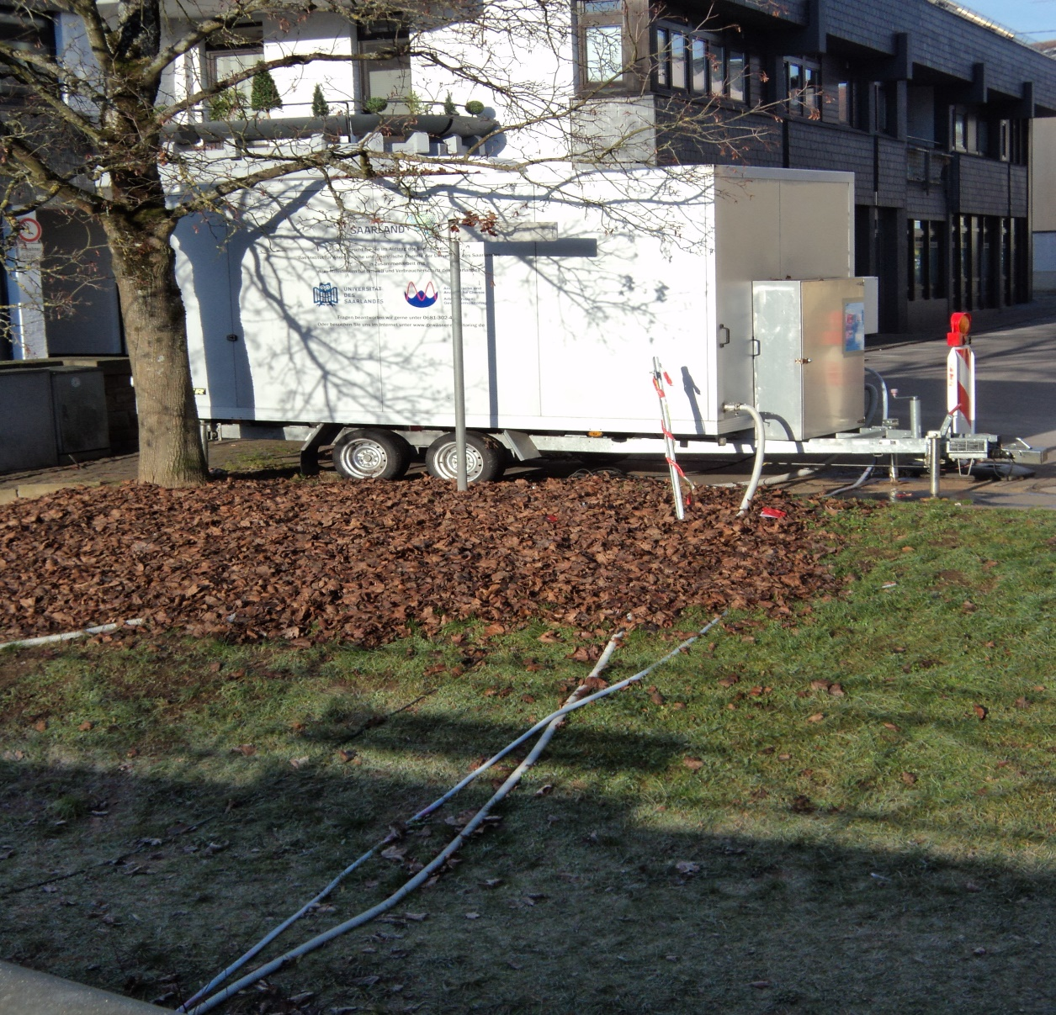
Fig. 1. Water monitoring station (Saardand lands, Germany) (Photo credit: Olena Mitryasova)
The river hard hit due to the extraction of coal. Mine and waste water discharged from coal industry enterprises in the area of the upper reaches of the river. River flow is 2,2 m³/s (River Basin Management, 2014), (Water Quality Indicators, 2018).
Another object is a small river Mertvovod in Mykolaiv region (Ukraine).
The length of the river is near 100 km, the area of the drainage basin is 1820 km². The river valley is predominantly trapezoidal, width up to 3 km, depth up to 40-50 m. The floodplain is 200-300 m wide, up to 1-1,5 km below the ground. The generator is twisted; its average width in the lower reaches is up to 20 m. The slope of the river is 1,8 m/km (South Bug River Basin), (Quality Measurements, 1997).
The Research Results and Discussions
The analysis of samples carried out for the following parameters: electrical conductivity of water is an indicator of geological conditions in the water region, and also reflects the industrial load on the water (Mazlum, Ozer, Mazlum, 1999), (Pohrebennyk, Romaniuk, 2013).
Conductivity (or specific conductance) of an electrolyte solution is a measure of its ability to conduct electricity. Conductivity measurements are used routinely in many environmental applications as a fast, inexpensive and reliable way of measuring the ionic content in a solution. In many cases, conductivity is linked directly to the total dissolved solids. Specific electric conductivity of thawing snow (60 mkSm/cm) approaches the conductivity of distilled water (15-30 mkSm/cm). Mineral water have values of specific electrical conductivity from 160 mkSm/cm to 750 mkSm/cm (Pohrebennyk, Romaniuk, 2013).
Electrical conductivity is a numerical expression of the capacity of a water solution to conduct electrical current. Electric conductivity of natural water depends largely from the concentration of dissolved mineral salts and temperature. Natural water is the solution mixtures of strong electrolytes. The mineral portion of water make up ions: Na⁺, K⁺, Ca²⁺, Cl⁻, SO₄²⁻ , HCO₃⁻. These ions showed electrical conductivity of natural waters. The presence of other ions, such as Fe³⁺, Fe²⁺, Mn²⁺, Al³⁺, NO₃⁻, HPO₄⁻, H₂PO₄⁻ especially not affect into conductivity (Water Quality Indicators, 2018).
The value of the conductivity shows the degree of mineralization of natural waters. Complications arise when evaluating the total content of mineral substances (salinity) from specific electrical conductivity is associated with different specific electrical conductivity of solutions of various salts with increased electrical conductivity with increasing temperature. Conductivity value is roughly measure the total concentration of electrolytes, mainly inorganic, and used in programs of observations as the water environment for assessing salinity waters. Specific electrical conductivity is a convenient total indicator of anthropogenic influence, is an indicator of geological conditions and also reflects the industrial load onto water basin (South Bug River Basin).
Electric conductivity of natural waters depends on the concentration of dissolved mineral salts and temperature. Pure water is characterized by a very low electrical conductivity, water saturated chemical compounds characterized by high electrical conductivity.
Nitrates are an indicator that explains of eutrophication’s reason; is used as an important indicator of diffuse pollution by fertilizers (leaching from the soil), as well as the characteristics of the sewage works. In fig. 2 shows the graph of correlation relationship between electrical conductivity and NO₃─.

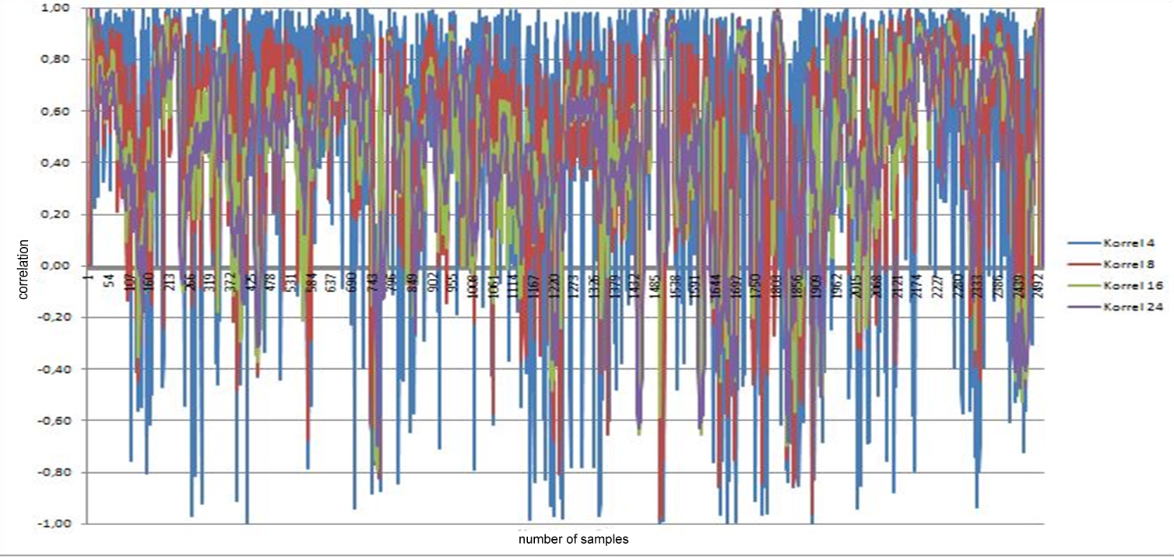
Fig. 2. Diagram of correlation between electrical conductivity and NO₃─

The fig. 3, which was investigated, is the electrical conductivity of natural water, which depends on the concentration of dissolved mineral salts and temperature.
Fig. 3 exhibits a clear shift from the correlation value «+» to «−». Nitrate concentration gradually increases and reaches a value of 6,5 mg/l (MPC ≤ 5 mg/l), which leads to an increase in the electrical conductivity of the water, which reaches 350 mkSm/cm (MPC 300mkSm/cm).
After samples №22 (fig. 3 and 4) observed custom phenomenon between the parameters. The concentration of nitrates continues to increase with decreasing values of electrical conductivity of the water environment.
Dominant is the positive value of the correlation between the study parameters. Exception of this dependence can be traced, starting with 22 tests and then, when the correlation between electrical conductivity and concentration of nitrates is «-1». This pattern is a confirmation of the Onsager equation, which proves that when increasing the concentration of relatively large size of nitrate-ions decreases their mobility in water, which is the reason for the decreasing conductivity. It is an excess concentration of nitrates is associated with erosion of different types of fertilizers from the fields as a result of rainfall.
The correlation between electrical conductivity and nitrates in the river Rosselle, has mostly positive nature, i.e. traced dependency, when the increase of nitrates in water leads to an increase in electrical conductivity. However, the correlation between the tests is definitely a negative character values of the correlation at this period reaches the "-1".
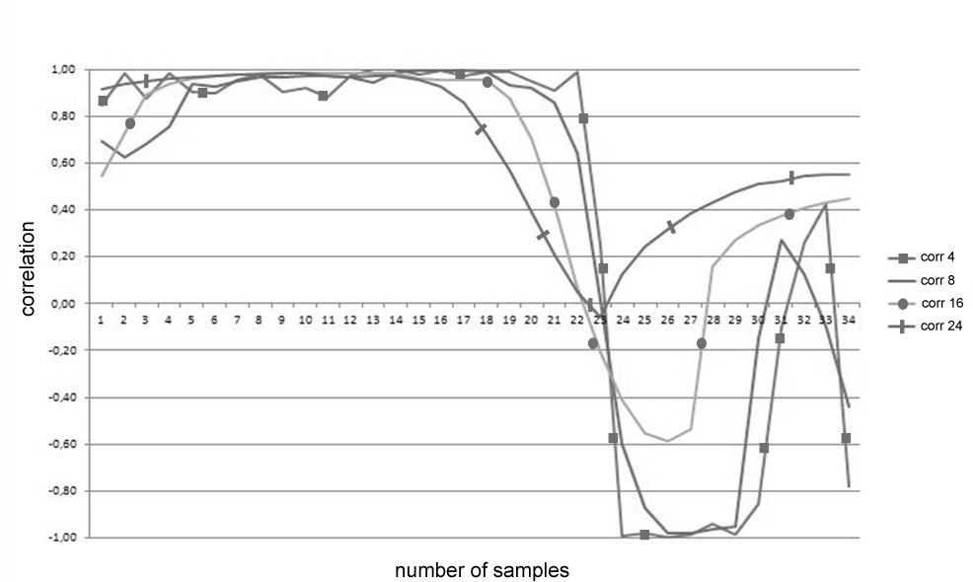
Fig. 3. Graph the correlation dependence between electrical conductivity
and NO₃─ (r. Bist)
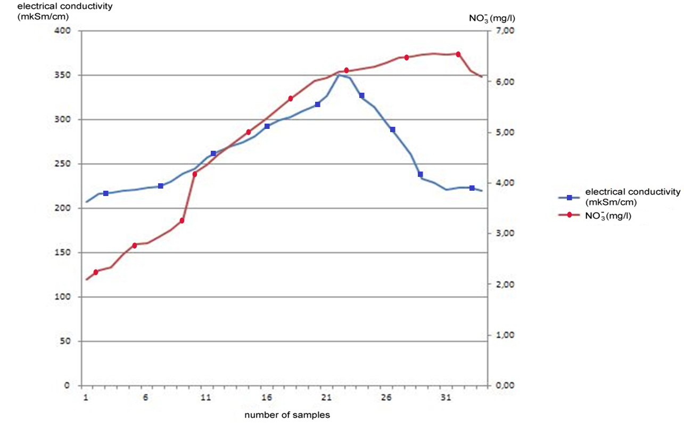
Fig. 4. Graph the relationship between electrical conductivity (mkSm/cm) and NO₃─ (mg/l)
r. Bist
The increase in the concentration of nitrate increases the conductivity of the water to a certain boundaries. Nitrate concentration reaches a level of 6 mg/l (MPC ≤ 5 mg/l), which leads to an increase in the electrical conductivity of the water, which reaches 350 mkSm/cm (MPC 300mkSm/cm).
Dependence of electrical conductivity of concentration has a maximum, and then the increasing of the concentration of electrolyte aqueous solution leads to a decrease of the conductivity. In this case, this amount to a maximum is 6mg/l, which is exceeding the maximum admissible values.
Electrical conductivity is determined by the amount of electricity that is transferred through the cross-section of conductors. Conductivity depends on the nature of the electrolyte and the solvent, temperature, concentration of the electrolyte. Electrical conductivity of solutions depends on the number of ions in a unit volume of solution from u of mobility of these ions, i.e. from the ease with which they move in an electric field.
Electrical conductance is caused by a number of carriers, i.e., ions, as well as the speed of their movements. In the area of dilute electrolytes speed little depends from the concentration and electrical conductance rises almost directly proportional to the concentration.
As the increasing of concentration interaction between the ions will be intensified, ion density of the atmosphere will be increased, which leads to a decrease in velocity of the ions. This effect begins to prevail over the increase in the number of ions, so at high concentrations the electrical conductivity is reduced. After sample № 24 (fig. 4, 5) the concentration of nitrates continues is increased, and the conductivity of the water environment is reduced.
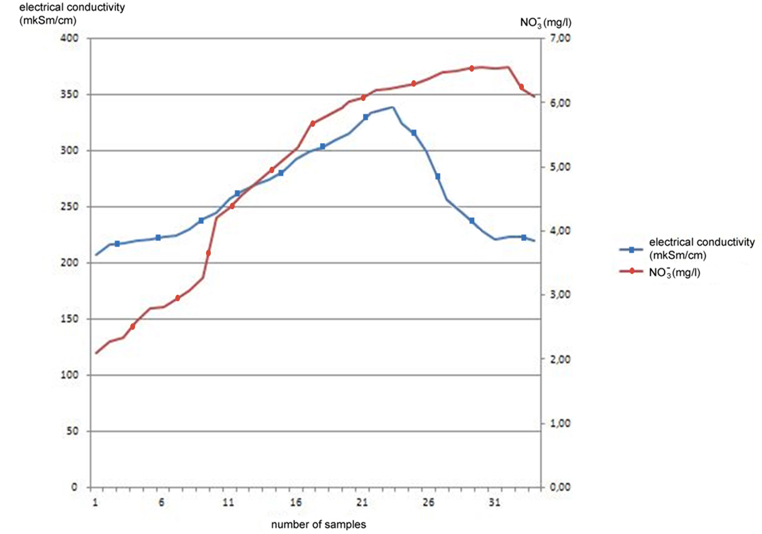
Fig. 5. Graph the relationship between electrical conductivity (mkSm/cm)
and NO₃─ (mg/l) r. Rosselle
Trending analysis of the studied indicators of Mertvovod water quality was conducted on an average value of each index. We used trend analysis for Mertvovod because we did not have enough data in time. Found a significant increase in phosphates with age, with a coefficient of correlation R=0,71 (fig. 6), indicating that contamination of the water facility. This phenomenon can to explain by using of various detergents with waste dumping and to a greater extent with the lack of quality sewer facilities.
Positive changes are founded that is conect with decrease in the content of COD (fig. 7), which indicates about reduction in the use of oxygen on oxidation of inorganic and organic substances.
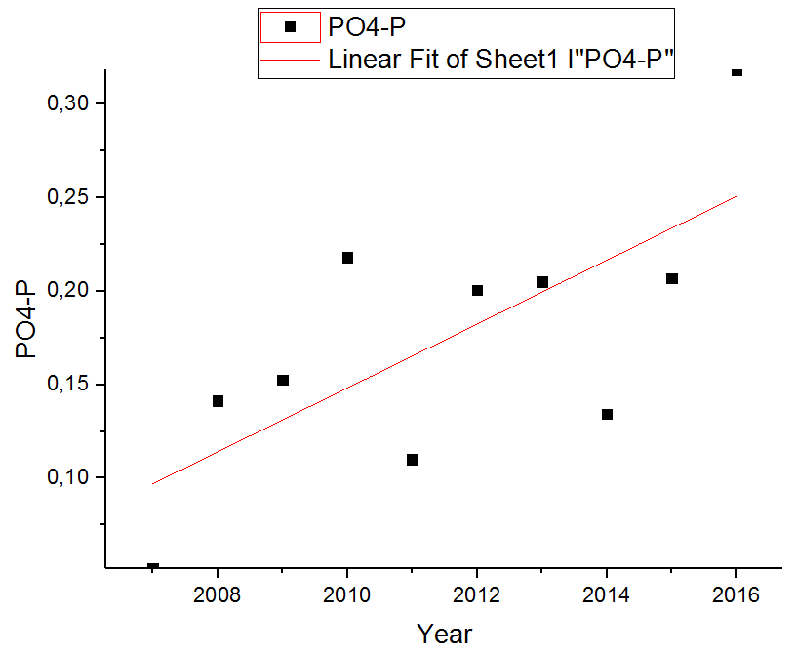
Pearson R = 0,71
Fig. 6. Dependence of concentration of phosphates with years
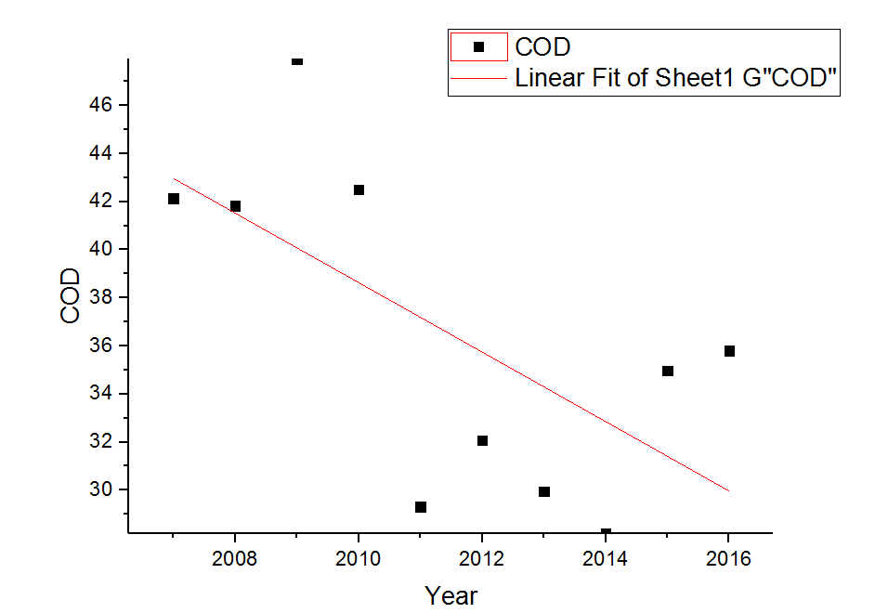
Pearson R= - 0,65

Fig. 7. The dependence of the COD with years
Conclusions
The status of the small river is an indicator of the water security of natural surface water.
Large drainage basins carry the influence of many factors that gives the opportunity to identify and predict events, therefore, for the prevention and suppression of sources of pollution of the water environment of large rivers it is necessary to analyze in detail the state of water quality of small rivers.
The method of correlative analysis is useful for the detection of custom periods between the parameters of water quality, which further helps to identify sources of pollution, interpret phenomena and predict the situation related to the change in the quality of the water environment.
Correlation analysis of the concentration of nitrates and conductivity showed that for r. Bìst and r. Rosselle dominates is the positive value of the correlation between the study parameters, which proves their strong interaction. However, at certain concentrations of nitrate-ions observed custom phenomenon of sharp decrease in correlation to the «-1», which is explained by the Onsager equation, namely an excess concentration of nitrates is associated with erosion of different types of fertilizers from the fields as a result of rainfall.
Using the data of correlative analysis, you can manage processes that occur in water basins. Established and documented dependencies can be used not only for the study of rivers Bìst and Rosselle, as well as for any natural pools for the analysis and explanation of the processes that occur in the aquatic environment.
Using of trend analysis for r. Mertvovod gave a clear idea about the change of each indicator over the years. A significant increase by phosphates is detected, which is associated with the collection of cleansers with domestic waters and more with the lack of quality sewer facilities. A significant reduction of COD over the years is detected.
Further perspective is the study of the ways of reducing intake of phosphates to water facility by the reconstruction and improvement of sewage. It is also relevant to further study the dependencies between water quality indicators, as well as their interpretation.
Acknowledgements
We would kindly thank the department of inorganic and analytic chemistry of the Saarland University (Germany) for the opportunity to conduct the experimental work in the framework of the project DAAD.
References
Klymenko, M., Prishchepa, A, Voznyuk, N. (2006) Monitoring of the Environment: tutorial / M. O. Klymenko, – K.: «Alma Mater», 360 p. (in ukr.)
Mazlum, N, Ozer, A, Mazlum, S. (1999) Interpretation of Water Quality by Principal Components Analysis. Tropical Journal of Engineering and Environmental Science, 23, 19-26.
Mitryasova, O., Pohrebennyk, V. & others (2016) Environmental Natural Water Quality Assessment by Method of Correlation Analysis, Conference Proceedings. «16th International Multidisciplinary Scientific Geoconference SGEM 2016», (Albena, Bulgaria, 30 June – 6 July 2016), Book 5, Volume II, Ecology and Environmental Protection, 317–324.
Pohrebennyk, V., Romaniuk, A. (2013) Computer-informatition System for Operational Ecological Monitoring Water Environment: monograph, Lviv: Lviv Polytechnic National University, 160 p. (in ukr.)
Quality Measurements of the Composition and Properties of Environment Objects and Sources of their Pollution, Ukraine, Kyiv, Mìnecosecurity, 1997, 662 p. (in ukr.).
River Basin Management Plan for Pivdenny Bug: river basin analysis and measures. Available at https://www.researchgate.net/profile/Sergey_Afanasyev2/publication/268180951_Project_
financed_by_Swedish_International_Development_Agency_INSTITUTIONAL_STRENGTHENING_AND_CAPACITY_BUILDING_FOR_THE_UKRAINIAN_RIVER_BASIN_MANAGEMENT_AUTHORITY_River_Basin_Management_Plan_for_Pivden/links/546353120cf2c0c6aec3a9ee/Project-financed-by-Swedish-International-Development-Agency-INSTITUTIONAL-STRENGTHENING-AND-CAPACITY-BUILDING-FOR-THE-UKRAINIAN-RIVER-BASIN-MANAGEMENT-AUTHORITY-River-Basin-Management-Plan-for-Pivden.pdf
River Bist [Electronic resource] ─ Available at http://www.gewaesser-monitoring.de/userfiles/downloads/Bericht_Bist_2013.pdf
River Rossel [Electronic resource] ─ Available at http://www.gewaesser-monitoring.de/userfiles/downloads/Bericht_Rossel_2013.pdf
Rybalova, O. V. (2011) Comprehensive Approach to the Determination of the Ecological State of the Basin of Small Rivers, Problems of Environmental Protection and Technological Safety. - Collection of scientific papers UkrSRI. - Kharkiv, P. 88-97. (in ukr.)
Snedecor, G.W. Cochran, W.G. (1980) Statistical Methods. 7th edition. Iowa State University Press, Ames, 507 p.
Vasenko, O.G., Ribalova, O.G, Poddashkin, O.V. (2010) Hierarchical Approach to Evaluation of Ecological Risk Worsening the State of Surface Water Ecosystems, Problems of Environmental Protection and Ecological Security: A Collection of Scientific Papers, Rider, 32, 75-90. (in ukr.)
Water Quality Indicators [Electronic resource] ─ Available at http://www.gewaesser-monitoring.de/en/?Water-Quality-Indicators, 2018.
Water Security, monography: Petro Mohyla Black Sea National University, University of the West of England, editor: prof. Olena Mitryasova & prof. Chad Staddon, 2016
Weather in Saarbruken [Electronic resource]. Available at http://www.weatherbase.com/weather/weather.php3?s=80701&cityname=Saarbrucken-.

