Appendix C

Paper: “Exploring the effects of the correlation within and between data tables on Procrustes analysis output: interpretation for ecologists”
Francy J. G. Lisboa ^{a,b*}, Ruth J. Mitchell ^{b}, Stephen Chapman ^{b}, Jacqueline M. Potts^{c}, Ricardo L. L. Berbaraª
ª Soil Science Department, Agronomy Institute, Federal Rural University of Rio de Janeiro, Seropédica-RJ, 23890000, Brazil
^{b} The James Hutton Institute, Craigiebuckler, Aberdeen, AB15 8QH United Kingdom.
^{c} Biomathematics & Statistics Scotland, Craigiebuckler, Aberdeen, AB15 8QH

* Corresponding author: Tel/Fax 55 21 26828045; email address: agrolisboa@gmail.com

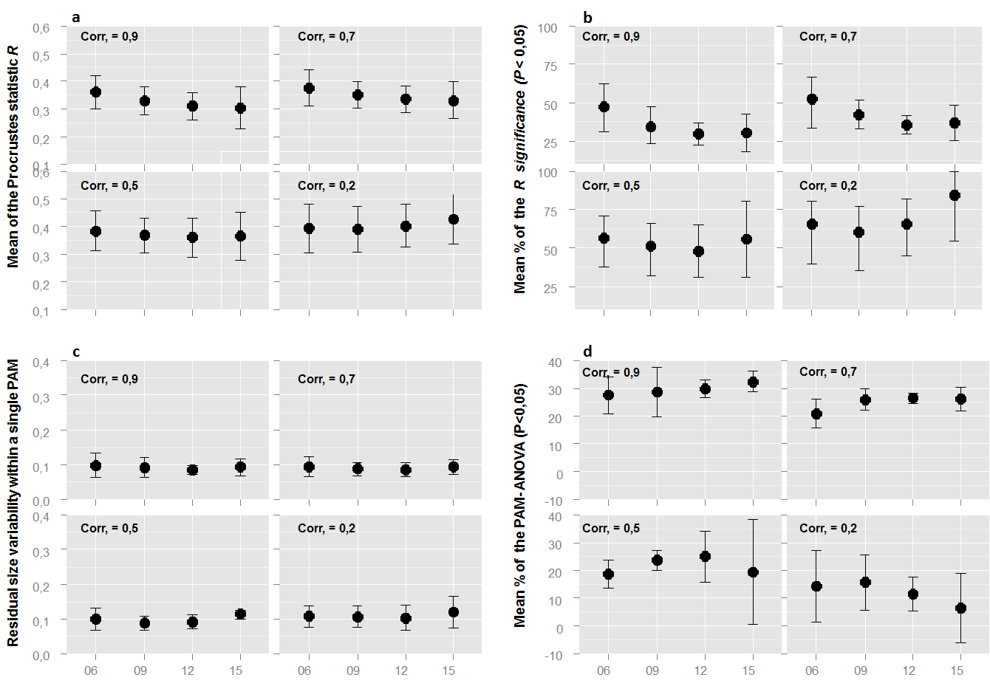
Figure 1. Effects of increasing number of correlated variables (6, 9, 12, and 15) across different correlation levels (0.2, 0.5, 0.7, 0.9) within the X data table on Procrustes results when use both, X and Y data tables, as ordination axes – based matrices. A) Effect on Procrustes correlation statistic R; B) Effect on significance of Procrustean relationship (P value); C) Effect on residual size ranging within the vector of relationship (Procrustean association metric: PAM); D) Effect on ANOVA significance by using the PAMs as response and land use type (4 levels) as categorical predictor. The X (soil fertility) and the Y (PLFA profile) data tables are derived from Lisboa et al. (2014b). The correlation within Y data table was held fixed (original correlation structure). Means ± 1 SE of 8 pre-Procrustes transformations related to ordination axes – based matrices simulated 100 times are shown (Fig. 1).

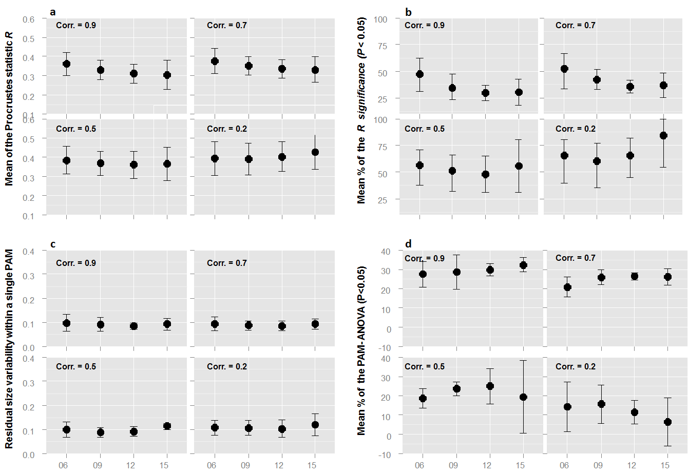
Figure 2. Effects of increasing number of correlated variables (6, 9, 12, and 15) across different correlation levels (0.2, 0.5, 0.7, 0.9) within the X data table on Procrustes results when use both, X and Y data tables, as dissimilarity/distance matrices. a) Effect on Procrustes correlation statistic R; b) Effect on significance of Procrustean relationship (P value); c) Effect on residual size ranging within the vector of relationship (Procrustean association metric: PAM); d) Effect on ANOVA significance by using the PAMs as response and land use type (4 levels) as categorical predictor. The X (soil fertility) and the Y (PLFA profile) data tables are derived from Lisboa et al. (2014b). The correlation within Y data table was held fixed (original correlation structure). Means ± 1 SE of 4 pre-Procrustes transformations related to dissimilarity/distance matrices simulated 100 times are shown (Fig. 1 c).

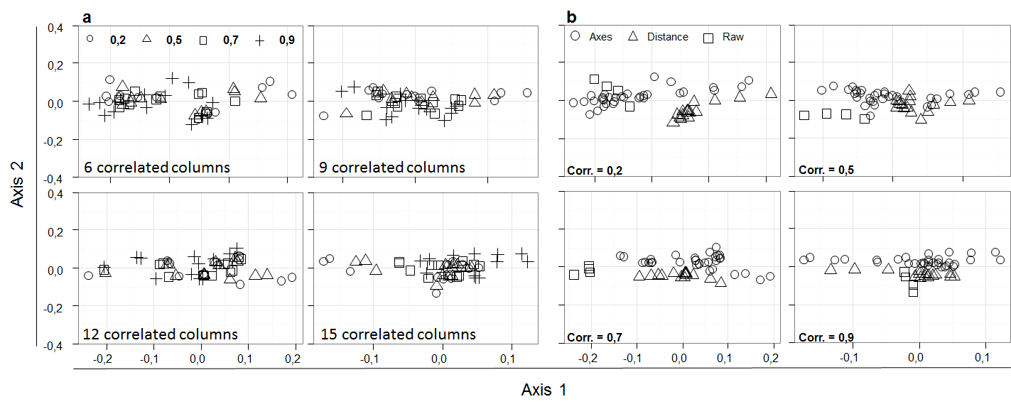
Figure 3. Effect of increasing the number of variables/columns correlating in the X data table (soil fertility) on the ordination of Procrustes residual vectors (PAMs) retained from Procrustes relationships. The X (soil fertility, n=53, p=15) and the Y (PLFA profile, n=53, p=20) data tables are derived from Lisboa et al. (2014b). Four each correlation levels (0.9, 0.7, 0.5, and 0.2) the number of correlated columns increases from 6 to 15 (total soil fertility variables). The correlation structure within the Y data table was held fixed (original correlation structure). In A, PAMs are grouped according to the number of variables correlating in X (6, 9, 12, and 15) in a given correlation level (0.9, 0.7, 0.5, and 0.2). In B, the PAMs are grouped based on the correlation level in a given number of correlated columns in X. Each symbol represents the mean PAM from 100 simulations of each pre-Procrustes transformations described in (Fig. 1 c) of the main text.

Literature cited
Lisboa, F. J. G; Chaer, G. M; Fernandes, M. F; Berbara, R. L. L; Madari, B. E. 2014. The match between microbial community structure and soil properties is modulated by land use types and sample origin within an integrated agroecosystem. Soil Biology and Biochemistry 78: 97-108

