

**Figure S1**. Map of sampled wetland sites over Sweden. Right panel: boxplots of the number of observations and sampled area per region.

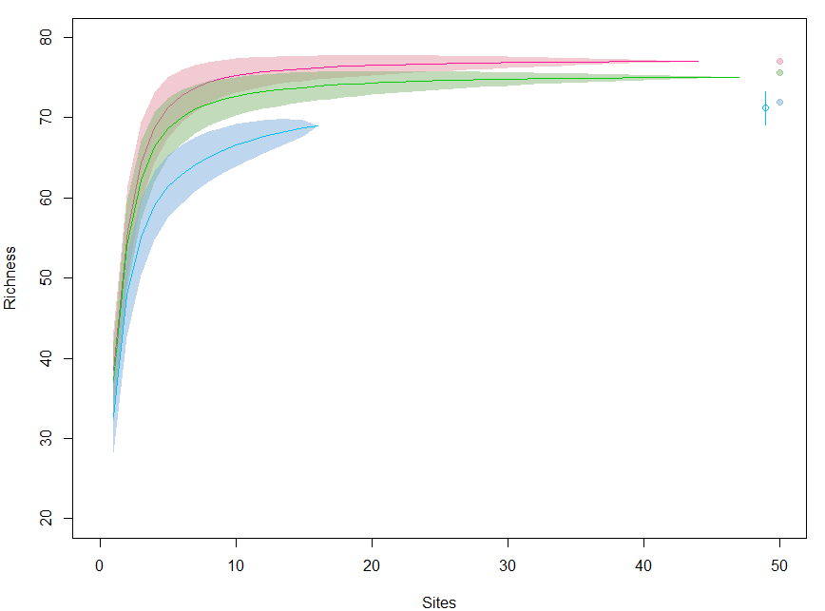

**Figure S2.** Species accumulation curves (same colors as Figure S1) obtained with function *specaccum* from the ´vegan´ package for R. Filled dots are the asymptote of the richness accumulation curves regional estimated as the sum of all species observed at least once *(S1d*) per region. Empty dot and whisker is species accumulation curve using bootstrap (function *specpool* from R package ´vegan´).

**Table S1**: parameter estimates and model evaluation of all models fitted to local richness estimates.

|  |  |  |  |  |  |  |  |  |  |  |  |  |  |  |
| --- | --- | --- | --- | --- | --- | --- | --- | --- | --- | --- | --- | --- | --- | --- |
|  | Observed | | | |  | Spread | | | |  | Consecutive | | | |
| **1d** | Intercept | %Incr/Unit | p-value | AIC |  | Intercept | %Incr/Unit | p-value | AIC |  | Intercept | %Incr/Unit | p-value | AIC |
| Null | 53.3 | NA | 0 | 756.8 |  | 66.7 | NA | 0 | 662.3 |  |  |  |  |  |
| Area | 53.3 | 3.83 | 0.003 | 750.3 |  | 66.7 | 1.05 | 0.375 | 663.6 |  |  |  |  |  |
| log(Area) | 53.2 | 1.55 | 0.002 | 749.3 |  | 66.7 | 0.31 | 0.482 | 663.8 |  |  |  |  |  |
| NoVisits | 53.1 | 9.21 | 0 | 707.6 |  | **66.6** | **1.86** | **0.113** | **661.9** |  |  |  |  |  |
| log(NoVisits) | **53.0** | **4.14** | **0** | **692.2** |  | 66.6 | 0.65 | 0.141 | 662.2 |  |  |  |  |  |
| Comb | 53.0 | NA | 0.157 | 692.2 |  | 66.6 | NA | 0.567 | 663.5 |  |  |  |  |  |
| **20d** |  |  |  |  |  |  |  |  |  |  |  |  |  |  |
| Null | 14.5 | NA | 0 | 1768.7 |  | 47.2 | NA | 0 | 661.0 |  | 34.4 | NA | 0 | 661.5 |
| Area | 14.3 | 14.58 | 0 | 1735.1 |  | 47.2 | 2.03 | 0.145 | 660.9 |  | 34.4 | 2.79 | 0.085 | 660.6 |
| log(Area) | 14.2 | 8.91 | 0 | 1701.9 |  | 47.2 | 0.47 | 0.375 | 662.2 |  | 34.4 | 0.62 | 0.311 | 662.5 |
| NoVisits | 12.6 | 54.68 | 0 | 1140.7 |  | **47.2** | **3.72** | **0.007** | **655.9** |  | **34.4** | **5.11** | **0.001** | **653.6** |
| log(NoVisits) | **11.1** | **37.22** | **0** | **854.9** |  | 47.2 | 1.21 | 0.021 | 657.7 |  | 34.4 | 1.39 | 0.023 | 658.4 |
| Comb | 11.1 | NA | 0.479 | 856.4 |  | 47.2 | NA | 0.362 | 657.1 |  | 34.4 | NA | 0.286 | 654.5 |
| **30d** |  |  |  |  |  |  |  |  |  |  |  |  |  |  |
| Null | 8.3 | NA | 0 | 1827.1 |  | 41.7 | NA | 0 | 664.4 |  | 26.7 | NA | 0 | 665.8 |
| Area | 8.1 | 20.48 | 0 | 1787.7 |  | 41.7 | 2.76 | 0.061 | 662.9 |  | 26.7 | 2.71 | 0.142 | 665.7 |
| log(Area) | 8.0 | 12.24 | 0 | 1761.5 |  | 41.7 | 0.66 | 0.241 | 665.0 |  | 26.7 | 0.63 | 0.369 | 667.0 |
| NoVisits | 6.3 | 77.32 | 0 | 1069.6 |  | **41.7** | **4.57** | **0.002** | **656.8** |  | **26.7** | **5.61** | **0.002** | **658.5** |
| log(NoVisits) | **4.9** | **60.00** | **0** | **801.9** |  | 41.7 | 1.42 | 0.011 | 660.0 |  | 26.7 | 1.41 | 0.044 | 663.7 |
| Comb | 4.8 | NA | 0.522 | 803.5 |  | 41.7 | NA | 0.217 | 657.3 |  | 26.7 | NA | 0.408 | 659.8 |
| **45d** |  |  |  |  |  |  |  |  |  |  |  |  |  |  |
| Null | 3.4 | NA | 0 | 1267.0 |  | 34.2 | NA | 0 | 679.1 |  | 18.0 | NA | 0 | 663.6 |
| Area | 3.2 | 37.11 | 0 | 1208.2 |  | 34.2 | 3.83 | 0.018 | 675.6 |  | 18.0 | 2.96 | 0.186 | 663.9 |
| log(Area) | 3.1 | 23.01 | 0 | 1193.2 |  | 34.2 | 0.86 | 0.167 | 679.1 |  | 18.0 | 0.88 | 0.303 | 664.5 |
| NoVisits | 1.9 | 114.77 | 0 | 583.4 |  | **34.1** | **6.26** | **0** | **666.2** |  | **18.0** | **6.04** | **0.006** | **658.3** |
| log(NoVisits) | **1.1** | **115.21** | **0** | **399.1** |  | 34.2 | 1.84 | 0.003 | 672.2 |  | 18.0 | 1.29 | 0.128 | 663.3 |
| Comb | 1.1 | NA | 0.614 | 400.9 |  | 34.1 | NA | 0.12 | 665.8 |  | 18.0 | NA | 0.452 | 659.7 |