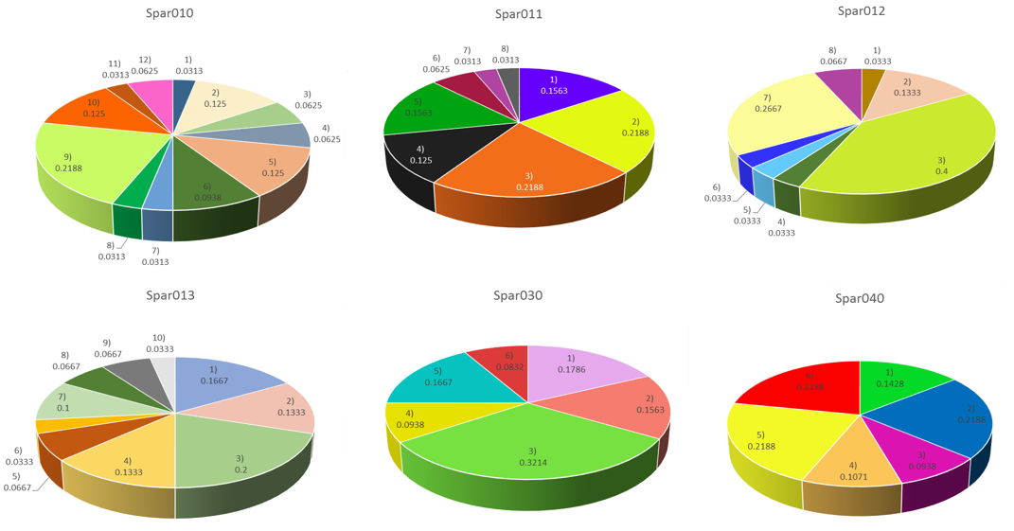
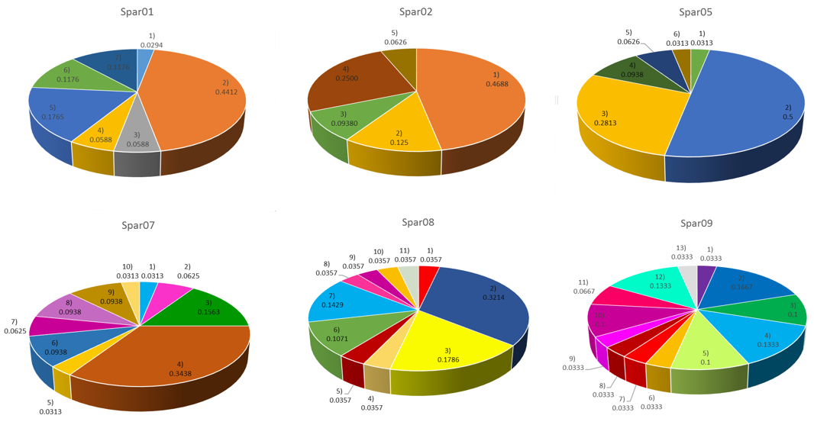
Supplementary material 2: Allelic frequencies of amplified microsatellite loci, inner numbers represent the absolute frequencies of the different alleles.

