Membrane and luminal proteins reach the apicoplast by different trafficking pathways in the malaria parasite Plasmodium falciparum
Rahul Chaudhari, Vishakha Dey, Aishwarya Narayan, Shobhona Sharma, Swati Patankar

Supplementary Images showing raw data for the blots for Figure 1C, Figure 6A and Figure 6E

We reproducibly find single bands on Western blots with the antibodies against PfTPx_{Gl} (Chaudhari et al, 2012 and subsequent experiments done in the lab) and only pre-processed and processed proteins for ACP-GFP using anti-GFP antibodies. No bands are developed by the antibodies in any other parts of the blot. Therefore, a few of these blots were cut before development so as to save on antibodies and because two different antibodies had to be used on different parts of the same blot.

Supplementary Image 1: Blot for ACP-GFP panel in Figure 1C
Supplementary Image 2: Blot for PfTPx_{Gl} panel in Figure 1C
Supplementary Figure 3: Loading Control in Figure 1C
Supplementary Image 4: Blot for ACP-GFP panel in Figure 6A
Supplementary Image 5: Blot for PfTPx_{Gl} panel in Figure 6A
Supplementary Image 6: Blot for ACP-GFP panel in Figure 6E
Supplementary Image 7: Blot for PfTPx_{Gl} panel in Figure 6E

Supplementary Image 1
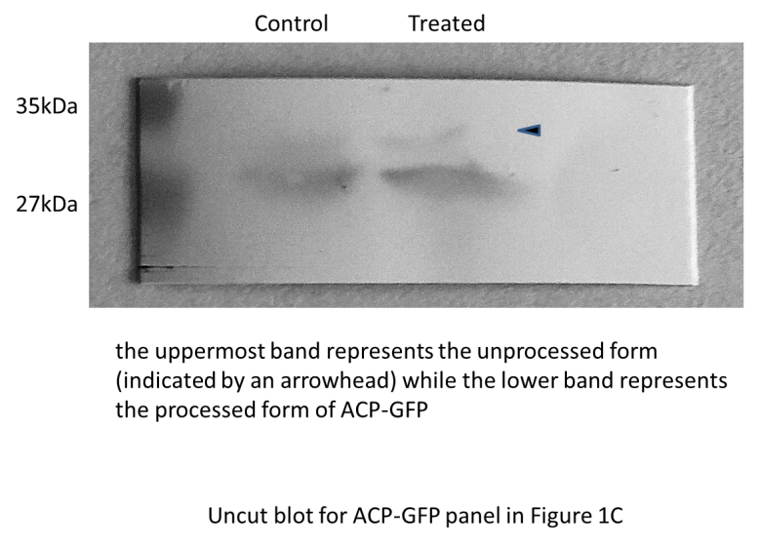

Supplementary Image 2
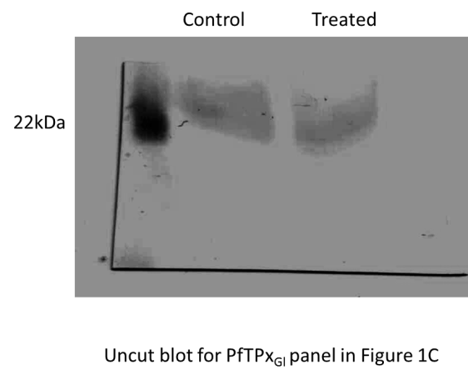

Supplementary image 3
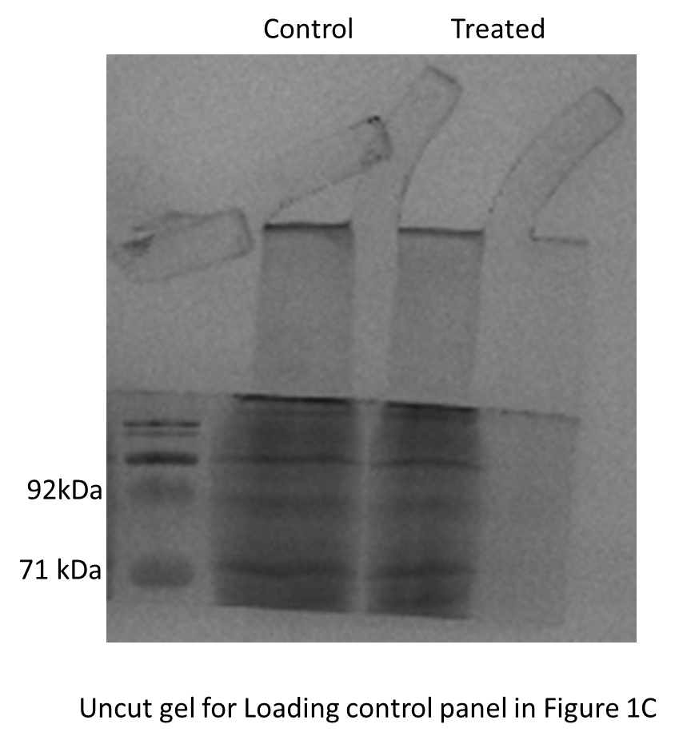

Supplementary Image 4
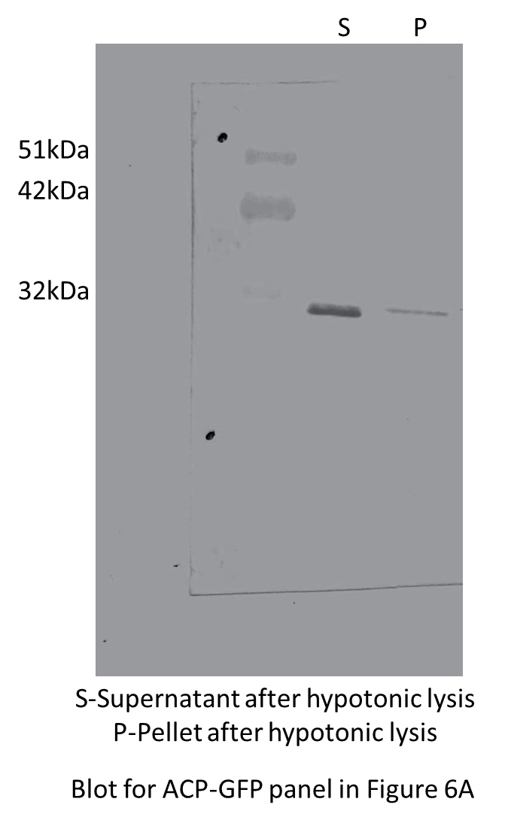

Supplementary Image 5
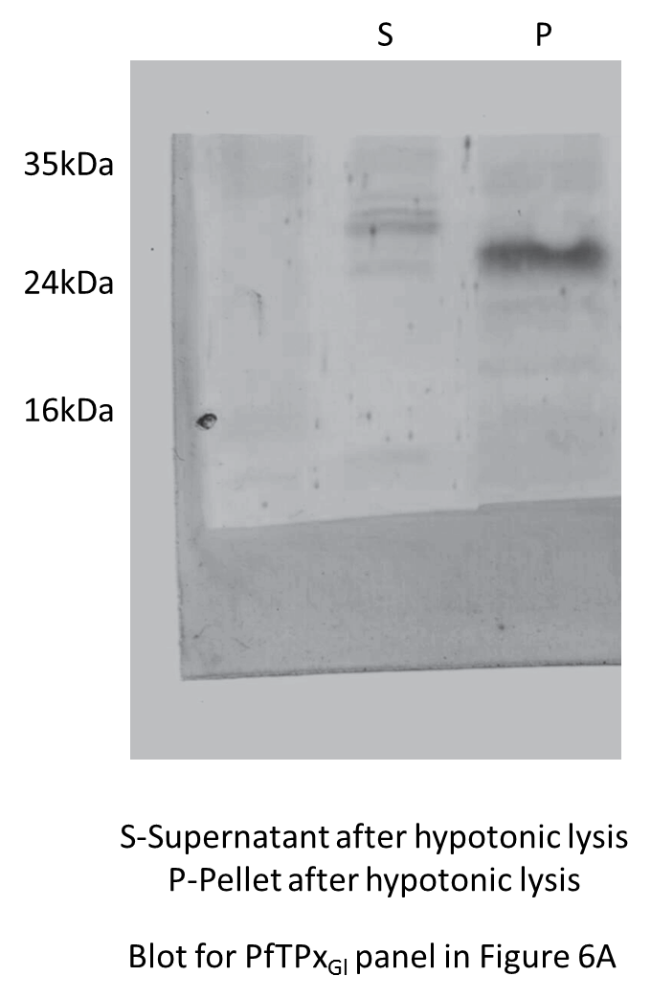

Supplementary Image 6
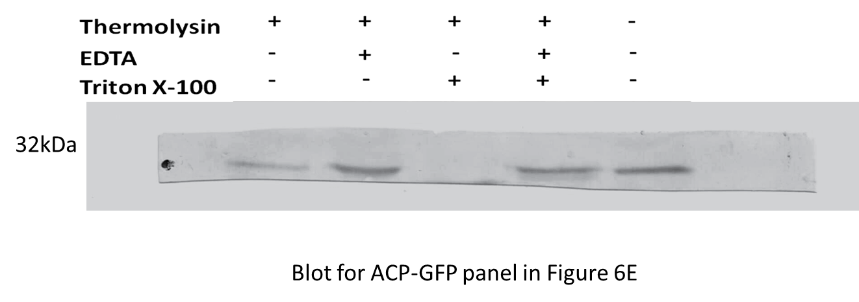

Supplementary Image 7
