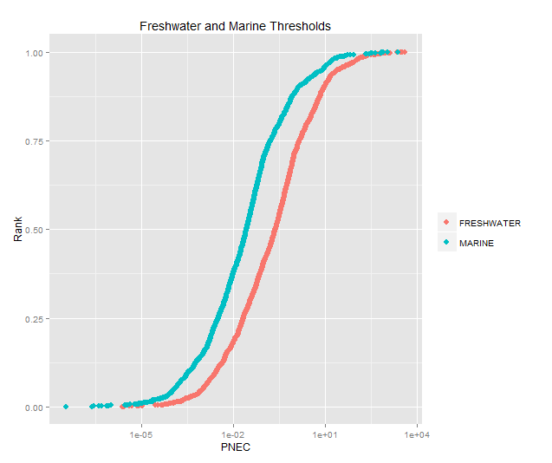
Supporting Figure 1: The cumulative distributions of PNEC_{freshwater} and PNEC_{marine}.for industrial chemicals

