Supplementary Figures for
Palmer-Young EC

Pollen extracts increase growth of a trypanosome parasite of bumble bees
Supplementary Figures S1-S3
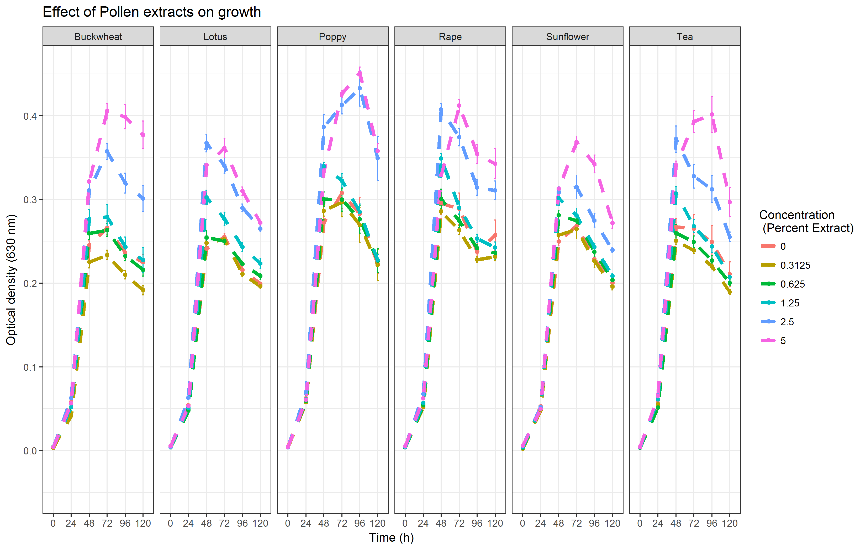
Supplementary Figure 1. Growth curves for the individual pollen experiment.
The x-axis shows time of the experiment. Points and error bars show means and standard errors for n=8 replicates per treatment concentration. Readings were taken at 24 h intervals. Lines represent different concentrations.

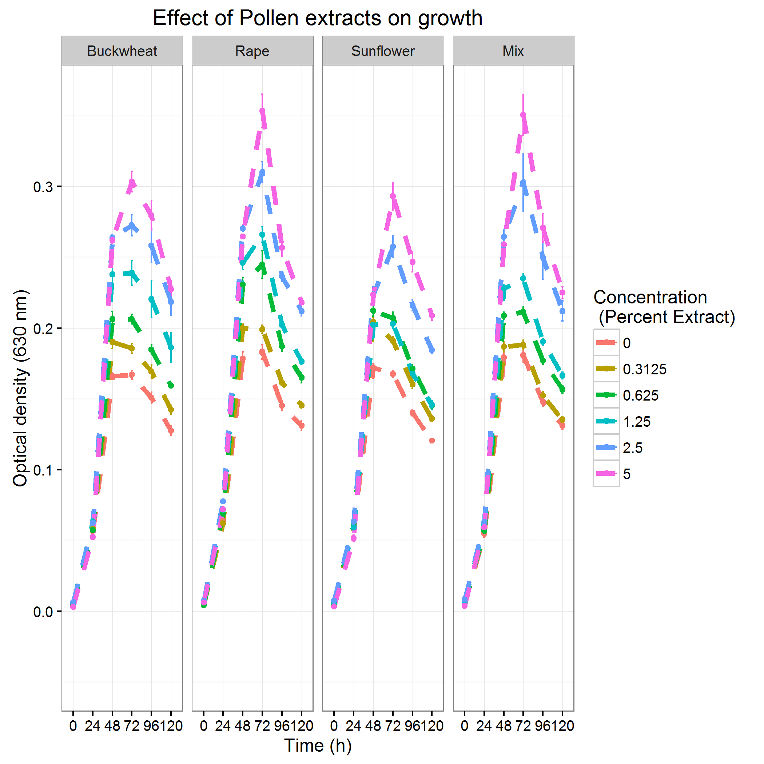
Supplementary Figure 2. Growth curves for the mixed-pollen experiment
The x-axis shows time of the experiment. The "mix" treatment consisted of equal proportions of buckwheat, rape, and sunflower pollen extracts. Points and error bars show means and standard errors for n=8 replicates per treatment concentration. Readings were taken at 24 h intervals. Lines represent different concentrations.

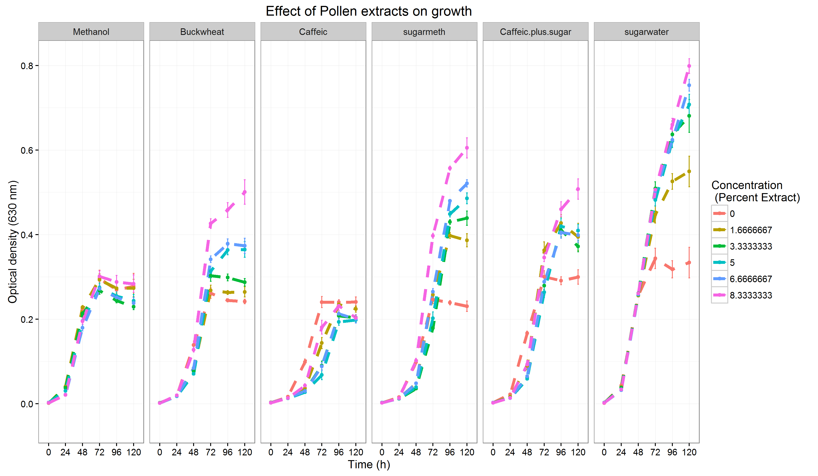
Supplemental figure 3. Growth curves for the chemical additions experiment.
The x-axis shows time of the experiment. The “caffeic acid treatment consisted of 4000 ppm caffeic acid in 50% methanol. The "sugar" treatment consisted of 20% w/v sugar in 50% methanol. Points and error bars show means and standard errors for n=5 replicates per treatment concentration. Readings were taken at 24 h intervals. Lines represent different concentrations.

