SUPPORTING INFORMATION
Mountain colonisation, miniaturisation and ecological evolution in New Guinea Frogs (Choerophryne, Microhylidae)
Paul M. Oliver, Amy Iannella, Stephen J. Richards and Michael S.Y. Lee

Appendix S1 Summary data for all ingroup and outgroup specimens included in phylogenetic and morphological analyses, and overall ecophenotypic data for major lineages.

Table S1. Summary information for all Choerophryne specimens examined in this study. (note Genbank numbers will be provided in full before publication)

Name | Species | Clade | Locality | Country | Province | Specimen | 12S | 16S | Latitude | Longitude | Altitude (m a.s.l)
SJR9565 | alpestris | a | Kaijende Highlands | Papua New Guinea | Enga Province | SJR9565 | xx | xx | -5.54 | 143.05 | 3200
SJR9553 | alpestris | a | Kaijende Highlands | Papua New Guinea | Enga Province | SJR9553 | xx | xx | -5.54 | 143.05 | 3200
SJR9545 | alpestris | a | Kaijende Highlands | Papua New Guinea | Enga Province | SJR9545 | xx | xx | -5.54 | 143.05 | 3200
SJR9070 | brevicrus | a | Spur off Muller Range | Papua New Guinea | Hela Province | SJR9070 | xx | xx | -5.95 | 142.75 | 2275
SJR9069 | brevicrus | a | Spur off Muller Range | Papua New Guinea | Hela Province | SJR9069 | xx | xx | -5.95 | 142.75 | 2275
UPNG10060 | brevicrus | a | Lake Tawa - Porgera | Papua New Guinea | Enga Province | UPNG10060 | xx | xx | -5.60 | 142.84 | 2300
SAMAR66098 | brevicrus | a | Lake Tawa - Porgera | Papua New Guinea | Enga Province | SAMAR66098 | xx | xx | -5.60 | 142.84 | 2300
ZMB76744 | brevicrus | a | Lake Tawa - Porgera | Papua New Guinea | Enga Province | ZMB76744 | xx | xx | -5.60 | 142.84 | 2300
SJR9066 | darlingtoni | a | Spur off Muller Range | Papua New Guinea | Hela Province | SJR9066 | xx | xx | -5.95 | 142.75 | 2275
SJR12008 | darlingtoni | a | Muller Range, Western Province | Papua New Guinea | Western Province | SJR12008 | xx | xx | -5.66 | 142.30 | 1630
SJR12011 | darlingtoni | a | Muller Range, Western Province | Papua New Guinea | Western Province | SJR12011 | xx | xx | -5.66 | 142.30 | 1630
SJR12014 | darlingtoni | a | Muller Range | Papua New Guinea | Western Province | SJR12014 | xx | xx | -5.66 | 142.30 | 1630
SJR10536 | fafniri | a | Central Ranges | Papua New Guinea | Hela Province | SJR10536 | xx | xx | -6.10 | 143.10 | 2060
SJR10545 | fafniri | a | Central Ranges | Papua New Guinea | Hela Province | SJR10545 | xx | xx | -6.10 | 143.10 | 2060
SJR10548 | fafniri | a | Central Ranges | Papua New Guinea | Hela Province | SJR10548 | xx | xx | -6.10 | 143.10 | 2060
SJR9622 | fafniri | a | Lake Tawa - Porgera | Papua New Guinea | Enga Province | SJR9622 | xx | xx | -5.60 | 142.84 | 2300
SJR9638 | fafniri | a | Lake Tawa - Porgera | Papua New Guinea | Enga Province | SJR9638 | xx | xx | -5.60 | 142.84 | 2300
ZMB70313 | laurini | a | Wandamen Peninsula | Indonesia | West Papua Province | ZMB70313 | EU100107 | EU100223 | -2.81 | 134.58 | 800-950
ZMB61913 | laurini | a | Wandamen Peninsula | Indonesia | West Papua Province | ZMB61913 | EU100104 | EU100220 | -2.81 | 134.58 | 800-950
ZMB70312 | laurini | a | Wandamen Peninsula | Indonesia | West Papua Province | ZMB70312 | EU100106 | EU100222 | -2.81 | 134.58 | 800-950
ZMB70311 | laurini | a | Wandamen Peninsula | Indonesia | West Papua Province | ZMB70311 | EU100105 | EU100221 | -2.81 | 134.58 | 800-950
SJR9696 | pandanicola | a | Kaijende Highlands | Papua New Guinea | Enga Province | SJR9696 | xx | xx | -5.50 | 143.08 | 2900
SJR9697 | pandanicola | a | Kaijende Highlands | Papua New Guinea | Enga Province | SJR9697 | xx | xx | -5.50 | 143.08 | 2900
SJR8644 | siegfriedi | a | Mt Elimbari | Papua New Guinea | Chimbu Province | SJR8644 | xx | xx | -6.19 | 145.16 | 2500
SJR8649 | siegfriedi | a | Mt Elimbari | Papua New Guinea | Chimbu Province | SJR8649 | xx | xx | -6.19 | 145.16 | 2500
SJR8658 | siegfriedi | a | Mt Elimbari | Papua New Guinea | Chimbu Province | SJR8658 | xx | xx | -6.19 | 145.16 | 2500
SJR10537 | sp A1 | a | Central Ranges | Papua New Guinea | Hela Province | SJR10537 | xx | xx | -6.10 | 143.10 | 2060
SJR10549 | sp A1 | a | Central Ranges | Papua New Guinea | Hela Province | SJR10549 | xx | xx | -6.10 | 143.10 | 2060
SJR9091 | sp A1 | a | Spur off Muller Range | Papua New Guinea | Hela Province | SJR9091 | xx | xx | -5.95 | 142.75 | 2275
SJR12109 | sp A2 | a | Muller Range | Papua New Guinea | Southern Highlands Province | SJR12109 | xx | xx | -5.49 | 142.30 | 2875
SJR8500 | sp A3 | a | Moran | Papua New Guinea | Southern Highlands Province | SJR8500 | xx | xx | -6.24 | 143.13 | 1700
SJR9834 | sp A4 | a | Foya Mountains | Indonesia | Papua Province | SJR9834 | xx | xx | -2.57 | 138.72 | 1600
SJR9835 | sp A4 | a | Foya Mountains | Indonesia | Papua Province | SJR9835 | xx | xx | -2.57 | 138.72 | 1600
SJR9924 | sp A5 | a | Foya Mountains | Indonesia | Papua Province | SJR9924 | xx | xx | -2.59 | 138.72 | 1220
SJR9926 | sp A5 | a | Foya Mountains | Indonesia | Papua Province | SJR9926 | xx | xx | -2.59 | 138.72 | 1220
SJR2325 | sp A6 | a | Iagifu Ridge Summit | Papua New Guinea | Southern Highlands Province | SJR2325 | xx | xx | -6.43 | 143.21 | 1300
SJR12004 | sp A6 | a | Muller Range, Western Province | Papua New Guinea | Western Province | SJR12004 | xx | xx | -5.66 | 142.30 | 1630
SJR12013 | sp A6 | a | Muller Range, Western Province | Papua New Guinea | Western Province | SJR12013 | xx | xx | -5.66 | 142.30 | 1630
SJR12049 | sp A6 | a | Muller Range, Western Province | Papua New Guinea | Western Province | SJR12049 | xx | xx | -5.66 | 142.30 | 1630
SJR12003 | sp A6 | a | Muller Range, Western Province | Papua New Guinea | Western Province | SJR12003 | xx | xx | -5.66 | 142.30 | 1630
SJR8566 | sp A6 | a | Moran | Papua New Guinea | Southern Highlands Province | SJR8566 | xx | xx | -6.24 | 143.13 | 1700
SJR8505 | sp A6 | a | Moran | Papua New Guinea | Southern Highlands Province | SJR8505 | xx | xx | -6.24 | 143.13 | 1700
SJR10484 | sp A7 | a | Upper Strickland | Papua New Guinea | Western Province | SJR10484 | xx | xx | -5.81 | 142.31 | 213
SJR10483 | sp A7 | a | Upper Strickland | Papua New Guinea | Western Province | SJR10483 | xx | xx | -5.81 | 142.31 | 213
SJR10474 | sp A7 | a | Upper Strickland | Papua New Guinea | Western Province | SJR10474 | xx | xx | -5.81 | 142.31 | 213
SJR10871 | sp A7 | a | Muller Range | Papua New Guinea | Western Province | SJR10871 | xx | xx | -5.73 | 142.26 | 515
SJR10872 | sp A7 | a | Muller Range | Papua New Guinea | Western Province | SJR10872 | xx | xx | -5.73 | 142.26 | 515
SJR10873 | sp A7 | a | Muller Range | Papua New Guinea | Western Province | SJR10873 | xx | xx | -5.73 | 142.26 | 515
SJR10874 | sp A7 | a | Muller Range | Papua New Guinea | Western Province | SJR10874 | xx | xx | -5.73 | 142.26 | 515
SJR8620 | sp A7 | a | Moro Seepage ~ 1 km from boom gate | Papua New Guinea | Southern Highlands Province | SJR8620 | xx | xx | -6.37 | 143.22 | 928
SJR8619 | sp A7 | a | Moro Seepage ~ 1 km from boom gate | Papua New Guinea | Southern Highlands Province | SJR8619 | xx | xx | -6.37 | 143.22 | 928
SJR10413 | sp A7 | a | Upper Strickland | Papua New Guinea | Western Province | SJR10413 | xx | xx | -5.90 | 142.44 | 953
SJR10412 | sp A7 | a | Upper Strickland | Papua New Guinea | Western Province | SJR10412 | xx | xx | -5.90 | 142.44 | 953
SJR2280 | sp A7 | a | Iagifu Ridge Summit | Papua New Guinea | Southern Highlands Province | SJR2280 | xx | xx | -6.43 | 143.21 | 1300
SJR2279 | sp A7 | a | Iagifu Ridge Summit | Papua New Guinea | Southern Highlands Province | SJR2279 | xx | xx | -6.43 | 143.21 | 1300
SJR2319 | sp A8 | a | Iagifu Ridge summit | Papua New Guinea | Southern Highlands Province | SJR2319 | xx | xx | -6.43 | 143.21 | 1300
SJR10221 | sp A8 | a | Karius Range | Papua New Guinea | Hela Province | SJR10221 | xx | xx | -5.99 | 142.67 | 1368
SJR8504 | sp A8 | a | Moran | Papua New Guinea | Southern Highlands Province | SJR8504 | xx | xx | -6.24 | 143.13 | 1700
SJR8556 | sp A8 | a | Moran | Papua New Guinea | Southern Highlands Province | SJR8556 | xx | xx | -6.24 | 143.13 | 1700
ZMB70342 | amomani | b | Amoman Mountains, Pulau Japen | Indonesia | Papua Province | ZMB70342 | EU100136 | EU100252 | -1.75 | 136.32 | 1050-1100
ZMB70348 | arndatorum | b | Japen Island | Indonesia | Papua Province | ZMB70348 | EU100140 | EU100256 | -1.78 | 136.33 | 550-650
ZMB70352 | arndatorum | b | Japen Island | Indonesia | Papua Province | ZMB70352 | EU100141 | EU100257 | -1.78 | 136.33 | 550-650
ZMB70346 | arndatorum | b | Japen Island | Indonesia | Papua Province | ZMB70346 | EU100139 | EU100255 | -1.78 | 136.33 | 550-650
SJR12022 | burtoni | b | Muller Range, Western Province | Papua New Guinea | Western province | SJR12022 | xx | xx | -5.66 | 142.30 | 1630
SJR8511 | burtoni | b | Moran | Papua New Guinea | Southern Highlands Province | SJR8511 | xx | xx | -6.24 | 143.13 | 1700
SJR3295 | burtoni | b | Moran | Papua New Guinea | Southern Highlands Province | SJR3295 | xx | xx | -6.24 | 143.13 | 1700
SAMAR67920 | epirrhina | b | North Slope of Central Cordillera | Papua New Guinea | Sandaun Province | SAMAR67920 | xx | KM362424 | -4.65 | 141.72 | 850
PNGNM24045 | epirrhina | b | North Slope of Central Cordillera | Papua New Guinea | Sandaun Province | PNGNM24045 | xx | KM362423 | -4.65 | 141.72 | 850
SAMAR67519 | gracilirostris | b | Upper Strickland River | Papua New Guinea | Western Province | SAMAR67519 | xx | KF561136 | -5.81 | 142.31 | 213
SAMAR67520 | gracilirostris | b | Upper Strickland River | Papua New Guinea | Western Province | SAMAR67520 | xx | xx | -5.81 | 142.31 | 213
SAMAR64986 | gracilirostris | b | Muller Range | Papua New Guinea | Western Province | SAMAR64986 | xx | xx | -5.73 | 142.26 | 515
SAMAR67514 | gracilirostris | b | Karius Range | Papua New Guinea | Hela Province | SAMAR67514 | xx | xx | -5.99 | 142.67 | 1368
SAMAR67517 | gracilirostris | b | Karius Range | Papua New Guinea | Hela Province | SAMAR67517 | xx | xx | -5.99 | 142.67 | 1368
SAMAR67921 | grylloides | b | North Slope of Central Cordillera | Papua New Guinea | Sandaun Province | SAMAR67921 | xx | KM362425 | -4.65 | 141.72 | 900
SAMAR65929 | longirostris | b | Mt Menawa | Papua New Guinea | Sandaun Province | SAMAR65929 | xx | xx | -3.31 | 141.70 | 780
SAMAR65930 | longirostris | b | Mt Menawa | Papua New Guinea | Sandaun Province | SAMAR65930 | xx | xx | -3.31 | 141.70 | 780
SAMAR65931 | longirostris | b | Mt Menawa | Papua New Guinea | Sandaun Province | SAMAR65931 | xx | xx | -3.31 | 141.70 | 780
SAMAR65932 | longirostris | b | Mt Menawa | Papua New Guinea | Sandaun Province | SAMAR65932 | xx | xx | -3.31 | 141.70 | 780
ZMB0359 | microps | b | Wondowoi Mountains | Indonesia | West Papua Province | ZMB70359 | EU100137 | EU100253 | -2.97 | 134.63 | 380-900
ZMB70360 | microps | b | Wondowoi Mountains | Indonesia | West Papua Province | ZMB70360 | EU100138 | EU100254 | -2.97 | 134.63 | 380-900
SJR6052 | nigrescens | b | Foya Mountains | Indonesia | Papua Province | SJR6052 | xx | xx | -2.37 | 138.21 | 500
ZMB70354 | nigrescens | b | Japen Island | Indonesia | Papua Province | ZMB70354 | EU100142 | EU100258 | -1.78 | 136.33 | 650
SAMAR60661 | proboscidea | b | Wamangu | Papua New Guinea | East Sepik Province | SAMAR60661 | xx | xx | -3.79 | 143.65 | 110
SAMAR60663 | proboscidea | b | Wamangu | Papua New Guinea | East Sepik Province | SAMAR60663 | xx | xx | -3.79 | 143.65 | 110
SAMAR60662 | proboscidea | b | Wamangu | Papua New Guinea | East Sepik Province | SAMAR60662 | xx | xx | -3.79 | 143.65 | 110
SJR8985 | proboscidea | b | Wamangu | Papua New Guinea | East Sepik Province | SJR8985 | xx | xx | -3.79 | 143.65 | 110
SJR8673 | proboscidea | b | Wamangu | Papua New Guinea | East Sepik Province | SJR8673 | xx | xx | -3.79 | 143.65 | 110
SJR8995 | proboscidea | b | Wamangu | Papua New Guinea | East Sepik Province | SJR8995 | xx | xx | -3.79 | 143.65 | 110
SJR8994 | proboscidea | b | Wamangu | Papua New Guinea | East Sepik Province | SJR8994 | xx | xx | -3.79 | 143.65 | 110
SAMAR60659 | rostellifer | b | Utai | Papua New Guinea | Sandaun Province | SAMAR60659 | xx | xx | -3.68 | 141.58 | 100
SJR3766 | rostellifer | b | Utai | Papua New Guinea | Sandaun Province | SJR3766 | xx | xx | -3.68 | 141.58 | 100
SAMAR60654 | rostellifer | b | Utai | Papua New Guinea | Sandaun Province | SAMAR60654 | xx | xx | -3.68 | 141.58 | 100
SJR9852 | sp B1 | b | Foya Mountains | Indonesia | Papua Province | SJR9852 | xx | xx | -2.57 | 138.72 | 1600
MZB11978 | sp B1 | b | Foya Mountains | Indonesia | Papua Province | MZB11978 | xx | xx | -2.57 | 138.72 | 1600
SJR9858 | sp B1 | b | Foya Mountains | Indonesia | Papua Province | SJR9858 | xx | xx | -2.57 | 138.72 | 1600
SJR13272 | sp B2 | b | Central Lowlands | Papua New Guinea | Gulf Province | SJR13272 | xx | xx | -7.03 | 144.93 | 65
SJR13273 | sp B2 | b | Central Lowlands | Papua New Guinea | Gulf Province | SJR13273 | xx | xx | -7.03 | 144.93 | 65
SJR9089 | sp B3 | b | Spur off Muller Range | Papua New Guinea | Hela Province | SJR9089 | xx | xx | -5.95 | 142.75 | 2275
SJR9649 | sp B3 | b | Lake Tawa - Porgera | Papua New Guinea | Enga Province | SJR9649 | xx | xx | -5.60 | 142.84 | 2300
SJR2232 | exclamitans | c | Huon Peninsula | Papua New Guinea | Morobe Province | SJR2232 | xx | xx | -6.10 | 146.56 | 1830
SJR2231 | exclamitans | c | Huon Peninsula | Papua New Guinea | Morobe Province | SJR2231 | xx | xx | -6.10 | 146.56 | 1830
SJR13320 | sp C1 | c | Central Lowlands | Papua New Guinea | Gulf Province | SJR13320 | xx | xx | -6.89 | 144.89 | 90
SJR3266 | sp C1 | c | Libano | Papua New Guinea | Southern Highlands Province | SJR3266 | xx | xx | -6.40 | 142.98 | 253
SJR3147 | sp C1 | c | Darai | Papua New Guinea | Gulf Province | SJR3147 | xx | xx | -7.13 | 143.61 | 440
SJR3148 | sp C1 | c | Darai | Papua New Guinea | Gulf Province | SJR3148 | xx | xx | -7.13 | 143.61 | 440
SJR8622 | sp C1 | c | Moro Seepage ~ 1 km from boom gate | Papua New Guinea | Southern Highlands Province | SJR8622 | xx | xx | -6.37 | 143.22 | 928
SJR9581 | fafniri | a | Lake Tawa - Porgera | Papua New Guinea |  | SJR9581 |  |  | -5.60 | 142.84 | 2300
SJR6028 | arndtorum | b | Foya Mountains | Indonesia | Papua Province | SJR6028 |  |  | -2.37 | 138.21 | 500
SAMAR67518 | gracilirostris | b | Upper Strickland River | Papua New Guinea | Western Province | SAMAR67518 |  |  | -5.90 | 142.44 | 953
SAMAR67515 | gracilirostris | b | Karius Range | Papua New Guinea | Hela Province | SAMAR67515 |  |  | -5.99 | 142.67 | 1368
SAMAR67516 | gracilirostris | b | Karius Range | Papua New Guinea | Hela Province | SAMAR67516 |  |  | -5.99 | 142.67 | 1368
SAMAR67928 | grylloides | b | North Slope of Central Cordillera | Papua New Guinea | Sandaun Province | SAMAR67928 |  |  | -4.62 | 141.69 | 440
SJR6186 | nigrescens | b | Marina Valen Village | Indonesia | Papua Province | SJR6186 |  |  | -2.39 | 138.20 | 500
SAMAR60664 | proboscidea | b | Wamangu | Papua New Guinea | East Sepik Province | SAMAR60664 |  |  | -3.79 | 143.65 | 110
SAMAR60665 | proboscidea | b | Wamangu | Papua New Guinea | East Sepik Province | SAMAR60665 |  |  | -3.79 | 143.65 | 110
SAMAR60666 | proboscidea | b | Wamangu | Papua New Guinea | East Sepik Province | SAMAR60666 |  |  | -3.79 | 143.65 | 110
SAMAR60667 | proboscidea | b | Wamangu | Papua New Guinea | East Sepik Province | SAMAR60667 |  |  | -3.79 | 143.65 | 110
SAMAR60668 | proboscidea | b | Wamangu | Papua New Guinea | East Sepik Province | SAMAR60668 |  |  | -3.79 | 143.65 | 110
SAMAR60669 | proboscidea | b | Wamangu | Papua New Guinea | East Sepik Province | SAMAR60669 |  |  | -3.79 | 143.65 | 110
SJR7302 | proboscidea | b | Wanang | Papua New Guinea | Madang Province | SJR7302 |  |  | -5.23 | 145.20 | 150
SJR7300 | proboscidea | b | Wanang | Papua New Guinea | Madang Province | SJR7300 |  |  | -5.23 | 145.20 | 150
SJR7301 | proboscidea | b | Wanang | Papua New Guinea | Madang Province | SJR7301 |  |  | -5.23 | 145.20 | 150
SJR7272 | proboscidea | b | Wanang | Papua New Guinea | Madang Province | SJR7272 |  |  | -5.23 | 145.20 | 150
SJR7145 | proboscidea | b | Yoro | Papua New Guinea | East Sepik Province | SJR7145 |  |  | -4.51 | 145.15 | 200
SJR7184 | proboscidea | b | Yoro | Papua New Guinea | East Sepik Province | SJR7184 |  |  | -4.51 | 145.15 | 200
SJR7211 | proboscidea | b | Yoro | Papua New Guinea | East Sepik Province | SJR7211 |  |  | -4.51 | 145.15 | 200
SJR7217 | proboscidea | b | Yoro | Papua New Guinea | East Sepik Province | SJR7217 |  |  | -4.51 | 145.15 | 200
SJR7224 | proboscidea | b | Yoro | Papua New Guinea | East Sepik Province | SJR7224 |  |  | -4.51 | 145.15 | 200
SAMAR60653 | rostellifer | b | Utai | Papua New Guinea | Sandaun Province | SAMAR60653 |  |  | -3.68 | 141.58 | 100
SAMAR60655 | rostellifer | b | Utai | Papua New Guinea | Sandaun Province | SAMAR60655 |  |  | -3.68 | 141.58 | 100
SAMAR60657 | rostellifer | b | Utai | Papua New Guinea | Sandaun Province | SAMAR60657 |  |  | -3.68 | 141.58 | 100
SAMAR60658 | rostellifer | b | Utai | Papua New Guinea | Sandaun Province | SAMAR60658 |  |  | -3.68 | 141.58 | 100
SAMAR60660 | rostellifer | b | Utai | Papua New Guinea | Sandaun Province | SAMAR60660 |  |  | -3.68 | 141.58 | 100
SJR13068 | sp. | b | Sepik Basin | Papua New Guinea | Sandaun Province | SJR13068 |  |  | -4.55 | 141.96 | 70
MZB1200 | sp4foyas | b | Foya Mountains | Indonesia | Papua Province | MZB1200 |  |  | -2.57 | 138.72 | 1600
MZB11980 | sp4foyas | b | Foya Mountains | Indonesia | Papua Province | MZB11980 |  |  | -2.57 | 138.72 | 1600
SJR13069 | species? | b | Sepik Basin | Papua New Guinea | Sandaun Province | SJR13069 |  |  | -4.55 | 141.96 | 70
SJR3309 | burtoni | d | Moran | Papua New Guinea | Southern Highlands Province | SJR3309 |  |  | -6.24 | 143.13 | 1700
SAMAR62475 | burtoni | d | Moran | Papua New Guinea | Southern Highlands Province | SAMAR62475 |  |  | -6.24 | 143.13 | 1700
SAMAR62476 | burtoni | d | Moran | Papua New Guinea | Southern Highlands Province | SAMAR62476 |  |  | -6.24 | 143.13 | 1700
SJR9650 | porgera | d | Lake Tawa - Porgera | Papua New Guinea | Enga Province | SJR9650 |  |  | -5.60 | 142.84 | 2300
SJR14303 | sp | d | Central Lowlands | Papua New Guinea | Gulf Province | SJR14303 |  |  | -6.94 | 145.10 | 90
SJR14331 | sp | d | Central Lowlands | Papua New Guinea | Gulf Province | SJR14331 |  |  | -6.98 | 144.99 | 100
SJR14332 | sp | d | Central Lowlands | Papua New Guinea | Gulf Province | SJR14332 |  |  | -6.98 | 144.99 | 100
SJR14346 | sp | d | Central Lowlands | Papua New Guinea | Gulf Province | SJR14346 |  |  | -6.98 | 144.99 | 100

Table S2. Summary information for outgroup genetic samples

Genus | Species | Specimen | 12S | 16S
Cophixalus | balbus | ZMB62594 | EU100143 | EU100259
Cophixalus | humicola | ZMB69704 | EU100147 | EU100263
Cophixalus | tridactylus | ZMB69696 | EU100149 | EU100265
Copiula | major | ZMB62074 | EU100152 | EU100268
Copiula | obsti | ZMB62555 | EU100154 | EU100270
Copiula | pipiens | ZMB64112 | EU100158 | EU100274
Genyophryne | thomsoni | BPBM20357 | EU100159 | EU100275
Liophryne | dentata | BPBM15370 | EU100178 | EU100294
Liophryne | schlaginhaufeni | BPBM22754 | EU100179 | EU100295
Oreophryne | atrigularis | ZMB62216 | EU100182 | EU100298
Oreophryne | clamata | ZMB67353 | EU100189 | EU100305
Oreophryne | sibilans | RG6936 | EU100194 | EU100310
Oreophryne | unicolor | ZMB70188 | EU100199 | EU100315
Oxydactyla | crassa | BPBM17061 | EU100207 | EU100323

Table S3. 16S genetic distances between recognised species and candidate species of Choerophryne.

 | exclamitans | spC1 | longirostris | proboscidea | spA7 | spA8 | laurini | spA5 | spA4 | spA3 | alpestris | spA2 | brevicrus | spA6 | spA1 | pandanicola | darlingtoni | fafniri | siegfriedi | epirrhina | nigrescens
exclamitans | _
spC1 | 4.5 | _
longirostris | 18.3 | 18.9 | _
proboscidea | 18.3 | 19.1 | 6.0 | _
spA7 | 17.7 | 19.6 | 17.6 | 17.9 | _
spA8 | 17.6 | 19.4 | 16.4 | 16.4 | 9.8 | _
laurini | 15.8 | 18.4 | 17.1 | 16.6 | 16.1 | 15.6 | _
spA5 | 15.8 | 17.0 | 15.8 | 15.3 | 12.8 | 12.9 | 9.3 | _
spA4 | 15.0 | 17.5 | 16.0 | 16.9 | 14.8 | 12.8 | 14.3 | 12.0 | _
spA3 | 15.5 | 17.2 | 16.0 | 16.2 | 13.2 | 14.2 | 11.0 | 11.1 | 8.6 | _
alpestris | 15.2 | 17.9 | 14.3 | 15.0 | 13.5 | 13.6 | 10.0 | 9.5 | 8.5 | 6.3 | _
spA2 | 14.7 | 16.6 | 15.0 | 15.3 | 13.8 | 13.3 | 11.1 | 9.8 | 8.4 | 5.4 | 5.9 | _
brevicrus | 14.5 | 16.3 | 15.1 | 15.1 | 13.6 | 12.8 | 10.9 | 9.9 | 8.2 | 5.2 | 5.6 | 2.6 | _
spA6 | 13.7 | 15.7 | 13.5 | 13.8 | 12.4 | 12.0 | 10.6 | 9.1 | 9.0 | 7.8 | 8.0 | 7.5 | 7.2 | _
spA1 | 14.2 | 16.5 | 15.1 | 14.8 | 12.3 | 11.4 | 10.3 | 9.8 | 9.9 | 8.3 | 7.2 | 7.1 | 6.6 | 6.6 | _
pandanicola | 14.7 | 17.0 | 16.2 | 16.7 | 11.1 | 11.8 | 11.3 | 10.1 | 10.6 | 9.9 | 8.2 | 9.0 | 8.8 | 9.0 | 5.8 | _
darlingtoni | 12.9 | 16.0 | 14.6 | 15.0 | 11.9 | 11.5 | 10.9 | 9.7 | 7.8 | 8.8 | 6.7 | 8.0 | 7.5 | 7.7 | 5.0 | 3.7 | _
fafniri | 13.8 | 15.7 | 15.1 | 15.3 | 12.4 | 12.6 | 12.0 | 11.2 | 10.1 | 10.2 | 8.8 | 9.3 | 8.6 | 8.0 | 6.1 | 5.0 | 4.5 | _
siegfriedi | 14.2 | 16.2 | 14.0 | 14.0 | 12.1 | 12.1 | 12.0 | 10.9 | 10.1 | 10.2 | 8.1 | 9.5 | 9.0 | 8.5 | 6.0 | 5.1 | 3.6 | 3.4 | _
epirrhina | 16.0 | 18.1 | 15.4 | 14.6 | 18.5 | 18.8 | 18.1 | 16.7 | 16.4 | 15.6 | 16.4 | 15.7 | 15.7 | 15.2 | 15.1 | 14.9 | 14.6 | 14.7 | 13.8 | _
nigrescens | 16.8 | 18.7 | 14.8 | 14.3 | 17.3 | 17.5 | 16.6 | 16.2 | 16.8 | 15.1 | 16.2 | 16.8 | 16.2 | 14.7 | 15.3 | 15.7 | 15.3 | 15.3 | 15.2 | 7.3 | _
microps | 19.5 | 20.4 | 19.9 | 19.0 | 21.5 | 22.6 | 19.1 | 21.3 | 22.6 | 20.4 | 20.0 | 20.9 | 20.6 | 18.7 | 18.6 | 17.6 | 16.9 | 17.0 | 16.5 | 10.5 | 11.0
amomani | 20.0 | 21.4 | 18.6 | 17.3 | 22.1 | 21.3 | 18.9 | 20.6 | 22.8 | 20.0 | 19.6 | 19.6 | 19.1 | 16.5 | 17.7 | 18.9 | 18.0 | 17.4 | 18.3 | 13.8 | 14.0
spB1 | 16.9 | 18.9 | 15.3 | 15.0 | 18.8 | 19.2 | 17.8 | 17.3 | 17.2 | 17.0 | 16.7 | 16.2 | 15.7 | 14.5 | 14.8 | 15.0 | 14.4 | 13.9 | 13.7 | 9.0 | 10.9
arndtorum | 20.0 | 21.4 | 18.7 | 17.8 | 21.4 | 22.0 | 18.9 | 20.0 | 21.8 | 19.6 | 19.1 | 18.9 | 18.7 | 16.6 | 18.0 | 16.9 | 16.4 | 16.0 | 16.0 | 12.2 | 12.7
grylloides | 16.8 | 17.9 | 15.4 | 15.4 | 20.1 | 18.2 | 16.9 | 16.8 | 17.8 | 17.5 | 18.0 | 16.6 | 16.9 | 14.5 | 15.8 | 17.9 | 16.9 | 17.3 | 17.8 | 15.3 | 15.8
gracilirostris | 16.6 | 18.3 | 13.5 | 13.8 | 17.0 | 18.1 | 16.5 | 14.7 | 17.1 | 15.8 | 15.5 | 14.7 | 15.2 | 13.6 | 13.8 | 14.9 | 14.1 | 14.4 | 14.8 | 14.0 | 13.3
spB2 | 19.0 | 20.0 | 16.1 | 15.6 | 18.0 | 17.3 | 17.8 | 16.3 | 18.3 | 17.9 | 17.3 | 16.6 | 16.5 | 14.9 | 16.7 | 17.6 | 16.5 | 17.3 | 17.1 | 18.3 | 15.5
spB3 | 16.1 | 18.6 | 13.8 | 13.8 | 13.5 | 14.5 | 14.5 | 12.6 | 13.3 | 13.4 | 13.3 | 12.6 | 13.3 | 12.1 | 12.2 | 12.6 | 12.3 | 13.6 | 13.8 | 13.9 | 13.8
burtoni | 16.5 | 17.9 | 14.6 | 14.8 | 15.9 | 15.7 | 14.5 | 13.9 | 15.2 | 14.6 | 14.4 | 13.9 | 13.9 | 12.5 | 12.4 | 12.9 | 12.0 | 13.4 | 13.5 | 15.7 | 13.3

Table S3. Cont’d

 | nigrescens | microps | amomani | spB1 | arndtorum | grylloides | gracilirostris | spB2 | spB3 | burtoni
exclamitans
spC1
longirostris
proboscidea
spA7
spA8
laurini
spA5
spA4
spA3
alpestris
spA2
brevicrus
spA6
spA1
pandanicola
darlingtoni
fafniri
siegfriedi
epirrhina
nigrescens | _
microps | 11.0 | _
amomani | 14.0 | 10.3 | _
spB1 | 10.9 | 7.9 | 5.9 | _
arndtorum | 12.7 | 7.7 | 6.6 | 4.8 | _
grylloides | 15.8 | 17.6 | 17.2 | 15.4 | 17.1 | _
gracilirostris | 13.3 | 14.8 | 16.1 | 13.3 | 15.1 | 12.5 | _
spB2 | 15.5 | 20.8 | 19.5 | 16.9 | 20.0 | 16.9 | 16.0 | _
spB3 | 13.8 | 17.6 | 18.0 | 14.5 | 16.9 | 15.0 | 12.5 | 12.8 | _
burtoni | 13.3 | 17.1 | 16.9 | 14.5 | 17.1 | 12.3 | 12.5 | 11.7 | 9.3 | _

Table S4. Summary information of maximum male body size, elevational range and calling height for Choerophryne in clades A and B.

 |  |  |  | Bayetraits | Bayestraits |  | BEAST | BEAST
Species | SUL (mm) | log SUL | range (m) | elevation (m) | calling height (cm) |  | elevation | calling height | datasource
Choerophryne sp B3 | 9.3 | 0.968 | 2275-2300 | 2300 | 10 |  | M | t | This study
Choerophryne grylloides | 12.5 | 1.097 | 400-900 | 700 | 30 |  | H | t | Iannella et al. 2015
Choerophryne sp B1 | 12.7 | 1.104 | 1600-1800 | 1700 | 10 |  | L | t | This study
Choerophryne sp A2 | 13.38 | 1.126 | 2500* | 2500 | 10 |  | M | t | This study
Choerophryne burtoni | 14.1 | 1.149 | 1630-2037 | 1800 | 50 |  | L | s | This study, Richards et al. 2007
Choerophryne gracilirostris | 14.7 | 1.167 | 213-1368 | 800 | 20 |  | H | t | Iannella et al. 2014
Choerophryne sp A3 | 14.7 | 1.167 | 1700* | 1700 | 50 |  | L | s | This study
Choerophryne arndtorum | 14.8 | 1.167 | 550-650 | 600 | 120 |  | H | t | Günther 2008
Choerophryne eppirhina | 15 | 1.176 | 850* | 800 | 20 |  | H | t | Iannella et al. 2015
Choerophryne amomani | 15.1 | 1.179 | 1050-1100 | 1100 | 30 |  | L | t | Günther 2008
Choerophryne sp A6 | 15.49 | 1.190 | 1300-1700 | 1500 | 200 |  | L | s | This study
Choerophryne rostellifer | 15.6 | 1.193 | 100-1320 | 700 | 300 |  | H | s | This study
Choerophryne sp A5 | 16.4 | 1.215 | 1200* | 1200 | 300 |  | L | s | This study
Choerophryne sp A8 | 16.63 | 1.221 | 1300-1700 | 1500 | 200 |  | L | s | This study
Choerophryne laurini | 17.1 | 1.233 | 800-950 | 900 | 300 |  | L | s | Günther 2000
Choerophryne sp A7 | 17.1 | 1.233 | 213-1300 | 700 | 300 |  | H | s | This study
Choerophryne microps | 17.3 | 1.238 | 380-900 | 600 | 100 |  | H | t | Günther 2008
Choerophryne brevicrus | 17.7 | 1.248 | 2117-2900 | 2500 | 30 |  | M | t | Günther and Richards 2011
Choerophryne sp B2 | 17.7 | 1.248 | 300* | 300 | 30 |  | H | s | This study
Choerophryne nigrescens | 17.9 | 1.253 | 5-820 | 400 | 250 |  | H | s | Günther 2008
Choerophryne sp A4 | 18.6 | 1.270 | 1600-1800* | 1700 | 200 |  | L | s | This study
Choerophryne pandanicola | 19.6 | 1.292 | 2900* | 2900 | 300 |  | M | s | Günther and Richards 2011
Choerophryne proboscidea | 19.67 | 1.294 | 100-854 | 400 | 200 |  | H | s | This study
Choerophryne darlingtoni | 19.84 | 1.298 | 1600-2000 | 1800 | 200 |  | L | s | This study
Choerophryne seigfreidi | 20.7 | 1.315 | 2500* | 2500 | 200 |  | M | s | This study
Choerophryne sp A1 | 20.89 | 1.320 | 2060-2275 | 2100 | 400 |  | M | s | This study
Choerophryne alpestris | 22.6 | 1.354 | 3100-3500 | 3300 | 30 |  | U | t | Günther and Richards 2011, Kraus 2010
Choerophryne longirostris | 23.7 | 1.375 | 950-1200 | 1100 | 200 |  | L | s | This study, Kraus and Allison 2001
Choerophryne fafniri | 25.6 | 1.409 | 2060-2300 | 2200 | 200 |  | M | s | This study

Supplementary references used to generate table S4.

Günther R. (2000) Albericus laurini species nova, the first record of the genus Albercus (Anura, Microhylidae) from the west of New Guinea. Mitteilungen aus dem Museum fur Naturkunde in Berlin Zoologische Reihe, 76, 167–174.
Günther R. (2008) Descriptions of four new species of Choerophryne (Anura, Microhylidae) from Papua Province, Indonesian New Guinea. Acta Zoologica Sinica, 54, 653–674.
Gunther R. & Richards S.J. (2011) Five new microhylid frog species from Enga Province, Papua New Guinea, and remarks on Albericus alpestris (Anura, Microhylidae). Vertebrate Zoology, 61, 343–372.
Iannella A., Oliver P., & Richards S. (2015) Two new species of Choerophryne (Anura, Microhylidae) from the northern versant of Papua New Guinea’s central cordillera. Zootaxa, 4058, 332–340.
Iannella A., Richards S., & Oliver P. (2014) A new species of Choerophryne (Anura, Microhylidae) from the central cordillera of Papua New Guinea. Zootaxa, 3753, 483–493.
Kraus F. & Allison A. (2010) A Review of the Endemic New Guinea Microhylid Frog Genus Choerophryne. Herpetologica, 57, 214–232.
Richards S.J., Dahl C.S., & Hiaso J. (2007) Another new species of Choerophryne (Anura: Microhylidae) from Southern Highlands Province, Papua New Guinea. Transactions of the Royal Society of South Australia, 131, 135–141.

Supplementary Figures

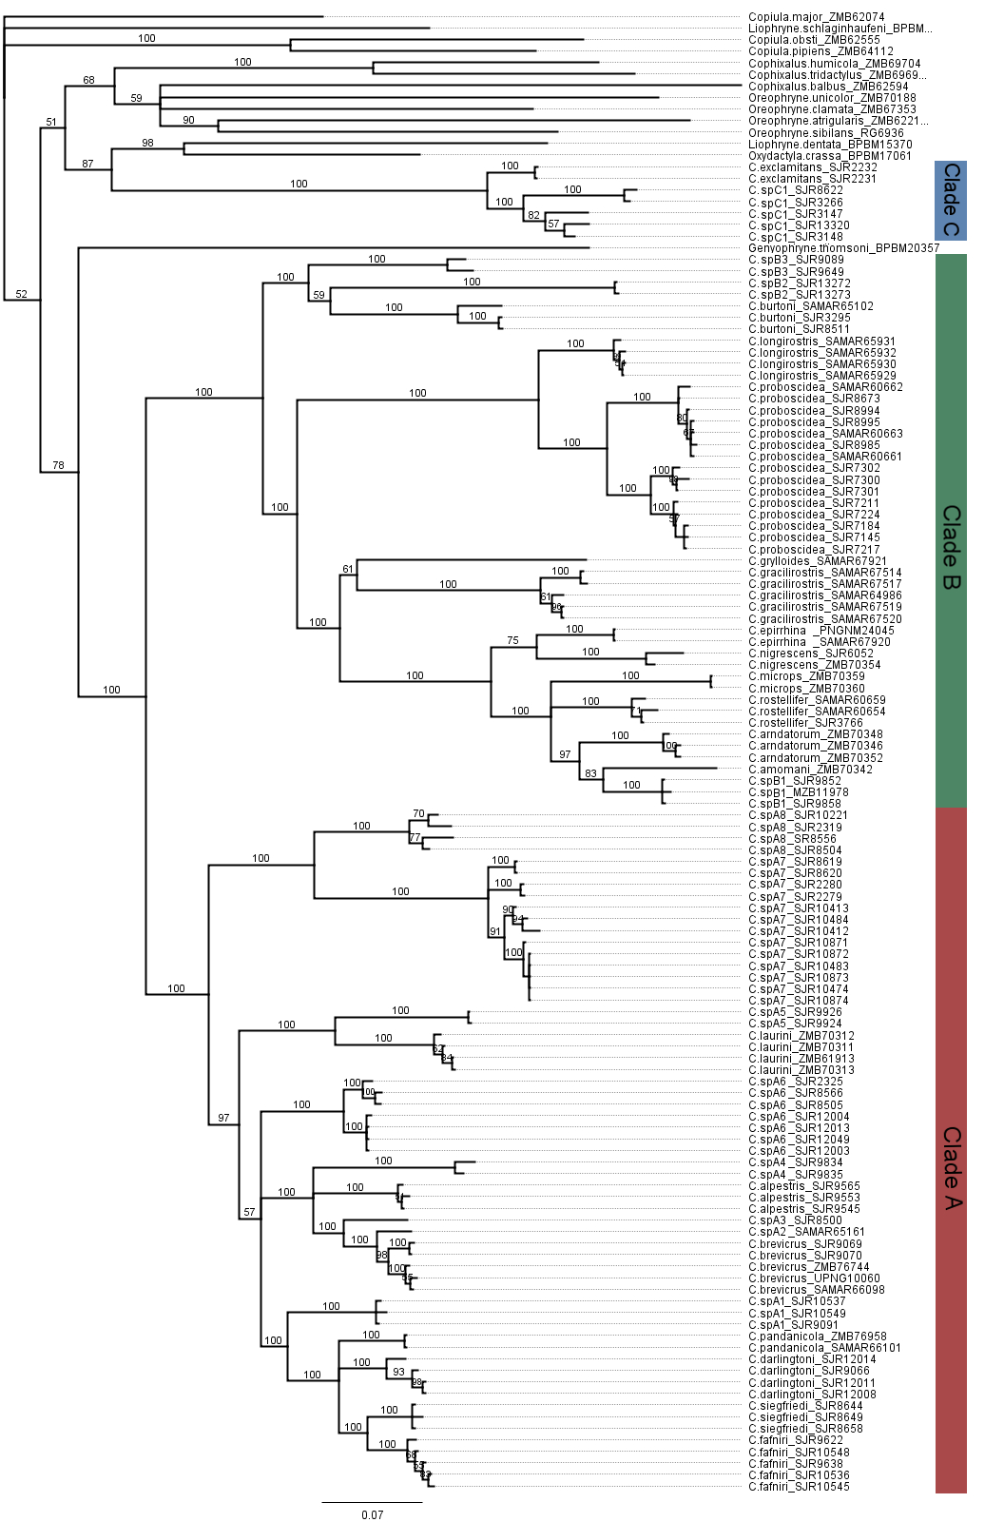

Figure S1. Summary Bayesian Tree with posterior probabilities for all Choerophryne from which sequence was obtained, plus selected outgroups.

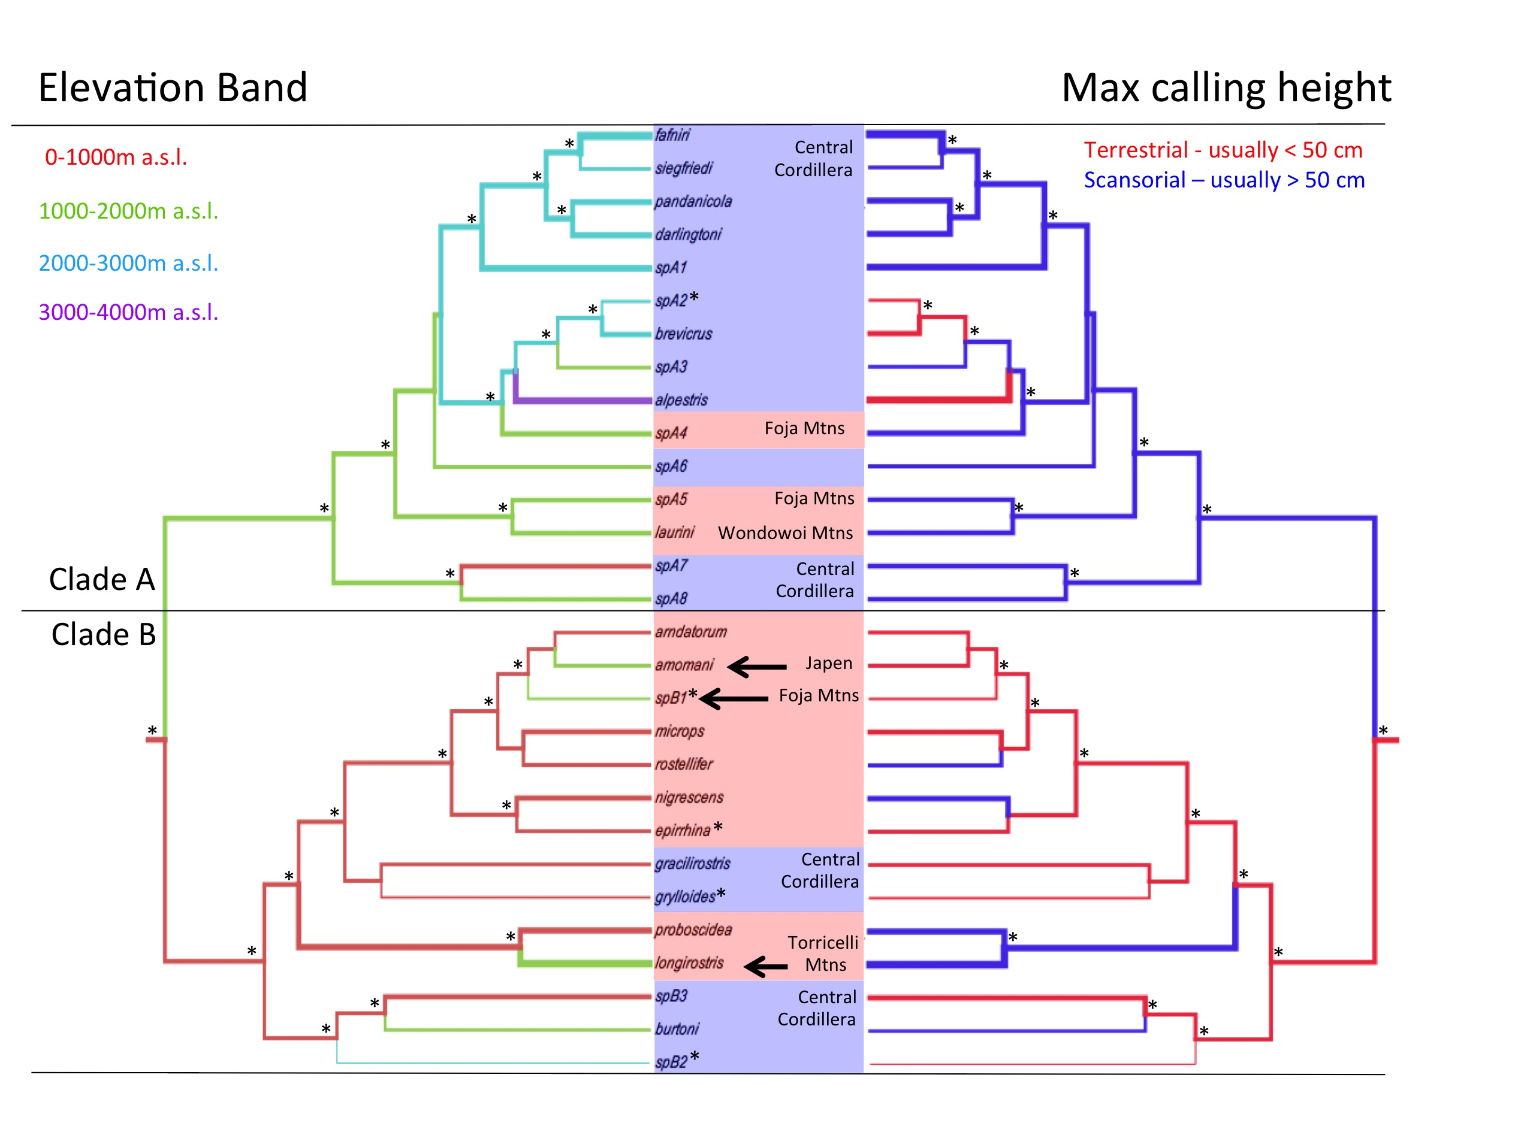

Figure SI2. Trait evolution in the major lineages of Choerophryne estimated using BEAST based on discrete character codings. Ancestral states with a probability of greater than 60% are indicated with an asterisk. Branch widths on both trees are proportional to maximum recorded adult male SVL and very small taxa (<15mm) are indicated with bold and an asterisk. Taxa with distributions in the Central Cordillera are highlighted in blue, while those from northern New Guinea are in red. Three inferred upslope shifts in Clade B into lower montane forest in the North Papuan Mountains are indicated by arrows.

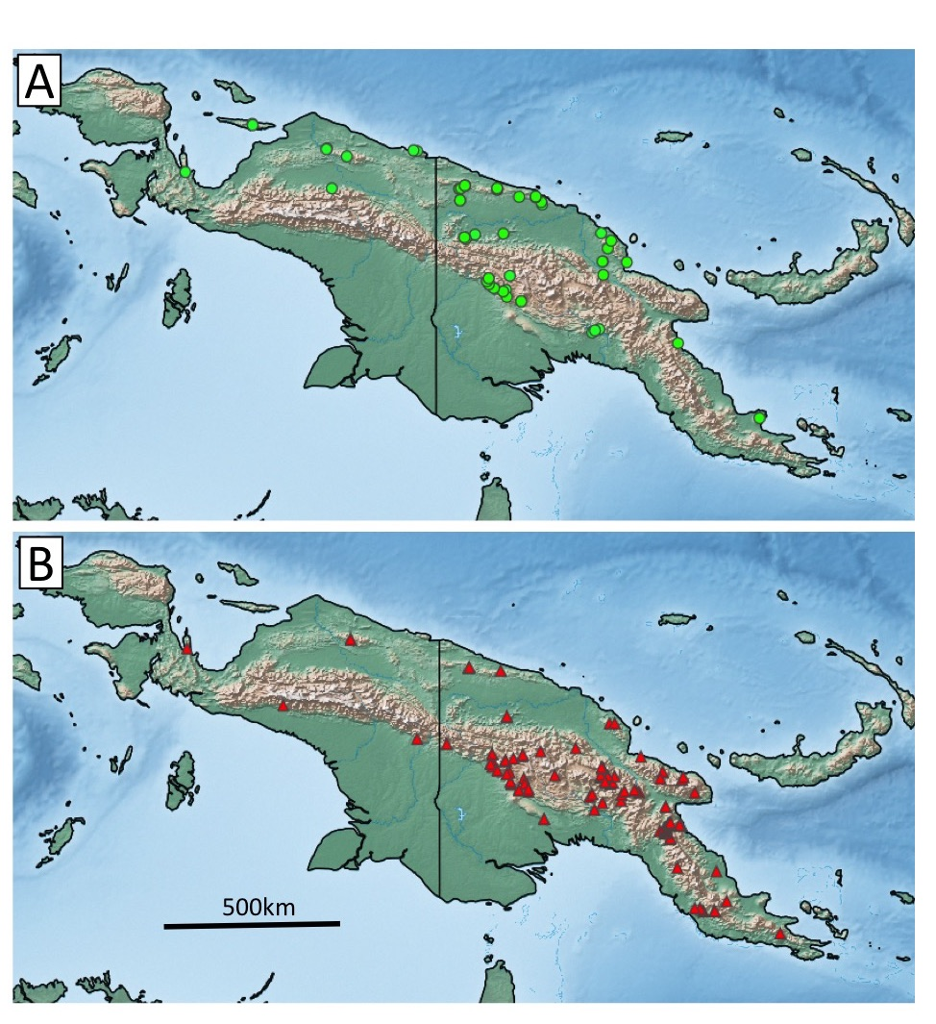

Figure SI3. Summary of museum records for Choerophryne grouped by phenotype. A) taxa with an extended maxillary process (in large part corresponded to Clade B, but see Kraus, 2013 for a probable exception from Milne Bay Province), and B) taxa lacking an extended maxillary process, rendering them morphologically consistent with genotyped samples in Clade A and C.

