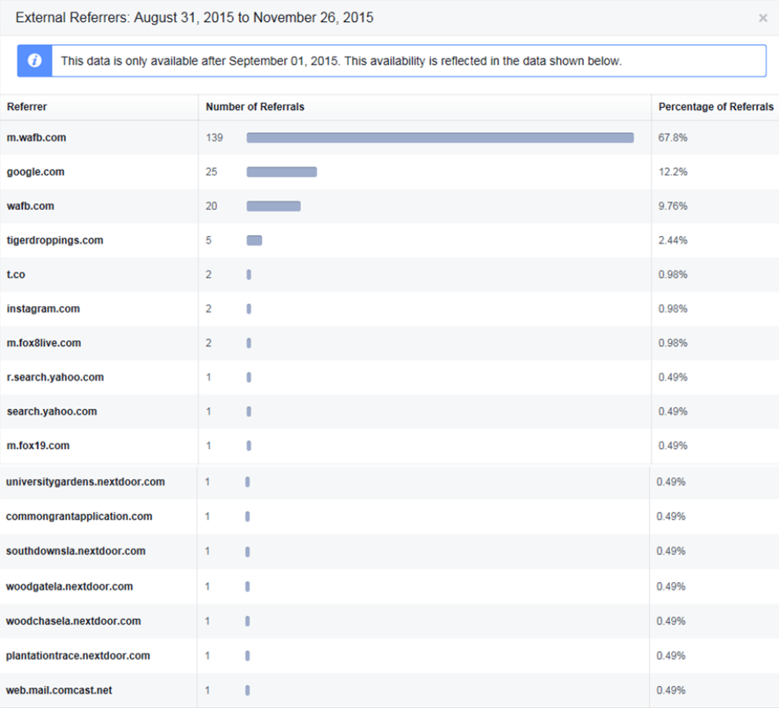
Figure S1: The number of people who viewed our Facebook Page due to a referral from an external website for the first 88 days of data collection, from 31 August 2015 to 26 November 2015.

Table S1: Locations in and around Baton Rouge where foxes were directly or indirectly been given supplementary feeding by residents as reported between 31 August 2015 and 30 April 2016.

Areas where Foxes are Receiving Supplementary Feeding from Residents
Location | Estimated number of Foxes | Commentary
Highland Rd. and Kenilworth Pkwy area: Copperfield Ct. | 7 | Supplemented daily before dawn
BREC Bluebonnet Swamp | Many | Captured on remote camera; cat food used as bait
Ponchatoula, LA | 4 | “I’m pretty sure they eat cat food every night”
University Lakes: E. Lakeshore Dr. near Standford Ave. | 3 | Baby foxes “eat our cats leftover food every night”
St. Francisville, LA | 3 | 2 Videos foxes sharing food with cats
Port Allen: Along N. River Rd. | 3 | Video showing foxes eating from bowl
LSU Bird Refuge | 5 | Resident leaving pet food

Table S2: Locations where foxes were reported or seen to have been road-killed between 31 August 2015 and 30 April 2016.

Local Foxes Reported or Observed as being Road-killed
Location | Estimated number of Foxes
Highland Rd. and Kenilworth Pkwy area | 6
Starring Ln (between Highland Rd. and Burbank Dr.) | 1
University Lake: Standford Ave. | 1
University Lake: West Lakeshore and S. Campus Dr. | 1
University Lake: Near LSU Bird Refuge | 1
Mid City: Belmont Ave. | 1
Florida Blvd and Airline Hwy ramp | 1
Southdown subdivision: Robert E. Lee High School | 1
Bluebonnet Blvd and Jefferson Hwy area | 1
Total | 14

Table S3: Locations where foxes were living around storm culverts as reported or seen between 31 August 2015 and 30 April 2016.

Local Foxes Reported or Observed as Using or Living in
Drainage Tunnels/Storm Culverts
Location | Estimated number of Foxes
Highland Park area | Some
Highland Rd. and Kenilworth Pkwy area | 8
BR Center for Visual and Performing Arts | Few
Ponchatoula, LA | 4
Hundred Oaks and Arlington Ave. | 2
Baker, LA | 1
Tunnels under Arline Hwy | -

Table S4.

Areas where Local Fox Dens were Reported or Observed
Location | Date
Kenilworth: Louray and Chandler Dr. (in empty lot) | 2014
Southdown subdivision | 2015
University Lakes (20 dens) | March 2015, 2016
Highland Rd. and Kenilworth Pkwy area | 2016
University Acres subdivision | Over last 10 years

Table S5: Mean distance of the foxes from the nearest water source for each common location from 31 August 2015 to 30 April 2016.

Distance of the Foxes or Group of Foxes Sighted from the Nearest Water Source (miles)
 | University Lakes and City Park area | University Acres | Highland Rd. and Kenilworth Pkwy area | Goodwood Blvd. and Lobdell Ave. area | Broadmoor Schools zone
 | University Lake | Bayou Fountain | Bayou Fountain | Ward Creek | Jones Creek
 | 0.02 | 0.09 | 0.06 | 0.02 | 0.31
 | 0.02 | 0.15 | 0.07 | 0.05 | 0.33
 | 0.02 | 0.26 | 0.07 | 0.10 | 0.52
 | 0.04 | 0.27 | 0.08 | 0.20 | 0.60
 | 0.04 | 0.31 | 0.10 | 0.20 | 0.70
 | 0.05 | 0.32 | 0.11 | 0.32
 | 0.05 | 0.34 | 0.12 | 0.33
 | 0.06 | 0.34 | 0.19 | 0.58
 | 0.08 | 0.34 | 0.20
 | 0.10 | 0.35 | 0.22
 | 0.14 | 0.37 | 0.22
 | 0.22 | 0.48 | 0.22
 |  | 0.52 | 0.22
 |  |  | 0.44
 | Dawson Creek |  | Dawson Creek
 | 0.04 |  | 0.23
 | 0.06 |  | 0.33
 | 0.14 |  | 0.45
 | 0.23 |  | 0.48
 | 0.24
 | 0.30
 | 0.58
Mean | 0.13 | 0.32 | 0.21 | 0.23 | 0.49
Standard Deviation | ±0.14 | ±0.11 | ±0.13 | ±0.18 | ±0.17

