Supplementary Data File
Supplementary Figures
Figure S1. Hypothetical example of variability count distributions for a pathway and a reference. A. The reference distribution corresponds to a hypothetical data set with 10,000 genes where 2,500 genes are in the low variability category, 5000 in the medium and 2500 in the high variability category. B. The count distribution of Pathway 1 contains a total of 100 genes from the dataset. From these 100 genes, 10 are in the low variability category, 55 in the medium, and 25 in the high variability category. The pathVar method assesses how different these two distributions are from each other using either an exact test or a Chi-squared test.

Figure S2. Summarizing the main functional themes in significant REACTOME terms obtained for the one-group pathVar analysis of the human embryonic stem cell lines. Classification of the statistically significant terms from REACTOME (adjusted P-value < 0.01) for A. the 125 terms for the Yan data set (passage 0), B. the 106 significant terms for the Yan data set (passage 10). C. the 69 significant terms for the Bock data set.

Supplementary Tables
Table S1. Number of significant pathways obtained for the three stem cell data sets in the one-group case (adjusted P-value < 0.01). Number of significant pathways obtained for A. KEGG and B. REACTOME in the one-group case when using pathVar based on either the variability statistic, or average gene expression. We also report the number of significant pathway terms that were identified in both the mean-based and variability-based analysis.
Pathway Database | Datasets | Type | Genes | Samples | Significant for variability (SD) | Significant for mean | Intersection mean/variability
KEGG | Bock hESC | Microarray | 7632 | 20 | 25 | 24 | 9
 | Bock iPSC | Microarray | 7646 | 12 | 19 | 21 | 9
 | Yan hESC | Single cell RNA-seq | 6667 | 34 | 11 | 14 | 8
REACTOME | Bock hESC | Microarray | 7632 | 20 | 65 | 138 | 43
 | Bock iPSC | Microarray | 7646 | 12 | 66 | 149 | 42
 | Yan hESC | Single cell RNA-seq | 6667 | 34 | 95 | 131 | 94

Table S2. Statistically significant pathway terms from one-group pathVar analysis using the SD for the Bock human embryonic stem cell lines (adjusted P-value < 0.01). A. KEGG pathways and B. REACTOME terms.
A. KEGG.
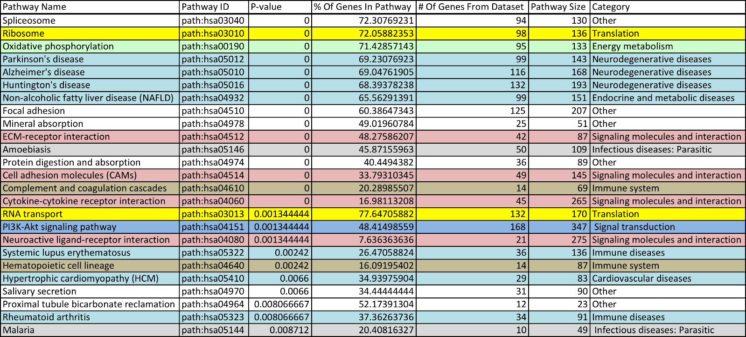

B. REACTOME.
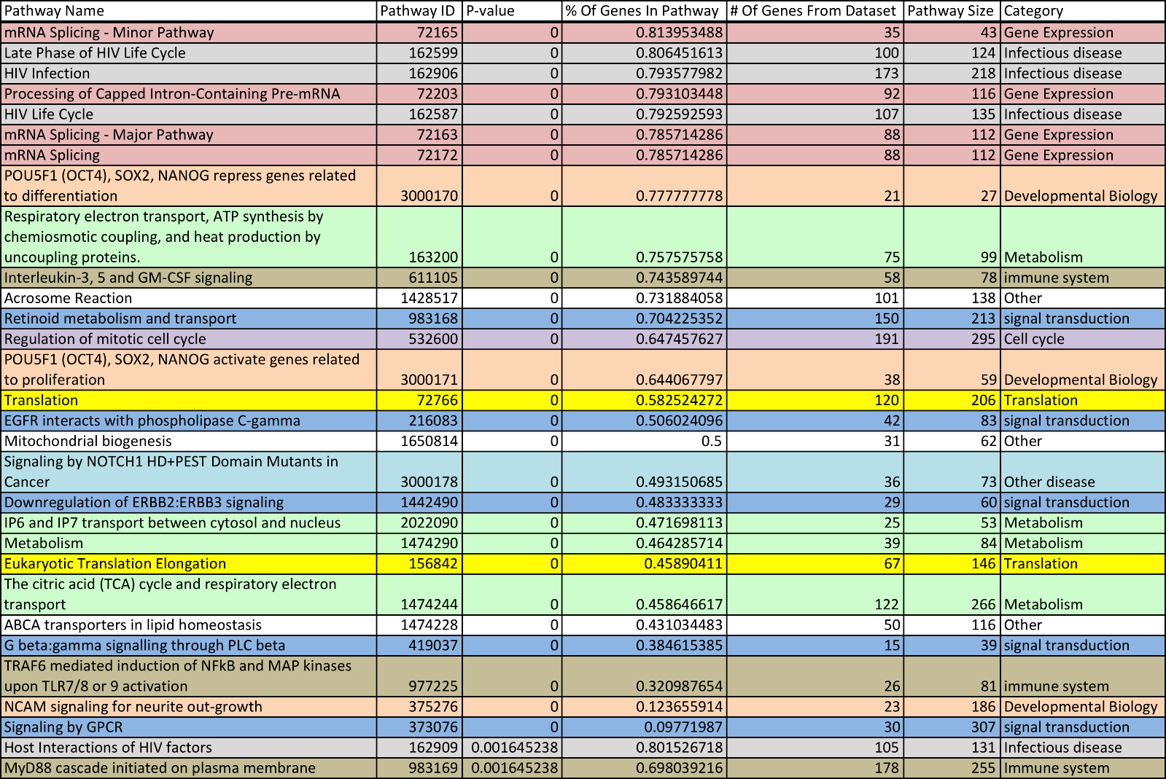
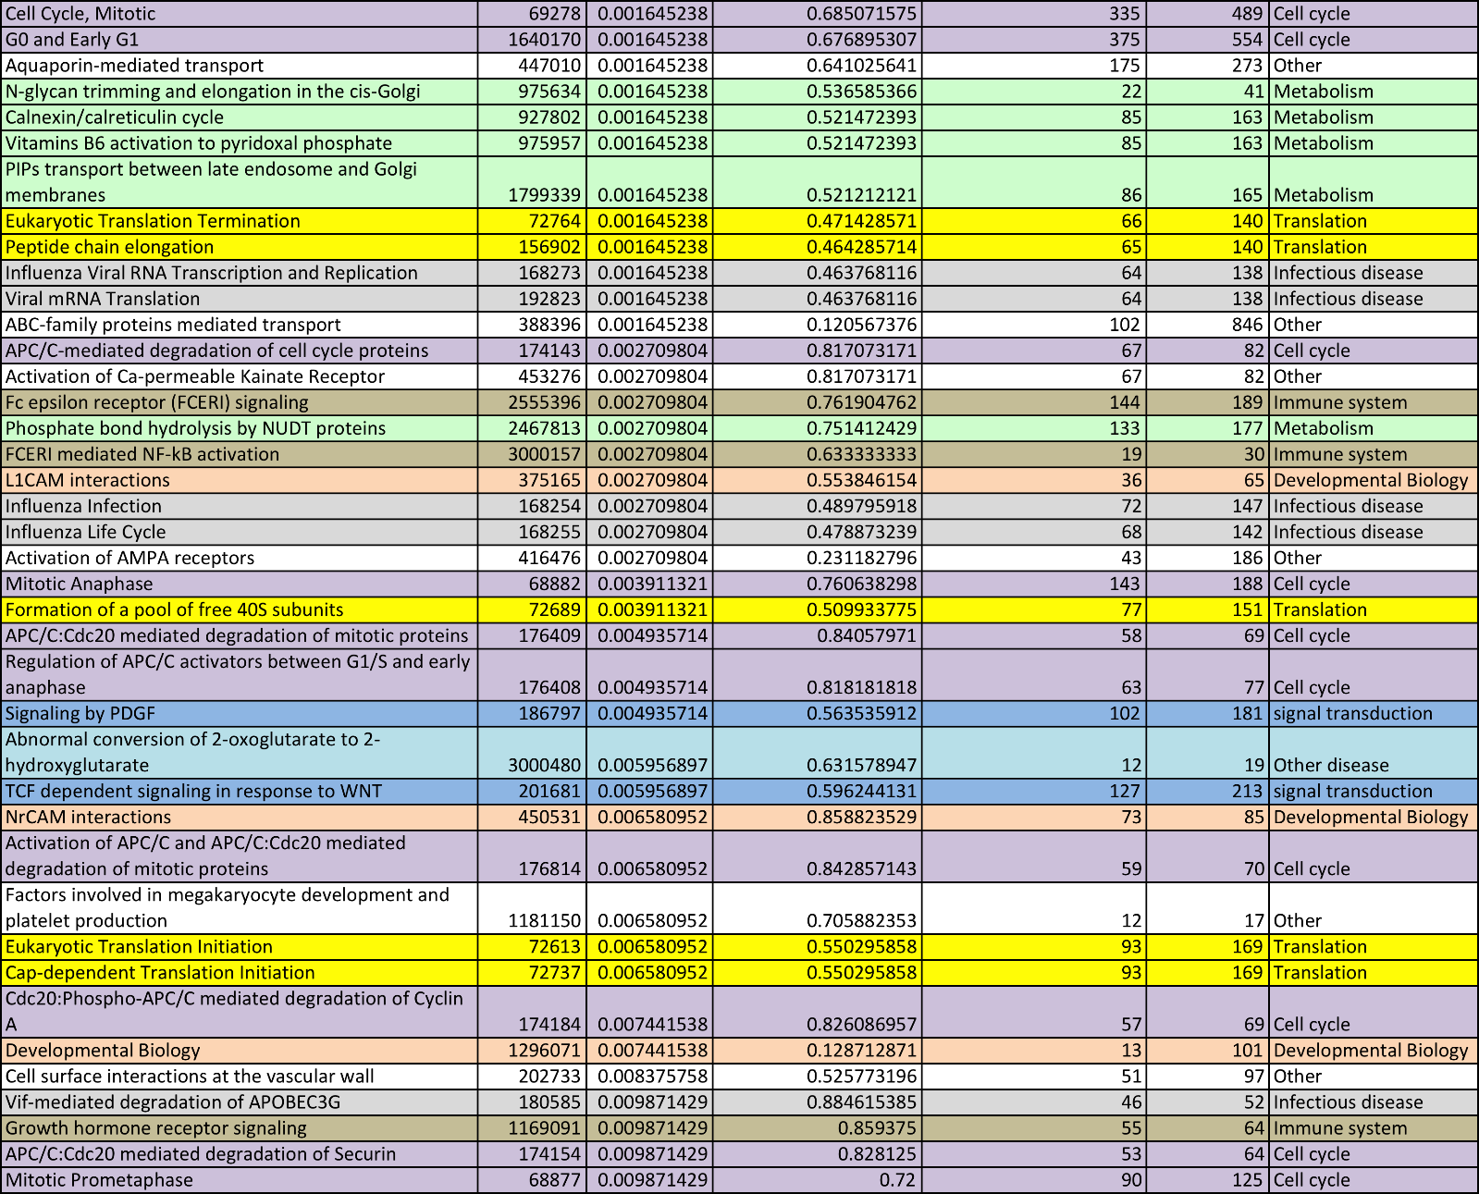

Table S3. Statistically significant pathway terms from one-group pathVar analysis using the SD for the Yan single human embryonic stem cells profiled at passage 0 (adjusted P-value < 0.01). A. KEGG pathways and B. REACTOME terms.
A. KEGG
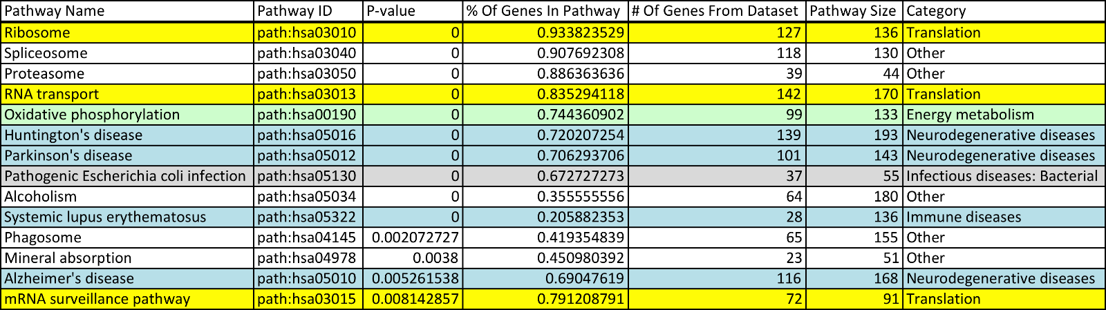

B. REACTOME.

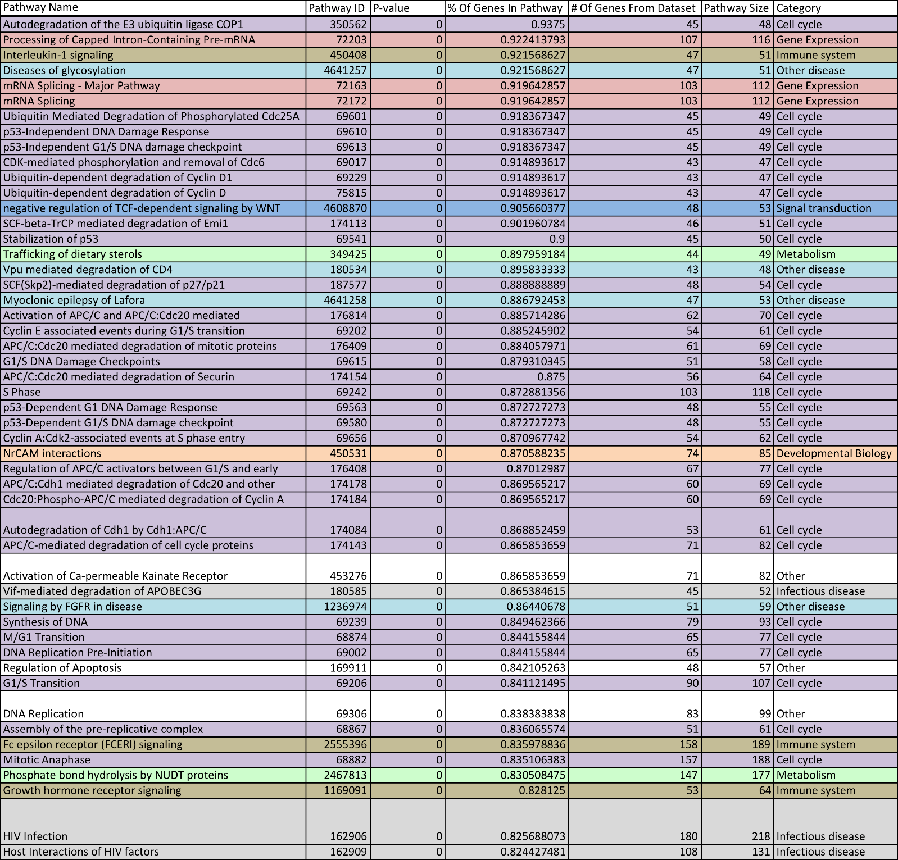

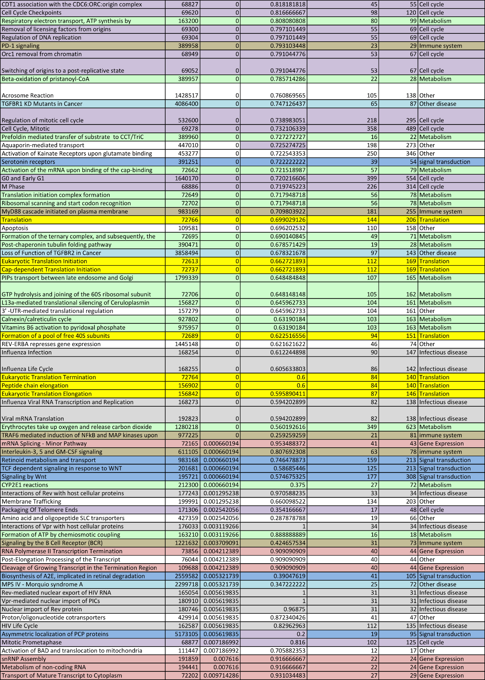

Table S4. Statistically significant pathway terms from one-group pathVar analysis using the SD for the Yan single human embryonic stem cells profiled at passage 10 (adjusted P-value < 0.01). A. KEGG pathways and B. REACTOME terms.
A. KEGG.
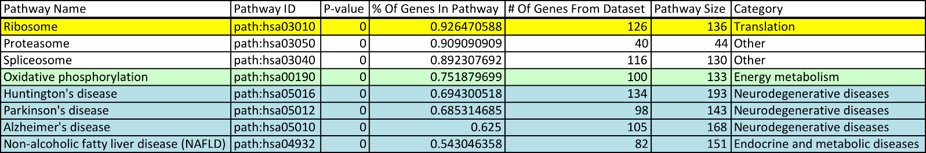
B. REACTOME.
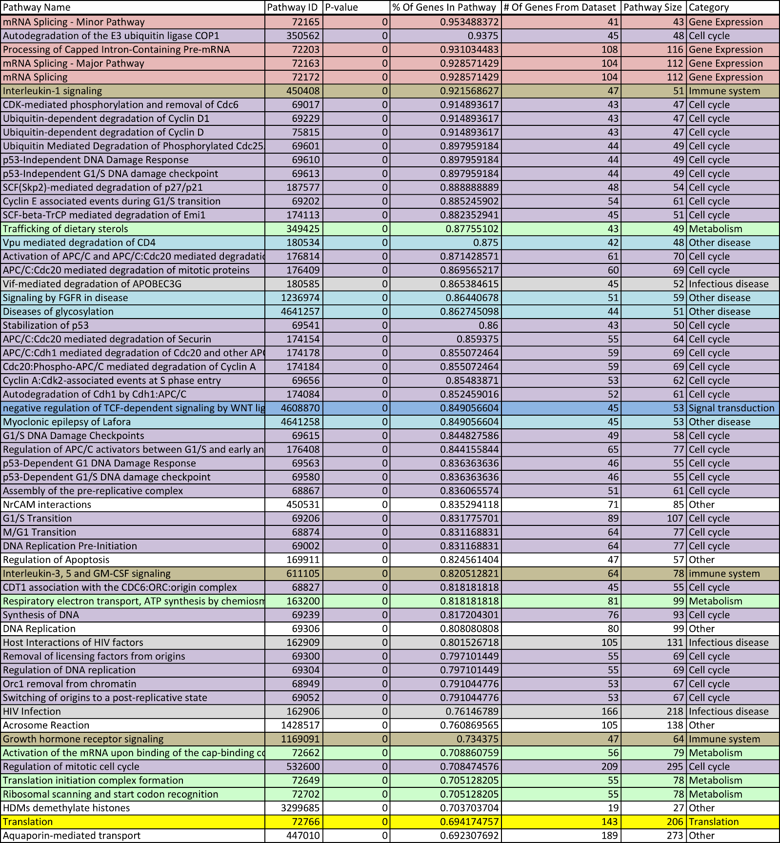
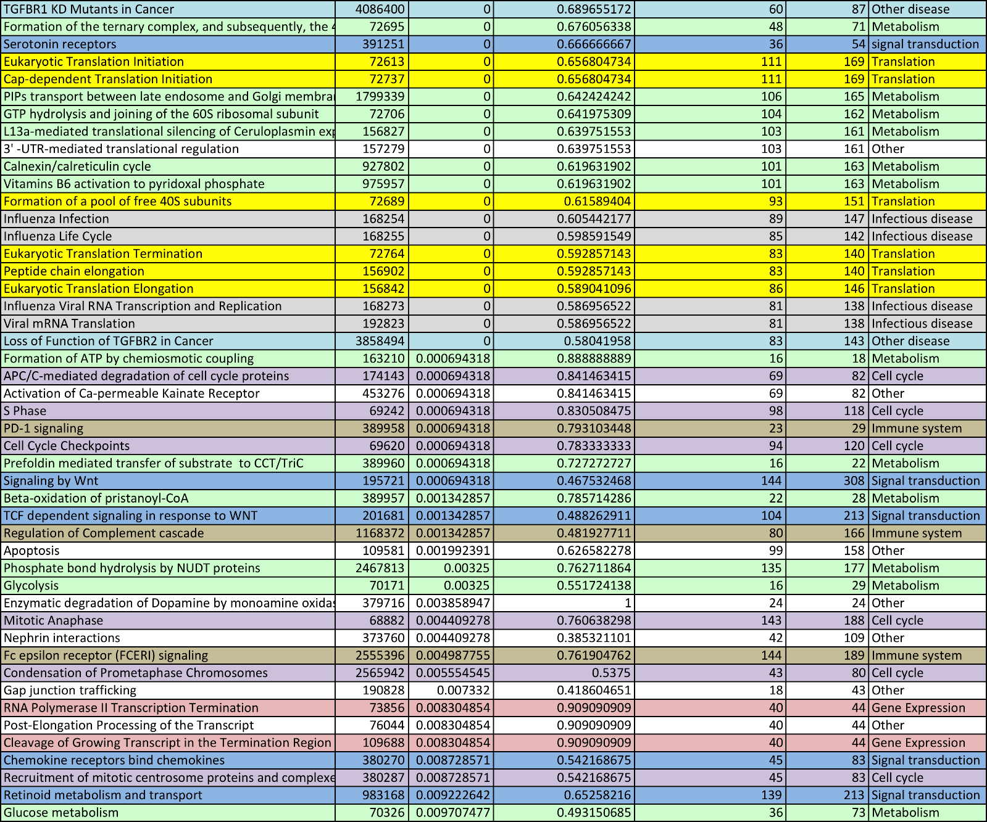

Table S5. Number of significant pathways obtained for the ESC versus iPSC two-group case (adjusted P-value < 0.01). Number of significant pathways obtained for A. KEGG and B. REACTOME in the two-group case when using pathVar based on either the variability statistic, or average gene expression. We also report the number of significant pathway terms that were identified in both the mean-based and variability-based analysis.
Pathway Database | Comparison | Samples | Genes | Significant for variability (SD) | Significant for mean | Intersection mean/variability
KEGG | ESC vs iPSC | 20 ESCs, 12 iPSCs | 7564 | 6 | 1 | 0
REACTOME | ESC vs iPSC | 20 ESCs, 12 iPSCs | 7564 | 30 | 3 | 1

Table S6. Statistically significant pathways with a change in gene expression variability using pathVar based on the SD between human ESCs and iPSCs from the Bock data set (adjusted P-value < 0.01).
A. KEGG.
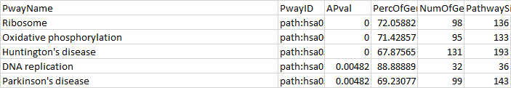
B. REACTOME.
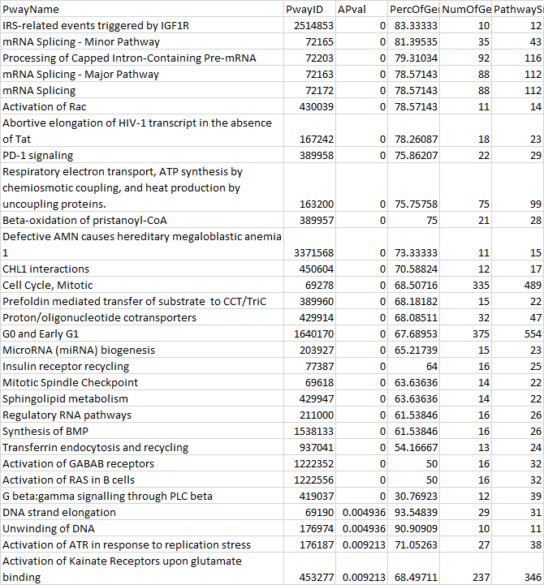

Table S7. Statistically significant pathways with a change in average gene expression using pathVar based on average expression between human ESCs versus iPSCs from the Bock data set (adjusted P-value < 0.01).
A. KEGG.

B. REACTOME.

Table S8. Number of significant pathways obtained for all gene expression datasets for the one-group case (adjusted P-value < 0.01). Number of significant pathways obtained for A. KEGG and B. REACTOME in the one-group case when using pathVar based on either the variability statistic, or average gene expression. We also report the number of significant pathway terms that were identified in both the mean-based and variability-based analysis.

A. KEGG

Datasets | Type | Genes | Samples | Variability | Significant for variability | Significant for mean | Intersection mean/variability
TCGA AML | RNA-seq | 14681 | 173 | MAD | 80 | 130 | 48
TCGA GBM | RNA-seq | 16216 | 169 | SD | 93 | 141 | 60
TCGA OVC | RNA-seq | 16187 | 309 | MAD | 96 | 117 | 58
Yan hESC | Single cell RNA-seq | 6667 | 34 | SD | 11 | 14 | 8
Bock hESC | Microarray | 7632 | 20 | SD | 25 | 24 | 9
Bock iPSC | Microarray | 7646 | 12 | SD | 19 | 21 | 9
1000 Genomes | RNA-seq | 11945 | 660 | MAD | 9 | 84 | 7
Host Malaria | Microarray | 24891 | 98 | CV | 34 | 145 | 30
Parasite Malaria | Microarray | 5199 | 56 | CV | 16 | 60 | 14
Mouse Hippocampus | Microarray | 18138 | 100 | CV | 4 | 99 | 4
Mouse Striatum | Microarray | 18138 | 98 | CV | 2 | 92 | 2
Down syndrome iPSC | Microarray | 21040 | 12 | SD | 9 | 102 | 4
Wild-type iPSC | Microarray | 21040 | 15 | SD | 11 | 115 | 6

B. REACTOME

Datasets | Type | Genes | Samples | Variability | Significant for variability | Significant for mean | Intersection mean/variability
AML | RNA-seq | 14681 | 173 | MAD | 347 | 396 | 248
GBM | RNA-seq | 16216 | 169 | SD | 424 | 439 | 291
OVC | RNA-seq | 16187 | 309 | MAD | 351 | 447 | 287
Yan hESC | Single cell RNA-seq | 6667 | 34 | SD | 95 | 131 | 94
Bock hESC | Microarray | 7632 | 20 | SD | 65 | 138 | 43
Bock iPSC | Microarray | 7646 | 12 | SD | 66 | 149 | 42
1000 Genomes | RNA-seq | 11945 | 660 | MAD | 19 | 308 | 16
Host Malaria | Microarray | 24891 | 98 | CV | 22 | 387 | 22
Down syndrome iPSC | Microarray | 21040 | 12 | SD | 31 | 437 | 20
Wild-type iPSC | Microarray | 21040 | 15 | SD | 38 | 478 | 27

Table S9. Number of significant pathways obtained for all gene expression datasets for the two-group case (adjusted P-value < 0.01). Number of significant pathways obtained for A. KEGG and B. REACTOME in the two-group case when using pathVar based on either the variability statistic, or average gene expression. We also report the number of significant pathway terms that were identified in both the mean-based and variability-based analysis.

A. KEGG

First dataset | Second dataset | Genes | Variability | Significant for variability | Significant for mean | Intersection mean/variability
AML | 1000 Genomes | 9060 | MAD | 186 | 250 | 186
GBM | 1000 Genomes | 9088 | MAD | 128 | 245 | 123
OVC | 1000 Genomes | 9102 | MAD | 176 | 247 | 173
Bock hESC | Bock iPSC | 7564 | SD | 6 | 1 | 0
Down syndrome iPSCs | Wild-type iPSCs | 9039 | SD | 75 | 0 | 0
Mouse Hippocampus | Mouse Striatum | 18138 | CV | 116 | 0 | 0

B. REACTOME

First dataset | Second dataset | Genes | Variability | Significant for variability | Significant for mean | Intersection mean/variability
AML | 1000 Genomes | 9060 | MAD | 444 | 713 | 440
GBM | 1000 Genomes | 9088 | MAD | 309 | 711 | 303
OVC | 1000 Genomes | 9102 | SD | 352 | 715 | 350
Bock hESC | Bock iPSC | 7564 | SD | 30 | 3 | 1
Down syndrome iPSCs | Wild-type iPSCs | 9039 | SD | 236 | 19 | 6

Table S10. Top ten statistically significant KEGG pathways (adjusted P-value < 0.01) in the two-group cancer versus normal comparisons. We report the top ten pathways or all the significant pathways if there were less than ten for A. AML vs 1000 Genomes, B. GBM vs 1000 Genomes, C. OVC vs 1000 Genomes. Blue cells denote terms that were observed for both the variability-based and average expression-based pathVar analyses. Yellow cells denote terms that were unique to either the variability-based or average expression-based pathVar analysis.
A. AML vs 1000 Genomes.
MAD
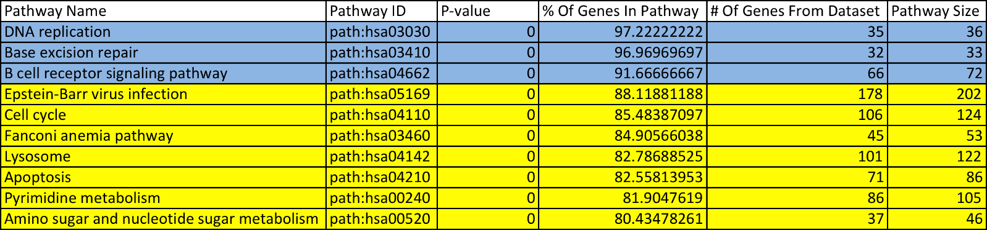
Mean
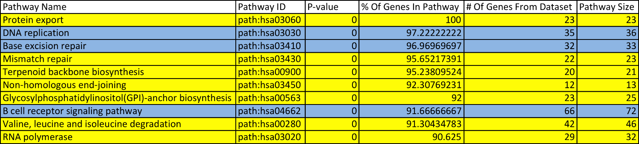
B. GBM vs 1000 Genomes
MAD
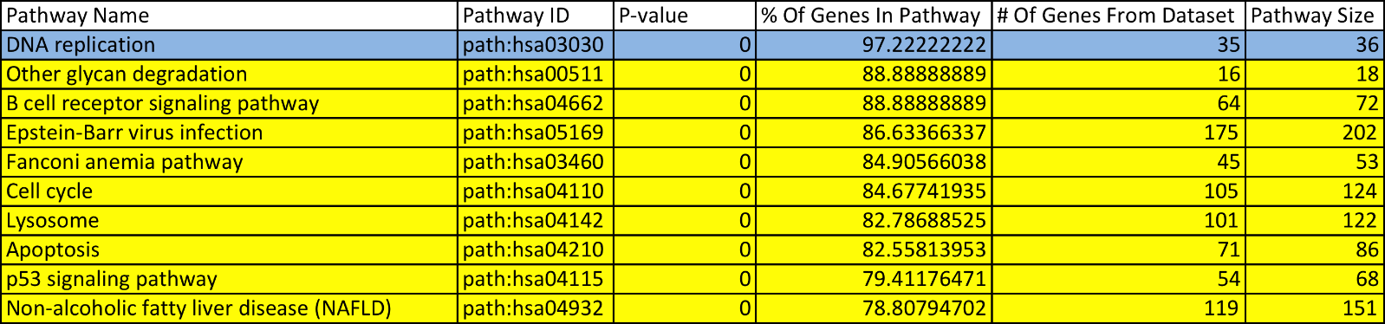
Mean
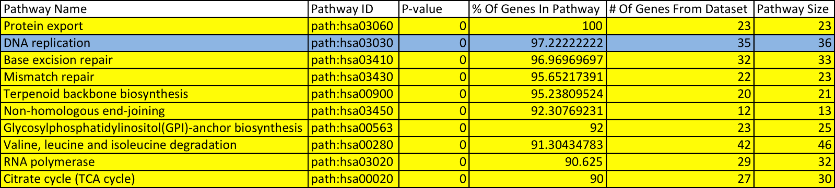

C. OVC vs 1000 Genomes
MAD
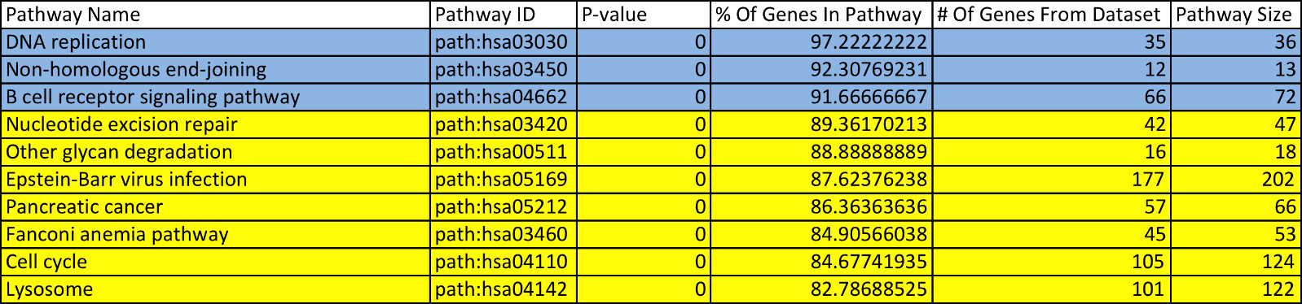
Mean
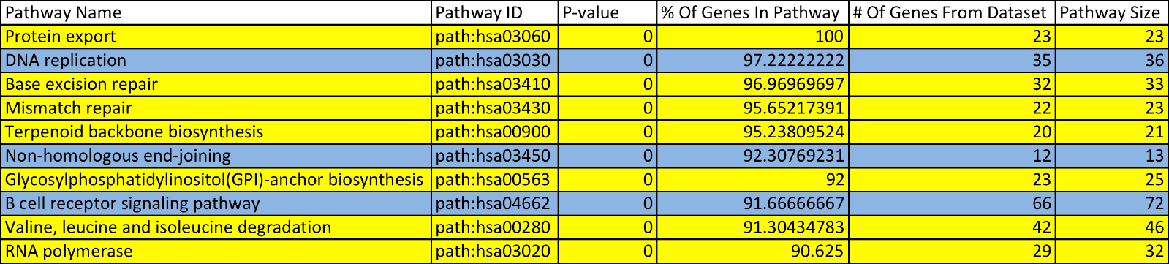

Table S11. Top ten statistically significant REACTOME terms (adjusted P-value < 0.01) in the two-group cancer versus normal comparisons. We report the top ten pathway terms or all the significant pathways if there were less than ten for A. AML vs 1000 Genomes, B. GBM vs 1000 Genomes, C. OVC vs 1000 Genomes. Blue cells denote terms that were observed for both the variability-based and average expression-based pathVar analyses. Yellow cells denote terms that were unique to either the variability-based or average expression-based pathVar analysis.

A. AML vs 1000 Genomes.

MAD
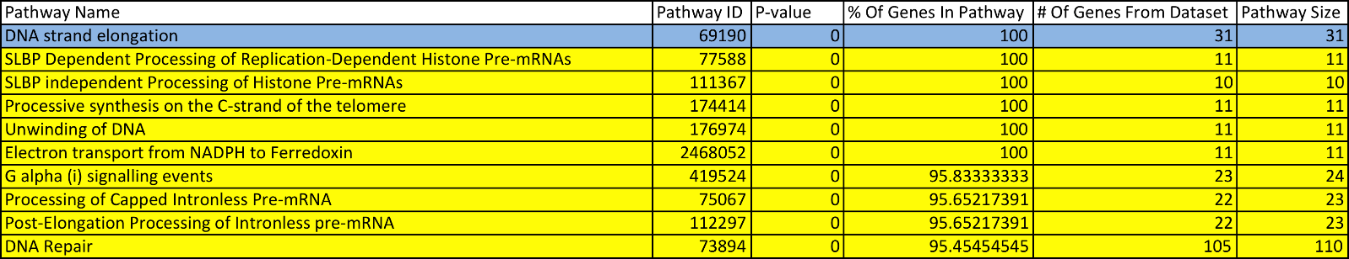

Mean
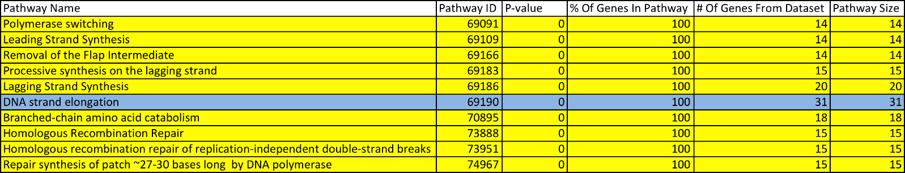

B. GBM vs 1000 Genomes.

MAD
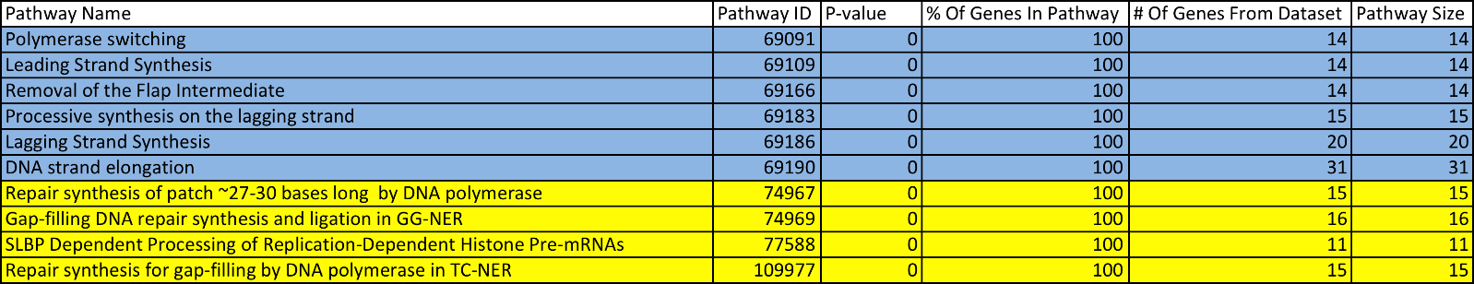

Mean
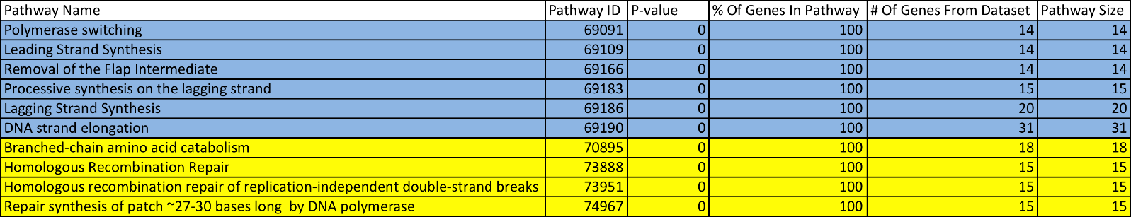
C. OVC vs 1000 Genomes.

MAD
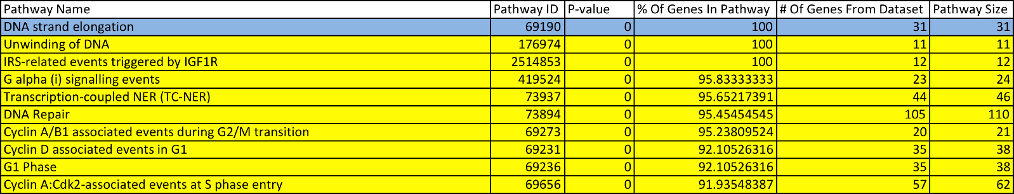

Mean

Supplementary Texts
Text S1: Simulations and Power Calculations to Test Parameters of the pathVar Method

Text S2: Pre-processing Steps Applied to the Stem Cell Gene Expression Data Sets

Text S3: Application of pathVar versus GSEA on Ten Different Gene Expression Datasets

