Table S1: Glossary of abbreviations

Abbreviation | Definition
TSA | Total surface area
LSA | Surface area consisting of corallites
CT scan | Computed tomography scan
PL TSA | Total surface area of specimen based on planar photography
PL LSA | Surface area of the specimen consisting of corallites, according to planar photography
PH TSA | Total surface area of specimen based on photogrammetry
PH LSA | Surface area of specimen consisting of corallites, according to photogrammetry
PH Vol | Volume of the specimen according to photogrammetry
CT TSA | Total surface area of specimen based on computed tomography scans
CT LSA | Surface area of specimen consisting of corallites, according to computed tomography scans
CT Vol | Volume of the specimen according to computed tomography scans

Table S2: ID number, species, morphotype, number of photographs used for photogrammetry and dimensions for each coral skeleton used. The images of each coral are from photogrammetry or photographs used for measuring planar area. The images were selected to provide the best view of characteristics that are useful for species identification.
ID number | Species | Morphotype | Alternative Morphotype (according to AIMS, 2013) | Mean number of images used for photogrammetry | Bounding box  (LxWxH,  in cm) | Image
1 | Acropora nasuta | Branching | Corymbose | 128 | 19.1 x 20.8 x 15.4
2 | Acropora polystoma | Branching | Corymbose | 113 | 21.7 x 27.0 x 17.0
3 | Acropora hyacinthus | Branching | Table | 132 | 22.0 x 18.4 x 17.0
4 | Symphyllia radians | Massive | Hemispherical | 48 | 9.4 x 11.9 x 6.1 | 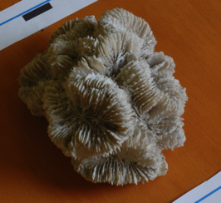
5 | Porites spp | Massive | Stumpy | 112 | 17.2 x 17.3 x 8.8 | 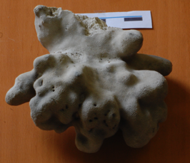
6 | Montipora spp. | Massive | Stumpy | 77 | 16.3 x 18.1 x 8.1 | 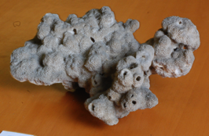
7 | Favia stelligera | Massive | Spherical | 82 | 11.7 x 14.1 x 6.2 | 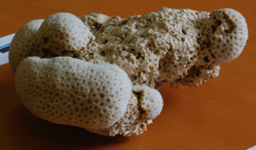
8 | Goniastrea retiformis | Massive | Hemispherical | 140 | 20.9 x 22.1 x 12.8 | 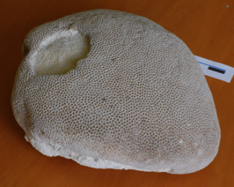
9 | Porites spp | Massive | Stumpy | 62 | 11.0 x 11.2 x 8.8 | 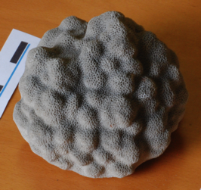
10 | Podabacia crustacea | Encrusting | Plate | 97 | 22.5 x 19.1 x 5.8
11 | Echinopora gemmacea | Encrusting | Laminar | 78 | 12.5 x 17.0 x 4.3 | 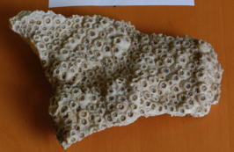
12 | Acropora hyacinthus | Branching | Table | 94 | 22.3 x 19.2 x 4.3
13 | Leptoria irregularis | Encrusting | Submassive | 94 | 25.1 x 21.8 x 12.9
14 | Platygyra crosslandi | Encrusting | Plate | 74 | 20.4 x 11.9 x 11.1 | 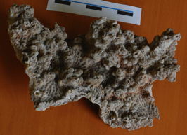
15 | Acropora formosa | Branching | Arborescent | 93 | 22.1 x 18.5 x 9.6
16 | Symphyllia recta | Massive | Hemispherical | 67 | 6.7 x 6.8 x 3.9 | 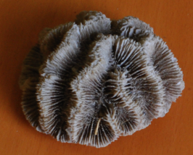
17 | Porites spp | Massive | Stumpy | 82 | 6.5 x 7.5 x 6.4 | 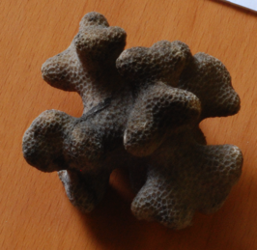
18 | Acropora hyacinthus | Branching | Table | 68 | 16.3 x 14.9 x 4.9 | 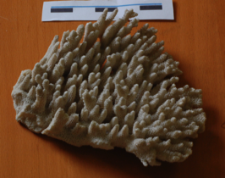
19 | Acropora cytherea | Branching | Table | 105 | 11.1 x 8.3 x 4.6 | 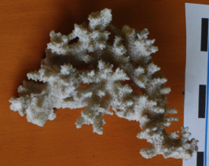
20 | Goniastrea retiformis | Massive | Hemispherical | 50 | 13.1 x 7.3 x 9.7 | 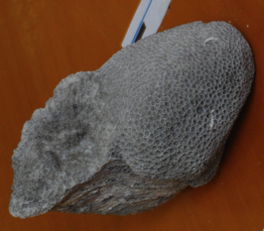
21 | Acropora formosa | Branching | Arborescent | 58 | 6.9 x 9.5 x 16.6 | 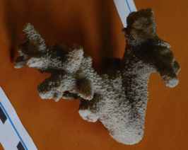
22 | Acropora carduus | Branching | Bottlebrush | 97 | 6.0 x 7.7 x 10.5 | 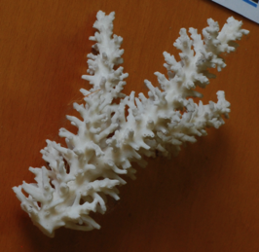

Specimen 1  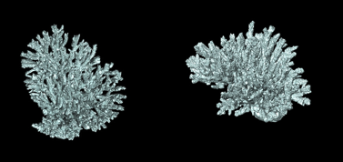  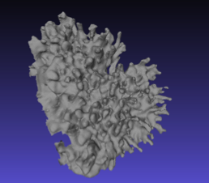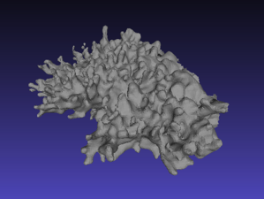 | Specimen 3  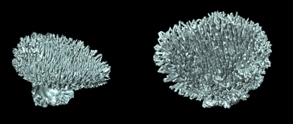  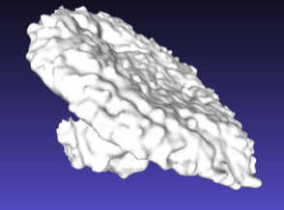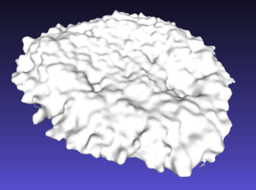
Specimen 4  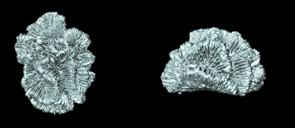  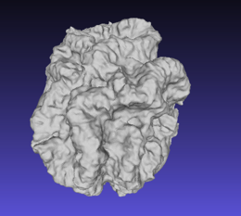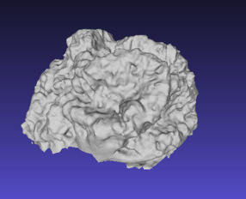 | Specimen 8  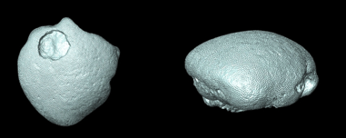  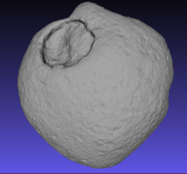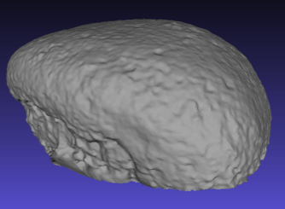
Specimen 11  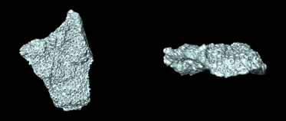  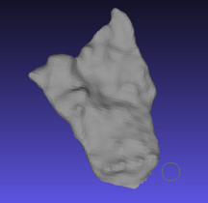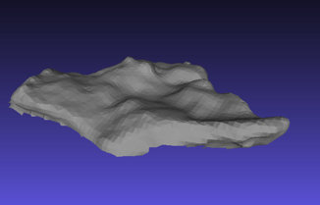 | Specimen 15  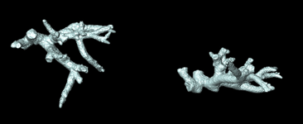  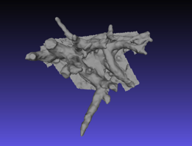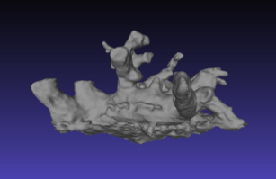
Specimen 17  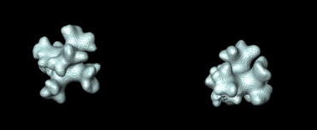  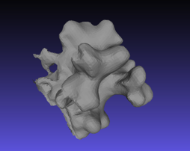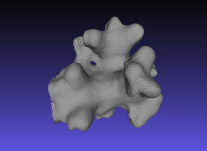 | Figure S1: 3D reconstructions of selected coral specimens at similar orientations respectively based on X-ray Computed Tomography (black background) and Photogrammetry (blue background).

