Supplementary Information for:
Comparative genomics of Pseudomonas syringae pathovar tomato reveals novel chemotaxis pathways associated with motility and plant pathogenicity
Christopher R. Clarke¹, Byron W. Hayes¹, Brendan J. Runde¹, Eric Markel², Bryan M. Swingle^{2,3}, and Boris A. Vinatzer¹
¹Department of Plant Pathology, Physiology, and Weed Science. Virginia Tech. Blacksburg, VA, USA.
² Emerging Pests and Pathogens Research Unit, Robert W. Holley Center for Agriculture and Health, ,United States Department of Agriculture-Agricultural Research Service, Ithaca, NY, USA.
³Plant Pathology and Plant-Microbe Biology Section, School of Integrative Plant Science, Cornell University, Ithaca, NY, U.S.A.

Correspondence: thechrisclarke@gmail.com
Contents:
Tables S1-S2
Figures S1-S7
Author Contributions

Other Files included in this submission
Supplementary videos 1-3

Annotation | Start | End | Frame | Length(nt) | Accession
che1 - based on 60k-90k ctg 127 PtoT1 genome (some accession #s are from other strains)
hypothetical | 77 | 796 | -3 | 720 | NP_790769
glutothione s-trans | 1010 | 1795 | -3 | 786 | ZP_03398314
hypothetical | 1789 | 2145 | +1 | 357 | ZP_03398315
pilin | 2426 | 3355 | -3 | 930 | ZP_03398316
PilB | 3086 | 4780 | +2 | 1695 | ZP_03398317
PilC | 4783 | 6000 | +1 | 1218 | ZP_03398318
PilD | 6002 | 6874 | +2 | 873 | ZP_03398319
dephospho-CoA kinase | 6871 | 7494 | +1 | 624 | ZP_03398320
hypothetical (DNA gyr inhib) | 7491 | 7700 | +3 | 210 | NP_790761
hypothetical protein | 7967 | 8293 | -3 | 327 | ZP_03398322
hypothetical | 8490 | 9119 | +3 | 630 | ZP_03398323
MOSC domain prot | 9116 | 9649 | +2 | 534 | ZP_03398324
NADH dehydrogenase | 9866 | 11164 | +2 | 1299 | ZP_03398325
mcp | 11592 | 12806 | +3 | 1215 | ZP_03398326
cheY-122 | 12816 | 13184 | +3 | 369 | ZP_03398327
STAS domain prot | 13211 | 13501 | +2 | 291 | ZP_03398328
cheA-678 | 13614 | 15650 | +3 | 2037 | ZP_03398329
- | 15684 | 15908 | +3 | 225 | -
mcp | 15679 | 17334 | +1 | 1656 | ZP_03398330
cheW | 17371 | 17910 | +1 | 540 | ZP_03398331
cheR | 17920 | 18729 | +1 | 810 | ZP_03398332
cheD | 18726 | 19232 | +3 | 507 | ZP_03398333
cheB | 19222 | 20298 | +1 | 1077 | ZP_03398334
hypothetical | 20332 | 21543 | -1 | 1212 | ZP_03398335
hopAI1 | 21712 | 22515 | -1 | 804 | ZP_03398336
hopAH1 | 22682 | 23950 | -3 | 1269 | ZP_03398337
hopAG1 | 24054 | 26159 | -2 | 2106 | ZP_03398338
hypothetical | 26159 | 26410 | -3 | 252 | ZP_03398339
sensor hist kinase | 27216 | 28829 | -2 | 1614 | ZP_03398341
che2 - Based on ctg57 155K-220K PtoT1 genome (some accession #s are from other strains)
transcriptional activ anr | 12957 | 13691 | +3 | 735 | ZP_03395676
adenine phosribotransf | 13753 | 14301 |  | 548 | ZP_03395677
hypothetical | 14432 | 14776 | -2 | 345 | ZP_03395678
cheW | 14834 | 15313 | -2 | 480 | ZP_03395679
cheW | 15371 | 16258 | -2 | 888 | ZP_03395680
parA | 16334 | 17122 | -2 | 789 | ZP_03395681
chemotB | 17168 | 18055 | -2 | 888 | ZP_03395682
chemotA | 18062 | 18802 | -2 | 741 | NP_791807
cheB | 18802 | 19974 | -3 | 1173 | ZP_03395684
cheA | 20025 | 22265 | -1 | 2241 | ZP_03395685
cheZ | 22299 | 23084 | -1 | 786 | ZP_03395686
cheY | 23104 | 23478 | -3 | 375 | ZP_07231294
flg biosynth sigma | 23732 | 24472 | -2 | 741 | ZP_03395688
fleN | 24469 | 25302 | -3 | 834 | NP_791801
flhF | 25418 | 26746 | -2 | 1329 | NP_791800
flhA | 26758 | 28797 | -3 | 2040 | NP_791799
flhB | 29272 | 30408 | -3 | 1137 | NP_791798
fliR | 30410 | 31186 | -2 | 777 | NP_791797
fliQ | 31202 | 31471 | -2 | 270 | NP_791796
fliP | 31497 | 32249 | -1 | 753 | NP_791795
flliO | 32249 | 32689 | -2 | 441 | NP_791794
fliN | 32690 | 33148 | -2 | 459 | NP_791793
fliM | 33210 | 34178 | -1 | 969 | NP_791792
fliL | 34188 | 34691 | -1 | 504 | NP_791791
fliK | 35246 | 36670 | -2 | 1425 | ZP_03395701
HPT dom. Cont. | 36769 | 37077 | -3 | 309 | NP_791788
response regulator | 37159 | 38724 | -3 | 1566 | ZP_03395703
STAS | 38870 | 39469 | -2 | 321 | NP_791786
fliJ | 39255 | 39704 | -1 | 450 | NP_791785
fliI | 39711 | 41123 | -1 | 1413 | NP_791784
fliH | 41059 | 41877 | -3 | 819 | ZP_03395707
fliG | 41893 | 42909 | -3 | 1017 | ZP_05638959
fliF | 42902 | 44686 | -2 | 1785 | NP_791781
fliE | 44702 | 45031 | -2 | 330 | ZP_03395710
sigma54-dep tran reg fleR | 45273 | 46688 | -1 | 1416 | ZP_03395711
hypothetical | 46688 | 47902 | -2 | 1215 | ZP_03395712
trans reg fleQ | 48025 | 49500 | -3 | 1476 | ZP_03395713
fliS | 49999 | 50388 | -3 | 390 | NP_791775
fliD | 50514 | 51986 | -1 | 1473 | ZP_03395716
flaG | 52070 | 52468 | -2 | 399 | ZP_03395717
fliC | 52535 | 53383 | -2 | 849 | ZP_03395718
3-oxoacyl synthase | 53713 | 54642 | -3 | 930 | ZP_03395719
glycosyl transferase | 54925 | 57831 | -3 | 2907 | ZP_03395720
glycosyl transferase | 57963 | 61079 | -1 | 3117 | ZP_03395721
flgL | 61627 | 63219 | -3 | 1593 | ZP_03395722
flgK | 63233 | 64942 | -2 | 1710 | NP_791767

Table S1. Genes in the che1 and che2 clusters and associated accession numbers.

Gene | Purpose | Forward Primer | Reverse Primer
cheA1 | Disruption | AAAAAGGGCCCTGATTgcaaagccctgtggttgc | AAAAAATCGATTCATatgacccttggccggttt
cheA2 | Disruption | AAAAAGGGCCCTGATgctagcgcctctacgaggtt | AAAAAATCGATTCATTacgaattcgaaaacctgctg
cheA1 | Disruption - integration check | accggcactgacctcgtt | cgatttcaatgacgatgctg
cheA2 | Disruption - integration check | gcgtttcgataccgtggtc | ctcgtttgacagtgctgtgg
cheA1 | Cloning | AAAAACTCGAGGAAGCCCGTGAGCTGTTG | AAAAAGAGCTCCAAATCCGTCAGCGAGAAG
cheA2 | Cloning | AAAAACTCGAGTTAGGGAGCACCCCATGA | AAAAAGAGCTCGCAACCCCGGATTCAAATA
cheA1 | Deletion | GGGTGTCGTGCTGTAACGCGTCTATTTGAAGTACCGCCGGGTGATCGACAAAGGAAGTCATCGTGAGCATTAATCTCGATGTGGAGGCTGGAGCTGCTTC | TGGTGGAAATCTTCAGATCGTAGAACCATTTCATCGGGTTACTCCTTGGAATTGCAAATCCGTCAGCGAGAAGCGGGCGACATATGAATATCCTCCTTAG
cheA1 | Sequencing | CCCTGGAGGTCAGCATGTCTACAA
cheA1 | Sequencing | CTCAGCAGCTTCCTGCTCCATCT
cheA1 | Integration check and sequencing | CCGAAGCAGCTCGCATGGA | TGTCGATCAGGATGATCTGG
cheA1 | Sequencing | GGTCATCCAGCGCGAGGC
cheA1 | Sequencing | CTGAGCGGCCTGATTCACCT
cheA1 | Sequencing | GTTTGCTGCCGCAGATCGC
cheA1 | Sequencing | CTGACGATCTACACCGTGACCGAA
cheA1 | Sequencing | CCCTGGAGGTCAGCATGTCTACAA
cheA1 | Sequencing | CTCAGCAGCTTCCTGCTCCATCT
cheA1 | Sequencing | GCTGAACATCTGACGATCCTGGT
scar | Deletion scar check | GTGTAGGCTGGAGCTGCTTC
scar | Deletion scar check | CATATGAATATCCTCCTTA
cheA2 | cheA-2 deletion 5' Flank | CGAGGAAAGCACGCCGATCA | GAAGCAGCTCCAGCCTCCACGGCGCCGAAGCTCATGGG
cheA2 | cheA-2 deletion 3' Flank | CTAAGGAGGATATTCATATGGCCGCTCGGCGTATTTGA | GCAGGCGCACGACTGGACA
cheA2 | Integration check and sequencing | ATCAGAGCAGCCGATTGTCTG | CTGGTGACCGAAGTAGAGGGCA
cheA2 | Sequencing | GGCCGAAGAGGTGTCGCA
cheA2 | Sequencing | GGCAGTGCCGGTGGTGGT
cheA2 | Sequencing | CGTCTTTCCTACGTCGTCAGGCT
cheA2 | Sequencing | CAGGCGTGTGGTGAGCATGA
cheA2 | Sequencing | GACAAGGGTGAAGGTCCGCA
cheA2 | Sequencing | CTTGCCGTTGGTGGCGGT
cheA2 | Sequencing | CGTCTTTCCTACGTCGTCAGGCT
cheA2 | Sequencing | CAGGCGTGTGGTGAGCATGA
cheA2 | Sequencing | CGTCCAGAGCATCCAGCGT
Table S2. Primers used in the study.

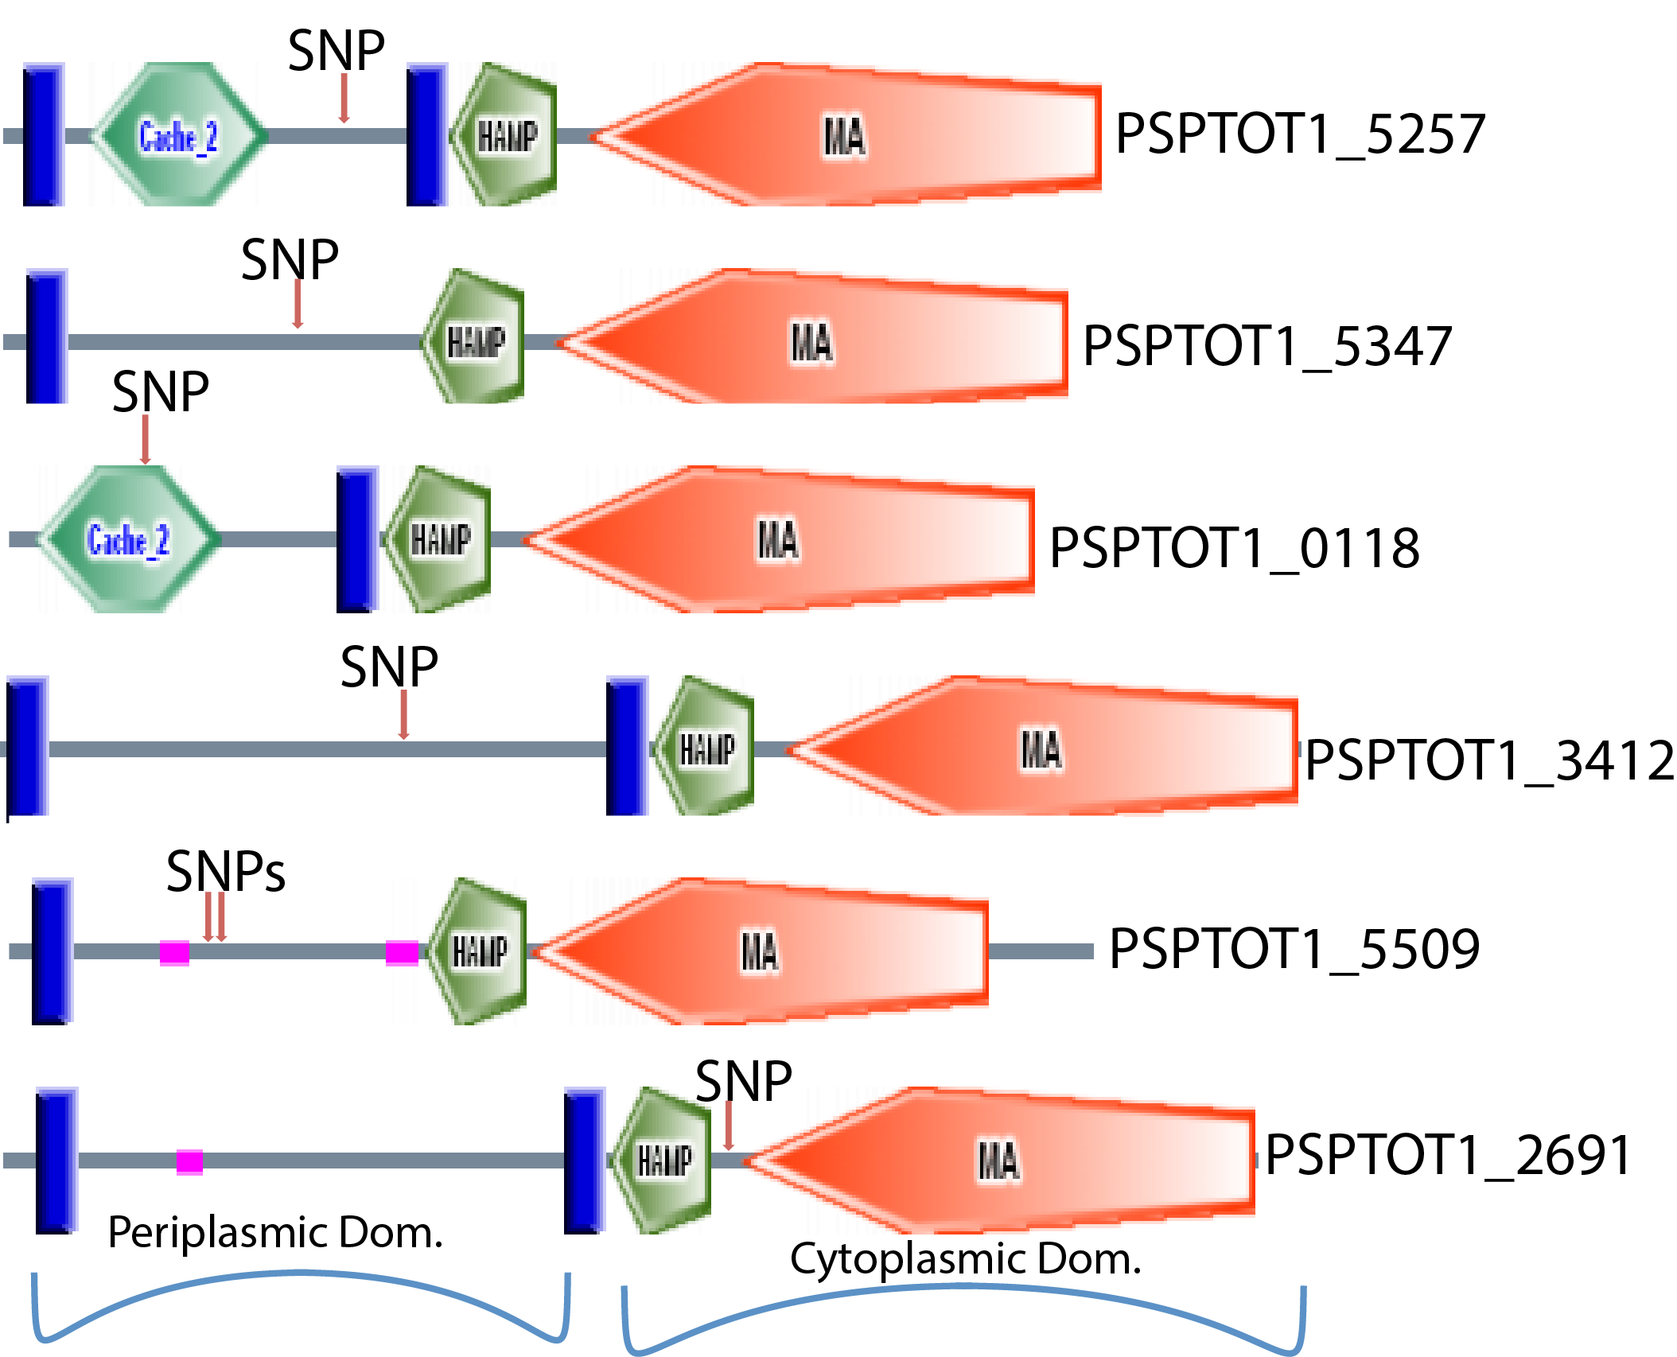
Figure S1. Location of single nucleotide polymorphisms in methyl-accepting chemotaxis proteins

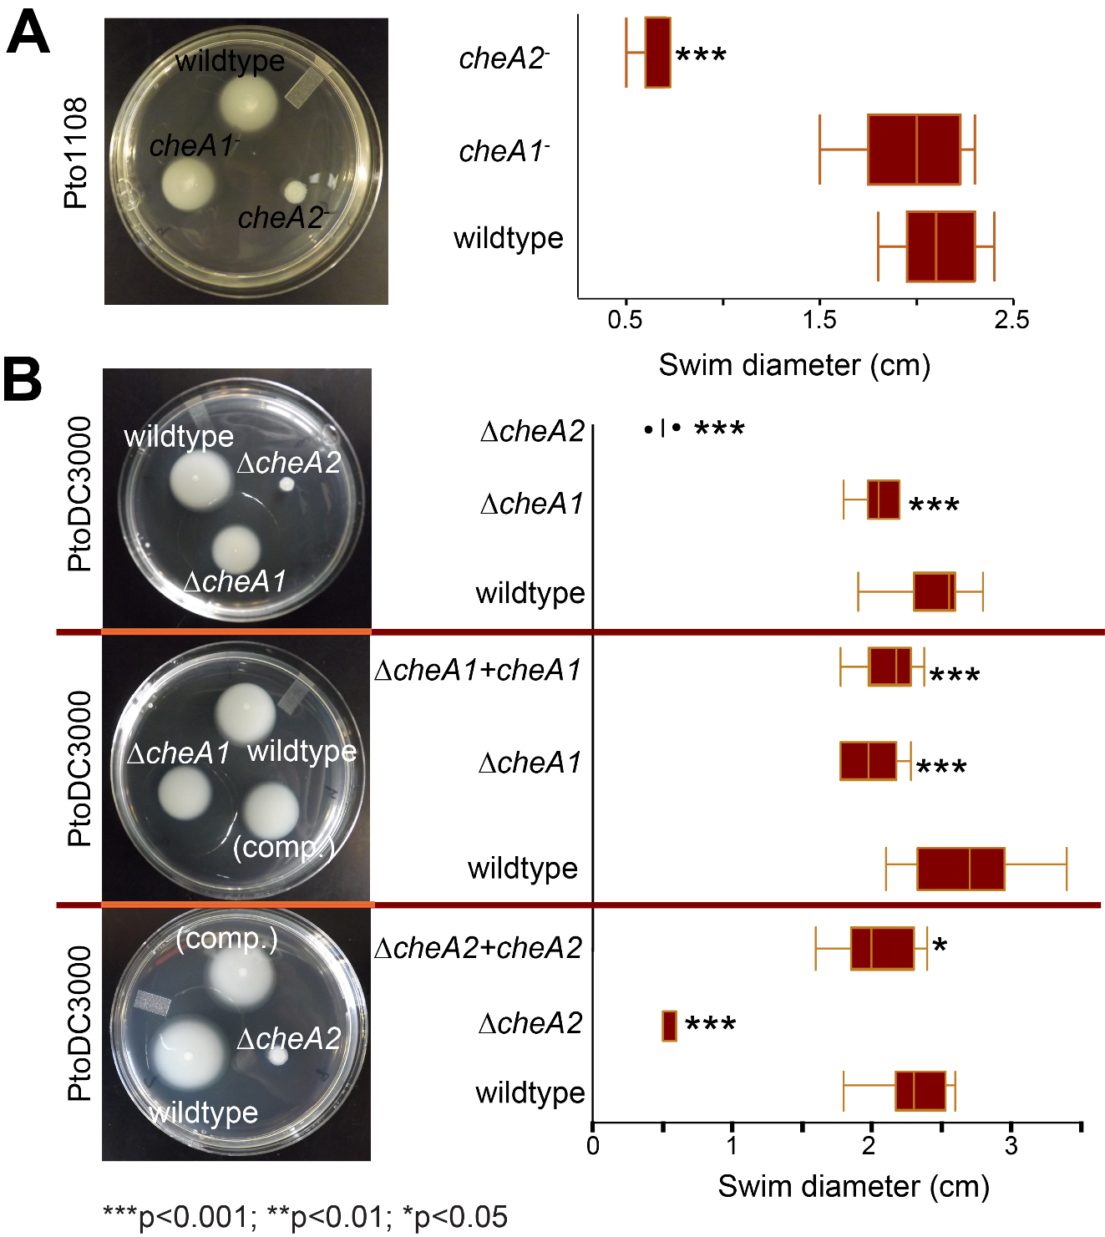
Figure S2. Example pictures and box plots of the colony diameter two days after inoculation of Pto1108 chemotaxis disruption strains (A) or PtoDC3000 chemotaxis deletion strains (B) on 0.28% agar KB swim plates. n = 10 and essentially identical results were obtained in 3 independent experiments. * indicates statistical difference between mutant strain and wildtype and the indicated p-value using a Student’s t-test.

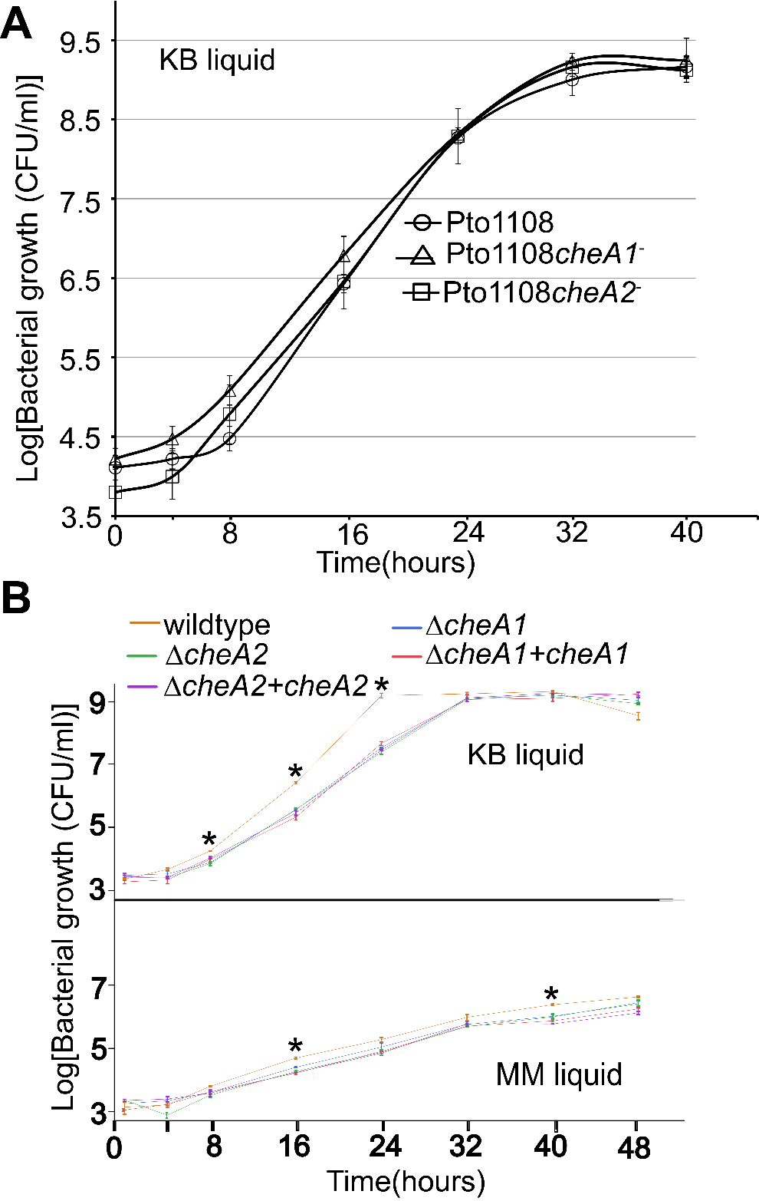
Figure S3. Growth of Pto1108 chemotaxis disruption mutants (A) and PtoDC3000 deletion mutants (B) in liquid culture. For A, n= 8. For B, n=3 and essentially identical results were obtained in 2 independent experiments. * indicates that the wildtype strain had a significantly different (p<0.01) population density than all other strains at that time point.
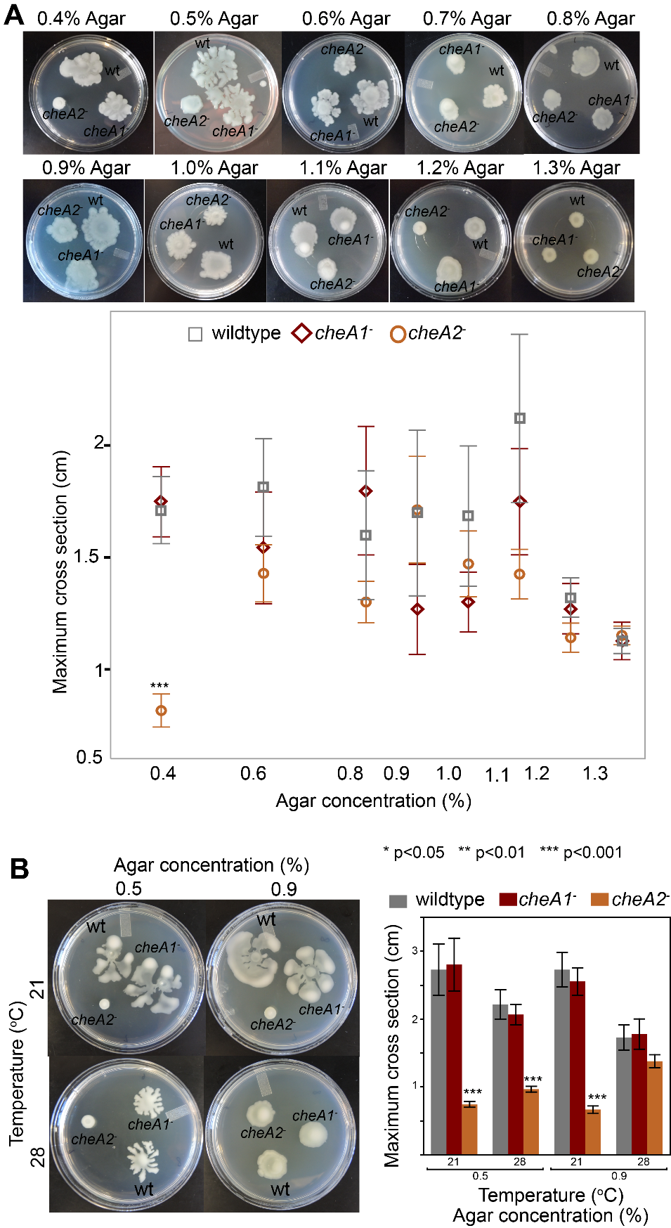
Figure S4. Example pictures and plotted average maximum swarm diameter of strain Pto1108 chemotaxis disruption mutants at 21ºC (A) or 28ºC or 21ºC (B). n=8. * indicates significant differences in swim diameter for any strain between the two temperatures at the indicated p-values using a Student’s t-test.
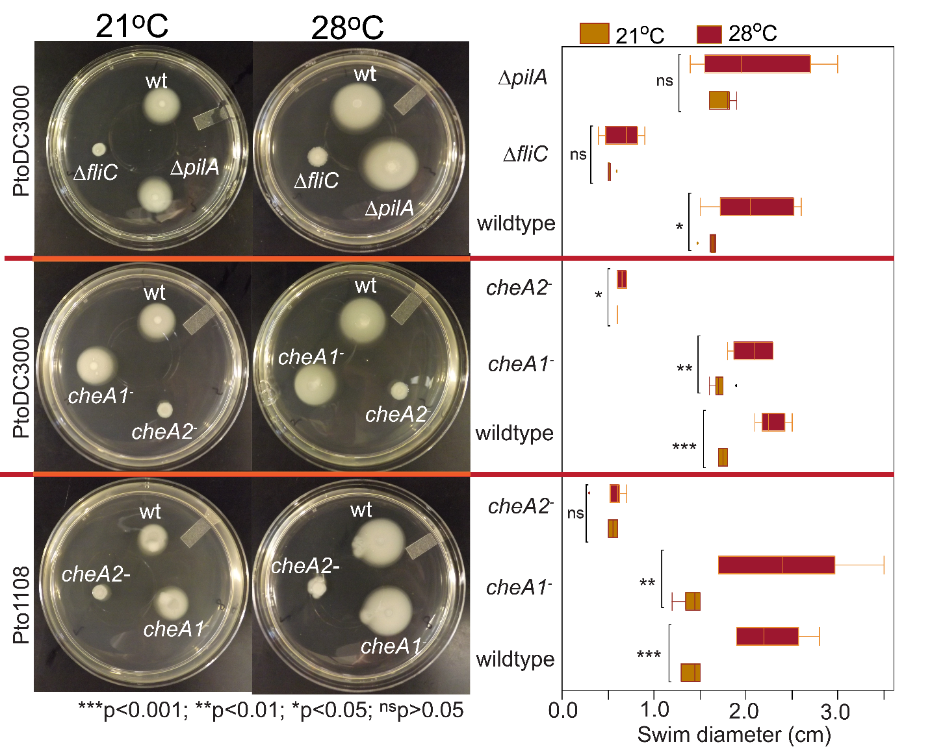
Figure S5. Example pictures and box plots of the colony diameter two days after inoculation of the indicated strains on 0.28% agar KB swim plates at 28ºC or 21ºC. * indicates significant differences in swim diameter for any strain between the two temperatures at the indicated p-values using a Student’s t-test. The smaller swim diameter is reflective of the slower growth rate of Pto at 21ºC. No mutant strain has altered swimming motility relative to wild type due to temperature.

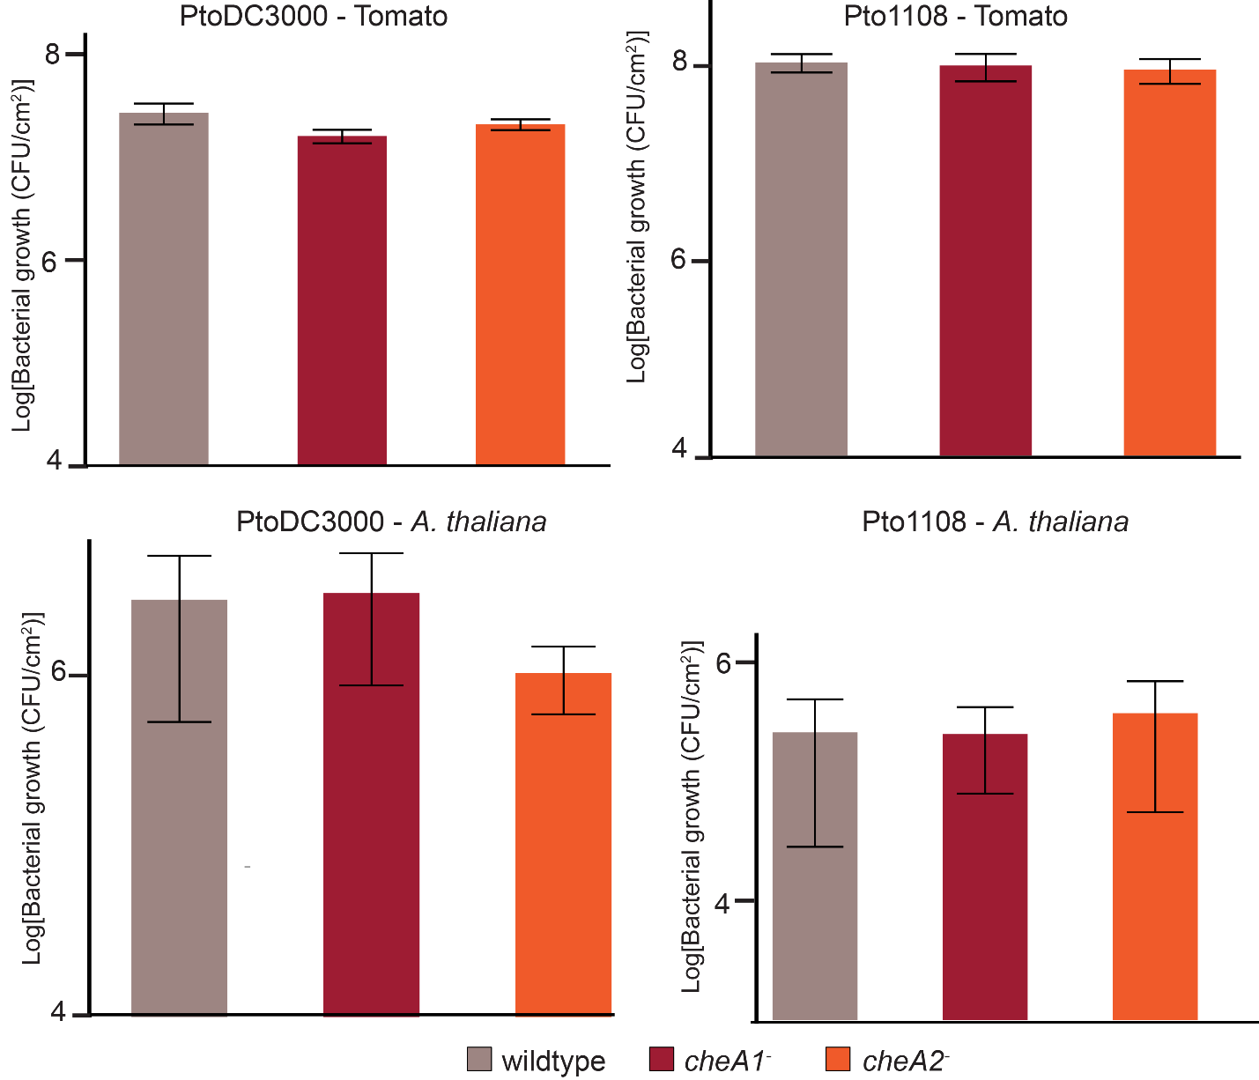
Figure S6. Growth of PtoDC3000 or Pto1108 on tomato (S. lycopersicum cv. Rio Grande) or A. thaliana ecotype Columbia 4 days following syringe infiltration inoculation at 0.001 (A. thaliana) or 0.0001 OD₆₀₀ (tomato). Data represent the average of 4 replicates and error bars are the standard error. Similar results were obtained in at least 4 independent experiments for all sections.
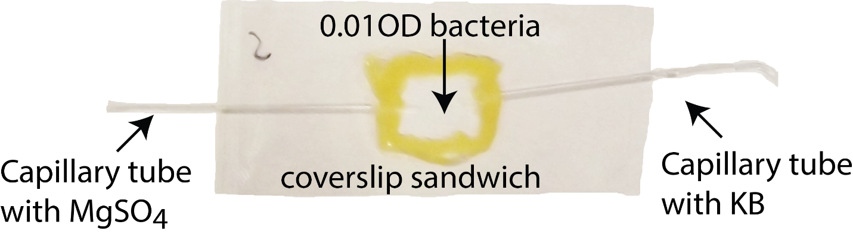
Figure S7. Setup for chemotaxis split capillary assay.

Author contributions: CRC and BAV designed the research; CRC performed the experiments with assistance from BWH and BJR; EM and BMS created the cheA deletion strains; CRC wrote the manuscript with subsequent editing from the other co-authors.

