Distribution and characteristic of nitrite-dependent anaerobic methane oxidation bacteria in wastewater treatment plants and agriculture fields of northern China
Ru Ma . Zhen Hu*
Shandong Provincial Key Laboratory of Water Pollution Control and Resource Reuse, School of Environmental Science and Engineering, Shandong University, No. 27 Shanda South Road, Jinan 250100, Shandong, People’s Republic of China. E-mail: huzhen885@sdu.edu.cn

Fig. S1 Composition of bacteria community at phylum level in four samples.
Table S1. The primers and thermal proﬁles used in this study
Table S2. Phylotype coverage, diversity and richness estimators of 16S rRNA genes and pmoA genes at a phylogenetic distance of 3%

Fig. S1 Composition of bacteria community at phylum level in four samples.
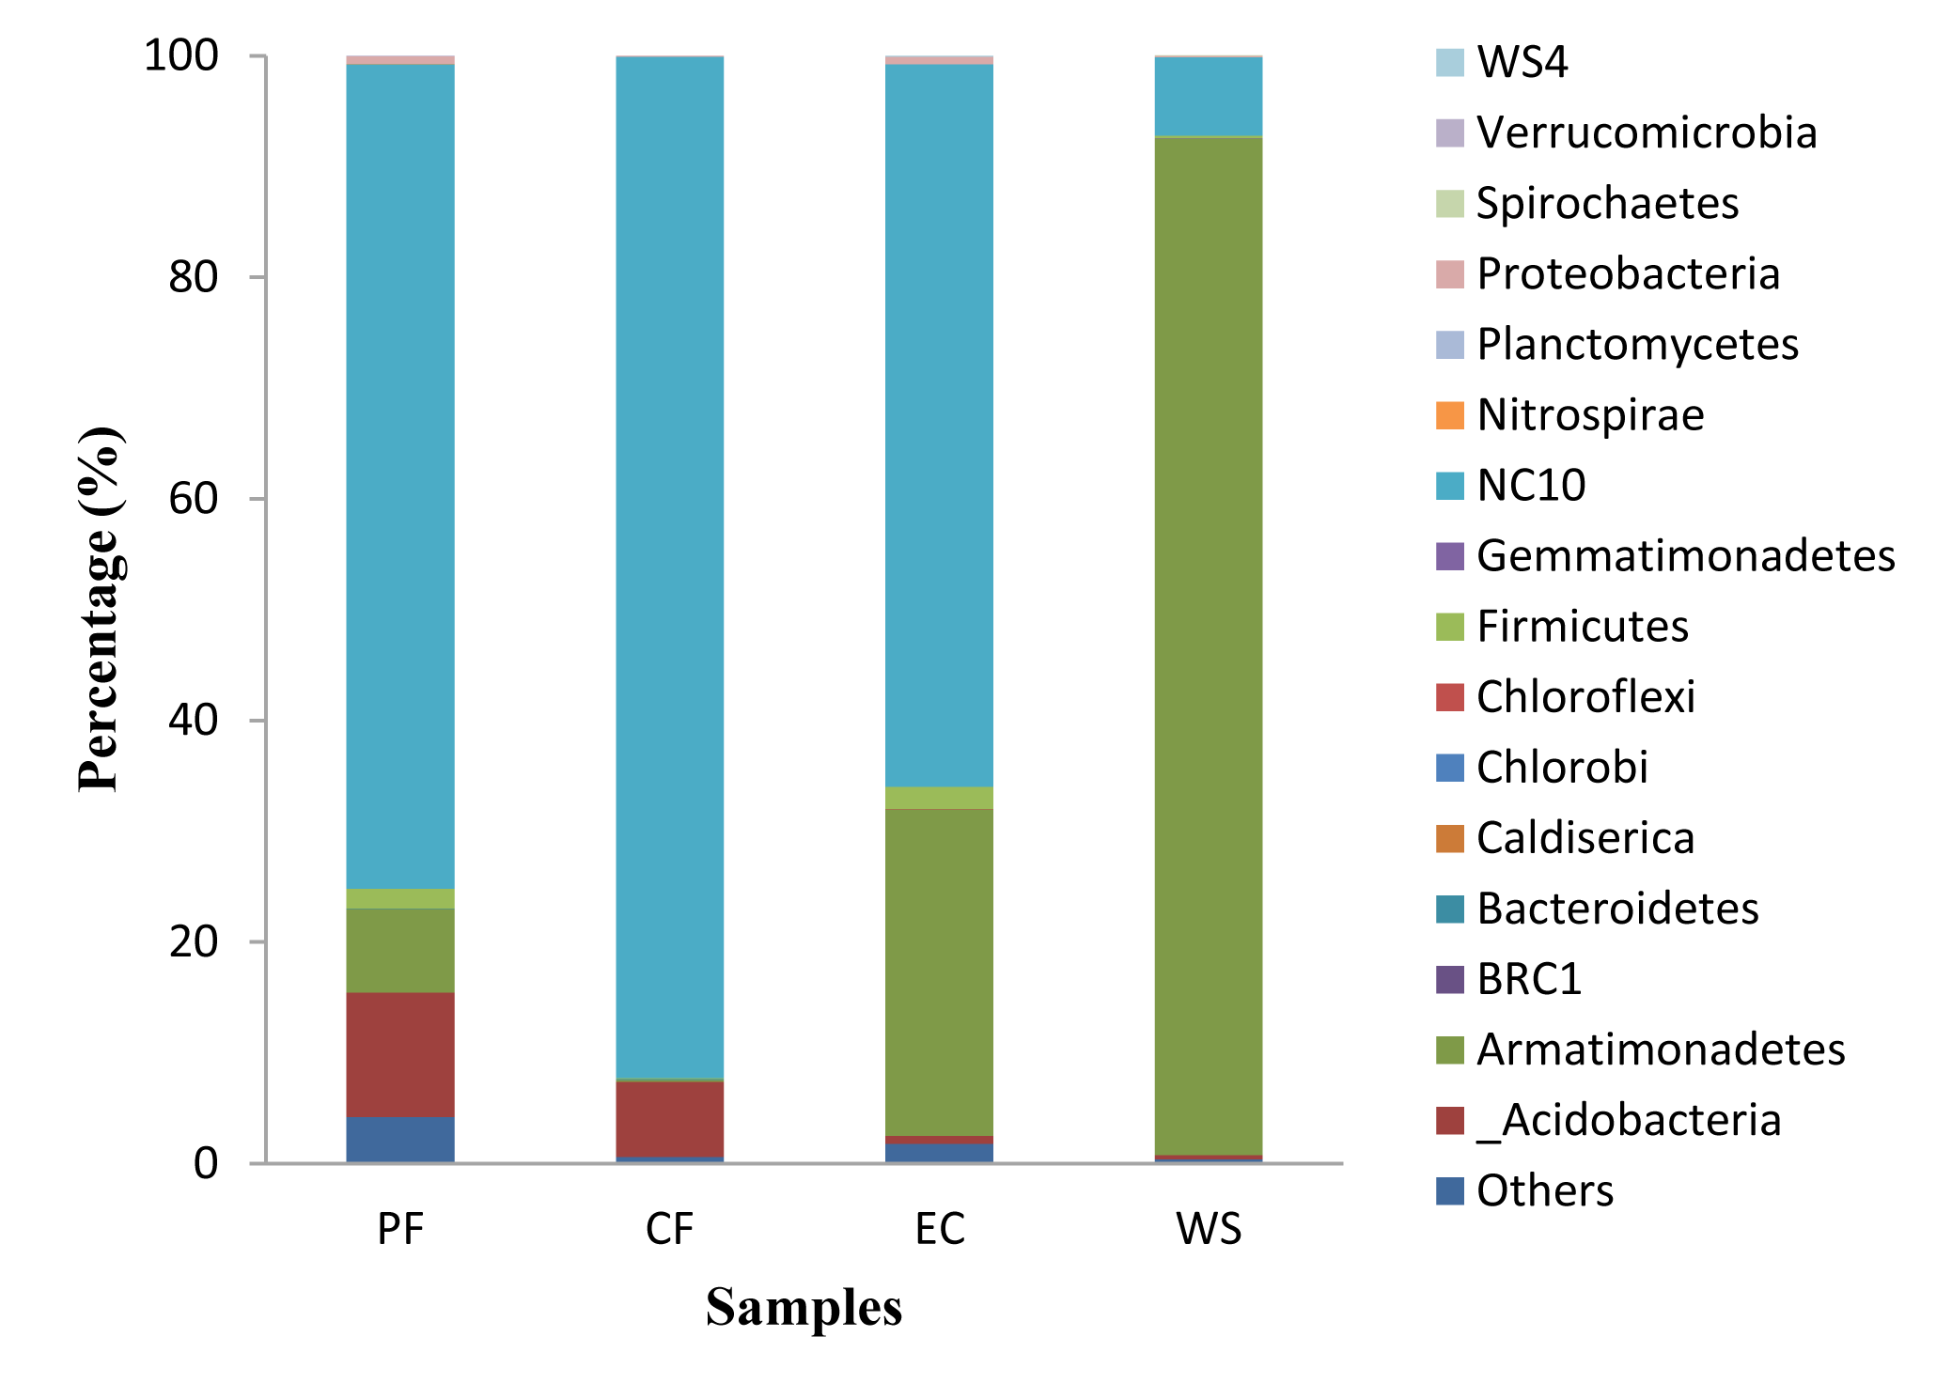
Table S1. The primers and thermal proﬁles used in this study.

Primer | Sequence (5’-3’) | Speciﬁcity | Position | Thermal proﬁles | References
1545R  202F | CAKAAAGGAGGTGATCC  GACCAAAGGGGGCGAGCG | Bacteria 16S rRNA  M. oxyfera 16S rRNA | 1529–1545  193 | 10min at 95℃, followed by 35 cycles of 30s at 95℃, 30s at 51℃and 60s at 72℃ | ( Juretschko et al. 1998; Ettwig et al. 2009)
qp1F  qp1R  qp2R | GGGCTTGACATCCCACGAACCTG  CGCCTTCCTCCAGCTTGACGC  CTCAGCGACTTCGAGTACAG | M. oxyfera 16S rRNA  M. oxyfera 16S rRNA  M. oxyfera 16S rRNA | 1001  1201  1481–1500 | 10 min at 95, followed by32 cycles of 60s at 95℃, 60s at 50 ℃and 45s at 72℃(pcr,qp1F- qp2R)  3 min at 95℃, followed by 40 cycles of 60 s at 95 ℃, 60 s at59℃ and 60s at 72℃(qpcr,qp1F-qp1R) | (Ettwig et al. 2009)
A189b  cmo682  cmo182  cmo568 | GGNGACTGGGACTTYTGG  TCGTTCTTYGCCGGRTTT  TCACGTTGACGCCGATCC  GATGGGGATGGAGTATGTGC | M. oxyfera pmoA  M. oxyfera pmoA  M. oxyfera pmoA  M. oxyfera pmoA | 136-153  649-666  182-199  549-568 | 4 min at 94℃,followed by35 cycles of 60 s at 94 ℃,60 s at 56 ℃and 60s at 72℃ | (Luesken et al. 2011)
Table S2. Phylotype coverage, diversity and richness estimators of 16S rRNA genes and pmoA genes at a phylogenetic distance of 3%

Sample | 16S rRNA |  |  |  |  |  |  | pmoA
 | OTUs | ACE | Chao | Shannon | Simpson | Good’s coverage (%) |  | OTUs | ACE | Chao | Shannon | Simpson | Good’s coverage (%)
PF | 536 | 972.2 | 1015.3 | 4.11 | 0.81 | 88.13 |  | 95 | 110.46 | 105.56 | 0.72 | 0.16 | 98.13
CF | 434 | 765.0 | 773.6 | 4.00 | 0.81 | 86.68 |  | 113 | 136.18 | 138.59 | 0.76 | 0.18 | 93.91
EC | 348 | 601.2 | 580.9 | 3.42 | 0.78 | 90.22 |  | 85 | 105.61 | 119.5 | 0.57 | 0.13 | 97.97
WS | 203 | 351.7 | 325.2 | 1.30 | 0.26 | 94.70 |  | 117 | 123.82 | 130.13 | 0.80 | 0.19 | 92.76

