Exploiting freely available imagery to improve land cover characterization and shallow landslide detection
Stefano Crema1, Marco Cavalli1, Giulia Bossi1, Luca Schenato1, Simone Frigerio1 and Lorenzo Marchi1

1 CNR IRPI, Corso Stati Uniti 4, 35127, Padova, Italy

Corresponding author:
Stefano Crema1
Email address: stefano.crema@irpi.cnr.it

Abstract
Natural hazards and land management issues can benefit nowadays from the increasing availability of free, high-resolution satellite imagery that opens the way to fine scale detailed investigations. In high elevation catchments the analysis of vegetation dynamics deserves particular attention since little climatic modifications can be amplified in such fragile systems. For the same reasons, the dynamic of instability phenomena as response to an input hydrological forcing, requires a meticulous spatial representation in order to better represent the active processes at catchment scale.
The present work focuses on the analysis of high-resolution freely available imagery (Microsoft® Bing Maps™ Platform) that enables the characterization of vegetation cover and the automatic mapping of shallow landslides in an alpine catchment. Semi-automatic detection of vegetation is carried out at the fine scale using both orthophotos and freely available satellite imagery. The analysis based on the satellite imagery showed a better accuracy in respect to the one based on the orthophotos. In particular, satellite imagery analysis showed high sensitivity and high specificity even in low illumination conditions, while, for the same circumstances, orthophotos-based analysis shows a significant wrong detection rate. In the framework of a long term, multi-temporal and high-resolution characterization of vegetation cover and for a rapid mapping of shallow instability phenomena, the effectiveness of the proposed approach can speed up the representation of the local conditions towards an improvement of land management strategies and hazard and risk assessment.
Keywords: Automatic detection, Vegetation patterns, Maximum Likelihood Estimation, headwater catchment, shallow landslides, Bing Maps™, landslide mapping, high resolution imagery.

Introduction
Classification and mapping of vegetation is a key methodological issue for the management of natural resources (Xie et al., 2008). The increasing availability of free and high-resolution imagery dataset offers a great potential to leverage for a detailed and multi-temporal assessment of the vegetation dynamic.
Fine resolution vegetation cover assessment can help in setting up a correct soil properties parameterization for improved hydrological modelling (Oubeidillah et al., 2014). Furthermore, when focusing on uniform vegetated areas, the automatic detection of non-vegetated areas can be a good proxy of slope instability phenomena (Guzzetti et al., 2012).
With the above-mentioned conditions, the analysis of high-resolution, freely available imagery can improve intrinsic efficiency of the detection of vegetation cover and the automatic recognition of shallow landslides at increasing time frequency. In the long run and on the global scale the integration of such techniques with morphometric assessment of landscape features can pave the way towards an improvement of land management strategies and hazard and risk assessment. In the following sections, the effectiveness of the approach is validated in a study area.

DATA AND methods
The study area is the Rio Vauz catchment (1.9 km2), an headwater catchment located in the Dolomites, Eastern Italian Alps (Figure 1). The site ranges in elevations between 1847 m a.s.l. and 3152 m a.s.l.. Average monthly temperatures vary during the year from -5.7 °C in January to 14.1 °C in July. Mean annual precipitation is about 1220 mm, 49% is in form of snow. Spring and early summer snowmelt is frequently associated with high-flow conditions but summer thunderstorms and autumn precipitation determine important flood events as well. The upper part of the catchment is dominated by Dolomitic outcropping bedrock and debris whereas the central and lower part are vegetated by alpine grassland and sparse trees. The morphology of the study site is deeply influenced by the geo-structural setting, in particular in relation to the characteristics of structural discontinuities. The catchment is object of several measurements campaigns: the hydrological response is monitored since several years both in the rocky subcatchments of the upper part and in soil-mantled subcatchments of the middle and lower part of the catchment (Penna et al., 2015, 2016a,b) and morphometric characterizations of rocky areas and scree slopes have been also carried out (Marchi et al., 2015; Trevisani et al., 2009).
The first step of the analysis consisted in the mosaicking of the image tiles, downloaded at the maximum zoom level (with a pixel resolution of about 0.3 m) from Bing Maps™ (© 2016 Microsoft, © 2016 HERE, 2014 DigitalGlobe) satellite terrain imagery. The download was performed with GMapCatcher (https://github.com/heldersepu/gmapcatcher) and with SASPlanet (https://bitbucket.org/sas_team/sas.planet.src/overview), programs designed for viewing and downloading high-resolution satellite imagery. GMapCatcher is a basic suite written in Python and can run on Linux, Windows and Mac OSX. The downloaded tiles need to be post-processed and georeferenced to reconstruct the image. SASPlanet is a complete suite for downloading and managing freely available high-resolution satellite images, at present only windows binaries are made available but its Open Source nature will hopefully bring to cross platform portability in near future. For the same area, a 0.15 m orthophoto dated 2006 was available. The satellite image was georeferenced in ArcGIS (ESRI, 2014) identifying common and stable features in the two images. The images were compared in terms of effectiveness in detecting the vegetation. To this purpose a common set of training areas has been selected for the two images; training areas were a priori classified among vegetation and no-vegetation classes. Particular attention was paid in order to select training areas that remained undisturbed in the time lag between the images (2006-2014). A Maximum Likelihood Estimation Classification (MLE) (Strahler, 1980) was then performed on the two images and an initial assessment of the effectiveness of the two outcomes was carried out. The effectiveness of the approach was assessed focusing on an evenly illuminated selected area that was not affected by disturbances or soil/rock cover variation.

RESULTS AND CONCLUSIONS
At catchment scale (Figure 1) the quality of the orthophoto is excellent in terms of resolution and color clearness. The only apparent limitation is related to the poor illuminating conditions since shadowed areas cover significant part of the orthophoto. The satellite image shows instead an overall good quality both in terms of light and shadows conditions and as respects to the high resolution of the data.
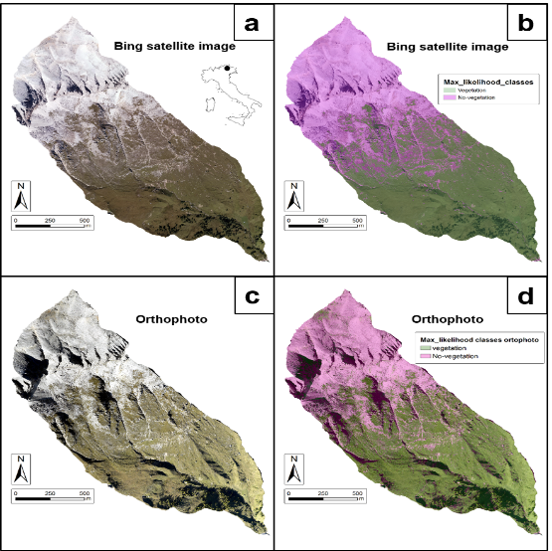
Figure 1 Study area with satellite terrain dataset (a) and orthophoto (c) and results of MLE classification on the presence or absence of vegetation at catchment scale using satellite image (b) and orthophoto (d)
A qualitative assessment of the georeferencing accuracy exhibits a good matching between the images with slightly higher distortion effects and uneven matching related to the rock cliff areas.
First results and visual interpretation on the semi-automatic detection of the presence or absence of vegetation in the study area show a very good performance in the case of satellite imagery analysis while the orthophoto-based classification seems to be characterized by a poor discriminant effectiveness.
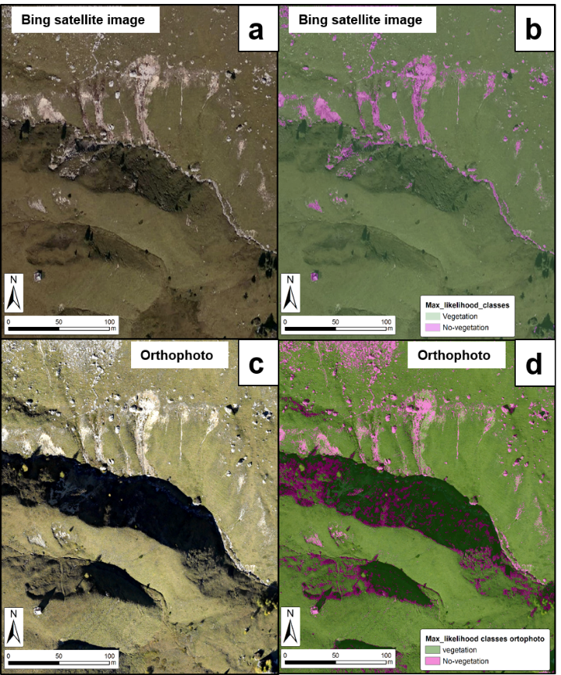
Figure 2 Shallow landslides within the study area: satellite image (a) satellite image-derived classification results (b), orthophoto (c) and orthophoto-derived classification results (d)

A detailed analysis of the results, focusing on an area where several shallow landslides are affecting the slope and sparse trees are present in the lower portion (Figure 2 and Figure 5), highlights the effectiveness of the satellite image-derived classification not only considering the correct interpretation of shadowed areas but also in relation to the more precise boundary detection of the instability phenomena. The same behavior is shown when considering the upper portion of the catchment (Figure 3), characterized mainly by dolomitic cliffs and sparse herbaceous vegetation or even when focusing on an anthropic structure in the middle-lower part of the catchment. Markedly wrong classifications emerge in relation to the orthophoto-based classification both in shadowed areas in the upper part of the catchment and under medium illuminating condition in the middle-lower portion. Satellite image-based classification is instead very precise also in the above-mentioned conditions without significant wrong classification neither in the rocky headwater catchments nor close by the anthropic structure.
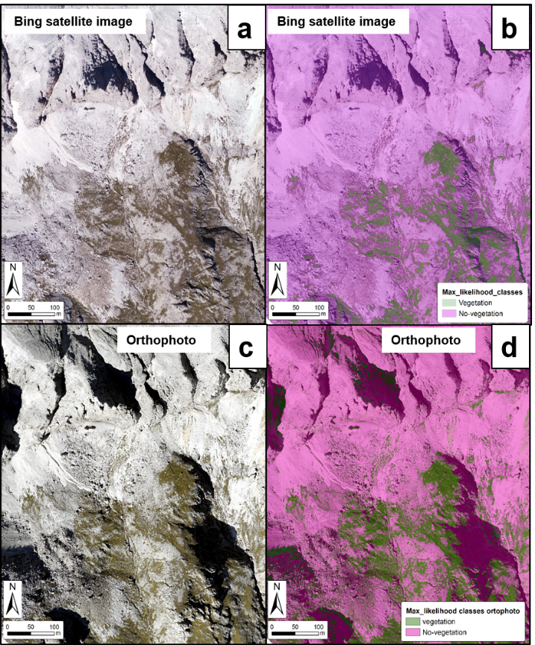
Figure 3 Dolomitic cliffs and sparse grasslands within the study area: satellite image (a) satellite image-derived classification results (b), orthophoto (c) and orthophoto-derived classification results (d)
In all the analyzed cases, in shadowed areas, a clear different behavior between the two images emerged (Figures 2, 3, 5 and 6). This discrepancy in behavior is partially related to the Red, Green and Blue (RGB) pixel values of the two images especially in shadowed conditions. RGB bands show similar values in shadowed areas under vegetation and shadowed areas close by rocky cliffs in the orthophoto, while different values are observed, for the same two settings, in the satellite image. This discrepancy can be likely ascribed to the different spectral bandwidth acquired by the two technologies, with a finer spatial resolution panchromatic band associated to the satellite images. For a quantitative performance analysis and to enlighten the bias brought by shadows in the orthophoto, a shallow landslide of about 1000 m2 was selected. The selected landslide has kept the same eroded area extent between 2006 and 2014. Same illuminating conditions (no shadows) can be appreciated, thus helping for an objective analysis. Several training sets areas at catchment scale, have been selected to evaluate the influence of shadows on the orthophoto and to assess the performance on the selected area. In particular, the classification on the orthophoto has been carried out with:
• training areas in common with the satellite image (with important shadowed areas in the orthophoto)
• ad hoc training areas for the orthophoto classification, excluding shadowed areas under vegetation
• ad hoc training areas for the orthophoto classification, including shadowed areas under vegetation
• ad hoc training areas for the orthophoto classification, excluding shadowed areas both under vegetation and in the upper rocky portion of the catchment.
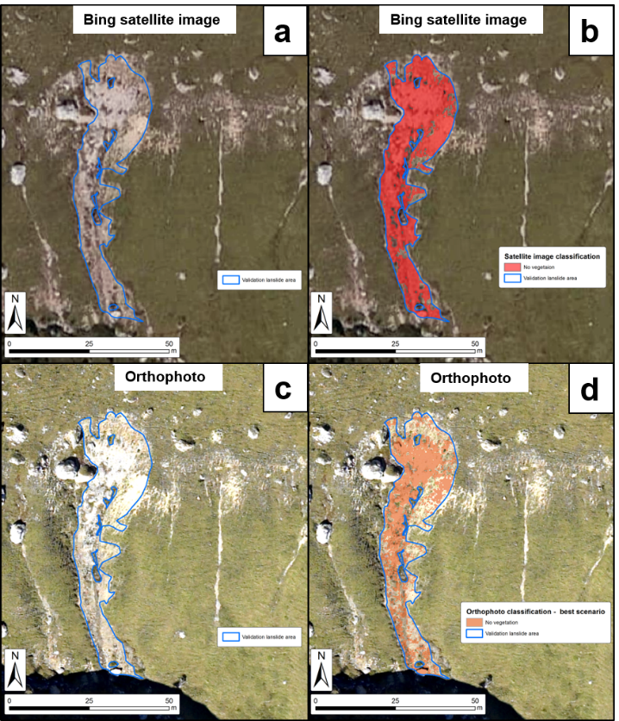
Figure 4 Shallow landslide validation area and classification outputs: satellite image (a) satellite image-derived classification results (b), orthophoto (c) and orthophoto-derived classification results (d), with best scenario presented.
On all the analyzed scenarios orthophoto based classification showed a moderately good performance (always <65% correctly identified erosion areas) while satellite image based classification reached 90% (Figure 4). Erosion areas were in any case better classified than vegetation areas that, in the orthophoto, suffered from shadowing conditions. The best results in terms of correctly erosion areas detected (< 65%) using the orthophoto, were obtained using vegetated shadowed areas and rocky shadowed areas in the training sets. Even if the selected landslide is not affected by shadows and ad hoc training areas with no shadows have been also used but the performance showed no important variation, thus supporting the above mentioned differences between the images, especially in shadowed conditions. Similar performances (64% correctly identified erosion areas) using the orthophoto based classification were obtained ignoring shadowed areas both under vegetation and in the rocky part of the catchment with the important drawback of a completely wrong classification of all the shadowed areas (identified always as erosion areas). Quantitative assessment of wrong-classified vegetation areas, especially in shadowed condition, has not been carried out but the widespread presence of wrongly classified vegetated areas in the orthophoto supports its poor effectiveness for the estimation of the vegetation detection (Figure 5 and Figure 6). On the other hand, a very good performance in terms of correct detection of vegetation-covered areas, can be appreciated with the satellite image derived classification with roughly negligible wrong classification ratio (Figure 5). A very important feature to be noticed is the discriminant power of the satellite-based classification especially in shadowed areas. Shadowed areas in the upper rocky part of the catchment are correctly classified as no-vegetation and shadowed areas under vegetation are correctly classified as vegetation (Figure 3 and Figure 5).
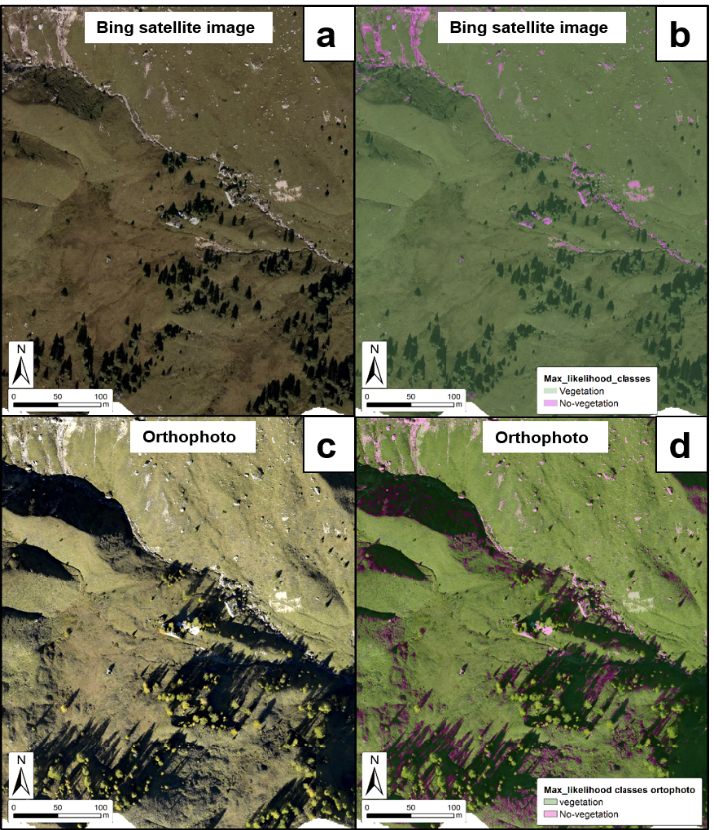
Figure 5 Shallow landslides and sparse forest within the study area: satellite image (a) satellite image-derived classification results (b), orthophoto (c) and orthophoto-derived classification results (d)
In conclusion, an overall good performance of the satellite analysis emerged and, when sticking on vegetation-covered slopes, the semi-automatic detection of areas without vegetation could be a useful instrument for a first characterization and mapping of shallow landslides exploiting the increasing availability of high-resolution freely available images for a better risk assessment and environmental management.
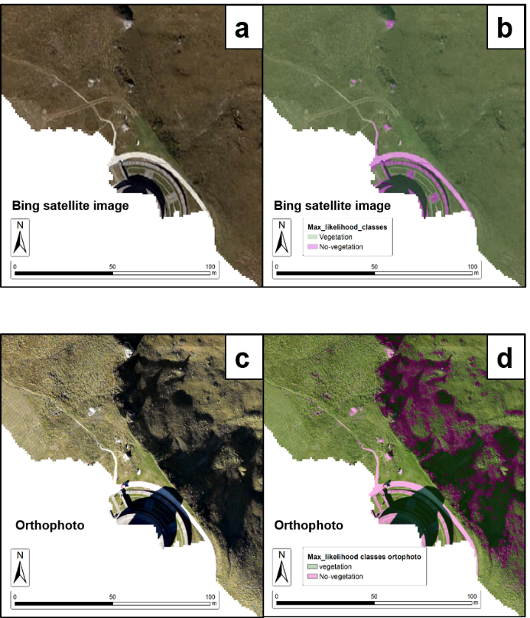
Figure 6 Artificial structure within the study area: satellite image (a) satellite image-derived classification results (b), orthophoto (c) and orthophoto-derived classification results (d)

References
ESRI, 2014. ArcGIS Desktop: Release 10.3. Redlands, CA. Environmental Systems Research Institute.
Guzzetti, F., Mondini, A.C., Cardinali, M., Fiorucci, F., Santangelo, M., Chang, K.-T., 2012. Landslide inventory maps: New tools for an old problem. Earth-Sci. Rev. 112, 42–66. doi:10.1016/j.earscirev.2012.02.001
Marchi, L., Cavalli, M., Trevisani, S., 2015. Hypsometric Analysis of Headwater Rock Basins in the Dolomites (Eastern Alps) Using High-Resolution Topography. Geogr. Ann. Ser. Phys. Geogr. 97, 317–335. doi:10.1111/geoa.12067
Oubeidillah, A., Kao, S.-C., Ashfaq, M., Naz, B., Tootle, G., 2014. A large-scale, high-resolution hydrological model parameter data set for climate change impact assessment for the conterminous US. Hydrol. Earth Syst. Sci. 18, 67–84. doi:10.5194/hess-18-67-2014
Penna, D., Mantese, N., Hopp, L., Dalla Fontana, G., Borga, M., 2015. Spatio-temporal variability of piezometric response on two steep alpine hillslopes. Hydrol. Process. 29, 198–211. doi:10.1002/hyp.10140
Penna, D., Van Meerveld, H.J., Zuecco, G., Dalla Fontana, G., Borga, M., 2016a. Hydrological response of an Alpine catchment to rainfall and snowmelt events. J. Hydrol. 537, 382–397. doi:10.1016/j.jhydrol.2016.03.040
Penna, D., Zuecco, G., Crema, S., Trevisani, S., Cavalli, M., Pianezzola, L., Marchi, L., Borga, M., 2016b. Response time and water origin in a steep nested catchment in the Italian Dolomites. Submitted to Hydrological Processes.
Strahler, A.H., 1980. The use of prior probabilities in maximum likelihood classification of remotely sensed data. Remote Sens. Environ. 10, 135–163. doi:10.1016/0034-4257(80)90011-5
Trevisani, S., Cavalli, M., Marchi, L., 2009. Variogram maps from LiDAR data as fingerprints of surface morphology on scree slopes. Nat Hazards Earth Syst Sci 9, 129–133. doi:10.5194/nhess-9-129-2009
Xie, Y., Sha, Z., Yu, M., 2008. Remote sensing imagery in vegetation mapping: a review. J. Plant Ecol. 1, 9–23. doi:10.1093/jpe/rtm005

