Supporting information
Contents:

- Figure_S1. Sharks size frequency distribution between DOVs and UVC
- Table_S1. Fish species most responsible for dissimilarity between wave exposures.

Figure_S1. Sharks size (mm) distribution recorded by DOVs and UVC. Data was obtained from 69 transects at 7 study sites across Darwin and Wolf Islands.

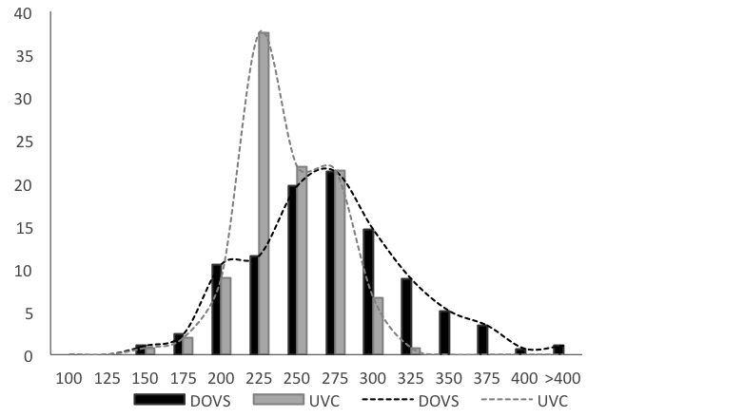

Table_S1. Fish species most responsible for the dissimilarity between wave exposures (SE vs. NW) based on Similarity of Percentages (SIMPER) analysis. Values are biomass (t ha⁻¹). Diss. – average dissimilarity. SD – Standard deviation. Contrib% – percent contribution to dissimilarity. Cum. % – Cumulative dissimilarity.
Species | SE | NW | Diss. | SD | Contrib% | Cum.%
Sphyrna lewini | 18.44 | 0 | 35.07 | 1.13 | 38.51 | 38.51
Paranthias colonus | 2.49 | 0.67 | 18.72 | 0.96 | 20.55 | 59.06
Carcharhinus galapagensis | 3.09 | 0 | 16 | 0.64 | 17.57 | 76.63
Caranx melampygus | 1.06 | 0 | 2.52 | 0.28 | 2.77 | 79.4
Taeniura meyeni | 0.01 | 0.14 | 2.24 | 0.22 | 2.46 | 81.86
Prionurus laticlavius | 0.03 | 0.1 | 2.13 | 0.41 | 2.33 | 84.2
Kyphosus analogus | 0 | 0.15 | 1.97 | 0.2 | 2.16 | 86.36
Lutjanus novemfasciatus | 0.05 | 0.03 | 1.35 | 0.28 | 1.48 | 87.84
Scarus ghobban | 0 | 0.05 | 1.2 | 0.22 | 1.32 | 89.16
Holacanthus passer | 0.03 | 0.07 | 0.99 | 0.52 | 1.09 | 90.25

