SUPPLEMENTARY INFORMATION APPENDIX

The genome and transcriptome of the Phalaenopsis yield insights into floral organ development and flowering regulation

Jian-Zhi Huang^{1*}, Chih-Peng Lin^{2,4*}, Ting-Chi Cheng¹, Ya-Wen Huang¹,Yi-Jung Tsai¹, Shu-Yun Cheng¹, Yi-Wen Chen¹, Chueh-Pai Lee², Wan-Chia Chung², Bill Chia-Han Chang^{2,3#}, Shih-Wen Chin^{1#}, Chen-Yu Lee^{1#} & Fure-Chyi Chen^{1#}

¹Department of Plant Industry, National Pingtung University of Science and Technology, Pingtung 91201, Taiwan
²Yourgene Bioscience, Shu-Lin District, New Taipei City 23863, Taiwan
³Faculty of Veterinary Science, The University of Melbourne, Parkville Victoria 3010 Australia
⁴Department of Biotechnology, School of Health Technology, Ming Chuan University, Gui Shan District, Taoyuan 333, Taiwan

*These authors contributed equally to this work.
#Correspondence should be addressed to B-C.H.C. (bchang@yourgene.com.tw), S.-W.C. (swchin@mail.npust.edu.tw), C.-Y.L. (culee@mail.npust.edu.tw) & F.-C.C. (fchen@mail.npust.edu.tw)

Table of Contents
SI TEXT........................................................................................................................1
S1. Genome sequencing and assembly.......................................................................1
S1.1 Whole genome shotgun sequencing using the Illumina technology.............1
S1.2 Library construction, sequencing and quality control...................................1
S1.3 Estimation of genome size using K-mer........................................................1
S1.4 De novo assembly of the Phalaenopsis genome...........................................1
S1.5 Assembly evaluation......................................................................................2
S1.6 GC comparison..............................................................................................2
S2. Gene prediction and annotation...........................................................................2
S2.1 Repetitive elements identification.................................................................2
S2.2 RNA-Seq of different tissues.........................................................................3
S2.3 RNA-Seq mapping and transcript reconstruction..........................................3
S2.4 High confidence (HC) and Medium Confidence (MC) Phalaenopsis gene set.................................................................................................................4
S2.5 Protein-coding gene annotation.....................................................................4
S2.6 Analysis of non-coding RNAs.......................................................................4
S3. Phalaenopsis gene family analysis........................................................................5
S3.1 Detection of gene families from the Phalaenopsis genome using OrthoMCL..................................................................................................5
S3.2 Gene family comparison of Phalaenopsis, Oryza, Arabidopsis and Vitis.....5
S3.3 Transcription factor in Phalaenopsis.............................................................5
S3.3.1 MADS-box genes...............................................................................6
S3.3.2 TCP genes...........................................................................................7
S3.3.3 WRKY genes......................................................................................7
S4. miRNA analysis......................................................................................................8
S4.1 Small RNA library development and sequencing..........................................8
S4.2 miRNA gene and target prediction.................................................................8
S4.3 GO and Pfam analysis of the target genes.....................................................8
S4.4 miRNA and target gene analysis....................................................................9
S5. Regulation of Phalaenopsis floral organ development and flowering time....10
S5.1 Genes involved in floral organ development……………………………...10
S5.2 Genes involved in flowering time regulation...............................................11
S6. Molecular marker development………………………………………………..12
S6.1 Simple sequence repeat (SSR) analysis.......................................................12
S6.2 Single nucleotide polymorphism (SNP) analysis.........................................12
SI FIGURES………………………………………………………………………...14
SI TABLES…………………………………………………………………………..32
SI Reference………………………………………………………………………....43
Supplementary Note
S1. Genome sequencing and assembly
S1.1 Whole-genome shotgun sequencing using Illumina technology
The Phalaenopsis Brother Spring Dancer ‘KHM190’ orchid hybrid (Fig. S1a) was obtained from I-Hsin Biotechnology (Chiayi, Taiwan) and grown in a fan-and-pad greenhouse at National Pingtung University of Science and Technology (Pingtung, Taiwan), under natural daylight and at controlled temperatures of 27 to 30°C. Total DNA was extracted from Phalaenopsis leaves using a standard CTAB method (Doyle & Doyle 1987).

S1.2 Library construction, sequencing and quality control
To sequence the Phalaenopsis genome, we applied a whole-genome shotgun strategy and next-generation sequencing technologies using the Illumina HiSeq 2000 platform. Illumina short-insert paired-end (insert size: 250 bp) and large-insert mate-pair (3, 5, and 8 kb) libraries were prepared following the manufacturer’s instructions. In total, we generated approximately 300.5 Gb of sequences, and 278.89 Gb were retained for assembly after performing quality trimming using CLC Genomic Workbench 5.5 (http://www.clcbio.com/) to filter out low-quality reads (Table S1).

S1.3 Estimation of genome size through K-mer analysis
We adopted a method based on the K-mer distribution to estimate genome size. We used higher-quality reads (215.9 Gb) from short-insert size libraries (250 bp) to obtain more accurate estimations. A K-mer refers to an artificial sequence division of K nucleotides. Under this definition, a raw sequence read with L bp contains (L – K + 1) K-mers. The frequency of each K-mer was calculated from the genomic reads, and the K-mer frequencies followed a Poisson distribution for a deep-sequenced genome. Thus, the genome size, G, is calculated as G = Knum / Kdepth, where Knum is the total number of K-mers, and Kdepth is the highest peak detected. K was set to 17 in our project based on our empirical analysis. In this work, K was 17; Knum was 175,493,961,632; and Kdepth was 50. We therefore estimated the Phalaenopsis genome size to be 3.45 Gb (Fig. S2 and Table S2).

S1.4 De novo assembly of the Phalaenopsis genome
We performed whole-genome assembly using Velvet (https://www.ebi.ac.uk/~zerbino/velvet/) (Zerbino & Birney 2008) with K-mer 63. To fill the gaps inside the constructed scaffolds, we use Gapcloser to reduce the N ratio in the final assembly (http://soap.genomics.org.cn/down/GapCloser_release_2011.tar.gz) (Luo et al. 2012). The total contig length of the assembly reached 2.39 Gb (69.28% of 3.45 Gb), with an N50 length of 1.49 kb (longest, 50.94 kb), and the genome assembly was 3.1 Gb, with a scaffold N50 length of 100.94 kb (longest, 1.4 Mb) (Fig. S3 and Table S3). Scaffolds with lengths greater than 10 kb accounted for more than 74.8% of the assembly (Table S4).

S1.5 Assembly evaluation
The assembled genome of Phalaenopsis was validated using 8,188 Sanger-derived ESTs for Phalaenopsis downloaded from NCBI and was aligned to the assembly using BLAT (Kent 2002) with the default parameters. As a result, 7,701 genes (95% identity and over 50% coverage) were matched to the de novo Phalaenopsis assembly. The validation procedure confirmed the presence of 6,928 genes in the Phalaenopsis genome assembled with stringent parameters (95% identity and 90% coverage) (Table S5). Thus, the draft sequences represent a considerable portion of the Phalaenopsis genome, with high quality and coverage.

S1.6 GC comparison
Using 500-bp non-overlapping sliding windows, we calculated the GC contents of four species (Phalaenopsis, Arabidopsis thaliana (2000), Oryza sativa japonica (2005), and Vitis vinifera (Jaillon et al. 2007)). All four species showed peaks of GC content between 0.3 and 0.4. The GC content of the Phalaenopsis genome was 34.6%, which was similar to the GC contents of A. thaliana (38%), O. sativa japonica (38.3%) and V. vinifera (36%) (Fig. S4a). In addition, the data revealed the relationship between the sequencing depth and GC content. Nearly all regions with a GC content between 20% and 60% presented a sequencing depth of > 20x coverage (Fig. S4b).

S2. Gene prediction and annotation
S2.1 Identification of repetitive elements
There are two main types of repeats in the genome, tandem repeats and transposable elements (TEs). We used Tandem Repeats Finder (Version 4.04) (Benson 1999) and Repbase (composed of many transposable elements, Version 15.01) (Jurka et al. 2005) to identify tandem repeats in the Phalaenopsis genome. We identified transposable elements in the genome at the protein and DNA levels. At the protein level, RepeatProteinMask (Smit et al. 1996-2010)[10], an updated tool in the RepeatMasker package (Version 4.0.2), was employed to conduct RM-BlastX searches against the transposable element protein database. At the DNA level, RepeatMasker (Smit et al. 1996-2010)[10] was applied, using a combined library of Viridiplantae lineage-specific TEs in Repbase (RELEASE 2013/04/22) and a de novo repeat sequence library of the Phalaenopsis genome defined with RepeatModeler (Version 1.0.7) (Smit et al. 1996-2010)[10]. The TE sequences were classified based on the reported system. Long terminal repeat (LTR) retrotransposons, mainly consisting of Gypsy-type (24.43%) and Copia-type (4.43%) LTRs, were predominant (Table S6). In addition, we aligned the classified TE families to the consensus sequences in the Repbase library. The distribution of transposable element divergence rates showed a peak at 17% (Fig. S5).

S2.2 RNA-Seq of different tissues
To generate a comprehensive view of the Phalaenopsis transcriptome, we applied the Illumina HiSeq 2000 system to perform high-throughput RNA-Seq analyses of four different types of samples: shoot tip tissues from shortened stems, floral organs (sepal, petal and labellum), leaves and protocorm-like bodies (PLBs). RNA was isolated from frozen orchid tissues via the TriSolution method (GeneMark, Taipei). The RNA solution was then treated with RNase-free DNase I (Promega, Taipei) to eliminate contaminating DNA. The quantity and quality of the RNA were evaluated using an Experion automated electrophoresis system (Bio-Rad). RNA samples with an RNA quality indicator (RQI) >8 were sent to Yourgene Bioscience on dry ice (New Taipei City, Taiwan) for mRNA purification and cDNA construction. The cDNA library for transcriptome sequencing was constructed with the Illumina TruSeq RNA sample prep kit. First- and second-strand cDNA was synthesised using reverse transcriptase (Clontech) with random hexamer primers and then subjected to end repair, A-tailing and adaptor ligation. Then, a total of 15 libraries were constructed with an insert size ranging from 200 to 300 bp (Table S7), and PCR amplification was performed for 15 cycles.

S2.3 RNA-Seq mapping and transcript reconstruction
To annotate transcriptionally active regions of the Phalaenopsis genome, RNAs from four different tissues were sequenced using Illumina transcriptome sequencing technology (Supplementary Table 7). The 100-bp paired ends of the samples were pooled, and each sample dataset was aligned against the library-based repeat-masked assembly of Phalaenopsis using Bowtie2 (v2.1.0.0) (Langmead & Salzberg 2012) and TopHat (v2.0.8b) (Trapnell et al. 2009) with the default settings and the previously determined mean inner distance between mate pairs. We utilised TopHat to identify exon-intron splicing junctions and refine the alignment of the RNA-Seq reads to the genome. Cufflinks software (v2.1.1) (Pollier et al. 2013; Trapnell et al. 2012) was then employed to define a final set of predicted genes. Using the RNA-Seq approach, we predicted 54,659 gene loci and 76,370 spliced transcripts in the assembly (Dataset S1 and S2).

S2.4 High-confidence (HC) and Medium-confidence (MC) Phalaenopsis gene set
In total, 54,659 protein-coding loci were predicted. Of these loci, 41,153 were well supported (30~100% coverage) by either ESTs or NCBI proteins and were classified as high-confidence (HC) and medium-confidence (MC) genes. The HC and MC gene set comprised 41,153 genes predicted by Cufflinks (Pollier et al. 2013; Trapnell et al. 2012) (Dataset S3). Of the remaining genes, 13,506 were classified as low-confidence (LC); for these genes, the EST and/or protein alignment coverage was < 30%. The HC and MC gene sets were used to perform gene family analyses and various expression analyses.

S2.5 Protein-coding gene annotation
The genes in the HC and MC gene sets were functionally annotated based on homology to annotated genes from the NCBI non-redundant database (Supplementary Tables 10). The functional domains of Phalaenopsis genes were identified by comparing their sequences against protein databases, including the Gene Ontology (GO) (2008), Kyoto Encyclopedia of Genes and Genomes (KEGG) (Kanehisa et al. 2012) and Pfam (Finn et al. 2014; Finn et al. 2011) databases. GO terms were obtained using the Blast2GO program (Conesa & Gotz 2008). In the GO annotations, 16,034, 27,294, and 16,360 genes were assigned to the biological process, cellular compound, and molecular function categories, respectively (Fig. S8a). Based on KEGG pathway mapping, we were able to assign a significant proportion of the Phalaenopsis gene set to KEGG functional or biological pathway categories (11,452 sequences; 140 KEGG orthologous terms) (Dataset S4). To investigate protein families, we compared the Pfam domains of Phalaenopsis. A total of 1,842 Pfam domains were detected among the Phalaenopsis sequences. The most abundant protein domains in Phalaenopsis were pentatricopeptide repeats (PPRs, pfam01535), followed by the WD40 (pfam00400), EF hand (pfam00036) and ERM (Ezrin/radixin/moesin, pfam00769) domains (Fig. S8b and Dataset S5).

S2.6 Analysis of non-coding RNAs
Noncoding RNAs, including rRNAs, tRNAs, snRNAs and snoRNAs, were predicted in the Phalaenopsis genome. To predict Phalaenopsis tRNA genes, we used tRNAscan-SE (v 1.23) (Lowe & Eddy 1997) with eukaryote parameters. We predicted 655 tRNA genes with an average length of 74.5 bp (Tables S8). The rRNA fragments were identified by aligning the rRNA template sequences (Rfam database release 11.0) (Burge et al. 2013; Gardner et al. 2009) against the Phalaenopsis genome using BLASTN with an e-value of 1e-5 and a cutoff identity of ≥85%. The snoRNA and snRNA genes were annotated using Bowtie 2 (Langmead & Salzberg 2012) software by searching against the Rfam database. We identified 562 rRNAs, 290 snoRNAs and 263 snRNAs in the Phalaenopsis genome (Table S8).

S3. Phalaenopsis gene family analysis
S3.1 Detection of gene families from the Phalaenopsis genome using OrthoMCL
We used OrthoMCL (v 1.4) (Chen et al. 2006; Li et al. 2003) to define gene family clusters for Phalaenopsis, Oryza, Arabidopsis and Vitis gene models. First, we employed Blastp with an E-value cutoff of 1e-5 and a minimum match length of 50% to compare protein sequences with a database containing the full protein datasets of the 4 selected species. To define the ortholog cluster structure, a Markov clustering algorithm (MCL) for the resulting similarity matrix (Szilagyi & Szilagyi 2013) was used to define the orthologous cluster structure, employing an inflation value (-I) of 1.5 (OrthoMCL default). Splice variants were removed from the dataset, and the longest predicted protein sequences were subsequently filtered for premature stop codons and incompatible sequences.

S3.2 Comparison of the Phalaenopsis, Oryza, Arabidopsis and Vitis gene families
A total of 142,785 sequences from Phalaenopsis, Oryza, Arabidopsis and Vitis were clustered into 23,420 gene families using OrthoMCL. A total of 8,532 clusters contained sequences from all four genomes. Among the 41,153 protein-coding sequences predicted for Phalaenopsis, 37,324 genes were clustered in a total of 15,885 families.

S3.3 Transcription factors in Phalaenopsis
Transcription factors (TFs) are key regulators of the transcriptional expression of genes in biological processes. To identify TF families, we performed classification based on the rules of PlantTFDB v3.0 (Jin et al. 2014) (http://planttfdb.cbi.edu.cn/) for TF domain structure. In total, 3,309 predicted TFs were identified, including 56 families and representing 6.34% of the 41,153 predicted protein-coding loci. The most highly represented TF families were the bHLH (279 genes), AP2/EREBP (271 genes), NAC (224 genes), MYB-related (211 genes) and MYB (179 genes) families (Dataset S11 and S12). We performed a detailed phylogenetic analysis and identified different expression patterns of 3 well-known transcription factor families to provide highly focused views of gene family expansion and contraction in Phalaenopsis. An HMMER (v3.0) (Finn et al. 2011) search was also conducted for defined MADS-box, TCP and WRKY gene family sequences.

S3.3.1 MADS-box genes
MADS-box genes are of ancient origin and are found in plants, yeasts and animals (Trobner et al. 1992). This gene family can be divided into two main lineages, referred to as type I and type II. Type I genes only share sequence similarity with type II genes in the MADS domain (Alvarez-Buylla et al. 2000). Most of the well-studied plant genes are type II genes and contain three domains that are not present type I genes: an intervening (I) domain, a keratin-like coiled-coil (K) domain, and a C-terminal (C) domain (Munster et al. 1997). These genes are best known for their roles in the specification of floral organ development, the regulation of flowering time and other aspects of reproductive development (Dornelas et al. 2011). MADS-box genes are also widely expressed in vegetative tissues (Messenguy & Dubois 2003; Parenicova et al. 2003). The ABCDE model comprises ﬁve major classes of homeotic selector genes: A, B, C, D and E, most of which are MADS-box genes (Theissen 2001). However, research on the ABCDE model has primarily focused on herbaceous plants and has not fully explained how diverse angiosperms evolved. The functions of many other genes expressed during floral development remain obscure. Phalaenopsis exhibits unique ﬂowers involving three types of perianth organs: outer tepals, lateral inner tepals, and a labellum (Rudall & Bateman 2002). Despite its unique ﬂoral morphological features, the molecular mechanism of floral development in Phalaenopsis remains largely unclear, and further research is needed to identify genes involved in floral differentiation. Recently, several remarkable research studies on Phalaenopsis MADS-box genes have revealed important roles of some of these genes in floral development, such as four B-class DEF-like MADS-box genes that are differentially expressed between wild-type plants and peloric mutants with lip-like petals (Tsai et al. 2004) and a PI-like gene, PeMADS6, that is ubiquitously expressed in petaloid sepals, petals, columns and ovaries (Tsai et al. 2005).
In the Phalaenopsis genome sequence assembly, a total of 122 genes were predicted to encode MADS-box family proteins (Dataset S12). To obtain a more accurate classification, phylogenetic trees were constructed via the neighbour-joining method, with 1000 bootstraps using MEGA5 (Tamura et al. 2011). We identified 122 MADS-box genes in the Phalaenopsis genome (Fig. S7). The differentially expressed genes (DEGs) among 122 Phalaenopsis MADS-box genes were obtained from our Phalaenopsis RNA-Seq data (Dataset S11). The expression profile indicated that most MADS-box genes are widely expressed in diverse tissues. A comprehensive analysis including phylogenic and differential expression profiling of the Phalaenopsis MADS-box gene family identified 122 MADS-box genes in the Phalaenopsis genome. These results will be helpful to elucidate the regulatory roles of these genes in Phalaenopsis floral organ development.

3.3.2 TCP genes
The TCP genes comprise a plant-speciﬁc transcription factor family with a basic helix-loop-helix structure that allows DNA binding and protein-protein interactions 38. The name TCP is derived from the founding members of the family: Teosinte Branched 1 (TB1) from maize, the Antirrhinum gene Cycloidea (CYC), and two PCNA promoter-binding factors, PCF1 and PCF2, from rice (Cubas 2004; Martin-Trillo & Cubas 2010). Members of the TCP family play crucial roles regulating the differentiation of shape and size in floral organs and leaves (Barkoulas et al. 2007; Cubas et al. 1999), vegetative branching patterns (Aguilar-Martinez et al. 2007; Doebley et al. 1997; Takeda et al. 2003), bilateral symmetry in several plant species and cell division (Cubas 2004).
In Phalaenopsis, 57 members of the TCP family were identified (Supplementary Table 12 and Figure). The trees were computed and drawn with ClustalW and MEGA5.1 (Dataset S11). The expression profile indicated that most TCP genes are widely expressed in diverse tissues (Dataset S11).

3.3.3 WRKY genes
Members of the plant WRKY gene family are ancient transcription factors that are involved in the regulation of various physiological processes, such as development and senescence, and in the plant response to many biotic and abiotic stresses45. This family contains at least one conserved DNA-binding domain with a highly conserved WRKYGQK heptapeptide sequence and a zinc finger motif (CX4-7CX22-23HXH/C or Cx7Cx23HXC) at the C-terminus (Rushton et al. 2010). In the Phalaenopsis genome sequence, a total of 164 genes were predicted to encode WRKY family proteins. Phylogenetic trees were computed and drawn with ClustalW and MEGA5.1 (Fig. S11). The expression patterns of WRKY genes were analysed in the Phalaenopsis global gene expression atlas in a variety of tissues using RNA-Seq analysis. All WRKY genes were expressed in at least one of the tissues (Dataset S11). In this study, we searched the Phalaenopsis genome sequence to identify the WRKY genes of Phalaenopsis. Detailed analysis, including gene classification, annotation, phylogenetic evaluation and expression profiling based on RNA-Seq data were performed on all members of the family. Our results provide a foundation for further comparative genomic analyses and functional studies on this important class of transcriptional regulators in Phalaenopsis.

S4. miRNA analysis
S4.1 Small RNA library development and sequencing
Total RNA was obtained from Phalaenopsis tissue samples, including the, shoot tip tissues of shortened stems, floral organs (sepal, petal and labellum), leaves and protocorm-like bodies (PLBs). We used 10 μg of total RNA as the initial input for library construction. Following 15% polyacrylamide denaturing gel electrophoresis, the small RNA fragments with lengths in the range of 16–32 nt were isolated from the gel and purified. Next, a Phalaenopsis small RNA library was prepared with the TruSeq Small RNA Sample Prep Kit (Illumina), using the Illumina TruSeq small RNA sample preparation protocol. Finally, the small RNA library was sequenced directly using the Illumina HiSeq 2000 platform at Yourgene Bioscience in Taiwan.

S4.2 miRNA gene and target prediction
The raw sequencing data were filtered with s Perl scripts to delete low-quality reads, adapters and contamination. The clean reads were aligned against plant repeat databases using Bowtie 2 software (Langmead & Salzberg 2012) to discard abundant non-coding RNAs (rRNA, tRNA, snRNA, and snoRNA) (http://rfam.sanger.ac.uk/ and http://plantrepeats.plantbiology.msu.edu/). The remaining unique filtered sequences were then compared with known mature and precursor miRNAs (pre-miRNAs) from other plant species deposited in miRBase 19 (Kozomara & Griffiths-Jones 2014)(http://www.mirbase.org/) using Bowtie software to search the conserved miRNAs. We used miRDeep2 (Friedlander et al. 2012) and INFERNAL (v 1.1) software (Nawrocki & Eddy 2013) to predict miRNA precursor sequences from the sequenced small RNAs.
The putative target sites of the miRNA candidates were identified by aligning the miRNA sequences with the assembled ESTs of Phalaenopsis using Bowtie software. The rules for target prediction were based on those of Allen et al. (2005) (Allen et al. 2005) and Schwab et al. (2005) (Schwab et al. 2005), in which mismatched bases were penalised according to their location in the alignment. To understand their biological function, these target genes were subjected to searches against the NCBI non-redundant database.

S4.3 GO and Pfam analysis of target genes
To better understand the functions of the miRNA targets, we performed GO analysis using the Blast2GO program (Conesa & Gotz 2008) and Pfam (Finn et al. 2014) based on Blastx hits against the NCBI Nr database, with an E-value threshold of less than 10-5.

S4.4 miRNA and target gene analysis
We obtained 6,976,375 unique small RNA (sRNA) tags from 92,811,417 sRNA raw reads ranging from 18 to 27 bp (Dataset S6 and S7), among which the 24 nt category was the most abundant type of small RNA (34.59%) (Fig. S6). All of the conserved miRNA families showed a size distribution similar to their counterparts in Arabidopsis (Kasschau et al. 2007), Oryza (Jeong et al. 2011) and Medicago (Lelandais-Briere et al. 2009; Wang et al. 2011). The 650 miRNA sequences belong to 188 conserved miRNA families, with the number of members ranging from 1 to 23 (Dataset S8). Identification of miRNA targets is a prerequisite to understanding the functions of miRNAs. To identify potential targets of miRNAs, we screened Phalaenopsis transcriptomes in our database. As a result, we identified 1,644 potential target genes from 96 out of 188 miRNA families, and the representative targets for each miRNA family are listed in Dataset S9.
To better understand the functional roles of the predicted target genes in Phalaenopsis, we analysed the functional enrichment of all miRNA targets GO and Pfam analysis. The predicted miRNA targets showed enrichment in GO terms from the biological process, cellular component and molecular function categories. We identified 24 GO terms in the biological process category that showed strong enrichment in cellular and metabolic processes. In the cellular component category, the enriched GO terms included cell parts, organelles and organelle parts. In the molecular function category, the enriched GO terms included binding, catalytic activity and nucleic acid binding transcription factor activity (Fig. S7).
In addition, we investigated the assignments using homology searches against the Pfam database. A total 1,543 conserved protein domains with 603 variations were confirmed in the complete set of transcripts. PPR_2 (pfam13041) was first among these top domains, with a total of 129 hits. The second and third most frequent domains were PPR_1 (pfam12854) (64 hits) and PPR (pfam01535) (58 hits) (Dataset S10). We identified most transcription factor domains in Phalaenopsis transcriptomic sequences at E-values below 1e-4. Transcription factor genes are of particular importance because transcription factors may play a role in regulating the expression of other member genes. For example, AP2 and SBP family transcription factors, which are important in floral organ and lateral organ development and cell fate within the inflorescences of Arabidopsis (Chandler et al. 2007) and maize (Chuck et al. 2007), were predicted to be targets of mir-172 and mir-156, respectively (Dataset S9).

S5. Regulation of Phalaenopsis floral organ development and flowering time
S5.1 Genes involved in floral organ development
To investigate the potential mechanism underlying the variation in Phalaenopsis floral organ development, in the wild-type and peloric mutant of Phalaenopsis ‘KHM190’ (Fig. S12a and 12b), we evaluated the sepals, petals and labella of 0.2-cm buds through RNA-Seq analysis. The RNA-Seq data were mapped to the genomes using Bowtie and TopHat with the default parameters. We applied DEGseq software (Wang et al. 2010) to systematically screen for differentially expressed genes (DEGs) between the wild-type and peloric-mutant flower tissues (sepal, petal and labellum). Overall, a total of 1,838 genes were significantly differentially expressed between the peloric sepal (PS) and wild-type sepal (NS) libraries, 758 genes between the peloric petal (PP) and wild-type petal (NP) libraries and 1,147 genes between the peloric labellum (PL) and wild-type labellum (NL) libraries. To identify the most interesting candidates, we measured the levels of expression of 27 genes through real-time PCR analysis. Among these genes, PhAGL6a, PhAGL6b and PhMADS4 stood out as the most interesting candidates. These genes were signiﬁcantly upregulated in the lip-like petals and lip-like sepals of the peloric mutant flowers. In addition, PhAGL6b was significantly downregulated in the labellum of the big lip mutant, with no change in the expression of PhAGL6a being observed (Huang et al. 2015). Furthermore, we cloned the full-length cDNA sequences of PhAGL6a, PhAGL6b and PhMADS4 from the lip-like petal, lip-like sepal and big lip mutant of Phalaenopsis. Unexpectedly, we found that alternative splicing of PhAGL6b leads to the production of three different in-frame transcripts (PhAGL6b-1, PhAGL6b-2 and PhAGL6b-4) and one frameshift transcript (PhAGL6b-3) only in the big lip mutant (Fig. S13).
To determine whether the alternatively spliced forms of PhAGL6b affect the conversion of the labellum to a petal-like organ in the big lip mutant, we performed RT-PCR (Table S11) of total RNA extracted from the labellum organs of plants with different big lip mutant phenotypes and wild-type plants (Fig. S14a) to amplify the transcription products of PhAGL6b. Interestingly, among all of the big lip mutant phenotypes, 500~700 bp bands were detected, corresponding to PhAGL6b alternatively spliced forms, which were not found in any of the other plants (Fig. S14b).
We further examined the expression of PhAGL6b and its alternatively spliced forms in the labellum organs of plants with different big lip mutant phenotypes and wild-type plants via real-time PCR (Supplementary Table 24). In the big lip mutants, PhAGL6b expression was reduced by 42~70%, whereas all of the alternatively spliced forms were expressed more strongly compared with the wild-type plants (Fig. S15). In summary, the RT-PCR and real-time PCR experiments corroborated the specific expression of the alternatively spliced forms of PhAGL6b in the petal-like lip of big lip mutants. Thus, PhAGL6b might play crucial roles in the development of the labellum in Phalaenopsis.

S5.2 Genes involved in the regulation of flowering time
Phalaenopsis plants are usually grown at average daily temperatures of ≥28°C to promote leaf production and inhibit flower initiation, whereas a low-temperature regimen (25/20°C day/night) is used to induce flowering (Blanchard & Runkle 2006). Although some studies have demonstrated the importance of low-temperature requirements for flower initiation in Phalaenopsis (Chen et al. 2008), the underlying regulatory mechanism has yet to be elucidated. In this study, we aimed to identify the potential low-temperature transcriptional regulation of Phalaenopsis flowering time.
Thus, we performed a transcriptome analysis using the RNA-Seq method with mRNA from Phalaenopsis floral meristem tissues. The P. aphrodite orchid hybrid was obtained from Chainport Orchids (Pingtung, Taiwan) and grown in a fan-and-pad greenhouse at National Pingtung University of Science and Technology (Pingtung, Taiwan) under natural daylight and controlled temperatures of 27 to 30°C for 6 months. Phalaenopsis plants constituting the untreated group were subsequently grown at a constant high-temperature (BH) (30/27°C day/night) to inhibit flower initiation. Low-temperature (BL) treatment was carried out at 22/18°C (day/night) for 1 to 4 weeks. The RNA samples from the Phalaenopsis BL1~4 and BH shoot tip tissues of shortened stems described above were subjected to analysis on the Illumina HiSeq 2000 platform. We applied DEGseq software (Wang et al. 2010) to systematically screen for DEGs between the BL1~4 and BH groups. Furthermore, several criteria were applied to filter the refined list of DEGs in floral meristem tissues: a transcript should exhibit (1) ≥ 2 FPKM in at least one tissue and (2) a ≥ 2-fold-change compared with at least one of the other four tissues. Among the DEGs, 5,836, 6,415, 6,575 and 6,237 genes were upregulated, and 1,740, 1,894, 1,960 and 2,331 genes were downregulated, based on analysis of BL1/BH, BL2/BH, BL3/BH and BL4/BH, respectively (Fig. S16 and Dataset S13).
We focused our analysis of the Phalaenopsis floral meristem transcriptome on genes associated with flowering time regulation, an attribute that is extremely important for the transition to flowering. Therefore, we investigated the candidate genes whose annotation suggested a potential association with flowering time regulation. According to the annotation of unigenes, we obtained 86 genes related with flowering time. Some of them are listed in Supplementary Table 19. These genes include photoperiod pathway genes such as GIGANTEA (GI), PHYTOCHROME INTERACTING FACTOR 3 (PIF3), LATE ELONGATED HYPOCOTYL (LHY), PHYTOCHROME A and B (PHYA, PHYB), and CONSTANS (CO); vernalization pathway genes related to VERNALIZATION (VRN), HETEROCHROMATIN1 (LHP1) and FRIGIDA (FRI); autonomous pathway genes related to FCA, FPA, FLOWERING LOCUS KH DOMAIN (FLK) and LUMINIDEPENDENS (LD); floral integrator pathway genes related to AP1, AP2, AGAMOUS (AGL), FLOWERING LOCUS T (FT), FRUITFULL (FUL) and LEAFY (LFY); and GA signalling pathway genes related to GIBBERELLIN BIOSYNTHESIS GENES, GIBBERELLIN RECEPTOR (GID), DELLA domain and GAMYB. Moreover, 122 MADS-box genes were uncovered (Dataset S11). These unigenes constitute important resources for future research on Phalaenopsis flowering time regulation.

S6. Molecular marker development
S6.1 Simple sequence repeat (SSR) analysis
SSRs are the most widely applied class of molecular markers used in genetic studies, with applications in many fields of genetics, including genetic conservation, population genetics and molecular breeding. SSRs in the Phalaenopsis genome were predicted using MIcroSAtelitte (MISA) (http://pgrc.ipk-gatersleben.de/misa/). The predicted SSRs were classified into five types according to their tandemly arranged copy number: di-, tri-, tetra-, penta- and hexa-nucleotide motifs repeated in tandem. We detected 532,285 SSRs in the Phalaenopsis genome. The statistics for the SSRs (di- up to hexamers) are shown in Supplementary Table 20 and Supplementary Figure 17. In Phalaenopsis, dimers (79.71%) and trimers (15.75%) were the most abundant. We observed that SSRs were predominantly located in intergenic (84.33%) regions than in exonic (0.47%) and intronic (15.20%) regions in Phalaenopsis genome. To design SSR primers, were considered di-, tri-, tetra-, penta-, hexa- or compound repeat units, and 95,285 primer pairs were successfully designed that can be converted into genetic markers (Dataset S15).

S6.2 Single nucleotide polymorphism (SNP) analysis
SNPs are the most abundant type of molecular genetic marker in genomes, and numerous SNPs have been identified in many species (Feltus et al. 2004; Lam et al. 2010; Lu et al. 2012; Romay et al. 2013). To identify SNP markers in the Phalaenopsis genome, we re-sequenced the genome of Phalaenopsis pulcherrima ‘B8802’ which is a summer flowering species, and after filtering out low-quality reads, 30 Gb of the Phalaenopsis ‘B8802’ sequence were aligned to the Phalaenopsis ‘KHM190’ genome with scaffolds using CLC Genomics Workbench with the default settings. As a result, 75.2% of the reads were aligned to the Phalaenopsis ‘KHM190’ genome. Then, CLC Genomics Workbench was employed to call SNPs for this accession. We detected 691,532 SNP sites, including 20,654 homozygotes and 22,625 heterozygotes. Further analysis of the datasets showed that 9,364 SNPs were located in exons, 13,896 SNPs were located in introns and 20,019 SNPs were located in intergenic regions (Fig. S18 and Table S10 and Dataset S16).

SI FIGURES

Figure S1. Phalaenopsis ‘KHM190’ (a) and ‘B8802’ (b and c) accessions used for genome sequencing.

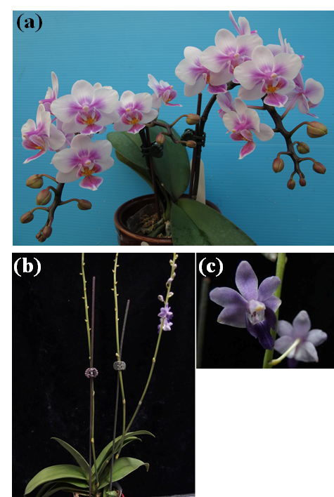

Figure S2. Distribution of the 17-mer depth of the high-quality reads.

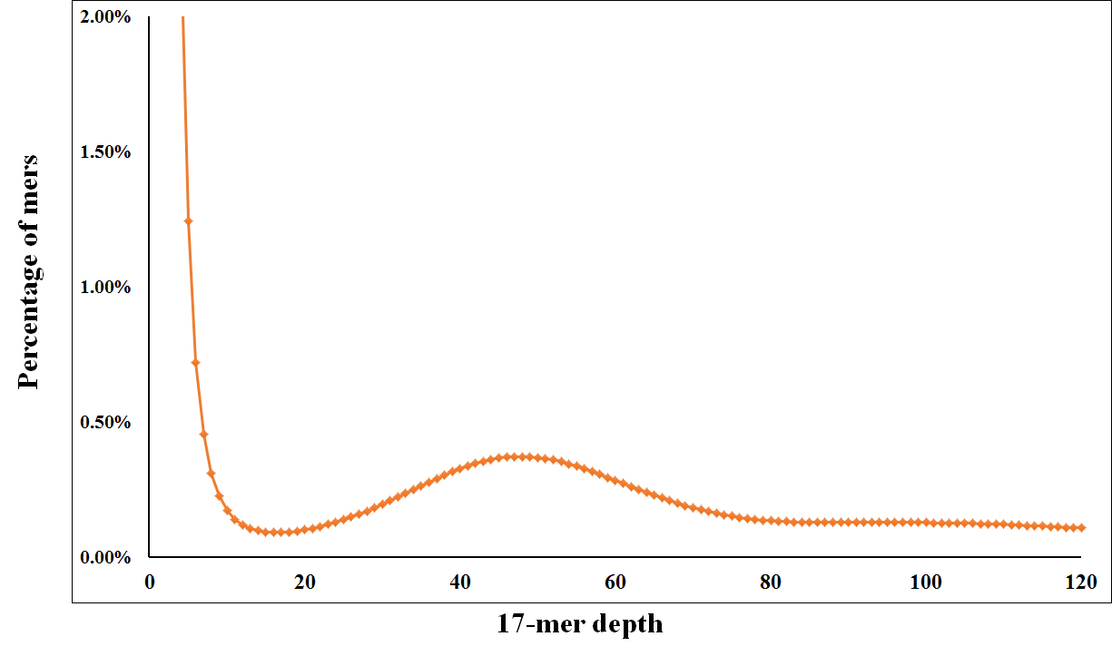

Figure S3. Read-depth distribution in the Phalaenopsis genome assembly.

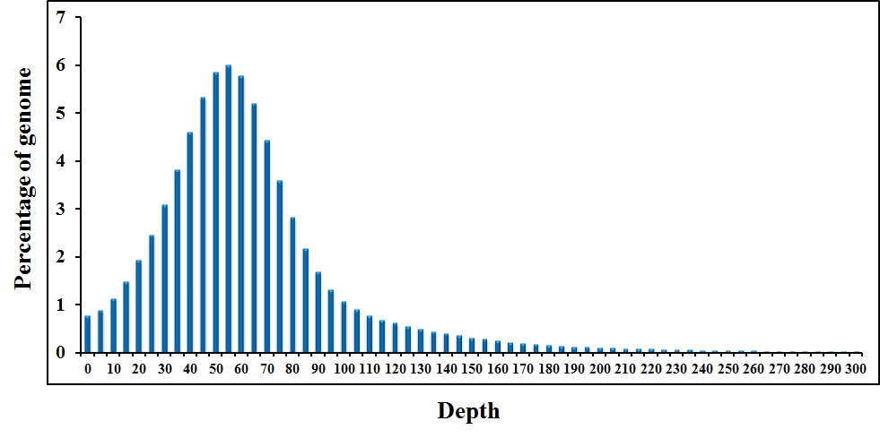

Figure S4. Comparison of the GC content distribution between Phalaenopsis and three other plant species (a) and the GC content vs. the average sequencing depth in Phalaenopsis (b).

(a)
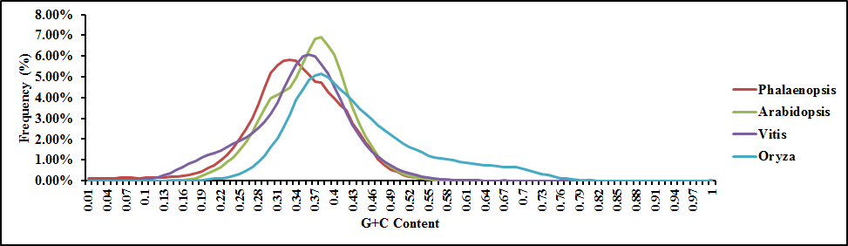

(b)
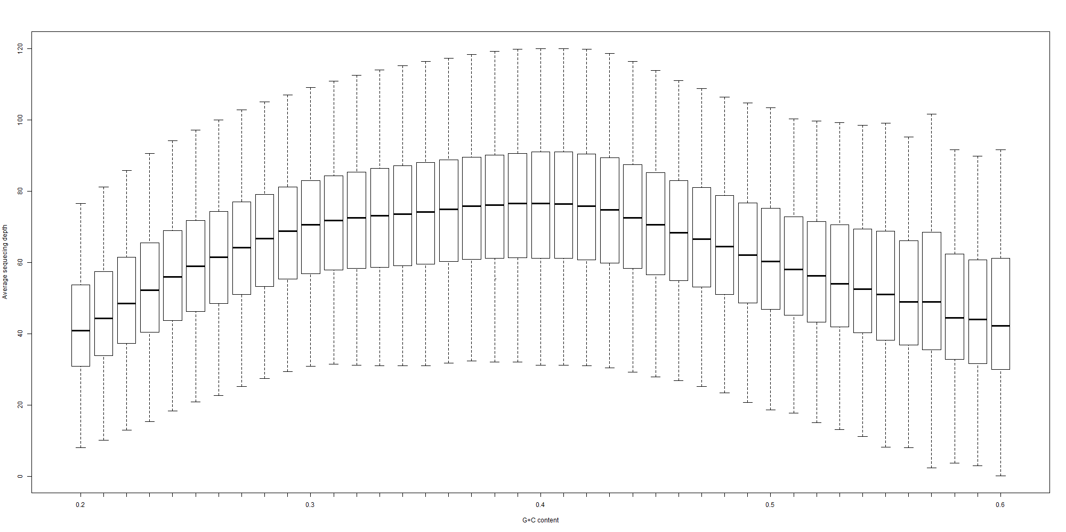

Figure S5. Divergence distribution of the classified TE families in the Phalaenopsis genome. To analyse the divergence, different TE families were aligned onto the Repbase library. DNA: DNA elements; LINE: long interspersed nuclear elements; LTR: long terminal repeat transposable element; SINE: short interspersed nuclear elements.

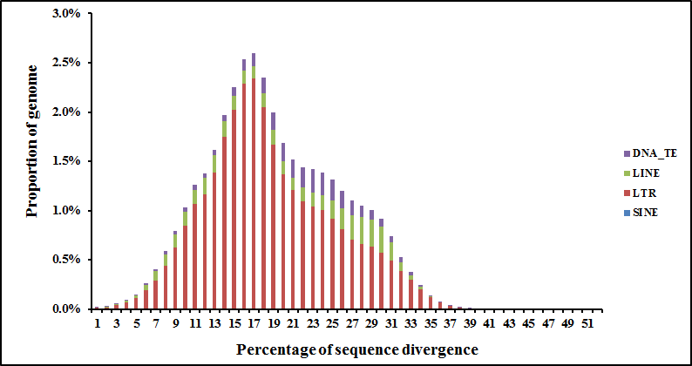

Figure S6. Size distribution of small RNAs based on deep sequencing

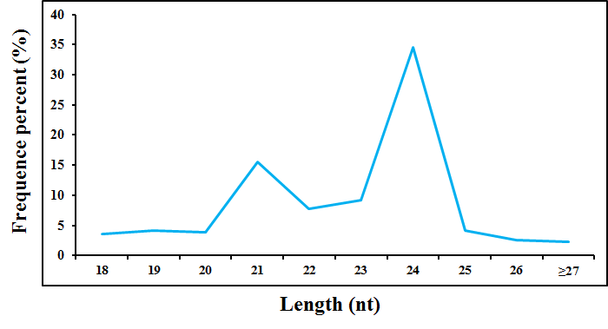

Figure S7. GO analysis of miRNA target genes

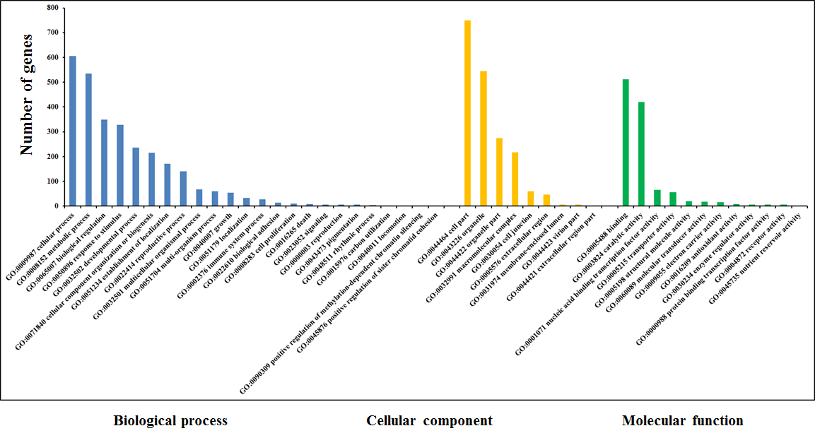

Figure S8. GO (a) and Pfam (b) annotation of Phalaenopsis protein-coding genes.

(a)
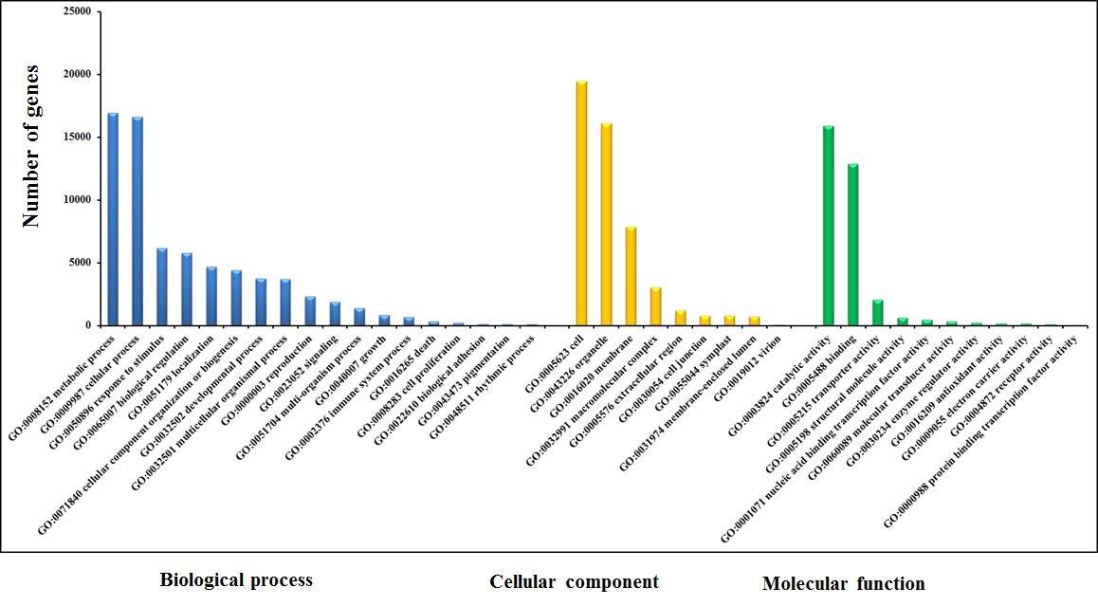
(b)
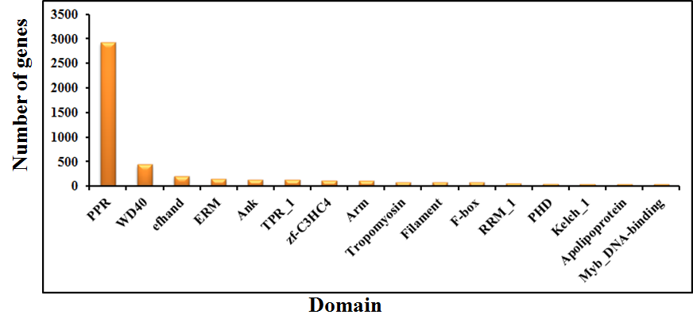

Figure S9. Phylogenetic analysis of PhMADS genes in Phalaenopsis.

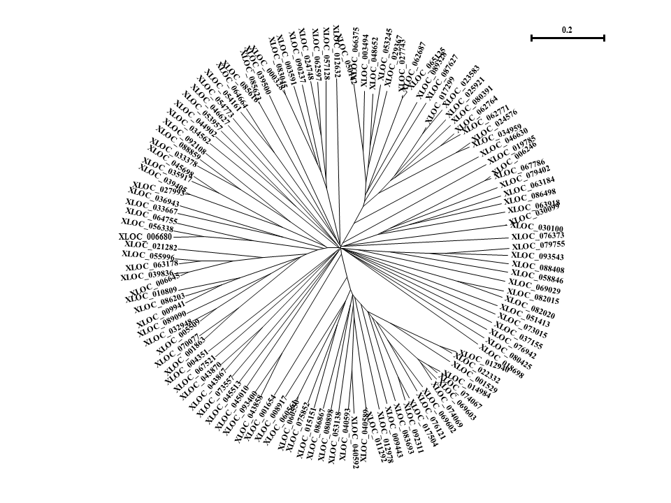

Figure S10. Phylogenetic analysis of PhTCP genes in Phalaenopsis.

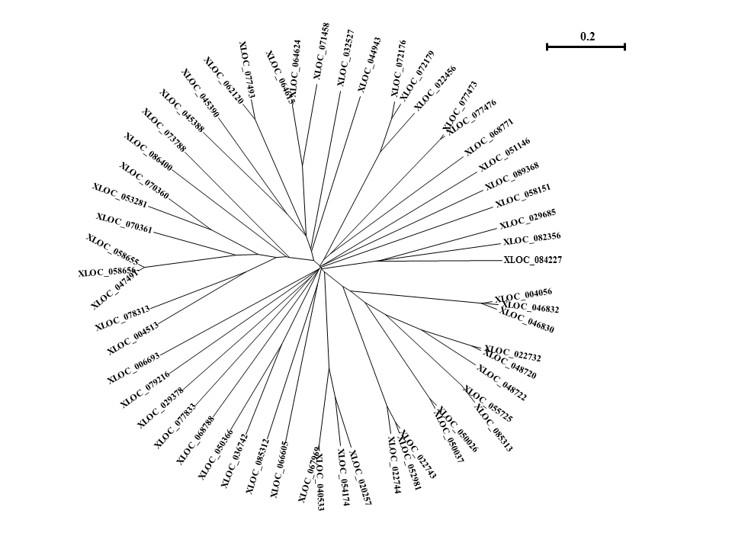

Figure S11. Phylogenetic analysis of PhWRKY genes in Phalaenopsis.

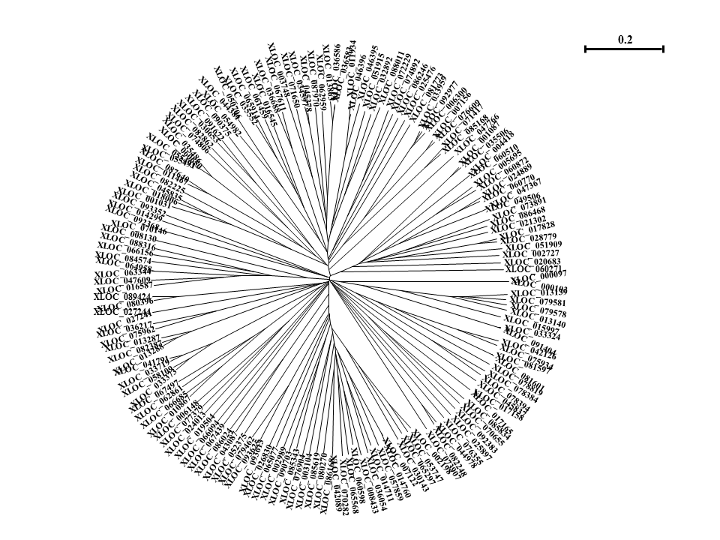

Figure S12. Flowers of the wild-type (a) and peloric mutant (b) of Phalaenopsis Brother Spring Dancer ‘KHM190’. Bar = 1 cm; Primary Phalaenopsis ‘KHM190’ PLB after cutting and growth on induction medium for 0 week (c) and Primary Phalaenopsis ‘KHM190’ PLB after cutting and growth on induction medium for 2 week (d). Bar = 05 cm; Phalaenopsis aphrodite wild type leaf (e) and Phalaenopsis aphrodite mutant with leaf intervein chlorosis (f). Bar = 5 cm; Phalaenopsis aphrodite with shoot tip tissues from shortened stems: constant high-temperature treatment was carried out at 30/27°C (day/night) (g) and low-temperature treatment was carried out at 22/18°C (day/night): 1 week (h), 2 week (i), 3 week (j), 4 week (k).

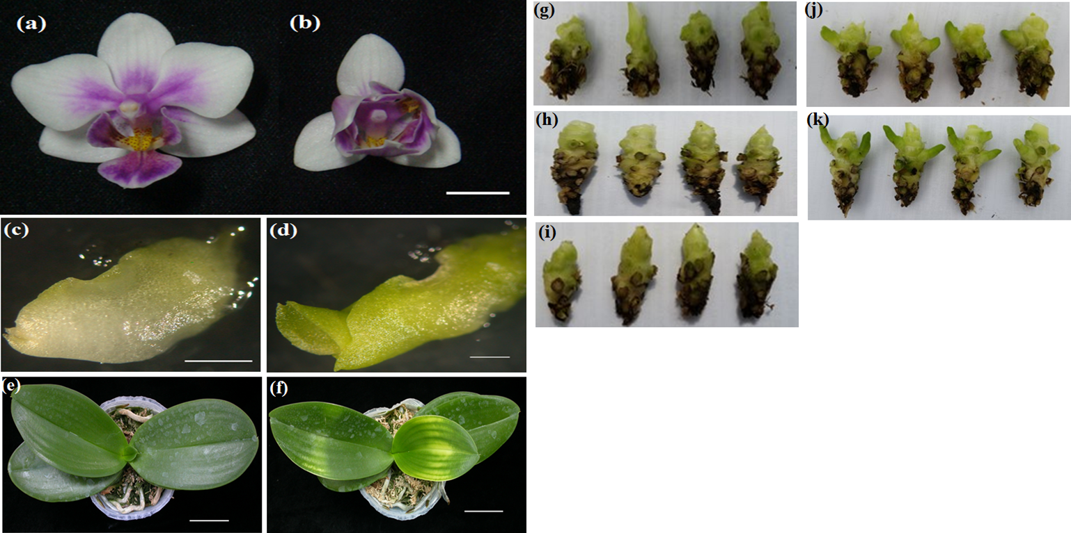
Figure S13. Discovery of five splicing patterns. PhAGL6b represents the constitutive splicing pattern; PhAGL6b-1~PhAGL6b-4 indicate alternative splicing patterns (a). Alignment of the nucleic acid sequences of alternatively spliced forms of PhAGL6.

(a)
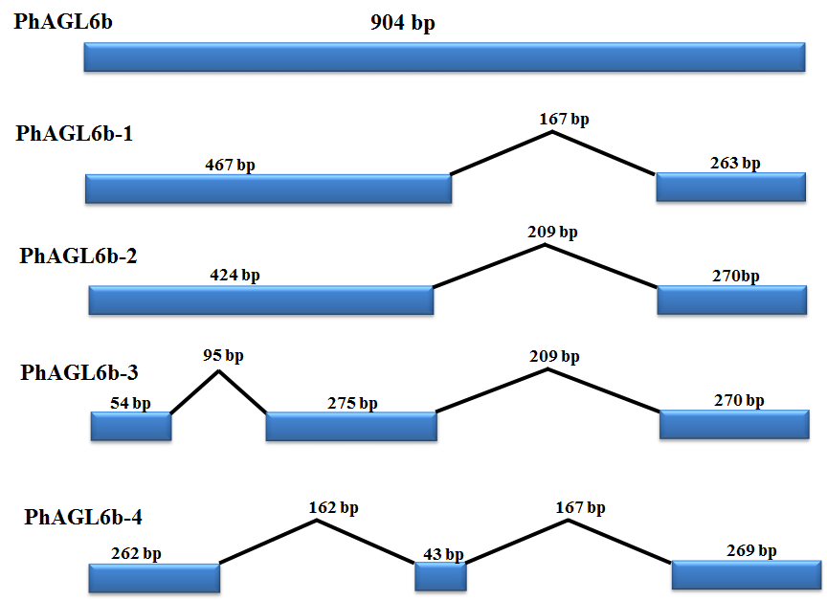
(b)
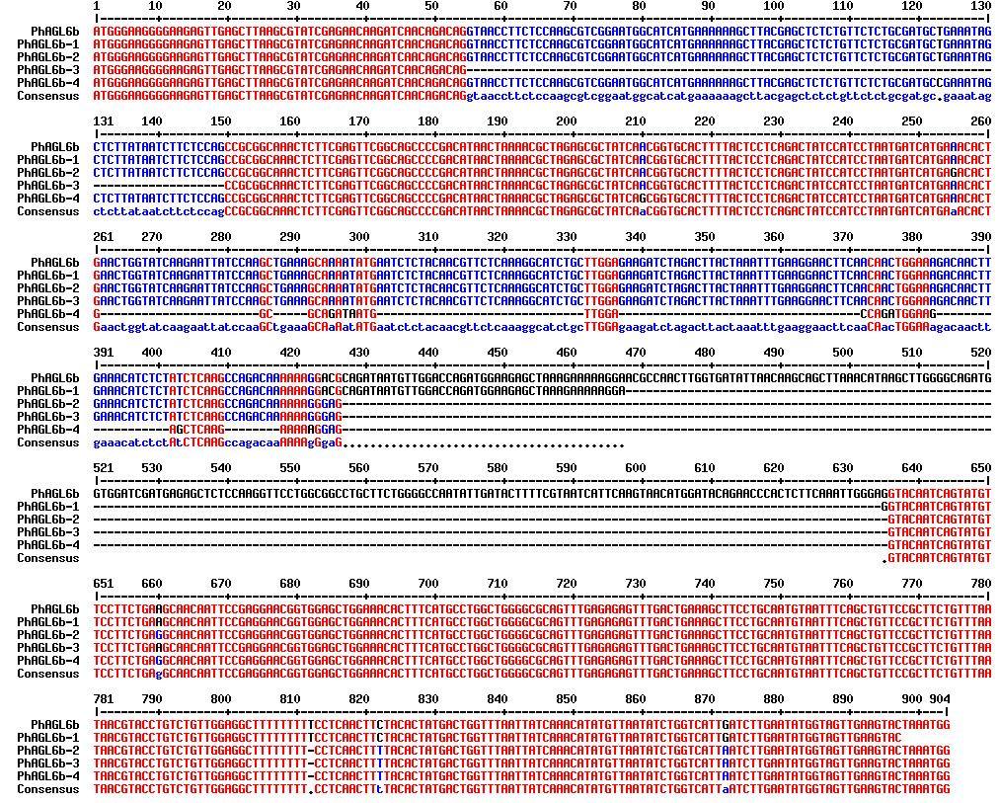

Figure S14. Different labellum types of wild-type and big lip mutant Phalaenopsis flowers (a). RT-PCR analysis of the mRNA splicing pattern of PhAGL6b in wild-type plants (98201-WT1 and 98201-WT2) and different big lip mutant types.

(a)
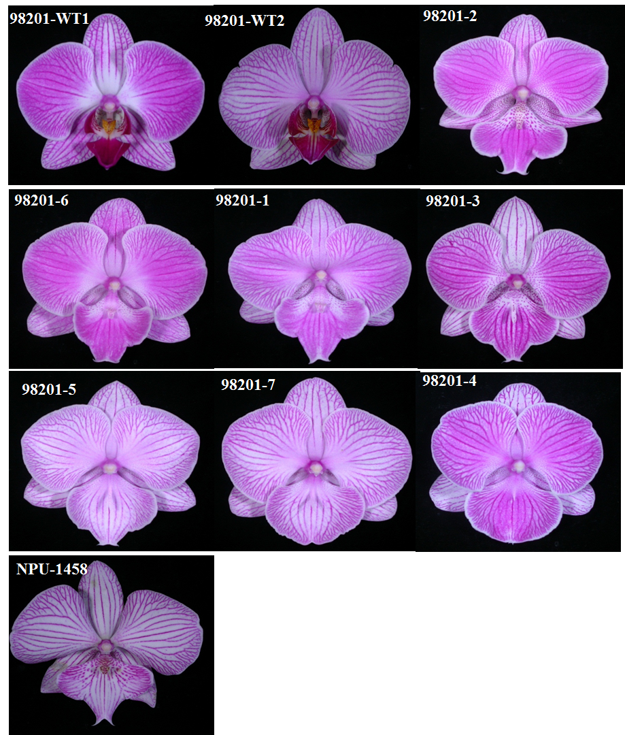
(b)
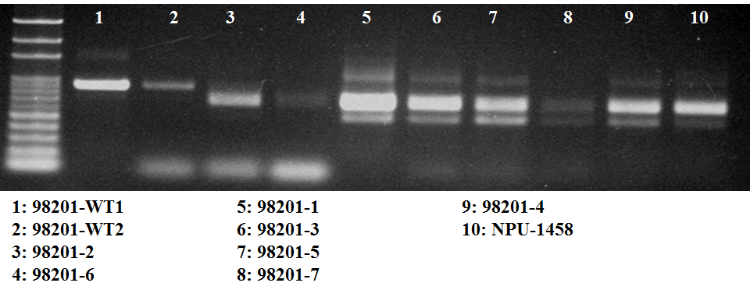

Figure S15. Splicing variants of PhAGL6b, as detected via qRT-PCR in the labellum organ of different big lip mutant types.

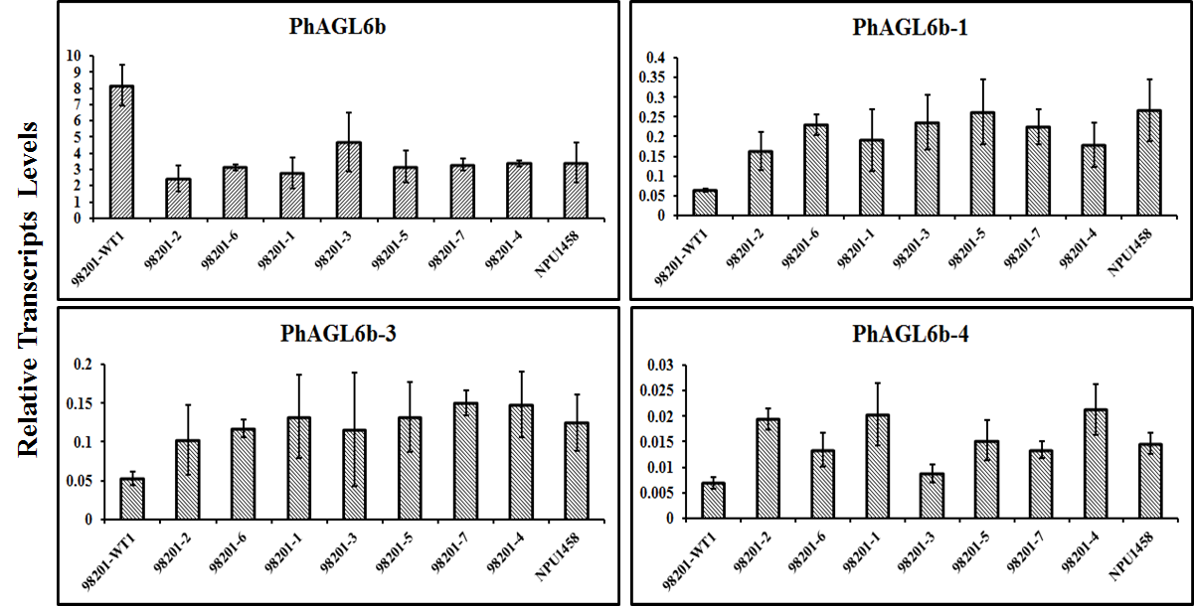

Figure S16. Changes in gene expression profiles between constant high temperature (BH) and cool temperature (BL1~BL4; 1w to 4w) treatments. The numbers of up- and downregulated genes in BL1 and BH, BL2 and BH, BL3 and BH, and BL4 and BH. Five libraries are summarised (a). Expression profiles of genes of flowering time regulation pathway with high temperature and cool temperature treatment. The genes with twofold change in expression during cool temperature treatments were selected (b).

(a)
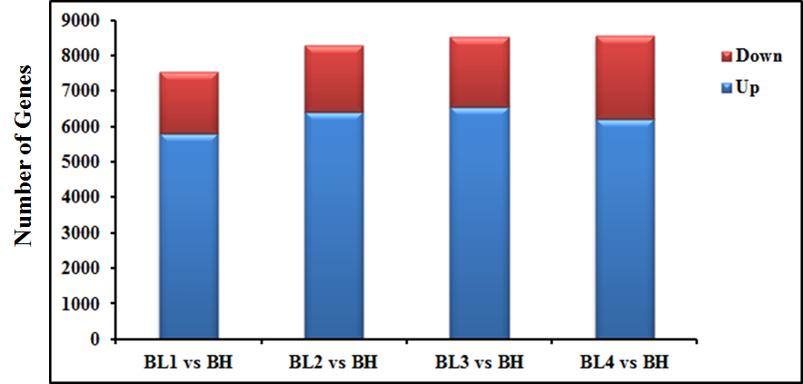
(b)
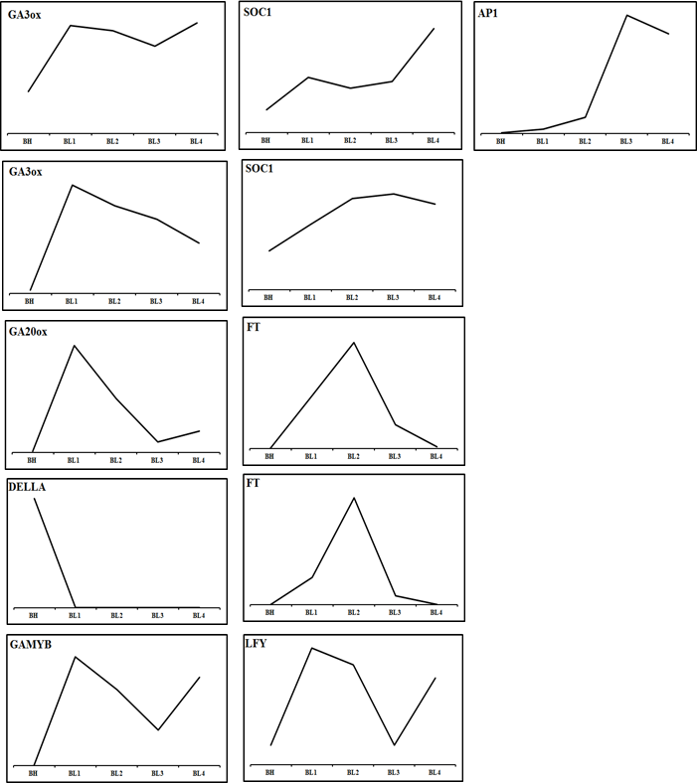

Figure S17. Types and numbers of nucleotide motifs among the predicted SSR markers in Phalaenopsis. a, Di-; b, Tri-; c, Tetra-; d, Penta-; e, Hexa-nucleotide motifs.

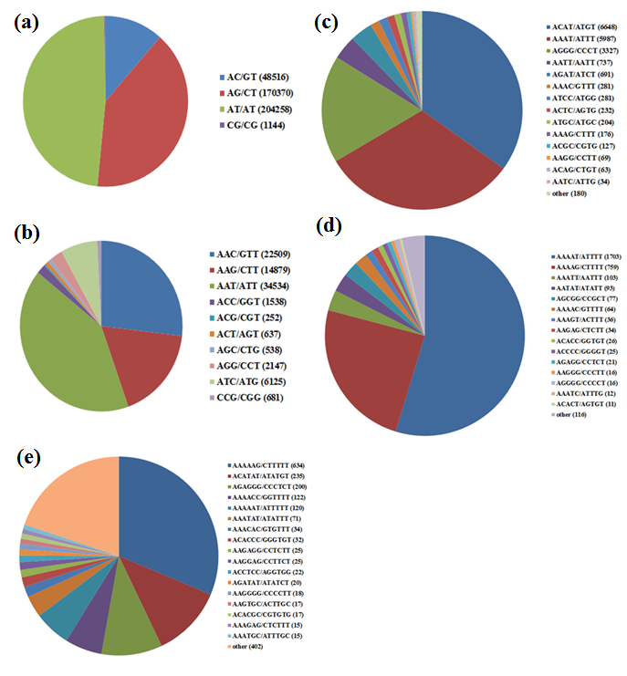

Figure S18. (a) Base substitutions for SNPs between ‘KHM190’ and ‘B8802’ are shown. (b) Length distribution of indels. Small indels were identified between ‘KHM190’ and ‘B8802’.

(a)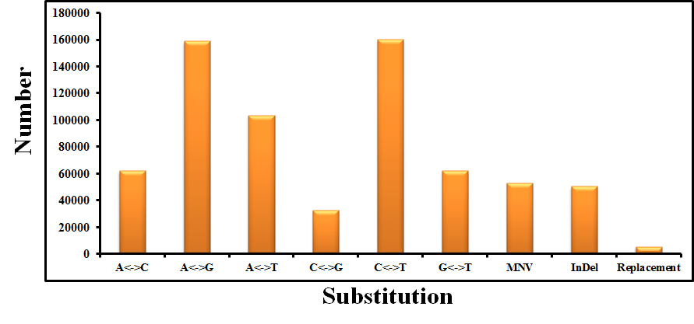

(b)

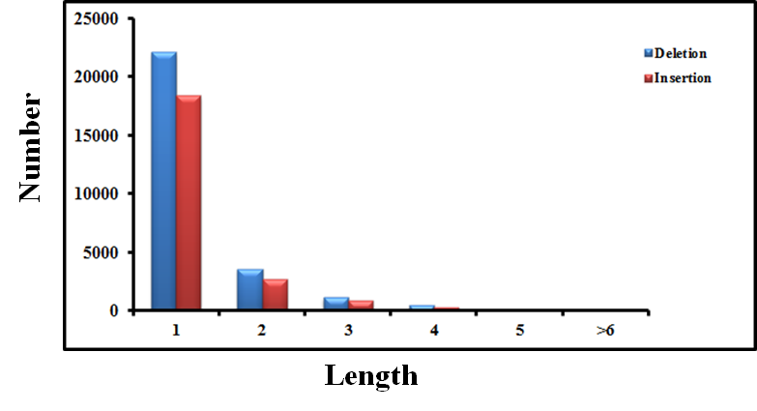
SI TABLES

Table S1. Summary of sequencing data for the Phalaenopsis ‘KHM190’ genome.
Paired-end
insert size Raw reads Qualified reads
Total Reads Sequence Total Reads Sequence
data length coverage data length coverage
(Gb) (bp) (X) (Gb) (bp) (X)
250 bp 235.6 101 90.63 215.9 95 83.02
3 kb 7.65 101 2.94 7.2 96 2.76
5 kb 55.8 168 21.46 54.4 165 20.91
8 kb 1.4 101 0.55 1.4 99 0.54

Table S2. Statistics for the K-mer distribution.
Kmer Kmer number Kmer Genome Bases used Reads used Depth (X)
depth Size
17 175,493,961,632 50.0336 3,450,299,293 211,038,882,492 2,221,571,754 61.1654

Table S3. Summary of the Phalaenopsis genome assembly.
Contig Scaffold
Size (bp) Number Size (bp) Number
N90 239 1,963,018 492 304,925
N80 469 12,541,52 5,373 5,7336
N70 743 849,322 18,062 20,752
N60 1,075 581,348 54,618 10,961
N50 1,489 391,766 100,943 6,804
Longest 50,944 1,402,447
Total size 2,394,603,655 3,104,268,398
Total number (≥1 kb) 630,316 149,151
Total number (≥10 kb) 6,102 32,342
GC ratio (%) 34.6 30.7

Table S4. Distribution of scaffold length for the Phalaenopsis genome assembly.
Scaffold length (kb) Number Total length (bp) Average length (bp) Percentage (%)
>100 6,857 1,557,536,000 227,145 50.2
>10 32,342 2,321,440,805 71,777 74.8
>1 149,151 2,687,668,326 18,020 86.6

Table S5. Assessment of the sequence coverage of the Phalaenopsis genome assembly using ESTs.
EST length Number >50% of sequence >80% of sequence ≥ 90% of sequence
mapped by one mapped by one mapped by one
scaffold scaffold scaffold
Number Ratio (%) Number Ratio (%) Number Ratio (%)
All 8,188 7,701 94.05 7,610 92.94 6,928 84.61
>200 bp 7,669 7,294 95.11 7,204 93.93 6,535 85.21
>500 bp 5,418 5,162 95.27 5,082 93.80 4,673 86.25

Table S6. Summary of transposable elements in Phalaenopsis.
TE Classification Copies DNA Content (bp) DNA Content (%)
Class I: Retrotransposon 1,273,881 894,789,557 33.44
LTR-Retrotransposon 1,071,162 777,601,961 29.05
LTR/Gypsy 872,767 653,755,406 24.43
LTR/Copia 190,541 118,659,463 4.43
Other 7,854 5,187,092 0.19
Non-LTR Retrotransposon 202,719 117,187,596 4.39
LINE/L1 75,953 63,971,156 2.39
LINE/RTE-BovB 91,341 44,848,006 1.68
LINE/L2 28,098 5,785,445 0.22
LINE/I 7,327 2,582,989 0.10
Class II: DNA Transposon 241,185 78,304,951 2.91
CMC-EnSpm 64,545 22,518,411 0.84
hAT-Ac 91,599 22,317,836 0.83
PIF-Harbinger 44,475 18,675,443 0.70
MuLE-MuDR 14,171 6,916,377 0.25
hAT-Tag1 15,334 5,298,195 0.20
TcMar-Sagan 5,237 1,683,676 0.06
hAT-Tip100 5,824 895,013 0.03
Helitron 4,962 424,477 0.02
Satellite 9,082 8,577,798 0.32
Simple repeat 444,880 23,284,122 0.87
Low_complexity 81,701 5,120,206 0.19
Unclassified 1,765,138 588,613,261 21.99
Total content 3,820,829 1,598,926,178 59.74
Table S7. Transcriptome analysis of four organs of Phalaenopsis ‘KHM190’ via RNA-Seq.
Organ Usable data Transcripts Average length Maximum length Total size of transcripts
(Gb) (bp) (bp) (bp)
Shoot tip 35.2 56,609 914 19,384 51,769,072
Floral organs 32.5 40,192 1,081 17,075 43,464,697
Leaves 11.9 43,719 504 4,720 22,054,235
Protocorm-like body 9.9 61,736 653 5,042 40,324,120

Shoot tip: Constant high temperature (BH) and a cool temperature (BL) (1 to 4 weeks)
Floral organs: sepal, petal and labellum tissues of both the ‘KH190’ wild-type and peloric mutant
Leaves:
Protocorm-like body:

Table S8. Non-coding RNA genes in the Phalaenopsis genome.
Type Copy Average length Total length
(bp) (bp)
miRNA 188 82.8 53,815
tRNA 655 74.5 48,802
rRNA
18S 51 1,127.9 57,525
28S 17 105.6 1,690
5.8S 168 153.9 25,859
5S 326 118.2 38,528
SnoRNA
C/D-box 241 98.2 23,659
Other 49 87.6 4,290
snRNA 263 126.6 33,306

Table S9. Summary of the types and numbers of simple sequence repeat (SSR) types and numbers in the Phalaenopsis genome assembly.
Motif Occurrence Most frequent type
Di- 424,288 AG/CT/GA/TC
Tri- 83,840 AAC/GTT/AAG/CTT/AAT
ATT/AGG/CCT/ATC/ATG
Tetra- 19,017 ACAT/ATGT/AAAT/ATTT
AGGG/CCCT
Penta- 3,112 AAAAT/ATTTT/AAAAG
CTTTT /AAATT/AATTT
Hexa- 2,028 AAAAAG/CTTTTT
ACATAT/ATATGT
AGAGGG/CCCTCT
AAAACC/GGTTTT
Total 532,285

Table S10. Statistics for homozygous and heterozygous polymorphisms.
Sources Homozygous Heterozygous
SNP Indel SNP+Indel SNP Indel SNP+Indel
Gene region 9,946 566 10,512 10,438 879 11,317
Intergenic region 8,703 485 9,188 8,832 752 9,584

Table S11. Primers used for cDNA cloning, RT-PCR analyses and real-time RT-PCR

Primer Name Sequence
For cloning and RT-PCR analysis
PhAGL6-F: 5’ATGGGAAGGGGAAGAGTTGAGCTTAA3’
PhAGL6-R: 5’ TCAAACTGCGCCCCAGCCAGGCATGA3’

For real-time RT-PCR
PhAGL6qPCR-F 5’TAAGCTTGGGGCAGATGGTGG3’
PhAGL6qPCR-R 5’GTGGGTTCTGTATCCATGTTAC3’

PhAGL6-1qPCR-F 5’GAGCTAAAGAAAAAGGAGGTAC3’
PhAGL6-1qPCR-R 5’TCAAACTGCGCCCCAGCCAGGC3’

PhAGL6-3qPCR-F 5’AGATCAACAGACAGCCGCGGC3’
PhAGL6-3qPCR-R 5’ TTAGGATGGATAGTCTGAGGAG3’

PhAGL6-4qPCR-F 5’ATGATCATGAAACACTGGCGC3’
PhAGL6-4qPCR-R 5’TCAAACTGCGCCCCAGCCAGGC3’
References
2000. Analysis of the genome sequence of the flowering plant Arabidopsis thaliana. Nature 408:796-815. 10.1038/35048692
2005. The map-based sequence of the rice genome. Nature 436:793-800. 10.1038/nature03895
2008. The Gene Ontology project in 2008. Nucleic Acids Res 36:D440-444. 10.1093/nar/gkm883
Aguilar-Martinez JA, Poza-Carrion C, and Cubas P. 2007. Arabidopsis BRANCHED1 acts as an integrator of branching signals within axillary buds. Plant Cell 19:458-472. 10.1105/tpc.106.048934
Allen E, Xie Z, Gustafson AM, and Carrington JC. 2005. microRNA-directed phasing during trans-acting siRNA biogenesis in plants. Cell 121:207-221. 10.1016/j.cell.2005.04.004
Alvarez-Buylla ER, Pelaz S, Liljegren SJ, Gold SE, Burgeff C, Ditta GS, Ribas de Pouplana L, Martinez-Castilla L, and Yanofsky MF. 2000. An ancestral MADS-box gene duplication occurred before the divergence of plants and animals. Proc Natl Acad Sci U S A 97:5328-5333.
Barkoulas M, Galinha C, Grigg SP, and Tsiantis M. 2007. From genes to shape: regulatory interactions in leaf development. Curr Opin Plant Biol 10:660-666. 10.1016/j.pbi.2007.07.012
Benson G. 1999. Tandem repeats finder: a program to analyze DNA sequences. Nucleic Acids Res 27:573-580.
Blanchard MG, and Runkle ES. 2006. Temperature during the day, but not during the night, controls flowering of Phalaenopsis orchids. J Exp Bot 57:4043-4049. 10.1093/jxb/erl176
Burge SW, Daub J, Eberhardt R, Tate J, Barquist L, Nawrocki EP, Eddy SR, Gardner PP, and Bateman A. 2013. Rfam 11.0: 10 years of RNA families. Nucleic Acids Res 41:D226-232. 10.1093/nar/gks1005
Chandler JW, Cole M, Flier A, Grewe B, and Werr W. 2007. The AP2 transcription factors DORNROSCHEN and DORNROSCHEN-LIKE redundantly control Arabidopsis embryo patterning via interaction with PHAVOLUTA. Development 134:1653-1662. 10.1242/dev.001016
Chen F, Mackey AJ, Stoeckert CJ, Jr., and Roos DS. 2006. OrthoMCL-DB: querying a comprehensive multi-species collection of ortholog groups. Nucleic Acids Res 34:D363-368. 10.1093/nar/gkj123
Chen WH, Tseng YC, Liu YC, Chuo CM, Chen PT, Tseng KM, Yeh YC, Ger MJ, and Wang HL. 2008. Cool-night temperature induces spike emergence and affects photosynthetic efficiency and metabolizable carbohydrate and organic acid pools in Phalaenopsis aphrodite. Plant Cell Rep 27:1667-1675. 10.1007/s00299-008-0591-0
Chuck G, Cigan AM, Saeteurn K, and Hake S. 2007. The heterochronic maize mutant Corngrass1 results from overexpression of a tandem microRNA. Nat Genet 39:544-549. 10.1038/ng2001
Conesa A, and Gotz S. 2008. Blast2GO: A comprehensive suite for functional analysis in plant genomics. Int J Plant Genomics 2008:619832. 10.1155/2008/619832
Cubas P. 2004. Floral zygomorphy, the recurring evolution of a successful trait. Bioessays 26:1175-1184. 10.1002/bies.20119
Cubas P, Vincent C, and Coen E. 1999. An epigenetic mutation responsible for natural variation in floral symmetry. Nature 401:157-161. 10.1038/43657
Doebley J, Stec A, and Hubbard L. 1997. The evolution of apical dominance in maize. Nature 386:485-488. 10.1038/386485a0
Dornelas MC, Patreze CM, Angenent GC, and Immink RG. 2011. MADS: the missing link between identity and growth? Trends Plant Sci 16:89-97. 10.1016/j.tplants.2010.11.003
Doyle JJ, Doyle JL. 1987. A rapid DNA isolation procedure for small quantitiesof
fresh leaf tissue. Phyt Bull 19:11-15.
Feltus FA, Wan J, Schulze SR, Estill JC, Jiang N, and Paterson AH. 2004. An SNP resource for rice genetics and breeding based on subspecies indica and japonica genome alignments. Genome Res 14:1812-1819. 10.1101/gr.2479404
Finn RD, Bateman A, Clements J, Coggill P, Eberhardt RY, Eddy SR, Heger A, Hetherington K, Holm L, Mistry J, Sonnhammer EL, Tate J, and Punta M. 2014. Pfam: the protein families database. Nucleic Acids Res 42:D222-230. 10.1093/nar/gkt1223
Finn RD, Clements J, and Eddy SR. 2011. HMMER web server: interactive sequence similarity searching. Nucleic Acids Res 39:W29-37. 10.1093/nar/gkr367
Friedlander MR, Mackowiak SD, Li N, Chen W, and Rajewsky N. 2012. miRDeep2 accurately identifies known and hundreds of novel microRNA genes in seven animal clades. Nucleic Acids Res 40:37-52. 10.1093/nar/gkr688
Gardner PP, Daub J, Tate JG, Nawrocki EP, Kolbe DL, Lindgreen S, Wilkinson AC, Finn RD, Griffiths-Jones S, Eddy SR, and Bateman A. 2009. Rfam: updates to the RNA families database. Nucleic Acids Res 37:D136-140. 10.1093/nar/gkn766
Huang JZ, Lin CP, Cheng TC, Chang BC, Cheng SY, Chen YW, Lee CY, Chin SW, and Chen FC. 2015. A de novo floral transcriptome reveals clues into Phalaenopsis orchid flower development. PLoS One 10:e0123474. 10.1371/journal.pone.0123474
Jaillon O, Aury JM, Noel B, Policriti A, Clepet C, Casagrande A, Choisne N, Aubourg S, Vitulo N, Jubin C, Vezzi A, Legeai F, Hugueney P, Dasilva C, Horner D, Mica E, Jublot D, Poulain J, Bruyere C, Billault A, Segurens B, Gouyvenoux M, Ugarte E, Cattonaro F, Anthouard V, Vico V, Del Fabbro C, Alaux M, Di Gaspero G, Dumas V, Felice N, Paillard S, Juman I, Moroldo M, Scalabrin S, Canaguier A, Le Clainche I, Malacrida G, Durand E, Pesole G, Laucou V, Chatelet P, Merdinoglu D, Delledonne M, Pezzotti M, Lecharny A, Scarpelli C, Artiguenave F, Pe ME, Valle G, Morgante M, Caboche M, Adam-Blondon AF, Weissenbach J, Quetier F, and Wincker P. 2007. The grapevine genome sequence suggests ancestral hexaploidization in major angiosperm phyla. Nature 449:463-467. 10.1038/nature06148
Jeong DH, Park S, Zhai J, Gurazada SG, De Paoli E, Meyers BC, and Green PJ. 2011. Massive analysis of rice small RNAs: mechanistic implications of regulated microRNAs and variants for differential target RNA cleavage. Plant Cell 23:4185-4207. 10.1105/tpc.111.089045
Jin J, Zhang H, Kong L, Gao G, and Luo J. 2014. PlantTFDB 3.0: a portal for the functional and evolutionary study of plant transcription factors. Nucleic Acids Res 42:D1182-1187. 10.1093/nar/gkt1016
Jurka J, Kapitonov VV, Pavlicek A, Klonowski P, Kohany O, and Walichiewicz J. 2005. Repbase Update, a database of eukaryotic repetitive elements. Cytogenet Genome Res 110:462-467. 10.1159/000084979
Kanehisa M, Goto S, Sato Y, Furumichi M, and Tanabe M. 2012. KEGG for integration and interpretation of large-scale molecular data sets. Nucleic Acids Res 40:D109-114. 10.1093/nar/gkr988
Kasschau KD, Fahlgren N, Chapman EJ, Sullivan CM, Cumbie JS, Givan SA, and Carrington JC. 2007. Genome-wide profiling and analysis of Arabidopsis siRNAs. PLoS Biol 5:e57. 10.1371/journal.pbio.0050057
Kent WJ. 2002. BLAT--the BLAST-like alignment tool. Genome Res 12:656-664. 10.1101/gr.229202. Article published online before March 2002
Kozomara A, and Griffiths-Jones S. 2014. miRBase: annotating high confidence microRNAs using deep sequencing data. Nucleic Acids Res 42:D68-73. 10.1093/nar/gkt1181
Lam HM, Xu X, Liu X, Chen W, Yang G, Wong FL, Li MW, He W, Qin N, Wang B, Li J, Jian M, Wang J, Shao G, Sun SS, and Zhang G. 2010. Resequencing of 31 wild and cultivated soybean genomes identifies patterns of genetic diversity and selection. Nat Genet 42:1053-1059. 10.1038/ng.715
Langmead B, and Salzberg SL. 2012. Fast gapped-read alignment with Bowtie 2. Nat Methods 9:357-359. 10.1038/nmeth.1923
Lelandais-Briere C, Naya L, Sallet E, Calenge F, Frugier F, Hartmann C, Gouzy J, and Crespi M. 2009. Genome-wide Medicago truncatula small RNA analysis revealed novel microRNAs and isoforms differentially regulated in roots and nodules. Plant Cell 21:2780-2796. 10.1105/tpc.109.068130
Li L, Stoeckert CJ, Jr., and Roos DS. 2003. OrthoMCL: identification of ortholog groups for eukaryotic genomes. Genome Res 13:2178-2189. 10.1101/gr.1224503
Lowe TM, and Eddy SR. 1997. tRNAscan-SE: a program for improved detection of transfer RNA genes in genomic sequence. Nucleic Acids Res 25:955-964.
Lu P, Han X, Qi J, Yang J, Wijeratne AJ, Li T, and Ma H. 2012. Analysis of Arabidopsis genome-wide variations before and after meiosis and meiotic recombination by resequencing Landsberg erecta and all four products of a single meiosis. Genome Res 22:508-518. 10.1101/gr.127522.111
Luo R, Liu B, Xie Y, Li Z, Huang W, Yuan J, He G, Chen Y, Pan Q, Liu Y, Tang J, Wu G, Zhang H, Shi Y, Yu C, Wang B, Lu Y, Han C, Cheung DW, Yiu SM, Peng S, Xiaoqian Z, Liu G, Liao X, Li Y, Yang H, Wang J, and Lam TW. 2012. SOAPdenovo2: an empirically improved memory-efficient short-read de novo assembler. Gigascience 1:18. 10.1186/2047-217X-1-18
Martin-Trillo M, and Cubas P. 2010. TCP genes: a family snapshot ten years later. Trends Plant Sci 15:31-39. 10.1016/j.tplants.2009.11.003
Messenguy F, and Dubois E. 2003. Role of MADS box proteins and their cofactors in combinatorial control of gene expression and cell development. Gene 316:1-21.
Munster T, Pahnke J, Di Rosa A, Kim JT, Martin W, Saedler H, and Theissen G. 1997. Floral homeotic genes were recruited from homologous MADS-box genes preexisting in the common ancestor of ferns and seed plants. Proc Natl Acad Sci U S A 94:2415-2420.
Nawrocki EP, and Eddy SR. 2013. Infernal 1.1: 100-fold faster RNA homology searches. Bioinformatics 29:2933-2935. 10.1093/bioinformatics/btt509
Parenicova L, de Folter S, Kieffer M, Horner DS, Favalli C, Busscher J, Cook HE, Ingram RM, Kater MM, Davies B, Angenent GC, and Colombo L. 2003. Molecular and phylogenetic analyses of the complete MADS-box transcription factor family in Arabidopsis: new openings to the MADS world. Plant Cell 15:1538-1551.
Pollier J, Rombauts S, and Goossens A. 2013. Analysis of RNA-Seq data with TopHat and Cufflinks for genome-wide expression analysis of jasmonate-treated plants and plant cultures. Methods Mol Biol 1011:305-315. 10.1007/978-1-62703-414-2_24
Romay MC, Millard MJ, Glaubitz JC, Peiffer JA, Swarts KL, Casstevens TM, Elshire RJ, Acharya CB, Mitchell SE, Flint-Garcia SA, McMullen MD, Holland JB, Buckler ES, and Gardner CA. 2013. Comprehensive genotyping of the USA national maize inbred seed bank. Genome Biol 14:R55. 10.1186/gb-2013-14-6-r55
Rudall PJ, and Bateman RM. 2002. Roles of synorganisation, zygomorphy and heterotopy in floral evolution: the gynostemium and labellum of orchids and other lilioid monocots. Biol Rev Camb Philos Soc 77:403-441.
Rushton PJ, Somssich IE, Ringler P, and Shen QJ. 2010. WRKY transcription factors. Trends Plant Sci 15:247-258. 10.1016/j.tplants.2010.02.006
Schwab R, Palatnik JF, Riester M, Schommer C, Schmid M, and Weigel D. 2005. Specific effects of microRNAs on the plant transcriptome. Dev Cell 8:517-527. 10.1016/j.devcel.2005.01.018
Smit AFA, Hubley R, Green P. 1996-2010. RepeatMasker Open-3.0. [http://www.repeatmasker.org]
Szilagyi L, and Szilagyi SM. 2013. Efficient Markov clustering algorithm for protein sequence grouping. Conf Proc IEEE Eng Med Biol Soc 2013:639-642. 10.1109/EMBC.2013.6609581
Takeda T, Suwa Y, Suzuki M, Kitano H, Ueguchi-Tanaka M, Ashikari M, Matsuoka M, and Ueguchi C. 2003. The OsTB1 gene negatively regulates lateral branching in rice. Plant J 33:513-520.
Tamura K, Peterson D, Peterson N, Stecher G, Nei M, and Kumar S. 2011. MEGA5: molecular evolutionary genetics analysis using maximum likelihood, evolutionary distance, and maximum parsimony methods. Mol Biol Evol 28:2731-2739. 10.1093/molbev/msr121
Theissen G. 2001. Development of floral organ identity: stories from the MADS house. Curr Opin Plant Biol 4:75-85.
Trapnell C, Pachter L, and Salzberg SL. 2009. TopHat: discovering splice junctions with RNA-Seq. Bioinformatics 25:1105-1111. 10.1093/bioinformatics/btp120
Trapnell C, Roberts A, Goff L, Pertea G, Kim D, Kelley DR, Pimentel H, Salzberg SL, Rinn JL, and Pachter L. 2012. Differential gene and transcript expression analysis of RNA-seq experiments with TopHat and Cufflinks. Nat Protoc 7:562-578. 10.1038/nprot.2012.016
Trobner W, Ramirez L, Motte P, Hue I, Huijser P, Lonnig WE, Saedler H, Sommer H, and Schwarz-Sommer Z. 1992. GLOBOSA: a homeotic gene which interacts with DEFICIENS in the control of Antirrhinum floral organogenesis. EMBO J 11:4693-4704.
Tsai WC, Kuoh CS, Chuang MH, Chen WH, and Chen HH. 2004. Four DEF-like MADS box genes displayed distinct floral morphogenetic roles in Phalaenopsis orchid. Plant Cell Physiol 45:831-844. 10.1093/pcp/pch095
Tsai WC, Lee PF, Chen HI, Hsiao YY, Wei WJ, Pan ZJ, Chuang MH, Kuoh CS, Chen WH, and Chen HH. 2005. PeMADS6, a GLOBOSA/PISTILLATA-like gene in Phalaenopsis equestris involved in petaloid formation, and correlated with flower longevity and ovary development. Plant Cell Physiol 46:1125-1139. 10.1093/pcp/pci125
Wang L, Feng Z, Wang X, and Zhang X. 2010. DEGseq: an R package for identifying differentially expressed genes from RNA-seq data. Bioinformatics 26:136-138. 10.1093/bioinformatics/btp612
Wang T, Chen L, Zhao M, Tian Q, and Zhang WH. 2011. Identification of drought-responsive microRNAs in Medicago truncatula by genome-wide high-throughput sequencing. BMC Genomics 12:367. 10.1186/1471-2164-12-367
Zerbino DR, and Birney E. 2008. Velvet: algorithms for de novo short read assembly using de Bruijn graphs. Genome Res 18:821-829. 10.1101/gr.074492.107

