Turk Talk screenshots for PeerJ

A series of screenshots to illustrate how to play and direct a Scenario using Turk Talk approach.

Here is the Visual Editor concept map for http://demo.openlabyrinth.ca/labyrinthManager/global/606, our first OpenLabyrinth case design, using the Turk Talk approach.

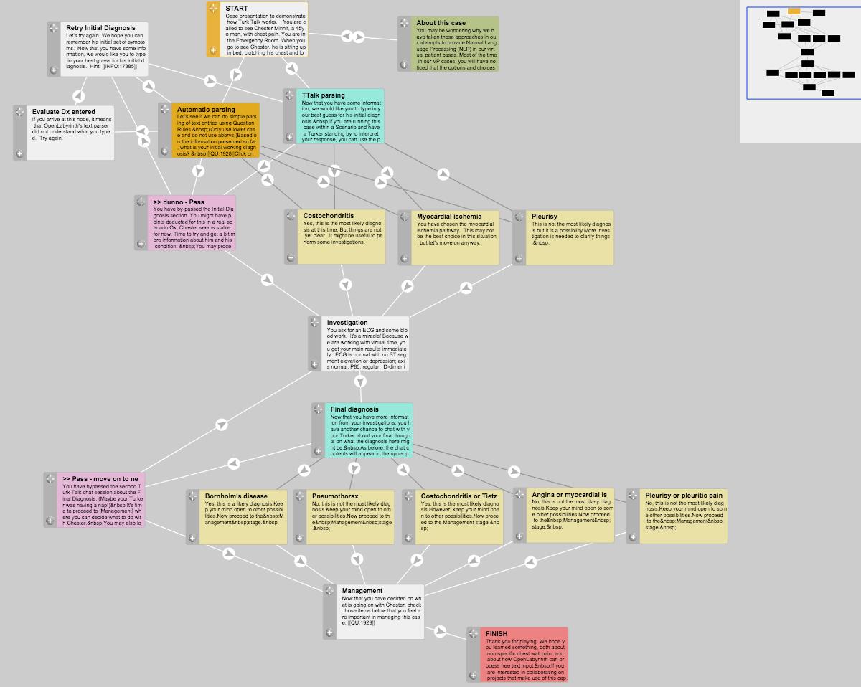
Figure 1: concept map for first Turk Talk case.

In this concept map, extracted from our first Turk Talk case design, the flow is from top downwards. Each Node contains a single page within the case or labyrinth, linked according to the arrowed lines. The aquamarine nodes are Turk Talk nodes where the learner interacts with the facilitator. The light yellow nodes are the possible destination points that the facilitator can send the learner on to. The dark grey links signify hidden paths that are not immediately apparent to the learner as a choice but that the facilitator can direct them along.

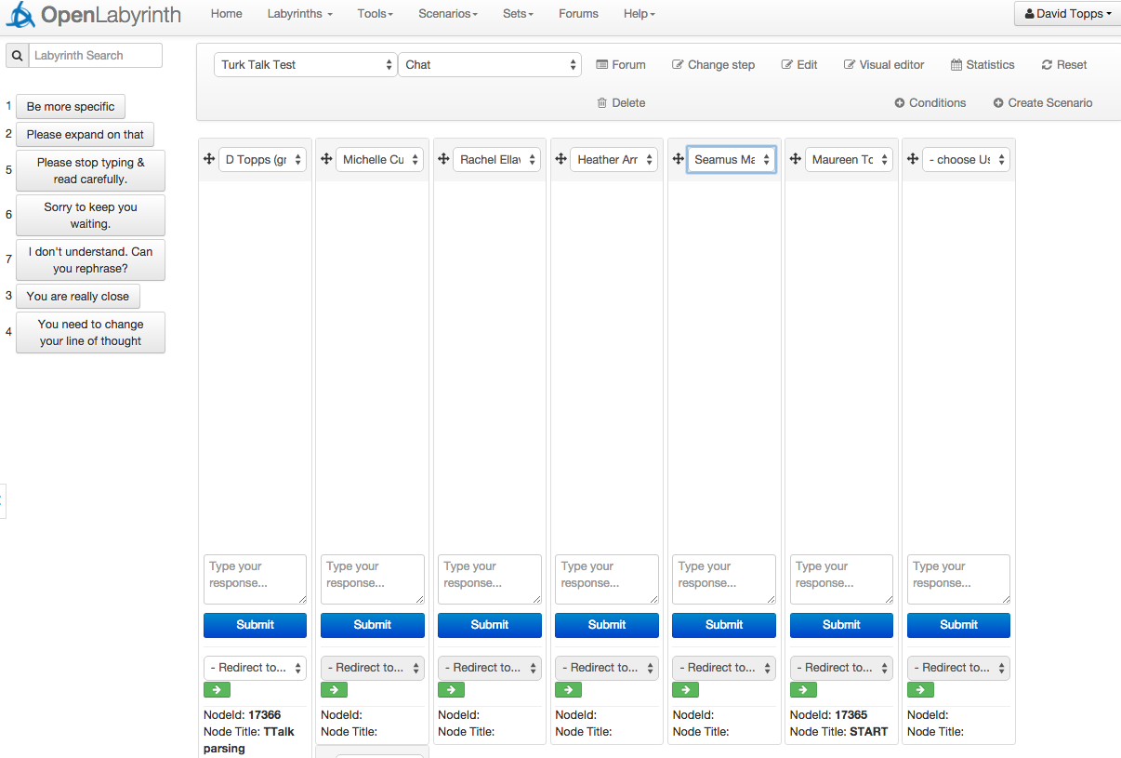

Figure 2: Scenario Director's chat view
In Figure 2, the Chat view shows what the Scenario Director will see while waiting for the learners to login and start the case. Note the shortcut text macros in the top left, that can be inserted into any column.

The columns can be assigned to any learner and can also be dragged into a different viewing order. Each column displays the current Turk Talk conversation with that learner, and has its own input field, a list of Nodes that the facilitator can redirect the learner to, and the current Node/location of that learner.
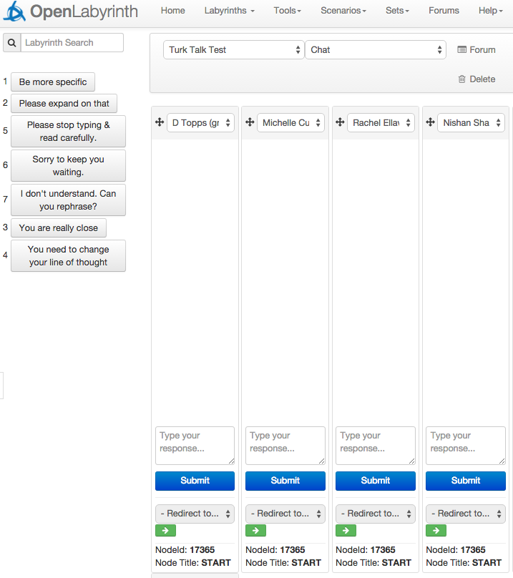
Figure 3: four users waiting at the START node

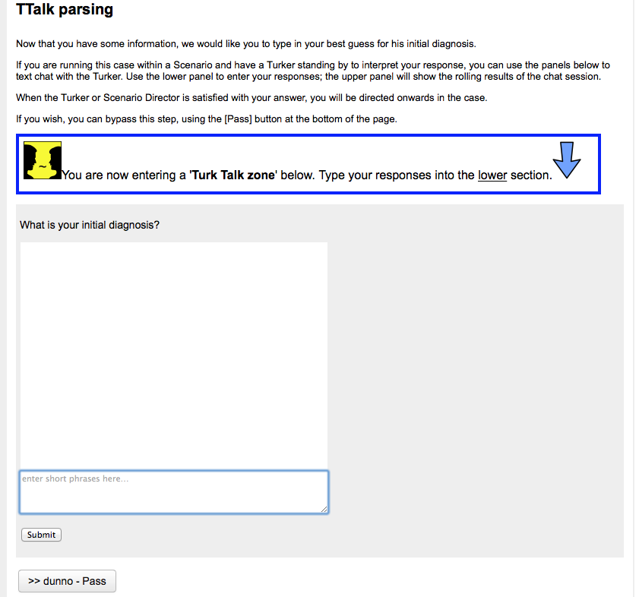
Figure 4: what the learner sees when they reach their first Turk Talk node.

This user has reached the first Turk Talk node. Text is entered in the lower portion of the dialog box. Note the highlighter box drawing the user’s attention to this.

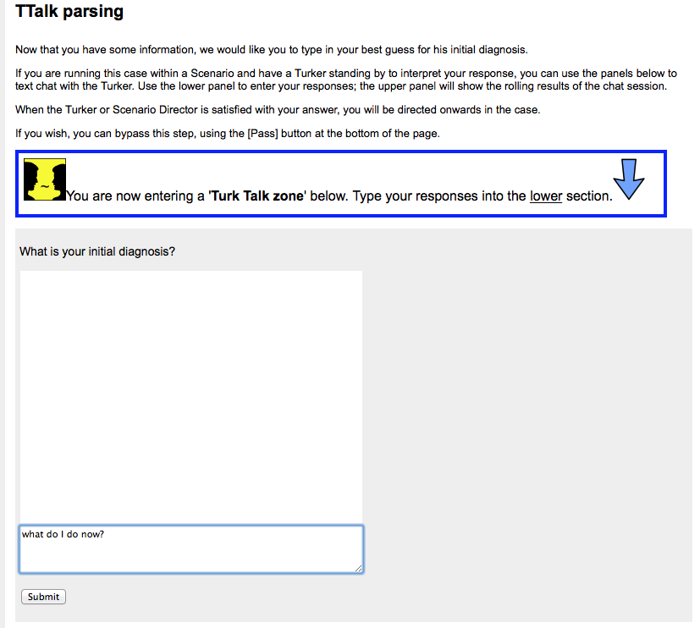
Figure 5: remind users to enter text in the lower portion of the column
When the learner clicks [Submit], the message is sent to the Turker.

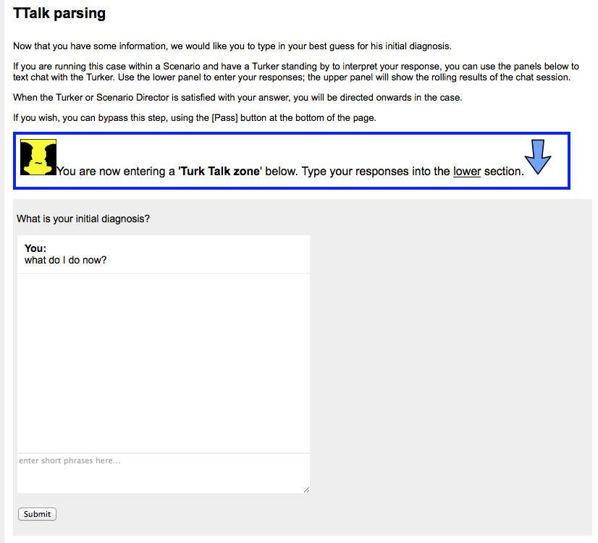
Figure 6: the sent message appears in the learner's chat column
…and the Turker then sees this text in the learner’s column…

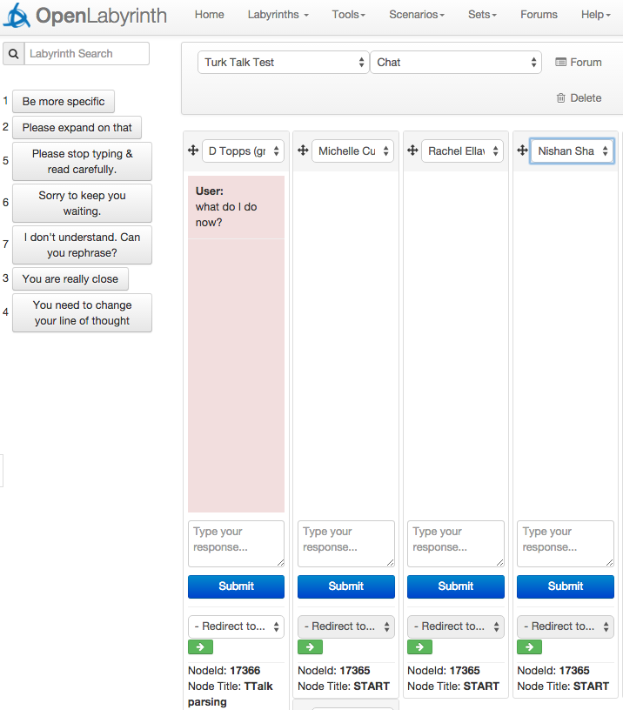
Figure 7: Scenario Director's view, showing activity in column 1
Note that this column goes pink to draw attention to waiting input. The Turker types their response just below that column…

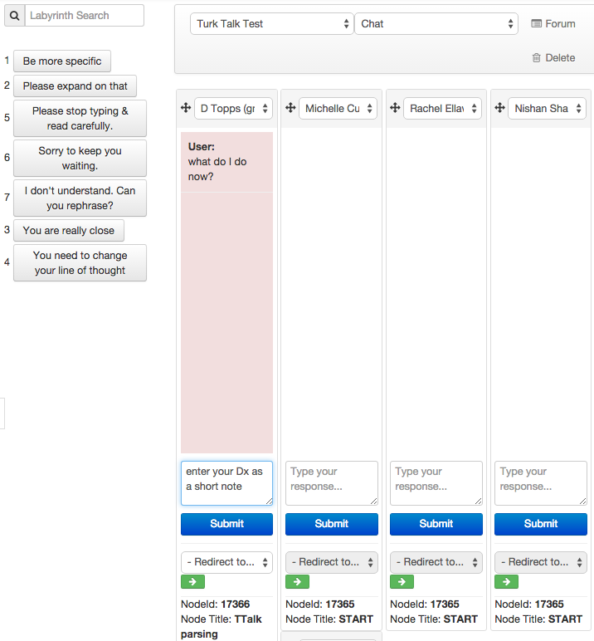
Figure 8: showing where the facilitator types their questions and responses to the learner
…and this is sent back to the learner when the Turker clicks the blue [Submit] button for that column.

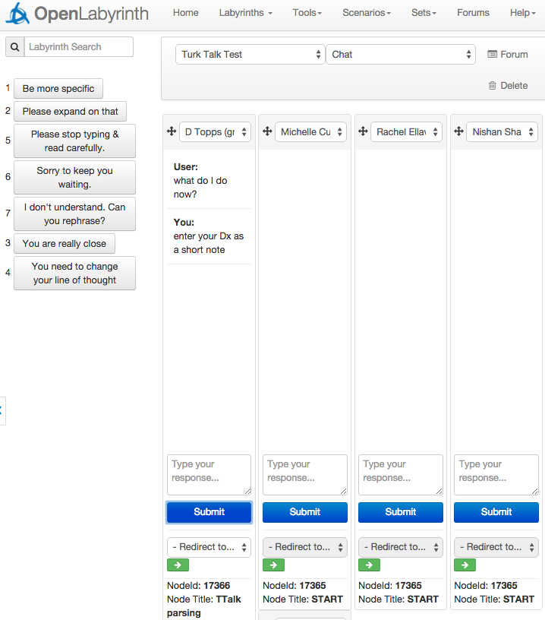
Figure 9: column 1 shows the new response and the pink color is cleared.
…at which point, the column turns from pink to white again. And this is what the learner now sees on their screen…

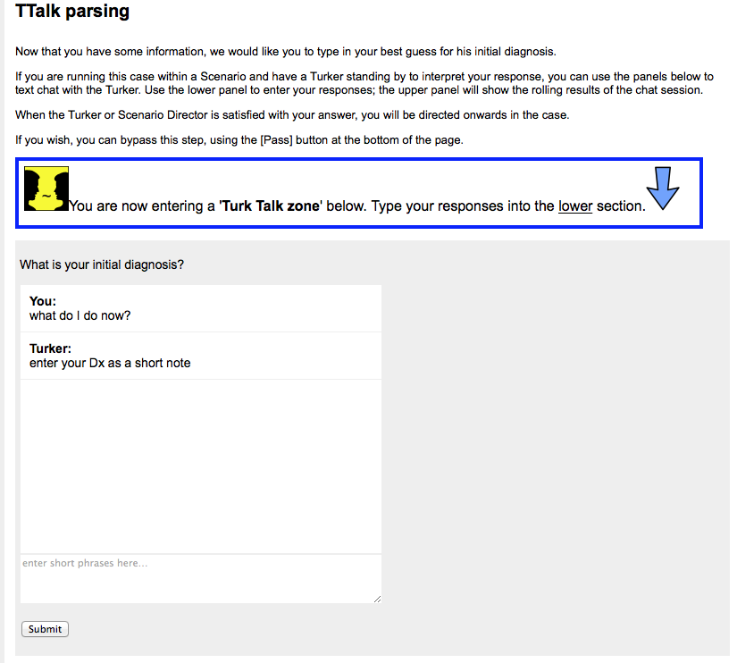
Figure 10: what the learner sees when the facilitator replies
Now, on this next diagram, we have four learners all on the same first Turk Talk node…

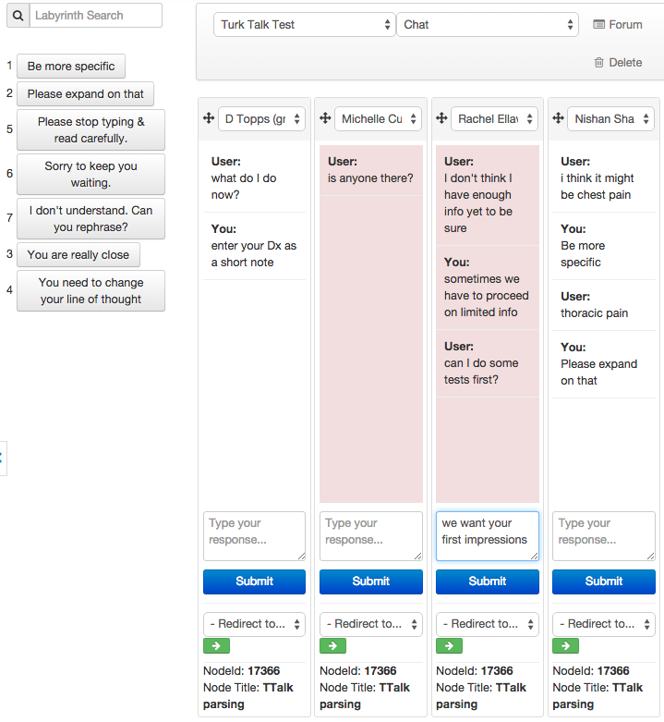
Figure 11: showing conversations with four users.
You will notice that the middle two learners are waiting for responses from the facilitator. Column 3 has a response that is just about to be sent out by the facilitator

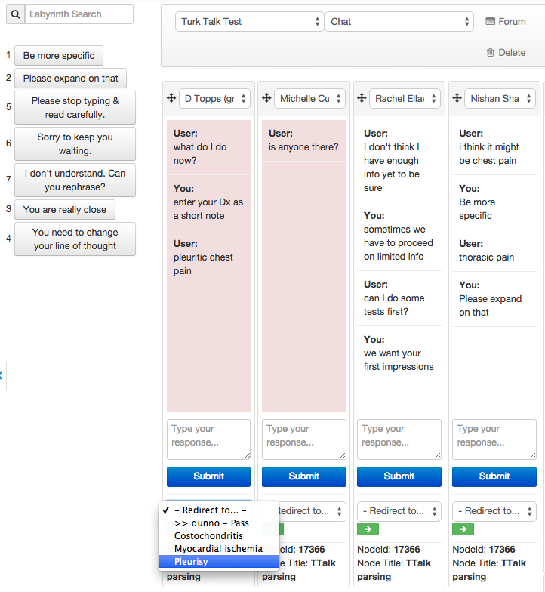
Figure 12: showing the dropdown list of target nodes that the facilitator can redirect towards.
Now column 1 has responded with an answer that is close enough and the Turker is about to redirect them onwards to the node titled ‘Pleurisy’, using the dropdown list of target nodes available at that point. If you refer back to the concept map at the top of this document, you will see the Nodes that are reachable from the ‘TTalk parsing’ node, namely ‘>> dunno – Pass’ (in pink), ‘Costochondritis’, ‘Myocardial ischemia’ and ‘Pleurisy’, (all in pale yellow). Because the links to the latter three Nodes have been greyed out, they are not visible as options to the learner as direct links but are still available as directable pathways for the facilitator to send the Learner along.

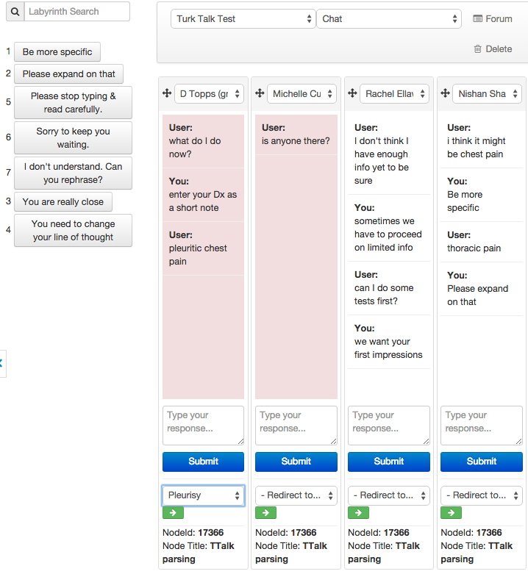
Figure 13: the target has been chosen for column 1 but not yet activated
The learner is not redirected until the Turker clicks the green arrow.

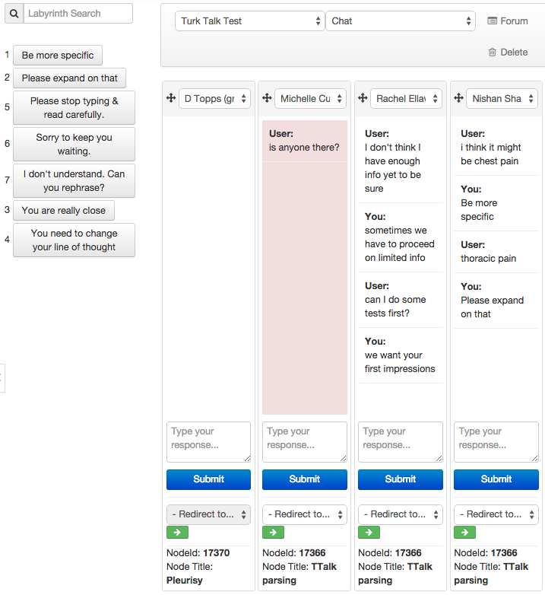
Figure 14: column 1 has now been moved onwards and the chat is cleared.
When the learner is moved on, as in Column 1, the chat column is cleared and the node location now shows the Turker that the learner is on the ‘Pleurisy’ node. And this next diagram is what the learner now sees as a new node, with a Turk Talk session:

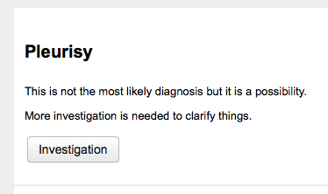
Figure 15: learner's view once redirected onwards
It is important to provide your facilitators, Turkers and Scenario Directors with a script that illustrates these pathways and what are considered to be acceptable answers.

See Turker Script for Scenario 95a.docx

