# Supplementary Results

# Socioeconomic results

Overall, 25.3% of households in our target population (i.e., excluding inland villages) were sampled (Table S1). Sampling was fairly balanced across habitats and geographic regions (24% of total households in coastal habitat, 31% in island, 24% in mangrove; 32% of households in northern region, 26% in central region, and 19% in southern region). The total number of households in 2010 was based on censuses and surveys undertaken in 2006 across Velondriake’s 24 villages, which estimated a population size of 5,925 in 1,243 households [1,2]. Assuming a population growth of 2.95% [3] and using information from key informant interviews about household relocations, the total population in 2010 was 7,563 in 1,354 households; 1,186 excluding inland villages (applying a stratum-specific average household size that ranged from 4.64 to 7.71 with a mean of 5.58, as determined by this survey) (Table S2).

Households are poor, and as expected there is variation between regions and habitats (Table S3). Figures in the table are expressed in Malagasy Ariary (MGA) the official currency; according to the World Bank, 1 USD = 2,025 MGA in 2011, and $1 PPP = 1,142 MGA.

Per capita income is thus well below the $2 per day PPP poverty line in every quadrant except for island villages (Table S4), and across all quadrants, 81% of households lived below $2 per person per day. Households were highly dependent on fishing and gleaning for their income (average 82% of household income), and on other natural resource-dependent activities, such as tourism, lime or charcoal production, mariculture, or the curio trade (an additional 4% of household income).

Few households ate octopus, on average, only 2% of a household’s weekly meals featured octopus.

Supplementary Tables:

**Table S1. Estimated population and number of households and household survey sample size by stratum**

|  |  |  |  |  |
| --- | --- | --- | --- | --- |
| Region | Estimated Population | Estimated # of Households | Household Survey Sample | % Sampled |
| North Island | 758 | 156 | 37 | 23.7% |
| North Coastal | 631 | 135 | 40 | 29.6% |
| North Mangrove | 489 | 74 | 40 | 54.1% |
| Central Island | 433 | 83 | 37 | 44.6% |
| Central Coastal | 1926 | 280 | 42 | 15.0% |
| Central Mangrove | 151 | 24 | 23 | 95.8% |
| South Coastal \* | 471 | 94 | 40 | 42.6% |
| South Mangrove | 1,800 | 342 | 42 | 12.3% |
| **Total** | **6,659** | **1,188** | **301** | 25.3% |
| Inland † | 904 | 168 | - |  |

\* No South-Island villages exist.

† Excluded from survey but within Velondriake’s boundaries.

**Table S2. Fishers’ octopus sale prices**

|  |  |  |  |  |  |  |  |
| --- | --- | --- | --- | --- | --- | --- | --- |
| **Year** | **Northern** | **Central** | **Southern** | **Average** | **CPI** | **Average** | **Average** |
| (MGA / kg) | (MGA / kg) | (MGA / kg) | (nominal MGA / kg) | (%) | (2011 MGA / kg) | ($ 2011 PPP / kg) |
| 2003 |  | 400 |  | 400 | 2.8 | 867 | 0.76 |
| 2004 |  | 800 |  | 800 | 14.3 | 1,687 | 1.48 |
| 2005 |  | 1,000\* |  | 1,000 | 18.3 | 1,845 | 1.62 |
| 2006 | 2,000 | 1,300 |  | 1,650 | 11.5 | 2,573 | 2.25 |
| 2007 | 1,600 | 1,300 | 1,200 | 1,367 | 9.6 | 1,911 | 1.67 |
| 2008 | 1,000 | 1,000 | 1,200† | 1,067 | 8.9 | 1,361 | 1.19 |
| 2009 | 1,000 | 1,000 | 1,000 | 1,000 | 8.4§ | 1,172 | 1.03 |
| 2010 | 1,000 | 1,000 | 1,000 | 1,000‡ | 8.1§ | 1,081 | 0.95 |
| 2011 | 1,000 | 1,000 | 1,000 | 1,000‡ |  | 1,000 | 0.88 |
|  |  |  |  |  | **Mean** | **1,500** | **1.31** |

\* Price rose to 1,200 MGA at some point during year

† Price rose to 1,500 then dropped to 1,000 during the year

‡ In 2009 and 2010, octopuses over 2 kg caught on the opening day of the closure were worth 1,400 MGA a kilogram

§ Since our initial analysis (2011), these numbers have been retro-actively updated to 9.2 and 9.3, respectively. Our analysis reflects the 2011 numbers shown here.**Table S3. Village characteristics: stratum, population, and households**

|  |  |  |  |  |  |  |
| --- | --- | --- | --- | --- | --- | --- |
| **Village name** | **Habitat** | **Region** | **Population 2006** | **# HH 2006** | **Population 2010** | **# HH in 2010** |
| *Ambalorao* | *Inland* | *South* | *105* | *14* | *118* | *22* |
| *Ankilimalinike* | *Inland* | *South* | *84* | *15* | *95* | *18* |
| *Befandefa* | *Inland* | *South* | *614* | *146* | *691* | *128* |
| Ankitambagna | Coastal | South | 86 | 16 | 97 | 19 |
| Tampolove | Coastal | South | 311 | 61 | 350 | 70 |
| Tsimivolo | Coastal | South | 21 | 3 | 24 | 4 |
| Agnolignoly | Mangrove | South | 234 | 50 | 263 | 49 |
| Ampasimara | Mangrove | South | 125 | 25 | 141 | 26 |
| Ankindranoke | Mangrove | South | 448 | 85 | 504 | 93 |
| Lamboara | Mangrove | South | 526 | 106 | 612 | 122 |
| Vatoavo | Mangrove | South | 249 | 52 | 280 | 50 |
| Ampasilava | Coastal | Central | 321 | 63 | 509 | 96 |
| Andavadoaka | Coastal | Central | 1,220 | 233 | 1,419 | 184 |
| Andambatihy | Island | Central | 72 | 16 | 173 | 37 |
| Nosy Hao | Island | Central | 259 | 62 | 86 | 16 |
| Nosy Mitata | Island | Central | 131 | 25 | 39 | 7 |
| Nosy Ve | Island | Central | 119 | 22 | 134 | 23 |
| Antsatsamoroy | Mangrove | Central | 90 | 14 | 101 | 16 |
| Antseranangy | Mangrove | Central | 44 | 7 | 50 | 9 |
| Ambolimoke | Coastal | Northern | 89 | 20 | 100 | 18 |
| Bevato | Coastal | Northern | 472 | 93 | 531 | 117 |
| Andragnombala | Island | Northern | 150 | 27 | 169 | 35 |
| Nosy Be | Island | Northern | 523 | ND | 589 | 121 |
| Belavenoke | Mangrove | Northern | 435 | 88 | 489 | 74 |
| **Sampled Velondriake**  **(excluding inland)** | | | **5,925** | **1,068** | **6,659** | **1,186** |
| **All Velondriake (including inland)** | | | **6,728** | **1,243** | **7,563** | **1,354** |

**Table S4. Average household incomes across regions and habitats (2011 MGA per week)**

|  |  |  |  |  |
| --- | --- | --- | --- | --- |
|  | Coast | Island | Mangrove | **Average** |
| North | 44,869 | 90,597 | 59,541 | 67,387 |
| Central | 82,467 | 70,680 | 58,290 | 78,440 |
| South | 53,546 | NA | 40,358 | 43,201 |
| **Averagea** | 73,094 | 83,855 | 45,076 | **62,111** |

aAverage is based on a number of household-weighted average.

**Table S5. Average daily per capita income across regions and habitats (2011 PPP per person per day)**

|  |  |  |  |  |
| --- | --- | --- | --- | --- |
|  | Coast | Island | Mangrove | Average |
| North | 2.05 | 3.16 | 1.42 | 2.34 |
| Central | 1.71 | 2.06 | 1.45 | 1.75 |
| South | 1.51 | NA | 1.09 | 1.18 |
| Averageb | 1.74 | 2.76 | 1.18 | **1.72** |

bAverage is based on a population-weighted average.

Supplementary Figures:

**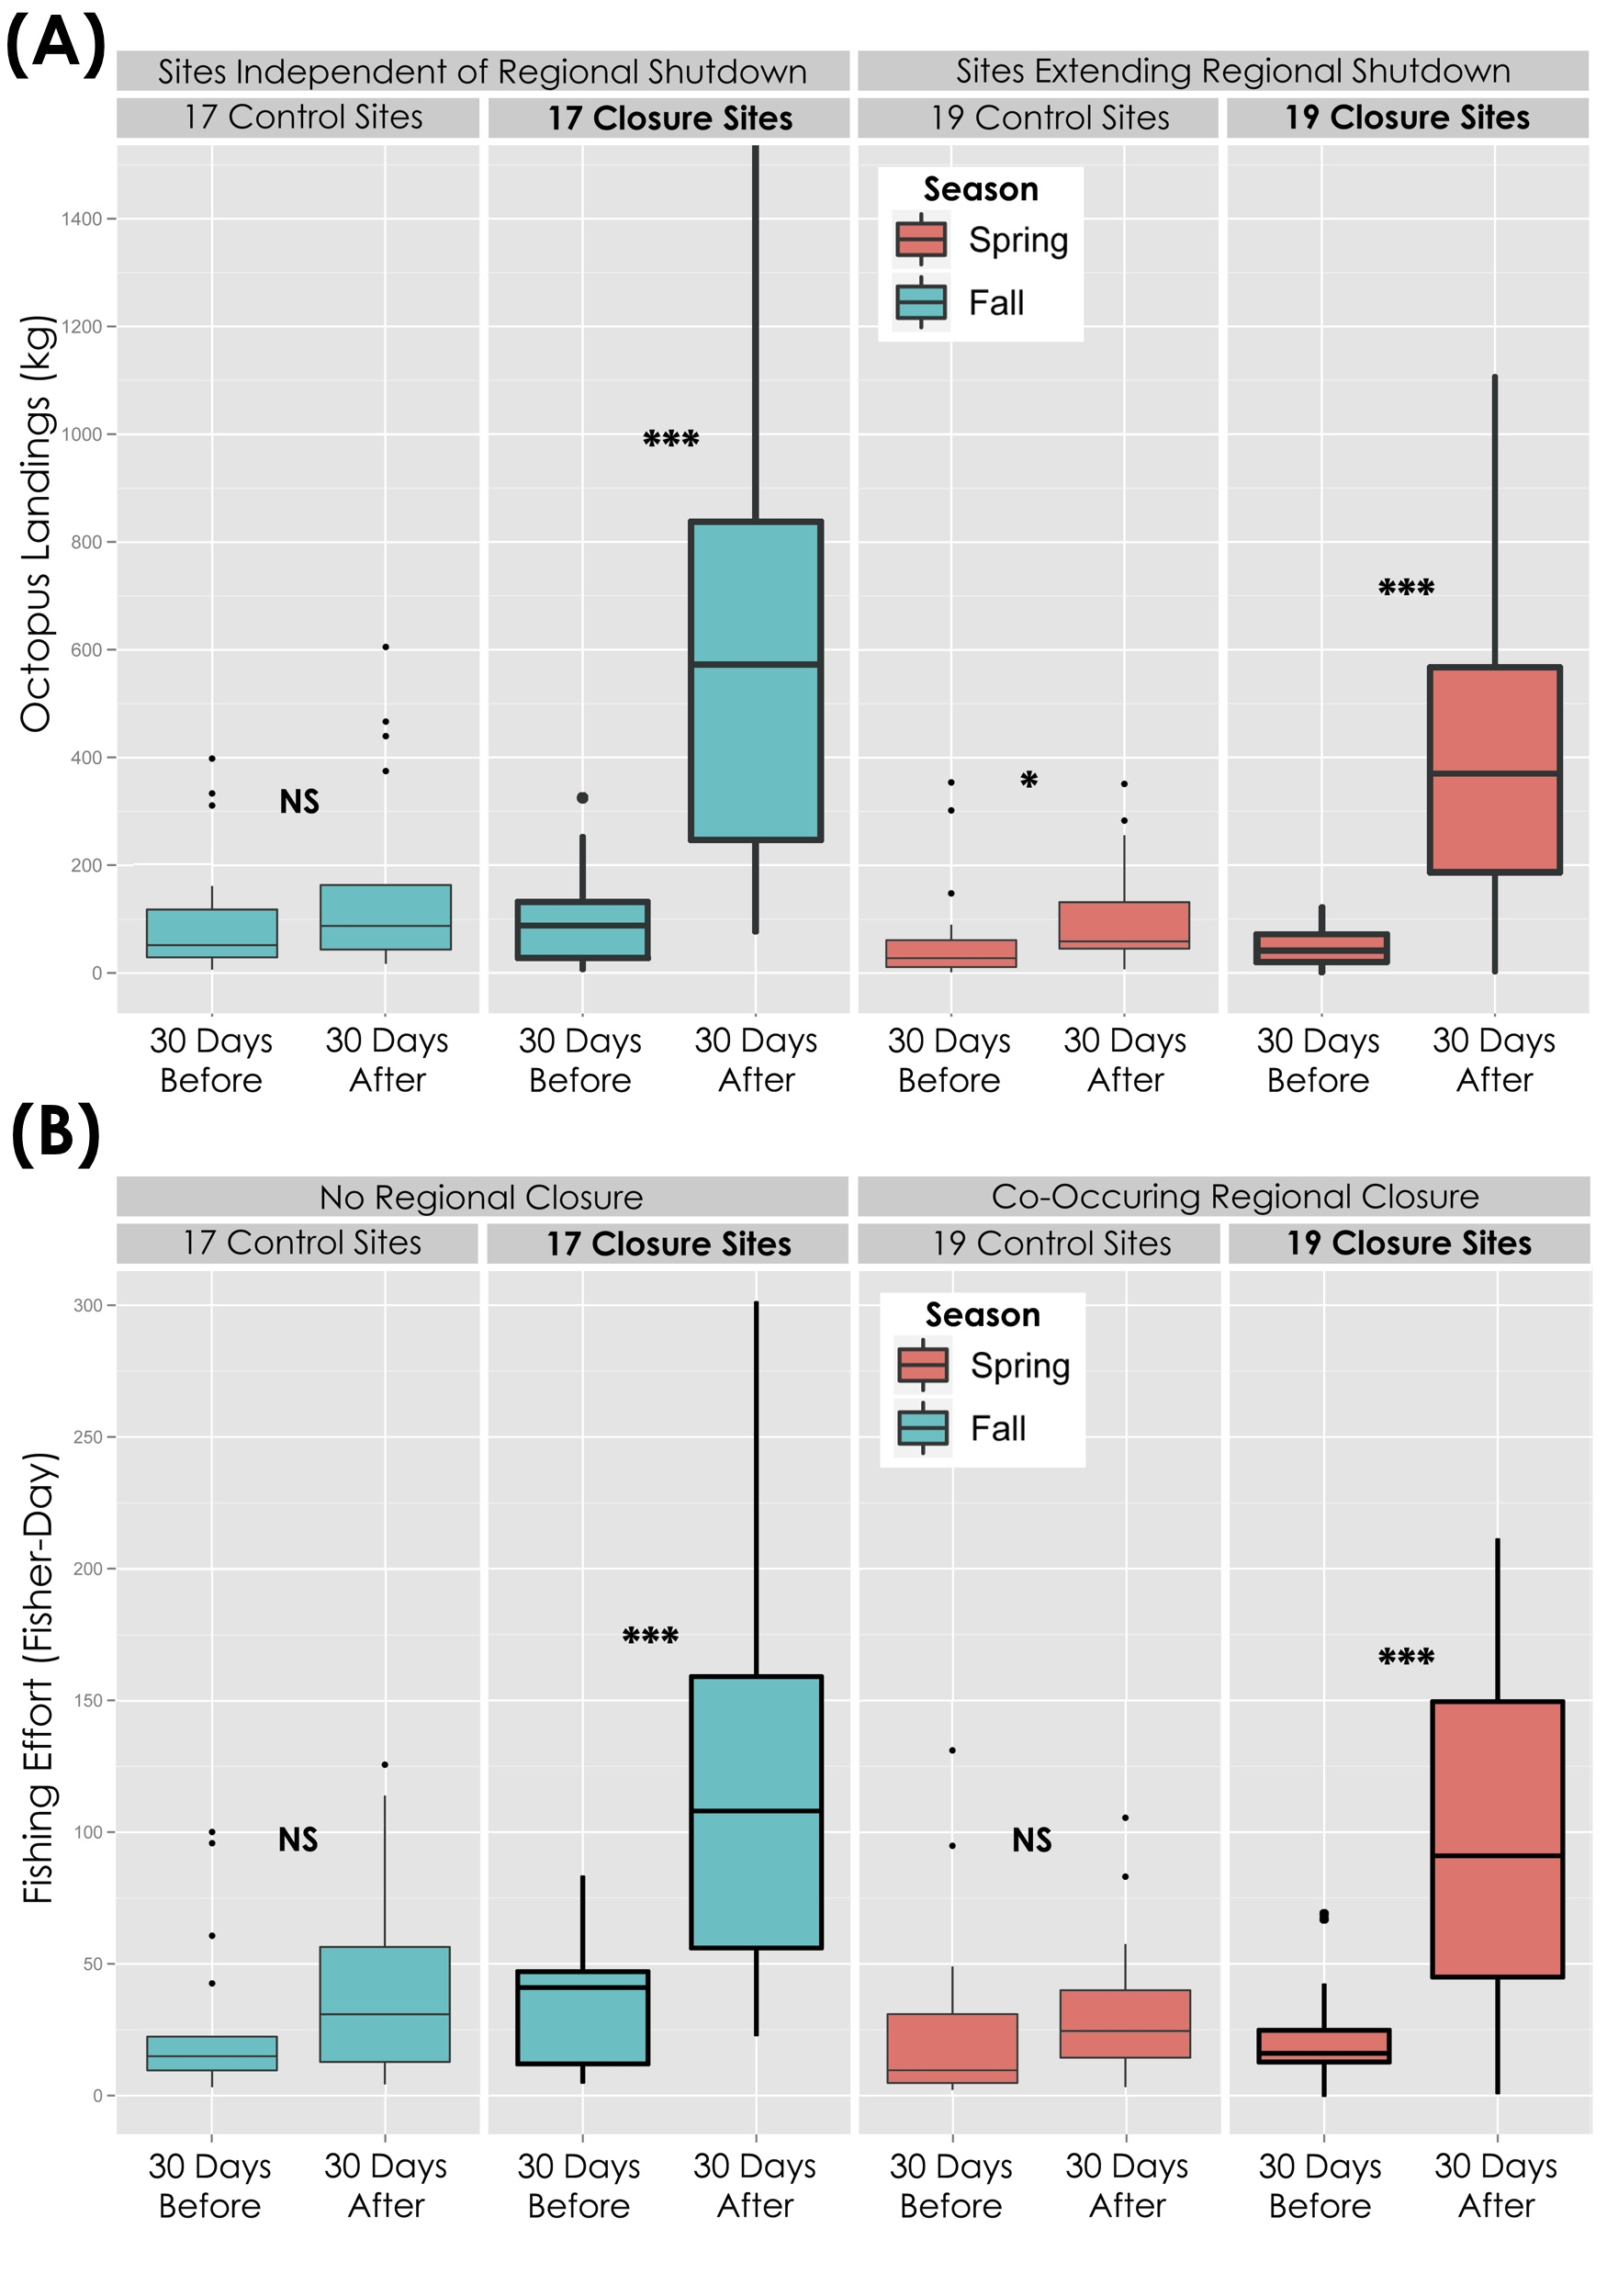**

**Figure S1.** Site-level (a) octopus landings (kg) and (b) fishing effort (fisher-days), 30 days before and after closure at closed sites and paired control sites. Data are separated by season, thus separating those closures that occurred independently of a regional fishery shutdown (“no ban”, 17/36), and those that extended the shutdown (“ban”, 19/36). Significance indicators show distinctions between a particular group and its “before” group comparison, independent contrasts from linear mixed models. NS = Not Significant; \*=p<0.05; \*\*\* = p < 0.001. Seasons indicate timing of closure reopening, Spring = February-May, Fall = June-September.

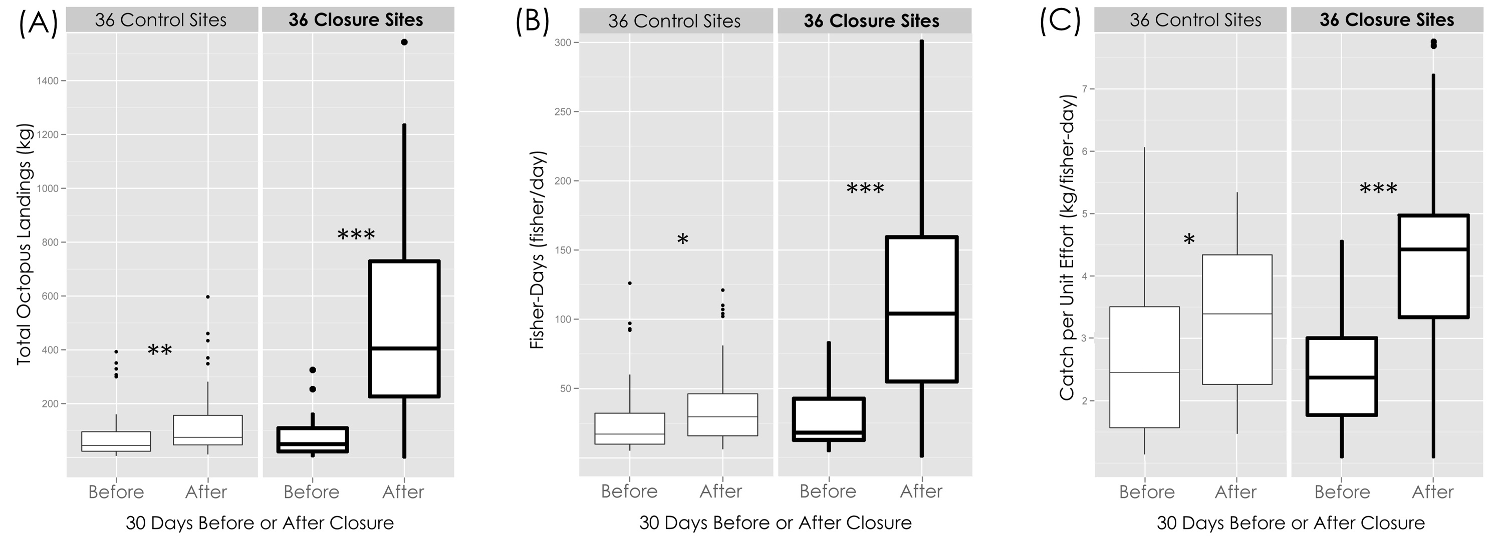

**Figure S2.** Site-level (a) octopus landings (kg), (b) fishing effort (fisher-days), and (c) catch-per-unit effort (kg/fisher-day), 30 days before and after closure at closed sites and paired control sites. Data are aggregated across season/fishery shutdown. Significance indicators show distinctions between a particular group and its “before” group comparison, independent contrasts from linear mixed models. NS = Not Significant; \*=p<0.05; \*\*=p<0.01; \*\*\* = p < 0.001.

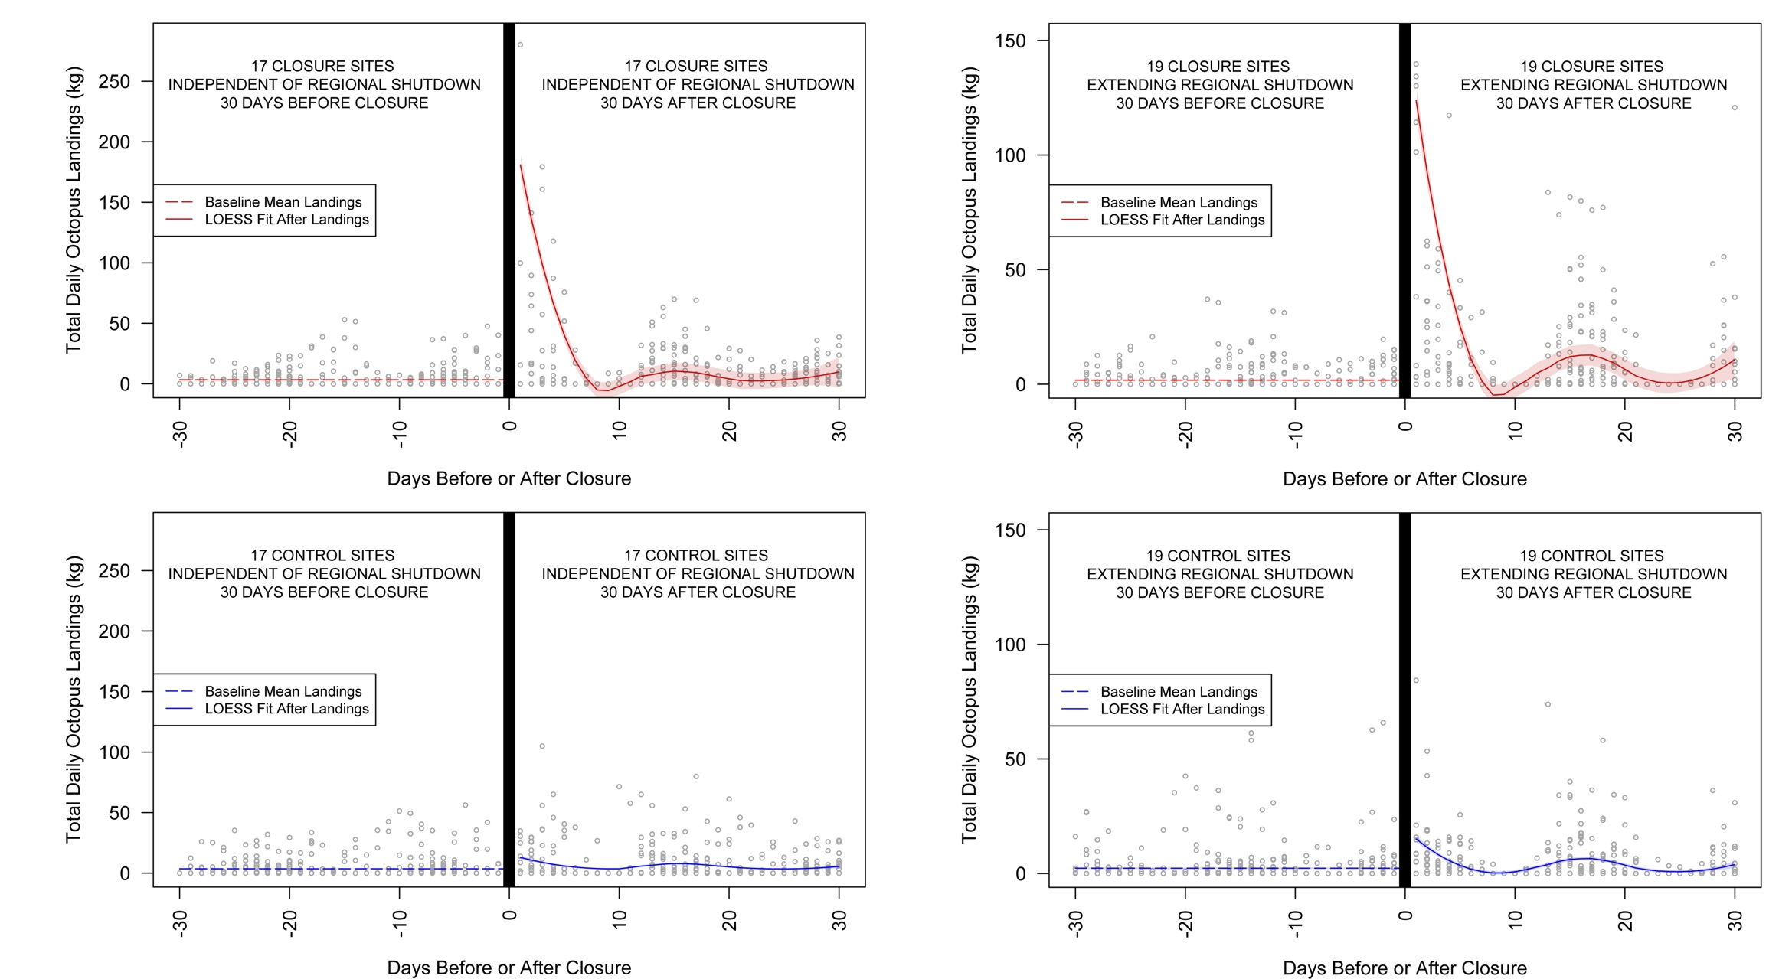

**Figure S3.** Site-level octopus landings (kg) 30 days before and after closure at closed sites (upper, red) and paired control sites (lower, blue). Data are separated by season, thus separating those closures that occurred independently of a regional fishery shutdown (“no ban”, 17/36), and those that extended the shutdown (“ban”, 19/36). Raw daily totals are shown as gray points, with an overall mean and 95% CI shown as a red/blue line ‘before’, and a LOESS fit with 95%CI shown ‘after’. Note that due to timing the opening with the low spring tide, data ‘after’ are in phase with tidal cycles, while those ‘before’ are not.

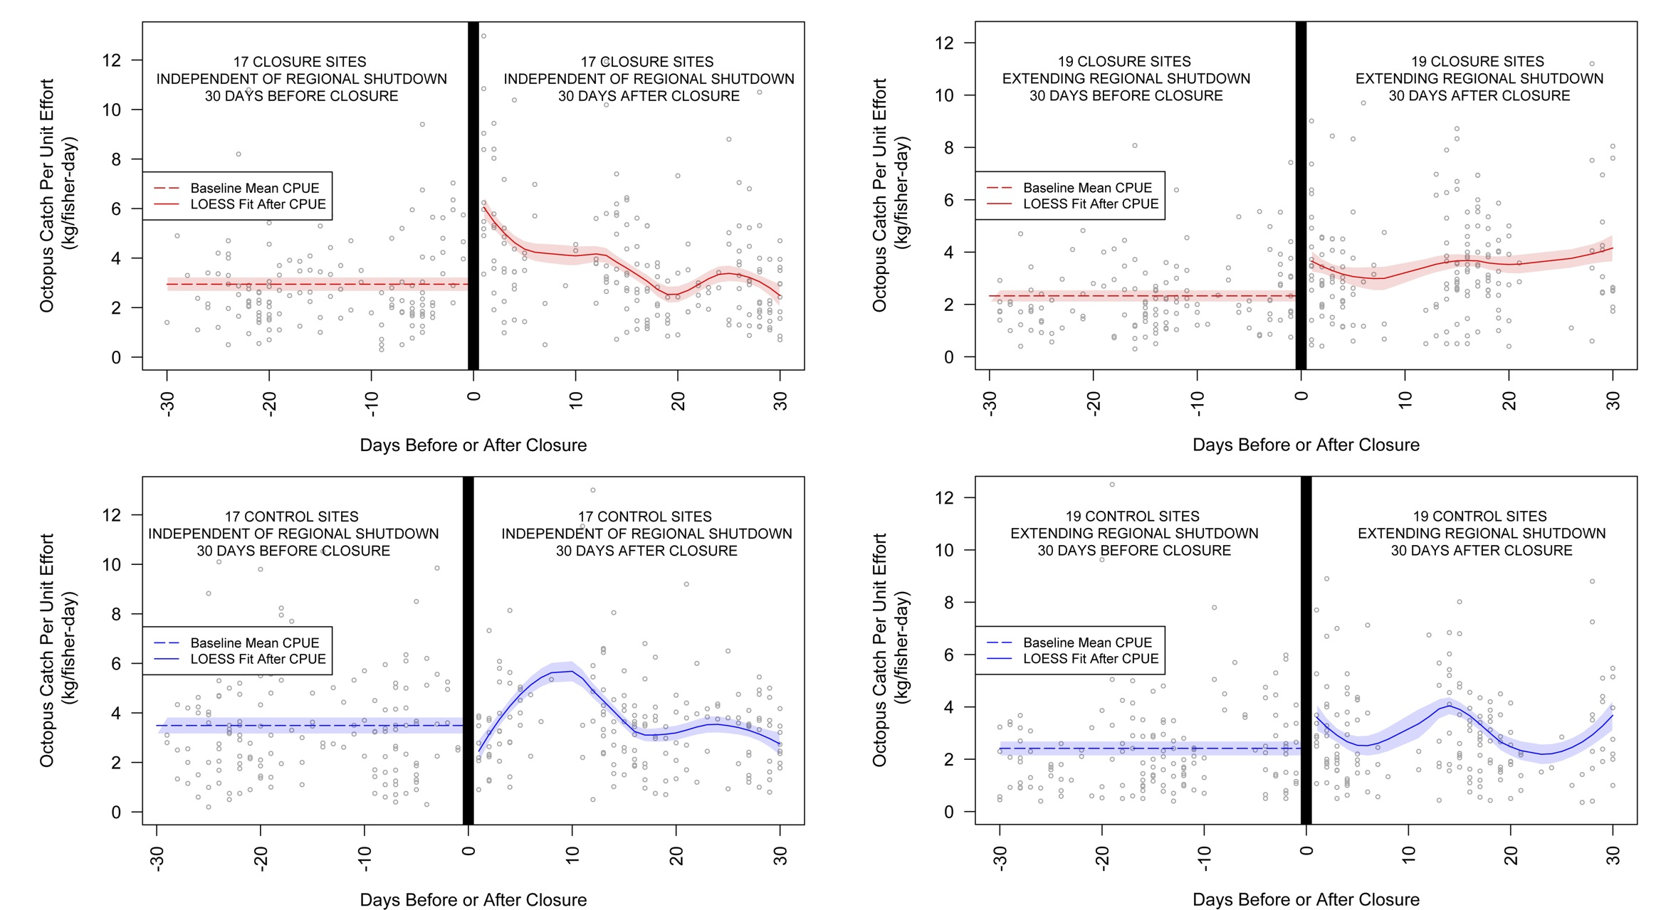

**Figure S4.** Site-level catch-per-unit-effort (kg/fisher-day) 30 days before and after closure at closed sites (upper, red) and paired control sites (lower, blue). Data are separated by season, thus separating those closures that occurred independently of a regional fishery shutdown (“no ban”, 17/36), and those that extended the shutdown (“ban”, 19/36). Raw daily totals are shown as gray points, with an overall mean and 95% CI shown as a red/blue line ‘before’, and a LOESS fit with 95%CI shown ‘after’. Note that due to timing the opening with the low spring tide, data ‘after’ are in phase with tidal cycles, while those ‘before’ are not.

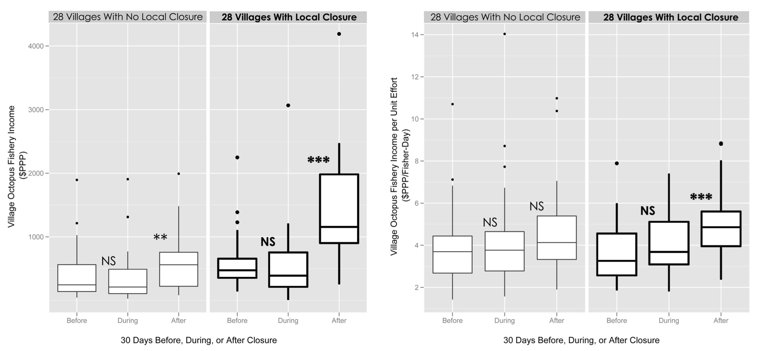

**Figure S5.** Total village-level octopus fishing income ($PPP), and village-level octopus fishing income per unit of fishing effort ($PPP/fisher-day) 30 days before, during, and after closures, at villages both with and without closures. The data depicted are from 28 closure periods showing closure-sponsoring villages and their paired control villages from 2004-2011. Data are aggregated by season. As “during” periods are not exactly 30 days, “during” values are scaled to a per-30-day measure. Significance indicators show distinctions between a particular group and its “before” group comparison, from linear mixed-effect model. NS = Not Significant; \* = p < 0.05; \*\* = p < 0.01; \*\*\* = p < 0.001.

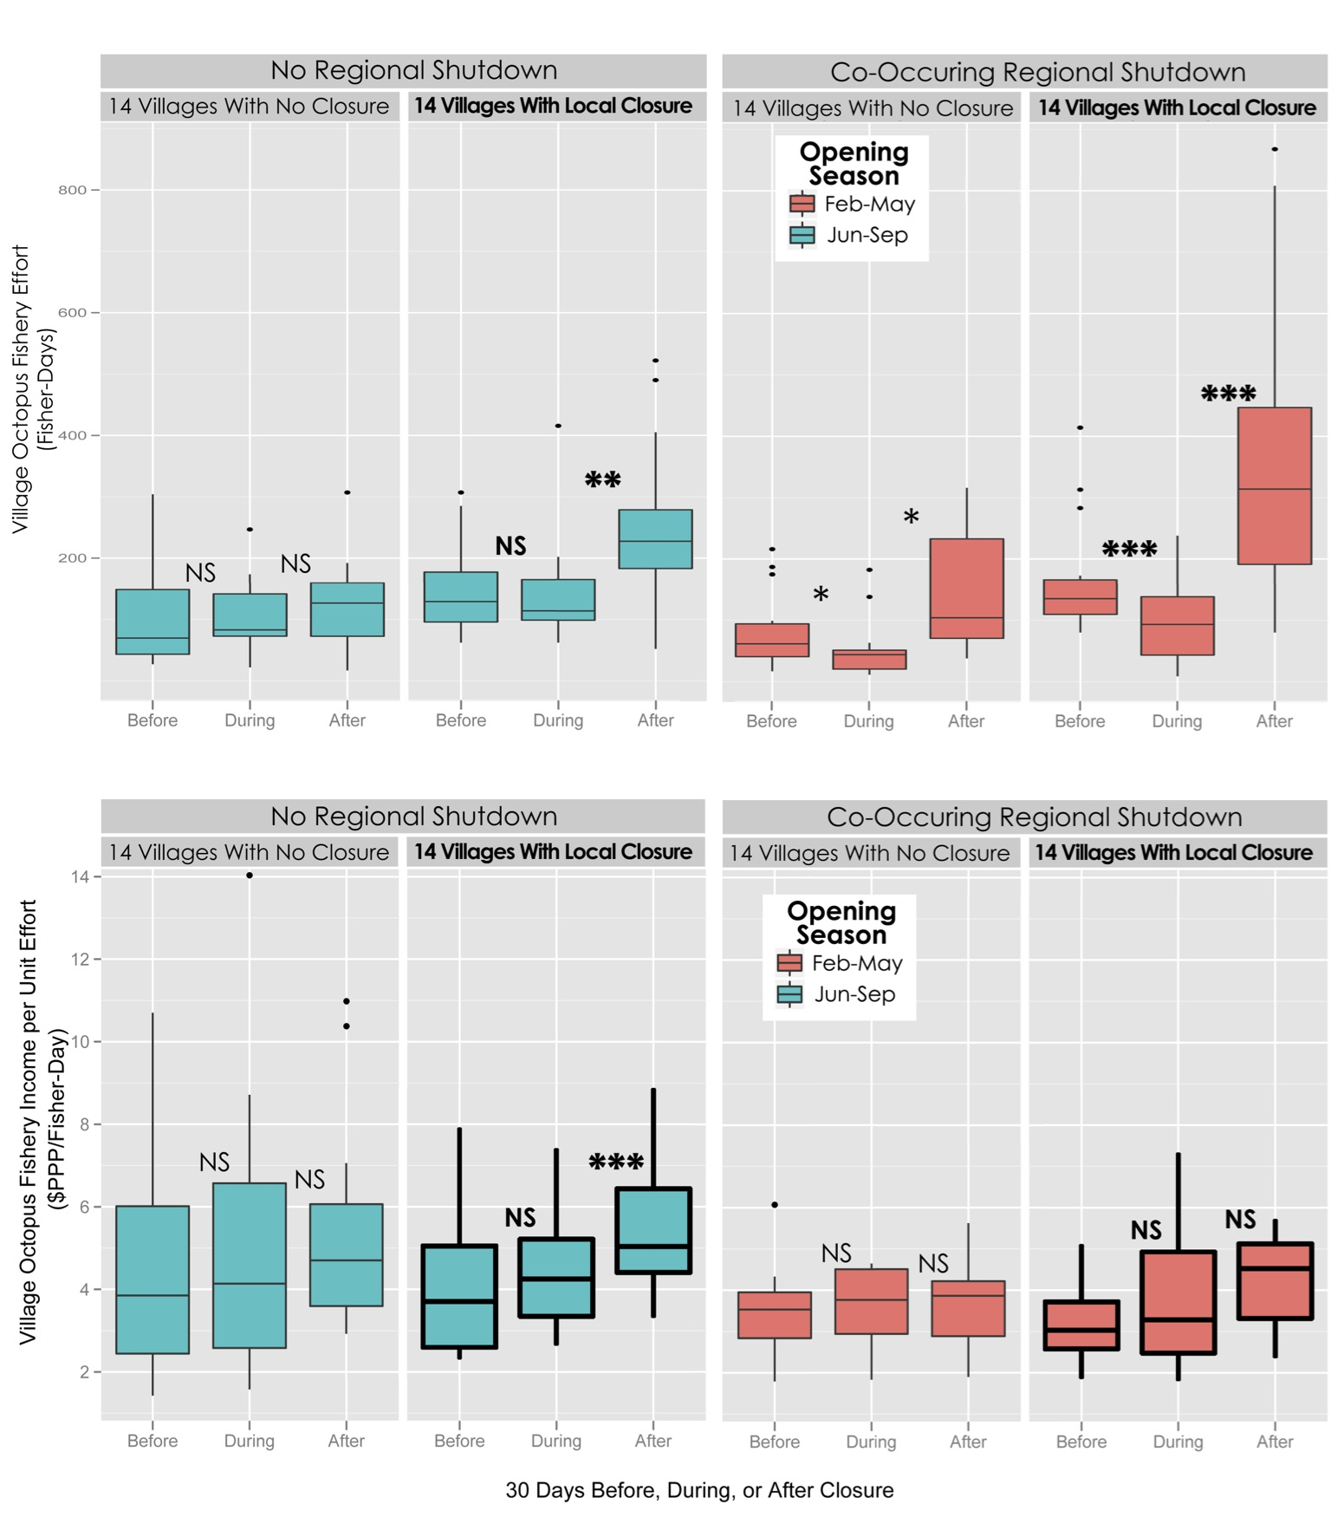

**Figure S6.** Total village-level octopus fishing effort (fisher-days) and village-level octopus fishing income per unit effort ($PPP/fisher-day) 30 days before, during, and after closures, at villages both with and without closures. The data depicted are from 28 closure periods showing closure-sponsoring villages and their paired control villages from 2004-2011. Data are separated by season, thus separating those closures that extended a regional fishery shutdown, and those that occurred independently of the shutdown. As “during” periods are not exactly 30 days, “during” values are scaled to a per-30-day measure. Significance indicators show distinctions between a particular group and its “before” group comparison, from linear mixed-effect model. NS = Not Significant; \* = p < 0.05; \*\* = p < 0.01; \*\*\* = p < 0.001.

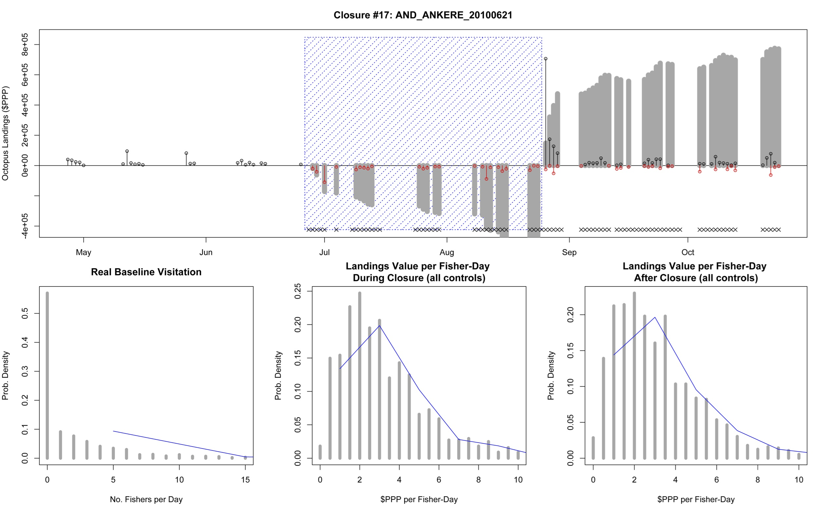

**Figure S7. Site-base model example.** Here we plot an example of a single site in our site-based cost model, showing a timeline of the closure, with closure period (blue hatching), presence of fishing in nearby villages (x’s along bottom), actual recorded landings (i.e. closure ‘benefits’, black circles/bars), modeled foregone landings (i.e. closure ‘costs’, red circles/bars), and running sums (gray bars). Below we see the three distributions from which the counter-factual landings are simulated: the pattern of visitation at this site across the whole dataset (excluding data from closure and post-closure periods), and value-per-unit effort distributions both during and 60-days after the closure (again, excluding data from closure and post-closure periods).

**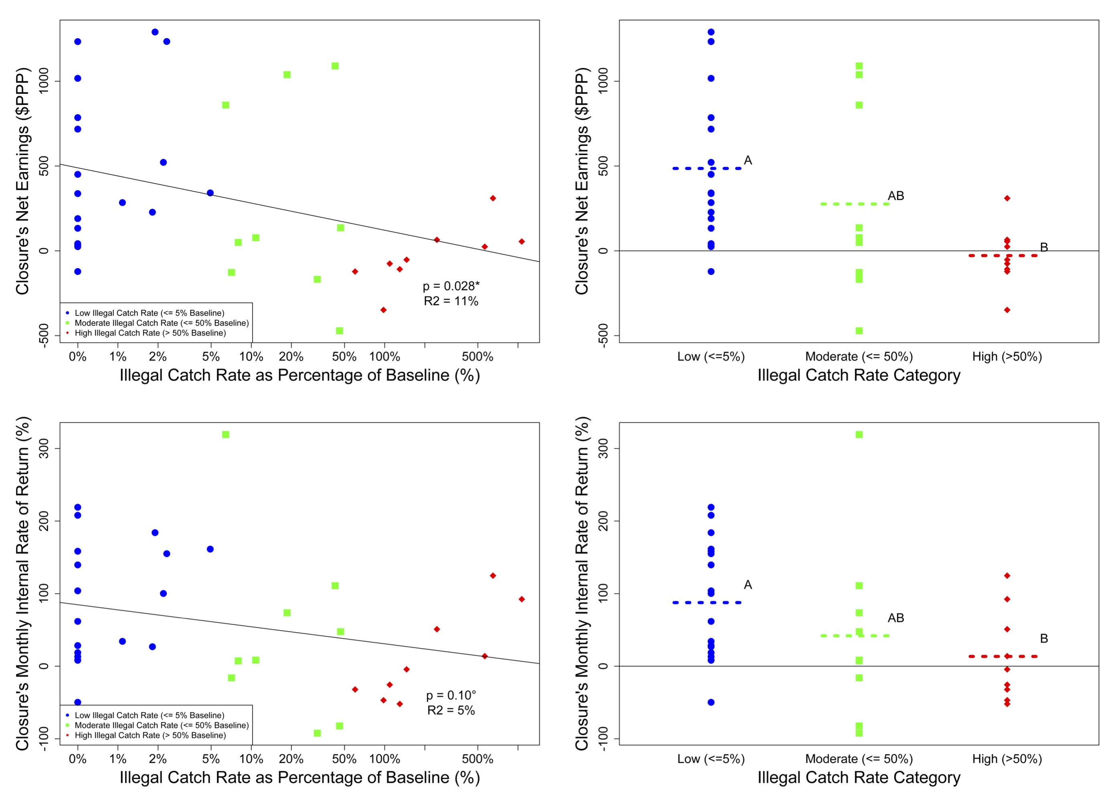Figure S8. Illegal Fishing Rate vs. NE & IRR.** Here we compare a site’s modeled Net Earnings and monthly IRR to Illegal Catch Rates expressed as reported landings from a closed site during the closure as a percentage of baseline landings during the 60 days before closure. Comparisons among both NE & IRR, and Illegal catch rate are shown both as continuous regressions, and across catch rate categories.

Macintosh HD:Users:TomOliver:Dropbox:BV_OctoFest_2014:Data:Raw:SettlementThoughts:Seasonality_NEW_SamplingNormalized_Settlement_0.33g.pdf

**Figure S9.** *Seasonality in Settlement and Catch-Per-Unit-Effort (CPUE)*. Here we plot frequency of octopus settlement (as back-calculated from individual mass at capture and a species-level growth curve) with Julian day, including data from 2004-2011 (blue bars). Overlaid on these data is a LOESS fit of seasonal CPUE variation with 95%CI (red lines), with closure sites removed. In green we show the timing of the annual regional fishery shutdown, which began in 2006. Note the increase in CPUE variability during this more data-poor time. Below we plot the cross-correlation of these trends, showing a maximal correlation at 159 days.

**References:**

1. Epps M (2008) A Socioeconomic Baseline Assessment: Implementing the socioeconomic monitoring guidelines in southwest Madagascar. Blue Ventures Conservation Report.

2. Langley J, Harris A, Nihalani N (2006) The 2004-2005 census of Andavadoaka, southwest Madagascar. Blue Ventures Conservation Report. 29 pp.

3. INSTAT (2012) Pauvreté à Madagascar. Antananarivo, Madagascar: INSTAT.