Supporting Information for

The Blurred Line between Form and Process: a Comparison of Stream Classification Frameworks
Alan Kasprak*^{,1}, Nate Hough-Snee*^{,1,2}, Tim Beechie³, Nicolaas Bouwes⁴, Gary Brierley⁵, Reid Camp^{1,4}, Kirstie Fryirs⁶, Hiroo Imaki⁷, Martha L. Jensen¹, Gary O’Brien¹, David L. Rosgen⁸, and Joseph M. Wheaton^{1,2}
¹Department of Watershed Sciences, Utah State University, Logan, UT 84322-5210, USA
²Ecology Center, Utah State University, Logan, UT, 84322-5210, USA
³Watershed Program, Fish Ecology Division, Northwest Fisheries Science Center, NOAA Fisheries, Seattle, WA 98112, USA
⁴Eco Logical Research, Providence, UT, USA
⁵School of Environment, University of Auckland, New Zealand
⁶Department of Environmental Sciences, Macquarie University, Sydney, Australia
⁷Pacific Spatial Solutions, Reston, VA, USA
⁸Wildland Hydrology, Fort Collins, CO, USA, 80524
*These authors made equal contributions to the manuscript.
akasprak@aggiemail.usu.edu; nate@natehough-snee

Contents of this file
Text S1
Figures S1 to S11
Tables S1 to S3
KMZ of Figure 2 Data

Introduction
This supporting information contains descriptions of the methods and requisite datasets used to complete river styles, natural channel classification, natural channel design, and statistical clustering used in the manuscript. It also contains graphical comparisons between the classification frameworks. Data used in the manuscript can be accessed at https://etal.egnyte.com/dl/jFf0eCZB5m. Note that any discrepancies between Natural Channel Classification in line and point data are the result of merging disparate linework datasets (NHD and NHD+) and are display artifacts only. Individual points have been checked for agreement with original NCC classification.

Text S.1. Statistical Classification Methods and Results Supplement
To classify streams of the John Day Basin, we used divisive clustering by partitioning around medoids to classify CHaMP reaches by their physical metrics. We opted to use divisive hierarchical clustering over hierarchical agglomerative clustering, because this approach initially takes into account the global distribution of the sample data. We grouped 33 unique stream reaches based on reach-level habitat attributes. A Euclidean distance matrix was calculated from the standardized data. This distance matrix was clustered into cluster configurations with 3-11 groups of reaches. These cluster solutions were assessed for their mean silhouette width and cluster uniqueness was verified using PERMANOVA models (Anderson, 2001) at an alpha of P < 0.05. The final cluster solution that we selected based on silhouette width and PERMANOVA models had four unique stream clusters. Clusters are summarized by channel attributes below in Table S.2. We validated channel attribute associations using principal components analysis (PCA) of the reach-level habitat attributes and fitting vectors of environmental variables over the PCA solution (Figure 3; Figure S5). We present the correlations between each channel form attribute and the principal components in Tables S.3 and S.4.

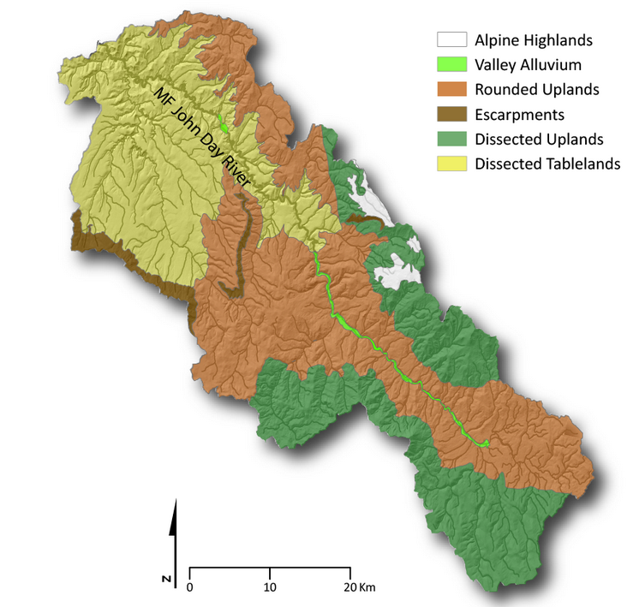
Figure S.1. Landscape units delineated as an early step in the River Styles Framework of Brierley and Fryirs (2005) as employed by (O’Brien and Wheaton, 2015).

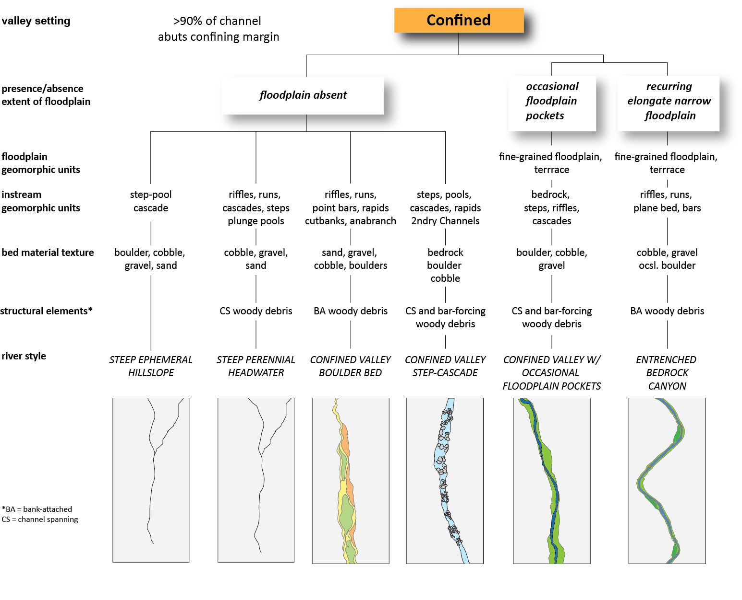
Figure S.2. River styles tree used to determine reach type for confined channels. Figure from O'Brien and Wheaton (2015).

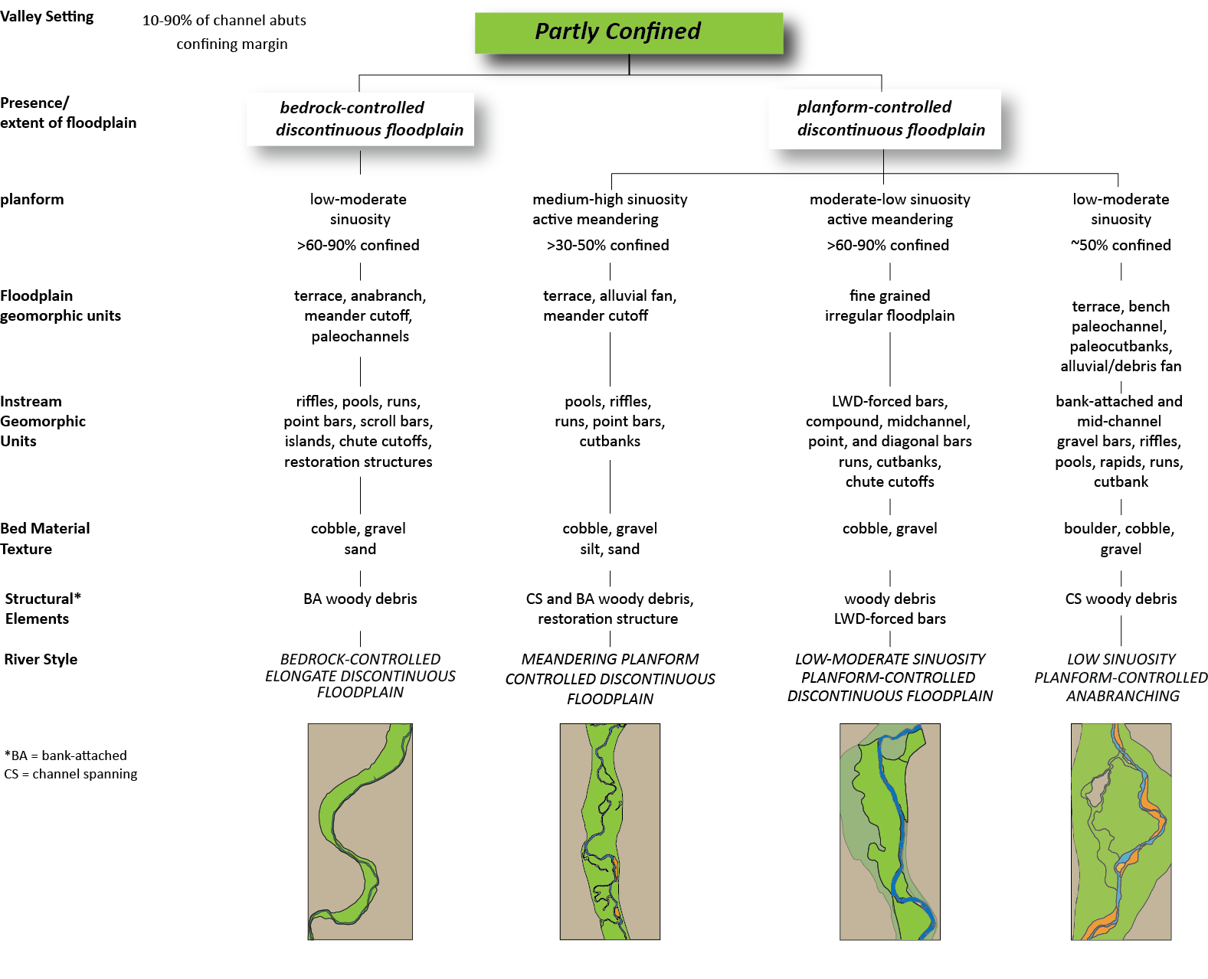
Figure S.3. River styles tree used to determine reach types for partly confined channels. Figure from O'Brien and Wheaton (2015).

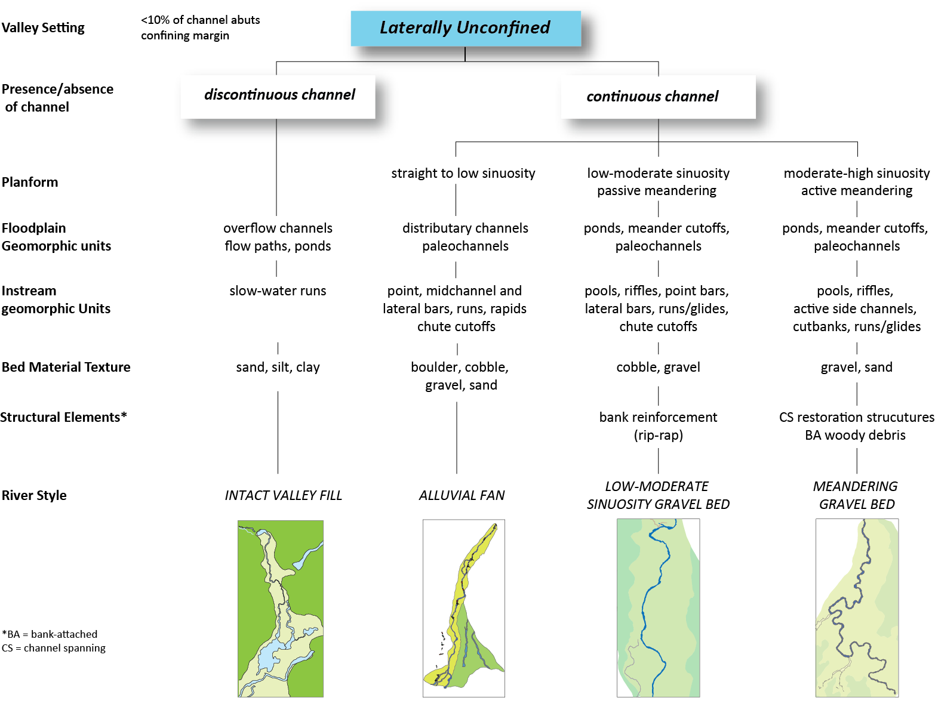
Figure S.4. River styles tree used to determine reach types for laterally unconfined channels. Figure from O'Brien and Wheaton (2015).

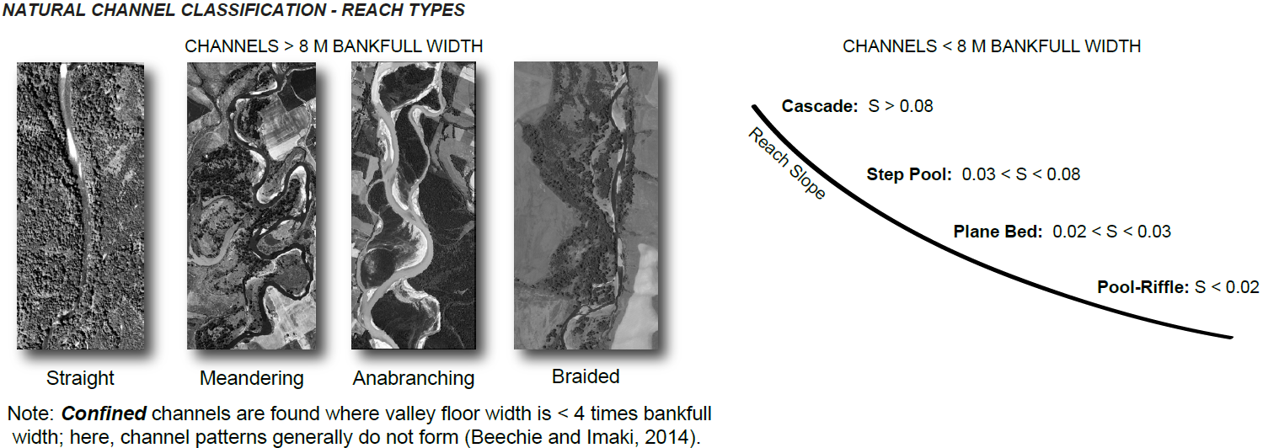

Figure S.5. The Natural Channel Classification framework used in identifying historic planforms of the Middle Fork John Day Watershed for the entire watershed stream network and CHaMP reaches. Modified from Beechie and Imaki [2014].

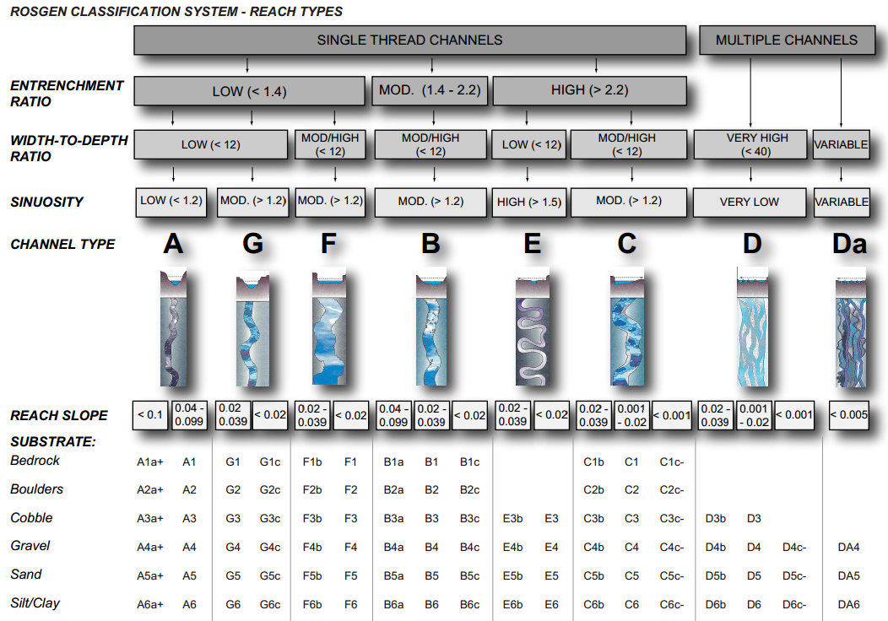

Figure S.6. Hierarchical tree used in the Rosgen Classification System (Rosgen, 1994; Rosgen and Silvey, 1996) to determine reach types at CHaMP reaches of the Middle Fork John Day River watershed.

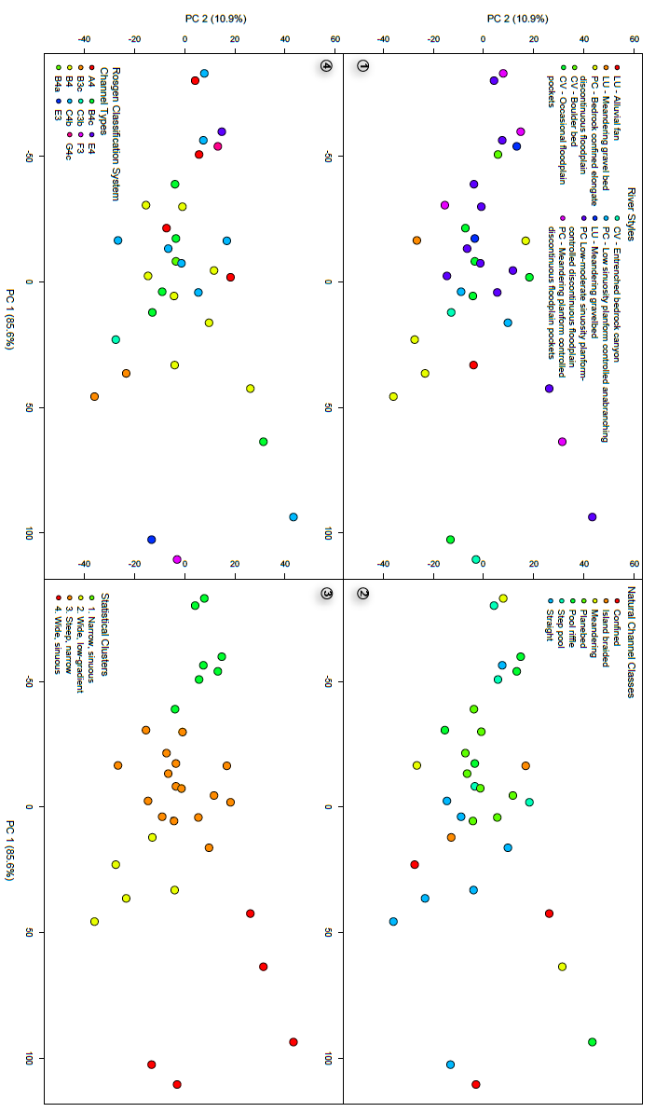
Figure S.7. PCA Ordination of the 33 CHaMP reaches, plotted by classification results from each framework. Clockwise from top left: River Styles, Natural Channel Classification, Rosgen Classification System, and Statistical Classification.

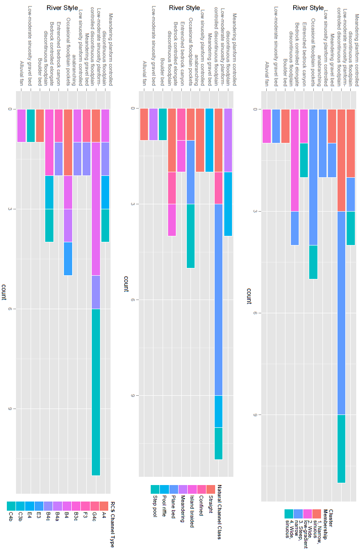
Figure S.8. Histograms of the number of CHaMP reaches classified into each level of each classification framework, grouped by River Styles. All classification level counts are presented from most confined (warm colors) to least confined (cool colors).
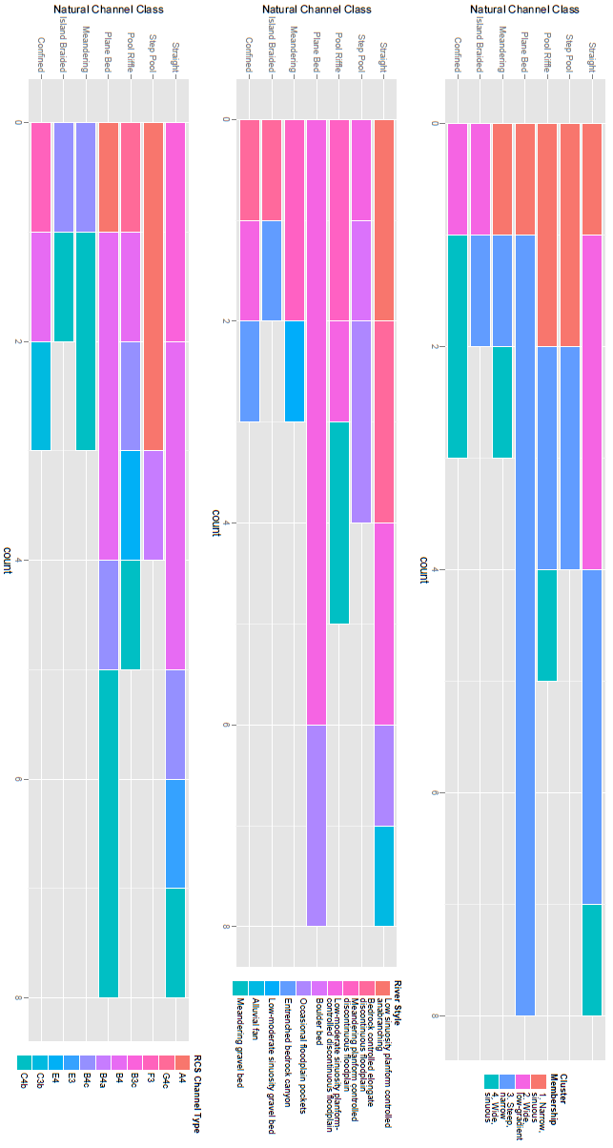

Figure S.9. Histograms of the number of CHaMP reaches classified into each level of each classification framework, grouped by Natural Channel Classification. All counts are presented from most confined (warm colors) to least confined (cool colors).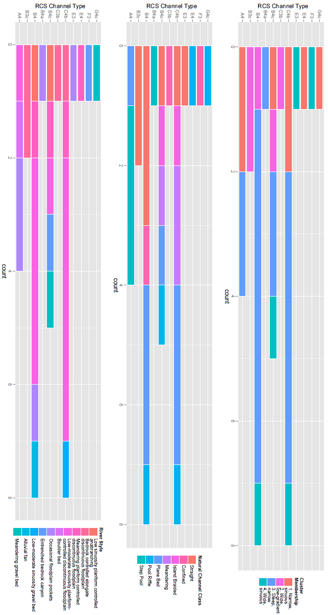
Figure S.10. Histograms of the number of CHaMP reaches classified into each level of each classification framework, grouped by Rosgen Classification System. All counts are presented from most confined (warm colors) to least confined (cool colors).

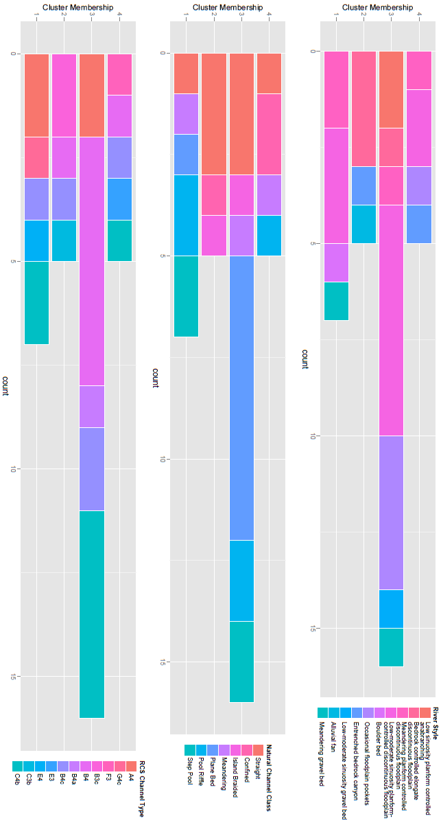
Figure S.11. Histograms of the number of CHaMP reaches classified into each level of each classification framework, grouped by statistical clustering. All counts are presented from most confined (warm colors) to least confined (cool colors).

Table S.1. Summarized channel metrics for each cluster derived from partitioning around medoids. Values are the mean value for each cluster.
Cluster | Bankfull width (m) | Sinuosity (%) | Gradient (%) | D16 (mm) | D50 (mm) | D84 (mm) | Wetted  Width (m) | Bankfull width to depth ratio
1 | 2.82 | 1.13 | 1.50 | 5 | 26 | 61 | 2.52 | 14.75
2 | 18.1 | 1.15 | 0.54 | 41 | 67 | 125 | 10.17 | 32.35
3 | 6.40 | 1.18 | 1.79 | 18 | 49 | 97 | 3.78 | 23.20
4 | 8.62 | 1.07 | 1.28 | 9 | 40 | 182 | 5.35 | 26.89

Table S.2. Principal component summary statistics include the PCA rotation for channel attributes (rows) by components (columns). The standard deviation, variance explained, and cumulative variance explained by each component are listed in bottom three rows.
Metric | PC1 | PC2 | PC3 | PC4 | PC5 | PC6 | PC7 | PC8
Bankfull width | 0.063 | -0.133 | 0.599 | -0.451 | -0.476 | -0.207 | 0.382 | 0.027
Sinuosity | -0.001 | 0.001 | -0.003 | -0.004 | -0.002 | 0.034 | 0.088 | -0.996
Gradient | -0.005 | 0.016 | -0.060 | 0.025 | 0.057 | -0.946 | -0.307 | -0.059
D₁₆ | 0.133 | -0.625 | -0.242 | 0.485 | -0.545 | -0.023 | 0.021 | 0.000
D₅₀ | 0.286 | -0.690 | -0.052 | -0.397 | 0.530 | 0.013 | -0.006 | 0.000
D₈₄ | 0.944 | 0.316 | -0.054 | 0.041 | -0.072 | 0.000 | -0.001 | -0.001
Wetted width | 0.035 | -0.081 | 0.321 | -0.157 | -0.225 | 0.246 | -0.865 | -0.068
Bankfull width to depth ratio | 0.072 | -0.093 | 0.686 | 0.614 | 0.369 | -0.024 | 0.052 | -0.001
Standard deviation | 47.904 | 17.071 | 7.328 | 4.547 | 3.406 | 0.989 | 0.604 | 0.116
Proportion  of variance explained | 0.858 | 0.109 | 0.020 | 0.008 | 0.004 | 0.000 | 0.000 | 0.000
Cumulative proportion of variance explained | 0.858 | 0.967 | 0.987 | 0.995 | 0.999 | 1.000 | 1.000 | 1.000

Table S.3. Structure correlations between principal components and channel attributes.
Metric | PC1 | PC2 | PC3
Bankfull width | 0.471 | -0.358 | 0.691
Sinuosity | -0.313 | 0.066 | -0.146
Gradient | -0.23 | 0.246 | -0.388
D₁₆ | 0.494 | -0.829 | -0.138
D₅₀ | 0.75 | -0.646 | -0.021
D₈₄ | 0.993 | 0.118 | -0.009
Wetted width | 0.486 | -0.405 | 0.691
Bankfull width to depth ratio | 0.494 | -0.225 | 0.717

