Convergent cross mapping algorithm
Consider time series of hypothetical variables X and Y. Convergent cross-mapping (CCM) employs state space reconstruction (SSR), thereby using time-lagged coordinates of each of these variables to produce shadow versions of their respective source manifolds. We will refer to these projection manifolds as M_{x} and M_{y}. To test whether X causes Y, CCM applies the following logic: Because manifold reconstruction preserves the Lyapunov exponents of the original system [18], if X causes Y, then time points that are close in M_{y} should also be close in M_{x}. Since M_{x} is constructed from lags of the observations of X, the points that are close in M_{x} will also have similar values in the corresponding time series. Therefore, if X causes Y, then M_{y} can tell us which observations of X should best predict a given point from X. Furthermore, predictability should increase with the number of manifold points that are considered.
To test whether X causes Y, M_{y} is used to infer the points in X that will best predict a given held-out point from X. We measure this performance using predictive skill, quantified by ρ_{ccm}. Intuitively, this procedure works as follows: A point is held out from X. We then use M_{y} to infer the points in M_{x} that will be closest to that point of interest. Using exponential weights derived from the relative pairwise distances of corresponding points in M_{y}, we predict the held-out point using other observations from X. Finally, ρ_{ccm} is calculated as the Pearson correlation between observed and predicted points, and so is a cross-validated measure. To examine whether the signal converges as expected for a causal relationship, these steps are repeated using increasing time series length (L).

Paramecium-Didinium system
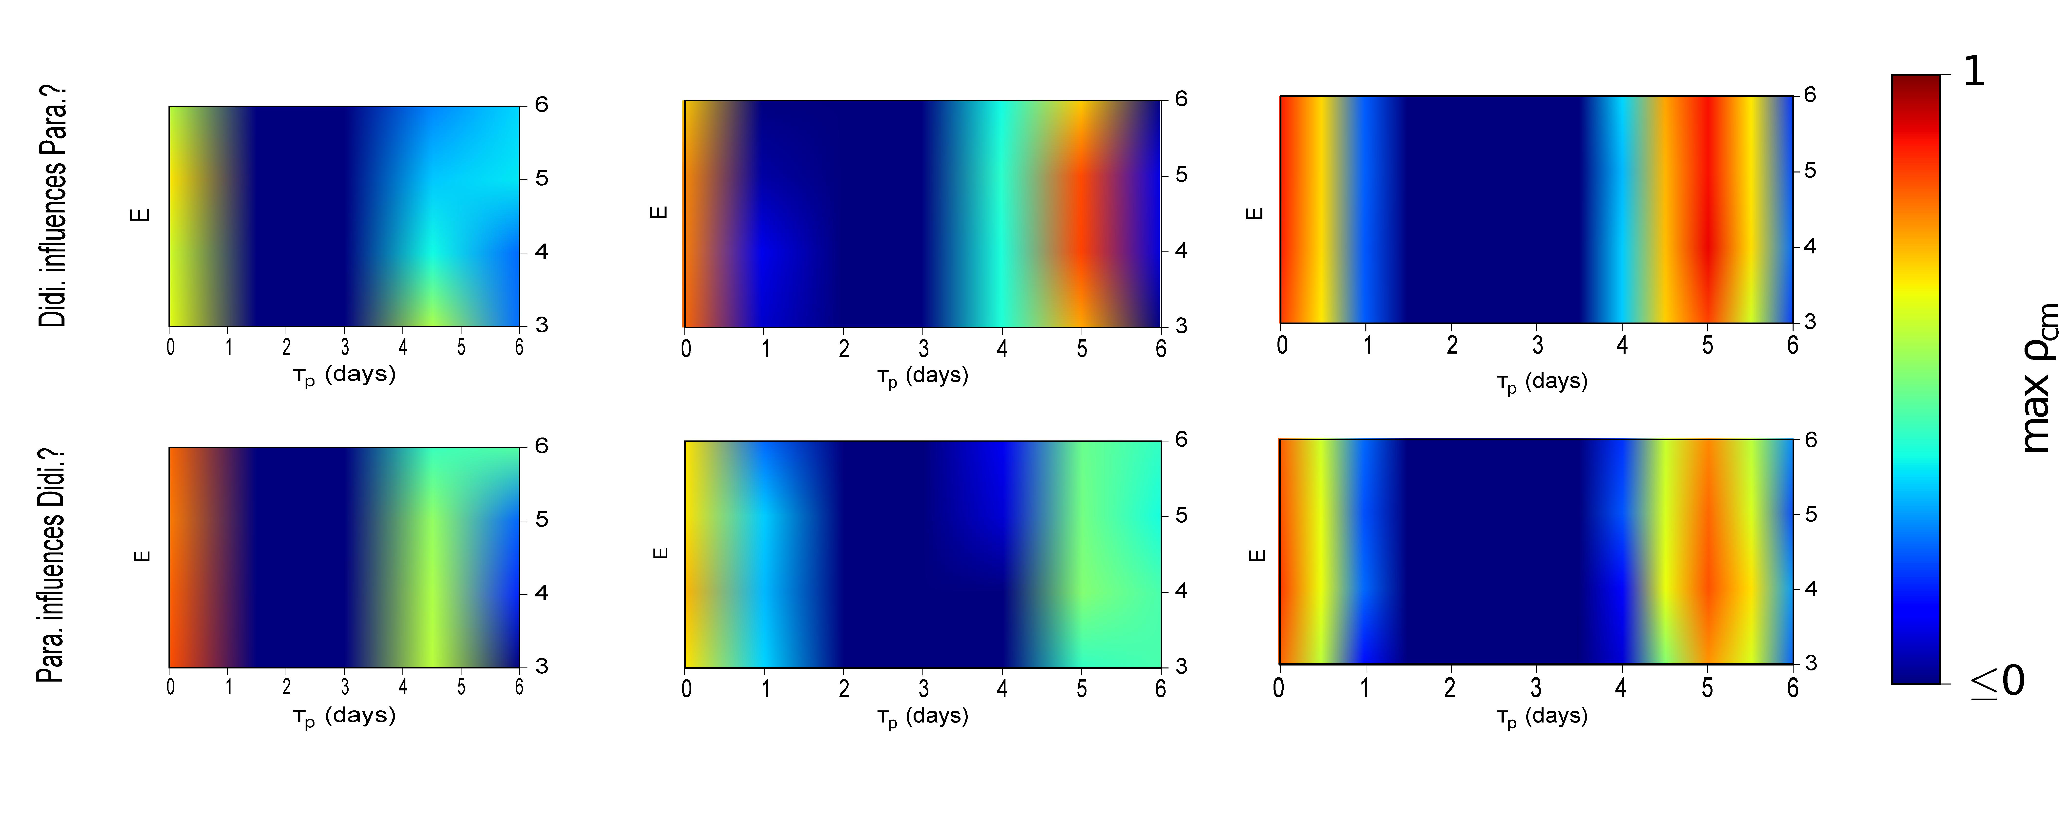
Didinium is a free-living unicellular carnivore. Paramecium is its prey. More information about this system, as well as interactive graphs of time series and manifold constructions, can be found at: http://cyrusmaher.github.io/CauseMap.jl/ParaDidiExample.html#paramecium-and-didinium
One-third thinned
One-half thinned
Full dataset

Figure S1. The maximal predictive skill as a function of E, tau p, and the number of included points.

Fourier transform analysis
We calculated the characteristic frequencies of the paramecium and didinium time series by performing fourier transform analysis using the rfft function in the python module scipy.

