Table S1: Biophysical data for the four study sites.

 | Strandveld | Limestone Fynbos | Sand Fynbos | Renosterveld
Nature reserve | Gouritz Mouth Local Authority Nature Reserve | Pauline Bohnen Local Authority Nature Reserve | Rein’s Private Nature Reserve | Werner Frehze Local Authority Nature Reserve
Plot coordinates | 34̊ 21’17.38”S; 21̊ 52’28.65”E | 34̊ 21’55.62”S; 21̊ 25’26.00”E | 34̊ 20’40.87”S; 21̊ 45’59.80”E | 34̊ 06’58.25”; 21̊ 14’59.70”E
MAP (mm) | 352 | 510 | 352 | 378
Soil description | Deep alkaline sand; moderately fertile | Shallow, alkaline sand overlying limestone; infertile | Deep, leached, acid sand: infertile | Shallow, slightly acid loam overlying clayey sub-soil; moderately fertile
Dominant species | Cassine peragua  (Celastraceae)  Eriocephalus africanus  (Asteraceae)  Osteospermum moniliferum  (Asteraceae)  Rhoicissus digitata  (Vitaceae)  Sideroxylon inerme  (Sapotaceae)  Zygophyllum morgsana  (Zygophyllaceae) | Erica spectabilis  (Ericaceae)  Ischyrolepis  leptocladus  (Restionaceae)  Leucadendron  meridianum  (Proteaceae)  Metalasia muricata (Asteraceae)  Stoebe muirrii  (Asteraceae)  Thamnochortus  muirrii  (Restionaceae) | Cliffortia illicifolia  (Rosaceae)  Erica dispar  (Ericaceae)  Leucadendron eucalyptifolium  (Proteaceae)  Leucospermum praecox  (Proteaceae)  Protea susannae  (Proteaceae)  Thamnochortus insignis  (Restionaceae)  Watsonia fourcadei  (Iridaceae) | Aloe ferox  (Asphodelaceae) Elytropappus rhinocerotis  (Asteraceae)  Ehrharta calycina (Poaceae)  Eriocephalus africanus  (Asteraceae) Metalasia pungens  (Asteraceae) Themeda triandra  (Poaceae)

Table S2. List of edible plant species found in each plot situated within a prominent vegetation type along the southern Cape lowlads of South Africa. The list is divided into underground storage organs and aboveground carbohydrates.

Vegetation | Carbohydrate category | Species
Renosterveld | Underground storage organ | Babiana patula; Cyphia digitata; Freesia caryophyllacea; Freesia leichtlinii; Pelargonium lobatum; Pelargonium rapaceum; Watsonia aletroides; Watsonia meriana
 | Aboveground | Carissa bispinosa (fruit); Diospyros dichrophylla (fruit); Microloma sagittatum (fruit); Muraltia spinosa (fruit); Osteospermum moniliferum (fruit); Osyris compressa (fruit); Searsia glauca (fruit); Sideroxylon inerme (fruit)
Limestone Fynbos | Underground storage organ | Babiana patula; Cyanella lutea; Cyphia digitata; Ferraria crispa; Freesia alba; Gladiolus cunonius; Gladiolus exilis; Gladiolus floribundus; Gladiolus virescens; Hesperantha falcata; Ixia micrandra; Moraea fugax; Pelargonium dipetalum; Pelargonium lobatum; Pelargonium triste; Rhoicissus digitata; Romulea rosea; Trachyandra ciliata; Trachyandra revoluta; Tritonia squalida; Watsonia fergusoniae
 | Aboveground | Astephanus triflorus (seedpods); Carissa bispinosa (fruit); Carpobrotus acinaciformis (fruit); Carpobrotus edulis (fruit); Cassine tetragona (fruit); Cynanchum obtusifolium (fruit); Euclea racemosa (fruit); Muraltia spinosa (fruit); Olea exasperata (fruit); Osteospermum moniliferum (fruit); Osyris compressa (fruit, seed); Searsia glauca (fruit); Searsia lucida (fruit); Sideroxylon inerme (fruit); Tetragonia decumbens (leaves); Trachyandra ciliata (inflorescences); Trachyandra revoluta (inflorescences); Zygophyllum morgsana (seed)
Sand Fynbos | Underground storage organ | Gladiolus guthriei; Gladiolus rogersii; Pelargonium triste; Trachyandra revoluta; Watsonia fourcadei
 | Aboveground | Carpobrotus edulis (fruit); Diospyros dichrophylla (fruit); Osteospermum moniliferum (fruit); Searsia glauca (fruit); Trachyandra revoluta (inflorescences)
Strandveld | Underground storage organ | Babiana patula; Chasmanthe aethiopica; Cyanella lutea; Cyphia digitata; Ferraria crispa; Freesia alba; Gladiolus floribundus; Oxalis pes-caprae; Pelargonium lobatum; Pelargonium triste; Rhoicissus digitata; Romulea rosea; Trachyandra ciliata; Trachyandra revoluta; Tritonia crocata
 | Aboveground | Carissa bispinosa (fruit); Carpobrotus acinaciformis (fruit); Cassine tetragona (fruit); Muraltia spinosa (fruit); Olea exasperata (fruit); Osteospermum moniliferum (fruit); Schotia afra (seed); Searsia glauca (fruit); Sideroxylon inerme (fruit); Tetragonia decumbens (leaves); Trachyandra ciliata (inflorescences); Trachyandra revoluta (inflorescences); Zygophyllum morgsana (seed)

Table S3.1. Species list of USOs (on left) and fruiting species (aboveground carbohydrate resources) (on right) and their acronyms encountered in the Phenology survey of the four basic vegetation types of the southern Cape lowlands to coastal margin.

USOs per study site/vegetation type | Acronym | Fruiting species per study site/vegetation type | Acronym
Strandveld |  | Strandveld
Babiana patulla | BAB PAT | Carissa bispinosa (fruit) | CAR BIS
Chasmanthe aetiopica | CHA AET | Carpobrotus acinaciformis (fruit) | CAR ACI
Cyanella lutea | CYA LUT | Cassine tetragona (fruit) | CAS TET
Cyphia digitata | CYP DIG | Muraltia spinosa (fruit) | MUR SPI
Ferraria crispa | FER CRI | Olea exasperata (fruit) | OLE EXA
Freesia alba | FRE ALB | Osteospermum moniliferum (fruit) | OST MON
Gladiolus floribundus | GLA FLO | Schotia afra (seed) | SCH AFR
Oxalis pes-caprae | OXA PES | Searsia glauca (fruit) | SEA GLA
Pelargonium lobatum | PEL LOB | Sideroxylon inerme (fruit) | SID INE
Pelargonium triste | PEL TRI | Tetragonia decumbens (veg.) | TET DEC
Rhoicissus digitata | RHO DIG | Trachyandra ciliata (veg.) | TRA CIL
Romulea rosea | ROM ROS | Trachyandra revoluta (veg.) | TRA REV
Trachyandra ciliata | TRA CIL | Zygophyllum morgsana (seed) | ZYG MOR
Trachyandra revoluta | TRA REV
Tritonia crocata | TRI CRO
Limestone Fynbos |  | Limestone Fynbos
Babiana patulla | BAB PAT | Astephanus triflorus (veg.) | AST TRI
Cyanella lutea | CYA LUT | Carissa bispinosa (fruit) | CAR BIS
Cyphia digitata | CYP DIG | Carpobrotus acinaciformis (fruit) | CAR ACI
Ferraria crispa | FER CRI | Carpobrotus edulis (fruit) | CAR EDU
Freesia alba | FRE ALB | Cassine tetragona (fruit) | CAS TET
Gladiolus cunonius | GLA CUN | Cynanchum obtusifolium (fruit) | CYN OBT
Gladiolus exilis | GLA EXI | Euclea racemosa (fruit) | EUC RAC
Gladiolus floribundus | GLA FLO | Muraltia spinosa (fruit) | MUR SPI
Gladiolus virescens | GLA VIR | Olea exasperata (fruit) | OLE EXA
Hesperantha falcata | HES FAL | Osteospernum moniliferum (fruit) | OST MON

Ixia micandra | IXI MIC | Osyris compressa (fruit, seed) | OSY COM
Moraea fugax | MOR FUG | Searsia glauca (fruit) | SEA GLA
Pelargonium dipetalum | PEL DIP | Searsia lucida (fruit) | SEA LUC
Pelargonium lobatum | PEL LOB | Sideroxylon inerme (fruit) | SID INE
Pelargonium triste | PEL TRI | Tetragonia decumbens (veg.) | TET DEC
Rhoicissus digitata | RHO DIG | Trachyandra ciliata (veg.) | TRA CIL
Romulea rosea | ROM ROS | Trachyandra revoluta (veg.) | TRA REV
Trachyandra ciliata | TRA CIL | Zygophyllum morgsana (seed) | ZYG MOR
Trachyandra revoluta | TRA REV
Tritonia squalida | TRI SQU
Watsonia fergusoniae | WAT FER
Renosterveld |  | Renosterveld
Babiana patulla | BAB PAT | Carissa bispinosa (fruit) | CAR BIS
Cyphia digitata | CYP DIG | Diospyros dichrophylla (fruit) | DIO DIC
Freesia caryophyllacea | FRE CAR | Microloma saggitatum (veg.) | MIC SAG
Freesia leichtlinii | FRE LEI | Muraltia spinosa (fruit) | MUR SPI
Pelargonium lobatum | PEL LOB | Osteospermum moniliferum (fruit) | OST MON
Pelargonium repaceum | PEL REP | Osyris compressa (fruit) | OSY COM
Watsonia alletroides | WAT ALL | Searsia glauca (fruit) | SEA GLA
Watsonia meriana | WAT MER | Sideroxylon inerme (fruit) | SID INE
Sand Fynbos |  | Sand Fynbos
Gladiolus guthriei | GLA GUT | Carpobrotus edulis (fruit) | CAR EDU
Gladiolus rogersii | GLA ROG | Diospyros dichrophylla (fruit) | DIO DIC
Pelargonium triste | PEL TRI | Osteospernum moniliferum (fruit) | OST MON
Trachyandra revoluta | TRA REV | Searsia glauca (fruit) | SEA GLA
Watsonia fourcadei | WAT FOU | Trachyandra revoluta (veg.) | TRA REV

Table S3.2 Species list summary of USOs (on left) and fruiting species (aboveground carbohydrate resources) (on right) and their acronyms encountered in the Phenology survey of the four basic vegetation types of the southern Cape lowlands to coastal margin.

Species summary USOs |  | Species summary fruiting
Babiana patula | BAB PAT | Astephanus triflorus (fruit) | AST TRI
Chasmanthe aethiopica | CHA AET | Carissa bispinosa (fruit) | CAR BIS
Cyanella lutea | CYA LUT | Carpobrotus acinaciformis (fruit) | CAR ACI
Cyphia digitata | CYP DIG | Carpobrotus edulis (fruit) | CAR EDU
Ferraria crispa | FER CRI | Cassine tetragona (fruit) | CAS TET
Freesia alba | FRE ALB | Cynanchum obtusifolium (fruit) | CYN OBT
Freesia caryophyllacea | FRE CAR | Diospyros dichrophylla (fruit) | DIO DIC
Freesia leichtlinii | FRE LEI | Euclea racemosa (fruit) | EUC RAC
Gladiolus cunonius | GLA CUN | Microloma sagittatum (fruit) | MIC SAG
Gladiolus exilis | GLA EXI | Muraltia spinosa (fruit) | MUR SPI
Gladiolus floribundus | GLA FLO | Olea exasperata (fruit) | OLE EXA
Gladiolus guthriei | GLA GUT | Osteospermum moniliferum (fruit) | OST MON
Gladiolus rogersii | GLA ROG | Osyris compressa (fruit, seed) | OSY COM
Gladiolus virescens | GLA VIR | Schotia afra (seed) | SCH AFR
Hesperantha falcata | HES FAL | Searsia glauca (fruit) | SEA GLA
Ixia micrandra | IXI MIC | Searsia lucida (fruit) | SEA LUC
Moraea fugax | MOR FUG | Sideroxylon inerme (fruit) | SID INE
Oxalis pes-caprae | OXA PES | Tetragonia decumbens (veg.) | TET DEC
Pelargonium dipetalum | PEL DIP | Trachyandra ciliata (veg.) | TRA CIL
Pelargonium lobatum | PEL LOB | Trachyandra revoluta (veg.) | TRA REV
Pelargonium rapaceum | PEL REP | Zygophyllum morgsana (seed) | ZYG MOR
Pelargonium triste | PEL TRI
Rhoicissus digitata | RHO DIG
Romulea rosea | ROM ROS
Trachyandra ciliata | TRA CIL
Trachyandra revoluta | TRA REV
Tritonia crocata | TRI CRO
Tritonia squalida | TRI SQU
Watsonia aletroides | WAT ALL
Watsonia fergusoniae | WAT FER
Watsonia fourcadei | WAT FOU
Watsonia meriana | WAT MER

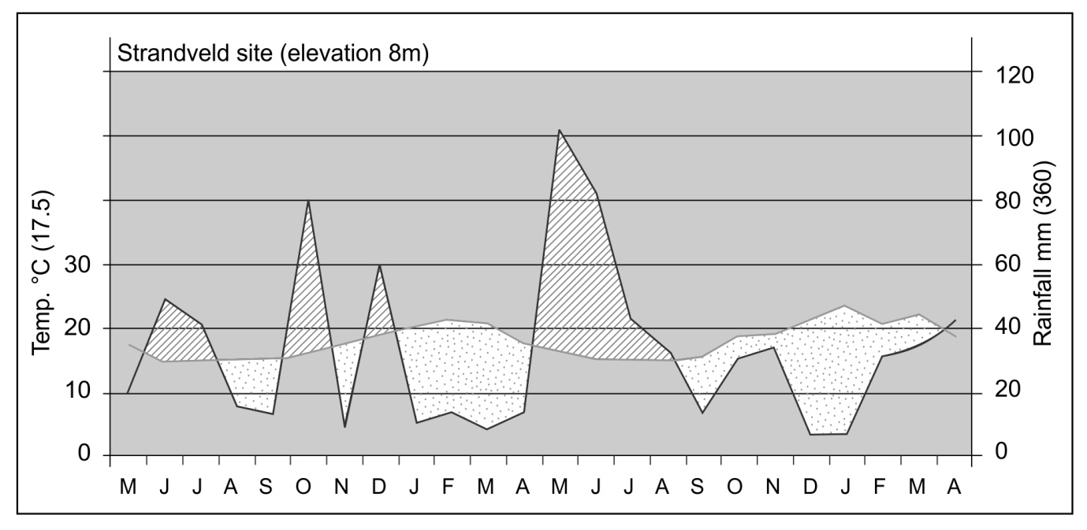

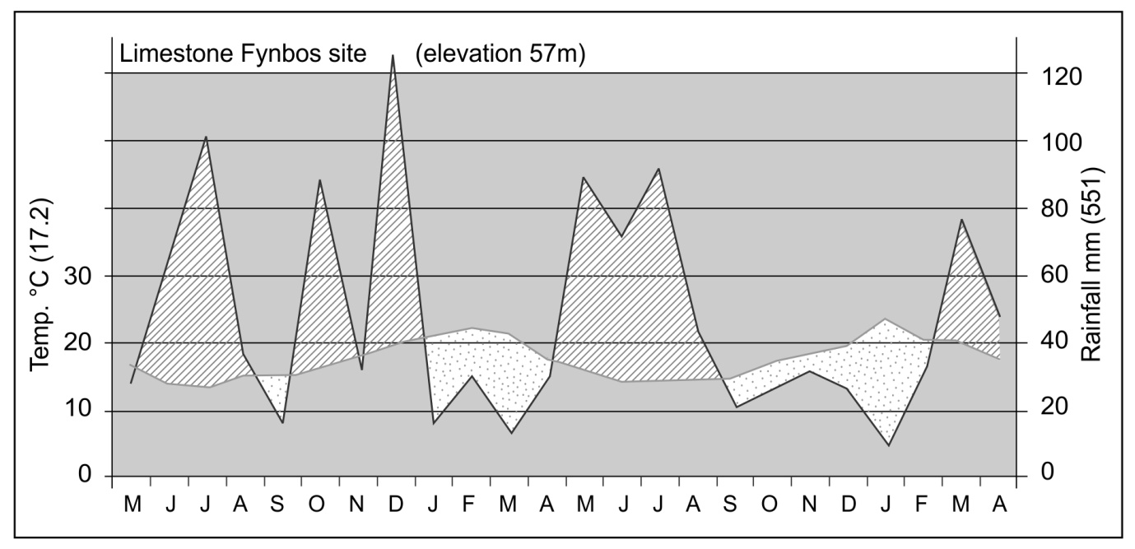

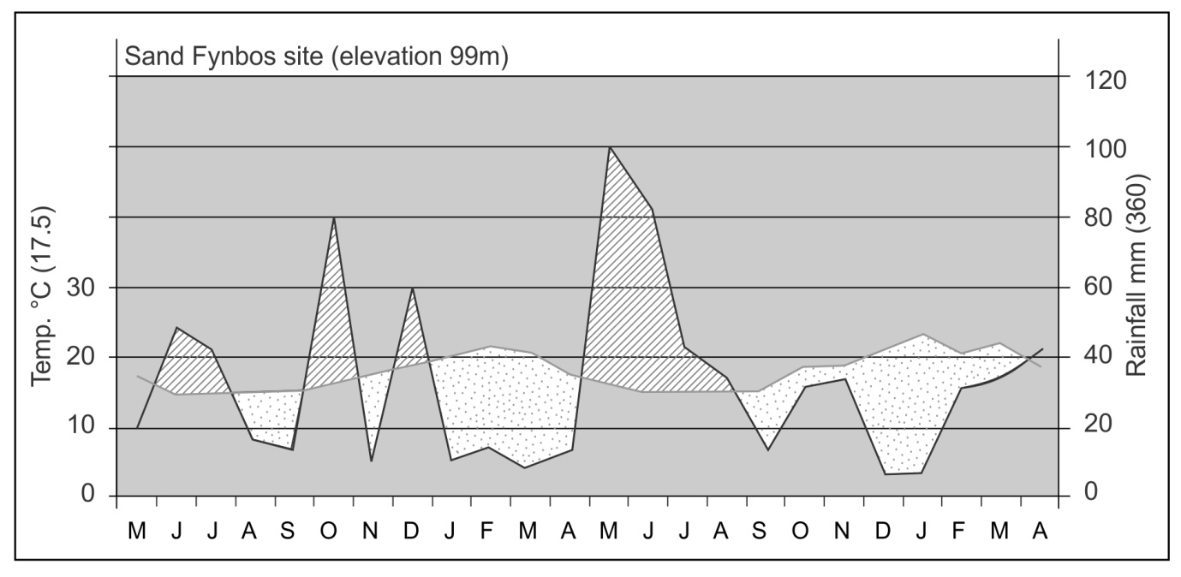

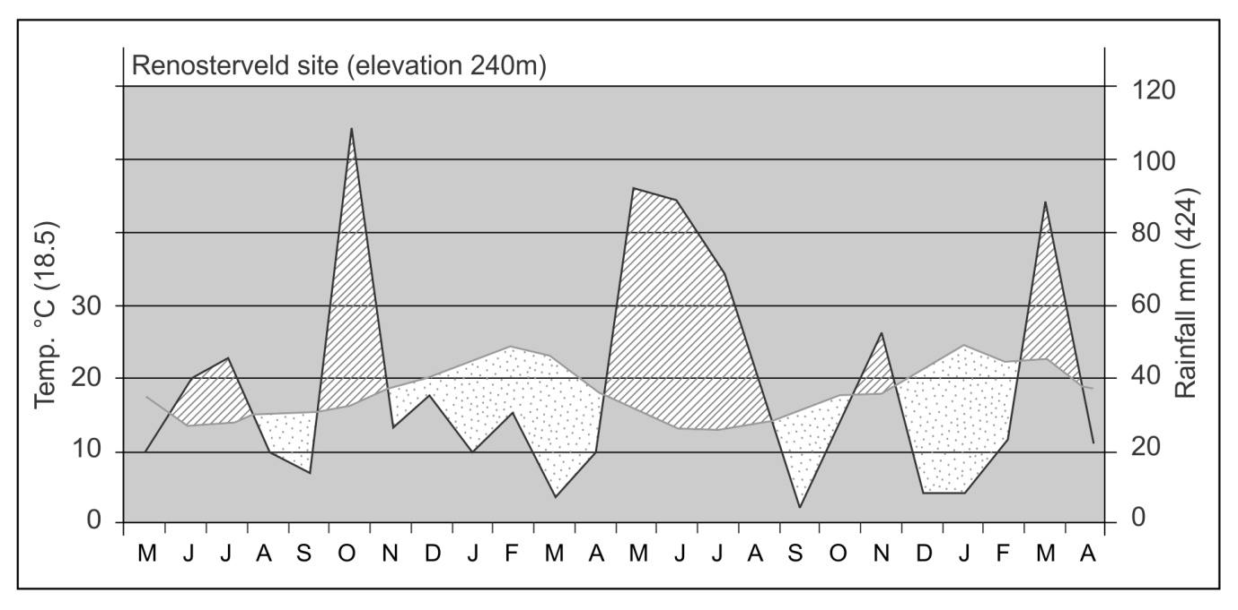
Fig. S1. Climate diagrams showing temperature and rainfall patterns for the study sites during the survey period (May 2010-April 2012). Mean values of temperature and rainfall are shown in parentheses.

USOs
Dry leaves
Green leaves
Flowering
Not visible

Limestone Fynbos

 | J | F | M | A | M | J | J | A | S | O | N | D
Babiana patula
Iridaceae
 | J | F | M | A | M | J | J | A | S | O | N | D
Cyanella lutea
Tecophilaeaceae
 | J | F | M | A | M | J | J | A | S | O | N | D
Cyphia digitata
Campanulaceae
 | J | F | M | A | M | J | J | A | S | O | N | D
Ferraria crispa
Iridaceae
 | J | F | M | A | M | J | J | A | S | O | N | D
Freesia alba
Iridaceae
 | J | F | M | A | M | J | J | A | S | O | N | D
Gladiolus cunonius
Iridaceae
 | J | F | M | A | M | J | J | A | S | O | N | D
Gladiolus exilis
Iridaceae
 | J | F | M | A | M | J | J | A | S | O | N | D
Gladiolus floribundus
Iridaceae
 | J | F | M | A | M | J | J | A | S | O | N | D
Gladiolus virescens
Iridaceae
 | J | F | M | A | M | J | J | A | S | O | N | D
Hesperantha falcata
Iridaceae
 | J | F | M | A | M | J | J | A | S | O | N | D
Ixia micrandra
Iridaceae
 | J | F | M | A | M | J | J | A | S | O | N | D
Moraea fugax
Iridaceae
 | J | F | M | A | M | J | J | A | S | O | N | D
Pelargonium dipetalum
Geraniaceae
 | J | F | M | A | M | J | J | A | S | O | N | D
Pelargonium lobatum
Geraniaceae
 | J | F | M | A | M | J | J | A | S | O | N | D
Pelargonium triste
Geraniaceae
 | J | F | M | A | M | J | J | A | S | O | N | D
Romulea rosea
Iridaceae
 | J | F | M | A | M | J | J | A | S | O | N | D
Trachyandra ciliata
Asphodelaceae
 | J | F | M | A | M | J | J | A | S | O | N | D
Trachyandra revoluta
Asphodelaceae
 | J | F | M | A | M | J | J | A | S | O | N | D
Tritonia squalida
Iridaceae
 | J | F | M | A | M | J | J | A | S | O | N | D
Watsonia fergusoniae
Iridaceae

Renosterveld

 | J | F | M | A | M | J | J | A | S | O | N | D
Babiana patula
Iridaceae
 | J | F | M | A | M | J | J | A | S | O | N | D
Cyphia digitata
Campanulaceae
 | J | F | M | A | M | J | J | A | S | O | N | D
Freesia caryophyllacea
Iridaceae
 | J | F | M | A | M | J | J | A | S | O | N | D
Freesia leichtlinii
Iridaceae
 | J | F | M | A | M | J | J | A | S | O | N | D
Pelargonium lobatum
Geraniaceae
 | J | F | M | A | M | J | J | A | S | O | N | D
Pelargonium rapaceum
Geraniaceae
 | J | F | M | A | M | J | J | A | S | O | N | D
Watsonia aletroides
Iridaceae
 | J | F | M | A | M | J | J | A | S | O | N | D
Watsonia meriana
Iridaceae

Sand fynbos

 | J | F | M | A | M | J | J | A | S | O | N | D
Gladiolus guthriei
Iridaceae
 | J | F | M | A | M | J | J | A | S | O | N | D
Gladiolus rogersii
Iridaceae
 | J | F | M | A | M | J | J | A | S | O | N | D
Pelargonium triste
Geraniaceae
 | J | F | M | A | M | J | J | A | S | O | N | D
Trachyandra revoluta
Asphodelaceae
 | J | F | M | A | M | J | J | A | S | O | N | D
Watsonia fourcadei
Iridaceae

Strandveld

 | J | F | M | A | M | J | J | A | S | O | N | D
Babiana patula
Iridaceae
 | J | F | M | A | M | J | J | A | S | O | N | D
Chasmanthe aethiopica
Iridaceae
 | J | F | M | A | M | J | J | A | S | O | N | D
Cyanella lutea
Tecophilaeaceae
 | J | F | M | A | M | J | J | A | S | O | N | D
Cyphia digitata
Campanulaceae
 | J | F | M | A | M | J | J | A | S | O | N | D
Ferraria crispa
Iridaceae
 | J | F | M | A | M | J | J | A | S | O | N | D
Freesia alba
Iridaceae
 | J | F | M | A | M | J | J | A | S | O | N | D
Gladiolus floribundus
Iridaceae
 | J | F | M | A | M | J | J | A | S | O | N | D
Oxalis pes-caprae
Oxalidaceae
 | J | F | M | A | M | J | J | A | S | O | N | D
Pelargonium lobatum
Geraniaceae
 | J | F | M | A | M | J | J | A | S | O | N | D
Pelargonium triste
Geraniaceae
 | J | F | M | A | M | J | J | A | S | O | N | D
Romulea rosea
Iridaceae
 | J | F | M | A | M | J | J | A | S | O | N | D
Trachyandra ciliata
Asphodelaceae
 | J | F | M | A | M | J | J | A | S | O | N | D
Trachyandra revoluta
Asphodelaceae
 | J | F | M | A | M | J | J | A | S | O | N | D
Tritonia crocata
Iridaceae

Fruiting species
Green leaves
Flowering
Ripe/edible fruit
Dry leaves
Not visible

Limestone Fynbos

 | J | F | M | A | M | J | J | A | S | O | N | D
Carissa bispinosa
Apocynaceae

Cassine tetragona
Celastraceae
 | J | F | M | A | M | J | J | A | S | O | N | D
Euclea racemosa
Ebenaceae
 | J | F | M | A | M | J | J | A | S | O | N | D
Muraltia spinosa
Polygalaceae
 | J | F | M | A | M | J | J | A | S | O | N | D
Olea exasperata
Oleaceae
 | J | F | M | A | M | J | J | A | S | O | N | D
Osteospernum moniliferum
Asteraceae
 | J | F | M | A | M | J | J | A | S | O | N | D
Osyris compressa
Santalaceae
 | J | F | M | A | M | J | J | A | S | O | N | D
Searsia glauca
Anacardiaceae
 | J | F | M | A | M | J | J | A | S | O | N | D
Searsia lucida
Anacardiaceae
 | J | F | M | A | M | J | J | A | S | O | N | D
Sideroxylon inerme
Sapotaceae
 | J | F | M | A | M | J | J | A | S | O | N | D
Astephanus triflorus
Apocynaceae
 | J | F | M | A | M | J | J | A | S | O | N | D
Carpobrotus acinaciformis
Aizoaceae
 | J | F | M | A | M | J | J | A | S | O | N | D
C. edulis
Aizoaceae
 | J | F | M | A | M | J | J | A | S | O | N | D
Cynanchum obtusifolium
Apocynaceae
 | J | F | M | A | M | J | J | A | S | O | N | D
Zygophyllum morgsana
Zygophyllaceae
 | J | F | M | A | M | J | J | A | S | O | N | D
Tetragonia decumbens
Aizoaceae
 | J | F | M | A | M | J | J | A | S | O | N | D
Trachyandra ciliata
Asphodelaceae

Renosterveld

 | J | F | M | A | M | J | J | A | S | O | N | D
Carissa bispinosa
Apocynaceae
 | J | F | M | A | M | J | J | A | S | O | N | D
Muraltia spinosa
Polygalaceae
 | J | F | M | A | M | J | J | A | S | O | N | D
Osteospermum moniliferum
Asteraceae
 | J | F | M | A | M | J | J | A | S | O | N | D
Searsia glauca
Anacardiaceae
 | J | F | M | A | M | J | J | A | S | O | N | D
Osyris compressa
Santalaceae
 | J | F | M | A | M | J | J | A | S | O | N | D
Sideroxylon inerme
Sapotaceae
 | J | F | M | A | M | J | J | A | S | O | N | D
Diospyros dichrophylla
Ebenaceae
 | J | F | M | A | M | J | J | A | S | O | N | D
Microloma saggitatum
Asclepiadaceae

Sand Fynbos

 | J | F | M | A | M | J | J | A | S | O | N | D
Osteospernum moniliferum
Asteraceae
 | J | F | M | A | M | J | J | A | S | O | N | D
Searsia glauca
Anacardiaceae
 | J | F | M | A | M | J | J | A | S | O | N | D
Carpobrotus edulis
Aizoaceae
 | J | F | M | A | M | J | J | A | S | O | N | D
Diospyros dichrophylla
Ebenaceae

Strandveld

 | J | F | M | A | M | J | J | A | S | O | N | D
Carissa bispinosa
Apocynaceae
 | J | F | M | A | M | J | J | A | S | O | N | D
Cassine tetragona
Celastraceae
 | J | F | M | A | M | J | J | A | S | O | N | D
Muraltia spinosa
Polygalaceae
 | J | F | M | A | M | J | J | A | S | O | N | D
Olea exasperata
Oleaceae
 | J | F | M | A | M | J | J | A | S | O | N | D
Osteospermum moniliferum
Asteraceae
 | J | F | M | A | M | J | J | A | S | O | N | D
Schotia afra
Fabaceae
 | J | F | M | A | M | J | J | A | S | O | N | D
Searsia glauca
Anacardiaceae
 | J | F | M | A | M | J | J | A | S | O | N | D
Sideroxylon inerme
Sapotaceae
 | J | F | M | A | M | J | J | A | S | O | N | D
Carpobrotus acinaciformis
Aizoaceae
 | J | F | M | A | M | J | J | A | S | O | N | D
Zygophyllum morgsana
Zygophyllaceae
 | J | F | M | A | M | J | J | A | S | O | N | D
Tetragonia decumbens
Aizoaceae
 | J | F | M | A | M | J | J | A | S | O | N | D
Trachyandra ciliata
Asphodelaceae

Fig. S2. Phenodiagrams of USOs and fruiting species (aboveground carbohydrate resources) encountered in the Phenology survey of the four primary vegetation types of the southern Cape lowlands to coastal margin.

