Appendix A: Supplementary Tables and Figures
Table A1: Description of the nine functional traits used in the analysis, including their units and functional interpretation.
Trait | Description | Units | Functional Interpretation
Exoskeleton material | The primary material used in forming the exoskeleton | Calcium carbonate, chitin | Defense mode
Body plan | The general layout of the organism | Articulate (cylindrical, laterally-compressed, ventrally-compressed), bulloid, turbinate, turriform | Habitat use and partitioning, defense mode
Trophic group | The primary trophic guild of the organism | Detritivore, filter feeder, grazer, omnivore, predator | Resource partitioning
Specific diet | The general group that forms the majority of the diet based on published analyses of diet preferences and/or gut contents | Benthic microalgae, bivalves, crustaceans, detritus, epibionts, epiphytic microalgae, hydroids, macroalgae, microalgae, polychaetes, sponges | Resource partitioning
Maximum length | The largest recorded size of the organism | Continuous, in mm | Habitat use and partitioning, resource partitioning
Water column position | Where the organisms spends the majority of its time | Benthos, epibenthos | Habitat use and partitioning
Mobility | The general state of activity of the organism | Crawling, free-swimming, tube-building | Habitat use and partitioning, colonization potential
Egg retention | Whether the organism retains its eggs or releases them into the water column | Brooding, external release | Colonization potential
Development mode | Whether the organism has a larval stage, and, if so, if that larvae disperse in the plankton | Direct, larval (non-planktonic), larval (planktonic) | Colonization potential

Figure A1: Importance plots derived from random forests for each community metric. The x-axis is the percent increase in the mean-squared error (MSE) and represents how poorly the model does at predicting the response when the variable on the y-axis is omitted. Points are scaled based on the size of the increase in MSE.
Figure A2: The average abundance ± 1 SE of each species through time. Colors and shapes distinguish between sampling location and type: light green circle = Chincoteague Bay eelgrass, dark green triangle = South Bay eelgrass, orange circle = Chincoteague drift algae, and brown triangle = South Bay drift algae.
Figure A3: Functional diversity (FD) through time for all traits, and suites of traits relating to diet (trophic level and specific diet), habitat use (position in the water column and mobility), life history (brooding vs. non-brooding and larval dispersal mode), morphology (exoskeleton material and body plan), and body size. Left panels are weighted by relative abundance; right panels are weighted by presence-absence.
Figure A4: The proportion of individuals through time that possess traits relating to habitat use (benthos vs. epibenthos) for Chincoteague and South Bay.
Figure A5: The proportion of individuals through time that possess traits relating to mobility (crawling vs. free-swimming vs. tube-building) for Chincoteague and South Bay.
Figure A6: The proportion of individuals through time that possess traits relating to exoskeleton type (calcium carbonate vs. chitin) for Chincoteague and South Bay.
Figure A7: The proportion of individuals through time that possess traits relating to egg retention (brooding vs. external release) for Chincoteague and South Bay.
Figure A8: The proportion of individuals through time that possess traits relating to development mode (direct development vs. larval, non-planktonic vs. larval, planktonic) for Chincoteague and South Bay.
Figure A9: Times series plotting the annual mean ± 1 SE for various community properties representing only gastropods. Light grey circles represent the mature bed in Chincoteague Bay. Black triangles represent the restored bed in South Bay. FD = functional diversity, calculated as Rao’s quadratic entropy from all nine functional traits.
Figure A10: Relationships among species based on all nine functional traits generated using principal coordinates analysis. The two axes together explain 68% of the variance in functional traits.
Figure A11: Times series plotting the monthly mean ± 1 SE for various community properties. Light grey circles represent the mature bed in Chincoteague Bay. Black triangles represent the restored bed in South Bay. FD = functional diversity, calculated as Rao’s quadratic entropy from all nine functional traits.
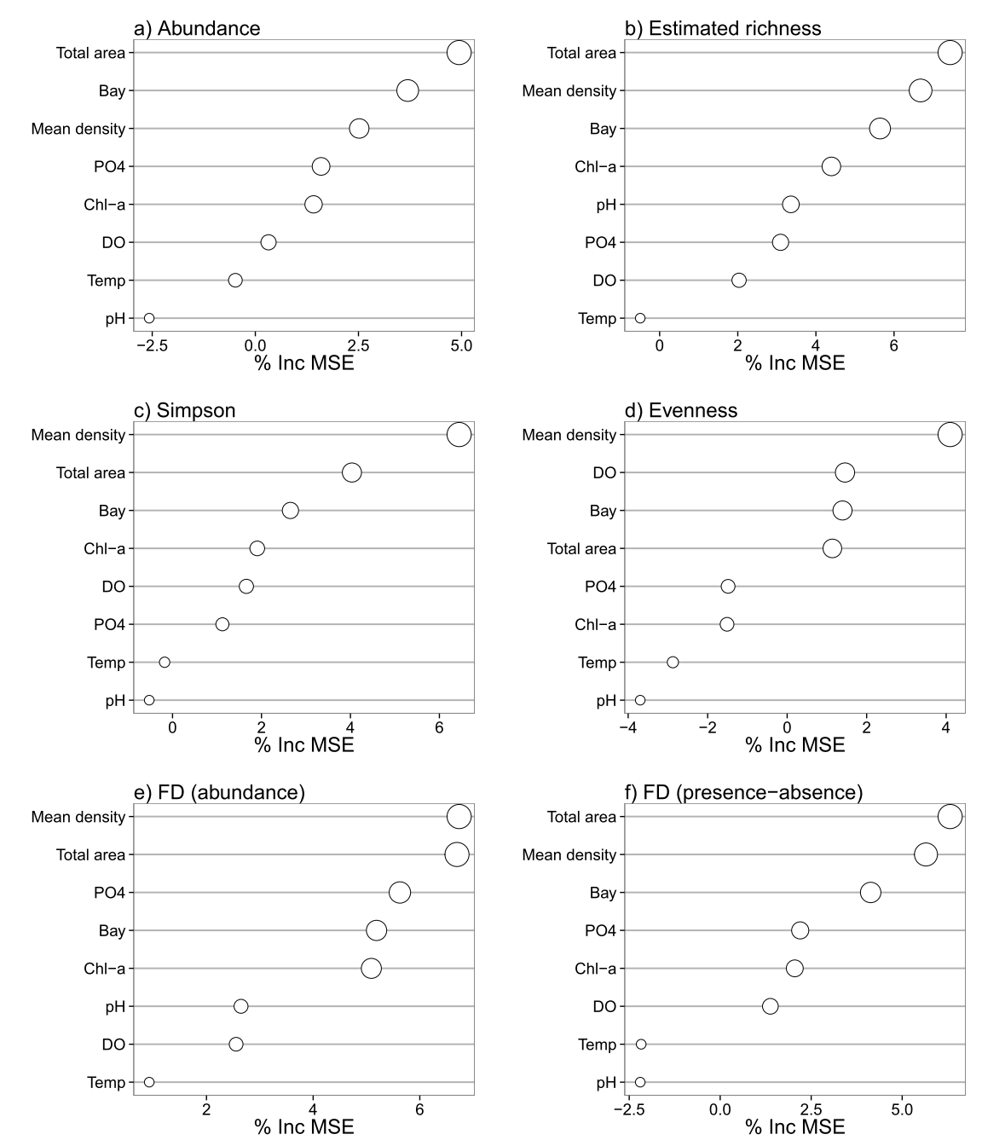
Figure A1
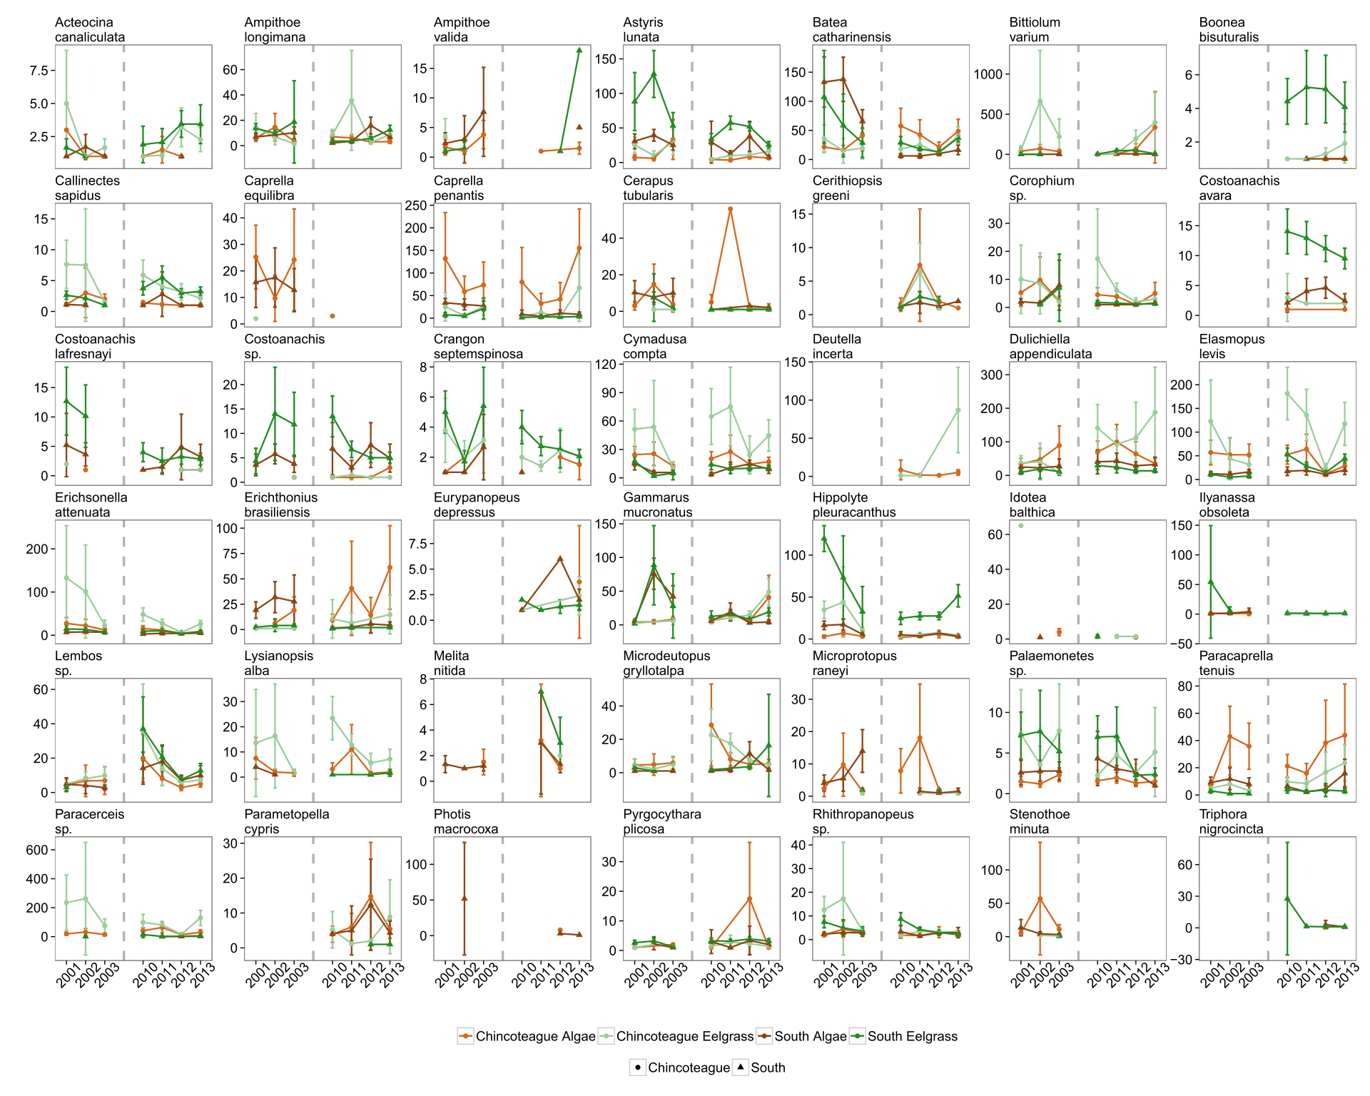
Figure A2
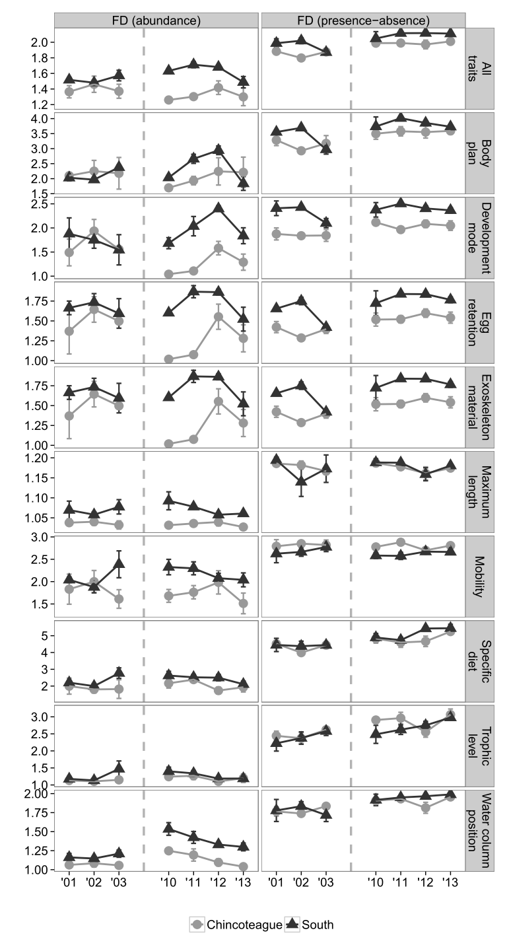
Figure A3

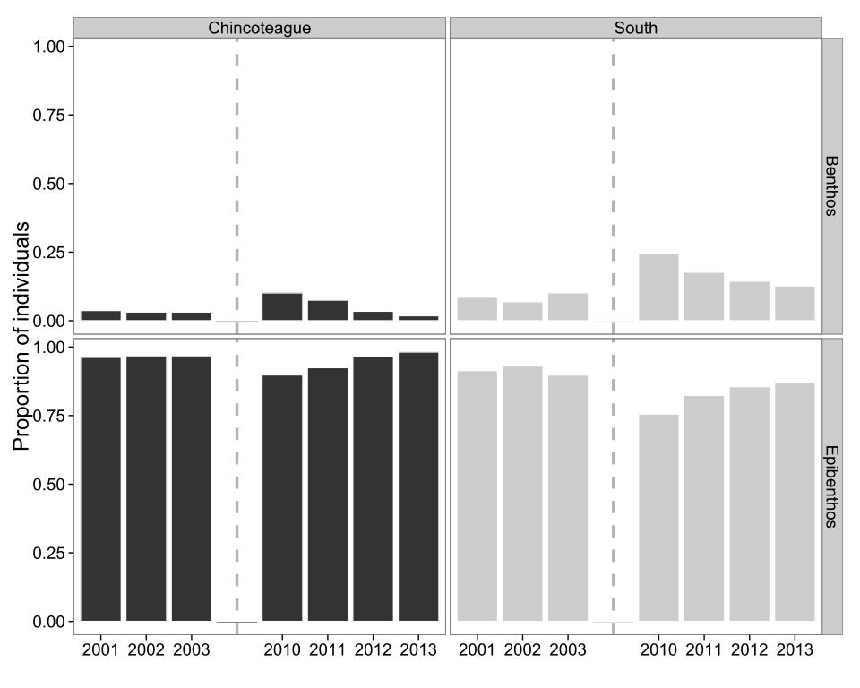
Figure A4
- 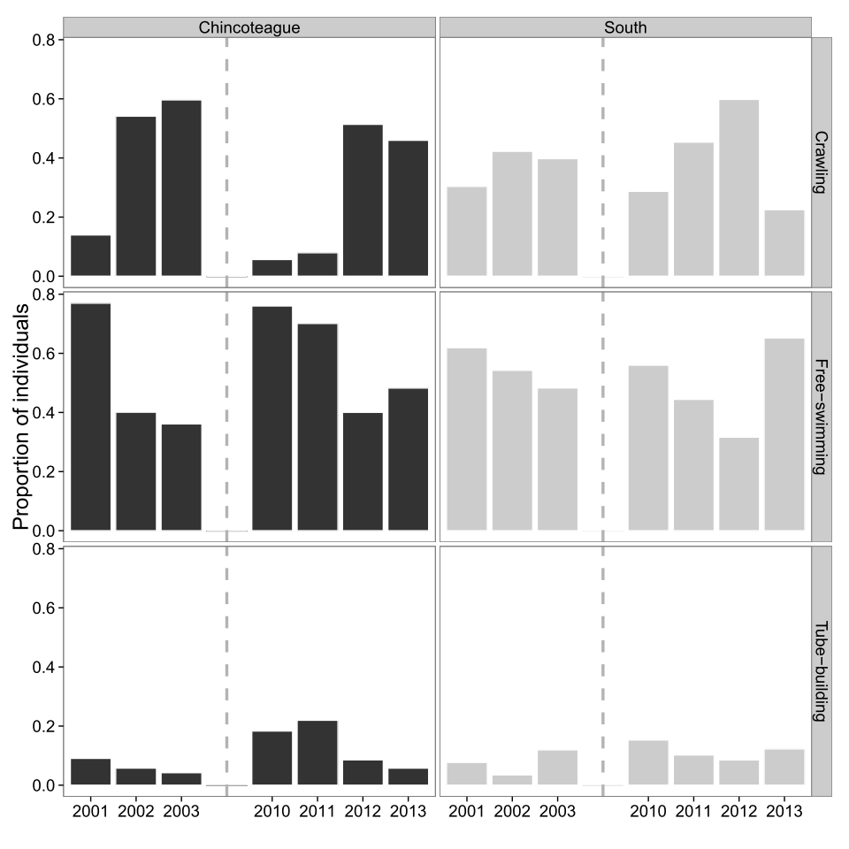
- Figure A5
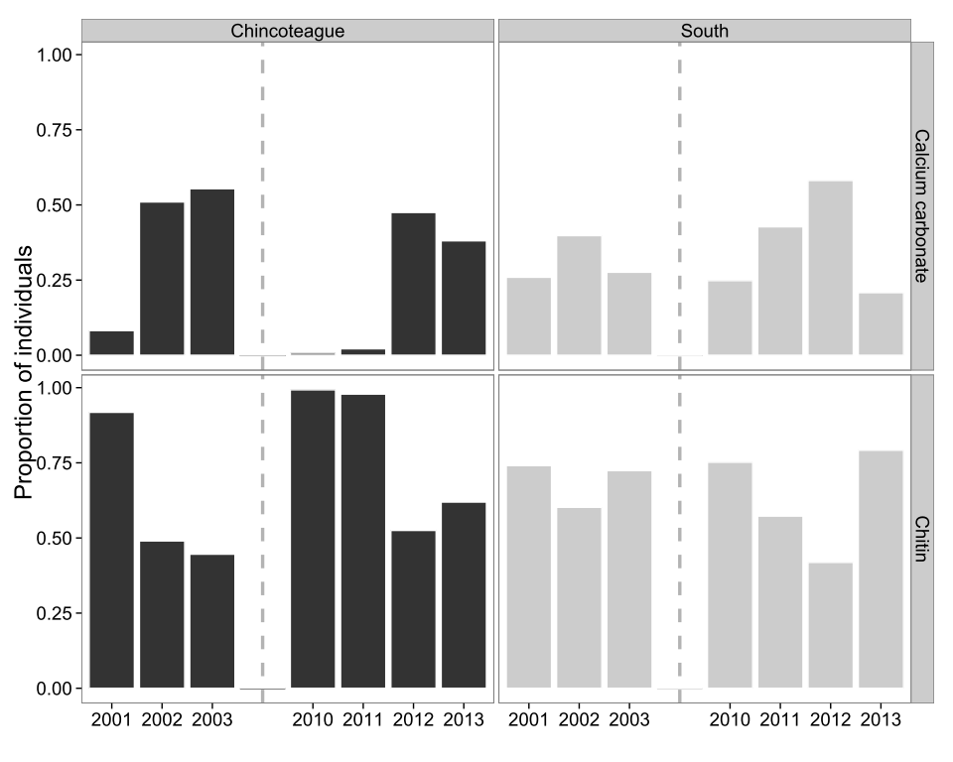
Figure A6
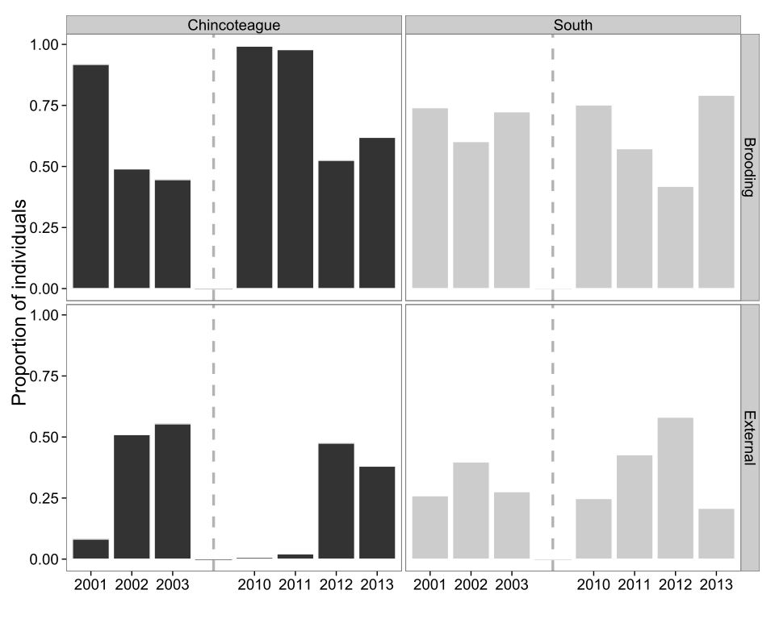
Figure A7
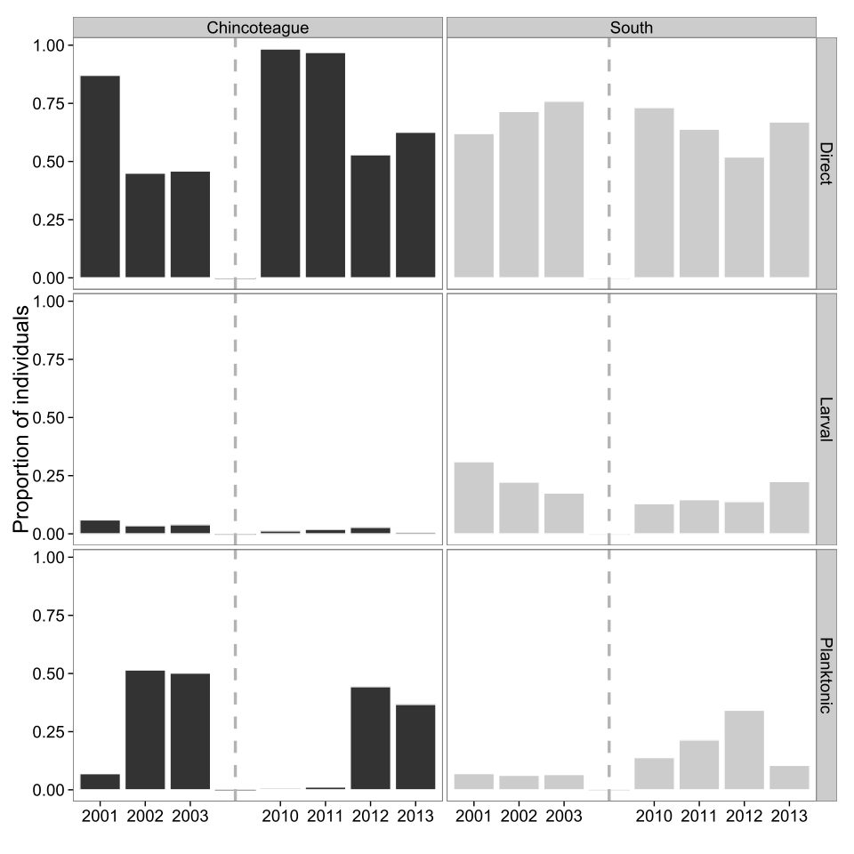
Figure A8
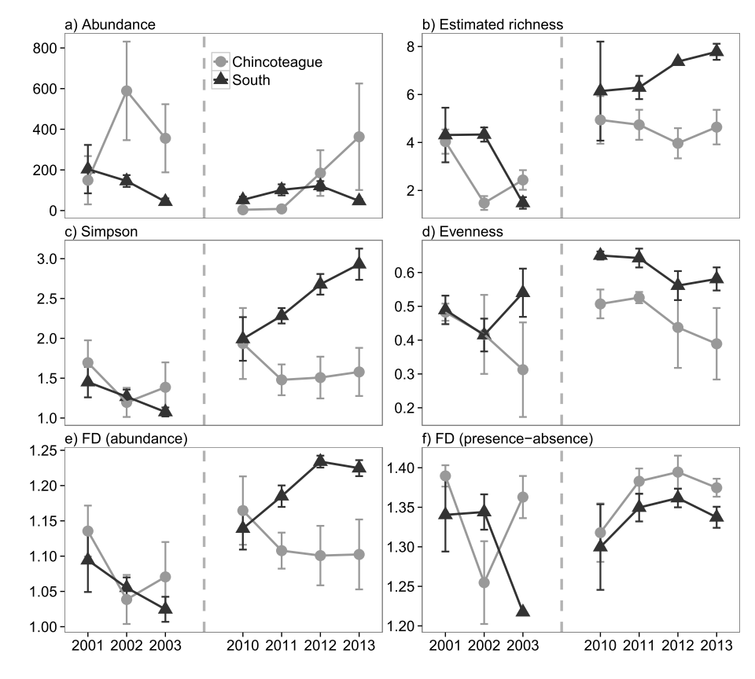
Figure A9
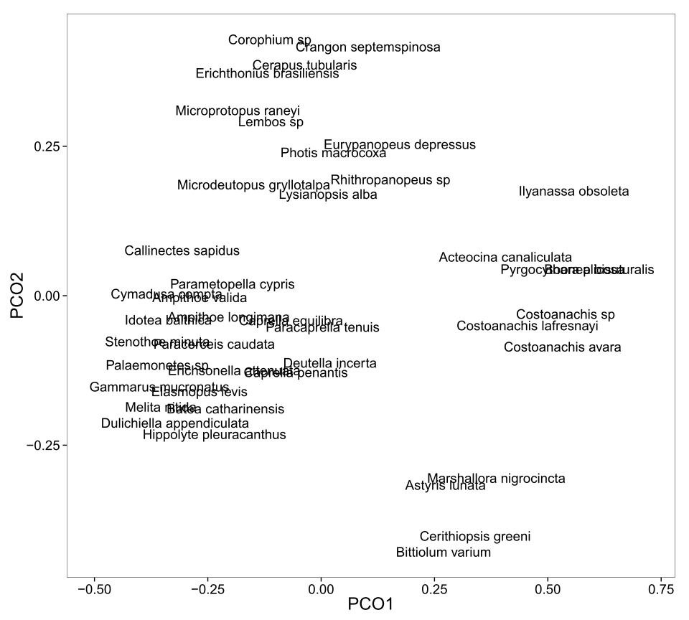
Figure A10
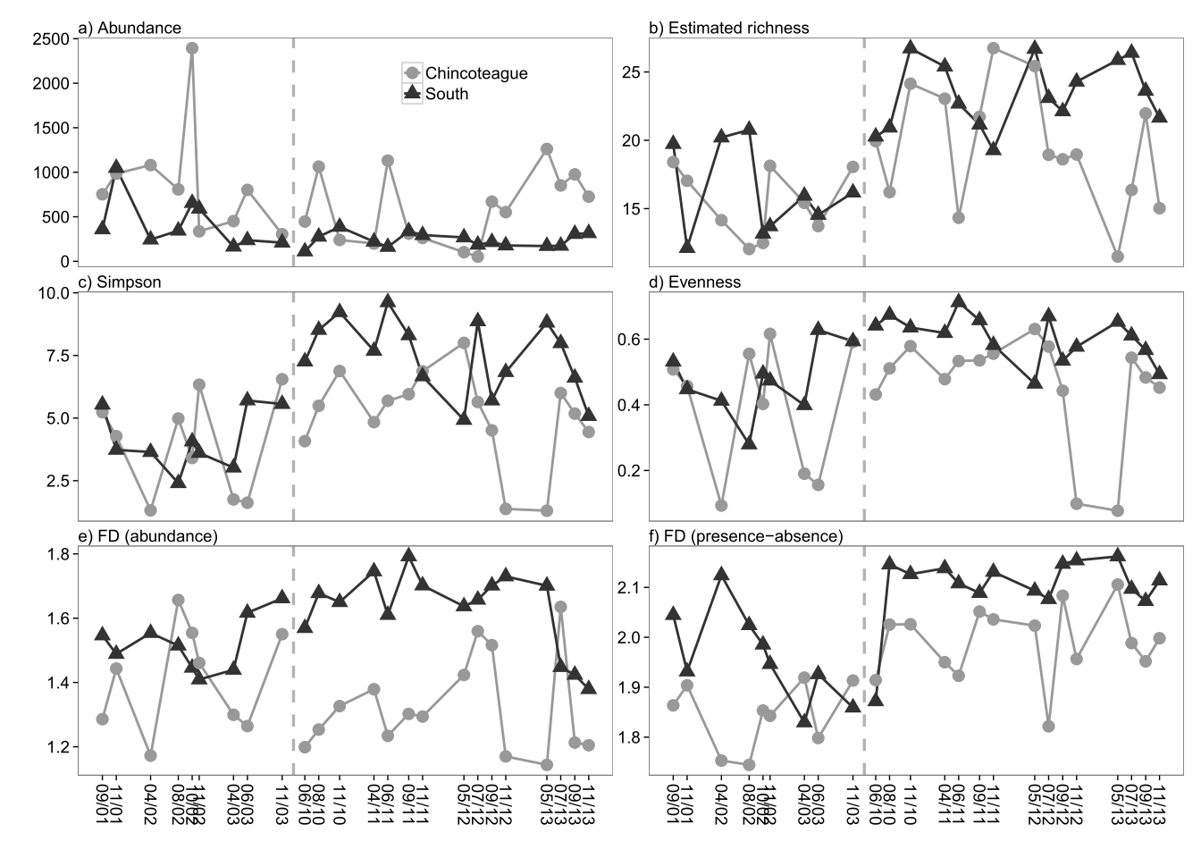
Figure A11

