Metagenomic and Satellite Analyses of Red Snow in the Russian Arctic

Nao Hisakawa, Steven Quistad, Eric Hester, Daria Martynova, Heather Maughan, Enric Sala, Maria Gavrilo, Forest Rohwer

Supplementary Materials

Methods
Satellite image analysis
Satellite images were obtained for the following locations and dates: Nansen Island in Franz Josef Land, Russia, in July of 1986, 2002, and 2006; Harding Ice Field, USA, in August of 2000, 2005, 2010, and 2014; Olympic National Park, USA, in July of 1996, 2002, 2008, and 2013; Rocky Mountains, Canada, in July of 1996, 2003, 2009, and 2014; Sierra Nevada, USA, in July of 1999, 2003, 2009, and 2013; Glacier National Park, USA, in July of 2002, 2006, 2010, and 2013; Mittivakkat Glacier, Greenland, in August of 1990, 2001, and 2014; Svalbard Archipelago, Norway, in July of 1989, 2002, 2006, and 2014; Grossglockner Mountain, Austria, in July of 1987, 2002, 2009, and August of 2013; Himalayas, India, in August of 1999, 2002, 2009, and 2014; and Mt Cook, New Zealand, in December of 1990, 2002, 2008, and 2014.
For each location, images acquired over multiple years were used to study red snow coverage over time. Images acquired in July and August for each year studied were used for the analysis in Northern Hemisphere locations because red snow becomes visible in July (Lutz et al. 2014; Remias et al. 2005) and can bloom on the snow surface into August (Takeuchi 2009). Red snow is not as visible in the snow-fields during May and June (Remias et al. 2005; Takeuchi 2009), so images from those months were not used. Images taken in July were chosen over images taken in August because red snow first blooms in July. For Mt. Cook, New Zealand, images acquired in December were used, as that is the beginning of the summer in the Southern Hemisphere. Not all of the available images acquired in the Landsat Archive database were suitable for analysis. Images acquired in the dark or images with extensive cloud cover that obstructed the view of the land surface were excluded from the analysis because they posed challenges in detecting surface snow color. The remaining images were visually inspected and sets of images that had no cloud cover over the area of interest were chosen for the analysis. Red snow abundances in Franz Josef Land over three different years were compared, including images from 1986 (taken on July 20 by Landsat 5), 2002 (taken on July 17 by Landsat 7), and 2006 (taken on July 2, 2006 by Landsat 5). The same red and green band designations (described in main article Methods) were used for images from both satellites Landsats 5 and 7.

Figures
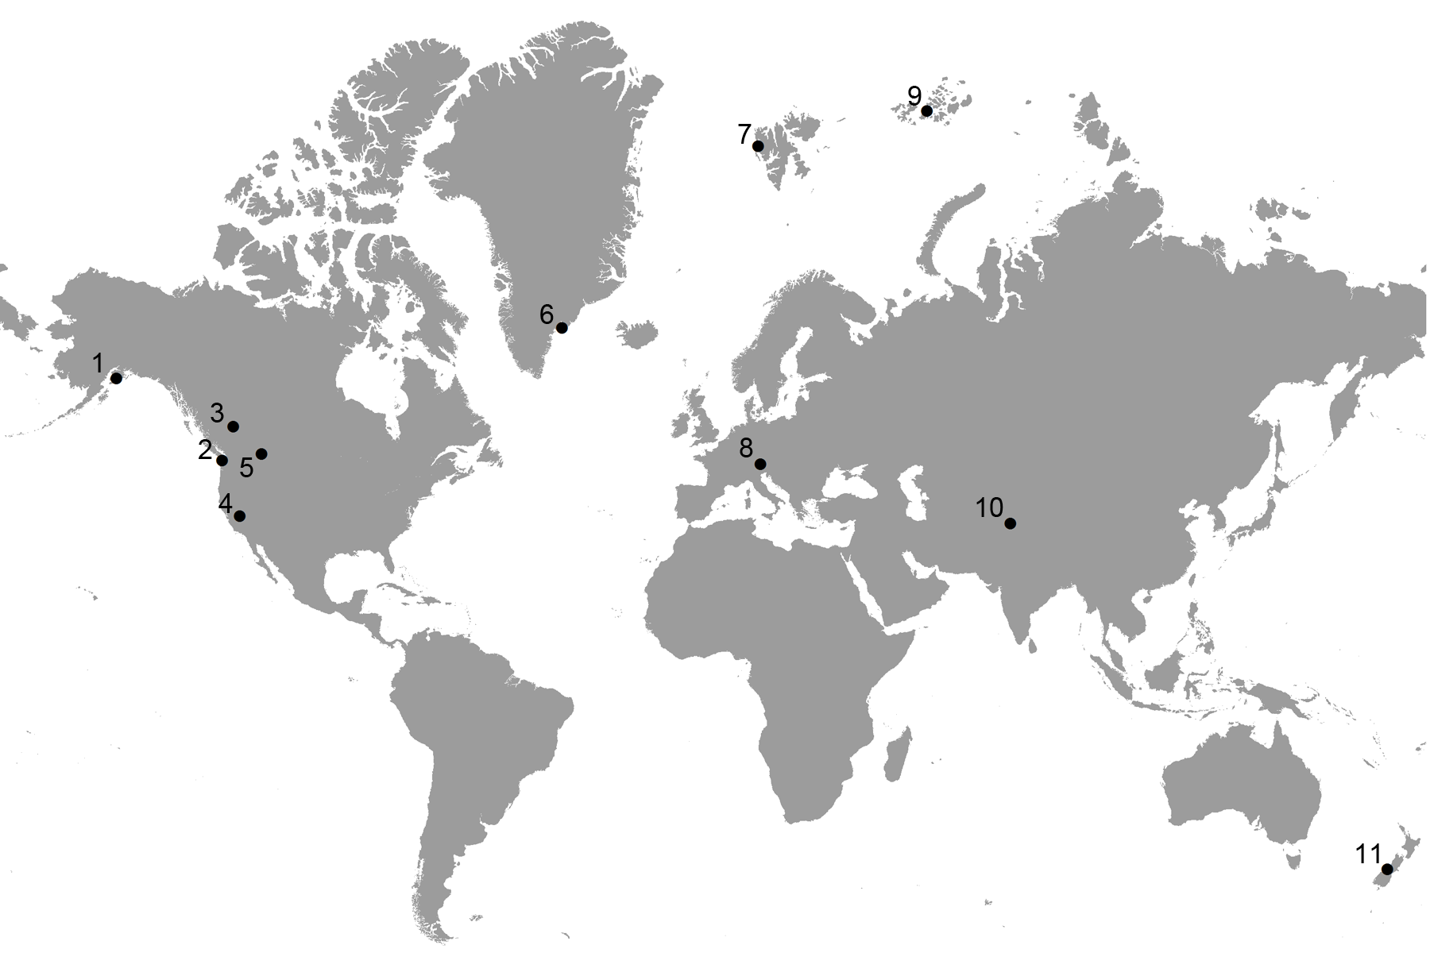

Supplementary Figure 1. Black points indicate the locations analyzed for red snow content. Harding Ice Field, United States (1); Olympic National Park, United States (2); Rocky Mountains, Canada (3); Sierra Nevada Mountain Range, United States (4); Glacier National Park, United States (5); Mittavikkat Glacier, Greenland (6); Svalbard Archipelago, Norway (7); Grossglockner Mountain, Austria (8); Nansen Island, Franz Josef Land (9); Himalaya Mountain Range, India (10); Mt. Cook, New Zealand (11).

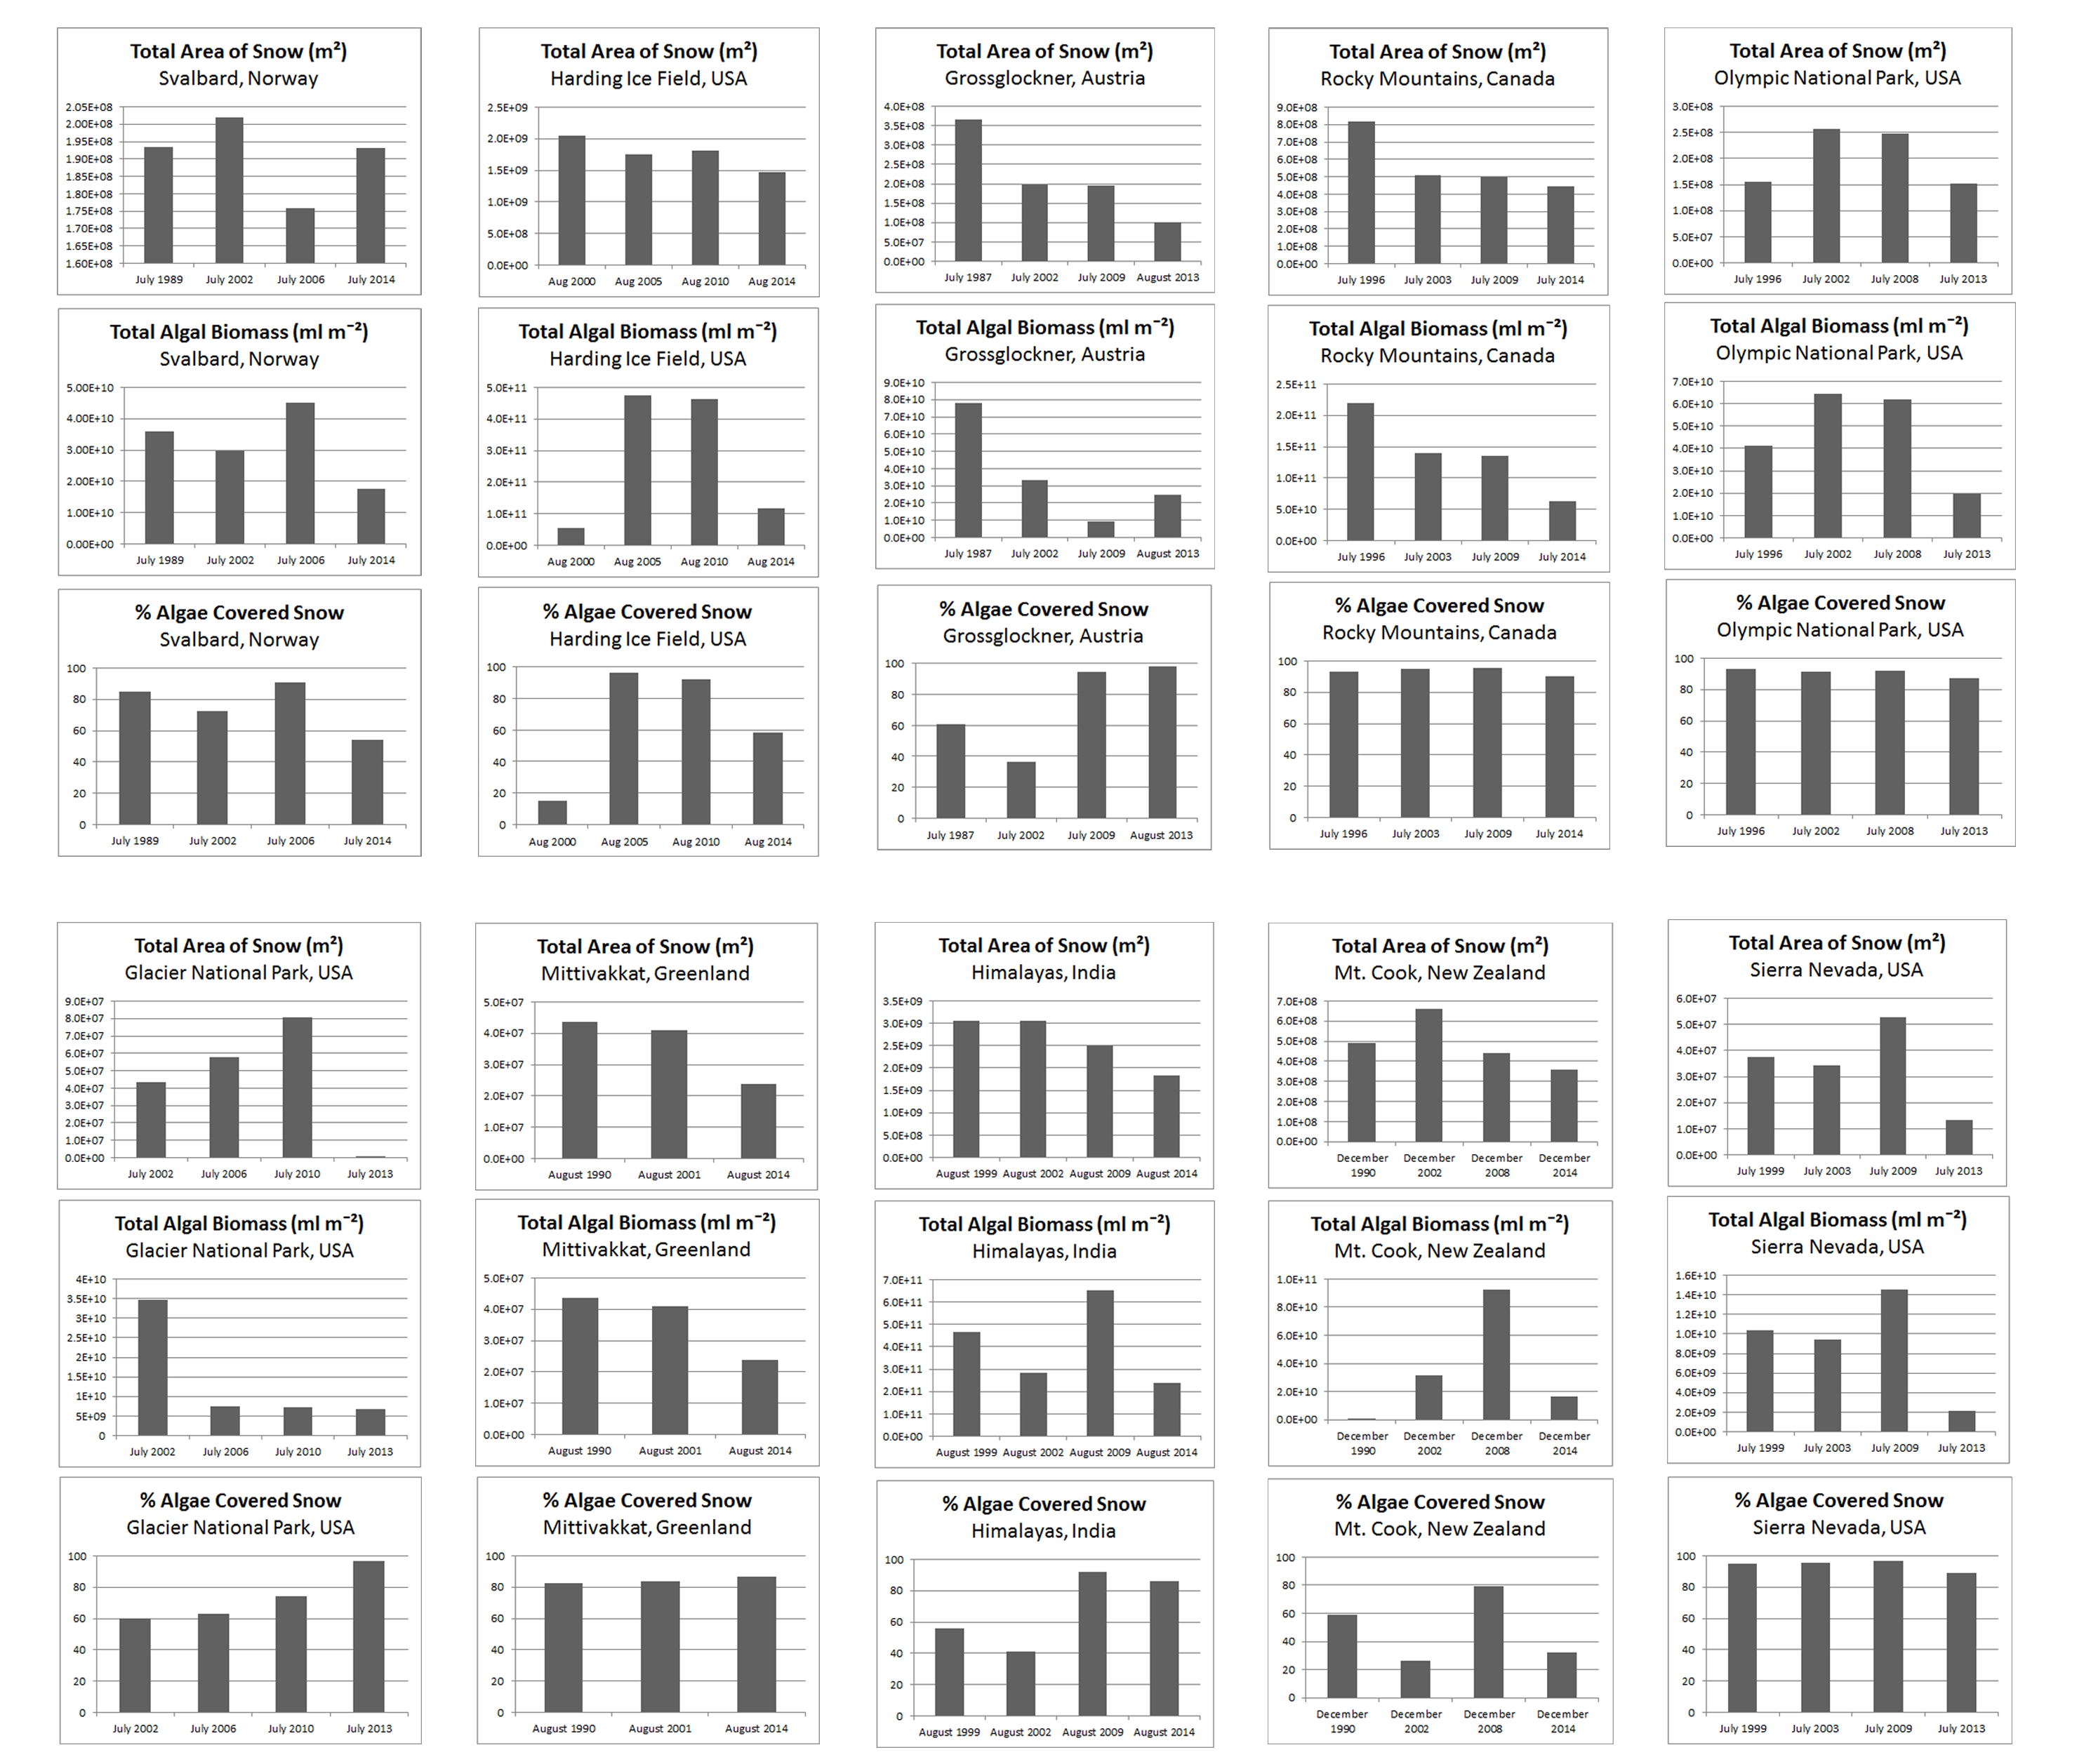
Supplementary Figure 2. A time series comparison of the total area of snow and sea ice, total algal biomass, and percentage of total snow that is covered with algae at ten different study sites.

Supplementary Figure 3. Clustering of snow and red snow communities based on similarities in taxonomic composition. Colored branches indicate significant clusters, with each color representing one cluster. Labels with ‘SVN’ correspond to white snow samples and ‘Greely 1’, ‘Greely 2’, and ‘Nansen’ correspond to red snow samples.

Supplementary Figure 4. Plot from principal components analysis of red snow and snow community taxonomic composition. Arrows indicate over-representation of certain taxa (red text) in particular red snow or snow communities (black text). Labels are described in the legend for Supplementary Figure 3.

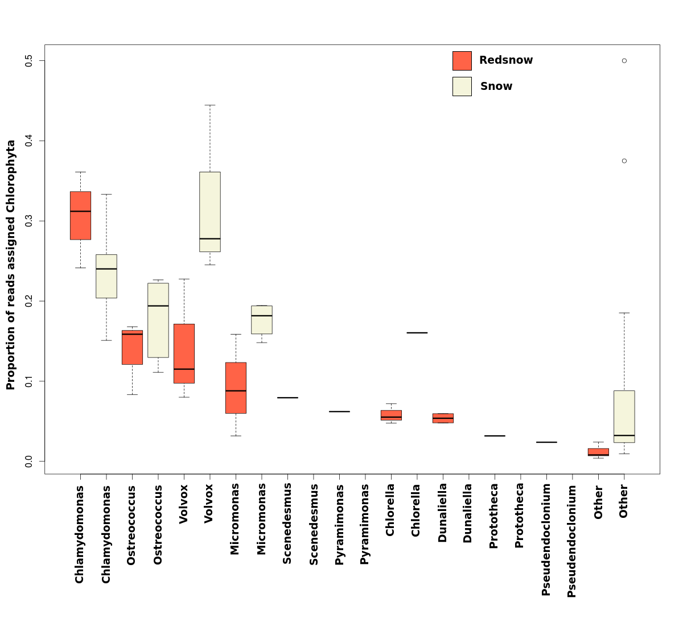
Supplementary Figure 5. Bar plots showing genus level comparisons of reads assigned to Chlorophyta. They y-axis shows the proportion of reads assigned to the phylum Chlorophyta for each genus. Red bars indicate data from red snow samples and khaki bars indicate data from snow. Snow metagenomes did not contain any reads from the following genera: Scenedesmus, Pyramimonas, Dunaliella, Prototheca, and Pseudendoclonium.

Supplementary Figure 6. Clustering of snow and red snow samples based on similarities in functions encoded by each community sample. Colored branches indicate significant clusters, with each color representing one cluster. Labels are described in the legend for Supplementary Figure 3.

Supplementary Figure 7. Principal components analysis of red snow and snow community functions. Arrows indicate over-representation of certain functional categories (red text) in particular red snow or snow communities (black text). Labels are described in the legend for Supplementary Figure 3.

Tables
Supplementary Table 1. The relationship between reflectance band ratio values, C. nivalis biomass, and the proposed level of algae abundance, extrapolated from a positive linear correlation between reflectance band ratio and algal biomass that was shown in previous research (Takeuchi et al. 2006).
Red to green reflectance band ratio | Algal biomass (ml mˉ²) | Mean algal biomass (ml mˉ²) | Algae abundance level
< 1 | < 100 | Not applicable | Insignificant
1 – 1.04 | 100 – 168.75 | 134.375 | Low
1.04 – 1.08 | 168.75 – 237.5 | 203.125 | Medium
1.08 – 1.12 | 237.5 – 300 | 268.75 | High
> 1.12 | > 300 | 300 | Very high

Supplementary Table 2. Metagenomic samples.
Sample name | GPS | Date | Character of snow | MG-RAST ID | Reference
SVN7 | 78.92, 11.94 | April 19 2008 | spring snowpack | 4451070.3 | (Maccario et al. 2014)
SVN8 | 78.92, 11.94 | April 19 2008 | spring snowpack | 4451073.3 | (Maccario et al. 2014)
SVN18 | 78.92, 11.94 | April 25 2008 | spring snowpack | 4451075.3 | (Maccario et al. 2014)
SVN35 | 78.92, 11.94 | May 9 2008 | spring snowpack | 4451065.3 | (Maccario et al. 2014)
SVN40 | 78.92, 11.94 | May 13 2008 | spring snowpack | 4451076.3 | (Maccario et al. 2014)
SVN48 | 78.92, 11.94 | May 20 2008 | spring snowpack | 4451068.3 | (Maccario et al. 2014)
SVN56 | 78.92, 11.94 | May 27 2008 | spring snowpack | 4451069.3 | (Maccario et al. 2014)
SVN64 | 78.92, 11.94 | June 2 2008 | spring snowpack | 4451072.3 | (Maccario et al. 2014)
SVN65 | 78.92, 11.94 | June 2 2008 | spring snowpack | 4451071.3 | (Maccario et al. 2014)
Greely 1 | 81.00, 58.30 | August 15 2013 | red | 4614610.3 | This paper
Greely 2 | 81.00, 58.30 | August 15 2013 | red | 4614611.3 | This paper
Nansen | 80.55, 54.11 | August 23 2013 | red | 4614609.3 | This paper

References:
Lutz S, Anesio AM, Villar SEJ, and Benning LG. 2014. Variations of algal communities cause darkening of a Greenland glacier. Fems Microbiology Ecology 89:402-414. Doi 10.1111/1574-6941.12351
Maccario L, Vogel TM, and Larose C. 2014. Potential drivers of microbial community structure and function in Arctic spring snow. Frontiers in Microbiology 5. ARTN 413
DOI 10.3389/fmicb.2014.00413
Remias D, Lutz-Meindl U, and Lutz C. 2005. Photosynthesis, pigments and ultrastructure of the alpine snow alga Chlamydomonas nivalis. European Journal of Phycology 40:259-268. Doi 10.1080/09670260500202148
Takeuchi N. 2009. Temporal and spatial variations in spectral reflectance and characteristics of surface dust on Gulkana Glacier, Alaska Range. Journal of Glaciology 55:701-709.
Takeuchi N, Dial R, Kohshima S, Segawa T, and Uetake J. 2006. Spatial distribution and abundance of red snow algae on the Harding Icefield, Alaska derived from a satellite image. Geophysical Research Letters 33. Artn L21502
Doi 10.1029/2006gl027819

