Supplemental Material

Table S1: Default values for the parameters in the model.

Symbol | Description | Value
T | maximum lifespan | 30
e_{max} | maximum amount of energy from food patch | 10
p_{b} | background predation risk | 0 - 0.5
p_{r} | reproduction predation risk | 0 - 0.5
w_{r} | weight reproduction | 0.1
b | strength of sexual selection | 1 - 5
d₀ | background disease risk | 0.3
L | effectiveness of immune defense | 0.5

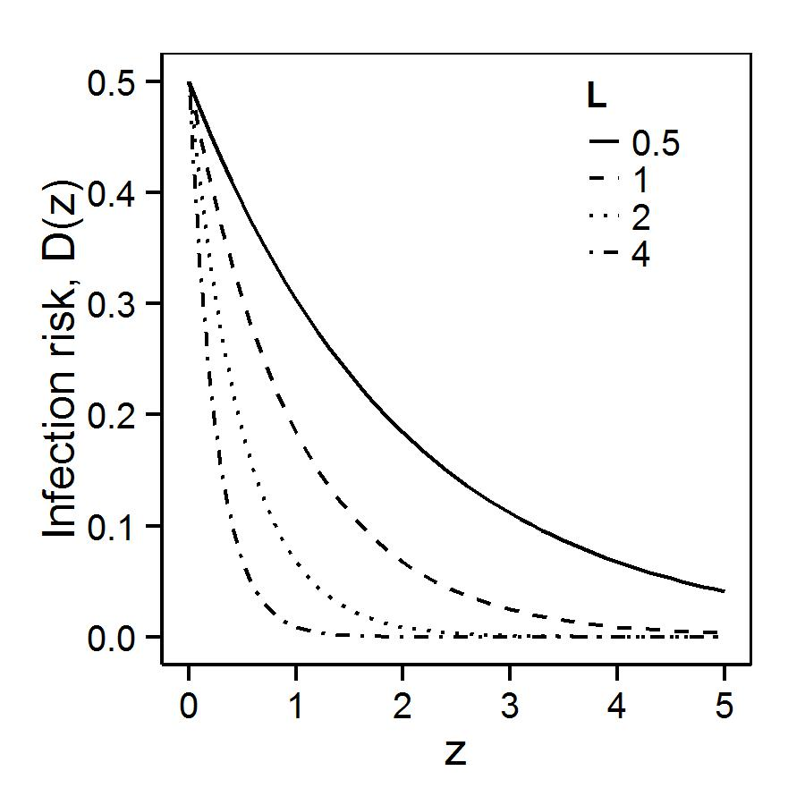
Figure S1. Relationship between immune function and mortality risk from disease, under various levels of immune effectiveness (L).

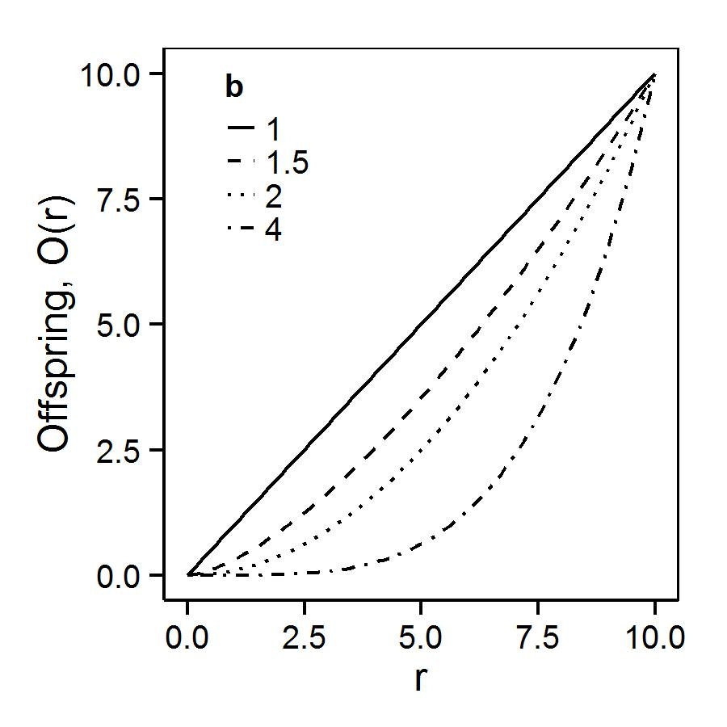
Figure S2. Relationship between reproductive effort and offspring production, under different levels of sexual selection (b).

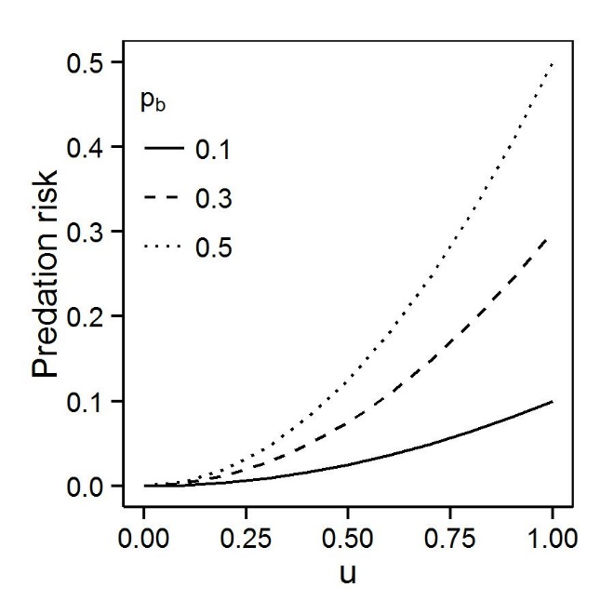
Figure S3. Relationship between predation risk (p_{b}) and foraging activity (u).

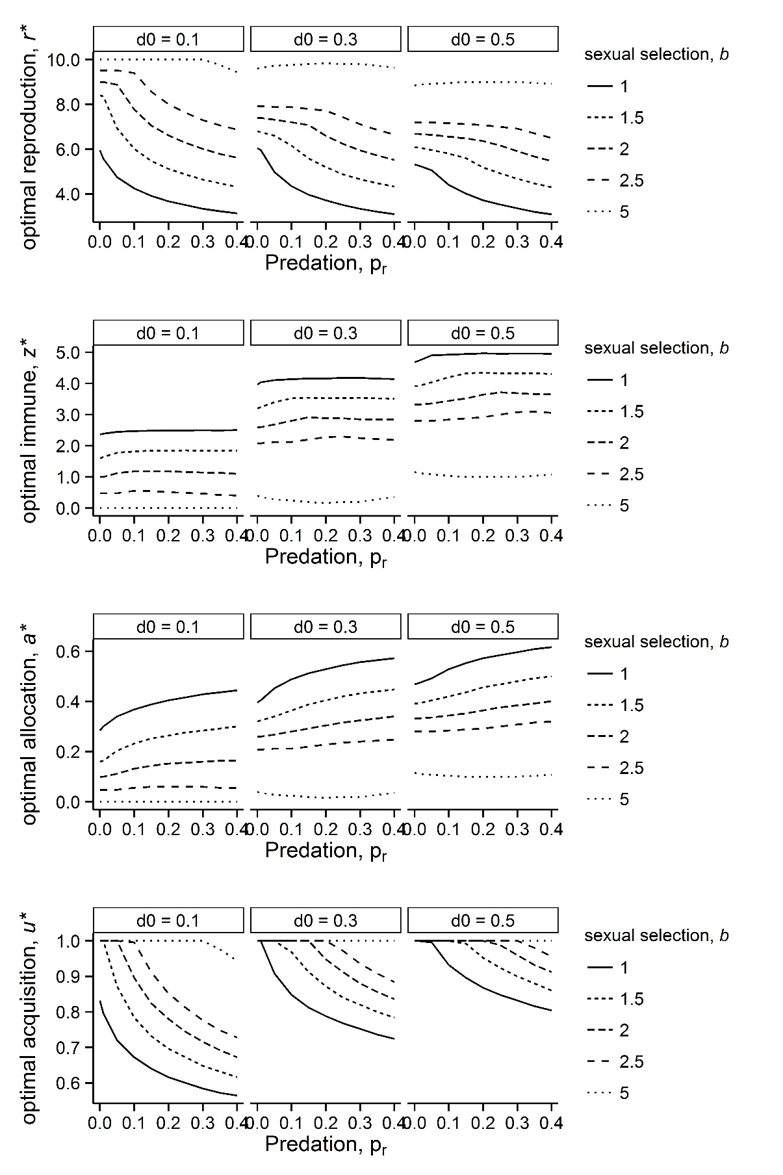
Figure S4. Effect of disease rate (d₀) for scenario 5 (Morphological). Each row shows a different response variable and each column a different disease rate. Predation risk associated with sexual trait is along the x-axis. Different line types indicate different level of sexual selection.

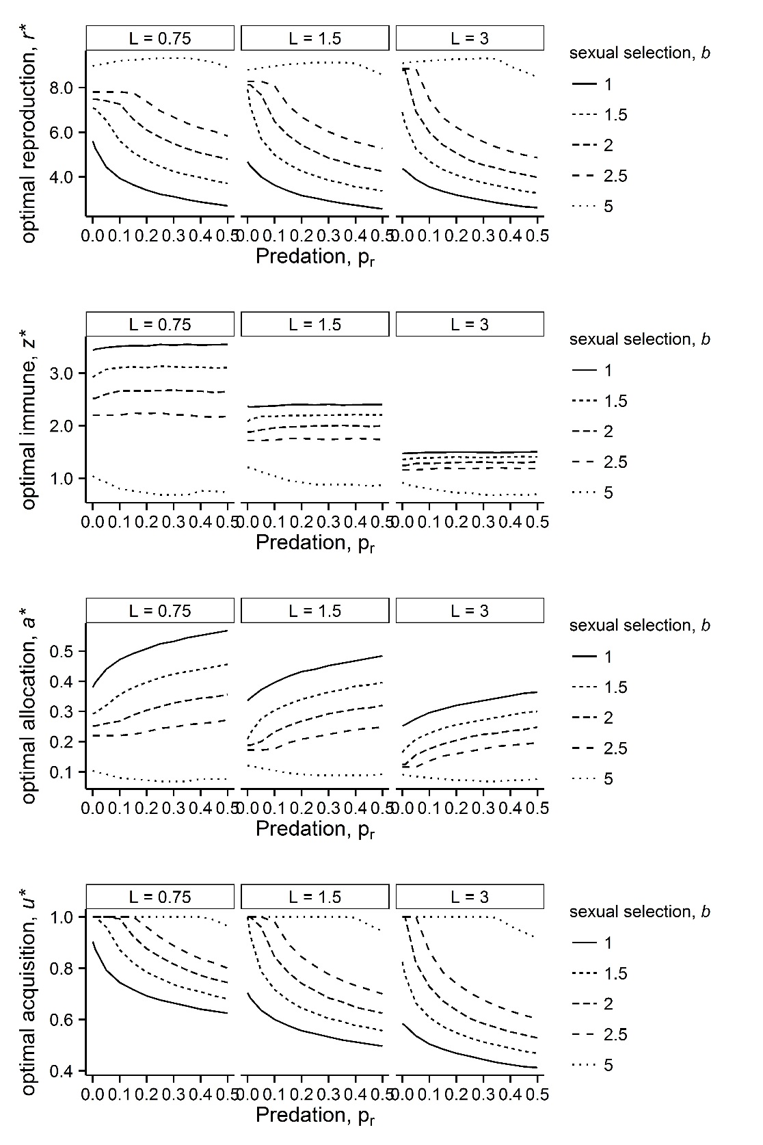

Figure S5. Effect of disease efficiency (L) for scenario 5 (Morphological). Each row shows a different response variable and each column a different disease efficiency. Predation risk associated with sexual trait is along the x-axis. Different line types indicate different level of sexual selection.

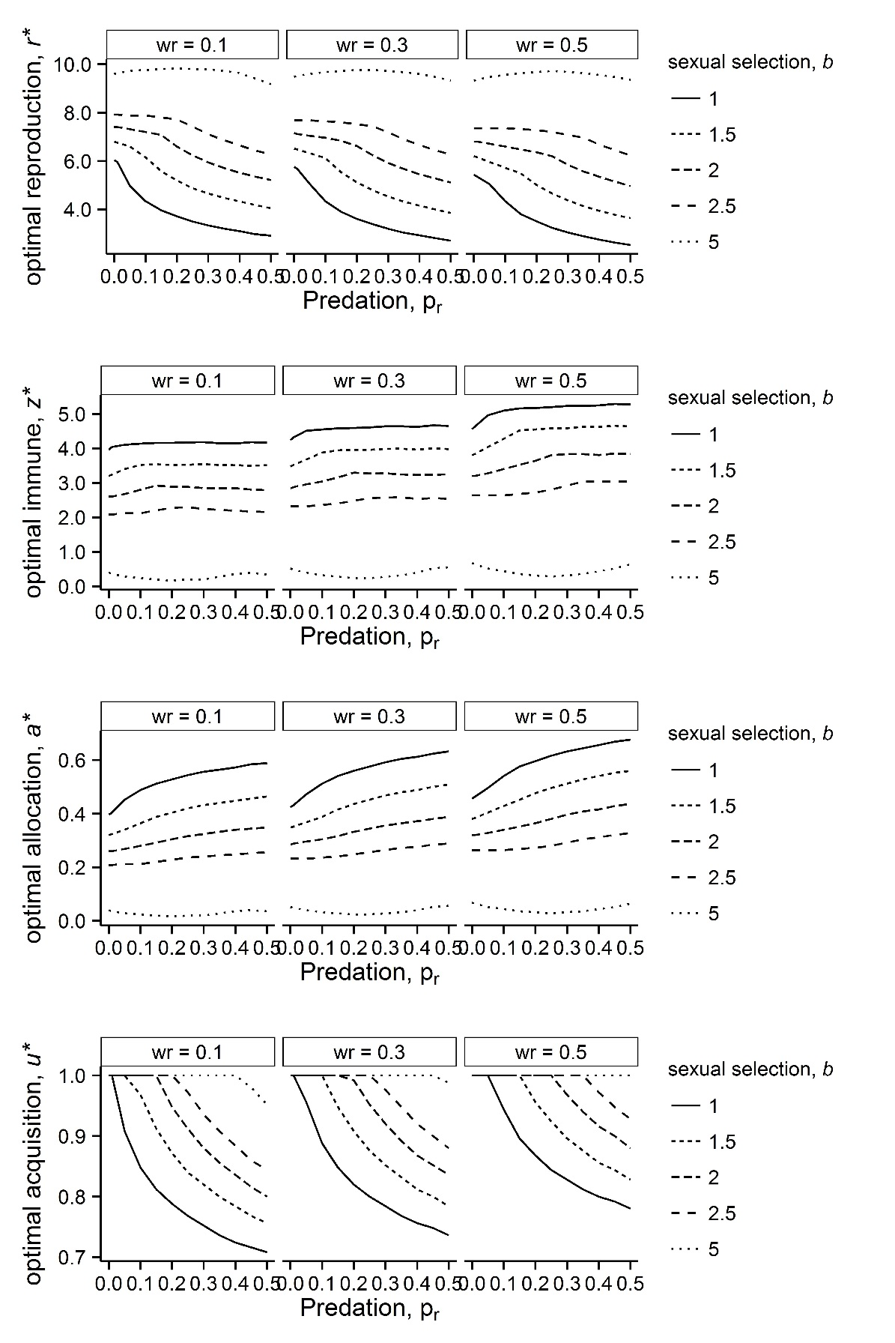
Figure S6. Effect of reproduction duration (w_{r}) for scenario 5 (Morphological). Each row shows a different response variable and each column a different w_{r}. Predation risk associated with sexual trait is along the x-axis. Different line types indicate different level of sexual selection.

